

Task 1 – Reading Task Template
Upload your photo of your A3 in-class notes here:
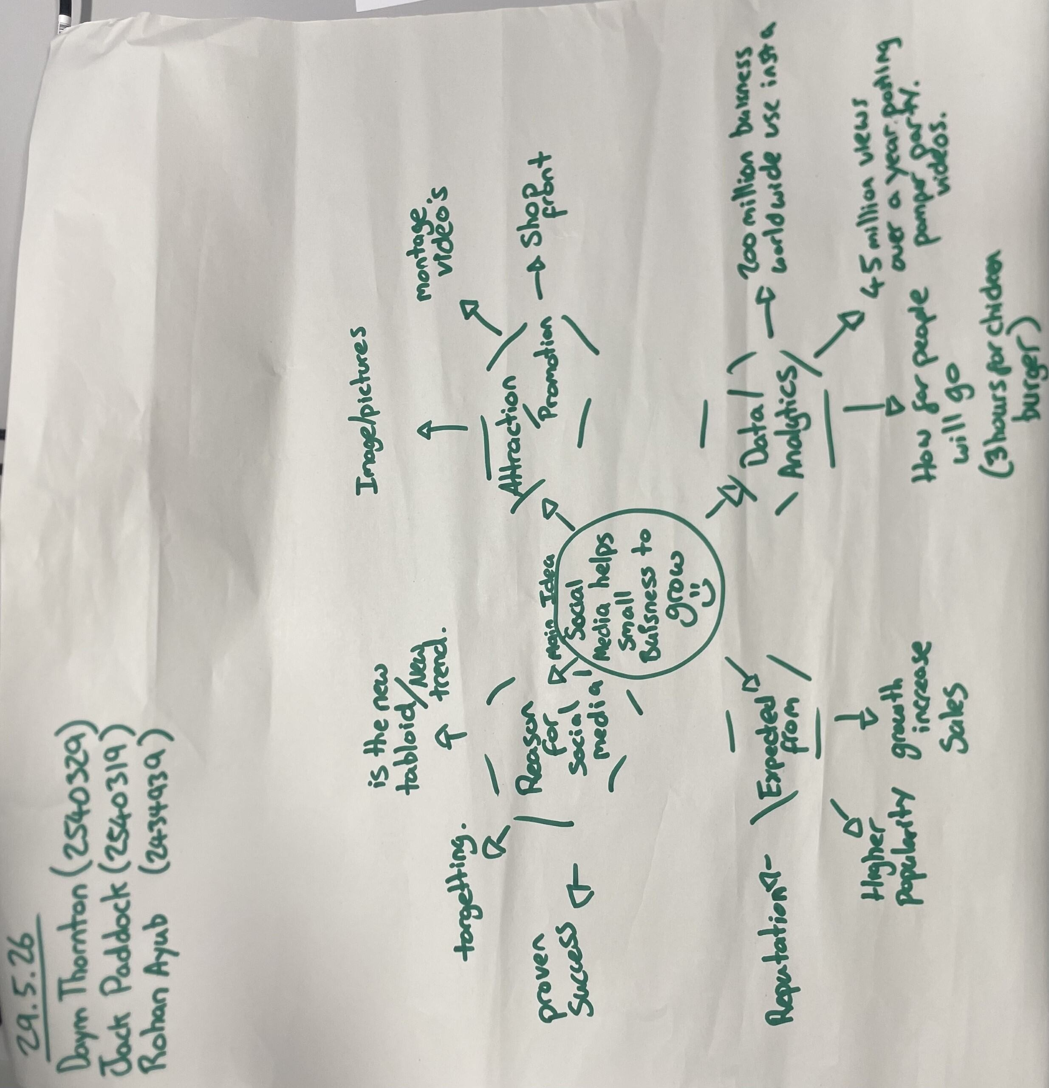

1. Answer these questions using the sentence starters below
a. What is the main idea of the text?
The main idea is to do with social media and how it helps small business to grow further and bigger.
b. What are two key points?
One key point is reasons for using social media and how it helps grow the business
Another key point is data and analysis which show our popularity and how much customer and money we make.
c. What part of the text did you find most important? Why?
The most important part is the reputation and people read reviews for in real life perspectives so depending on your reviews and previous visit can impact on how much custom and attraction you get.
d. Was anything unclear or difficult to understand?
I was not sure about how to explain every minor link as some time they entangle with another point made on the gram and therefore throws me a little bit.
e. How did your group help you understand the text better?
My group helped me by giving different ideas and expressing the reason why, so my understanding becomes broader and bigger.
3. One sentence reflection
Question: What did you find challenging about this task?
The hardest part was handwriting it up with proper gramma and no mistake to make it more presentable.

