PROF: AMARE DEATA
RADHIKA PATEL - 2314136

Strategic Management
(LCMB7003)

Table of Contents
Task 1: Précis 2
Task 2: Individual Assignment 5
Emergence of Virtual Organisations: Understanding the Landscape 5
Strategic Planning for Virtual Organisations 5
Designing Virtual Organisations 6
Leading Virtual Organisations 8
Reflections and Future Directions 9
References 11

Task 1: Précis
The paper "Global Innovation Systems - A Conceptual Framework of Innovation for Transnational Contexts" by Christian Binz and Bernhard Truffer (2017) focuses on the disadvantages of traditional frameworks of IS in capturing and explaining global innovation processes. When economies are highly interconnected and technology can cross borders, the given picture is that economists should acknowledge that the existing models based on national and regional contexts cannot understand the dynamics in a globalised world as technology/innovation can be considered as a multi-scalar network. In essence, it is essential to develop a more formal basis for innovation research and policy to have a qualified theory.
The study proposes a Global Innovation Systems(GIS) conceptual model which integrates national, regional, sectoral, and technological IS insights with new subsystem and structural coupling principles. This concept is based on a subsystem definition as a network of players who are the source of resources for innovative activity, namely knowledge, market access, financial investment, and technology legitimacy without any territorial boundaries (Binz and Truffer, 2017). Structural linkages provide mechanisms through which different subsystems can communicate and share resources across multiple geographical and institutional regions.
The authors propose a typology of GIS configurations based on two dimensions: the prevailing STI as a mode of innovation (Science-Technology-Innovation (STI) vs. DUI (Doing, Using, Interacting), the system of valuation (standardised vs. customised).customised). This typology is illustrated by empirical demonstrations from four different emerging clean technology industries, which reveals each industry could possess a different GIS structure. For example, the industry that follows a STI mode of innovation and standardised valuation processes such as solar photovoltaics are footloose GIS configurations having globalised innovation processes and emergence of the market formations which are less dependent from a particular geographical context (Binz and Truffer, 2017). However, for instance, pioneer sectors such as wind power technology typified by the DUI modes or the customised organisations experience the locale sticky configurations (GIS) meaning that the innovations and market processes are deeply entrenched in local or regional processes.
The paper meticulously utilises various diagrams and a detailed table to articulate the complex dynamics of Global Innovation Systems (GIS) across different industrial contexts, each illustrated through specific figures that delineate the structural couplings and subsystems in distinctive industries.
Figure 1 presents a conceptual model of a hypothetical GIS in healthcare, elucidating the interconnectedness of various organisational types like research institutes, NGOs, and companies across multiple scales—global, transnational, national, and regional. This model demonstrates the porous and interconnected nature of innovation systems, where national and regional systems intermingle through shared actors and institutions, showcasing the fluid boundaries within the GIS framework (Binz and Truffer, 2017).
Figure 2 classifies selected clean-tech industries within an innovation-valuation framework, plotting industries across axes representing innovation modes and valuation systems. Here, mature solar photovoltaics are identified as having a 'footloose' GIS, indicating a high degree of global integration in both innovation and valuation. This contrasts with early wind power, which exhibits a 'spatially sticky' GIS indicative of a firm reliance on local contexts for innovation and market interactions.
Besides, Table 1 delineates four Global Innovation System (GIS) configurations across industries, elucidating distinct modes of innovation, investment, market formation, and legitimation. These configurations range from market-anchored to production-anchored GIS, showcasing the interplay between global integration and local adaptation in innovation systems, shaping knowledge creation, investment strategies, and market dynamics (Binz and Truffer, 2017).
Figure 3 details the GIS configuration for the solar photovoltaics industry, highlighting its global operational scope in innovation and valuation-related subsystems. This indicates a significant global span of activities like market formation and technology legitimation, underpinning the industry’s global reach and minimal dependence on local contexts.
Figure 4 focuses on the early wind power industry, displaying a GIS with pronounced local and regional engagement in both innovation and valuation. This localised focus underscores the industry’s reliance on regional resources and market conditions, which are crucial during the initial stages of technology development.
Figure 5 explores the carbon capture and storage industry, illustrating a market-anchored GIS where knowledge creation operates globally but market formation and investment are more localised. This reflects a need for global knowledge exchange paired with region-specific market strategies to meet local regulatory and environmental standards (Binz and Truffer, 2017).
Figure 6 maps the GIS configuration in the electric car industry, showing a blend of local and global dynamics where innovation and investment are primarily localised, while market formation and legitimacy reach across global markets. This mix highlights the industry's reliance on localised innovation processes alongside a strategy to tap into international market opportunities.
Figure 7 traces the evolution of GIS configurations across four clean-tech industries from 1990 to 2015. This timeline provides a historical perspective on how industries like CCS, solar PV, electric cars, and wind power have transitioned between more localised and more globalised approaches in their innovation and valuation systems, reflecting the dynamic nature of technological evolution and market adaptation over time (Binz and Truffer, 2017).
The paper concludes that the GIS framework offers substantial explanatory power and can significantly enhance our understanding of global innovation dynamics. It connects the interpreted complexities with theoretical constructions, maintaining that a system of innovation that captures the multi-scaled and transnational nature is imperative in policy making. The authors acknowledge that the current model is, firstly, a starting point for the empirical tests and secondly, the theoretical refinement. They suggest research on different domains and the development of GIS configurations evolve which is the impact they have on policy effectiveness.
This study indicates that there are several flaws, for instance, the necessity of additional empirical data that could serve as evidence to support the proposed GIS configurations and the greater interconnectedness of this approach with existing economic models. The authors call for more case studies and comparative studies to validate and refine the GIS methodologies to make them more robust and applicable within more industries and contexts.

PRECIS
SUMMARY- INNOVATION SYSTEMS
This study provides a unique analytical framework for examining innovation in technological processes that occur across national borders and in international contexts. According to the authors' argument, most theories and policy proposals regarding innovation systems have adopted a national or regional perspective, so lacking to take into account the growing globalisation of innovation efforts across businesses and industries.
To address this flaw, the authors draw on fresh insights in the theory of global innovation as well as information from the literature on innovation systems. Their approach is multi-scale, perceiving innovation systems as spanning multiple spatial scales, from small-scale local economies and areas to a large-scale globally interconnected system.
Based on this multi-scalar GIS ideas, the authors propose a typology of four typical configurations that a GIS can have. Two main characteristics set these four groups apart: the form of innovation that occurs (supplier-dominated versus science-based innovation, for example) and the guiding concept of product valuation in a particular market (cost versus unique features).
In a supplier-dominated, cost-based business like automobile production as opposed to a science-based, competitive market like pharmaceutical, a GIS, for instance, would be very different.
To demonstrate the analytical worth of their method, the authors examine four emerging clean technology industries: bioethanol, solar energy, wind power, and electric vehicles. Based on qualitative data, they depict how creative activities in various sectors are organised across globally dispersed subsystems of knowledge creation, markets, manufacturing, etc., and how the couplings between these subsystems form an overall GIS.
The authors argue that implementing a thorough GIS methodology is necessary for two reasons: First off, it enables scholars who study innovation systems to develop more thorough justifications for the intricate geographic dynamics present to modern invention processes.
Theoretical work to date has focused on national or subnational scales.
Developing innovation policies and interventions that are more suited to the globalised structure of invention across industries can also be helped by a Geographic Information System (GIS) perspective. More specifically, it can guide global innovation assistance through international coordination policies related to laws, finance, labour transfers, intellectual property, and other areas.
In summary, this work provides a novel multi-scalar model—a conceptual contribution—for the analysis of globally linked but spatially scattered innovation systems. The increasing globalisation of innovation processes across industries highlights the relevance of this kind of approach to policy. The clean-tech business examples highlight the analytical viewpoint that a GIS offers.

In conclusion, in order to effectively support innovation and industrial development in an increasingly globalized context, governance techniques and institutions must be adapted to the unique characteristics of various GIS arrangements. Overall, although GIS are mostly natural evants that are difficult to actively plan or manage top-down, there are many of chances for future studies to create justifications for strategies that better take advantage of the connections that exist across the world in the innovation process.

PRESENTATION SLIDES :
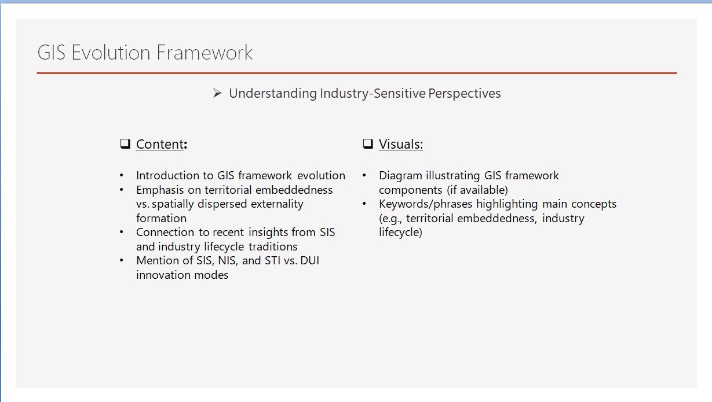

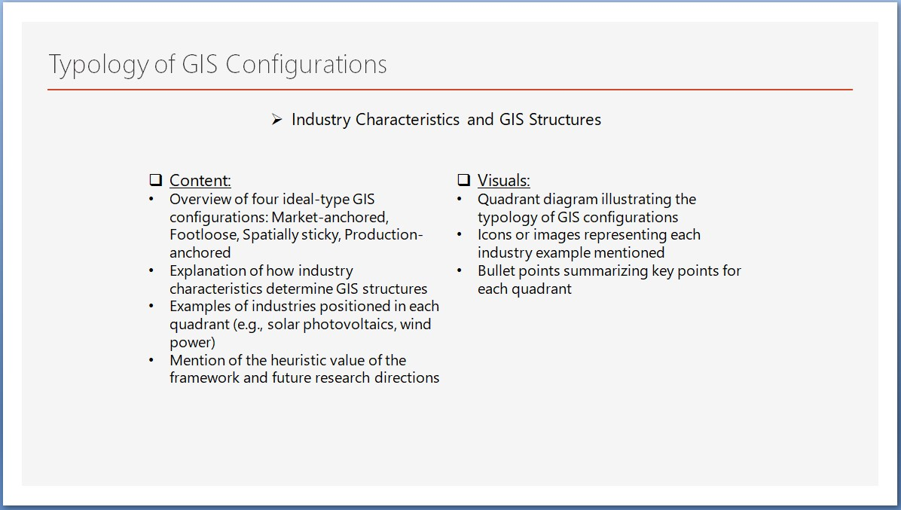

Task 2: Individual Assignment

Emergence of Virtual Organisations: Understanding the Landscape
Virtual organisations demonstrate a drastic shift from hierarchical structures of the past to agile, decentralised ones, driven by the technological evolution of the last decade. The main reason for this change is the reply of the modern business world to the need for flexibility and scalability (Narin, 2021). With its high speed and cloud computing sources, the Internet has removed the boundaries for collaboration among remote workers. By the time 2025 comes, half of all organisations will have adopted digital infrastructure to ensure the change process (Medium, 2023).
In this regard, the shift to virtual organizations may not be free from difficulties. Critics, however, believe that online settings can impede workflow dynamics due to lack of co-location; hence, creativity and teamwork can be affected. On the other hand, this doubt is grounded in the fact that one can manage these challenges effectively and with the help of the right technological tools, such as advanced project management software and real-time communication platforms. Companies such as Automattic and Basecamp serve as role models of successful virtual organisations, employing workers around the globe. They still collaborate and show the business viability and operational benefits of virtual structures, allowing for innovation and operational efficiency in various sectors (HBR, 2021).

Strategic Planning for Virtual Organisations
As virtual companies operate on a separate set of operating systems and in the "digital" environment, strategic planning for them is different from the one used by conventional companies. The fundamental concepts of strategic management in this type of organisation are an innovative and efficient utilisation of their technological resources to improve flexibility, a coherent alignment with general enterprise objectives, and adjustments to rapidly changing environmental conditions (Smuts et al. 2020).
Virtual firms can undergo transformations and adaptations easier than traditional organisations because they do not have the constraints of a conventional business. Long-term incidents are generally handled by planning and evaluated through short-term activities rather than through long-term goals (Rathore, 2023). Located within dynamic regions, digital companies consecutively deploy logistics and mobility measures. The outflow of decentralised operations becomes the ultimate advantage and the primary competitive advantage of digital companies in the industry. Organisations were 40% faster in strategic planning as of 2024 than conventional enterprises, actuating this speed in adapting (Morrison-Smith and Ruiz, 2020).
However, the mission and vision of the organisation should keep being aligned with all the strategic decisions to facilitate the advancement of the long-term goals. Thus, alignment around organisational identity, purpose orientation for remote teams, and goal attainment under common targets will be established (Ghonim et al. 2022). The absence of physical clues and team dispersion have made virtual alignment a highly complex. Leaders must use effective communication methods, visualise goals and build virtual relationships to avoid fragmentation and preserve organisational unity despite the geographical boundaries.
Technological advancement also tends to play a significant role in virtual firms' strategic planning. Technology can improve the whole operation of leadership. Artificial intelligence and machine learning are widely used in virtual companies to position these businesses strategically and offer services (Bharadiya, 2023). Technology disrupts the strategic environment of the business. Virtual companies have to remain competitive by chasing new technological enhancements and integrating new technologies.
Critics say that this dependence on technology may put such organisations in peril if they eventually get disrupted in the digital space or experience cyber threats. To this end, even a single breach or a system failure can paralyze an operation, making cybersecurity measures and IT resilience planning indispensable components of strategic planning. In reaction, major virtual organisations spend about 10-15% of their annual budget only on upgrading and securing their IT systems, which is much more than in traditional setups (Roshanaei, 2021).

Designing Virtual Organisations
Virtual organisations' setup success directly grows with their design principles and frameworks. While decentralised structures and flexible communicating systems are usually applauded for providing agility and innovation, they may also face difficulties in coordination and decision-making bottlenecks (Dühring and Zerfass, 2021). For example, enterprises like GitLab have adopted a virtual organisational structure whereby remote teams can effectively operate and interact despite time zone differences. On the one hand, this can bring a lot of confusion and delay if the communication and decision-making process are unclear. The argument is that agile methodologies like Scrum deal with such issues through iterative development and adaptive planning (Bhavsar et al. 2020). Thus, some professionals argue that understanding the nature and complexity of these situations is a prerequisite to determining the effectiveness of such techniques, which may depend on the type of culture. These may be successful in such situations where rigid hierarchies exist or strict laws exist. One of the crucial principles to this is integrating these concepts, which will promote internalisation of the particular conditions and environments of the virtual sphere, increasing the efficiency and adaptability of the virtual companies.
The organization's processes in the virtual world significantly influence its efficiency, flexibility and robustness. Take into account a decentralised management structure contributes to efficiency by enabling employees to make independent and thoughtful choices However, this is not done without keeping it under control (Kahl et al. 2023). Using cloud-based collaborative applications also enhances resilience by enabling smooth remote work but there are chances of data privacy. The ability of an organisation to maintain a balance between flexibility and control is vital, to maximise the agility and resilience of a working unit in any virtual environment. Zoom is an example of a company that scaled up its infrastructure to deal with the dramatic increase in remote working throughout the COVID-19 pandemic (Aloisi and De Stefano, 2022).
It takes theoretical and pragmatic approaches to investigate the best practices and trends of virtual organisation design. Collaborative organisational structures advance remote teams' flexibility and communication, which comes in line with digital platforms (Raza, 2024). Critics argue that a lot of virtual communication can even jeopardise the quality of relationships and innovation. Therefore, Salesforce has successfully applied virtual design principles that have allowed for agile decision-making and digital connection for better productivity. Technology innovations such as VR and AI make it possible to design optimal virtual teams, yet the personnel's acceptance and training problems remain outstanding (Bibbò and Morabito, 2022). Hence, irrespective of the value of a theoretical framework, it will bring results only if adopted and adapted to the new requirements of the organisation.

Leading Virtual Organisations
Previewing virtual teams and distributed workforce leadership problems and options is complex. Using virtual teams means flexibility and various experiences among team members, but executives need help. Teamwork is severely challenged without direct verbal or non-verbal interactions (Morrison-Smith, and Ruiz, 2020). Miscommunications and arguments can come from informational ways, less precisely from virtual communications. Time zones and cultural problems can derail teamwork and decision-making. By embracing being proactive, we can dramatically undermine these issues. Microsoft employs contact activities such as virtual team-building and cultural sensitivity training as means of helping remote workers establish rapport (Microsoft, 2021). Through data analytics and project management technologies, leaders can monitor the work of a team and distribute resources accordingly. Along with the optimization of remote work, leaders face various challenges in managing remote staffing, such as data privacy laws and cybersecurity issues. Successful virtual leadership involves tech-savviness, emotional awareness and flexibility to take full advantage of remote workforce assets and prevent potential risks (‌Israfilov et al. 2020).
The leadership, cooperation and engagement in virtual worlds are dependent on it. Leaders who listen through open communication and set clear directions to build team trust (Ben Sedrine et al. 2021). Leaders can cultivate group work and open communication by demonstrating empathy and listening to their staff. Proactive engagement initiatives incorporating virtual team building and regular updates can make remote workers feel less alone and connected. To connect workers, Google relies on coffee break meetings and peer events (Forbes, 2021). While digital fatigue and feeling of isolation are some of the challenges leadership faces, it requires them to find ways for sustained engagement. Using technology to support productive interactions and offer opportunities to enhance skills and recognition, leaders can strengthen cohesion and motivation in a virtual working environment and accomplish organisation objectives (‌Marsh et al. 2022).
The tactics that are utilised in communication, relationship management, and performance management are extremely important to the success of virtual leadership. In the first place, managers need to make constant and clear communication a top priority in order to bridge the gap that exists between different locations and ensure that the firm is moving in the right path. Real-time, direct engagement and a sense of community are both viable outcomes that can be achieved through the utilisation of a variety of communication tools such as video conferencing, instant messaging, and cloud collaboration (Raji et al. 2024).
Furthermore, courageous relationship-building initiatives like virtual coffee dates and personal check-ins help build trust and rapport among teammates, improving collaboration and morale.
Virtual performance management systems also need emphasis on results and flexible feedback. The leaders can establish realistic expectations and KPIs, which will assist remote team members to track progress and measure success well. For instance, Salesforce creates performance charts and uses regular performance reviews to monitor individual and team performance from remote places as well (Luthia, 2022). It is possible that a flexible leadership style is required in order to address issues such as sustaining productivity and providing support and assistance to employees who are concerned. When feedback and training programmes are delivered through remote coaching alongside frequent performance evaluations, this approach creates an environment for leaders that is beneficial and supportive. Therefore, the achievements of the successful virtual teams is a direct consequence.

Reflections and Future Directions
With the analysis of virtual organizations, one may have critical ideas concerning the matter. First, organizational effectiveness, flexibility and adaptability are all vital capabilities and this is the primary purpose that design principles serve. Organizations can improve their virtual structure in terms of goals and functions much faster if they evaluate the impacts of various design options on communication, decision-making and collaboration process (Kristensen et al. 2021). Moreover, the analysis has also revealed the restraints of managing remote teams and project teams which operate in different locations. They demonstrate the leadership significance of trust, collaboration, and participation.
It is evident that the virtual organization management research of the present that is undergoing alterations in the remote work and technological development aspects can be achieved only with incorporating the settings factor. Technology-based analysis, involving artificial intelligence and virtual reality among virtual teams, and how this plays out on the mental health of individuals and on the productivity of society, should not be overlooked(Zhang et al., 2022). Besides sufficient research is needed to prove the effectiveness of such leadership practices on organisation performance and how they influence innovation.
To that end, businesses that provide a large number of employees with virtual workspaces must review and change their policies frequently because of the ongoing advancement in the number of remote workers and virtual teams. By the same token, it is achieved through the use of the most effective communication facilities, determination-based working time, as well as the participation of training and supporting members of the virtual team. Furthermore, the key principles of credibility, collegiality, and responsibility in leadership should percolate down into the virtual world where it could be through which collaborations and teams are formed (Kohntopp and McCann, 2020).
Therefore, analysis of the virtual ventures by the critics will aim at ascertaining strategies that are suitable to defeat their weaknesses. Virtual element's complexities and virtual workplace policy layers' relations' cognitiveness, help organization to become sensitive and competent in implementing relevant policy for virtual workplace, and this will eliminate the imbalances and the advantages it offers (Ashtari et al. 2020). In conclusion, critical influence style for e-organizations overcomes their resistance and enables the innovation of the investment ecosystem, which is constantly evolving in the era of digitalization and interconnectivity.

References
Aloisi, A. and De Stefano, V., 2022. Essential jobs, remote work and digital surveillance: Addressing the COVID‐19 pandemic panopticon. International Labour Review, 161(2), pp.289-314.
Ashtari, N., Bunt, A., McGrenere, J., Nebeling, M. and Chilana, P.K., 2020, April. Creating augmented and virtual reality applications: Current practices, challenges, and opportunities. In Proceedings of the 2020 CHI conference on human factors in computing systems (pp. 1-13).
Ben Sedrine, S., Bouderbala, A. and Nasraoui, H., 2021. Leadership style affects virtual team efficiency: trust, operational cohesion and media richness roles. Journal of Management Development, 40(5), pp.365-388.
Bharadiya, J.P., 2023. Machine learning and AI in business intelligence: Trends and opportunities. International Journal of Computer (IJC), 48(1), pp.123-134.
Bhavsar, K., Shah, V. and Gopalan, S., 2020. Scrum: An agile process reengineering in software engineering. International Journal of Innovative Technology and Exploring Engineering, 9(3), pp.840-848.
Bibbò, L. and Morabito, F.C., 2022. Neural network design using a virtual reality platform. Global Journal of Computer Science and Technology, 22(D1), pp.45-61.
Binz, C. and Truffer, B., 2017. Global Innovation Systems—A conceptual framework for innovation dynamics in transnational contexts. Research policy, 46(7), pp.1284-1298.
Dennison, K. (2021). How Leaders Can Increase Engagement And Build Stronger Teams. [online] Forbes. Available at: https://www.forbes.com/sites/karadennison/2021/08/11/how-leaders-can-increase-engagement-and-build-stronger-teams/.
Dühring, L. and Zerfass, A., 2021. The triple role of communications in agile organizations. International Journal of Strategic Communication, 15(2), pp.93-112.
Ghonim, M.A., Khashaba, N.M., Al-Najaar, H.M. and Khashan, M.A., 2022. Strategic alignment and its impact on decision effectiveness: a comprehensive model. International Journal of Emerging Markets, 17(1), pp.198-218.
‌Israfilov, N., Borisova, O., Kartashova, O., Davydova, N., Biserova, G. and Gryaznukhin, A., 2020. Motivation and employee effectiveness in online learning environments: Leadership strategies of new generation and emotional intellect. International Journal of Emerging Technologies in Learning (iJET), 15(9), pp.258-279.
Kahl, J., de Klerk, S. and Whiteoak, J., 2023. Managing empowerment: adjusting organisational units' autonomy to achieve corporate agility. Journal of Organizational Effectiveness: People and Performance, 10(4), pp.527-545.
Kohntopp, T. and McCann, J., 2020. Leadership in virtual organizations: Influence on workplace engagement. The Palgrave handbook of workplace well-being, pp.1-26.
Kristensen, S.S., Shafiee, M. and Shafiee, S., 2021. Organization design in motion: designing an organization for agility. Proceedings of the Design Society, 1, pp.2349-2358.
Luthia, M., 2022. Reimaging talent management through adaptive performance in the next normal. SDMIMD Journal of Management, pp.113-124.
‌Marsh, E., Vallejos, E.P. and Spence, A., 2022. The digital workplace and its dark side: An integrative review. Computers in Human Behavior, 128, p.107118.
Morrison-Smith, S. and Ruiz, J., 2020. Challenges and barriers in virtual teams: a literature review. SN Applied Sciences, 2(6), pp.1-33.
Morrison-Smith, S. and Ruiz, J., 2020. Challenges and barriers in virtual teams: a literature review. SN Applied Sciences, 2(6), pp.1-33.
Narin, N.G., 2021. A content analysis of the metaverse articles. Journal of Metaverse, 1(1), pp.17-24.
Network, T.T.G. (2023). Investment and Progress. [online] Medium. Available at: https://techsoup.medium.com/investment-and-progress-b59963f161c0 [Accessed 2 May 2024].
Raji, M.A., Olodo, H.B., Oke, T.T., Addy, W.A., Ofodile, O.C. and Oyewole, A.T., 2024. Business strategies in virtual reality: a review of market opportunities and consumer experience. International Journal of Management & Entrepreneurship Research, 6(3), pp.722-736.
Rathore, B., 2023. Digital transformation 4.0: integration of artificial intelligence & metaverse in marketing. Eduzone: International Peer Reviewed/Refereed Multidisciplinary Journal, 12(1), pp.42-48.
Raza, A., 2024. The Future of Work: Trends Impacting Business Management. Journal for Business Research Review, 2(1), pp.63-71.
Roshanaei, M., 2021. Resilience at the core: critical infrastructure protection challenges, priorities and cybersecurity assessment strategies. Journal of Computer and Communications, 9(8), pp.80-102.
Smuts, S., van Der Merwe, A. and Smuts, H., 2020, April. A strategic organisational perspective of Industry 4.0: a conceptual model. In Conference on e-Business, e-Services and e-Society (pp. 89-101). Cham: Springer International Publishing.
TECHCOMMUNITY.MICROSOFT.COM. (2021). Fostering Team Building and Employee Connections. [online] Available at: https://techcommunity.microsoft.com/t5/driving-adoption-blog/fostering-team-building-and-employee-connections/ba-p/2156151.
Tippmann, E., Scott, P.S. and Gantly, M. (2021). Which Hybrid Work Model Is Best for Your Business? [online] Harvard Business Review. Available at: https://hbr.org/2021/08/which-hybrid-work-model-is-best-for-your-business.
Zhang, Z., Wen, F., Sun, Z., Guo, X., He, T. and Lee, C., 2022. Artificial intelligence‐enabled sensing technologies in the 5G/internet of things era: from virtual reality/augmented reality to the digital twin. Advanced Intelligent Systems, 4(7), p.2100228.

