UNESCO Heritage Profile – England

There are two reasons for which England has been selected as the nation of focus. Firstly, it is the nation the author is most familiar with. Secondly, England (and the UK at large) currently has no representation on UNESCO’s list of intangible cultural heritage.
Cultural | Natural
(i) to represent a masterpiece of human creative genius | (vii) to contain superlative natural phenomena or areas of exceptional natural beauty and aesthetic importance
(ii) to exhibit an important interchange of human values, over a span of time or within a cultural area of the world, on developments in architecture or technology, monumental arts, town-planning or landscape design | (viii) to be outstanding examples representing major stages of earth's history, including the record of life, significant on-going geological processes in the development of landforms, or significant geomorphic or physiographic features
(iii) to bear a unique or at least exceptional testimony to a cultural tradition or to a civilization which is living or which has disappeared | (ix) to be outstanding examples representing significant on-going ecological and biological processes in the evolution and development of terrestrial, fresh water, coastal and marine ecosystems and communities of plants and animals
(iv) to be an outstanding example of a type of building, architectural or technological ensemble or landscape which illustrates (a) significant stage(s) in human history | (x) to contain the most important and significant natural habitats for in-situ conservation of biological diversity, including those containing threatened species of outstanding universal value from the point of view of science or conservation
(v) to be an outstanding example of a traditional human settlement, land-use, or sea-use which is representative of a culture (or cultures), or human interaction with the environment especially when it has become vulnerable under the impact of irreversible change
(vi) to be directly or tangibly associated with events or living traditions, with ideas, or with beliefs, with artistic and literary works of outstanding universal significance. (The Committee considers that this criterion should preferably be used in conjunction with other criteria)
UNESCO’s own definition of World Heritage, which is regularly revised, states that a site must fulfil one of ten selection criteria, which can be subdivided into two categories – essentially cultural (outstanding examples of human interaction either with themselves or the environment around them) and natural (outstanding examples of natural ‘beauty’ or representative examples of the natural world and natural history).

In the following report, references to this chart will be made by roman numerals (i, ii, iii, etc.)
To reiterate, a site need only fulfil one of these ten criteria.

Intangible heritage is defined by UNESCO as “the practices, representations, expressions, knowledge, skills – as well as the instruments, objects, artefacts and cultural spaces associated therewith – that communities, groups and, in some cases, individuals recognize as part of their cultural heritage.” – basically a focus on knowledge and practices rather than the physical. It should be obvious that England has plentiful examples that would fulfil these requirements, and yet England has no examples on the UNESCO list. The reason for this is well established – The UK is one of seventeen countries to have not ratified the 2003 Convention for the Safeguarding of the Intangible Cultural Heritage which originally set out these terms. With this in mind, profiles of England’s national heritage should bear in mind that England as a political entity has indicated less interest in intangible heritage.

Article One - Stonehenge, Avebury and Associated Sites

The site of Stonehenge, a large stone circle in Wiltshire of probable high astronomical importance, is potentially the most famous stone circle structure in the world. The stone circle at Avebury is the largest extant prehistoric stone circle in the world. These two circles, along with associated burial mounds, walls and other major monuments, make up the UNESCO listed greater site. Given world heritage status in 1986, Stonehenge has become a symbol of times immemorial.
Criteria for Selection
SAAS was selected for three criteria:
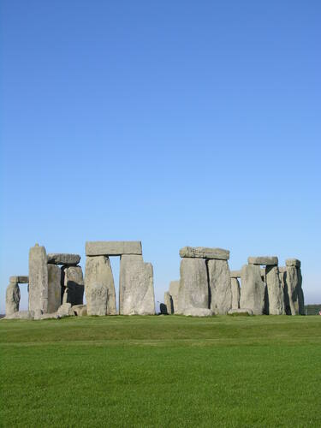
- (i) Stonehenge is unmatched worldwide in its design and engineering, and is the most sophisticated stone circle in the world. Some of its huge stones (some weighing over 40 tonnes) were transported 240km to the site, and several nearby associated sites are also massive in size. The Avebury stone circle is the largest in the world, consisting of a 1.3km circle encompassing 180 stones. These huge, complex sites demonstrate the ability of prehistoric people to conceive of and construct large scale features.
Bandarin, 2022
- (ii) SAAS provide a unique glimpse of an evolution of monument building and of ever changing landscape usage. They have provided countless inspirations for modern society, and are still of high archaeological value.
- (iii) SAAS provide unparalleled insight into the funerary beliefs and practices of Neolithic Britain, as well as an understanding that said people could conceptualise their place in the world both spiritually and cosmically, considering the calendrical aspects of the stones.
SAAS may tell us little about modern Britain as an archaeological item, given its Neolithic and Bronze Age nature, but its history as an item of Heritage is perhaps more illuminating. It has only been some scarce 100 years that the stones have been in ‘public’ possession, having being gifted to the people in 1918 by a wealthy landowner who had purchased the property three years earlier.
Perhaps the most important segment of the modern history of Stonehenge is the Battle of the Beanfield. In this event, which took place in 1985 before the planned Stonehenge Free Festival that year, some 600 or so travellers were ambushed by over 1000 police officers, resulting in dozens of injuries, 140 destroyed vehicles, 537 arrests (the most on any single day since the Second World War) and 7 pet animal deaths. As of yet, there has been no official explanation for the violence that took place that day. However, the event highlighted the disdain that at least the police and / or political class (if not the wider populace in general) had at the time for the New Age travelling community, while the changing access to the stones since then culminating in today’s yearly open access events on the summer and winter solstices is a good indication of either changing attitudes to these ‘new age’ celebrations, or to changing understandings of police violence in Britain.
In any case, Stonehenge is now an incredibly popular tourist attraction, and is regularly visited religiously by Neo-Druids, Pagans and other similar religious peoples. If one were to consider SAAS in the context of intangible heritage in lieu of UNESCO recognition, the practices of these peoples would be a potential candidate.

Article Two – Dorset and East Devon Coast
Dorset and East Devon Coast, also known as the Jurassic Coast, was granted World Heritage status in 2001, and consists of 8 sections of 155km of coastline. These sites are of great importance to both modern palaeontology and to the cultural identity of the area. Several of the sites along this coastline – such as Durdle Door, Lulworth Cove and Chesil Beach – are iconic images of British coastlines, which contribute to DaEDC’s worthiness as an outstanding example of Britain’s natural heritage.
Criteria for Selection
- (viii) UNESCO considers that the fossil makeup of DaEDC – a fossil record that includes globally significant fossil discoveries and spans 185 millions years of the history of Earth – as well as “textbook exemplars of coastal geomorphological features, landforms and processes”

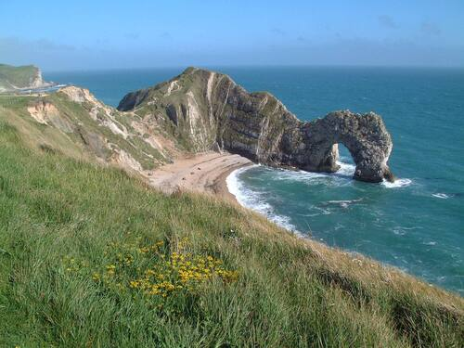
Two things are worth considering in regards to the cultural / political climate of this site – focussing on the site of Durdle Door.
Firstly, Durdle Door is owned privately, by the Lulworth Estate. While perhaps meaning little by itself, this understanding along with that of the donation of Stonehenge by the wealthy starts to build a clear image of England as a nation that is still controlled by the upper classes, and sites of national or even worldwide importance are still only accessible to the public to which they should be enjoyed by the ‘philanthropy’ of the landed gentry.
Secondly, one should consider the different ways that Durdle Door is enjoyed – in this case, the act of tomb stoning. Here, daredevils and thrill seekers climb to the top of the Durdle Door geological formation and leap into the water, stiffening their arms and legs vertically (thus taking on the appearance of a tombstone). As one would imagine, this is a dangerous activity, with at least 20 deaths and many more serious injuries since 2005. Nevertheless, tombstoning constitutes a use case for the site that does not fall into the interests of UNESCO but highlights a distinct subcultural meaning.
Simons, 2022

Article Three – The Tower of London
The Tower of London, a symbol of the Royalty of England, was granted status in 1988. With its White Tower built by William the Conqueror in 1066 and standing today as “the most complete example of an 11th century fortress palace remaining in Europe” which is the core of the fortress itself, the Tower of London is an icon of Britain. Its defensive value came from both defences to those without – sited at a bend in the Thames and housing a garrison – and defences against those within – controlling the citizenship of London by the same means. The site has been used as the site for several important state institution and is also the setting for major historical events in European history. Three queens were executed there, and the writing of religious prisoners during the Reformation crystalised the Tower of London’s reputation as an imposing (and quite literally towering) place of execution and torture.
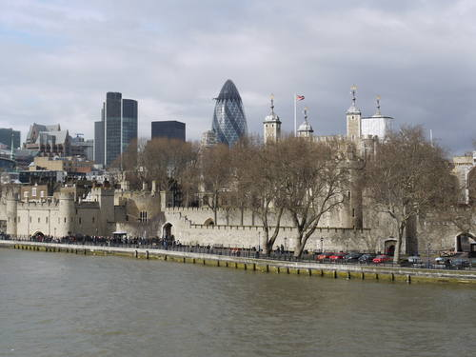
Criteria for Selection
Gutierrez-Conde, 2022
- (ii) The Tower of London has as a symbol for the royalty of England’s ability to protect, administer and punish their subjects since the Norman invasion.
- (iv) The central White Tower is an incredibly well preserved example of a Norman royal castle, and the rest of the fortress complex serves as a “major reference for the history of medieval military architecture”.

A reflection should be made regarding the following:
“The ability of the Tower to reflect its strategic siting and historic relationship to the City of London is vulnerable to proposals for development that do not respect its context and setting.“ – UNESCO, 2022
In the image above, we can see that the Tower of London no longer dominates the skyline - indeed, it is dwarfed by several buildings in the immediate background. It would seem that certain historical aspects – namely, the large and impressive nature of the structure and the reputation as a place to be afraid of – are completely lost in its modern context. While its location as part of the largest city in the UK is incidental, one could argue differently for the modern tourist object of the Tower of London. With Historic Royal Palaces offering audio guides, coffee and snacks in multiple cafes and kiosks, and souvenirs from various different shops, it is certainly the case that a deliberate effort has been made to ‘touristify’ the Tower, and in doing so removing or damaging the intimidation or the ‘fear factor’. While one would certainly be remiss to claim this is unique to the Tower of London, this feature highlights one of many possible tensions between the goals of tourism and the goals of UNESCO. Here, UNESCO seeks an entity that is most true to the ‘historical’ form, while the tourist organisations understand that concessions must be made to a cleaner or more sanitised version of a place that is historically a location of misery, and that transmission of the ‘historical’ character comes at the cost of literal preservation. One should also consider ‘royal respect’. In history, the Tower has demanded the respect of the populace for their royal overlords. In modernity, a level of respect for royalty is certainly assumed – else, an organisation would not concern itself purely with preservation of royal sites – but the respect is less of reverence and more of quaint novelty, which is certainly not the character of a prison that UNESCO would be particularly interested in.

Final Reflections
As these three sites suggest, England has an ample supply of varied World Heritage sites who’s continued preservation denote a political will to keeping this varied heritage alive. However, it is also clear that England still struggles with control of large pieces of its national heritage being controlled by, the property of, or institutional symbols of the upper classes, who’s interests may not always align with those of the national public. England must also continue the discussion on intangible heritage, and re-examine whether or not its reasoning for deciding originally not to ratify the intangible heritage convention still rings true today.

Bibliography
Daw, T. (2013) Cecil Chubb's Deed of Gift of Stonehenge. Available at: http://www.sarsen.org/2013/12/cecil-chubbs-deed-of-gift-of-stonehenge.html [Accessed 13/03/2022]
Harrison, S. (2019) The Safeguarding of Intangible Cultural Heritage in England: A Comparative Exploration. Available at: https://www.proquest.com/docview/2392047118?parentSessionId=bAzJTUXq%2FWBTa%2BvEjy%2BY4phyWK%2BBgFMwxlJAFPupRFY%3D&pq-origsite=primo&accountid=130472 [Accessed 11/03/2022]
Historic Royal Palaces (2022) Visit Us. Available at: https://www.hrp.org.uk/tower-of-london/visit/ [Accessed 13/03/2022]
Ping, S. (2021) Dorset's Durdle Door is doomed: Why it will collapse in the future and when it could happen. Available at: https://www.dorset.live/news/dorset-news/dorsets-durdle-door-doomed-collapse-5616625 [Accessed 13/03/2022]
Thompson, T. (2005) Twenty years after, mystery still clouds Battle of the Beanfield. Available at: https://www.theguardian.com/uk/2005/jun/12/ukcrime.tonythompson [Accessed 13/03/2022]
UNESCO (2022) Dorset and East Devon Coast. Available at: https://whc.unesco.org/en/list/1029 [Accessed 13/03/2022]
UNESCO (2022) Stonehenge, Avebury and Associated Sites. Available at: https://whc.unesco.org/en/list/373 [Accessed 11/03/2022]
UNESCO (2022) Text of the Convention for the Safeguarding of the Intangible Cultural Heritage. Available at: https://ich.unesco.org/en/convention#art2 [Accessed 11/03/2022]
UNESCO (2022) The Criteria for Selection. Available at: https://whc.unesco.org/en/criteria/ [Accessed 11/03/2022]
UNESCO (2022) Tower of London. Available at: https://whc.unesco.org/en/list/488 [Accessed 13/03/2022]
UNESCO (2022) United Kingdom of Great Britain and Northern Ireland. Available at: https://whc.unesco.org/en/statesparties/gb [Accessed 13/03/2022]

Bibliography (Images)
Bandarin, F. (2022) Stonehenge. Available at: https://whc.unesco.org/en/documents/110983 [Accessed 13/03/2022]
Gutierrez-Conde, M.J. (2022) Tower of London. Available at: https://whc.unesco.org/en/documents/110284 [Accessed 13/03/2022]
Simons, M. (2022) Durdle Door. Available at: https://whc.unesco.org/en/documents/114377 [Accessed 13/03/2022]

UNESCO, 2022. https://whc.unesco.org/en/criteria/
UNESCO, 2022. https://ich.unesco.org/en/convention#art2
Consider Morris dancing, if you dare, or ‘Afternoon Teas’
Harrison, S. (2019)
Hereafter referred to as SAAS
UNESCO, 2022. https://whc.unesco.org/en/list/373
Daw, T. (2013)
Thompson, T. (2005)
Though these, as all things, have been affected by the covid 19 epidemic.
UNESCO, 2022. https://whc.unesco.org/en/list/1029
Hereafter referred to as DaEDC
UNESCO, 2022. https://whc.unesco.org/en/list/1029
Ping, S. (2021)
Elgee, E. and Trim, L. (2021) – though this practice is not unique to Durdle Door.
UNESCO, 2022. https://whc.unesco.org/en/list/488
Or perhaps of Britain’s ruling class.
Historic Royal Palaces, 2022. https://www.hrp.org.uk/tower-of-london/visit/
(which by no means constitute an exhaustive list – the UK contains 33 sites inscribed on the World Heritage list - UNESCO, 2022. https://whc.unesco.org/en/statesparties/gb)

