P152873
Graphic Design

Word Count: 1488

Julia Lockheart and Gwenllian Beynon, Scott Smith and Martin Bush, Ryan L. Moule and Rob Jones.

The art I have chosen to feature in my exhibition is activist art. An activist according to the oxford dictionary is ‘A person who campaigns to bring about political or social change.’ The heightened interest into this topic it is ever-changing. According to Stephen Duncombe activist art frequently provides utility “creating a useful tool. These activist art practices aim to help specific publics by proving a needed service: a mobile phone app that guides immigrants across borders..” He also says it is a “creating a conversation, usually around uncomfortable or overlooked topics.” Another explanation from Ai Weiwei is that “If anything, art is... about morals, about our belief in humanity. Without that, there simply is no art.” This implies that all art is activist art of some form, which may be true and is just labelled by severity or sensitivity or whether it addresses social issues from example politics or cultural power structures. On research feminism had become an interest then leading into my idea of celebrating women.

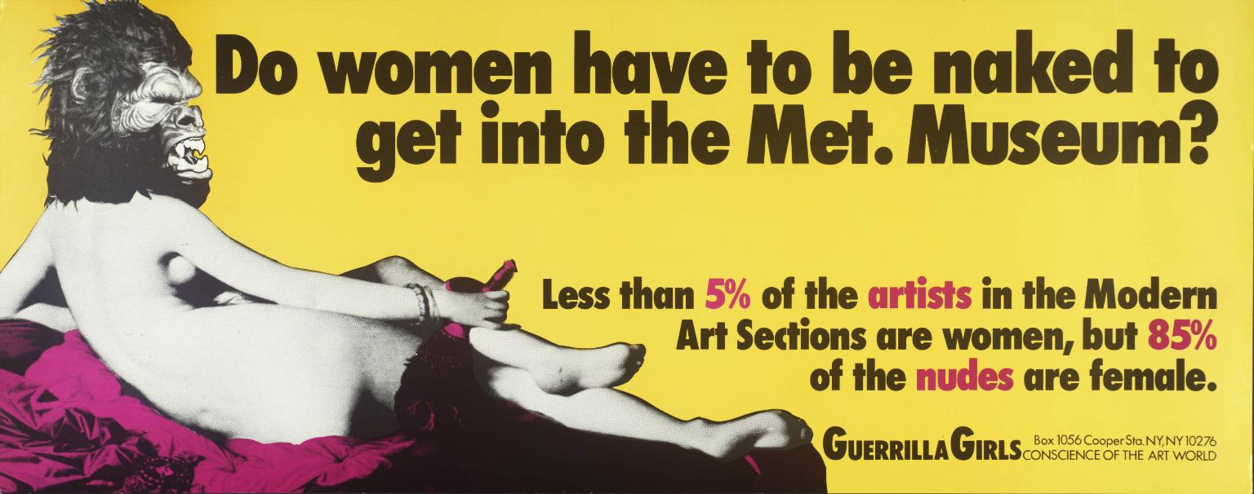

The exhibition will contain three different feminist artists work, The first group featuring in the exhibition is work from Guerrilla Girls a collective group based in New York are the first artists that will be included in the exhibition, They are a feminist group who over the years since 1985 have had 55 members, some stay members for weeks and some stick around for a while, some up to decades. They claim that their “anonymity keeps the focus on the issues”. By wearing guerrilla masks out in public they keep themselves anonymous and use visuals like graphic design and film to expose gender and ethnic bias issues. They have done over 100 street projects using posters and stickers. The piece chosen for the exhibition is 2014’s “Do women have to get naked to get into a music video?” it is a redesigned piece of one of their original pieces “Do women have to be naked to get into museums?” This poster has been shown a Pharrel Williams exhibition “G I R L” a contemporary show in 2014. Linda Nichlin an American feminist historian artist is another person who also argues the same point saying “"Well, if women really are equal to men, why have there never been any great women artists (or composers, or mathematicians, or philosophers, or so few of the same)?”.

According to Psychology today ‘We are drawn to warm colours, such as reds and oranges, so they’re good colours to put at the end of a longish hallway or to use to draw people toward a particular section of a large space.’ Yellow is a warm colour and is the majority of this art work so in theory people should be draw to the rounded space at the back of mission gallery creating a gathering and perfect opportunity for networking and making new friends. The poster has a humorous feel to it which will create a light mood.

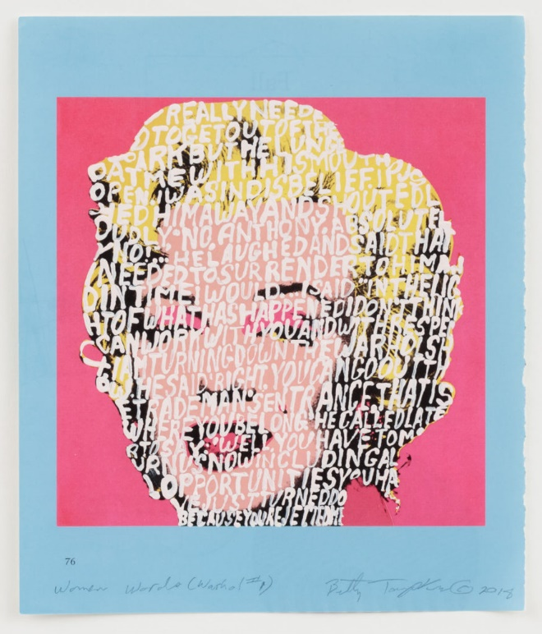

Secondly the exhibition will contain work from Betty Tompkins an artist who creates her ideas from her commitment to challenge the representation of female identity. It is an appropriation of Andy Warhol’s ‘Marilyn Monroe’ screen prints from 1967. The collection that will be featured is called ‘Women’s Words’ a series of images with words painted over the bodies and faces following a theme of light pink. Similarly, to the work above by Guerrilla Girls, the image is an interactive piece with text to read on them as an informative which means people will learn from it. This artwork focuses more on the sort of comments which are made to women she made 1,200 canvases using words from emails she has been sent from women around the world the main words sent were “bitch or mother”. Following a theme of images having words gives an obvious meaning which will broaden the exhibitions target audience and make it more understandable. The canvas chosen is one of the ones without swearing so is appropriate for all ages. The exhibition will be suitable for all ages.

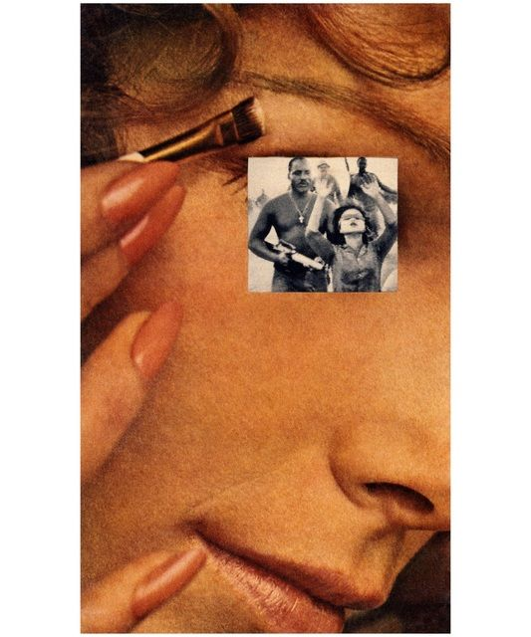

The third attributing art work is Martha Rosler’s Makeup/Hands Up part of the series House Beautiful: Bringing the War Home which is in protest again the Vietnam war. Like the other 2 art works this one is following along the same theme as it is an original image which has been edited to give it higher meaning. Combing photos of the war and images from magazines. This final piece will be situated at the start so that when you come in you take the image as you would with seeing it on its own before reading the other pieces. This way viewers can have more of an experience and take a more personal notion to it. Every one will have a different perspective on the image depending on a variety of different things such as age, upbringing and other life factors. This artwork is less colourful than the other 2 so as you view the other 2 artworks the mood will pick up.

After Deciding on the exhibition pieces, researching into a space Mission Gallery a home of contemporary art work is a nice intimate space for a celebration of women. With is being a 10 minute walk from the bus station it is easy for people to find and get too. It would fit 3 pieces well. On the image above labels have been draw to show where each piece will be displayed. Pink – Guerrilla Girls, yellow – Martha Rosler and then blue – Betty Tompkins. As stated above the reason for positioning it in that order is so the first piece can have all its views before the other work creates a clear message. It will be a one way system in and follow round to the back then to the left side on the way out. Next to the art works a short description will be displayed on a plaque, it will state the date the work was made and who by. All images have several common themes – warm colours, are all audacious and target women to reflect on how they are treated as professionals, mothers and individuals.

To reflect perhaps the exhibition would benefit from having more work in it, but also it is a heavy topic so it requires some thought and could be over complicated to have more than three. Also the space may become over crowded. Music composed by female musicians like Christina Petrowska or Louise Farrell playing will compliment the theme of the questions which stem off from the Guerrilla Girls poster. The lighting will be bright on the artworks and dimmer in other areas to create a chilled ambiance where the work will be the main focal point of the mission gallery. Emails of guests will be taken as part of data collection to notify them of future events and of social change, they will also receive offers on women’s items at local shops. A small donations collection could be done for a women’s support group charity such as women’s aid, the exhibition will be free entry so donations could be recommended. Networking will be encouraged at this exhibition so will be beneficial for women in business to attend.

To conclude I would like to emphasise that this is an exhibition is a celebration of women and about empowering each other. A quote from a well-known singer Kate Nash ‘“Feminism is not a dirty word. It does not mean you hate men, it does not mean you hate girls that have nice legs and a tan, and it does not mean you are a ‘bitch’ or ‘dyke’; it means you believe in equality.” This sums up the concept of the exhibition well.

Reference these
artnet News. (2019). Artist Betty Tompkins Explains Why the Vile Words Used to Describe Women are Worth Painting. [online] Available at: https://news.artnet.com/exhibitions/betty-tompkins-metoo-1406275 [Accessed 4 April 2019].

Encyclopedia Britannica. (2019). Linda Nochlin | American art historian. [online] Available at: https://www.britannica.com/biography/Linda-Nochlin [Accessed 1 May 2019].

artnet News. (2019). Artist Betty Tompkins Explains Why the Vile Words Used to Describe Women are Worth Painting. [online] Available at: https://news.artnet.com/exhibitions/betty-tompkins-metoo-1406275 [Accessed 7 May 2019].

Guerrilla Girls. (2019). PROJECTS/RESISTANCE — Guerrilla Girls. [online] Available at: https://www.guerrillagirls.com/projects [Accessed 4 May 2019].

Guerrilla Girls. (2019). PROJECTS/RESISTANCE — Guerrilla Girls. [online] Available at: https://www.guerrillagirls.com/projects [Accessed 19 May 2019].

Static.perrotin.com. (2019). [online] Available at: https://static.perrotin.com/presse_expo/CP_Group-Show-PW_1888_464.pdf?v=-62169984000 [Accessed 12 Mach 2019].

Cohen, A. (2019). Betty Tompkins Gives Art History a #MeToo Overhaul. [online] Artsy. Available at: https://www.artsy.net/article/artsy-editorial-betty-tompkins-art-history-metoo-overhaul [Accessed 8 March 2019].

GRINDON, G., 2010. Art & Activism. Art Monthly, (333), pp. 9-12.

DUNCOMBE, S., 2016. Does it Work? The Æffect of Activist Art. Social Research, 83(1), pp. 115-134,223.

Evans, David. Appropriation. London: Whitechapel, 2009. Print. Documents of Contemporary Art Ser.

Tuan, Yi-fu. Space and Place : The Perspective of Experience. Minneapolis ; London: U of Minnesota, 2005. Print.

