

Investigation into progressive web applications for the purpose of e-commerce.
by
Rhys Alexander Davies

Supervisor: James Williams
Second Marker: Sue Maw

Project submitted as part of the requirements for the award of
BSc (Hons) Computing (Web Development)

APRIL 2021
DECLARATION

I, Rhys Alexander Davies declare that I am the sole author of this Project; that all references cited have been consulted; that I have conducted all work of which this is a record, and that the finished work lies within the prescribed word limits.

This work has not previously been accepted as part of any other degree submission.

FORM OF CONSENT

I, Rhys Alexander Davies hereby consent that my Project, submitted in candidature for the B.Sc. (Hons) Computing (Web Development) degree, if successful, may be made available for inter-library loan or photocopying (subject to the law of copyright), and that the title and abstract may be made available to outside organisations.

Abstract
The ever-growing evolution of technology and the internet has brought many benefits. These include mobile commerce and the ability to shop from any location without the need to visit a store. Mobile commerce is usually satisfied through native applications that are developed for specific platforms, exploiting native features. it is proposed that progressive web applications are set to bridge web and mobile application development.
The value in a progressive web application is the provision of cost-effective development and deployment for multi-platform installation in one. This study proposes that PWA's can be the solution for e-commerce multi-platform coverage downloadable on any device to serve all user demographics.
The purpose of this study is to discover if progressive web applications are cable for the purpose of e-commerce by researching progressive web applications and e-commerce to produce a proof-of-concept progressive web application to be analysed against current guidelines.
The study is broken up into three parts such as theoretical and practical analysis. The theoretical section would take the form of a literature review analysing literature collected from journals, articles, books, and websites. The practical analysis section documents the development of a progressive web application including analysis results from surveyed data about the artifact created.

Contents
1 - Introduction 7
1.1 Aims and Objectives. 8
1.1.1 Project Aim: 8
1.1.2 Project Objectives: 8
2 - Literature Review 9
2.1 Progressive Web Applications 9
2.1.1 Service Workers 10
2.1.2 Web Manifest File 10
2.1.3 Hardware Access 10
2.1.4 Advantages to developing a progressive web application. 11
2.1.5 Disadvantages to developing a progressive web application. 11
2.2 Alternatives to progressive web applications. 12
2.2.1 Hybrid approach. 12
2.2.2 Native approach. 12
2.3 Comparison 13
2.3.1 Performance 13
2.3.2 Compatibility 14
2.3.3 Cost 14
2.3.4 Application Size 15
2.3.5 Hardware 15
2.4 Design 16
2.4.1 Frameworks 16
2.4.2 Databases 17
2.4.3 Payment Gateways 18
2.5 E-commerce 19
2.5.1 E-Commerce Business Models 20
2.5.2 Web Atmospherics 21
2.5.3 Consumer Behaviour 23
2.6 Case Studies 24
2.7 Conclusion 25
3 - Methodology 26
3.1 Research Methodology 26
3.1.1 Philosophy 26
3.1.2 Approach 27
3.1.3 Strategy 27
3.1.4 Risks & Limitations 28
3.1.5 Validity, Reliability & Generalisability 29
3.1.6 Data Evaluation Methods 30
3.2 Development Methodology 32
3.2.1 Software Development Methodology 32
3.2.2 Software Testing Methodology 32
3.3 Resources 33
3.3.1 Hardware Resources 33
3.3.2 Software Resources 33
3.3.3 Design Resources 33
3.3.5 Human Resources. 35
4 - Design 37
4.1 Preliminary research evaluation. 37
4.1.1 Results 37
4.2 Feature Driven. 43
4.2.1 Feature List & Plan. 43
5 - Implementation 59
5.1 Product Details Dynamic Variation Data 60
5.2 Admin Panel 61
5.3 Product Filtering 63
5.4 Checkout Process Using PayPal 65
5.5 PWA Implementation. 66
5.5.1 Service worker & Manifest file 66
5.6 Basket 68
5.7 Catalogue display & Searching 70
5.8 Login & Session Management 71
5.9 Acceptance Testing Results 72
5.10 Conclusion 72
6 - Results & Analysis 73
6.1 Survey 73
6.1.1 Section One – General Questions 73
6.1.2 Section Two – Uninstalled Application Tasks 73
6.1.3 Section Three – Installed Application Tasks 75
6.1.4 Section Four – Application Review 76
6.2 Lighthouse 77
7 – Evaluation 79
7.1 Objective One Evaluation 79
7.2 Objective Two Evaluation 79
7.3 Objective Three Evaluation 80
7.4 Objective Four Evaluation 80
7.5 Aim Evaluation 81
8 - Conclusion & Recommendations 82
8.1 Recommendations 83
9 - Reflection 84
References 86
Appendix 92
Appendix 1 92
Appendix 2 96
Appendix 3 97
Appendix 4 99
Appendix 5 101

1 - Introduction
Twenty years ago, having a mobile phone was considered a niche and the only use case for them was to send and receive calls. The thought of being able to browse websites on a mobile device was a distant thought, yet in the third quarter of 2020 50.81% of all web traffic was through a mobile device [1]. Mobile web usage is an ever-growing phenomenon with technology advancing each year to make mobile usage more affordable, accessible, and usable with phones becoming faster and even more capable. Further to this, mobile applications are being downloaded in the billions, with the number of mobile application downloads reaching 218 billion in 2020 [2]. With the previous statistics in mind, combining the two makes logical sense. Introducing progressive web applications, a technology looking to strike the balance between both native application development and web development. Progressive web applications are set to have a massive place in the business and technology industry. They pose to minimise cost and maximise profit without sacrificing anything in between and is the main operative for running a business, which is inevitably what progressive web applications set to provide. Progressive web applications set to minimise the cost of development through developing and maintaining one application, whilst increasing the profits through factors such as user-clickthrough, engagement time and conversion rate. Not to mention sacrificing nothing in the process as progressive web applications are rumoured to have the performance of a native app, including access to all the native features in the future.
The goal of the project is to understand if progressive web applications can be used for the purpose of e-commerce, this can be conducted through meeting the project objectives. Thorough research into the topics at hand through a literature review, covering the first and second objectives, in which the relevant avenues will be explored to support or contradict the study. To develop a proof a concept, a detailed design section will be completed and documented describing the approaches used and decisions made. Subsequently an implementation section will be complete showcasing the challenging and important parts of the development process with code extracts. The development will be put to the test in the results section where a survey will test different aspects of the implementation in order to prove or disprove the overarching aim.

1.1 Aims and Objectives.

1.1.1 Project Aim:
Investigate, develop, and analyse the capabilities of progressive web applications for the purpose of e-commerce.

1.1.2 Project Objectives:
- Research and Analyse progressive web applications used for e-commerce.
- Systematically assess current guidelines and best practices for e-commerce.
- Develop a proof-of-concept e-commerce progressive web application for evaluation against current guidelines.
- Evaluate the progressive web application using appropriate tools, for example Google lighthouse.

2 - Literature Review
The following review of literature draws conclusions from relevant research from the two relevant areas of study to the project, progressive web applications and e-commerce. Work that will be cited will either support or conflict with the study to eliminate any forms of bias from the research. The material being utilised in this study will consist of many different forms from academic papers, books, journals, conference proceedings and websites. The following section will explore the subjects mentioned in the objectives of the study and structured by researching progressive web applications first, followed by e-commerce.

2.1 Progressive Web Applications
The main intention behind the introduction of progressive web applications is to combine native phone app development with web development technologies. This is to achieve a seamless integration on a mobile platform, providing an effortless user experience between both phone and web applications. The application is developed once to be universally available across all devices and operating systems [3].
Progressive web applications utilise standard web technologies and frameworks used in the development of web applications, these include JavaScript, CSS (cascading style sheets) for stylisation and or frameworks like React, Vue or Angular. Progressive web applications can then be installed on the home screen of the compatible mobile devices and is made to look like a typical phone application that will include an icon and the name. The progressive web application then takes advantage of the default browser on that device, for example safari (iOS), and runs the appearance of a regular phone application, however is being run in an instance of the browser without the additional artifacts that browsers provide such as the URL bar [4] [5].
The core functionality of a progressive web application is outlined by google, the inventors of the PWA model, on their progressive web app checklist. These core functionalities include: That the Progressive web application must work on any browser chosen by the user, a responsive design that allows the application to scale up or down dependant on the size of the device being used, the ability to be used offline inhabiting the use of service workers to cache data, and fully accessible to all users passing the WCAG 2.0 accessibility requirements [6].

2.1.1 Service Workers
Service workers are background event-driven runtime scripts which do not interact with the DOM, document object model. The characteristics of a service worker include push notifications, increased performance through caching of data and providing offline access to users when there is no internet connection [7].
Service workers can communicate directly with the server to retrieve and cache data. To ensure maximum security service workers only perform over the HTTPS (Hypertext Transfer Protocol Secure). This helps avoid middleman attacks which, if successful, could lead to dreadful repercussions for the company [8].
There are many ways in which service workers can be used to give progressive web applications a more native feel on a mobile device such as the integration of the push notifications which can alert users in the same way native applications can, giving the user a more natural experience as if it was a native application [9] [10].

2.1.2 Web Manifest File
A web manifest file is a JSON syntax that contains the metadata which sets the icon of the application, contains the name of the application, the default background colour and theme in addition to the data for the splash screen for the loading screen of the app [11] [12]. By a project having a web manifest file of this type it satisfies the instal-ability aspect of the google progressive web application checklist.

2.1.3 Hardware Access
Progressive web applications have access to a lot of the native hardware such as Bluetooth, microphone, and can also access the camera on the device all through the use of different API’s. Although it is not yet possible to use security features such as fingerprint scanners or face recognition directly as a form of logging into an account, it is possible to invoke the use of the security features for payments using apple pay or google pay [13].

2.1.4 Advantages to developing a progressive web application.
- Developing a progressive web application comes with the benefit of reduced development cost. This is due to the application being developed once for multi-platform use. This allows for one team of developers to develop the same product as opposed to multiple teams developing the same product but for different platforms [14] .
- Progressive web applications come with the ability to be used partially offline. This is beneficial to the majority of users that may access the application [7]. By being able to access the application offline it makes the app more accessible to users on limited data plans or that do not have a reliable connection at all times.
- Although it is more of a certainty that modern day web development comes with safety features and protocols to make it hard for hackers to infiltrate a system. Progressive web applications come with the guarantee of the HTTPS protocol that arises with the use of service workers [8].
- The user experience of progressive web applications gives a universal format to applications throughout all devices. Users will find it easy to use between different devices and operating systems.
- SEO, search engine optimisation, is scored much higher when using progressive web applications meaning it is much more findable by users through search engines.

2.1.5 Disadvantages to developing a progressive web application.
- Not granted full access to all hardware features of the device, particularly fingerprint scanners and face identification.
- Some service worker features are not fully supported on iOS making it not fully compatible [15].

2.2 Alternatives to progressive web applications.
A cross-platform web application was attempted before the introduction of progressive web applications these are called hybrid web applications. The following will discuss how the hybrid and native approaches work to be compared against progressive web application.

2.2.1 Hybrid approach.
The hybrid approach combines native and web technologies to produce an application that has access to the native features of the device and is cross platform to an extent. The hybrid approach is restricted with access to the native API of that device. A JavaScript bridge is used to allow the native functionalities to be used alongside the web aspect of the application, consisting of the web-based languages such as HTML, CSS, and JavaScript [16]. The native side of the application can be developed individually for the different mobile operating systems it will be used on, therefore utilising each platform to its fullest for maximum performance. This approach manipulates the browser of the device and displays the content through a native container which for android is WebView and UI-WebView in iOS [17] [18] [19].

2.2.2 Native approach.
The native approach is designed purely for the use on an individual device utilising all the features the native API has to offer. Native applications allow for the highest performance as the devices native language is used, for example Swift and Objective C for iOS and Java for Android. This provides coefficient performance alongside the hardware used within the phone such as the CPU, Graphics Chip, and more specialised hardware such as facial recognition or fingerprint sensors, which are used as a secure login for native banking apps. Native applications are costly, this is due to the manpower needed to create an individual app for each operating system, which comes with the added cost of having agile teams with knowledge base on that native operating system to get the most out of developing a native application [18] [19] [20].

2.3 Comparison
In a world brimming with technology there are many different techniques to perform the same task each of which will come with its own set of advantages and disadvantages. The following section will compare progressive web applications against the alternative applications, each of which exchange similarities and differences.

2.3.1 Performance
The performance of an application is very important to users as proven by an article in 2016 by MediaShift. The study shows how long users expect to wait for a sports application to load. The result showed that 45% of those involved said they expected a load time of 2 seconds or less [21]. A further infographic, produced in 2020, by Diginow shows that one out of five shoppers will abandon their shopping cart if the website or transaction process is too slow [22]. These statistics show how important it is to have a high performing web application and how that can correspond into sales. Progressive web applications perform equally as efficiently as Native applications. This is mainly due to the previously discussed caching of data from service workers as it allows for the application to cache data and then load it quicker upon the users return, which is especially useful in low connection situations making it a better performer than native [23]. A study by Dirk-Jan Rensema into the performance and other aspects of progressive web applications proved that due to caching the webpage upon the second load the page would load faster using a cache first pattern, which is consistent with the data transferred upon page load which can be shown in figure 1 [24].
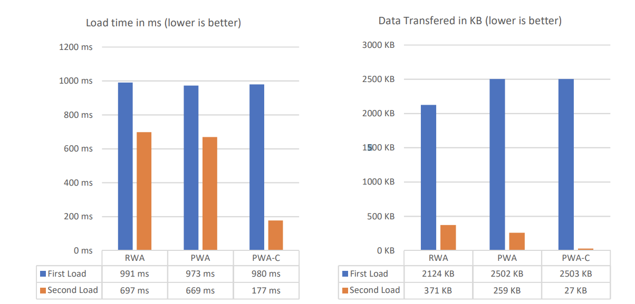
Figure 1, shows load times and data transferred of PWA with and without cached pages.

2.3.2 Compatibility
Progressive web applications were created with the intent of being compatible on the users operating system and have evolved to be exactly that, being supported across all major platforms and browsers. On the contrary, native applications are developed individually to work on one specific platform therefore, to be compatible for more than one operating system development had to take place for it. Figures 2 and 3 illustrate how the main components of progressive web applications, service workers and web manifest files, are supported on each operating system and their retrospective browser.
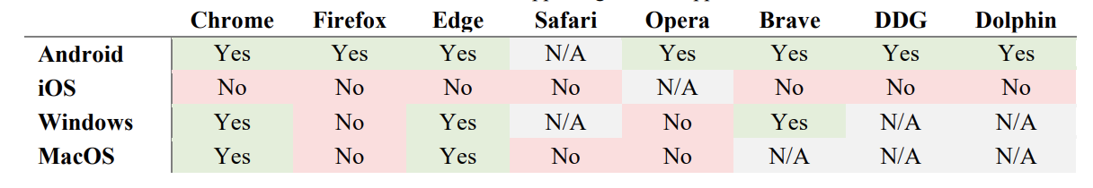
Table 1, shows operating systems browsers supporting web manifest files.
As shown in table 1, progressive web applications are widely supported across many operating systems and modern browsers. The most notable observation from table 1 is iOS, apple, does not support web manifest files on their operating system and therefore on their devices. This, although being a core aspect of a progressive web application, does not stop them from working on apple devices as of iOS 14 [15].
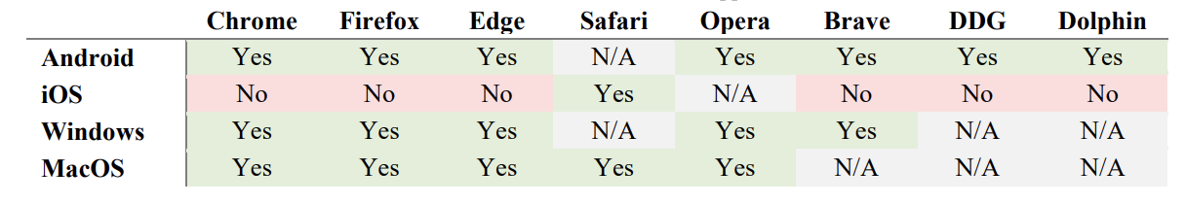
Table 2, shows operating systems browsers that are supporting service workers.
The significance of service workers to progressive web applications is shown in table 2 with how widely supported they are across the majority of browsers. Something to consider is iOS, although supporting service workers, do not support their function to send push notifications [15].

2.3.3 Cost
The cost and return of developing any form of application will be the main talking point to any company when deciding if it is a better investment to develop a native, hybrid or progressive web application. Progressive and Hybrid applications have a distinct advantage over a native solution, this is due to the latter having multiple development teams working on each version of the application for each individual platform, whereas progressive and hybrid applications are developed once for cross-platform capabilities therefore saving money [25].

2.3.4 Application Size
Mobile phone storage is becoming a necessity in present times with higher storage phone’s being released for extortionate extra costs. It is important to develop applications at the lowest size to ensure the user keeps the application installed. The 2017 Webist conference found that progressive web applications had an around about 157 times smaller install size than the same native application, and around 43 times smaller than that of a hybrid web application [26]. The smaller file size is justified by the progressive web application only installing the needed files to run through the device browser, therefore making it a much smaller install.

2.3.5 Hardware
The main difference between native compared to hybrid and progressive web applications is the way in which the application accesses the native hardware on the device, the minor difference being that hybrid and a progressive approach do not have full access to all of the native hardware features such as fingerprint scanners and face identification features, however do have access to the more common features such as camera, GPS and Bluetooth [4]. Native has direct access to all the hardware the phone has to offer whereas hybrid and progressive need to use an API bridge to be able to access the hardware. Given that progressive web applications need to access the devices hardware through an API it is an understandable assumption that it would slow down the performance of the application. A report into the speed of a native applications response time compared to progressive web applications showed that there were no significant limitations when it came to hardware access [27]. The results further showed that geolocation was quicker than native android apps across the tests run, demonstrating the potential of progressive web applications in the future.

2.4 Design

2.4.1 Frameworks
A study carried out by Blue Corona, a measurable marketing company, found that 38% of users will disengage with a website if they deem the design of the content on the webpage unattractive or too cluttered, e-commerce websites cannot afford to lose 38% of the traffic due to unattractive design [28]. There are many frameworks that support the frontend construction of websites allowing the developer greater tools to create a free-flowing, attractive and accessible front-end designs.

2.4.1.1 Angular
Angular is a frontend framework for single page websites. Originally founded in 2010 by google and is now written in typescript as opposed to JavaScript like its counterparts. Angular was initially written in the language JavaScript however, with the later versions it got re-written in typescript separating both versions which can now be identified as AngularJS, for the JavaScript version, and Angular, which is the modern typescript version. Angular is a component-based system that prides itself on its ability to be deployed for any target device [29] [30] [31].

2.4.1.2 React
React, which is managed by social media giant Facebook, is an encapsulated component-based frontend library that allows for the creation of interactive user interfaces. React inhabits a single page application environment as it supports the dynamic changing of data and states efficiently updating and rendering the view for the user at real time. React uses the file extension ‘JSX’ which stands for JavaScript XML and is an extension of the JavaScript syntax, allowing developers to write code corresponding to HTML. React is predominantly a client-side rendering library, meaning that upon initial load it may take some time to request all the relevant data from the server, however every consequential page load after this will be faster due to it being run client side. Nevertheless, react is versatile and also allows for server-side rendering of the framework [30] [31] [32].

2.4.1.3 Vue
Vue is a lightweight frontend framework founded in 2014 by Evan You. Vue is small in size, approximately 20KB, leading to incredibly fast load times. The lead idea behind the Vue framework is databinding and component work. Vue is used to create user interfaces, much like React, and is very scalable and versatile. The core of Vue consists of just the initial view layer which can be modified further by adding addition libraries to the Vue project to create a more complete framework. Vue, like react, predominantly uses the newer technique of client-side rending, however, does have the ability to be rendered server-side [30] [31] [33].

2.4.2 Databases
Databases are an integral part of an e-commerce site with all product information such as users, reviews, order details and more including in some instances payment details from users. The database choice is an integral part of creating a successful e-commerce application as it is the backbone for all processes on the website. The main decision is whether to use a SQL or NoSQL solution when choosing a database querying language. The upcoming section will discuss MySQL, a SQL based querying language, and MongoDB, a NoSQL based querying language.

2.4.2.1 My SQL
MySQL is a strictly structured querying language. MySQL uses tables to access data in a relational model which makes the database more flexible. Each row within the table must be represented by values of a specific datatype. MySQL uses a pre-defined schema that are based on the requirements of the project, including setting rules for the relationships of the database. MySQL’s performs well with data entry and retrieval as well as the ability to use indexes and data caches giving an extra performance boost [34] [35] [36].

2.4.2.2 Mongo DB
MongoDB is a document-based database system. Document based systems store and retrieve the data in text languages such as in XML and JSON. MongoDB provides a rich flexible querying language, supporting the main programming languages such as JavaScript, Java, and C++. MongoDB is very easy to scale up or down depending on the project size and need. Mongo database schema’s use 80% less storage due to the ease of horizontal scaling. MongoDB is very high performing and allows for thousands of data points to be entered at one time without any performance decrease. The risk of attack on a MongoDB database is lessened due to object querying, which means that there is no language to be parsed reducing the vulnerability to injection attacks [34] [35] [37] [38].

2.4.3 Payment Gateways
Payment gateways are the final step in the e-commerce process where money is exchanged for the order. A crucial part for the user is feeling secure and supported when checking out by having a wide variety of support and providing the necessary security badges. Two well-known payment gateways are PayPal and Stripe. Both Gateways contain free plans that allow access to their gateways, both however contain a transaction processing fee. PayPal’s transactional fee is 2.9% of the transaction with a $0.10 additional cost per transaction. Stripe’s transactional fee is also 2.9% with a $0.30 additional cost per transaction. PayPal is cheaper per transaction however Stripe is much better documented for website integration [39] [40] [41].

2.5 E-commerce
In 2019 e-commerce streams brought in $3.53 trillion in sales which shows the scale in which users use the internet to purchase goods, and this is expected to rise to $6.542 trillion by 2023 [42]. The 2020 COVID-19 pandemic has forced many shoppers to switch from conventional instore shopping to e-commerce as well as forcing the hand of many businesses to go digital, including having e-commerce stores tailored for their business. April 2020 saw the initial online impact in the EU with online sales increasing by 30% compared to the previous year, providing a need in the market for good user experience through these e-commerce outlets [43]. User experience and usability in e-commerce is used to increase the company’s likelihood of a sale from that user, called web atmospherics. Web atmospherics contributes to the layout and other aspects users would encounter when shopping instore, such as social presence to familiarise users by conjoining conventional retail with virtual retail, creating a more comfortable environment for the user to purchase in [44] [45]. To further increase the likelihood of sales e-commerce sites, incorporate a technique called consumer behaviour analysis which predicts the user’s probability of buying a product based off previous history and buying habits giving the user personalised recommendations [46].

2.5.1 E-Commerce Business Models

2.5.1.1 Business to Consumer (B2C)
A business to consumer is the most typically found type of e-commerce business model. This is where the business sells to the customer. Items bought from an online store such as clothing, flatpack furniture and so on is part of the business to consumer e-commerce model [47]. B2C models change the designs principles used to draw in sales. This model relies on the customer for the business to earn money, therefore the design has to be tailored to the end user in order to generate their custom and experience into a sale [48]. An example of this model in use is Boohoo.com, a strictly e-commerce clothing website that sell directly to the consumer.

2.5.1.2 Business to Business (B2B)
A business-to-business model is typically used in manufacturing. It involves businesses buying from other businesses, then likely selling to a consumer. An example of this is a computer manufacturer that buys microprocessors from another business in order to complete their product. Business to business models use design principles built around the information of the product rather than the end user, this is due to the end user being on that website for a specific reason not to browse [49].

2.5.1.3 Consumer to Business (C2B)
A consumer to business model is most usually found in elance work. Elance work is the process of the seller listing their service or product such as web design skills, where a buyer will buy the service from them. This model facilitates negotiation between the seller and the buyer and gives the seller full control over what orders they agree to complete [47] [50].

2.5.1.4 Consumer to Consumer (C2C)
A consumer-to-consumer based model is often referred to as an online market placement which are becoming more and more popular. Facebook and Instagram have joined long time market placement competitors eBay in the consumer-to-consumer model. The ecosystem of this model relies on the users to list and post items in which they buy and sell to each other. The design principles for this model of website are driven similarly to a business to consumer model where its very user friendly and presented in a way to encourage sales and new products [47] [51].

2.5.2 Web Atmospherics
Understanding web atmospherics is the key to getting the most out of an e-commerce site, as it cleverly allows the user to be put into a position where they are more likely to purchase a product benefitting the company. Web atmospherics is described as “the conscious designing of space to create certain buyer effects, specifically, the designing of buying environments to produce specific emotional effects in the buyer that enhances purchase probability” [45]. The user experience consists of cognitive, affective, emotional, social, and physical responses which needs to be converted into a virtual environment simulating a store, to create a positive effect on the user, increasing the users engagement as well as directing a positive influence on the users purchase intentions [52] [53]. Manganari proposed that web atmospherics consisted of four elements: Virtual Layout and Design, Virtual Atmospherics, Virtual Theatrics and Virtual Social Presence [45] [54].

2.5.2.1 Virtual Layout and Design
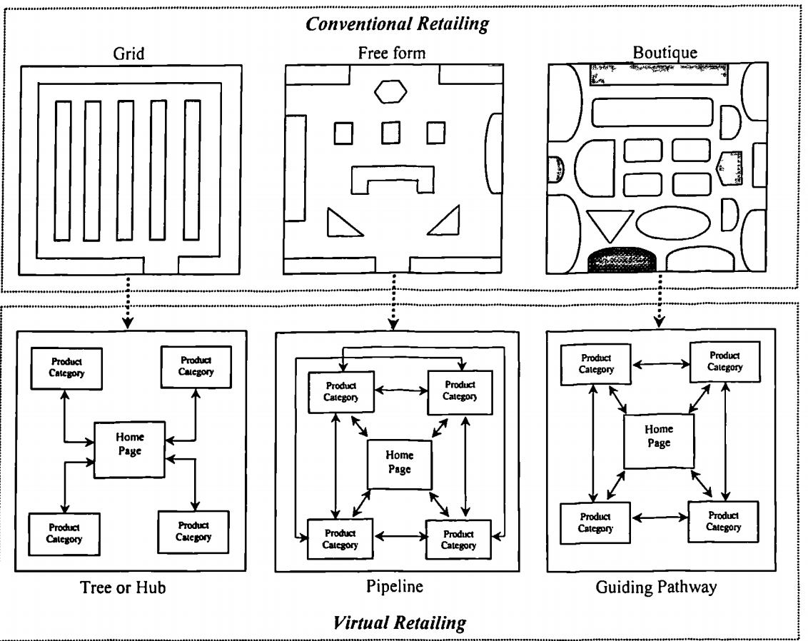
Figure 2, shows virtual retailing concepts and the corresponding conventional methods [55].
The layout and design of the website is a key aspect in converting user click-through into purchase follow-through. There are 3 main design concepts which are the tree or hub structure, the pipeline structure, and the guiding pathway structure. As shown in figure 2 these are the baseline layouts in which stores function, applying to the layout of products and also the layout of the navigation to the products. The more user friendly the navigation and layout is to use, the more likelihood of processing that experience into a sale. This is highly important in an e-commerce situation to get the layout correct [45] [55] [56] .

2.5.2.2 Virtual Atmospherics
The virtual atmospherics corresponds to the view and sound users would get via conventional retailing. Virtual retailing allows for the view to be interchangeable at the user’s discretion giving the user control over how many products they can see on a page at a given time, giving users the feel of a conventional shopping experience. Notably e-commerce sites use traditional icons to represent relevant aspects of the site such as shopping trollies or baskets to indicate a checkout, this is to keep the familiarity to the user [54] [55]. Sound is not directly applicable to virtual retailing however sound can be implemented in the form of haptics when adding items to shopping carts [57].

2.5.2.3 Virtual Theatrics
Virtual theatrics is the process of engaging a user via animation and video. Animation is used to keep the user engaged through the level of interactivity it provides. An example of this, in an e-commerce solution, would be animation to show item being added to cart, which is commonly used throughout many major e-commerce sites. Video is used to demonstrate the product at hand, in the same way game and movie companies release trailers to create a positive reaction out of the user. Thus, creating a positive user reaction and engagement therefore increasing the users purchase intention [54] [55] [58].

2.5.2.4 Virtual Social Presence
Virtual social presence is the technique of producing an environment where the user feels the social aspect of shopping during their online shopping experience [54]. This is usually through customer reviews which take use of getting users opinion, good or bad, on a product influencing the other users’ choices on that product. The higher the social presence is perceived to be on the website, by the user, the higher level of trust in the company resulting in higher sales [59]. A study published in the interacting with computers journal found that 5 different websites containing singular social presence features showed overall that a review system provided a higher feeling of social presence among its users [60].

2.5.3 Consumer Behaviour
Consumer behaviour is the probability of a user purchasing an item based off of their previous purchase and viewing history, thus benefitting both parties, company, and user, by recommending potential products it increases the chance of a sale and also the chance for users to discover new items that they were unaware of. It also allows websites to suggest more personalised suggestions based off their prediction, as well as adding the social aspect of suggesting items they may like based off other users purchases of that product [46] [61] [62].

2.6 Case Studies
Progressive web applications have been around since 2015 and since then many companies have made the switch from a native and web e-commerce application combination to the newer progressive web application style, which solves the native app and web app in one solution, these include: ASDA George, Flip-Kart and Alibaba.

2.6.1 ASDA George
ASDA George is a large clothing brand in the UK which made the switch to a progressive web application solution, which saw major increases in user engagement and performance which is as follows:
- 3.8x - Faster average page load time
- 2x - Lower bounce rate
- 31% - Increase in Conversion Rate
- 20% - More page views per visit
- 28% - Longer average time on site for visits from Home screen
The statistics show how a one third increase in the conversion rate of users coming to the site is achieved at the hands of a progressive web app solution, which also sees the SEO advantage of developing a progressive web app giving a one fifth boost to the amount of page visits the website received [63].

2.6.2 Flip-Kart
Flip-Kart the largest e-commerce outlet in India adopted the progressive web application strategy back in 2015. This was after the company encountered issues trying to maintain the performance to scale ratio of the website compared to that of their mobile app. By developing a PWA Flip-Kart saw increases in key areas where their website could not compare, they are as follows:
- Users time on site with Flipkart lite vs. previous mobile experience: 3.5 minutes vs 70 seconds.
- 3x more time spent on site.
- 40% higher re-engagement rate
- 70% greater conversion rate among those arriving via Add to home-screen.
- 3x lower data usage
The key performance insights provided show the benefits Flip-Kart has seen since switching. 70% conversion rate of sales from users installing the application via adding the application to home screen. This shows the benefit in which PWA’s can have to an e-commerce site [64].

2.6.3 Alibaba
Alibaba, a business-to-business trading e-commerce platform, is another consistent example of developing a progressive web application to boost the performance and userbase of their company. The main reason for the company moving to a progressive web application solution is due to their primary form of discovery being through the mobile web. The main benefits to switching to a progressive web application that Alibaba have observed are:
- 76% higher conversions across browsers.
- 14% more monthly active users on iOS; 30% on Android.
- 4X higher interaction rate from Add to home-screen.
30% more active user base from android users and 14% retrospectively on iOS. Paired with the 76% higher conversion rate, establishes progressive web applications as a viable e-commerce solution [65].

2.7 Conclusion
To conclude this section, many aspects of progressive web applications and e-commerce have been explored, of which a comparison has been conducted between the alternatives and progressive web applications that PWA’s are competing against. The design route of web applications was also researched with frontend frameworks, database management systems and payment gateways being the focus with the intent of using the research for the design and implementation of the project. Different factors of e-commerce were examined, namely web atmospherics and how they contribute to the design of web applications and why they are important. E-commerce business models were also explored in order to use for the implementation of the project. Finally, three e-commerce progressive web application case studies were looked at and the statistics that came from companies migrating to a progressive web application.

3 - Methodology

3.1 Research Methodology
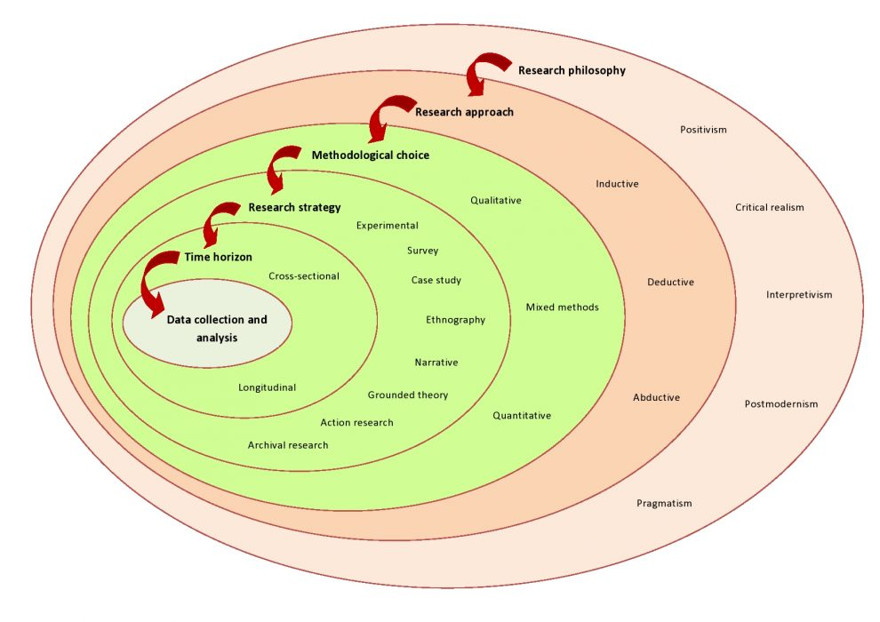
Figure 3, shows a research onion. A process for explaining the different stages of a research methodology [66].
A research onion has many layers, as shown in figure 3, comparative to an onion hence the name and is a method for guiding the writer through the different steps when developing a research methodology. The following section will discuss the research methodology that will be applied to the project using the research onion method and how each individual layer of the research onion is applicable to the project and why.

3.1.1 Philosophy
The research philosophy that has been chosen for the project is positivist. The positivist philosophy will be used throughout many aspects of the project most notably when choosing the types of technologies to use such as frameworks, databases, and payment gateways. This will be applied through research analysis of the technologies using other programmer’s experiments as a basis. Design idea’s will also be applied in a positivist manner by experiment with design ideas and using experimentation to create a design that suits the theme of the website. The disadvantages to using this philosophy is it is limited to data collection and the interpretation of that data. To avoid this impacting the project thorough research will be conducted into the topics at hand, such as frameworks, before a decision is made on what to use and how to implement it.

3.1.2 Approach
The approach being taken for the project will be that of deductive approach. The reason the project will use the deductive approach is due to all the development or design features being implemented will always have a theory of the outcome, such as performance or appearance. An example of this is the premise that implemented an SQL database will always hinder performance, this formulates a hypothesis that can then be proved or disproved through research in the literature review or through data collection. The problem with this approach is the initial premise made is based off of an opinion which can be misleading. To mitigate the impact this will have on the project a non-bias approach will be applied when using the deductive approach to get reliable results and inferences.

3.1.3 Strategy

3.1.3.1 Document Review
A document review in the form of a literature review will be one of the approaches taken in the project. The literature review will be used to gain a comprehensive understanding into progressive web applications and e-commerce techniques used. These include design methods such as frameworks, databases, payment gateways and e-commerce structures. The literature review will be concluded by summarising the main findings from the section.

3.1.3.2 Software Development Project
The second approach taken will be a software development approach. The outcome of the project is to develop an artifact taking the shape of an e-commerce progressive web application. The topic for the artifact will be a fictitious case study which will be an e-commerce clothing store called “Show Boat”.

3.1.3.3 Survey
The final approach taken for the project will be a survey. There will be two surveys involved in this project a preliminary survey and a concluding survey. The preliminary survey will take place before development has started where the participants will give their opinion on the features they expect when online shopping and what engages users on an e-commerce site. The concluding survey will take place at the end of the project once the development stage is complete, and the artifact can be hosted online for a select group of users to review different aspects relevant to the different topics of the project such as e-commerce and progressive web application features.

3.1.4 Risks & Limitations
R1 Gold Plating – One risk identified to the project is gold plating. Gold Plating is the term for adding unnecessary features that are not included inside the scope of the project. By a developer Gold Plating it will reduce the allocated time to finish the main, more relevant, parts of the project. To avoid this risk a road map could be implemented. By adding a road map to the project, it would allow for tight management of the features which can be sub-divided into current features which are being worked on, up next and then future additions for if there is time left at the end of the project. All the out-of-scope ideas can be added there.

R2 Time Constraints – The second risk tied to the project is time constraints. Time constraints can heavily affect a software development project due to unforeseen issues within development such as certain aspects and features of the website taking longer to be implemented therefore dedicating more time to developing an alternative method of implementation. Time constraints are inevitable however the impact can be minimized by creating a project plan. By using a project plan, it allows for set time to complete parts of the project including being able to manage the parts of the project that were completed earlier than expected, the extra time can then be allocated to the tighter parts of the project.

R3 Hardware Failure – Another potential risk to the project is possible hardware failure. Hardware failure would cause major issues to the project if the correct measures were not taken when saving and backing up the project. To avoid the impact that hardware failure would have on the project it is important to use the 3-2-1 backup rule to avoid data loss. By backing data up in 3 separate places the risk of loss is mitigated massively. Another way of preventing data loss is by using version control. Version control will allow for the development to be rolled back if there were any issues in the code that caused data loss furthermore it acts as a cloud storage that can be accessed anywhere with an internet connection.

L1 Hardware Limitations – One limitation tied to the project is the hardware limitations of the machine the project is being developed on. The workstation must have the ability to run all the necessary software at a usable speed. A viable option is to use a virtual machine. A virtual machine will provide the developer with the necessary power, depending on the virtual machine purchased, to complete the project using the necessary software.

L2 Development Understanding – Another limitation that could affect the project is the ability to understand documentation for the frameworks, database schema and or payment gateways being implemented. A solution for this is using online forums and educational videos on these as they are a great way to understand how they work. This can also result in an improvement to the application by using more efficient coding practices that will be picked up throughout research.

L3 Web Service Hosting – A limitation that could hinder the project is hosting the completed website. A main dependency in the project is for the website to be peer reviewed by a sample group and rate their experience, for this the website will have to be hosting online for it to be answered. A hosting provider will have to be found as well as paying for the service. To ensure that the project is hosted efficiently research will need to be carried out on how websites, specifically e-commerce websites, are hosted and the type of hosting that is needed.

3.1.5 Validity, Reliability & Generalisability

3.1.5.1 Validity
The validity of the project is based on two questions. Firstly, is the methodology chosen valid for answering the overarching objectives for the project? The positivist philosophy chosen is valid because it allows for the project to take form by drawing conclusions via analysis and experimentation of data gained through research and implementation, directly supporting the project which is a developmental style project. The deductive approach further supports the developmental style of the project as when development there is always a theory of the outcome. Secondly, is the software produced do what is it expected to do? To ensure the validity of the software produced does what it is meant to do a development methodology will be followed. The development methodology chosen is feature driven development, an agile approach, which will allow for the needed features to be developed feature by feature, this will be talked about further in the development methodology section including the testing model associated with this methodology.

3.1.5.2 Reliability
If the project were to be carried out by another researcher, the results of the project would be different each time. This is due to the broadness of the topic at hand. There are many different ways to research into developing both an e-commerce site and a progressive web application including many different technologies that can be used to develop the application.

3.1.5.3 Generalisability
The results of the project can be applied across the e-commerce business sector. As talked about previously e-commerce is a massive part of the internet, generating billions in sales across the year. The results of the project can be used for many small and large businesses to grow their e-commerce companies further with the added engagement and conversion rate to boost sales, as well as providing another dimension for their customers to buy the products provided.

3.1.6 Data Evaluation Methods

3.1.6.1 Data Collection
The primary research that will be conducted in the project will take the form of quantitative data collection. Quantitative data collection is the gathering an analysing of numerical data to find patterns and make quality analysis based of the results. Quantitative data collection suits the project as it will allow the subject group to numerically rate the different aspects of the website produced. The subject group will be sent the link to the website and a link to the survey, and this can be done through university email and across social media to get a wide dataset of age groups. For the survey to be effective and for conclusions to be drawn from the results the minimum amount of data returned must be in the 15-30 range for the preliminary survey and 40-60 range for the concluding survey. This will give a good understanding of the overall consensus of the questions asked in both surveys.

3.1.6.2 Data Evaluation
There will be two types of data evaluation in the project. The first evaluation technique will be using Googles evaluation tool Google Lighthouse. This tool is built specifically to measure a website for its progressive web application capabilities such as the Installability, offline capabilities, performance, and SEO. This data can be shown simply as a screenshot of the end result, and directly evaluate the individual scores including the comments the tool makes for improvements if there are any to be made.
To evaluate the primary research collected the data returned from google forms is plotted into easy-to-understand graphs which can be used to quantitatively analyse the data. The statistical analysis technique used to analyse the data will be inferential statistics. This is the process of making an inferred conclusion from the data retrieved, for example if the age group of 50-60 found installing the progressive web application to be difficult an inference could be made that it is due to their lack of technical.

3.2 Development Methodology

3.2.1 Software Development Methodology

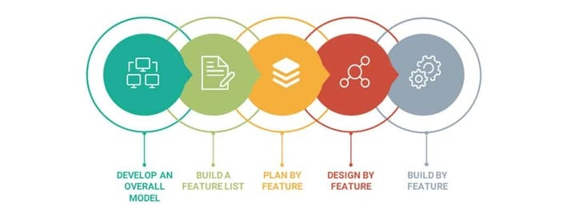
Figure 4, displays the five agile steps in the feature driven development methodology [67].
The software development methodology being used for the project is called feature driven development. Feature driven development is a highly adaptive agile process consisting of five steps, these steps are shown in figure 4. This development methodology is beneficial to the project as it allows for the software to be built in iterative stages. Each stage will have a review period before being implemented which allows for a better-quality end product, which is the overall goal of the agile process. The development methodology does come with the disadvantage of having to fully complete a feature before being able to move on and do the process on the next feature which can be very demanding on the developer [68].

3.2.2 Software Testing Methodology
The software testing methodology that has been adopted for the project is called “Acceptance Test-Driven development”. This methodology involves taking different perspectives involved in the project, such as customers, and writing acceptance tests from that perspective, which basically act as requirements to see if the tests pasts. This is the process of writing an acceptance test and the code is then written until the test is passed. The methodology is beneficial as it collaborates nicely with the software development methodology as the acceptance criteria can be written for the feature that is currently being developed and then the code can be written until the test is passed. A disadvantage of this method is that it removes the communication between customer and developer as the developer takes the perspective of the customer in order to write the test, however this will not affect the project massively as the project would have gone through preliminary data collection stage which will help write the tests [69].

3.3 Resources

3.3.1 Hardware Resources
The project is not hardware intensive. The only requirements for the project are a networked PC. Hardware such a server can be rented online for the duration needed to host the project.

3.3.2 Software Resources
There are many different software’s that will be utilised during the development of the project, these are listed below:
- Visual Studio Code: IDE where the project will be developed.
- Photoshop: To edit images of the products for the e-commerce store.
- Google Chrome: Browser being used for development.
- GitHub: This is being used to version control the project.
- Postman: Testing software that executes specific requests to the database send back the correct data.
- Figma: To create software prototypes.
All software listed above is free to use apart from photoshop. Photoshop provide a student license which is being made use of.

3.3.3 Design Resources

3.3.3.1 Development Stack.
A development stack is a set of languages, libraries and tools used in application development. Each stack have their own benefits and draw backs. The lit review section focused on choosing libraries and database language for the application. After the conducted research, the decision was made to use the MERN stack which stands for:
- MongoDB: Which is a document-based database system that parses data in the JSON syntax.
- Express which is a backend framework for creating middleware to respond to http requests.
- React: This is a frontend development tool for created dynamic websites.
- NodeJS: An open-source runtime server-side platform for developing server-side applications.

3.3.3.2 React
React was preferred as opposed to Vue and Angular for the size, scalability and most importantly the online documentation by the creators and fellow developers. React supports dynamic data changes through states which is important in an e-commerce environment as it allows for the user to cycle through products and product data such as images can update, respectively. Furthermore, react is rendered client side which yields a higher performance which is important for customer retention on the website which is a major plus for using the framework.

3.3.3.3 MongoDB
Mongo was chosen based on research conducted. In comparison of each other both are viable options in an e-commerce solution both providing excellent performance, the main criteria to meet for a mobile application, as well as being able to process large amount of data. MongoDB does appear to use less storage space server side due to the way in which the data is stored, which in an e-commerce situation would be very beneficial due to the wide variety of products to be held including many user reviews.

3.3.3.4 Express & NodeJS
Express and NodeJS are default selections for the MERN stack. To avoid complications by mixing server-side code and risk factors such as incomplete features on the website due to lack of understanding the decision was made to use the suggested server-side tools.

3.3.4 Development Case Study
The development of the e-commerce progressive web application will take the shape of a business to customer (B2C) model. The progressive web application will be an e-commerce clothing store called “Showboat” and will offer many royalty free fictitious products.

3.3.5 Human Resources.

3.3.5.1 Preliminary survey:
The preliminary survey will be asking people for their expected features and what helps users engage when on an e-commerce site, the results from this survey will help gauge the most important features to implement and will feed directly into the development. The preliminary study will also focus on whether participants rather browser shopping or application shopping, which will judge how effective the progressive web application side will be. The survey results can be paired with the research on web atmospherics to develop a working e-commerce site with all the expected and correctly implemented features.
This survey can be created through google forms which will make distribution easier with a link. The participants of this survey do not need to be of any gender as e-commerce is accessible to all genders, therefore the responses will aim to be as close to a fifty-fifty split as possible, gender will also not be a required input within the questionnaire. The ideal population size for this survey will be around 15-30 responses which should give a small consistent understanding of the relevant, important, engaging and required features That same meta will be applied for the age group and characteristics of the participants, as e-commerce ages in the 21st century vary, therefore putting a target age would hinder the accuracy of the results. Understandably there will be different results between the younger and older age groups as the older age groups will tend to veer towards the usability of the application whereas younger age groups will veer more towards the style.

3.3.5.2 Concluding Survey & Testing:
This survey and testing will be representative of the e-commerce site created and will require participants to use the website in both browser version and then the installed version (PWA). The participants will be questioned on their experience, firstly, of the browser version. This will include participants completing a series of tasks relating to their general e-commerce processes such as selected a product, adding it to basket and checking out, before being asked to rate their experience. The survey will then focus in on the specific web atmospheric features implemented, and did it make a difference to their shopping experience. The survey will proceed to get the participants to install the progressive web application version on their device and repeat the same tasks, comparing if they found the tasks easier to complete. Finally, the final question will ask users which version of their e-commerce experience they preferred, browser or application.
This survey will also be created via google forms for easy distribution and will be sent out to members of the university through email and potentially on social media if not enough data is initially collected. The target groups for this survey will be the same as the preliminary survey in that there will be no specific age group, genders or characteristics targeted as e-commerce is tailored for anyone. The ideal population size for the survey will be around 15-25 responses which should give an accurate result of the questions asked. Preferably some of the survey participants could have been observed to make observations on any issues, however due to COVID-19 this is not possible.
To evaluate if the survey and testing was successful results should take the form of preferring the progressive web application version of the e-commerce store created. This should also show to be the case in key areas such as checking out, searching for items and so on. If the progressive web application scores higher than the browser version, then it confirms that progressive web applications are viable for the purpose of e-commerce.

4 - Design
The following section discusses the important design decisions made when developing the artifact. These design decisions are detrimental to the project and contribute to the underlying success of failure of the implementation.

4.1 Preliminary research evaluation.
Research was conducted in the form of a survey in order to retrieve results about important features that should be included on the website and what features are most popular so they can be focused on. The questionnaire consisted of seven questions, garnering seventeen responses.

4.1.1 Results
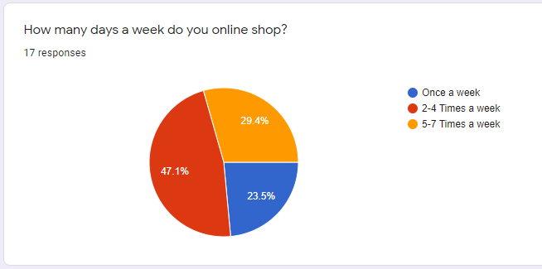
Figure 5, shows a pie chart of the responses to the first question.
As shown in figure 5, the first question was to gain information about the people answering the questionnaire. It is important to understand their relationship with e-commerce platforms. The results show that eight (47.1%) of the responses found themselves online shopping 2-4 times a week. It is important to note that there is near even split between shopping once a week and 5-7 times a week. From this it can be inferred that the majority of the results are from people that have some experience in an e-commerce environment, and therefore familiar with e-commerce designs, practices, and features that should be implemented.

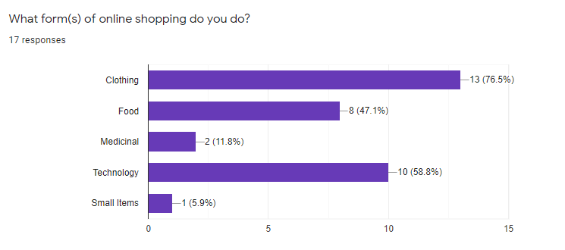
Figure 6, shows a bar chart for the forms of online shopping.
Another important decision that influenced the design is the form of online shopping completed by the user group, as shown in figure 6. It was important to understand what types of shopping the users participated in, in order to give the remainder of the results validity, as if none of the user group used e-commerce clothing stores, the features they found important would not be as relevant to the artifact developed. The results showed that 76% of the users use online shopping to search for clothing items and is the most popular result, which gives the remaining results validity towards the design and implementation of the desired features.

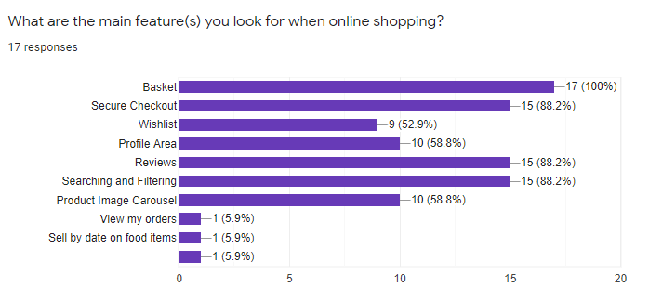
Figure 7, displays the main features users look for when online shopping.
The most important part of design and implementation is to work out what to implement. The results, shown in figure 7, show the main features users look for on e-commerce-based websites. The decision was made to implement the top five features from the results indefinitely to keep the scope of the project manageable with the option to add the other features if time allowed. The results unanimously show that all the users want a basket in order to aggregate items ready to checkout. A secure checkout was equally as important as reviews for the items and being able to filter products which resided with 88.2% of the result. The final features suggested is profile area, of which is standard for most e-commerce stores as it allows users to view their previous orders as suggested by another user in the results.

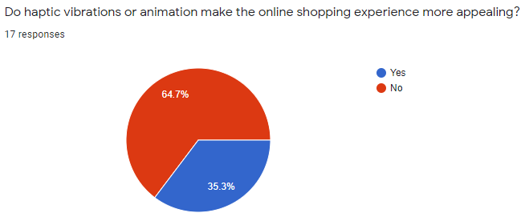
Figure 8, shows pie chart results for virtual theatrics.
As researched in the literature review, virtual theatrics and atmospherics can be used in many forms throughout a different range of topics. It was important to discover if the user group found any form of visual interactivity important and therefore whether it should be implemented. The results, 65% in favour of no, clearly outline that the user group do not believe them to be important and therefore will not be emphasised in the design of the application.

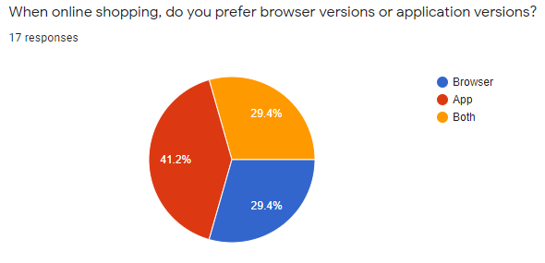
Figure 9, displays a pie chart showing device preferability.
Given the nature of the project it was important to identify user’s preference when online shopping whether it be in app, browser, or both. A follow up question was asked to explain their choice if possible, which had 14 responses. The general understanding from the responses is that users prefer phone app versions as they are generally more simplistic and easier to use. Using that understanding paired with the 41.2%, shown in figure 9, of the user group preferring an application over browser, it can be transferred and applied in the design process making decisions by providing a more simplistic user-friendly user interface.

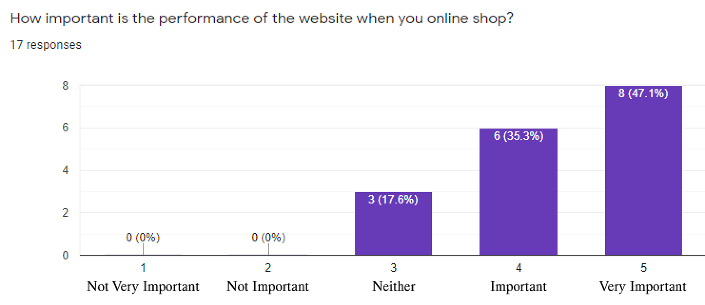
Figure 10, shows how users rate the importance of performance.
Figure 10’s results show the importance of performance to users. The results show that users think performance is between important and very important, tilted more towards very important with 47.1%. Given the results this will impact the implementation of the project ensuring measures are taken to get a good performance rating on the lighthouse evaluation tool in order to suffice the results of this question.

4.2 Feature Driven.
The selected development methodology requires the artifact to be created in a feature driven way. This entails developing a list of features, replacing a requirements list, that have to be created, designed, and then implemented into the application as well as performing the acceptance tests written in the design phase as per the testing methodology. Each implemented feature from the Navigation bar to product cards must have their own individual design, implementing the e-commerce research conducted in the literature review such as web atmospherics.

4.2.1 Feature List & Plan.
The following section will detail and display the design aspects of the project using the development methodology, feature driven development. Each feature, or requirement, of the project will be listed with sub requirements explaining what needs to be complete in order for the feature to be functional. Each feature will have a software prototype for pages or components such as navigation bar. The acceptance testing will also be written for each feature.

4.2.1.1 Database schema for users.

Description:
- User ID.
- Contain user First and last name.
- Email.
- Password.
- Admin Privileges
Design:
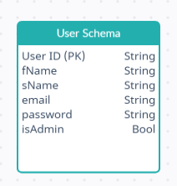
Figure 11, shows the planned user schema.
The planned design for the user schema can be seen in figure 11. The schema incorporates all the necessary fields in order for a user to register an account. The ‘IsAdmin’ label represents if the permission rights for the user as users with these rights will be able to access parts of the website standard users could not.
Acceptance Testing:
There is no acceptance testing needed for database design.

4.2.1.2 Database schema for products
Description:
- Product ID.
- Contain product name.
- Contain product category.
- Contain product description.
- Contain product variations (each product can have multiple colours. Each colour can have a different cost and different sizes. Each size has a different stock and quantity sold value for that product.

Design:
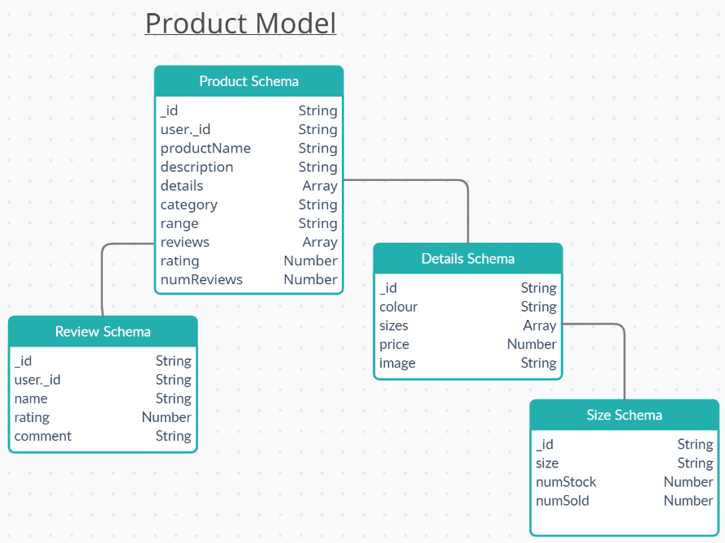
Figure 12, shows the planned product model.
The product model, as seen in figure 12, consist of 4 document schemas. The lines represent to where schema included in the main product schema. The product schema implements the details schema and is designed this way to incorporate a multitude of product variations and with each detail variation the potential for size and stock is different therefore providing the needs to include the size schema.

Acceptance Testing:
There is no acceptance testing needed for database design.

4.2.1.3 Database schema for orders.
Description:
- Order ID.
- User that ordered.
- Contain array of products details in order.
- Shipping address.
- Payment method & result.
- Subtotal, tax, shipping & total price.
- Boolean for status (Out for delivery, delivered[timestamped]).

Design:
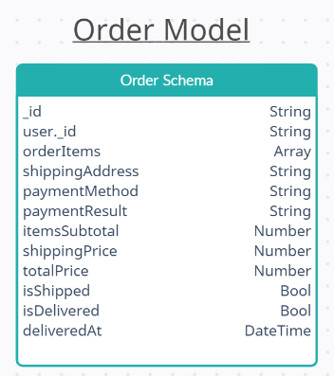
Figure 13, shows the planned order schema.
The order model consists of one schema, as shown in figure 13. The schema holds all the order information such as the user that ordered it, the items that were ordered and, the payment data from the PayPal API. The order schema also contains bools to monitor the status of the order such as if it has been shipped or delivered, including a timestamp.
Acceptance Testing:
There is no acceptance testing needed for database design.

4.2.1.4 Navigation Bar
Description:
- For browser and mobile browser.
- Use icon where possible.
- Include search bar.
- User profile options.
- Include Basket.
- Include Logo.
Design:
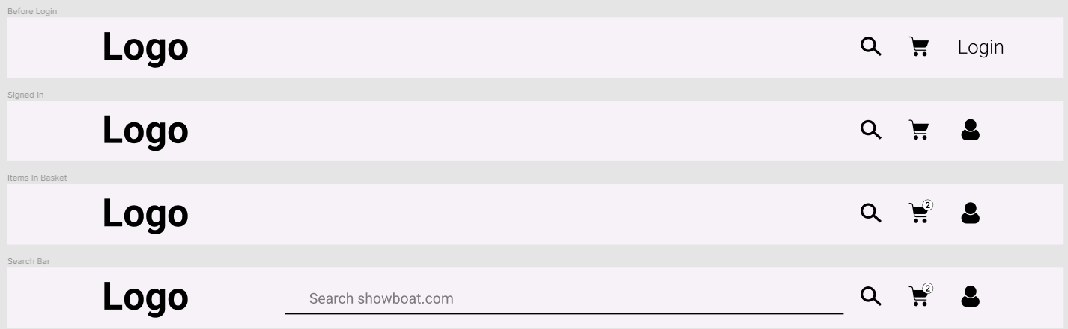
Figure 14, shows the navigation bar for browser with the four possible states.
Figma, a software prototyping tool, was used to get initial designs for the navigation bar and each state, as labelled and shown in figure 14. The design is minimalistic and uses many of the familiar icon’s users will be familiar with. The search button will need to be clicked in order for the custom search bar to show up, this is to keep in with the minimalistic design by showing ‘white-space’ beforehand.
Acceptance Testing:
Test #1: User will want to see all different access areas displayed.
Test #2: User would like an indication if they were logged in.
Test #3: User will want to see number of items in their basket.
Test #4: User will want to be able to search using the search bar.
Test #5: User will want to see the logo of the website.

4.2.1.5 App Bar
Description:
- For progressive web application.
- Repurpose navbar.
- Use icons.
Design:

Figure 15, shows progressive web application navigation and app bar.
Figure 15 illustrates the installed phone version of the application. The navigation component is repurposed and is reduced to just a search icon. The bottom of figure 15 shows an application bar where users can access their profile and basket. The design is in line with the results gathered from the preliminary survey by creating a user-friendly simplistic design. Due to space restrictions on phone, the search bar show underneath the navbar.
Acceptance Testing:
Test #6: User expect app bar to be loading on mobile version.
Test #7: user would want to see the search bar in a more visible location not overlapping the logo.
Test #8: User would want all the icons to go to their retrospective page.

4.2.1.6 Product card design
Description:
- Display product image.
- Display product review rating.
- Display product price.
Design:
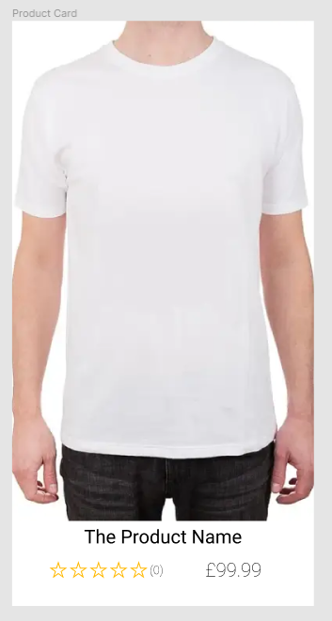
Figure 16, shows the product card design.
The product card, shown in figure 16, will be the main part of the application. The design uses virtual atmospherics to put focus on the product by displaying the image big compared to the product name and price which is smaller and below acting like a tag. The review star apply the virtual social presence aspect of web atmospherics.

Acceptance Testing:
Test #9: Users will want to see an image of the product.
Test #10: Users will want to see the name of the product.
Test #11: Users will want to see the price of the product.
Test #12: Users will want to see the rating of the product.

4.2.1.7 Product details page
Description:
- Display all the variation images.
- Display title, rating, price, and description
- Display all the available colours and sizes.
- Allow customer to select quantity.
- Dynamic Data depending on the colour.
- Any reviews relating to the product.
Design:
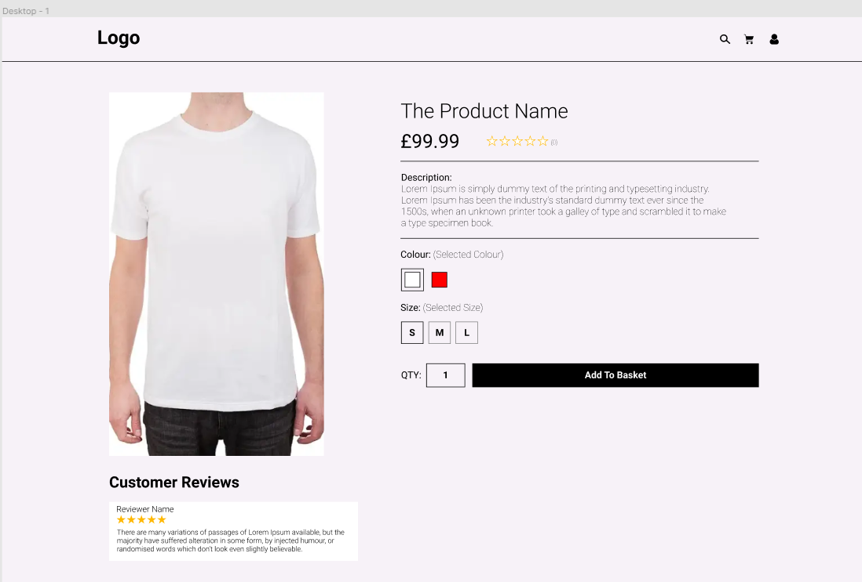
Figure 17, displays the design for the product details page.
The design for the product details page is shown in figure 17. The initial design excludes the image carousel as mentioned in the preliminary survey findings however implements a lot of notable features users would find on e-commerce sites such as colour and size selection for all that are available. Reviews relating to the product are also listed before the image.
Acceptance Testing:
Test #13: Users will want to see the image of the product colour that is selected.
Test #14: Users will want to add the item to basket.
Test #15: Users will want to see the reviews of the product.
Test #16: Users will want to see the rating of the product.
Test #17: Users will want to see the colours and sizes available.
Test #18: Users will want to see the name of the product.
Test #19: Users will want to see a description of the product.
Test #20: Users will want to select a quantity.
Test #21: Users will want to see the price of the product.
Test #22: Users will want to add item to their basket.

4.2.1.8 Basket Page
Description:
- Display all products in basket, with details (image, price, colour, size, qty).
- Display total cost and number of items in basket.
Design:
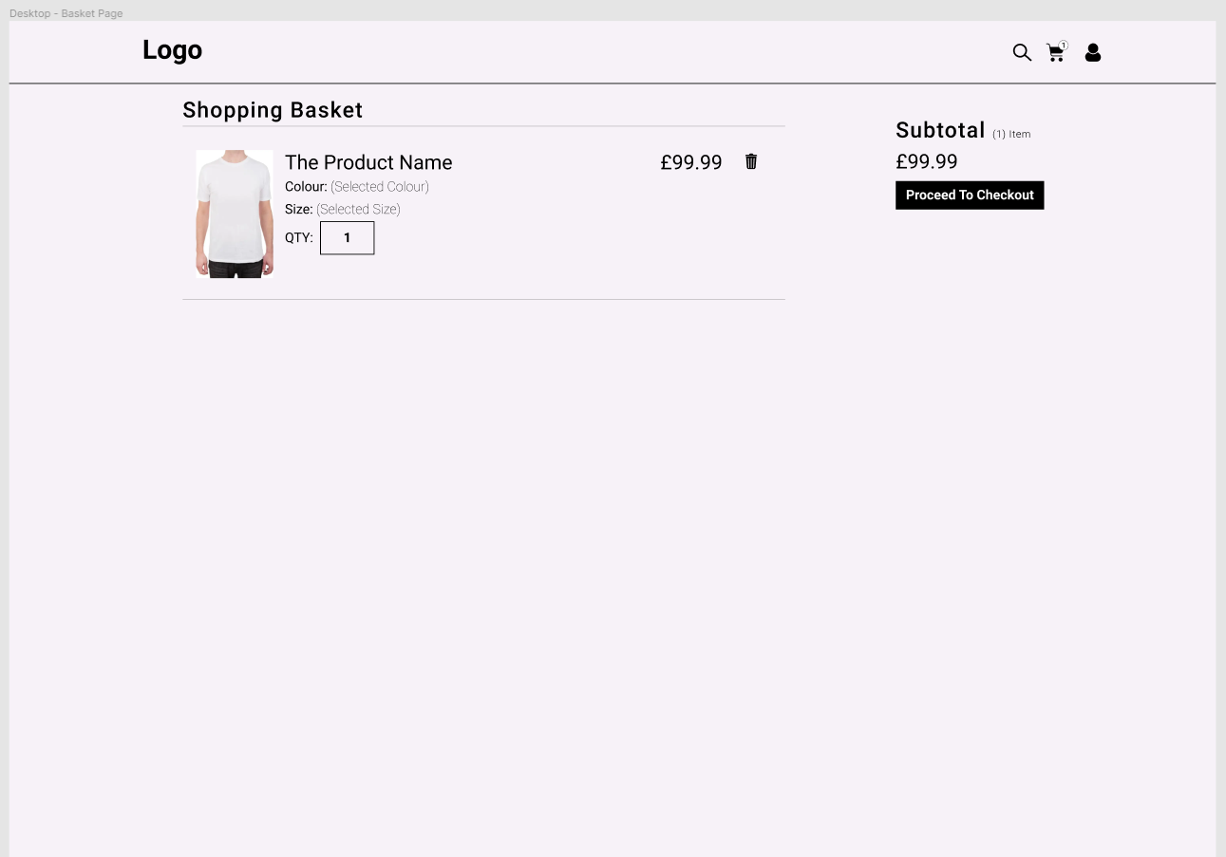
Figure 18, shows the design for the basket screen.
The shopping basket design is shown in figure 18. The design shows the users what the user has accumulated in their basket and what variations were selected, with an option to remove that item using the bin. The subtotal is shown to the users included a proceed to checkout button. The design is minimalistic and easy to use and will responsively resize for mobile devices.
Acceptance Testing:
Test #23: Users will want to see the image of the product in their basket.
Test #24: Users will want to remove the item from basket.
Test #25: Users will want to proceed to checkout.
Test #26: Users will want to see the subtotal.
Test #27: Users will want to see the colour, size and quantity selected.
Test #28: Users will want to proceed to checkout from basket.

4.2.1.9 Register and Login
Description:
- Login form.
- Register form.
Design:
The design for the login and register form will be basic and simple forms that require the user to enter their data. The design will not incorporate any extravagant styling or design decisions as the forms should be easy for users.
Acceptance Testing:
Test #29: User will want to be able to register an account.
Test #30: User will want to be able to login to the registered account.

4.2.1.10 User profile page
Description:
- Allow user to edit details.
- Allows users to view orders.
Design:
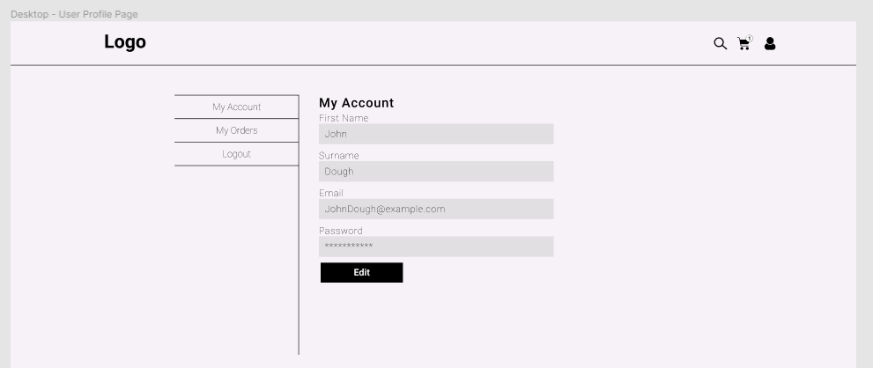
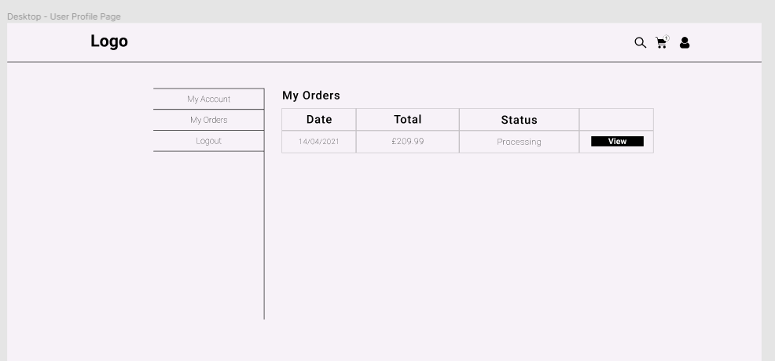
Figure 19, displays the profile page showing the two different options.
The design for the user profile page which was requested in the preliminary survey can be seen in figure 19. It makes use of lines to separate the elements making it easy for users to see and fits in with the overall style.
Acceptance Testing:
Test #31: User will want to be able to view and change their account details.
Test #32: User will want to be able to view all the orders they have made including price and the status the order is at.
Test #33: User will want to be able to logout.

4.2.1.11 Checkout
Description:
- Shows the items in the order.
- Show the total price of the order.
- Show the payment method (PayPal).
- Button to confirm PayPal payment.
Design:
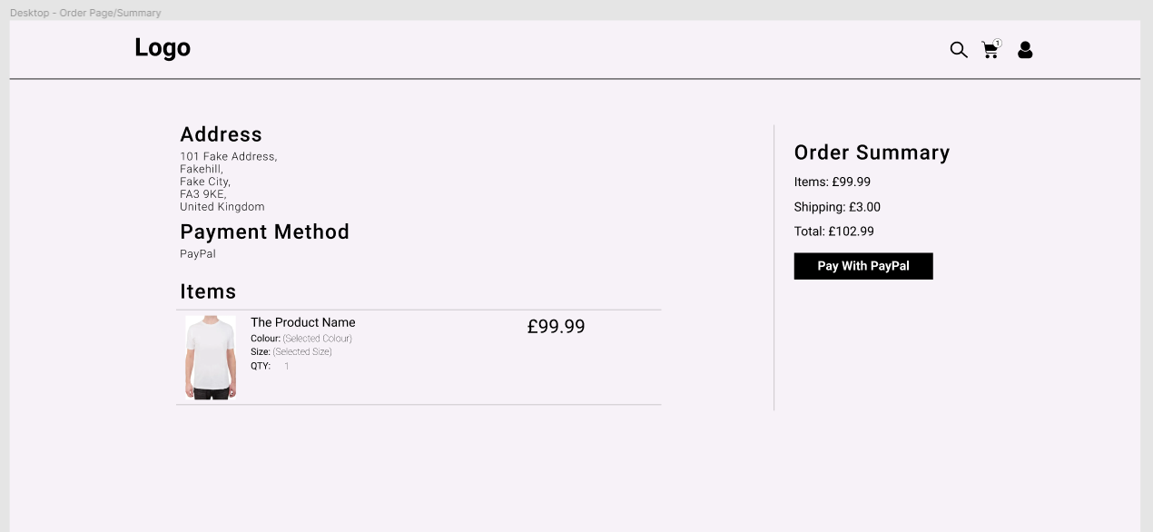
Figure 20, shows the order confirmation screen.
Figure 20 shows the order confirmation screen. The main objective of this page is for users to check over the details of the order such as address, payment method, items, and the cost breakdown. This page can be repurposed without the pay button for users to re-view the order from the user profile page. This page will also responsively size down for the PWA version.
Acceptance Testing:
Test #34: Users will want the items to be processed.
Test #35: Users will want to see if the address is correct.
Test #36: Users will want to see total payment summary.
Test #37: Users will want to see a secure payment, such as PayPal.

4.2.1.12 Product reviews.
Description:
- Include interactive star component to select rating.
- Give a description of their review.

Design:
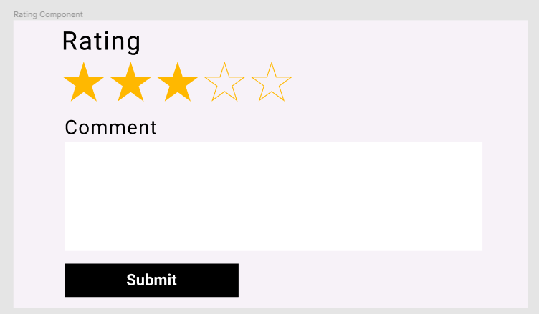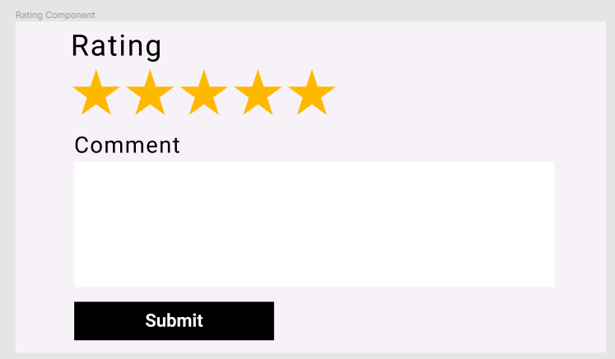
Figure 21, displays the design for the review component.
The rating component to satisfy the virtual social prensece dicussed in the literature review. This part of the component is the submitting of a user review where the user will select the star rating, enter their comment and submit, as shown in figure 21 with the interactive star rating.
Acceptance Testing:
Test #38: Users will want to choose a star rating.
Test #39: Users might wish to make a comment on the product.
Test #40: Users will want to submit the review.

4.2.1.13 Product filtering.
Description:
- Filter products on page by colour.
- Filter products on page by size.
- Sort Items by price and other attributes.
Design:
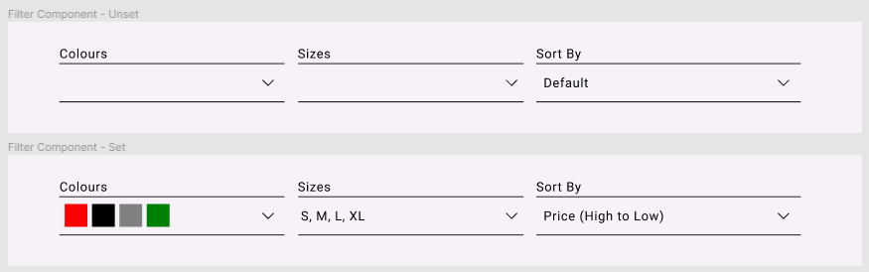
Figure 22, displays the design for the filtering component.
The proposed filter design is shown in figure 22. The design takes 3 filter intakes colour, size, and sort. The colours will be listed in a dropdown and when selected the corresponding colour will show, this method is the same for size. The sort by will have different sort options such as by price. The design behind this follows the same minimalistic line design through the whole site.
Acceptance Testing:
Test #41: Users will want to choose between multiple different colours.
Test #42: Users will want to choose between multiple different sizes.
Test #43: Users will want to sort products by different selectors.
Test #44: Users will want to see the colours chosen.
Test #45: Users will want to see the sizes chosen.
Test #46: Users will want to see the sort chosen.

4.2.1.14 Service workers.
Description:
- Add Installability through manifest file icons.
Note: Due to iOS mobile incompatibility, features like push notification and haptic interaction were not included. Although possible to include iOS mobile prevents users on that platform having access which makes the data gathering process at the end of the project more difficult due to different users using different devices.

Design:
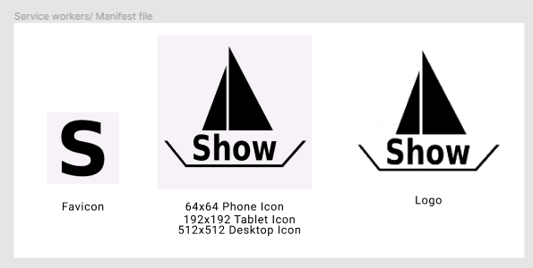
Figure 23, shows the designs for the manifest icons.
Figure 23 shows the logos and icons that will be used in the manifest file in order for the app to be installable. The design for the logo’s is representative of the name of the fictitious shop.
Acceptance Testing:
Test #47: User will want correct icon when installed.

5 - Implementation
The development of the progressive web application e-commerce site involved transferring the designs into JavaScript code which could be run on the browser. Visual studio code was used throughout the development of the project. The main features and challenging parts of the implementation follows.

5.1 Product Details Dynamic Variation Data
From an e-commerce standpoint when implementing the products, it was decided that each product would have many colours and the colours would have a varying size and together that colour and size value would have an individual stock value. The implementation of this proved to be a difficult task as to load the correct sizes, the size mapping function needed to be aware of the current colour variation which did not exist at the time causing errors.
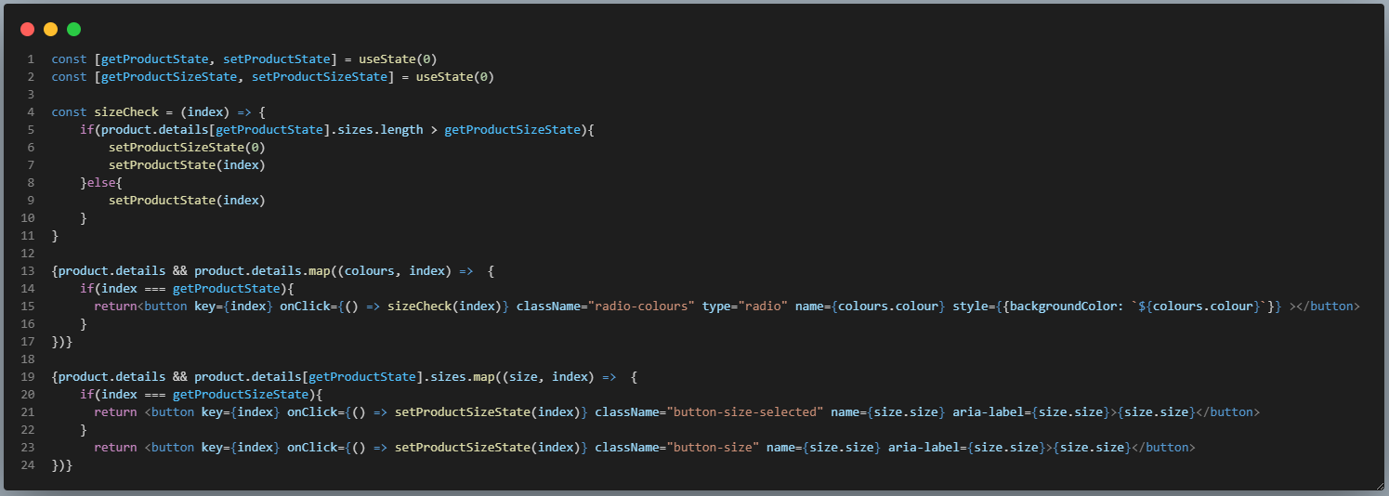
Figure 24, shows the working solution for the dynamic product data.
The way around this was to initially set the colour variation to 0 by default so it will always show the first colour variation. If another colour is selected, an on-click function, ‘size-check’ is called which sets the variation state so that a loop can be used to sypher through the sizes of the set variation. The working solution for the code is shown in figure 24.
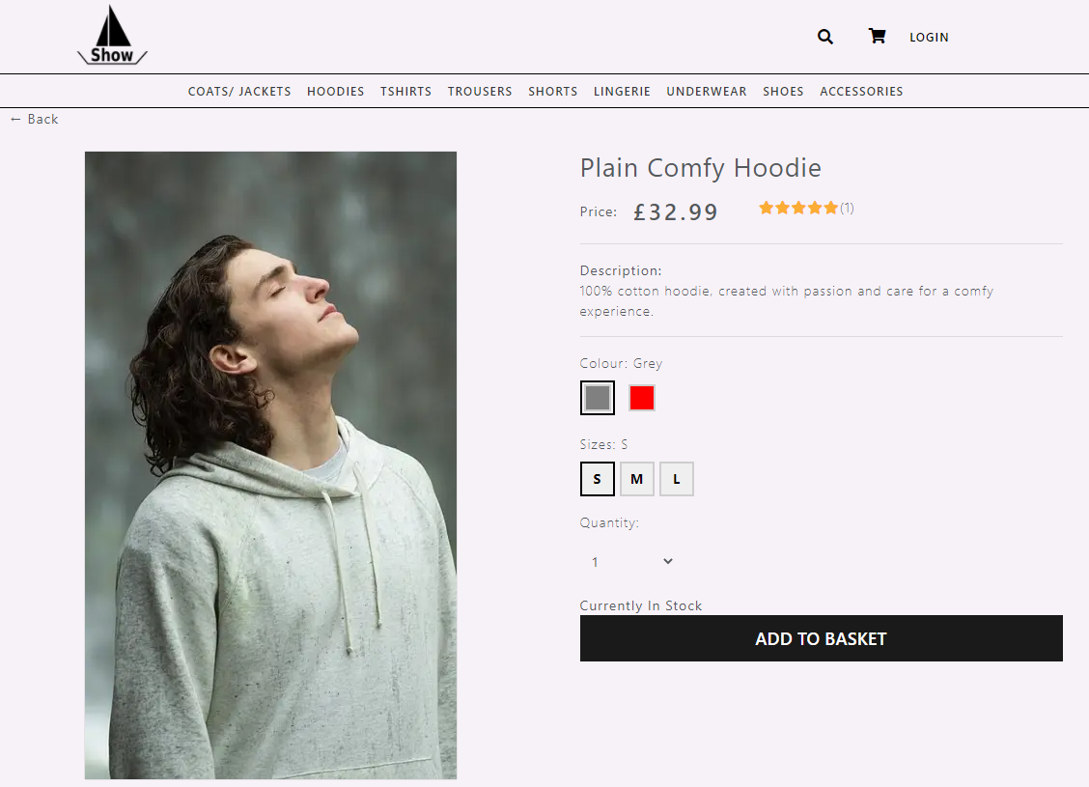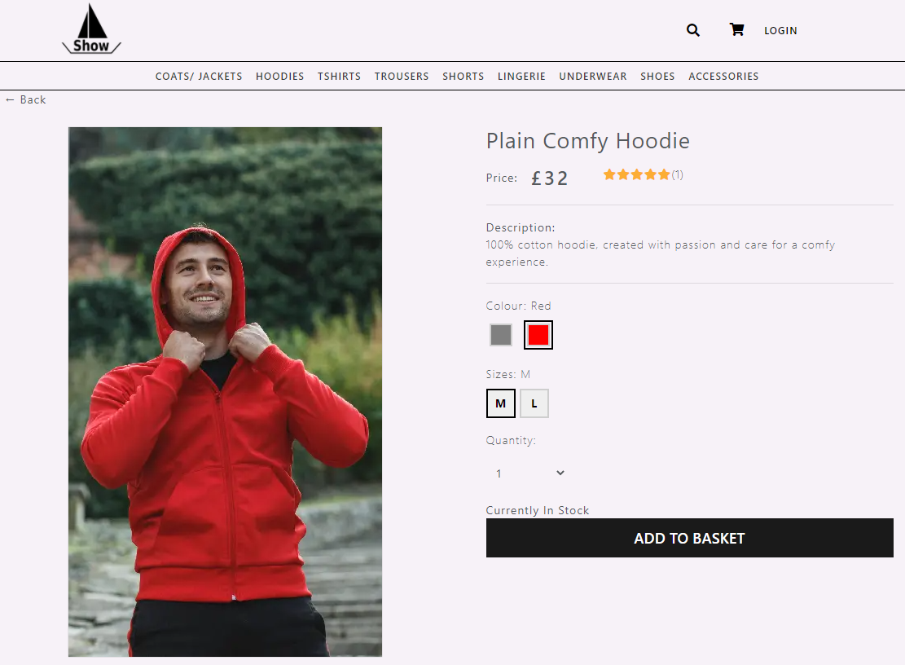
Figure 25, shows the final outcome for the dynamic product data. (Right, after)
Figure 25 shows the final outcome. Depicted on the left is the grey hoodie, when the red hoodie is chosen the data dynamically loads the corresponding image, sizes, and price. The result works exactly as expected.

5.2 Admin Panel
The admin panel was not initially planned and only became a point of interest midway through the development. The decision to implement an admin panel reflected on what occurs in production e-commerce websites that employees would use to add and remove items.
The implementation of adding new products was surrounded with problems. Firstly, the data needed to be sent to the backend, however with the implementation of different product variations this proved a challenge. The first challenge being how to parse the variation data into a JSON array that the database would accept. The second challenge was enabling multiple variations and how to concatenate each variation into whole data array together.
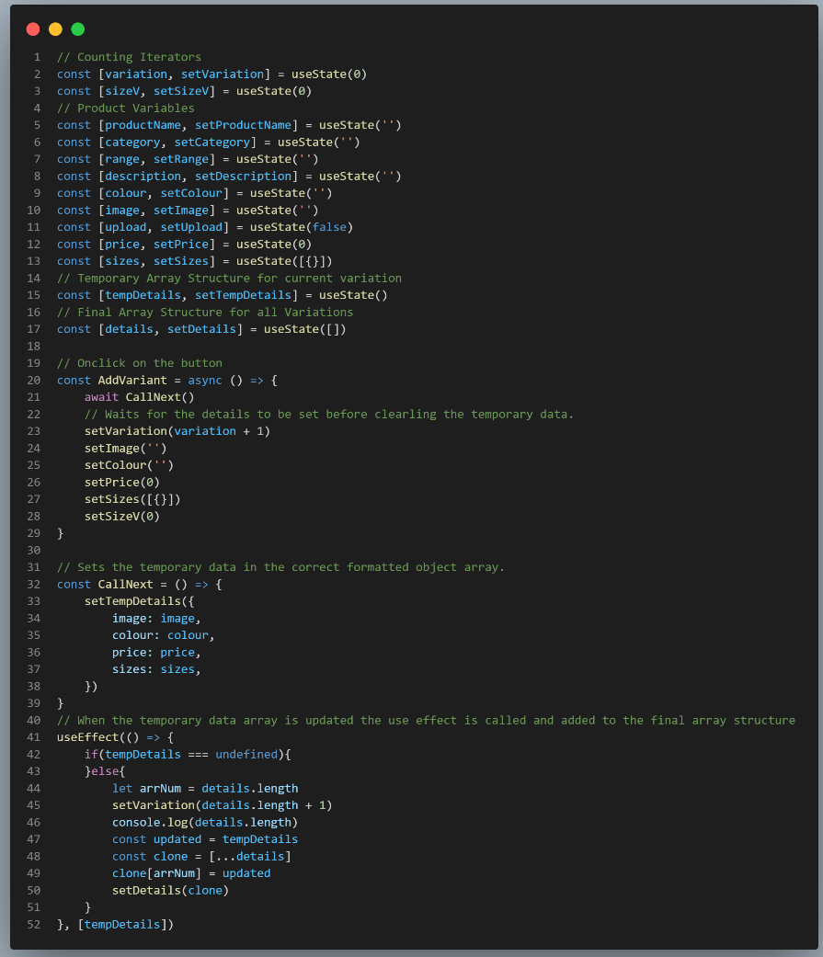
Figure 26, shows the main parts of admin panel code implemented code.
The solution to the two challenges were as followed. Firstly, the array was built individually at each text box, for example when a user entered a colour, the colour state would be updated using an on-change event. This was the case for each data entry box. When the set variation button is clicked, the details are individually set to a formatted array state via an on-click event, this can be seen in figure 26. The second challenge was made a lot easier with the previous solution as it was possible to iterate through the formatted array and plus one, allowing for the new variation to be added. The completed working outcome can be seen in figure 27 with the many variations added.
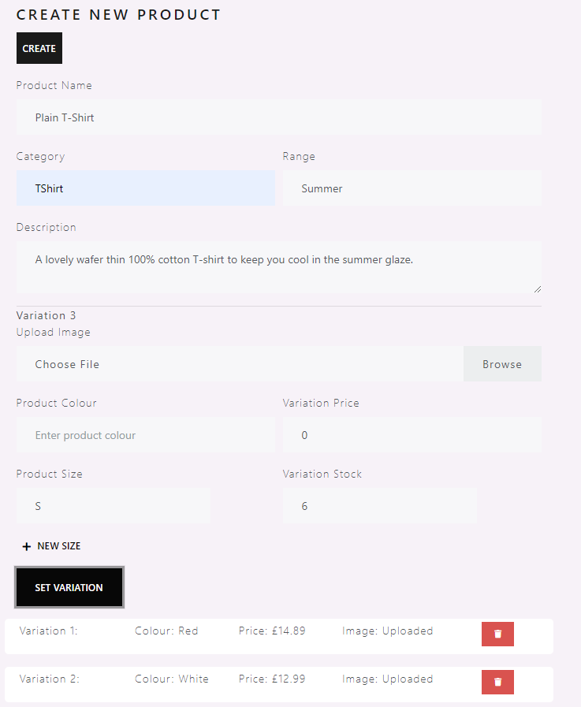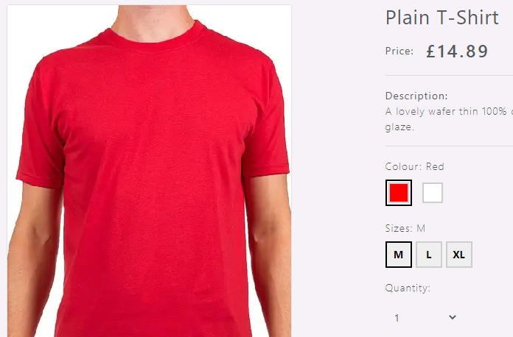
Figure 27, shows the working implementation for adding products.

5.3 Product Filtering
Filtering systems are a major part of e-commerce. The initial implementation of the filtering system was going to be through backend routes, this would involve retrieving the data based on a value set by the user and sorting the array server-side. The issue with this was there were many backend routes, and the code became wet. The settled solution was decided due to products showing once users had searched for a specific value, this meant the data was ready to be manipulated on the frontend.
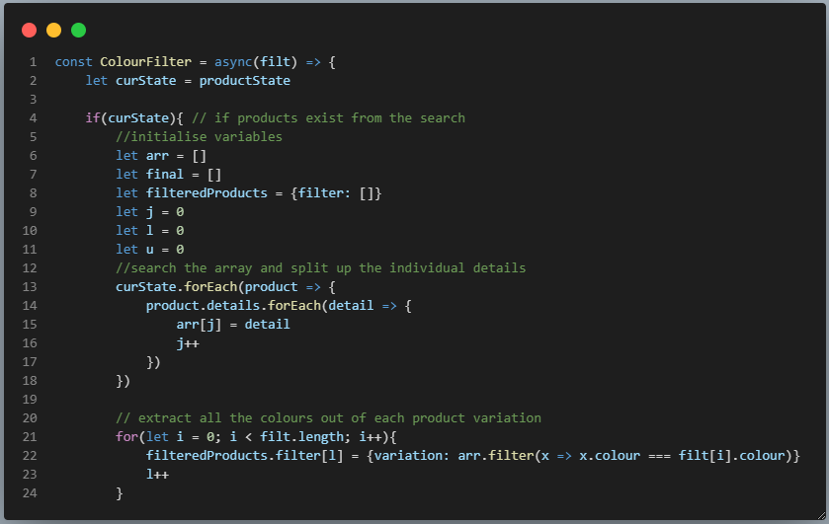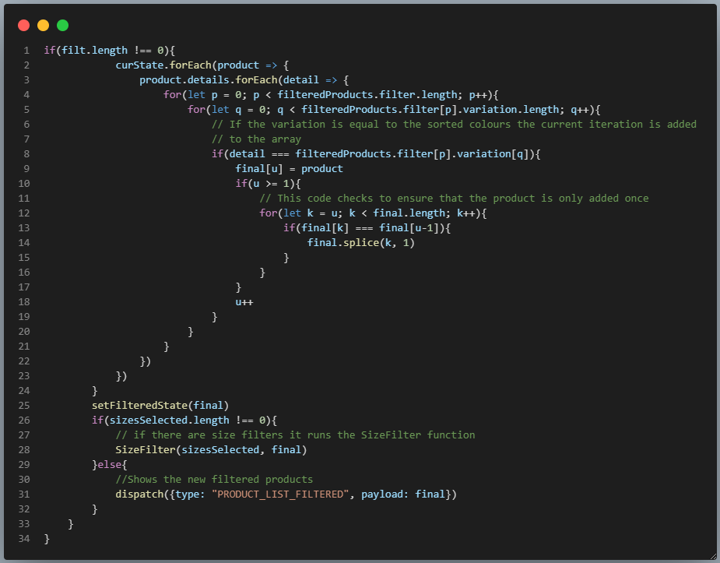
Figure 28, shows the code for the colour aspect of the filtering system.
As shown in figure 28, the products are passed into the function via an array. The details are extracted from the JSON object where the colours can then be sorted against the colours chosen by the user. To avoid the duplication of items, which occurred many times during testing, code was implemented to check the entire list by product IDs to ensure there were no duplicates.
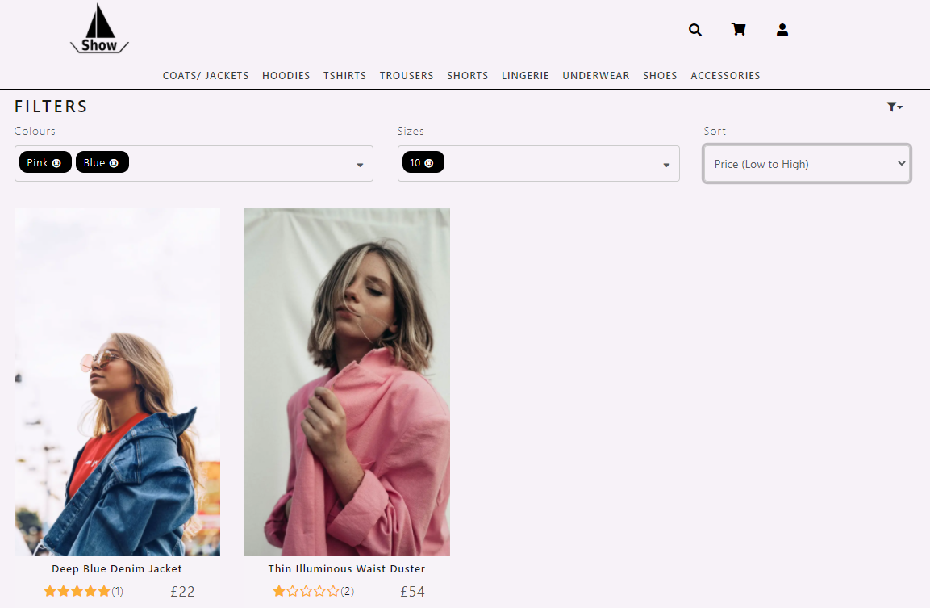
Figure 29, displays the working filtering system including sizes and sorts.
Figure 29 shows the full working filtering system. The design changed from the initial prototype designs to what can be seen in figure 29. This was to facilitate more with the off white and black theme of the website.

5.4 Checkout Process Using PayPal
As shown in the preliminary results a secure payment is one of the highest priorities when online shopping, with that in mind PayPal was used in order to process payments to orders.
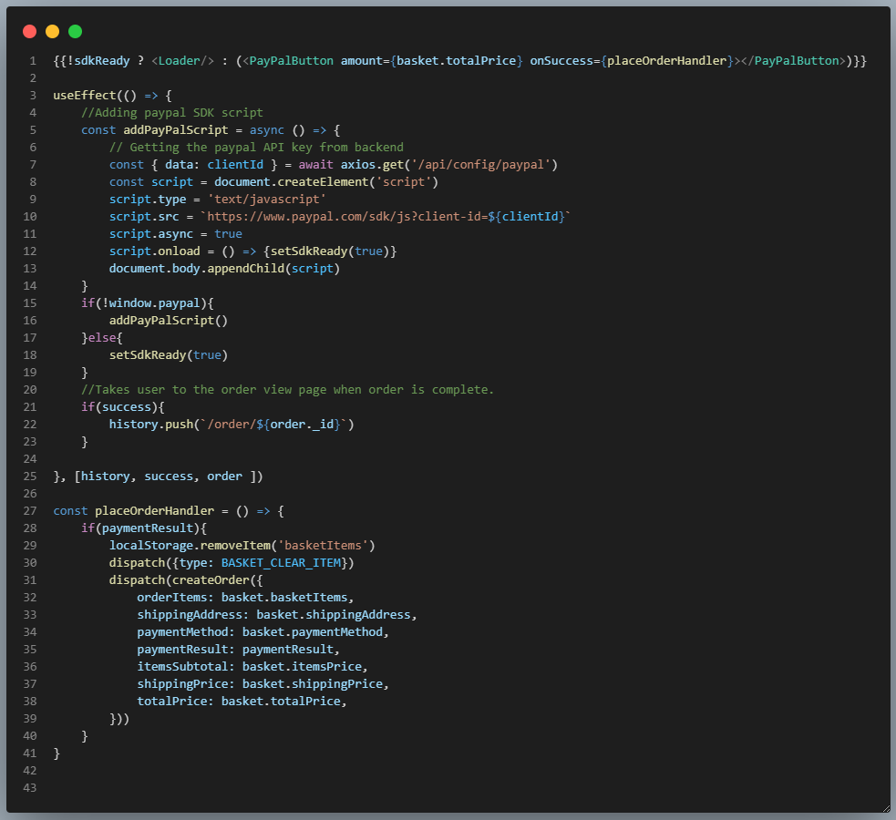
Figure 30, displays the main code for the PayPal functionality.
A PayPal supplied button is used, where the total cost of the basket is sent through the payment API. Upon clicking the button, a familiar PayPal window will pop-up asking users to enter their PayPal credentials, for testing purposes a test account was used. When users confirm the payment, the API sends back success data, if that is true the order is added to the database ready to be fulfilled by admin users. The working PayPal implementation can be seen in figure 31 below.
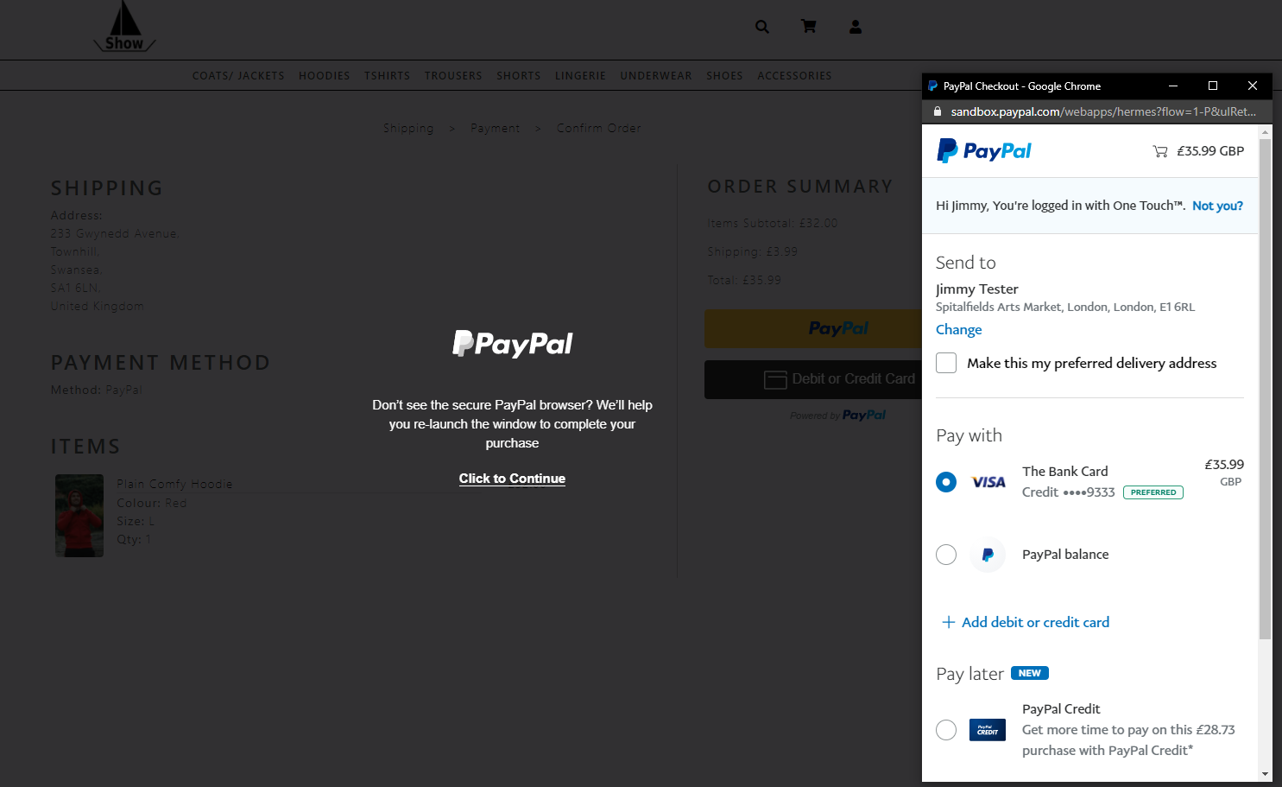
Figure 31, shows the working PayPal API on the order screen.

5.5 PWA Implementation.
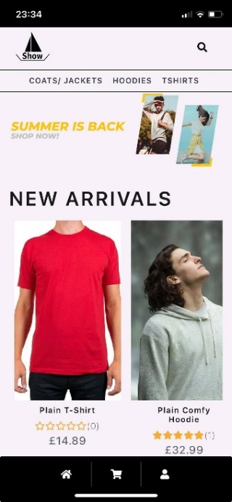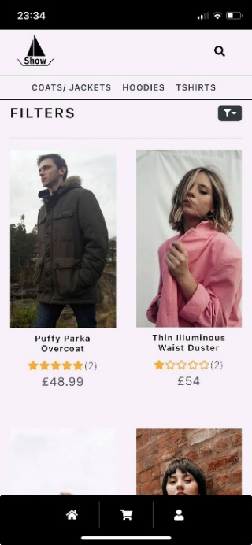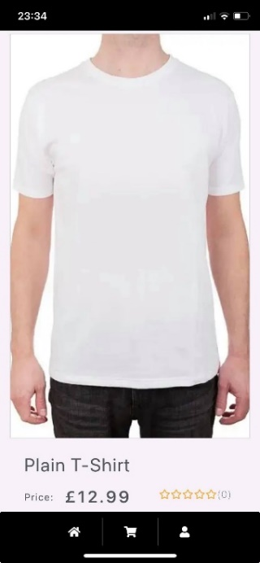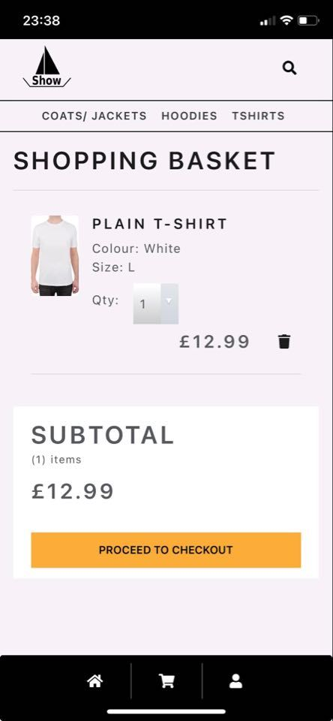
Figure 32, shows the process of adding items to basket on the installed PWA version.
The progressive web application is shown in figure 32. The app appears like a responsive web application within a native application container. In order to make the application have a different more native feel when installed, a dependency was used to check if the application booted in a standalone browser view and load the corresponding views.

5.5.1 Service worker & Manifest file
As discussed in the literature review, the service worker and manifest file are the key elements in order for the application to be considered a progressive web application.

5.5.1.1 Service Worker
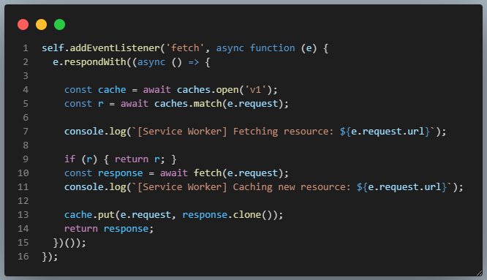
Figure 33, shows the code for caching endpoints.
The service worker was created, and the app was there by installable as shown in figure 32. An attempt at caching certain elements of the application for offline use was a main priority when designing the application. The offline code, shown in figure 33, worked not as expected showing the cached content however, if there were any changes to the page they were not showing. Online resources were used in order to replace cached data when the user was online so there was a constant stream of up-to-date data, however the implementation of this was abandoned.

5.5.1.2 Manifest File
The manifest file was implemented with no issues. The manifest file holds the icons and theme colours which were decided on in the design section making for easy implementation.

5.6 Basket
A main aspect of e-commerce is the basket system as it the focal point of interaction before money is exchanged and the order is complete. The implementation of the basket came with its problems. The problems originate from the way in which the product variations of the same products are handled, and the fact that the basket was being stored locally as opposed to the database. This is due to products having a unique identifier, id, and add the same product with a different variation would cause the application to delete the previously added item. The solution to this was give each item in the basket its own Basket ID.
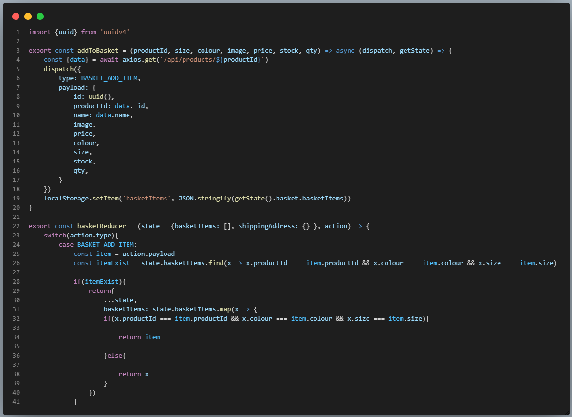
Figure 34, shows the solution code for the basket issue.
Figure 34 shows how an external library, UUID, was added to assign 32-character temporary ID. The ID is temporary, as once the particular item is removed from the basket the ID can be reused again. The ID is assigned through an action before being passed to a reducer to check if the item has been previously added, this can be seen in figure 34.
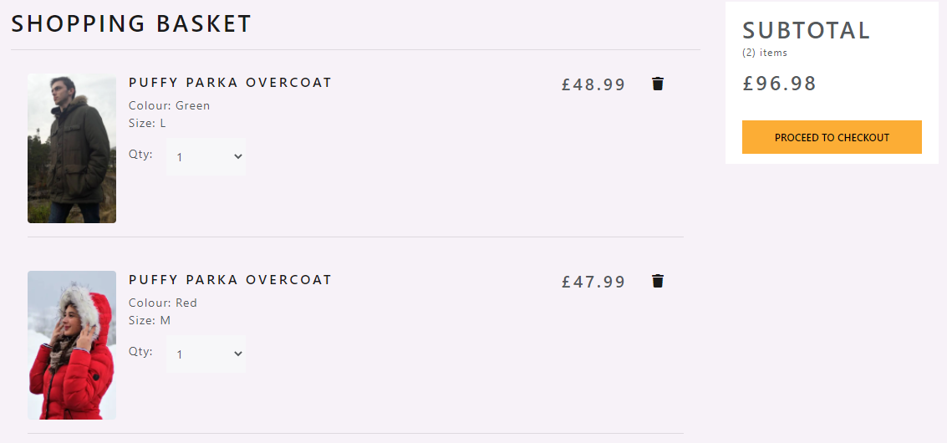
Figure 35, displays the working outcome on the website.
As shown in figure 35, two variations of the same coat can now be added to the basket, showing the implementation was a success.

5.7 Catalogue display & Searching
The catalogue display is another vital element in e-commerce and is mostly done through the backend. A request is sent to the endpoint for products and all the data from that endpoint will be retrieved. It is down to the frontend to make use of the data send and convert it into product cards.
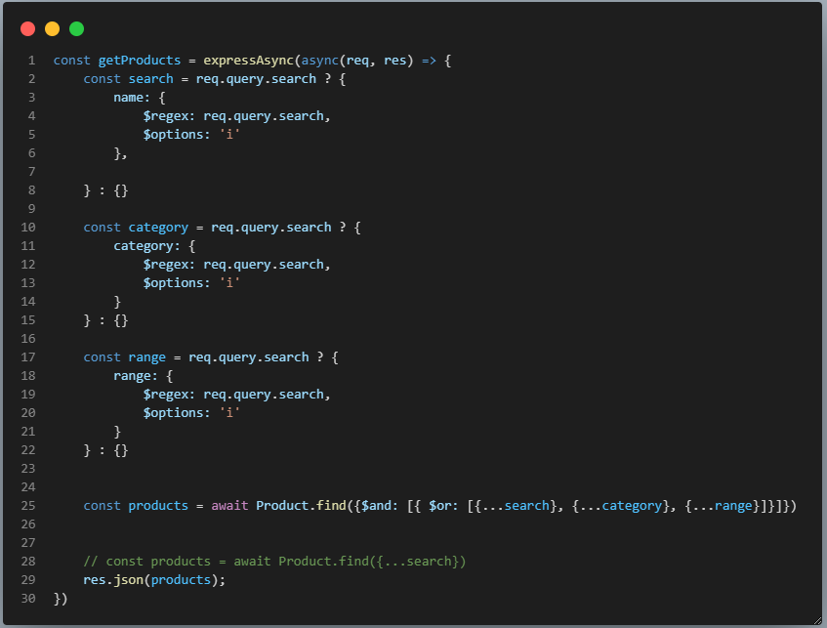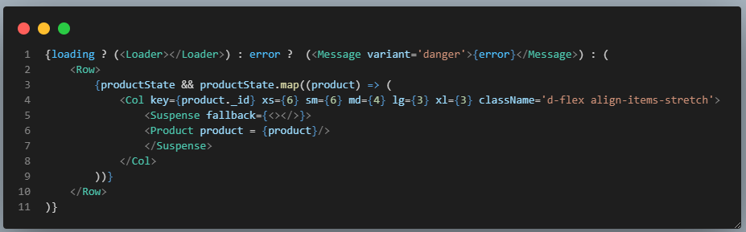
Figure 36, shows how the product data is retrieved from the backend and converted into frontend components.
When a request is sent to the ‘Get-Products’ endpoint, as shown in figure 36, the query is checked to see if there are any search parameters. If the search parameters exist the query is run, returning all the items relating to the users search request, an empty object bracket is used indicating that all the data within that document are to be returned. The data returned is then looped through and the individual data is sent to a card component which de-structures the data to be used in a product card, which can be seen in figure 37.
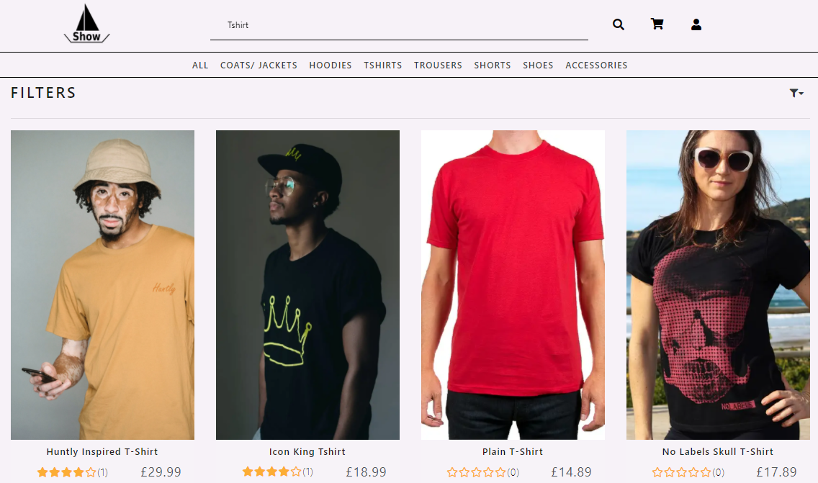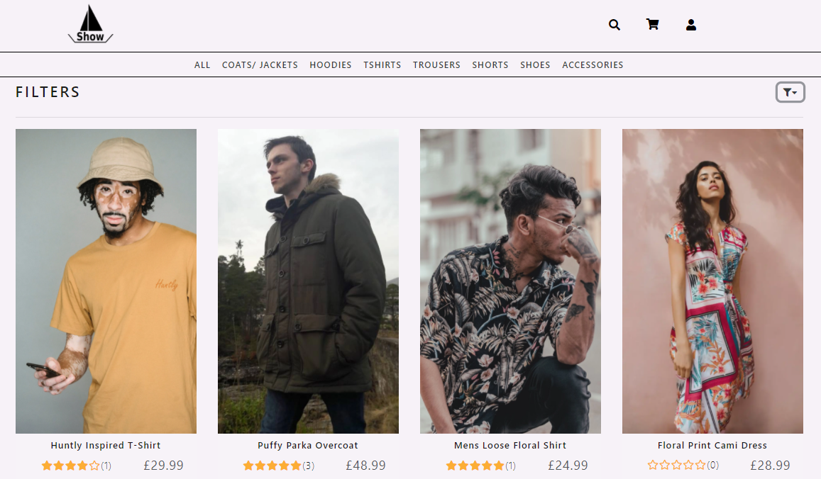
Figure 37, shows all the product cards for the returned data with and without a search.

5.8 Login & Session Management
Login and session management are important factors of e-commerce. Best practices for most e-commerce websites include using tokens for verification, and then logging users out after 30-45 minutes for security reasons. An interesting issue was encountered when developing the payment gateway for the application. The issue was that the user was being logged out because the token was expiring, however unless the browser was refreshed the user was still able to make orders. This caused a bigger issue where the user was able to process an order without the payment going through, which is a massive vulnerability for e-commerce. The solution can be seen below.
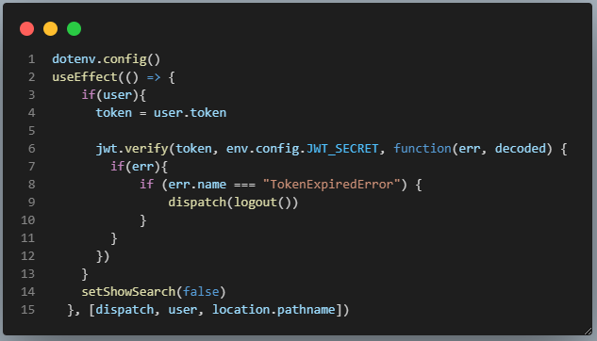
Figure 38, shows the solution to the payment breaking bug.
The solution to this bug was to identify if the token was expired and log the user out. There were two ways of handling this. The implemented way, shown in figure 38, where each time the path changed an error would be checked for, if the error existed and it matched the token expired syntax the user would be logged out. The non-implemented way was to set a timer server side for each user after the initial login, this in theory is a much better idea however becomes very server intensive and due to the expectations of hosting the final application on a free hosting service, it was decided not to implement this option.

5.9 Acceptance Testing Results
The acceptance testing results, shown in appendix 1, displays a table of all the tests conducted relating to that particular feature. In other words, the tests acted as requirements or inclusions for the feature to be complete and was referred too throughout the entire development process. All the tests were complete apart from one test. The one test that was not complete was the displaying of the number of basket items in relation to the number of items in the basket. This was something that was to be included towards the end of the project, after the main features had been included however due to time constraints it was left out. Creating features through acceptance testing provided a good app tailored towards the user’s needs, this technique is very scalable and could be completed in much more depth in order to get even better results.

5.10 Conclusion
In conclusion the design and implementation of the progressive web application has been a success. The majority of the required features have been implemented, bug checked and meet the acceptance testing criteria set in the original design. The implementation leaves many avenues for further research into other libraries such as react query which is middleware to make requests to the backend. A deeper delve into the research of service workers and caching in order to get a fully working caching implementation and push notifications for android, and hopefully iOS in the future should they decide to fully support service workers. Acceptance testing was a big contributor to the success of the implementation stage with the development of each feature using the acceptance tests as a basis for the creation and functionality. Acceptance tests are no substitute for development testing, such as white box testing techniques, but worked very well in conjunction with other forms of testing in order to get a good result. This would be a further avenue of exploration by using both development testing and acceptance testing.

6 - Results & Analysis
The project makes use of a survey and google lighthouse evaluative tool in order to garner results for the project. These results will be analysed in the following section.

6.1 Survey
The survey consisted of four sections. Each section was broken down into easy-to-understand tasks and questions in order to retrieve the most accurate results. The analysis of the survey results will be broken down by section. The survey received a total of 18 responses, these can be found in appendix 2,3,4 and 5.

6.1.1 Section One – General Questions
Section one asked three questions focused on gathering information about the user, the results of which are shown in appendix 2.

6.1.1.1 Question One
The results regarding age found that the majority of the responses were from the age group 18-25. This was expected due to the nature in which the survey was distributed as specified in the methodology.

6.1.1.2 Question Two
The level of computer literacy within the results was even, showing no superior group of computer users, this benefits the overall results as there is an even split in the ability of the user group meaning that the results from tasks performed in the survey will be unbiased, as there is not a clear group of literate users.

6.1.1.3 Question Three
As asked in the preliminary survey, it was important to understand the e-commerce familiarity of the user group. The results are generally balanced showing that 38.9% shopped 1-2 times a week, followed by 3-5 times a week. These results were expected as they fall into the average expected e-commerce access.

6.1.2 Section Two – Uninstalled Application Tasks
Section two required users to use the developed application and perform tasks. The tasks were set for the user to get a baseline of the uninstalled application. The questions and results for section two can be found in appendix 3.

6.1.2.1 Question One
An important factor to understand the compatibility between e-commerce and progressive web applications was the device in which the application was being accessed. The results show that the application was accessed 18 times across all three platforms, which further validify the results as it shows the application will be used in multi-platform situations as mentioned in the literature review. The application was accessed 50% by mobile, 33.3% by desktop and 16.7% by tablet. This directly supports how the project was introduced with over 50% of web access coming from a mobile device.

6.1.2.2 Question Two
Users were tasked with creating account and rating the easiness of the process. A majority of 66.7% of the user group responded saying it was very easy to complete, showing an overall success in the implementation of a login and registration system. A further 16.7% saying it was just easy. The correlation in the results is exactly the same spread of data as the age group which could indicate due to the minimalistic modern design the older age groups found it less easy to register as it is not abundantly visible.

6.1.2.3 Question Three
One of the main aspects of e-commerce were tested by tasking users to find any item and add it to their basket. The results showed an overwhelming 16 out of the 18 responses, 88%, finding it a very easy task to complete with the remaining 12% finding it easy. This positive result shows the implementation of the virtual layout and design as research in the literature review was a success.

6.1.2.4 Question Four (including written replies)
Another main aspect was tested, checking out. 77.8% of the user group were able to fully complete a checkout, indicated that the implementation of the feature was a success. It is important to note that the remaining 22.2% of users that could not checkout specified that they thought real money was required therefore aborted the process. Real money was not required and should have been made more apparent in the application or detailed in the question.

6.1.2.5 Question Five
To satisfy the virtual social presence aspect researched, users were tasked with writing a review for any product. The implementation of the review feature was a success and is backed up by the results where 27.8% of the user group thought the implementation was good and the remaining 72.2% thought it was excellent.

6.1.3 Section Three – Installed Application Tasks
Section three focused on the installed version of the application, known as the progressive web application. The users were asked to install the application and follows tasks within the installed version. The questions and results for section two can be found in appendix 4.

6.1.3.1 Question One
The users were asked to confirm if they could install the application. 94.4% of the user group were able to install, meaning just 1 person was unable to install. The user that could not install gave their account of why not, which was due to using Firefox which since the completion of the literature review have revoked their PWA support [70] [71]. This data alongside the spread of devices being used shows that overall, the data supports claims made that progressive web applications are the solution to cross-platform same application development as researched in the literature review. Understandably, if the sample size were larger, it is likely that more users would have had browser compatibility issues however given that only one user was unable to install in a sample size of 18, most users would still get the benefits of a progressive web application.

6.1.3.2 Question Two
For the installation of a progressive web application to be effective it is important that users found it easy to install, if users were able to install but they found it hard it would jeopardise how compatible progressive web applications are with e-commerce. The results show that 53.3% of the user group found it ‘very easy’ to install the application, followed by 26.7% finding it ‘easy’. This is a positive result as it displays that the install experience is generally easy therefore making progressive web applications all that more compatible in an e-commerce situation.

6.1.3.3 Question Three
Users were asked to use the application to perform a complete checkout and rate their experience, like with the uninstalled version. 80% of the users reported that the process was ‘Excellent’ on the installed version of the application. Compared to when uses were asked to complete the process previous only 77.8% were able to complete the process. The installed version of the application had more of a success rate which could be due to the 50% of mobile users which would receive a more native interface when using the installed app, making it easy to checkout.

6.1.3.4 Question Four (including written replies)
Users were asked to navigate the installed application using the navigation bar. This task was specifically set in order to see if there would be a clear split in data correlating with the device data that was gathered, this was not the case. The results indicated that 73.3% of the user group found the navigation ‘excellent’ to use, with a further 20% finding it ‘good’. Overall, this does not show any issues between the different navigation systems on different installed devices. This shows that users can switch between installed and non-installed with no issues.

6.1.4 Section Four – Application Review
Section four was used to understand if the implementation of the application was a success and also how the installed and uninstalled application compared against each other. The questions and results for section two can be found in appendix 5.

6.1.4.1 Question One
The users were asked to rate how the experience of the installed application compared against the uninstalled version. The expected results for this question were that the installed application would be equal or better. If the results are equal or better, it will clearly show that e-commerce can be used in a progressive web application manner. The results show that the entire user group thought the installed version was equal or better, more specifically 55.6% found that the experience of the installed application was equal to the uninstalled version and 44.4% found the installed applications experience better. These results prove the overarching aim meaning that progressive web applications can be used for the purpose of e-commerce.

6.1.3.2 Question Two
The majority of the users commented on the design, saying it was very minimalistic and easy to use which is exactly the style attempted in the design section. Two comments were about the install menu and making it possible clearer with more support for other browsers.

6.2 Lighthouse
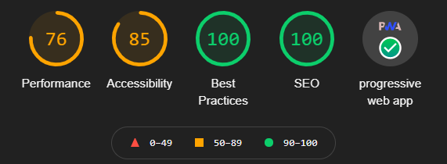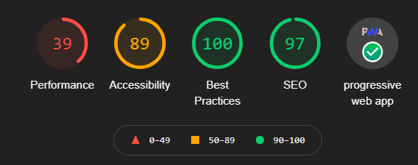
Figure 39, shows the highest lighthouse result for desktop(left) and mobile(right) version of the application after 3 attempts.
In order to fairly rate the application, the lighthouse test was run 3 times to get a rolling average of the performance, this is due to the performance depending on many factors at the time. The lighthouse results, seen in figure 39, shows for the most part very positive results. Most notably the progressive web application aspect has a green tick meaning that the application developed is successfully considered a progressive web application. It shows that the developed application is installable and also adheres to using HTTPS, service workers and manifest files.
The SEO which checks to ensure that the page is optimised for search engine results scored 100 for desktop and 97 for mobile, this means the application developed will provide high ranking SEO. Best practices, which checks the overall health of the code and web app, scored 100 in both desktop and mobile showing that the application has no code health vulnerabilities or clear improvements the tool can recommend.
The accessibility relates to how the application interacts with screen-readers and devices that help people with disabilities. The accessibility score is high however not 100. This is due to a component library used for the landing page. The component does not allow for labels and therefore lowers the accessibility score. To avoid this, the library could be edited to include label in order to increase the accessibility.
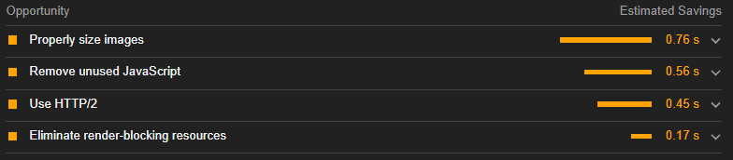
Figure 40, shows the suggestions to help performance.
The performance which is the metric used to measure the speed in which the application loads. The performance score was an average of 74 over 3 lighthouse tests on desktop and 38 on mobile. The performance is good however it was expected to be higher on both platforms and looking at the breakdown of the metric a clear understanding of why is shown, this can be seen in figure 40. The reason for this was predominantly image sizes, this is due to the product cards using a smaller image called a thumbnail which uses the enlarged photo which is sized for the product details page. This translates into the application transferring images larger than it needs too which takes time in order to get the larger images from the server. The solution to this would be to have a thumbnail tag in the product database schema, this would allow for the correct size image to be shown increase performance. The other performance limiter was the bundle size, there was an attempt to lower the bundle size using compression libraries before the build however these crashed the application and there was not enough time in the project to commit to learning the compression library when the performance score was already acceptable. Finally, using the HTTP/2 protocol was recommended, unfortunately, this protocol is not supported by the free hosting provider and therefore is out of the question for improving the performance.
Overall, the lighthouse results were an incredibly informative insight into the application and showed areas in which improvements could be made which have been discussed in the relevant parts. The lighthouse results were not as entirely successful as first hoped and the implementation of the compression library to lower the bundle size was unsuccessful, however the performance of the web application is around average in score and is still very fast for a user to use regardless of the score.

7 – Evaluation
The following evaluation section will document the key findings from each chapter and evaluated against the objectives of the project.

7.1 Objective One Evaluation
One of the objectives of the study was to research and analyse progressive web applications used for e-commerce. Extensive research was conducted into progressive web applications and how they compared to alternatives such as native and hybrid, which have been used in e-commerce situations. The comparison concluded that progressive web applications were a viable alternative to native development with equal performance ability, overall better compatibility, better cost for development, a smaller application size however not as much access to native hardware. The research conducted in this section would further help in the development of the project as it was understood the components needed in order to make a progressive web application. Case studies were also researched into companies with e-commerce websites that have made the switch over to progressive web application technology. The research showed that all the companies involved saw dramatic increases in conversion rates, engagement time, better re-engagement and so on. This section of the literature review satisfied this objective, garnering a comprehensive understanding of progressive web applications and the ecosystem around them including the benefits they have already provided to e-commerce companies.

7.2 Objective Two Evaluation
The second objective of the project was to systematically assess current guidelines and best practices for e-commerce. This transpired into looking at web atmospherics and e-commerce business models. The web atmospherics displayed a clear guidance into how conventional commerce has been applied and adapted into e-commerce from layouts, atmosphere, theatrics, and social presence. Researching this provided a base for the design and implementation, where web atmospherics could be implemented. The e-commerce business models depicted the different types of online business models that could be developed for the use of the project. Considering it was always the intentions to have users use the application in some form it made sense to choose a business to consumer model which the majority of the subject group would have had experience using before, providing reliable results. The results from this section showed that the inclusion of web atmospherics can increase the conversion rate of sales which was also shown in the case studies, which shows ground for e-commerce to be compatible with progressive web application technology. In all, the e-commerce section of the literature review explored the current guidelines and best practices used to build an e-commerce platform was thoroughly investigated and met the objective set by understanding the different concepts and strategies involved in building e-commerce.

7.3 Objective Three Evaluation
The third objective involved designing and developing an e-commerce progressive web application proof of concept. This objective was undoubtedly met, and the proof of concept was created with many industry tools and techniques in order to develop a professional application. The design section used the development methodology set out to design a feature list required in order to make the application a success. The feature list was aided by a preliminary questionnaire which explored design features associated with e-commerce platforms. The majority of the results backed up what was researched in the literature review, the anomaly being that the survey results did not agree that including virtual theatrics, animation, improved the engagement of their online shopping experience and for this reason animation was kept to a minimum in the design. The results from the survey were implemented as a main focus in the design stage. The implementation stage of the project was challenging however was a success with close to all the features from the design stage fully implemented and working, with the exception being a fully working service worker implementation. Most importantly for e-commerce a fully implemented checkout system was implemented. The payment gateway used was PayPal, which was taken out for the user testing stage and simulated however a lot was learnt about the implementation of payment gateways. Although the objective was met there are many things that would be changed. Firstly, MongoDB as the backend database. MongoDB is a great database system however it was found early on in the development that a relational database system would have been more suitable for the project such as the researched Postgres. The implementation of many product variations became an issue and caused issues in many parts of the project.

7.4 Objective Four Evaluation
The progressive web application was analysed by googles lighthouse tool. The results were good across the board achieving good accessibility, best practices and SEO including getting the progressive web application green tick meaning that the application was a successful progressive web app. However, the performance score of the application was very underwhelming scoring an average of 74 across three tests for desktop and an average of 38 across three tests for mobile devices. The application by eye was very fast and there were no waiting times so the performance score was not really understood until further analysis was conducted, which showed that there were extortionate package sizes being transferred. These packages included the images being shown on the website not being the correct size for the card, this could have been avoiding by having two versions of the image, one which would have been sized for the thumbnail and one for the product details page which can be something that would be done differently. The other performance limiter was the React JavaScript bundle size, an attempt at using compression software before building was attempted however due to time constraints the implementation was unable to be finished and therefore abandoned, this would be another thing that would be improved in the future. Overall, the objective was met through an in-depth analysis of the lighthouse results with an exploration of potential improvements for the performance aspect of the result.

7.5 Aim Evaluation
The aim of the project was to investigate, develop, and analyse the capabilities of progressive web applications for the purpose of e-commerce. The aim of the project was met through a series of objectives set and evaluated previously. The outcome of the project was proven that progressive web applications were viable for the purpose of e-commerce. The aim was proven through a final survey in which the participants were asked to perform tasks on the developed progressive web application when it was installed and installed rating their experience as they were performed, with the results showing an understanding of the web atmospherics researched in the literature review. The overarching question of the survey was if the installed version was better, equal, or worse. The results showed the subject group found it either better or equal, not a single participant found it worse which proved the hypothesis of progressive web applications being capable for the purpose of e-commerce.

8 - Conclusion & Recommendations
In conclusion, progressive web applications are viable for the purpose of e-commerce with great performance and significant features such as the ability to install the application on any device, offline mode and push notifications which will hopefully become more widely supported in order for progressive web applications to become the standard for developing e-commerce applications.
In addition, research was carried out for progressive web applications used for e-commerce. The first half of the literature review contributed to the completion of this objective and required a thorough investigation into the components that make a progressive web application and how they compare to the alternatives such as native applications. In this section it was important to discuss the design aspects of progressive web applications and what development stacks could be used which was broken down into frameworks, databases, and payment gateways.
Further research was carried out to assess current guidelines and best practices for e-commerce. The remaining half of the literature review contributed towards finding the current guidelines and best practices for e-commerce, this is where web atmospherics were discussed in detail with how they influence buyer’s decision by providing positive user reaction and engagement to the product to entice a sale, which ties nicely into the engagement statistics for the researched case studies, in which a lot of them saw big engagement increases which showed early signs of progressive web application and e-commerce compatibility which is promising for the success of progressive web applications going forward.
The development of the project contributed towards the success of the third objective which was to develop a proof-of-concept e-commerce progressive web application for evaluation against current guidelines. The development of the application required a design stage which used the development methodology, to create a feature list and then design by feature. The overall development of the project was a success, a fully functioning e-commerce progressive web application was implemented with a login system, order system, admin panel, basket, filter system for main features. The development of the project used the MERN stack which represents React, Express, MongoDB and Node. There were many challenges in the development, these were documented and overcome in the implementation section, with the exemption of service workers which proved a very challenging aspect of the application. Unfortunately, the inclusion of service workers was hindered due to the support from iOS. Knowing that users were going to eventually use the application, there was not much logic in adding push notifications or haptic feedback as testing would be difficult due to access to hardware, furthermore survey results would be inconsistent due to different users having different devices.
The evaluation of the progressive web application was conducted using the google lighthouse tool this was used to individually evaluate the application developed to see if it met PWA standards. The results showed that PWA standards were met, although an average performance score, this was due to the large payloads of images and JavaScript bundle. To further enhance the performance, image thumbnails could be added to the database to lower payload sizes and the implementation of a compression library could be fully utilised.
Additionally, the survey conducted showed very convincing results towards the support of progressive web applications with results showing the installed version of the application was equal or better than the uninstalled version. Prior to that discovery the results had shown that the implementation of e-commerce features was successful with user experience being rated the highest for most questions. The results from the survey directly contributed to proving the aim of the project to be a success.

8.1 Recommendations
One of the main recommendations for the project was to use a relationship database like Postgres as this would have made the implementation of product variations much easier, further too this specific sizes and colours could have been identified and referred to by ID. This switch would have avoided many of the issues encountered when developing the website, however it would be naive to think that switching to Postgres would not introduce its own issues. A further recommendation would be to have performed user testing through zoom or if conditions had of allowed in person, to get an understanding of how the users used the application which would have added another avenue to make changes from the user’s actions. Another recommendation would be to implement the stripe payment gateway as it was an area of research within the literature review, however PayPal was favoured. Many e-commerce applications utilise different gateways to cover many different cards that exist therefore stipe would be a good addition. Another addition would be to implement a product carousel so that users could scroll through all the product images as commonly found on many e-commerce websites.

9 - Reflection
In reflection the project was very successful, the aims and objectives set out were met and each section of the report and external learning resources provided a greater knowledge in many key areas of web development. The project began by learning a completely new topic in progressive web applications and discovering in-depth about all the positives and negatives relating to them. Further to this exploring the fundamentals of e-commerce, something which is taken for granted by the majority of users, and the theory that goes into the creation of e-commerce applications.
The design and implementation of the project were where the most was learnt. Using React, MongoDB, Node and express all of which had never been used before was a massive learning curve. The React framework was very impressive, and a lot was learnt about React and specifically the way in which React is built around state and component management. Overall, react was a good choice in framework and will definitely be used again in future projects. A big reflecting point for the project was how difficult database management can be when using what seems like the wrong tool for the job. MongoDB was great to use and will be used again however not for an e-commerce style project, not without deeper research into how document style databases work. There were many points throughout the project where using a sequel database would have solved a lot of the development issues, however there was a lot of perseverance and MongoDB prevailed in contributing to a successful application. Another thing to mention in regard to the implementation was how disappointing Apple’s support of progressive web applications was. The development of the project could have taken an alternative avenue if Apple more widely supported the features of progressive web applications. The implementation could have included a lot more web atmospherics if the support were there but features such as a haptic vibration and push notifications were avoided due to this. Stripe does enable apple pay when on an iPhone which provokes biometric scanners as researched in the literature review. The lighthouse performance results were hoped to have been higher. Only after receiving an average performance score did, it occur that the implementation of a bundle compressing library or changes to the database to include thumbnail images would be beneficial after some research, however by this point in the project it was too late to implement and therefore the average performance score was left how it was. Many users commented on the good performance of the application in the survey, making the average score seem like it does not reflect the actual performance, which can be used as a point of improvement for the future.
Overall, the project was completed to a high standard, everything that was set out to be complete was completed. The project was enjoyable to complete and certainly will influence the technologies used and learnt in the future using the successes and problems of this project to develop a more substantial application in the future.

References

[1] | Statista, “Percentage of mobile device website traffic worldwide from 1st quarter 2015 to 3rd quarter 2020,” Statista, 11 2020. [Online]. Available: https://www.statista.com/statistics/277125/share-of-website-traffic-coming-from-mobile-devices/. [Accessed 19 04 2021].
[2] | Statista, “Number of mobile app downloads worldwide from 2016 to 2020,” 01 2021. [Online]. Available: https://www.statista.com/statistics/271644/worldwide-free-and-paid-mobile-app-store-downloads/. [Accessed 19 04 2021].
[3] | P. V. Mole, “Progressive Web Apps: A Novel Way for Cross-Platform Development,” 09 09 2020.
[4] | B. Frankston, “Progressive Web Apps - Bits Versus Electrons,” IEEE Consumer Electronics Magazine, pp. 106-117, 2018.
[5] | T. A. Majchrzak, A. Biørn-Hansen and . T.-M. Grønli, “Progressive Web Apps: the Definite Approach to Cross-Platform Development?,” in Proceedings of the 51st Hawaii International Conference on System Sciences, 2018.
[6] | S. Richard and P. LePage, “What makes a good Progressive Web App?,” Google, 24 02 2020. [Online]. Available: https://web.dev/pwa-checklist/. [Accessed 22 10 2020].
[7] | F. S. Tahirshah, “Comparison between Progressive Web App and Regular Web App,” Blekinge Institute of Technology, Sweden, 2019.
[8] | A. Satyal, “DESIGNING AND DEVELOPING A WEBSITE WITH REACTJS,” Oulu University of Applied Sciences, 2020.
[9] | I. Malavolta, G. Procaccianti, P. Noorland and P. Vukmirovic´, “Assessing the Impact of Service Workers on the Energy Efficiency of Progressive Web Apps,” Universiteit Amsterdam, Amsterdam.
[10] | The Association for Computing Machinery, “Proceedings of the 1st International Workshop on Mobile Development,” in Mobile!’16, Amsterdam, 2016.
[11] | P. Thakur, “Evaluation and Implementation of Progressive Web Application,” Helsinki Metropolia University of Applied Sciences, Helsinki, 2018.
[12] | S. Ghimire, “Progressive Web App with ReactJS and Service Workers,” 13 09 2019. [Online]. Available: https://medium.com/swlh/create-a-progressive-web-app-with-reactjs-and-service-workers-f79f14d2e449. [Accessed 11 11 2020].
[13] | L. Vu, “Progressive Web App (PWA) and Hardware Access,” 23 07 2020. [Online]. Available: https://www.simicart.com/blog/pwa-hardware-access/. [Accessed 28 11 2020].
[14] | V. Aguirre, L. Delía, P. Thomas, L. Corbalán, G. Cáseres and J. F. Sosa, “PWA and TWA: Recent Development Trends,” Springer Nature Switzerland AG 2020, La Plata, 2020.
[15] | C. Love, “Progressive Web Applications (PWA) on iOS 13 & 14 Provide a Rich Channel to Reach Customers Despite the Platform Limitations,” Love2Dev, 16 06 2020. [Online]. Available: https://love2dev.com/pwa/ios/. [Accessed 30 11 2020].
[16] | M. Ivano, R. Stefano, S. Tommaso and T. Valerio, “End Users’ Perception of Hybrid Mobile Apps,” 2015.
[17] | VisualContext , “White Paper_Native Apps - Hybrid Apps - Progressive Web Apps,” VisualContext Digital GmbH, 2018.
[18] | R. Enihe and J. Joshua, “HYBRID MOBILE APPLICATION DEVELOPMENT: A BETTER ALTERNATIVE TO NATIVE,” Nigeria, 2020.
[19] | Worklight®, “HTML5, Hybrid or Native Mobile App Development,” Worklight, 2012.
[20] | A. Charland and B. Leroux, “Mobile application development: web vs. native,” Communications of the ACM, vol. 54, no. 5, pp. 49-53, 2011.
[21] | J. Hinman, “What Users Really Want From Mobile Apps,” 21 12 2016. [Online]. Available: http://mediashift.org/2016/12/survey-users-really-want-mobile-apps/. [Accessed 17 11 2020].
[22] | Diginow, “Website load time statistics,” 01 01 2020. [Online]. Available: https://www.diginow.co.uk/insights/website-load-time-statistics/. [Accessed 17 11 2020].
[23] | L. Pham, “PWA vs Native App: Which Is The Best Option In 2020?,” 16 07 2020. [Online]. Available: https://store.magenest.com/blog/pwa-vs-native-app-which-is-the-best-option/. [Accessed 27 11 2020].
[24] | D.-J. Rensema , “The Current State of Progressive Web Apps,” Karlstad, 2020.
[25] | A. Trachim and P. Chmielewska, “Cross-platform vs native vs hybrid vs PWA development,” itCraft, 07 05 2020. [Online]. Available: https://itcraftapps.com/blog/cross-platform-vs-native-vs-hybrid-vs-pwa-development/. [Accessed 28 11 2020].
[26] | A. Biørn-Hansen, T. A. Majchrzak and T.-M. Grønli, “Progressive Web Apps: The Possible Web-native Unifier for Mobile Development,” in Proceedings of the 13th International Conference on Web Information Systems and Technologies (WEBIST 2017), Oslo, 2017.
[27] | R. Fransson and A. Driaguine, “Comparing Progressive Web Applications with Native Android Applications,” 2017.
[28] | Blue Corona, “WEB DESIGN STATISTICS SMALL BUSINESS OWNERS SHOULD KNOW,” Blue Corona, 12 08 2018. [Online]. Available: https://www.bluecorona.com/blog/20-web-design-facts-small-business-owners/. [Accessed 21 11 2020].
[29] | Googlw, “Angular,” Google, [Online]. Available: https://angular.io/. [Accessed 22 11 2020].
[30] | S. b. Uzayr, N. Cloud and T. Ambler, JavaScript Frameworks for Modern Web Development, Apress, 2019.
[31] | E. Saks, “JavaScript frameworks: Angular vs React vs Vue,” 2019.
[32] | Facebook Inc, “React,” [Online]. Available: https://reactjs.org/. [Accessed 22 11 2020].
[33] | You, Evan;, “Vue JS,” Vue, [Online]. Available: https://vuejs.org/. [Accessed 22 11 2020].
[34] | M. Sarig, “MongoDB Vs MySQL: The Differences Explained,” 17 11 2017. [Online]. Available: https://blog.panoply.io/mongodb-and-mysql. [Accessed 06 02 2021].
[35] | C. Győrödi, R. Gyorodi, G. Pecherle and A. Olah, “A comparative study: MongoDB vs. MySQL,” in 13th International Conference on Engineering of Modern Electric Systems (EMES), 2015.
[36] | M. Smallcombe, “MongoDB vs. MySQL: Detailed Comparison of Performance and Speed,” 29 10 2020. [Online]. Available: https://www.xplenty.com/blog/mongodb-vs-mysql/. [Accessed 07 02 2020].
[37] | MongoDB, “What is MongoDB?,” [Online]. Available: https://www.mongodb.com/what-is-mongodb. [Accessed 06 02 2021].
[38] | D. Saha, “What is MongoDB and Why to use it?,” [Online]. Available: https://www.dotnettricks.com/learn/mongodb/what-is-mongodb-and-why-to-use-it. [Accessed 06 02 2021].
[39] | K. Moore, “Payment Gateways: Keeping Your Ecommerce Transactions Safe + Customers Happy (2020),” [Online]. Available: https://www.bigcommerce.co.uk/blog/payment-gateways/#examples-of-top-payment-gateways. [Accessed 07 02 2021].
[40] | PayPal, “Payflow Payment Gateway,” PayPal, [Online]. Available: https://www.paypal.com/us/webapps/mpp/payflow-payment-gateway. [Accessed 07 02 2021].
[41] | Stripe, “Stripe Payment Gateway,” Stripe, [Online]. Available: https://stripe.com/pricing. [Accessed 07 02 2021].
[42] | Statista, “Retail e-commerce sales worldwide from 2014 to 2023,” 19 03 2020. [Online]. Available: https://www.statista.com/statistics/379046/worldwide-retail-e-commerce-sales/. [Accessed 29 04 2020].
[43] | OECD, “E-commerce in the time of COVID-19,” OECD, 2020.
[44] | Z. Huang and M. Benyoucef, “e-commerce to social commerce: A close look at design features,” Electronic Commerce Research and Applications, pp. 247-259, 31 12 2012.
[45] | E. E. Manganari, G. J. Siomkos and A. P. Vrechopoulos, “Store atmosphere in web retailing,” European Journal of Marketing, vol. 43, no. 9/10, pp. 1140-1153, 2009.
[46] | W. W. Moe and P. S. Fader, “Dynamic Conversion Behavior at E-Commerce Sites,” Management Science, vol. 50, no. 3, pp. 326-335, 2003.
[47] | BigCommerce, “Types of Ecommerce Business Models: Traditional and Innovate New Ones to Consider,” BigCommerce, [Online]. Available: https://www.bigcommerce.co.uk/articles/ecommerce/types-of-business-models/. [Accessed 21 02 2021].
[48] | M. Cao, Q. Zhang and J. Seydel, “B2C e-commerce web site quality: an empirical examination,” Industrial Management & Data Systems, vol. 105, no. 5, pp. 645-661, 2005.
[49] | S. S.Y.Shim, V. S.Pendyala, M. Sundaram and J. Z. Gao, “Business-to-Business E-Commerce Frameworks,” Computer, vol. 33, no. 10, pp. 40-47, 2000.
[50] | C.-C. Lianga, W.-Y. Liangb and T.-L. Tseng, “Evaluation of intelligent agents in consumer-to-business e-Commerce,” Computer Standards & Interfaces, vol. 65, pp. 122-131, 2019.
[51] | J. Kiku and L. N.K.Leonard, “Trust in consumer-to-consumer electronic commerce,” Information & Management, vol. 45, no. 2, pp. 88-95, 2008.
[52] | A. L. Roggeveen, D. Grewal and E. B. Schweiger, “The DAST Framework for Retail Atmospherics: The Impact of In- and Out-of-Store Retail Journey Touchpoints on the Customer Experience,” Journal of Retailing, vol. 96, no. 1, pp. 128-137, 2020.
[53] | S. A. Manideep, D. Yedukondalu and M. Begum, “Impact of Online Store Atmospherics on Brand Equity: An Empirical Analysis on Wellness Products,” International Journal of Advanced Science and Technology, vol. 29, no. 5, pp. 6090-6096, 2020.
[54] | R. Gatautis and E. Vaiciukynaite, “WEBSITE ATMOSPHERE: TOWARDS REVISITED TAXONOMY OF WEBSITE ELEMENTS,” ECONOMICS AND MANAGEMENT, vol. 18, no. 3, 2013.
[55] | A. P. Vrechopoulos, “VIRTUAL STORE ATMOSPHERE IN INTERNET RETAILING: MEASURING VIRTUAL RETAIL STORE LAYOUT EFFECTS ON CONSUMER BUYING BEHAVIOUR,” Brunel University London, London, 2001.
[56] | M. S. Al-Rasheed, “The Impact of Online Consumer Reviews, Web Atmospherics, and Exogenous Factors on Consumer Behaviours and Their Purchase Decisions,” University of Lincoln, Lincoln, 2016.
[57] | Y. A. A. Bamarouf, “ENHANCING THE E-COMMERCE EXPERIENCE THROUGH HAPTIC FEEDBACK INTERACTION,” School of Engineering and Computing Sciences Durham University, Durham, 2012.
[58] | M. S. B. Mimoun, “ACA as E-Atmospherics: Is There an “Animation Predisposition” Effect?,” International Business Research, vol. 6, no. 6, 2013.
[59] | D. GEFEN and D. STRAUB, “Managing User Trust in B2C e-Services,” E-Service Journal, vol. 2, no. 2, pp. 7-24, 2003.
[60] | D. Cyr, . K. Hassanein, . M. Head and A. Ivanov, “The role of social presence in establishing loyalty in e-Service environments,” Interacting with Computers, vol. 19, no. 1, pp. 43-56, 2006.
[61] | K. Hjort, B. Lantz, D. Ericsson and J. Gattorna, “Customer segmentation based on buying and returning behaviour,” International Journal of Physical Distribution & Logistics Management, vol. 43, no. 10, pp. 852-865, 2013.
[62] | R. E. Goldsmith and E. Bridges, “Using attitudes to predict online buying behavior,” Quarterly Journal of Electronic Commerce, vol. 1, no. 3, pp. 245-253, 2000.
[63] | Google, “George.com enhances the mobile customer experience with new Progressive Web App,” Google, 02 2018. [Online]. Available: https://developers.google.com/web/showcase/2018/asda-george. [Accessed 2 12 2020].
[64] | Google, “Flipkart triples time-on-site with Progressive Web App,” 16 02 2017. [Online]. Available: https://developers.google.com/web/showcase/2016/flipkart. [Accessed 06 02 2021].
[65] | Google, “Alibaba,” 03 11 2017. [Online]. Available: https://developers.google.com/web/showcase/2016/alibaba. [Accessed 06 02 2021].
[66] | M. B. Tengli, “Research Onion: A Systematic Approach to Designing Research Methodology,” 08 2020. [Online]. Available: https://www.aesanetwork.org/research-onion-a-systematic-approach-to-designing-research-methodology/. [Accessed 08 02 2021].
[67] | V. Mirzoyan, “Why Should you use feature driven development,” 22 01 2020. [Online]. Available: https://www.google.com/url?sa=i&url=https%3A%2F%2Faist.global%2Fen%2Fuse-a-feature-driven-development&psig=AOvVaw1GZTKunddLMdyxF5iXTBUi&ust=1612912344800000&source=images&cd=vfe&ved=0CAIQjRxqFwoTCLiL1fS02-4CFQAAAAAdAAAAABAI. [Accessed 08 02 2021].
[68] | R. Lynn, “What is FDD in Agile?,” [Online]. Available: https://www.planview.com/resources/articles/fdd-agile/. [Accessed 21 02 2021].
[69] | agilealliance, “Acceptance Test Driven Development (ATDD),” agilealliance, [Online]. Available: https://www.agilealliance.org/glossary/atdd/#q=~(infinite~false~filters~(postType~(~'page~'post~'aa_book~'aa_event_session~'aa_experience_report~'aa_glossary~'aa_research_paper~'aa_video)~tags~(~'acceptance*20test~'atdd))~searchTerm~'~sort~false~sortDirec. [Accessed 21 02 2021].
[70] | J. Newman, “Firefox just walked away from a key piece of the open web.,” fastcompany, 26 01 2021. [Online]. Available: https://www.fastcompany.com/90597411/mozilla-firefox-no-ssb-pwa-support. [Accessed 18 04 2021].
[71] | I. Elliot, “Firefox Drops Support For PWA,” 06 01 2021. [Online]. Available: https://www.i-programmer.info/news/87-web-development/14261-firefox-drops-support-for-pwa.html. [Accessed 18 04 2021].

Appendix

Appendix 1
The following shows a table for the acceptance tests completed.

Test No | Acceptance Requirements | Critical |  | Test Result |  | Comments
Test No | Acceptance Requirements | Y | N | Accept | Reject | Comments
Test #1 | User will want to see all different access areas displayed | ✔ |  | ✔
Test #2 | User would like an indication if they were logged in. | ✔ |  | ✔
Test #3 | User will want to see number of items in their basket | ✔ |  |  | ✔ | Time constraints towards the end of the development stage meant this feature was left out of the final build.
Test #4 | User will want to be able to search using the search bar | ✔ |  | ✔
Test #5 | User will want to see the logo of the website | ✔ |  | ✔
Test #6 | Users expect app bar to be visible on mobile version | ✔ |  | ✔
Test #7 | User would want to see the search bar in a more visible location not overlapping the logo | ✔ |  | ✔
Test #8 | User would want all the icons to go to their retrospective page | ✔ |  | ✔
Test #9 | Users will want to see an image of the product | ✔ |  | ✔
Test #10 | Users will want to see the name of the product | ✔ |  | ✔
Test #11 | Users will want to see the price of the product | ✔ |  | ✔
Test #12 | Users will want to see the rating of the product | ✔ |  | ✔
Test #13 | Users will want to see the image of the product colour that is selected | ✔ |  | ✔
Test #14 | Users will want to add the item to basket | ✔ |  | ✔
Test #15 | Users will want to see the reviews of the product | ✔ |  | ✔
Test #16 | Users will want to see the rating of the product | ✔ |  | ✔
Test #17 | Users will want to see the colours and sizes available | ✔ |  | ✔
Test #18 | Users will want to see the name of the product | ✔ |  | ✔
Test #19 | Users will want to see a description of the product | ✔ |  | ✔
Test #20 | Users will want to select a quantity | ✔ |  | ✔
Test #21 | Users will want to see the price of the product | ✔ |  | ✔
Test #22 | Users will want to add item to their basket. | ✔ |  | ✔
Test #23 | Users will want to see the image of the product in their basket | ✔ |  | ✔
Test #24 | Users will want to remove the item from basket | ✔ |  | ✔
Test #25 | Users will want to proceed to checkout | ✔ |  | ✔
Test #26 | Users will want to see the subtotal | ✔ |  | ✔
Test #27 | Users will want to see the colour, size and quantity selected | ✔ |  | ✔
Test #28 | Users will want to proceed to checkout from basket. | ✔ |  | ✔
Test #29 | User will want to be able to register an account | ✔ |  | ✔
Test #30 | User will want to be able to login to the registered account | ✔ |  | ✔
Test #31 | User will want to be able to view and change their account details | ✔ |  | ✔
Test #32 | User will want to be able to view all the orders they have made including price and the status the order is at | ✔ |  | ✔
Test #33 | User will want to be able to logout | ✔ |  | ✔
Test #34 | Users will want the items to be processed | ✔ |  | ✔
Test #35 | Users will want to see if the address is correct | ✔ |  | ✔
Test #36 | Users will want to see total payment summary | ✔ |  | ✔
Test #37 | Users will want to see a secure payment, such as PayPal | ✔ |  | ✔
Test #38 | Users will want to choose a star rating | ✔ |  | ✔
Test #39 | Users might wish to make a comment on the product | ✔ |  | ✔
Test #40 | Users will want to submit the review | ✔ |  | ✔
Test #41 | Users will want to choose between multiple different colours | ✔ |  | ✔
Test #42 | Users will want to choose between multiple different sizes | ✔ |  | ✔
Test #43 | Users will want to sort products by different selectors | ✔ |  | ✔
Test #44 | Users will want to see the colours chosen | ✔ |  | ✔
Test #45 | Users will want to see the sizes chosen | ✔ |  | ✔
Test #46 | Users will want to see the sort chosen | ✔ |  | ✔
Test #47 | User will want correct icon when installed | ✔ |  | ✔

Appendix 2
How old are you?
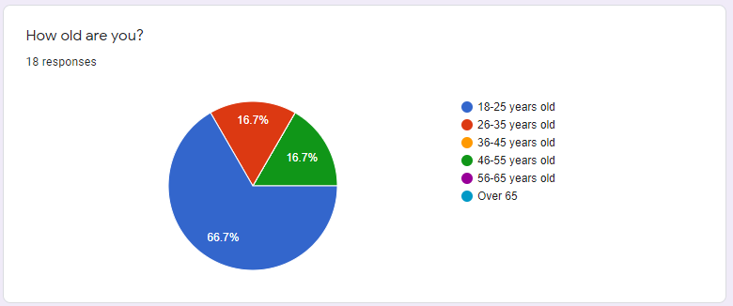
What is your level of computer literacy?
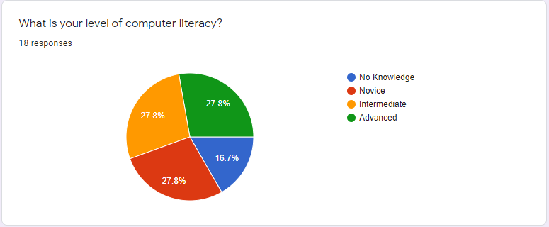
How many days a week do you access online shopping websites?
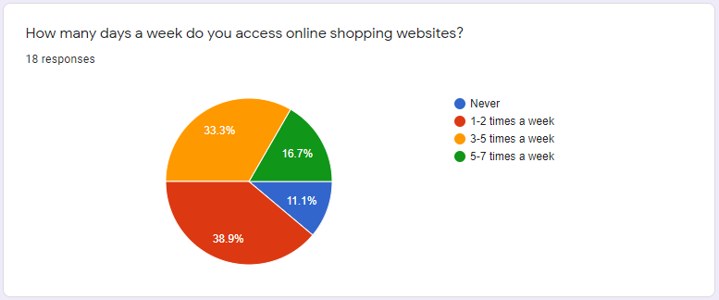

Appendix 3
- What device are you using to access the website on?
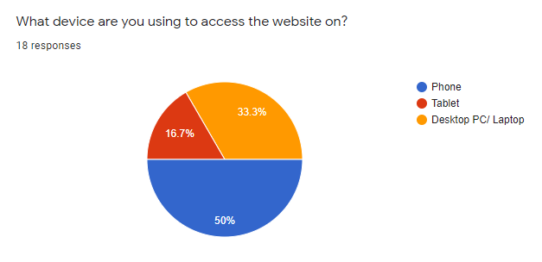

- TASK: Create an account on the linked website. How would you rate the ease of registration?
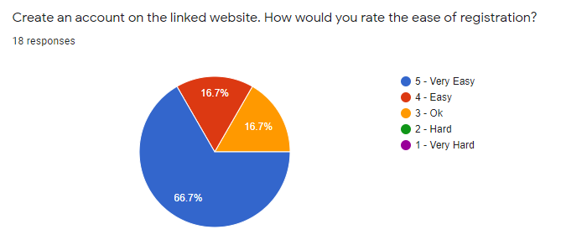
- TASK: Find a product and add it to your basket. How would you rate the ease of adding an item to your basket?
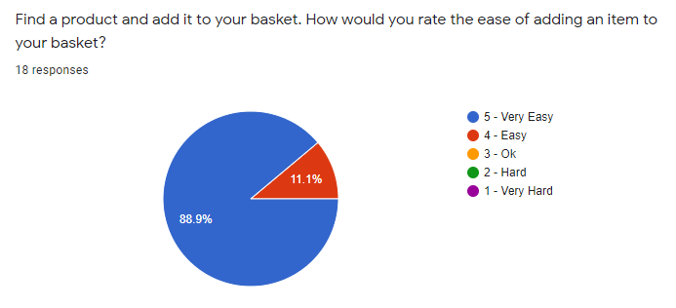

- TASK: Checkout the item you added to your basket. Were you able to complete the order?
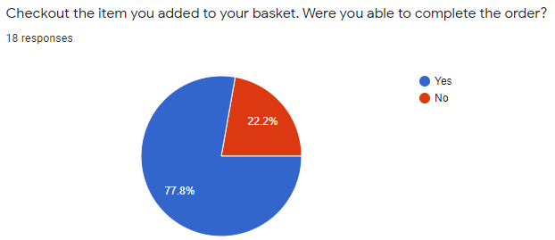
  - If no, please specify why:
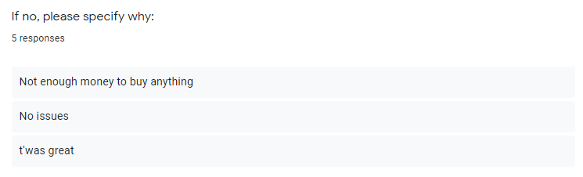
- TASK: Write a review on a product. How would you rate the review system?
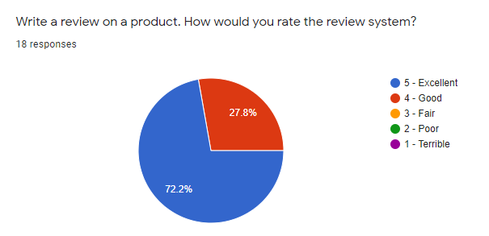

Appendix 4
- Were you able to install the application?
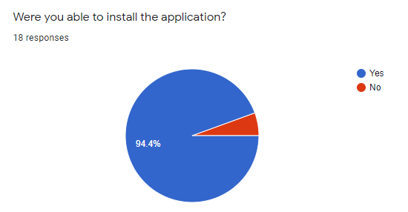

  - If not, specify why:
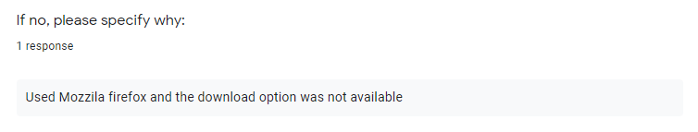

- If you installed the application, rate the ease of the install experience.
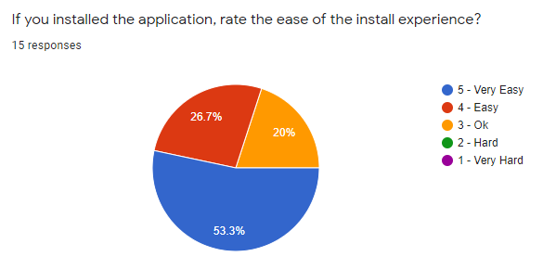

- Buy a product on the installed version of the application. How would you rate the process?
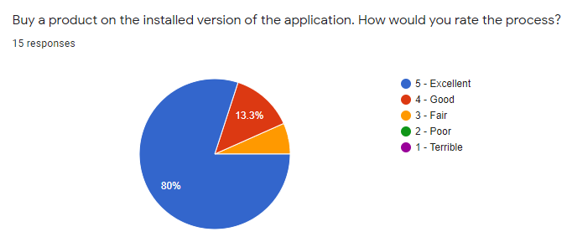
- On the installed application, navigate to your profile and view your orders. How would you rate the navigation bar?
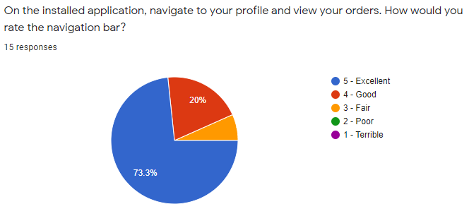

Appendix 5
- How did the installed applications experience compare to the alternative uninstalled version?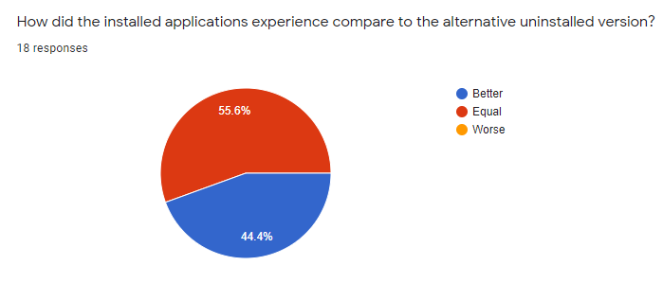
- Do you have any further comments or changes you would make?
Answers:
- Overall a very smooth experience. Really liked the design of the website.
- Very nice minimalistic design. Performance was speedy. Only improvement would be show the selected navigation tab.
- Have a manual download hyperlink available for example, if this download doesnt automatically start press here to download
- For install instructions, highlight the download button is in the URL search bar
- The home page font overlaps the bottom right image, when looking at the review rating next to the price it would be nice to be able to click on those stars at the top to take me to the reviews. The basket icon could show the number of items that have been added. Over all a really clean website design with great usability.
- No
- Nothing to be changed- worked very well and quite simple to do!
- Very familiar, easy to use.

