

BA BUSINESS MANAGEMENT

Individual reflective Report

Module: Introducing the Modern Workplace
Code: LCBB4003
Lecturer: Hoang Dang Nguyen
Name: Cristina-Loredana Balaban
Student ID: 2030114

SUBMITTED ON THE 5^{TH of} DECEMBER 2022

Table of Contents
Reflection on Group work Assignment based on the Gibbs Reflective Model 3
Description 3
Feelings or Thoughts 4
Evaluation 4
Analysis 4
Conclusion 5
Action plan 5
Reference List 6

Reflection on Group work Assignment based on the Gibbs Reflective Model

The Gibbs Reflective Model is one of the most popular reflection models that help an individual to explore an experience, learn from it, and plan how they will handle similar or related situations in the future. This model divides the process of reflection into six stages: description, feelings or thoughts, evaluation, analysis, conclusion, and action plan (Paterson and Chapman, 2013, p.9).

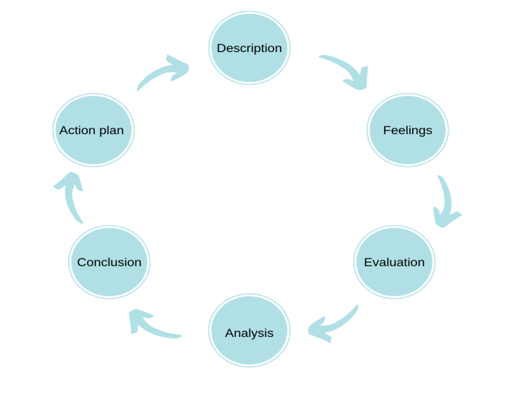
(Gibbs, 1998, cited by the University of Cambridge, n.d).

The objective of this report is to discuss my experience of working in a group using the Gibbs Reflective Model.

Description
The first stage of the Gibbs cyclical model of reflection involves giving a description of the experience, detailing what exactly happened. For the presentation group-work assignment, our lecturer required us to form a group of 4-5 students and select an organisation in the UK and make a critical analysis of it. We formed a group of five classmates and during our first meeting we decided to make the presentation on the Tesco Plc company and then we divided the topics between us. Each student had enough time to research the topic and write their own sections, after which the group leader could combine the five pieces of assignment into one coherent piece of work.

Feelings or Thoughts

The second stage of the Gibbs model requires one to talk about their feelings or thoughts they endured when dealing with the experience. Before forming the group, I knew I had a lot of work to do since the assignment seemed to be very much demanding. However, I was quite happy when we agreed to divide the work amongst ourselves as I knew I could manage my topic within the stipulated time. When my classmates were assigned their topics, I saw them cancel some of their plans so that they possibly concentrate on the assignment. On my side, I had a feeling that I failed the group because I could not manage to meet the deadline as we agreed on the first day, we were assigned the tasks. I ended up feeling guilty since I did not cancel other activities that were less important as my classmates did.

Evaluation

In the evaluation stage, the individual evaluates the various aspects of the situation and points out what went well and what did not go well. Also, at this stage the individual evaluates what they and other members did contributed to the situation. With regards to the group assignment, the things that I found good about group work was that every group member was comfortable with their assigned tasks and willing to contribute during discussions. Since every member carried extensive research on the selected topic, we were confident that we had produced quality work. The things that I believe did not go well was that completed my section later than required time we had agreed upon. Also, we could not set aside enough time to adequately discuss each topic. We assumed that each member did enough research and understood all the aspects, and ready respond to any issues that could arise.

Analysis

In this analysis stage the individual has an opportunity to make sense of the things that happened. Academic literature can be used to find reason why things went well or did not go well as anticipated. I think we managed to do the assignment well because at first, we went through all the topics and each member planned on the part of the assignment they could manage effectively based on their strengths and understanding of the topic. I was assignment the second topic which entailed discussing the organisational structure and it impacts the performance of an organisation. I had worked on such assignments before, and I was confident of producing quality work.
When working in groups, assigning roles based on individual strengths and weaknesses is very important. This guided our teamwork effectiveness and delegating tasks. On my side, I think I failed to meet the deadline because of my inability to manage time well. According to Moonaghi and Beydokhti (2017), procrastination is a major issue where an individual postpones starting a task without a good reason. This contributes to anxiety and frustrations as they may be forced to start working when the deadline is due.

Conclusion

This section requires the individual to talk about what happened, summarise what they learned about the situation and highlight what can be done differently to improve the outcome when they encounter a similar situation in the future. Through this assignment I have learned that working in groups is very important because members bring different ideas together to a complete a task that seems difficult when done alone. When given a task, it is good to divide it into sections and assign each member a part that they are comfortable with so that they can make meaningful contributions. I have also learned that managing time is very important. When working in groups in the future, I would need to focus on completing tasks on time to allow the group to discuss, combine the report and meet the deadline given by the lecturer.

Action plan

This is the last step of the reflection process where one plans how they will handle a similar or related situation in the future. When I am working in a group next time, I will suggest that we plan the things we expect from each member during our first meeting. With regards to meeting deadlines, I will ensure that I prioritise tasks that are very important and urgent and postpone activities that are less important and with long deadlines (van Eerde, 2015). By doing so, I will be able to give each task enough time and give quality work without being under pressure. For tasks that will require giving presentation, I will ensure that I complete them early so that I have time to prepare well.

Reference List

Moonaghi, H. K., and Beydokhti, T. B. 2017. ‘Academic procrastination and its characteristics: A Narrative Review’, Future of Medical Education Journal. 7,2, pp. 43-50. Available at:http://eprints.mums.ac.ir/421/1/FMEJ_Volume%207_Issue%202_Pages%2043-50.pdf , (Accessed, November 10, 2022).
Paterson, C. and Chapman, J. 2013.’Enhancing skills of critical reflection to evidence learning in professional practice’. Physical Therapy in Sport. vol.14 no.3, pp.133-138.
Availableat:https://eprints.bournemouth.ac.uk/21394/3/Enhancing%2520skills%2520of%2520critical%2520reflection%2520for%2520BURO.docx.pdf ,
(Accessed, November 10, 2022).
University of Cambridge (n.d). Models of Reflection.
Available at: https://libguides.cam.ac.uk/reflectivepracticetoolkit/models
(Accessed, November 9, 2022).
van Eerde, W. (2015). Time management and procrastination. The psychology of planning in organizations (pp. 328-349). Routledge.
Available at: https://dare.uva.nl/document/2/177644 , (Accessed, November 10, 2022).

