

School of Hospitality and Tourism Management
BA International Hotel Management
Module Code: BMIH5004

Management and Organisational Behaviour

Name: Vlad Alexandru Radu
ID:2111633

Total Word Count: 2,000

Table of Contents
Introduction 2
Concept of Blake and Mouton managerial grid 2
Critical evaluation of Doubletree by Hilton’s (Reading Pennsylvania) General Manager Craig Poole, while identifying his preferred management style 3
Concept of Adair’s Model of Action-Centred Leadership (ACL) 5
Evaluation of how effective Craig Poole may be within each of the three key functions of managerial leadership 6
Relevance of these findings in the modern business environment 7
Conclusion 8
References 9

Introduction
The report will present the analysis of the concepts of Blake and Mouton’s managerial grid and Adair’s Model of Action-Centred Leadership with comprehensive interpretations of Craig Poole, an eminent personality and the manager of Doubletree by Hilton. The current report suggests the contribution of Craig Poole and his role in the management of his team. The report will be evaluated based on the practical evaluations of Craig Poole, based on these two frameworks to judge his leadership and management styles in the practical scenario.

Concept of Blake and Mouton managerial grid
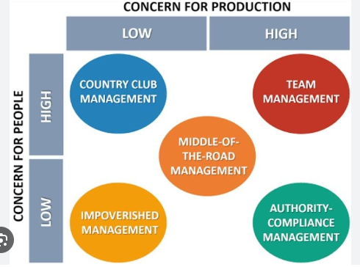
Figure 1: Blake and Mouton’s managerial grid
(Source: Srivastava et al., 2022)
Blake and Mouton's managerial grid is a framework to define the leadership pattern that resembles the pattern of work for the leaders and the managers based on their leadership styles. The Black and Mouton managerial grid defines the effectiveness of the managers to establish the balance in the management of the teams for striving for the ultimate goals and objectives. As opined by Srivastava et al. (2022), the model defines the different styles of leadership in the management of teams. As per Blake and Mouton’s managerial grid, the five different aspects of leadership have been highlighted.
The concept has been represented based on the graph with the X-axis depicting the concern for the production and the Y-axis standing for the concern of the people.
Impoverished (1, 1): This represents the leaders with the lowest concern for production and the people (Roy, 2019).
Country Club (1, 9): This component represents the leaders with the highest concern for people and lowest concern for production (Todăriţă, 2021).
Produce or Perish (9, 1): This component represents the leaders with the highest concern for production and the lowest concern for people (Roy, 2019).
Middle of the Road (5, 5): This component represents the leaders with both moderate concern for production and the people (Todăriţă, 2021).
Team (9, 9): This component represents the leaders with high concern for both people and production (Srivastava et al., 2022).

Critical evaluation of Doubletree by Hilton’s (Reading Pennsylvania) General Manager Craig Poole, while identifying his preferred management style
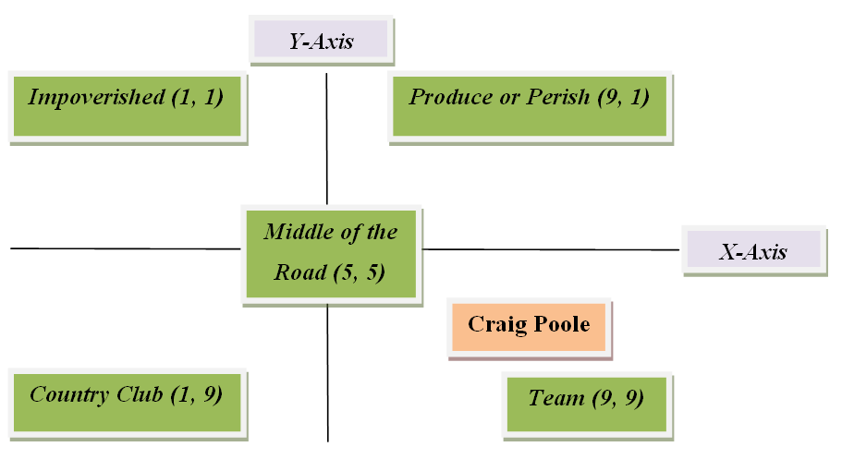
Figure 2: Position of Craig Poole in Blake and Mouton managerial grid
(Source: Self-Created)
Based on Blake and Mouton’s managerial grid the portrayal of Craig Poole in the role of management grid can be evaluated to understand his contribution to the field of hospitality and management. As opined by Dessein and Santos (2021), the success of a manager can be examined through direct observation, employee and stakeholder feedback, as well as access to significant financial and social data like financial performance, guest satisfaction ratings, and personnel turnover rates. Based on the evaluation of his performance on Blake and Mouton’s managerial grid, it can be inferred that the management pattern of Craig Poole depicts a high concern for both the people and the production. Thus, according to Blake and Mouton's managerial grid, Craig Poole should be placed in the team management grid representing the consistent performance of the Double Tree by Hilton during the tenure of Craig Poole.
As opined by Lopatta et al. (2020), Craig Poole resembles the elements of Blake and Mouton's managerial grid to portray the perfect example of the leadership attributes to lead his team in the competitive sector of the hospitality industry. Furthermore, the achievements of Double Tree by Hilton have portrayed remarkable performance under the tenure of Craig Poole in the hospitality industry to depict the perfect balance in his performance as a general manager. Craig Poole is placed on the fourth grid to highlight his supreme position in his path of achieving classic examples of managerial traits for leading Doubleton by Hilton. As opined by Lopatta et al. (2020), the capacity of Craig to establish precise goals, allocate resources effectively, and track progress towards them is a managerial leadership function. He has exhibited excellent planning and organizational abilities, given the staff precise directions, and made sure that projects are finished on schedule and to a high degree.
As argued by Dessein and Santos (2021), his capacity to inspire and involve team members' helps to support their professional development and foster an inclusive and respectful workplace. Therefore, it would be important to evaluate Craig's exact actions, behaviours, and results based on Blake and Mouton’s managerial grid to provide a more precise assessment of his effectiveness within each role. In this competitive business environment, the role of leadership has grown more complicated because of factors like globalisation, technology development, shifting consumer tastes, and uncertain economic conditions. So making the best use of the effective parameters ensures the success quotient of the team members to define the success of the organization as a whole. The role of Craig Poole based on Blake and Mouton’s managerial grid depicts his managerial efficiency to achieve the perfect balance in his task of achieving the perfect balance in the organisation. He strives for the productivity of the team based on the individual focus to strive for long-term focus.

Concept of Adair’s Model of Action-Centred Leadership (ACL)
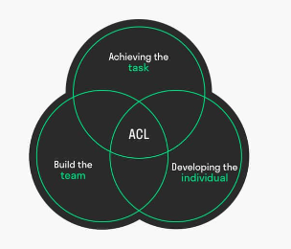
Figure 3: Adair’s Model of Action-Centred Leadership
(Source: Ackah et al., 2019)
As opined by Ackah et al. (2019), Adair’s Model of Action-Centred Leadership can be defined as the framework of leadership that emphasises the balance of the key components to derive the proper balance in maintaining effective leadership to achieve the perfect balance in the tasks. The model defines ensuring the proper balance in the management of the team using developing the team to support the individual aspect of the team members. Adair’s Model of Action-Centred Leadership consists of three aspects that depict the assimilation of the three elements to define the proper leadership framework.
Adair’s Model of Action-Centred Leadership consists of three elements:
Task: These aspects define the objectives and goals of the team that needs to be completed with the implementation of proper planning. As opined by Ross et al. (2021), this model suggests that an authentic leader should insist the good communication and the execution of tasks.
Team: As opined by Ross et al. (2021), the model emphasises that leaders should motivate their teams from their wholehearted participation in realising the outcomes of their efforts.
Individuals: As argued by Ackah et al. (2019), the leader should understand the potential of each member of the team to focus on their weaknesses and strengths for the best possible utilisation of their talents.

Evaluation of how effective Craig Poole may be within each of the three key functions of managerial leadership
Craig Poole is one of the renowned figures known for his eminent contribution to the field of hospitality management as a frontline worker to the higher level of managerial posts assisting various responsibilities. As cited by Mirčetić (2019), he is known for his super contribution as a general manager in Doubletree by Hilton. He has received many awards for his contribution to the hospitality sector. His awards define his excellence as a leader who devoted his time to setting objectives for his team to implement the strategies for better achievements. The achievements of Craig Poole have defined his ability to execute his part efficiently as a superb leader in the tasks of team management. The revenue figure of Double Tree Hilton has reached its all-time high of about 8.77 billion USD in 2022 during the tenure of Craig Poole (Statista, 2023). As opined by Manyuchi et al. (2020), his coordination with his team members to ensure the proper implication of his objectives is the outcome of his superb communication and coordination skills. The achievements of Craig Poole have shown his relentless services in monitoring the progress of his team members to achieve the well-deserved objectives to usher notable achievements and accolades in hospitality management. Craig has shown his abilities as a great leader based on Adair’s Model of Action-Centred Leadership to define his tasks in a well-articulated manner for getting better outputs from his team members.
As stated by Manyuchi et al. (2020), Craig Poole is well appreciated for his effort to motivate his team in the path of achieving superb achievement in realising his objectives to realise long-term achievements in the hospitality industry. Based on Adair’s Model of Action-Centred Leadership, it can be argued that Craig Poole fosters a good culture to infuse a good environment in the workplace. Craig Poole has motivated his team members to take part in wholehearted participation in the team efforts for the better realisation of the goals and objectives. As cited by Gadomska-Lila (2019), his interpersonal skills have inspired the team members to get the best effort and contribution from the team. His guidance and supervision have inspired his team members to understand the long-term vision and success of his ventures in the hospitality industry. During the tenure of Craig Poole, the Double Tree Hilton has expanded in the Asia Pacific region accounting for 624 properties in that particular region (Statista, 2023). The open communication and well-executed plans make Craig Poole a wonderful example of Adair’s Model of Action-Centred Leadership to mark the success based on the wonderful cooperation of his team members.
As stated by Gadomska-Lila (2019), based on Adair’s Model of Action-Centred Leadership Craig Poole has concentrated on the individual developments of his team members to address the strengths and weaknesses of his team members. Based on the feedback and reviews he used to encourage the individual assessment and the development of the individual team members to realise the collective efforts in the long-term realisation of the goals and objectives. Based on the interpretations of the individual talent of the team members Craig Poole has put his wholehearted efforts in motivating the team members based on the individual assessment of the team members. As argued by Maheshkar et al. (2023), the effective part of Craig Poole’s leadership based on Adair’s Model of Action-Centred Leadership can be best judged based on his relationship with the individual team members. The individual assessment of the team member’s capability depicts Craig Poole's effort to achieve effective coordination among the team members in realising the long-term objectives of his missions. One of the best efforts of Craig Poole, based on Adair’s Model of Action-Centred Leadership, is to make the utilisation of the talents of the individuals realise the long-term vision and goals.

Relevance of these findings in the modern business environment
As stated by Maheshkar et al. (2023), the findings of the Blake and Mouton managerial grid and Adair’s Model of Action-Centred Leadership are very much applicable in the practical application of the business environment. Both theories ensure healthy communication and effective coordination among the team members to achieve balance in teamwork by promoting individual talent. Both models help in achieving effective leadership to understand the importance of long-term guidance and support to the individual members for promoting team spirit. The understanding of the options to adapt in various situations depicts the supreme qualities of leadership. As opined by Srivastava et al. (2022), both models emphasise adaptability to the changing situations of the business world to maintain the proper balance in realising long-term objectives. The applicability of both models helps to achieve the structured framework in realising the objectives of the team based on capable leadership and management practice by allocating proper resources. The capability of the leadership to support the individual team members based on open communication helps to foster and sense of belongingness among the team members to realise the commitment to ensuring the best possible teamwork.

Conclusion
To conclude a positive workplace culture can be developed through effective managerial leadership, which can also inspire and excite workers and spur innovation and productivity based on superb coordination and collaboration. Effective managerial leadership is ultimately a dynamic process that calls for ongoing assessment, introspection, and development. The report suggests the contribution of Craig Poole defining his role in the management of his team. The report has been justified based on the practical evaluations of Craig Poole based on the two concepts to judge his leadership and management styles in the practical scenario of the business environment.

References
Ackah, D., (2019). Models of Leadership and Teamwork: Adairs Action-Centred Leadership Model (1973). Worldwide Journal of Multi-Disciplinary Studies, 1(5), pp.01-06.
Dessein, W. and Santos, T., (2021). Managerial style and attention. American Economic Journal: Microeconomics, 13(3), pp.372-403.
Gadomska-Lila, K., (2019). Impact of Generational Diversity on Leadership. Przedsiębiorczość i Zarządzanie, 20(6.3), pp.285-297.
Lopatta, K., Kaspereit, T. and Gastone, L.M., (2020). Part V: Managerial Style in Cost Asymmetry and Shareholder Value. FINANCIAL REPORTING AND MANAGERIAL DECISIONS, p.150.
Maheshkar, S.P. and Brahme, M.U., (2023). Leadership in Public Enterprises in India. In Leadership and Governance for Sustainability (pp. 1-20). IGI Global.
Manyuchi, M.M., Mbohwa, C. and Muzenda, E., (2020). Leadership in the Mining Sector: A Functional Approach for Optimum Team Performance in the Fourth Industrial Revolution. In 10th Annual International IEOM Conference, IEOM 2020 (pp. 2932-2936). IEOM Society.
Mirčetić, V., (2019). Determination of the Adapted Leadership Grid. In Proceedings of the International Conference, PAKSOM (pp. 205-210).
Ross, A., Koneri, L. and Stansell, P., (2021). Experiencing teamship by escaping the leadership lecture. Nurse Leader, 19(4), pp.401-404.
Roy, D., (2019). Managerial grid in macroeconomic perspective: An empirical study (2008–2017). Journal of Transnational Management, 24(3), pp.165-184.
Srivastava, N., Srivastava, N. and Srivastava, H.K., (2022). Critical evaluation of Blake and Mouton's managerial grid: a study of employees of IT sector in India. International Journal of Social Entrepreneurship and Innovation, 6(2), pp.145-158.
Statista (2023) Hilton Worldwide Revenue 2022, Statista. Available at: https://www.statista.com/statistics/297760/revenue-of-hilton-worldwide-holdings-inc/ (Accessed: 22 May 2023).
Statista (2023) Hilton Worldwide Hotels by region 2022, Statista. Available at: https://www.statista.com/statistics/297754/number-of-hilton-worldwide-hotels-by-geographical-region/ (Accessed: 22 May 2023).
Todăriţă, E.T., (2021). Leadership Style Determination according to Robert Blake and Jane Mouton’s Managerial Grid. In International conference KNOWLEDGE-BASED ORGANIZATION (Vol. 27, No. 1, pp. 241-246).

