BMSW4005
Professional Career Development

Task 2 – Report

Lecturer name: Rula Alousi

Student Name: Stan Madalina Stefania

Table of Contents
Introduction 3
Recruitment and Selection 4
Gibb’s Reflective Cycle 4
Recruitment & Selection: Reflection on the interview role play (interviewer and interviewee) 5
Analysis of the skills and knowledge for working successfully in this job role 7
The requirements of abilities and knowledge for employment 9
Analysing my strengths and areas for future development 10
Developing a personal development plan 12
Conclusion 14
References 15
Appendix 16
Job Description 16

Introduction
Fundamentally, self-development is the process of enhancing a person's knowledge and abilities to help them advance in their careers by reflecting on their learning in their job and activities. This report will reflect the lessons learned through my role-playing as an interviewer and interviewee, which will help me advance in my profession and accomplish my objectives as a HR Manager at The Good Marketer Group. I'll also talk about my strengths and areas for growth to further my career and create a development plan to increase my abilities and knowledge as a HR Manager (Tattum et al, 2017).

Recruitment and Selection

Gibb’s Reflective Cycle
Mainly, Gibb's reflective cycle is one of the most important repeating models of reflection, which takes a person through six steps: description, emotions, assessment, analysis, conclusion, and action plan. Gibb's models are beneficial since they allow a person to quickly analyse and assess his or her experiences using them (Bilal et al, 2019).
This approach is also useful for personal and professional growth. As a result, I believe I will use this approach when defining objectives or developing a personal and professional growth plan (Jabborov et al, 2020).
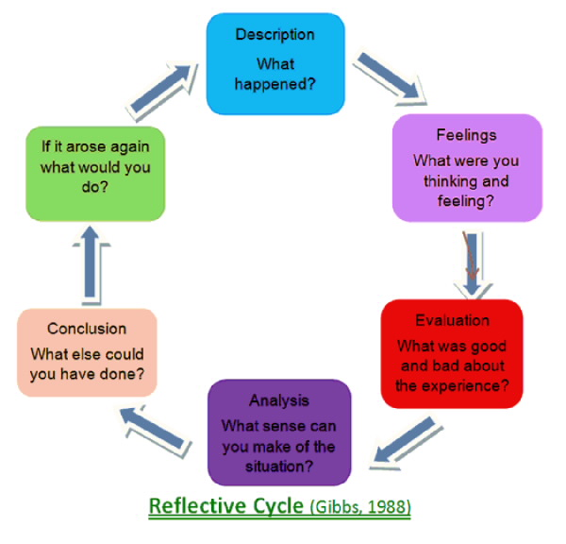
Figure: Gibb’s reflective cycle (Bilal et al, 2019).

Recruitment & Selection: Reflection on the interview role play (interviewer and interviewee)
According to Gibbs' reflective cycle, the first step is the description, which outlines the essential situation and specifics. For this reflection, I identify the important situation as recruiting and selection. In addition, I discuss how both the interviewee and the interviewer play roles throughout the recruiting and selection process. At this point, I'll attempt to discuss the most important factor to consider when hiring and choosing a candidate for a certain position (Salmi et al, 2017).
As an interviewee, I am both thrilled and worried because I believe I will be asked a lot of questions, and if I am unable to answer the question, it will have a bad effect on my career. But I'm also delighted because I believe I'll perform better in the job interview since I have sufficient abilities and knowledge (Bilal et al, 2019).
As part of an interview, I will be asked a variety of questions, some of which will be helpful to me and others which will be difficult. I can respond to the affirmative questions, but I am unable to respond to the difficult ones that are the roadblocks to advancement in my work. Moreover, some interviewers treat me brutally, while others treat me gently throughout my interview (Daniau et al, 2016).
I feel worried and can't recall the answers to the questions when they treat me badly. After analysing the experiences, I can conclude that the major issues were from a lack of interview skills or an insufficient amount of interview experience. As a result, I'll need to have earned experience through interviewing for several tests. Furthermore, as an interviewer, I must have asked the applicant the fundamental and vital questions to get the necessary abilities (Jabborov et al, 2020).
In addition, as an interviewer, I am quite thrilled because I have prepared several questions to assist in the recruitment and selection of the best candidate for the job. As a result, I believe that interview skills are essential for obtaining decent and stress-free work, which is why I believe I should have learned throughout the interview. Furthermore, an interviewer should have professionally conducted the interview and should not have asked needless questions (Bilal et al, 2019).

Finally, to advance in my professional life, I need to have obtained or increased my understanding of the interview system or interview technique. Furthermore, as an interviewer, I must have significantly improved my creative thinking and problem-solving abilities (Daniau et al, 2016).
From my role play as an interviewer, I've learned a lot about selecting the appropriate individuals for the right job so that work progress continues unabated. The role-playing of an interviewer will also help me to improve my skills in analysing the interviewer's mind-set, which will help me to select the best candidate for the job from among the interviewees (Salmi et al, 2017).
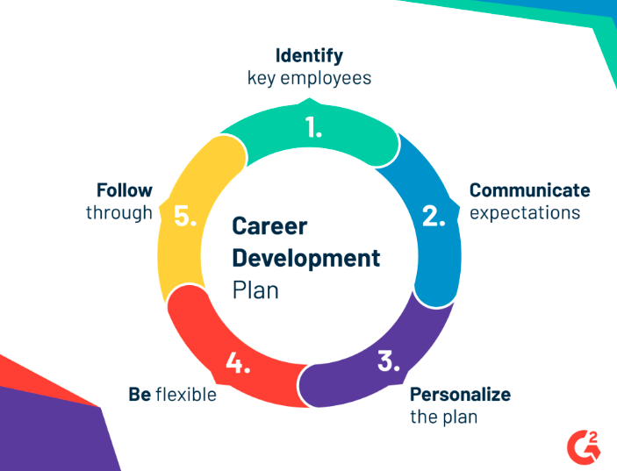
Figure: planning (Jabborov et al, 2020).

Analysis of the skills and knowledge for working successfully in this job role
Both skills and knowledge are critical for me to advance in my work. The right comprehension of knowledge and abilities will assist me in identifying weak spots and developing a growth plan to boost my career. To grasp the distinction between knowledge and skills, I must first recognise the value of knowledge and skills in my profession as a HR Manager at The Good Marketer Group (Quendler et al, 2016).
Teamwork skills
Collaboration is aided by teamwork abilities. Knowledge is a theoretical concept that will enable me to gather a large amount of data from a variety of sources, including books, newspapers, and other documents. By expanding my understanding of analysing, the information will assist me in analysing this extremely successfully in my professional job. The information I get from many sources will aid me in increasing my awareness, allowing me to make effective decisions to better my job as a HR Manager (Raiola et al, 2017).
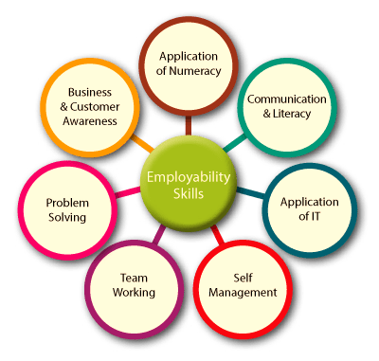
Figure: Employment skills (Salmi et al, 2017).

Problem-solving skills
To effectively solve the relevant business difficulties, problem-solving abilities are essential as a HR Manager because skills are the product of real effort, while knowledge is the consequence of the theoretical study, they are distinct from knowledge. Skills are extremely significant in helping me to advance in my profession by learning how to perform better in the job and reflecting on my career (Salmi et al, 2017).
Perseverance and motivation skills
To inspire others to complete the task, you'll need perseverance and motivating abilities. As an interviewee, the role-playing programme will greatly assist me in effectively and confidently approaching the interview board, as well as improving my capacity to deal with difficult situations in my professional life (Tattum et al, 2017). Skill is what will enable me to do my job flawlessly. I need to identify certain talents that I need to develop as a worker to enhance my performance and advance in my job as a HR Manager Ganal et al, 2019).
Communication skills
It will provide me with additional insight into the interviewer's mind-set and improve my patients' ability to demonstrate maturity in the interview board as a HR Manager Although the role-play scenario will greatly assist me in furthering my career, I believe I will have the chance to demonstrate my abilities on the interview board, where I will be able to demonstrate myself more effectively (Tattum et al, 2017). I would be able to confront the interview board with ease because of the experience and learning I gained through my role play method. In the role-playing programme, I encountered communication challenges that hampered my ability to communicate effectively with others (Jabborov et al, 2020).

The requirements of abilities and knowledge for employment
The value and readiness of skills and knowledge in obtaining a job are critical; therefore as a worker, I must develop my skills and expand my knowledge so that I may easily get my desired job using my abilities and knowledge. The information and skills I gained from my role play and development programme will help me get a competitive job since they will enable me to explore qualities that will quickly pique employers' interest in hiring me as a HR Manager Dong et al, 2017).
The information and abilities I've gained will help me stand out to potential employers, which will help me find work fast. The preparedness of my abilities and knowledge will increase the quality of my CV and application by displaying experience and talents that will assist me in impressing the job provider and obtaining my desired job more quickly as a HR Manager. I also need to work on my talents regularly so that I may continue to improve and increase my chances of landing a job (Halberstadt et al, 2019).
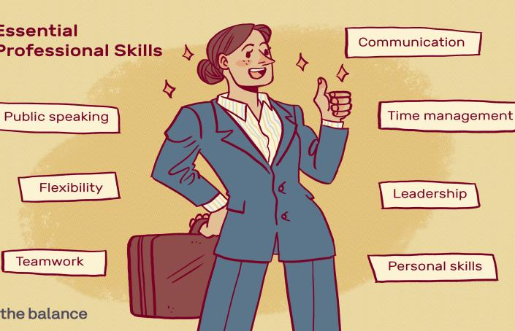
Figure: Abilities (Jabborov et al, 2020).
The interviewer's role-playing programme will provide me with several chances to strengthen my interpersonal communication skills, which will be crucial in my professional development. If I have enough opportunity to participate in more real-world experience from the development programme, the role-playing programme will be more beneficial to my career. Furthermore, adequate training might enhance my understanding, allowing me to work better (Salmi et al, 2017).

Analysing my strengths and areas for future development
Personal strengths are those aspects of my personality that can help me advance quickly in my work. A person's strength constantly opens doors for them to advance in their professional and personal lives. Below are some of my strengths as a HR Manager (Salmi et al, 2017).
My Strengths
Discipline
I am a self-disciplined person, and it is one of the major assets that allow me to effortlessly finish my tasks. Apart from that, discipline helps me a lot since it allows me to carefully plan out my daily chores so that I may finish them one by one according to the efficiency of my job (Bilal et al, 2019).
Creativity
I've always wanted to achieve something extraordinary, and my imagination has always aided me in this endeavour. Creativity enables me to think of new ways to finish an assignment, allowing me to easily complete difficult projects and deal with difficult situations (Daniau et al, 2016).
Determination
One of my qualities is determination, which has helped me significantly in my job advancement. My drive motivates me to adhere to my strategy and put in the necessary effort to reach my objective. It also enhances my enthusiasm for work and makes me more enthusiastic about my job (Tattum et al, 2017).

Areas to progress
Emerging communication- I need to improve my communication skills to strengthen myself since they will help me build connections with my co-workers and consumers (Salmi et al, 2017).
Analysing skills- I also need to improve my analysis abilities so that I can quickly assess what is best for the company and my career. In addition, this talent will boost my marketability at work as a HR Manager (Tattum et al, 2017).
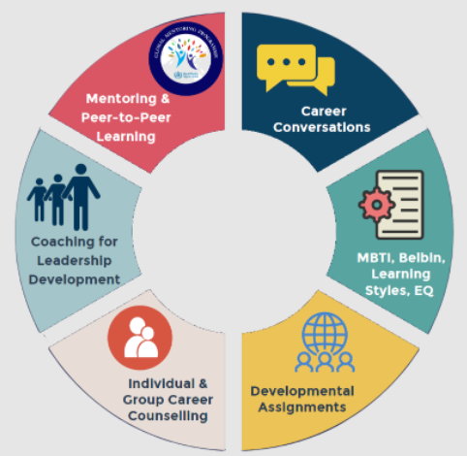
Figure: Areas to progress (Tattum et al, 2017).

Developing a personal development plan
Personal development plan
Goals | Action | Evidence of achievement | Target date
Enlightening communication | To quickly develop my communication skills, I need to communicate more with the professors, co-workers, and students (Jabborov et al, 2020). | Knowledge of effective communication will aid me in developing positive connections with all parties involved in my professional life (Tattum et al, 2017). | Within 2 months
Advance analysing skill | To increase my analytical talents, I must learn a lot and study more about various analytical models and frameworks (Salmi et al, 2017). | By analysing the settings and scenarios, this talent will assist me in making a critical choice concerning my professional career (Daniau et al, 2016). | Within 4 months
Enlightening time management | To effectively manage my time, I must adhere to a routine. I may also create a timetable to do so (Raiola et al, 2017). | Time management will help me perform better and finish my tasks on time (Halberstadt et al, 2019). | Within 3 months
Progress operational skills | I need to work with more experienced personnel and participate in everyday activities with them to improve my operational abilities (Daniau et al, 2016). | This will assist me in improving my performance and advancing my career as quickly as possible (Bilal et al, 2019). | Within 5 months
Progress IT skills | To expand my understanding of information and technology, I will need to seek training from various IT centres and specialists (Bilal et al, 2019). | With the help of current technology and up-to-date information, I will be able to do my responsibilities fast (Jabborov et al, 2020). | Within 6 months

Conclusion
Setting up an efficient development programme is necessary for everyone who wants to advance their profession. I'm constantly trying to figure out what my strengths and limitations are so that I can figure out what I should work on and what I should avoid improving. This report explains how my abilities and knowledge will help me work more successfully, as well as how ready those skills and knowledge are to get employment. Apart from that, I am a firm believer in lifelong learning, which has helped me significantly in my professional development as a HR Manager at The Good Marketer Group (Jabborov et al, 2020).

References
Bilal, S.Y.G. and Chen, S., 2019. The impact and effectiveness of faculty development program in fostering the faculty’s knowledge, skills, and professional competence: A systematic review and meta-analysis. Saudi journal of biological sciences, 26(4), p.688.
Daniau, S., 2016. The transformative potential of role-playing games—: From play skills to human skills. Simulation & Gaming, 47(4), pp.423-444.
Dong, Y., Bartol, K.M., Zhang, Z.X. and Li, C., 2017. Enhancing employee creativity via individual skill development and team knowledge sharing: Influences of dual‐focused transformational leadership. Journal of Organisational Behavior, 38(3), pp.439-458.
Ganal, N.N., Guiab, M.R. and Sario, M.L.P., 2019. Assessing the Training Needs of Teachers on the 21st Century Pedagogical Skills and Personal Development. The Normal Lights, 13(2).
Halberstadt, J., Timm, J.M., Kraus, S. and Gundolf, K., 2019. Skills and knowledge management in higher education: how service-learning can contribute to social entrepreneurial competence development. Journal of Knowledge Management. Rifat_Murad
Jabborov, U., 2020. DEVELOPING FUTURE ENGLISH LANGUAGE TEACHERS PROFESSIONAL SKILLS. Архив Научных Публикаций JSPI.
Quendler, E. and Lamb, M., 2016. Learning as a lifelong process-meeting the challenges of the changing employability landscape: competencies, skills and knowledge for sustainable development.
Raiola, G., 2017. Motor learning and teaching method. Journal of Physical Education and Sport, 17, pp.2239-2243. MURAD
Salmi, J., 2017. The tertiary education imperative: Knowledge, skills and values for development. Springer.
Tattum, D. and Tattum, E., 2017. Social education and personal development. Routledge.

Appendix

Job Description


