Luke MacDonald
2100654
technical case study
Fundamentals of Construction Technology

Contents
Offsite Construction 2
Ground Floor Construction and Wall Junctions 2
Timber Twin Frames 2
SIPs 3
Brick and Block 4
Window Opening in External Wall 5
Timber Twin Frame 5
SIPs 6
Brick and Block 6
Eaves and Roof Detailing 7
Timber Twin Frames 7
SIPs 8
Brick and Block 9
Recommendation 9
References 10

Offsite Construction
To define offsite construction, it is the manufacturing and planning of the structure component away from the building site and then transporting the component back to the site for installation, as proven by The Constructor who states that offsite construction is the planning, designing, fabrication, transportation of building items and its assembly on site with great speed. (No date) This method has numerous benefits, such as reduced construction time as the components would not have to be constructed on site, as well as a much higher and accurate level of quality control. There are four main categories within offsite construction which could be incorporated into the house. These include volumetric systems, such as a fully fitted bathroom fitted offsite and then transported for installation. Panelised Systems, where SIPS, walls, floors or roofs are constructed offsite and transported for installation. Sub-assemblies, where components such as staircases and roof trusses are produced offsite for quick installation. And finally component systems, where components are produced offsite unassembled but can easily be assembled quickly on site.

Ground Floor Construction and Wall Junctions

Timber Twin Frames
A sketch is shown below:
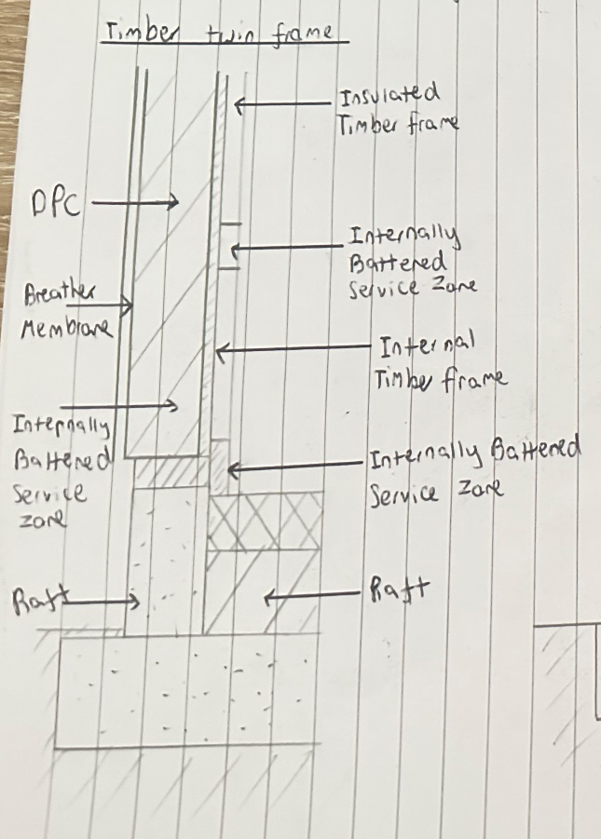
This sketch shows the timber twin frame, and the materials required for this method. This method provides high insulation because of the two timber studs along with a cavity. A timber twin frame ground floor typically involves an insulated concrete slab or a suspended timber floor as well as insulated concrete raft foundation with underfloor heating, which helps to achieve low U-values to adhere to building regulations Part L (May 2024). As well as this the joists resting on a perimeter wall while also having insulation between the joists if using a suspended timber floor or below the slabs if using the concrete slabs. It also contains a battered service zone for concealed services
Where the ground floor meets the external walls, the concrete slab is fixed to a sole plate which is separated by a DPC to prevent moisture, as well as the sole plate being the anchor point for the timber frames. Between the timber frames there is a gap to create a cavity that would be filled with insulation. The external wall is fitted with a breather membrane to both prevent water from entering the wall as well as allowing water vapour to escape. In comparison to SIPs, they offer very similar benefits in terms of thermal conditions, but SIPs require fewer onsite changes, as well as providing better air tightness but also have very limited flexibility. Out of the three methods, a timber twin frame provides a good balance.

SIPs
A sketch is shown below:
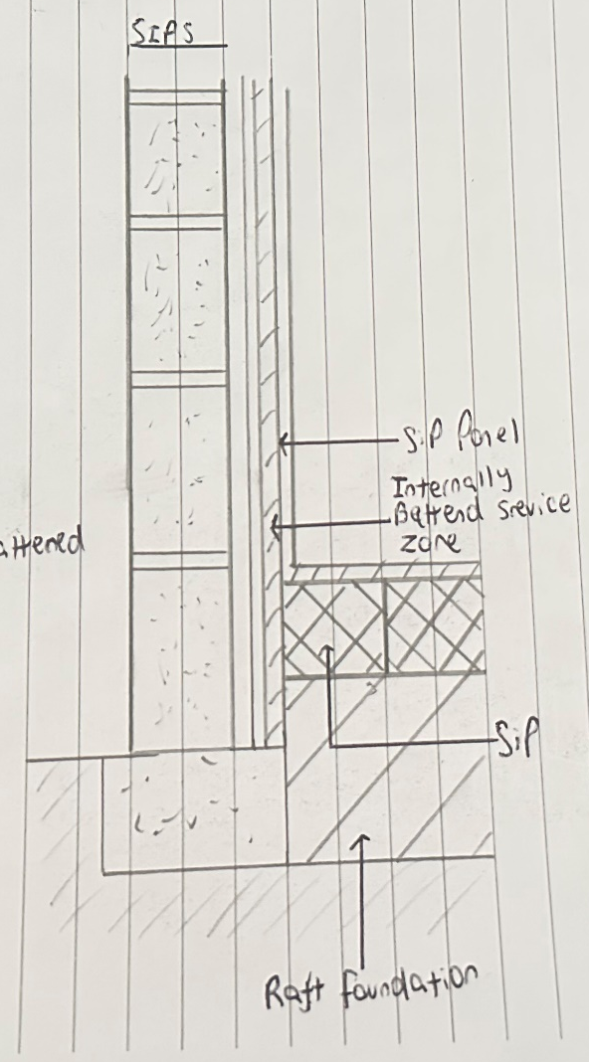
These panels have an insulation layer between them for insulation which provides a very good thermal performance, the best out of the three methods, achieving low U-values to adhere to building regulations Part L (May 2024). As for the ground floor, it is usually constructed using a concrete raft foundation, like the timber twin frame, also with insulation for floor heating. The SIPs are connected to the foundations at the junction with the external wall using either a sole plate or concrete along with a DPC to prevent any moisturte entring. It is also fitted with a breather membrane to allow water vapour to escape, as well as a cavity that is ventilated to allow for the smooth finish on the wall.
In comparion to the timber twin method, SIPs allow for very fast onsite assembly due to the factory precision when producing these, as well as a much higher air tightness. However, SIPs are not very felixible when it comes to onsite modifications as any modifications onsite can really affect the structural integrity of the components. In comparison to the brick and block method, it is extremely faster to construct onsite and is a lot less complex to carry out.

Brick and Block
A sketch is shown below:
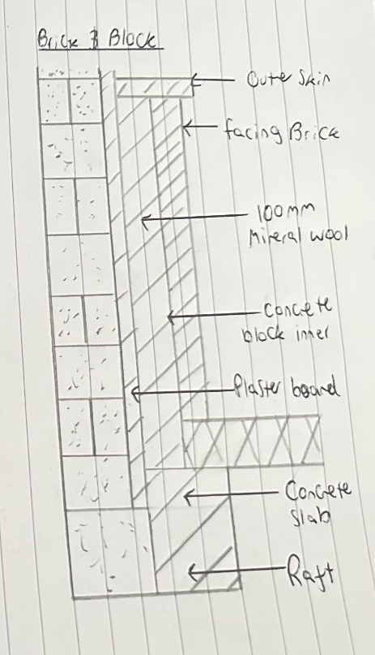
The brick and block system involves concrete inner block and brickwork externally, these both provide a good thermal properties as well as good acoustic properties. At the ground floor, it uses a conrete raft foundation, similar to the previous methods, with insulation for the heated floor to meet the building regulations Part L (May 2024). The junction where the floor and wall meet, the concrete inner block sits on the concrete slab with a DPC to again prevent moisture from entering. The brick on the external section of the wall is supported using wall ties that also include a breather membrane with cavities that would be insulated usinga wool. This traditional method is very reliable, however it has a long construction time due to the bricklaying, along with more manpower being required due to the bricklaying process.
In comparison to the timber twin frame, it has just as good thermal properties but require very careful and precise installation to ensure the good thermal properties. However it is a very slow installation method compared to SIPs and has a lower air tightness as a result of the SIPs method being very precisely produced. In terms of stability and longevity, the brick and block method requires a larger work force and a lot more precision.

Window Opening in External Wall

Timber Twin Frame
A sketch is shown below:
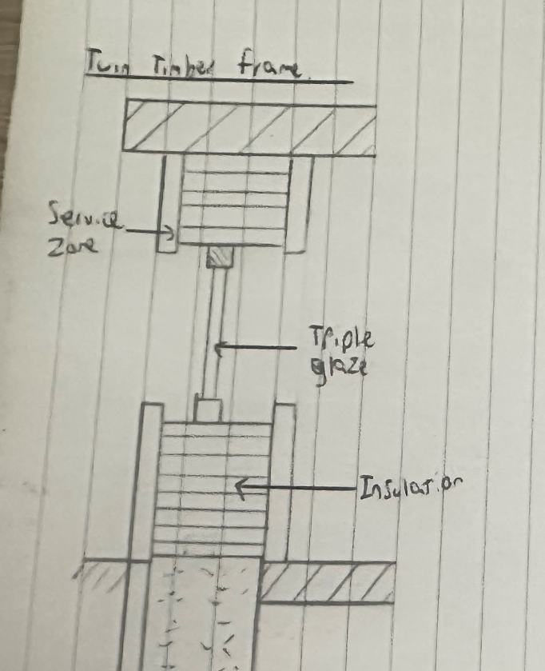
As for the Timber twin method, trimming the inner and outer stud frames with lintels and studs would form the window openings, as well as maintaining the structural integrity of the structure. As for the glass, high quality triple glaze panes would be used to maintain the thermal properties to ensure good insulation and no leaks.
Insulation like wool would be tightly packed around the studs to ensure good thermal performance, as well as an internal service batten zone to ensure easy access to any plumbing or electrical components. To allow any moisture to drain, it is fitted with a cavity tray and weeping holes to allow moisture to escape.
In comparison to the other methods, timber twin frames are very flexible and can be easily adjusted to sit if needed, however a method like SIPs would be difficult to adjust. As SIPs are factory produced and are made very specifically, any sort of adjustment could result in a loss of structural integrity. Brick and Block requires a higher work around the window openings but on the other hand offers high durability and resistance.

SIPs
A sketch of the SIPs method is shown below:
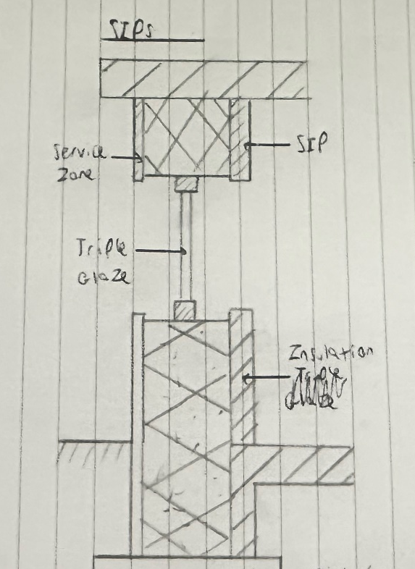
For the SIPs system, all components like window openings must be predesigned and precut at the factory, resulting in them having exact dimensions for installation. They have timber stud sections for each opening to ensure the panel strength stays consistent and structurally sound.
The finish of the SIP includes and vapour control layer as well as a plasterboard lining to ensure vapour can be released, as well as the external layer including an OSB sheathing, a vented cavity and a breathing membrane to allow it to prevent moisture entering and to allow vapour to be released. Again, cavity trays and weep holes are installed around the window to allow moisture to escape and to help manage the thermal properties.
In comparison to timber twin frames, SIPs are not very flexible and therefore any required changes onsite would be extremely hard to carry out, however SIPs have a much better airtightness. As for brick and block, it requires much more effort to ensure everything is done correctly to maximise thermal properties, but it is very flexible.

Brick and Block
A sketch of the brick and block system is shown below:
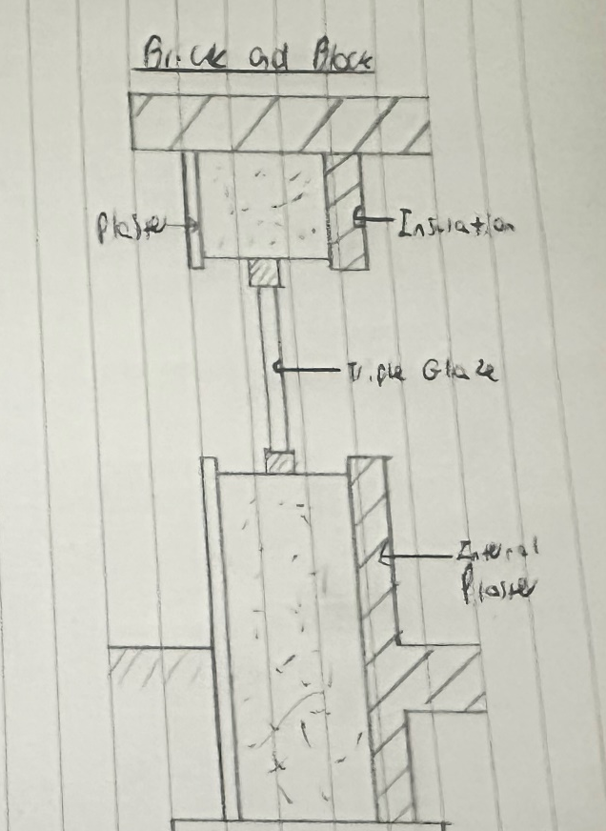
For the brick and block method, the window openings would be produced onsite by creating openings in the inner blockwork and the exterior brick. Concrete or steel lintels would be used as well as cavity trays and weep vents to allow moisture and vapour to escape. Using this method results in more flexibility in positioning and future adjustments of the window sizing.
Again, triple glazed windows would be used and placed closer to the centre to increase thermal properties, it will also include insulated cavities around the sills to again improve thermal properties and to meet building regulations Part L (May 2024).
In comparison to SIPs, brick and block is very flexible and can be easily adapted but also has lower airtightness. In terms of timber twin frames, the brick and block can have worse insulation if not executed precisely.

Eaves and Roof Detailing

Timber Twin Frames
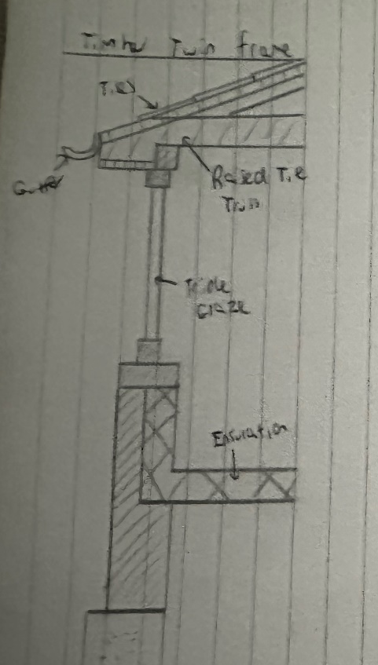
A sketch is shown below:
A timber twin frames eave must ensure weather protection and good thermal properties to comply with building regulations Part L (May 2024). The raised tie trusses are fixed to the top of the wall, and are tied to the rafters using metal truss clips to ensure wind resistance and stability. The OSB roof is covered with breathable membrane and ventilation to allow moisture and vapour to escape from beneath the tiles. The tiles are lapped and secured using screws and rubber washers to ensure watertightness.
Insulation placed within the twin frame ensured thermal thermal continuinity by carrying it it up to the roof level insulation, while also including an airtightness layer as well as a ventilation gap to prevent condensation.
Compared to SIPs this method is very flexible and allows for easy onsite altercations. In terms of brick and block, it has reduced heat loss and is a lot more simple to carry out.

SIPs
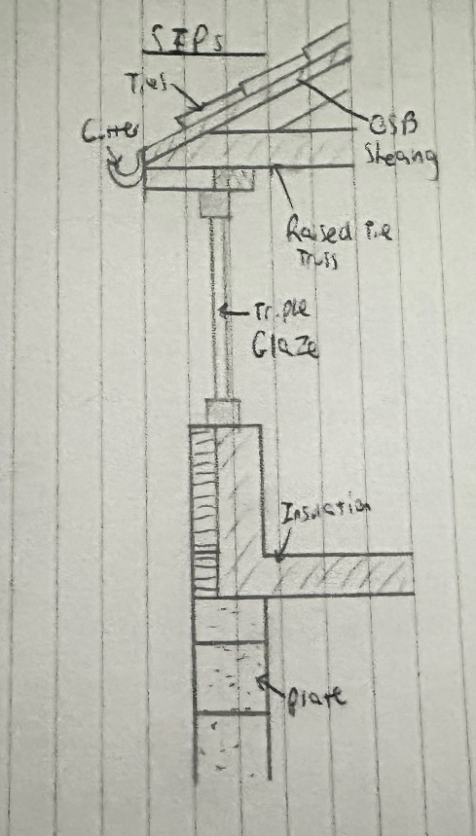
A sketch is shown below:
The eaves in the SIP system must ensure good thermal properties and weather protection, as well as ventilation to ensure it meets building regulations Part L (May 2024). The roof uses a raised tie truss that are fixed to the wall with metal truss clips to secure the roof in high winds. OSB sheathing is also used at the eaves with a breathable membrane to allow for drainage and water resistance. These are fixed with sealing screws to ensure watertightness.
The SIP panels would be insulated to ensure thermal properties are met and again continuous insulation would be used. The airtight layer carries from the wall to the roof to prevent moisture entering as well as to reduce heat loss
To compare, against timber twin frames it offers better thermal properties along with airtightness but again has very little flexibility for onsite adjustments. As for brick and block it requires less detailing at the eaves.

Brick and Block
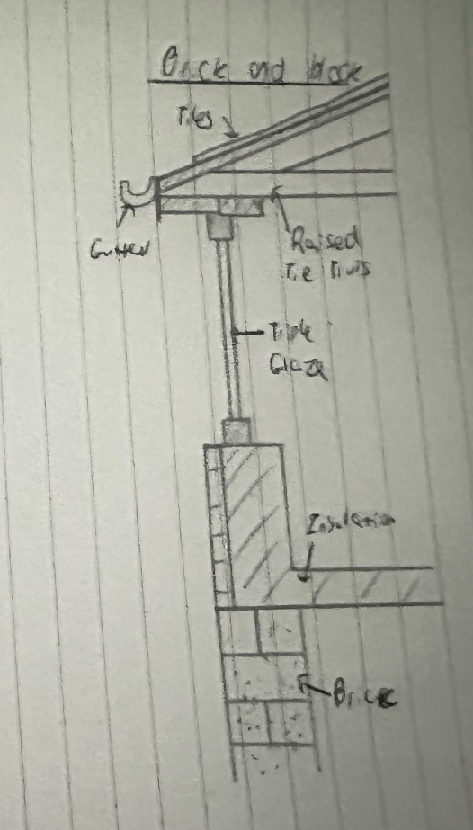
A sketch is shown below:
The eaves in the brick and block method again provide wather resistance and good thermal properties along with stability. It again uses the raised tie truss fixed to the concrete wall, it is also attached with metal truss clips to further ensure wind resistance.
The OSB sheathing at the eaves are covered with a breathable membrane under the tiles to ensure good water draining and to release moisture. Its again sealed with sealing screws to ensure a watertight seal. Insulation is applied beneath the roof, and an airtightness layer to prevent heat loss.
To compare to SIP, this system requires more labour onsite to ensure the method is correctly done to maximise thermal properties and airtightness, but has high flexibilty. As for the timber twin frame method, it is a much slower process in comparison and has beter thermal properties.

Recommendation
The timber twin frame system is the best fit for this situation and is recommended because of its thermal efficiency and flexibility. It is the most all-round system to use, it is very good at insulating and is very easy to add service zones. Compared to brick and block, it is very fast to build, requires less workload, and still has the desired render finish. Compared to SIPs, it has a much higher flexibility in terms of onsite adjustments, which can be very beneficial for a domestic project. The timber twin frame meets both the design requirement as well as the required performances. For the new home.

References
The Constructor (No date) What is Offsite Construction? Available at: What is Offsite Construction? – theconstructor.org (Accessed on: 28th April 2025)
Author (Date) Title. Available at: URL (Accessed on….)
ATSPACE (May 2024) Essential Guide: New Regulations U-value Handbook. Available at: ATSPACE-Essential-guide-new-regulations-U-value-handbook.pdf (Accessed on: 29th April 2025)

