Student name: Andreea Silica
Student number: 1808595
Course title: Project Management
Code of the course: LCBB5005
Lecturer name: Joy Botu

Table of Contents
Introduction 3
Project scope 3
Stakeholder identification 4
Timeline 6
Communication management plan 7
Budget plan 8
Risk management plan 8
Methodology 9
Quality management plan 11
Improvement management plan 11
Conclusion and recommendations 12
References 13

Introduction
Project management is considered as temporary documentation of the plans and activities that are needed to even execute in order to reach the objective and the goals so the selected project. Farmfoods, a UK based company under the retail industry, in this study, has been considered as the organisation that plans on developing a Membership Card facility for their customers for an efficient shopping experience. The study reflects the purpose and various steps to accomplish the development of the software that would benefit the company from offering the proposed service to its customers. The purpose of the development of this study is to demonstrate the various methodologies and management plans that are needed to be implemented for the successful completion of the membership card facility system for the customer by Farmfoods limited.

Project scope
Aim and objectives
Farmfoods aims to develop software that would effectively manage their customers with the help of a membership card for a better shopping experience (farmfoods.co.uk, 2019). The objectives that the company plans to achieve through this development could be detailed as follows.
- To provide customers with a cashless and efficient shopping experience
- To expand its business by attracting a vast number of customers
- To implement advanced technologies within their business operations
- To maintain sustainability the current marketing condition of the retail industry
Deliverables
deliverables | recipients | Delivery time | method
Software installation | Employees in the sales department | Business execution | deployment/installation
Membership card | customers | After registration | Hand-to -hand/ home delivery
offers | customers | weekly | Messages and emails
Table 1: Deliverables
(Source: Influenced by Jaber et al. 2018)
Considerations
In order to manage and retain the customers and monitor their purchases, it is needed for the company, Farmfoods to develop well-built software that would be able to manage the constraints of bills, dates, quantity of purchase and customer details. As per the views by Trojanowska and Dostatni (2017), with the help of these constraints, the company would be able to determine the frequency of customers and their importance. The company needs to develop its management plan in such a way that the development of this proposed software would require scheduling, budget balance, database management and quality control. The membership card that the company plans to deliver to their customers would enable the customer to buy the products from the company's dedicated stores with numerous offers and cashless purchases. This would eventually help in developing sustainable management of their business (Lawton, 2017).

Stakeholder identification
Stakeholders are those with any enthusiasm for the project's result (Wang et al., 2015). They are ordinarily the individuals from a project team, project managers, officials, project supporters, customers, and clients. Stakeholders are individuals who are put resources into the project and who will be influenced by the project anytime en route, and their info can straightforwardly affect the result (Trojanowska and Dostatni, 2017). It's a smart thought to rehearse great partner the board and always speak with them so as to team up on the project (Wang et al., 2015). All things considered, they have a stake by they way everything turns out. While dealing with a project, regardless of how large or little, one of the most fundamental pieces of the arranging procedure is the recognizable proof of the applicable project the executives stakeholders and the posting everything being equal and gatherings required at each progression in the existence cycle of a project. With regards to characterizing who those stakeholders are, the psyche ordinarily goes to the individuals who will utilize the gave administrations or result of a project. In spite of the fact that this may appear to paint a sensibly full picture, the end clients really involve only a little portion of the greater picture, only a couple of trees on the edges of the timberland (Wang et al., 2015). As per the PMI (Project The executives Establishment) the term alludes to "an individual, gathering or association that is effectively engaged with the project, any individual who may influence, be influenced by, or see itself to be influenced by a choice, movement, item or any kind of result of the project". In less complex words, anybody that has an enthusiasm for the project or is influenced by its results or whose information can affect the result. Top administration may incorporate the leader of the organization, VPs, executives, division managers, the corporate working board of trustees, and others (Trojanowska and Dostatni, 2017). These individuals direct the system and advancement of the association. On the in addition to side, you are probably going to have top administration support, which implies it will be simpler to enlist the best staff to complete the project, and obtain required material and assets; additionally perceivability can improve a project director's expert remaining in the organization. On the less side, disappointment can be very emotional and obvious to all, and if the project is huge and costly (most are), the expense of disappointment will be more significant than for a littler, less unmistakable project. The project team is comprised of those individuals devoted to the project or acquired on low maintenance premise (Wang et al., 2015). As project director, you have to give initiative, course, or more all, the help to team individuals as they approach achieving their undertakings. Working intimately with the team to take care of issues can assist you with gaining from the team and manufacture compatibility. Demonstrating your help for the project team and for every part will assist you with getting their help and collaboration. Normally the supervisor chooses what the task is and who can work with the project director on projects (Trojanowska and Dostatni, 2017). Keeping your chief educated will help guarantee that you get the vital assets to finish your project.
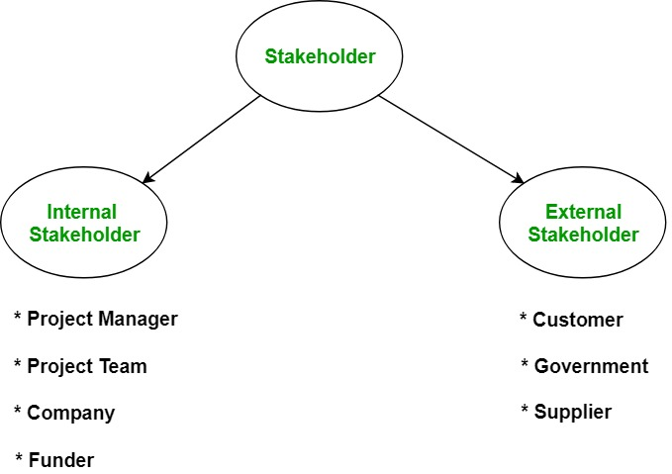
Figure 1: Stakeholder identification
(Source: Influenced by Wang et al. 2015)
Internal stakeholders
- Project manager
The project manager is considered as the centralized body who is involved in the decision making phases of the proposed project. In this case, the project manager is responsible for the development of the plans regarding various aspects as well as assigning the team for each task of the development plan (Kidston, 2015).
- Project team
The project team is the organisation team by the project manager who is responsible for the development of the software and its various tasks. With the help of this team, the project manager would be able to continue with the processes that are required to be initiated for the development process.
- Company
Farmfoods and its higher authorities are also considered as one of the stakeholders of the project because the company itself provides various date that are to be loaded in the database system of the software. In this way, the processes that are needed to be featured within the software would be accomplished accurately.
- Funder
The founder of the prophecy plays an important role in improvising capital to the company. In this way, the resources and the cost of manufacturing of the software would be yielded successfully.
External stakeholders
- Customers
Customers play an important role as the stakeholders as they help in the growth and development of the organisation's processes. In this case of Farmfoods, customers who buy a lot of items from the store would be offered with a membership card that would provide them with offers and benefits of gaining discounts over products. In this way, the company would be able to gain it’s retain and commitment.
- Suppliers
During the development of the software, the development team would be required to provide essential raw materials that would enable the proceedings of the development. The suppliers, in this case, are responsible for providing the necessary materials for the development within a specified time. The delay in the deliverance would instantaneously slow down the process of development.
- Government
The government of UK is playing the role of permitting the procedures and practices of the company's development plans. Without the consent of the government, no process would be initiated by the company. Therefore legal measures are to be taken by Farmfoods to continue their development processes.

Timeline
Main activities and stages | Week 1 to 2 | Week 3 to 6 | Week 7 to 11 | Week 12 to 14 | Week 14 to 18 | Week 19 to 24 | Week 25
Engagement of the employee
Initialization of the project requirements
Design the implementing the manufacturing process
practical timescale and cost judgment
Resource allocation
Monitoring tye development phase
closure
Table 3: Timeline
(Source: Influenced by Conlen et al. 2019)

Communication management plan
Communication type | Schedule | Mechanism | Initiating individual | Recipients
Coordination | daily | face -to-face | Team leader | Team members of the developing team
assistance | daily | Group meetings | Team leader and project manager | Team members of the developing team
Status update | weekly | reports | Project manager | stakeholders
Resource allocation | weekly | E-Mail | Development team | Suppliers and development team
Broadcasting advertisement | daily | Social media and internet based platforms | company | customers
Table 4: Communication plan
(Source: Influenced by Fyhn and Andersen, 2019)

Budget plan
Task | Cost (£) | Duration (weeks)
Data collection | 320 | 2-3
Project initiation including employee compensation | 200 | 1-2
Resource allocation | 3000 | 1-2
Raw materials | 2000 | 2-3
Development | 4000 | 4-5
Issuance of thee membership card | 500 | 1-2
Registration through legal procedures | 300 | 1-2
Promotion through advertising | 100 | 2-3
Table 5: Budget plan
(Source: Influenced by Cools et al. 2017)

Risk management plan
Risk factor | Affected area | Shutter factor | Responsibility individual | Solution
Unavailability of link for the transaction | Applicability of the card during the purchase | weak infrastructure of the software | IT department of the company | Technical assistance
Security Attacks from external entities | Confidential data of the company | Weak network security | IT department of the company | Implementation of security enhancements
Delay in the delivery of the product and features | Business slowdown | Poor efficiency of the development team | Project manager | Unavailability of sufficient funds
Irrelevant features excluding the planned structure and functions | System deficiency | Poor knowledge of technicality | Development team | Well trained employee assigning
Table 6: Risk management plan
(Source: Influenced by Reddel et al. 2017)

Methodology
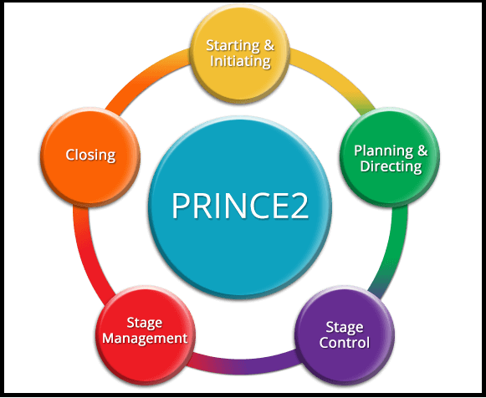
Figure 2: Prince2 model
(Source: Influenced by Vaníčková, 2017)
Overview
According to the various methods of project management, it could be stated that the software development plan that Farmfoods plans to deploy within their business environment would require planning and effective management of development phases. As stated by Tao et al. (2018), in this way, the company would be able to deliver its outcomes within a specified time and accuracy. The prince2 model of project management would be applied in this case, as the company needs to implement a generic theory of management instead of a specialized theory that are provided by other models of project management. According to Jamali and Oveisi (2016), Prince2 provides the development team with a generic way of management without reinitiating their methods, rather innovate their methods. The phases that the model exhibits provide a clear video of the steps that are to be managed by the team. Farmfoods assigns a skilled team for the development procedures providing them with the necessary features. These features are to be implemented by the development team and place them within the system such that the proposed offering would be generated.
Application
The prince2 model of project management lets the development team go through the following processes that would eventually help in managing all the activities of the project to be comprised.
- Starting and initiating
The initial stage of the project management starts with the collection of data as well as planning for the budget as well as other timeline schedules.
- Planning and directing
Each team of Farmfoods project development ids categorized into stages for management of activities. These teams are directed by a team leader that provides the management of the plans as proposed.
- Stage control
Each of the activities that are needed to be processed is required to be within the planning that has been developed in the initiation phase. Any disruption of the processes may lead to surplus cash flows and may lead to inefficient development (Highsmith, 2009). Therefore each stage of activities are required to be kept within control such that everything goes as per planning.
- Stage management
The management of each stage of development provides the development team with a guide to process their roles and responsibilities. The project manager is informed about the updates of the current situation of the development. This stage also consists of the testing of the software and debugging of the errors.
- Closing
The project once completed meeting its goals and objectives are said to proceed for its closure. At this stage, the company is ready to advertise their products and launch them in the market. Therefore the application of the membership card would be implemented and delivered to the customer for their use.

Quality management plan
The development of the software that the company plans would require relevant information about customer needs. For instance, the customers who buy groceries from the stores on a regular basis would eventually expect the company to provide them with discounts. The company, in this case, would offer the customer with a membership card that would enable them to avail discount for the products they buy. As exclaimed by Zamani et al. (2017), the eligibility of the customers to be a pursuer of their membership card would need to purchase items from the stores at a particular frequency. The quality of the services offered by the company should maintain such that the customers are able to benefit from their card facility. As concluded by Christensen et al. (2016), the customers, on the other hand, expects the company to provide the products of higher quality along with affordable prices. Hence, it is the responsibility of the company to provide the customer with a high quality of products along with the maintenance of price limits. In this way, the company old be able to gain a competitive advantage over other companies.

Improvement management plan
Field of improvement | Resources needed | Duration (weeks)
Registration of the customers eligible for the membership card through online portals | Company’s website development | 3-4
Security of the card-based transactions by the customers | System security including firewalls and antivirus | 2-3
Improved interface for the card users | Updating of the card with essential features and offers with time | 1-2
Table 7: Change management plan
(Source: Shakokani et al. 2016)

Conclusion and recommendations
Based on the various aspects of the development plan, it could be concluded that Farmfoods needs to explore its customer base before launching its membership card facility. In this way, the company would be able to gain a huge amount of positive responses as well as customer retain for the business. The products and offerings of the company need to be analysed using the software and relevant discounts are to be calculated upon those products that are to be offered to the customer who possess the membership cards. As concluded from the application of the card, it could be stated that on possessing the card the customer would be able to purchase the products of the company with a discounted price rather than regular customers.
It is recommended that the company would advertise their offerings through various social media websites and other platforms such that they would be able to attract a lot of customers. The eligibility of the membership card facility should be developed in such a way that the customer would purchase more items from their stores in order to gain their card. In this way, the company would be able to gain a competitive advantage over other companies and hence would retain a sustainable position in the market.

References
Christensen, C.M., Hall, T., Dillon, K. and Duncan, D.S., (2016). Know your customers’ jobs to be done. Harvard Business Review, 94(9), pp.54-62.
Conlen, J., Fu, H., Jehnke, M., Shetty, S. and Zhou, Y., 2(019). Timeline of Everything.
Cools, M., Stouthuysen, K. and Van den Abbeele, A., (2017). Management control for stimulating different types of creativity: The role of budgets. Journal of Management Accounting Research, 29(3), pp.1-21.
farmfoods.co.uk (2019). About us. Available at: https://www.farmfoods.co.uk/about-us.php [Accessed on 25.11.2019]
Fyhn, H. and Andersen, L., (2019). TEAM-LEADER WALK AS INTERDICIPLINARY COMUNICATION TOOL AT THE BUILDING SITE. In Research Conference Proceedings.
Highsmith, J. (2009) Agile Project Management: Creating Innovative Products, 2nd Ed., Addison-Wesley Professional
Jaber, H., Marle, F., Vidal, L.A. and Didiez, L., (2018). Criticality and propagation analysis of impacts between project deliverables. Research in Engineering Design, 29(1), pp.87-106.
Jamali, G. and Oveisi, M., 2016. A study on project management based on PMBOK and PRINCE2. Modern Applied Science, 10(6), p.142.
Kidston, P., (2015) Planning, Scheduling, Monitoring and Control: The Practical Project Management of Time, Cost and Risk. Association for Project Management (APM).
Lawton, I., (2017) Made Simple: Updated 2017 Version. 2nd Revised edition, P2MS Press.
Reddel, S.W., Barnett, M.H., Riminton, D.S., Dugal, T., Buzzard, K.A., Erickson, D., Beadnall, H.N., Fitzgerald, F., Gahan, D., Wang, D. and Ackland, T., (2017), October. Design and implementation of an automated platform supporting the Alemtuzumab risk management plan: The Alemtuzumab MS Safety Systems (AMS3) study. In MULTIPLE SCLEROSIS JOURNAL (Vol. 23, pp. 642-643). 1 OLIVERS YARD, 55 CITY ROAD, LONDON EC1Y 1SP, ENGLAND: SAGE PUBLICATIONS LTD.
Shakokani, M., Robinson, T., Cumming, D., Lovell, R., Bhagat, S., Powell, J. and Kaleel, S., (2016). Routine Bone Biopsy during Percutaneous Vertebroplasty or Kyphoplasty in the Treatment of Osteoporotic Vertebral Fractures. Does it Change the Management Plan? Do we Know the Costs?. Global Spine Journal, 6(1_suppl), pp.s-0036.
Tao, F., Qi, Q., Liu, A. and Kusiak, A., (2018). Data-driven smart manufacturing. Journal of Manufacturing Systems, 48, pp.157-169.
Trojanowska, J. and Dostatni, E., (2017). Application of the theory of constraints for project management. Management and production engineering review, 8(3), pp.87-95.
Vaníčková, R., (2017). Application of PRINCE2 project management methodology. Studia Commerciali Wratislaviensia, 10(38), pp.227-238.
Wang, W., Liu, W. and Mingers, J., (2015). A systemic method for organisational stakeholder identification and analysis using Soft Systems Methodology (SSM). European Journal of Operational Research, 246(2), pp.562-574.
Zamani, R., Brown, R.B., Beydoun, G. and Tibben, W., (2017). The architecture of an effective software application for managing enterprise projects. Journal of Modern Project Management.

