Computer Architecture

Lucian Anghel | 1917113

Table of Contents

Introduction 3
Scenario 1: Computer for an elderly relative 3
Reasons for choosing the specific components: 8
Scenario 2: PC for editing 4k video content 10
Reasons for buying this PC build: 17
References 18
Appendix: Tables 21

Introduction
Summary:
Computer Architecture is a specification representing the interaction of hardware and software technologies in creating a computer system. This report represents the configuration, details about each important component, as well the final build of two computer systems for the two given scenarios.

Scenario 1: Computer for an elderly relative
Computer configuration list:

- Gigabyte GA-A320M-S2H Micro ATX Motherboard (Gigabyte Technology, 2014)
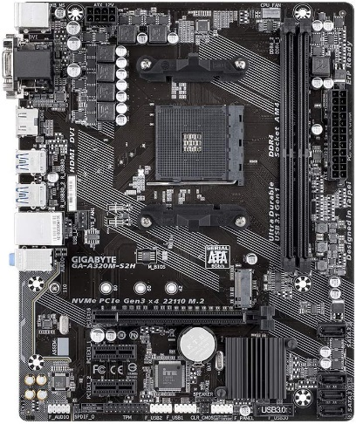
Price: 54.99
Manufacturer: Gigabyte
Model: GA-A320M-S2H
Socket CPU: AM4
Form factor: Micro ATX
Chipset: AMD A320
Max memory: 32 GB
Memory type: DDR4
Memory slots: 2
Memory speed: 2133, 2400, 2666, 2933, 3200.
Onboard ethernet: 1x1000 Mbit/s
SATA 6 Gb/s: 4
USB 2.0: 2
USB 3.2: 1

Figure 1 Motherboard

- AMD A6-9500 3.5GHz L2 2 Core Socket AM4 CPU (Advanced Micro Devices, 2017)
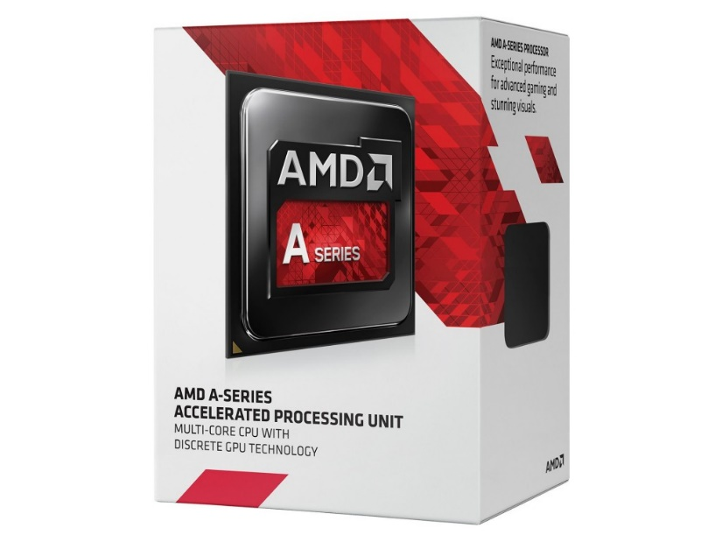
Price: 36.34
Series: AMD A6
CPU Socket: Socket AM4
Operating Frequency: 3.5 GHZ
Number of cores: 2
Number of threads 2
Integrated graphics type: AMD Radeon R5
Graphics Speed: 1029 MHZ

Figure 2 Processor

- Corsair Vengeance LPX 4 GB DDR4 2400 MHz (Corsair Memory, 2015)
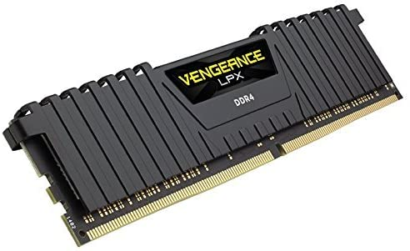
Price: 20.62
Brand name: Corsair
Series: LPX 8155
Form factor: 288- pin DIMM
RAM size: 4 GB
Memory technology: DDR4
Memory type: DDR4 SDRAM
RAM type: DDR4 SDRAM
Wattage: 125

Figure 3 RAM

- ADATA Ultimate SU630 240GB Solid State Drive (ADATA, 2018)

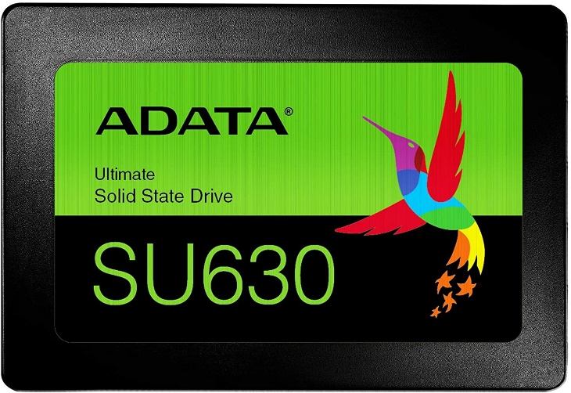
Figure 4 SSD Storage
Price: 23.99
Type: SSD
Form Factor: 2.5’’
SSD Read Speed: 520 MB/s
SSD Write Speed: 450 MB/s
Internal Connection: SATA III

- JUSTOP 500W Power Supply (Justop Limited, 2017)

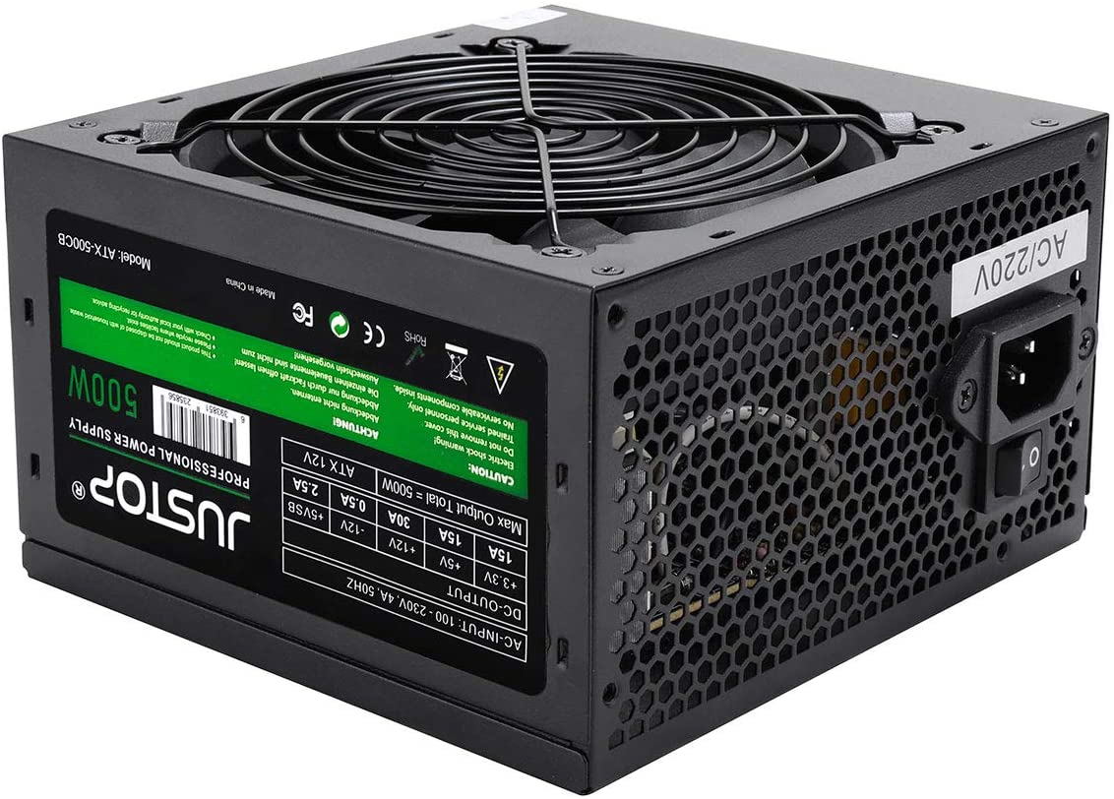
Figure 5 Power Suply

Price: 19.95
Power: 500W
Connectors: 20+4 Pin Main x1, 4-Pin 12V x 1
SATA Connector x 3
Floppy Drive Connector x 1

- ARCTIC Alpine 64 GT 25.6 CFM CPU Cooler (Arctic Cooling, 2008)
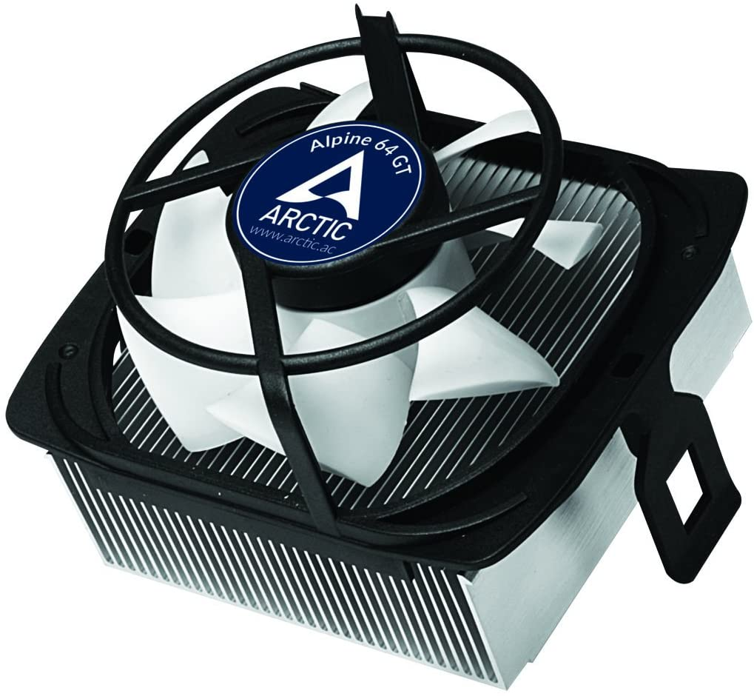

Price: 3.98
Model: Alpine 64 GT
Fan RPM: 500 – 2000 RPM
Height: 65 mm
CPU Socket: AM2, AM3, AM4, FM1, FM2

Figure 6 CPU Cooler

- iONZ KZ08 PC ARCTIC WHITE MID TOWER COMPUTER CASE (iONZ, 2020)
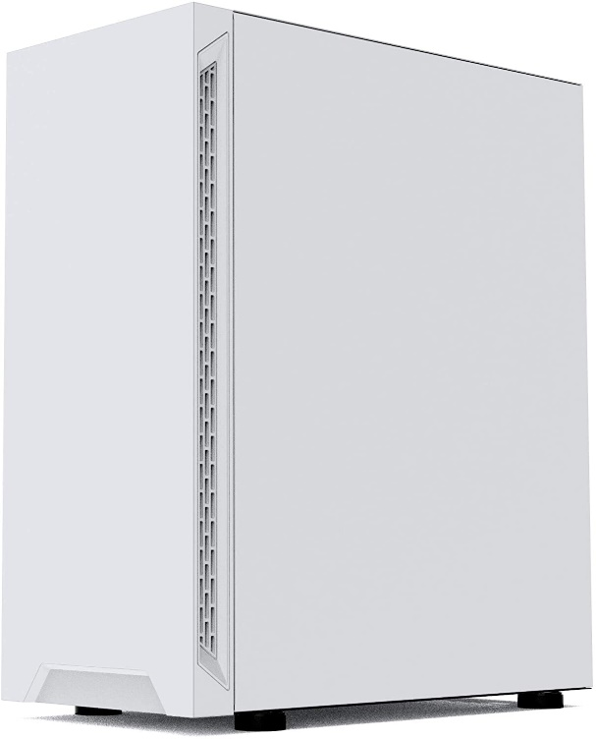
Figure 7 PC Case

Price: 30
Case Size :340x190x430MM. USB3.0 x 1 + USB2.0 x 2 + HD AUDIO. CPU Height : 165MM
Space for 5 x 120mm Cooling Fans. None Supplied.

(Anon., n.d.)

- AOC E2270SWHN 21.5" LED FHD (1920x1080) 5ms (AOC International, 2014)
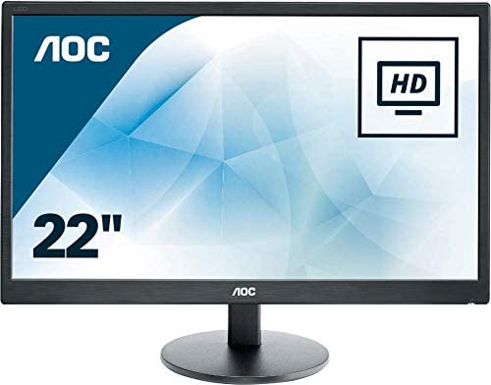
Figure 8 Monitor

Price 70
Brand name: AOC
Series: E2270SWHN
Screen Size: 22 inches
Screen Resolution 1920 x 1080 pixels
Maximum display resolution Full HD
HDMI port: Yes
VGA port: Yes

(Anon., n.d.) (Anon., n.d.) (Anon., n.d.) (Anon., n.d.) (Anon., n.d.) (Anon., n.d.) (Anon., n.d.) (Anon., n.d.) (Anon., n.d.) (Anon., n.d.) (Anon., n.d.) (Anon., n.d.) (Anon., n.d.)
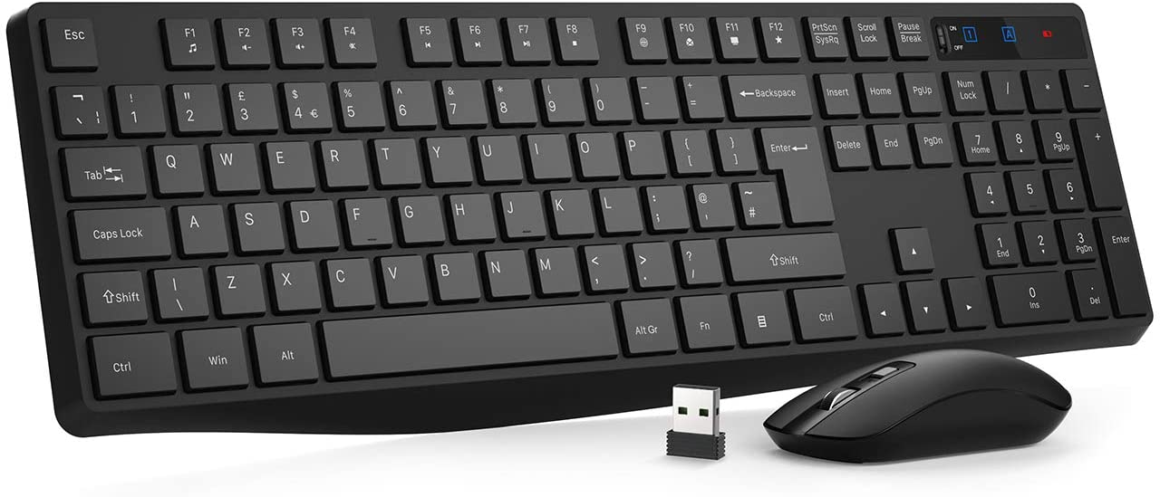
Price: 20
Brand name: VicTsing
Connection: wireless
Batteries: 1 AAA required
Nr of Lithium Ion cells: 1
Figure 9 Keyboard & Mouse

Reasons for choosing the specific components:
- Starting with the motherboard which is a Gigabyte GA-A320M-S2H with AM4 CPU socket which supports the latest AMD processors, with dual channel DDR4 memory slots with a maximum capacity of memory ram of 64 gb and 2133, 2400, 2666, 2933, 3200 MHZ supported speed, and ultra-fast onboard storage that offers better performance and support for PCIe and SATA interfaces. Has three high definition digital outputs that offers true HD quality. In terms of price and performance, the Gigabyte GA-A320M-S2H, is the perfect choice for a budget build.
- The AMD A6-9500 3.5GHz L2 2 Core Socket AM4 CPU, is a dual core processor with a clock speed of 3.5Ghz, including integrated graphics AMD Radeon R5 with a base frequency of 1029 Mhz which is perfect option because we will not add an external graphics card in order to stick to the budget. Memory type supported is DDR4. Pretty solid CPU processor with a good speed in comparison with an Intel processor for the same money and performance.
- Corsair Vengeance LPX is a highly stable in performance because of the precise manufacturing techniques employed by Corsair. With a DDR4 speed of 2400Mhz, capacity of 4 GB, it offers a very good performance for every system. Corsair Vengeance LPX is a very good choice for any system build.
- ADATA Ultimate SU630 240GB Solid State Drive is a perfect choice for any budget system builds because of two main reasons: affordable price and high performance speed. The 240 GB storage capacity will just be enough for an elderly person. Why I chose SSD over HDD? Quite simple, because of the speed. The ADATA SSD has up to 450/520Mbps reading and writing speeds for a smoother and faster boot, file transfers and downloads. Much cheaper and way to faster than an old and slow hard drive.
- JUSTOP 500W Power Supply comes with 1 x 12cm cooling fan offering excellent cooling and a quiet operation, ensuring the maximum lifespan of the components. It comes with 3x SATA connectors and a host of other connectors providing maximum compatibility with AMD CPU’s.
- ARCTIC Alpine 64 GT 25.6 CFM CPU Cooler offers a good cooling performance and minimizes the noise level in the same time. Great compatibility with AMD CPU’ sockets. For the price of 3.98 £, it’s just the ideal choice.
- iONZ KZ08 PC ARCTIC WHITE MID TOWER COMPUTER CASE is the definition of modern and style. The iONZ case comes with a tempered glass design of the side panel which allows a full view of the computer components and also looks great in any place.
- AOC E2270SWHN 21.5" LED FHD is ideal for compact workspaces, providing a sharp 21.5’’ Full HD screen of 1920x1080 pixels which is displayed in rich detail without requiring a high-end graphics card. Has a refresh rate of 60hz and a response time of 5ms for better and faster displaying of a new image.
- VicTsing Wireless Keyboard and Mouse 2.4GHz Wireless great design offers smooth and responsive typing experience which reduces also tiredness of fingers and wrists. The full sized keyboard includes also numeric keypad with a UK style layout. The 2.4G wireless technology provides stable connectivity and effective wireless range.
This setup build which costs around 300 £ is perfect in terms of budget and performance, an ideal balance. The configuration is above average at this price, and we will get a solid desktop build which can run undoubtedly up-to-date software applications. Surfing the internet will be a pleasure because of the AMD 3.5ghz core processor speed and the 4 GB Corsair RAM with clock speed of 2400 MHZ that can handle under-stress situations. The AOC full HD monitor will deliver high contrast and colourful image perfect for enjoying HD videos and photos. For an elderly person this setup is just fine.

Scenario 2: PC for editing 4k video content
Computer configuration list:

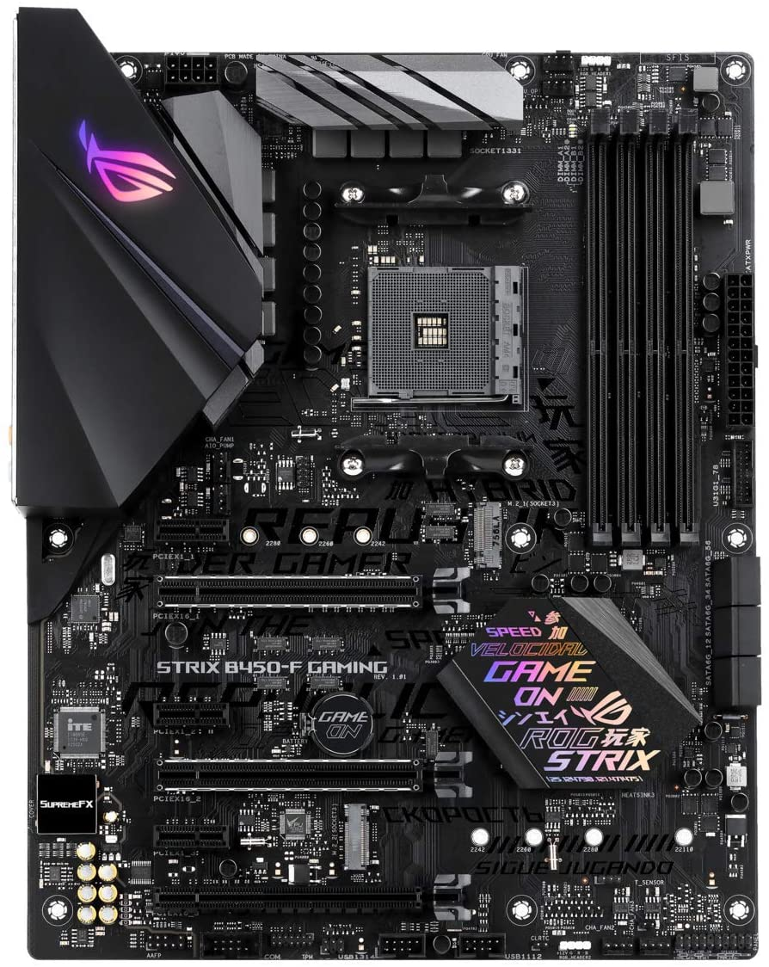
- ASUS ROG Strix B450-F Gaming ATX Motherboard (Asus, 2018)
Figure 10 Motherboard

Price: 118 £
Brand: Asus
Item model number: ROG STRIX B450-F GAMING
Form Factor: ATX
Processor brand: AMD
Processor socket: Socket AM4
Processor count: 8
RAM size: 64 GB
Memory Technology: DDR4
Graphics Card Interface: PCI-E
Number of USB 2.0 Ports
Wattage: 60

- AMD Ryzen™ 7 3800XT Processor (AMD, 2020)

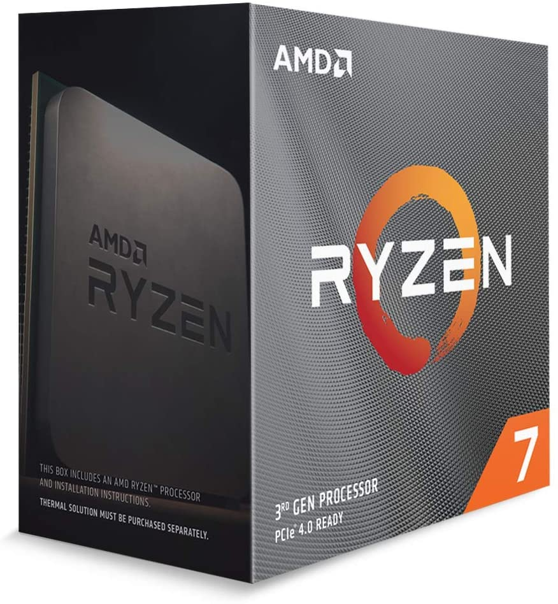
Price: 359.39
Brand: AMD
Item model number: AMD Ryzen 7
Series: Ryzen 7 3800XT
Processor speed: 4.7Ghz
Processor socket: Socket AM4

Figure 11 Processor

- Corsair Vengeance LPX 64 GB DDR4 2133 MHz (Corsair Memory, 2015)
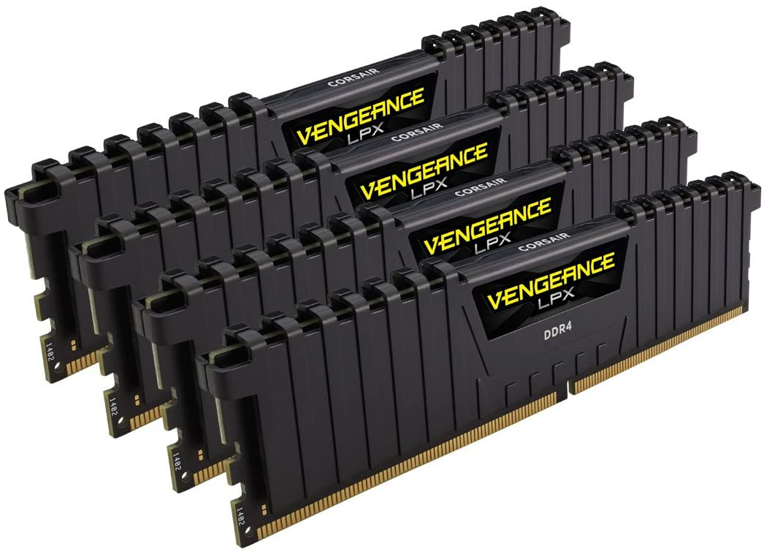
Figure 12 RAM

Price: 236.57 £
Brand: Corsair
Item model: CMK64GX4M4A2133C13
Series: Vengeance LPX
RAM size: 64 GB
Memory type: DDR4 SDRAM
Memory clock speed: 2133 Mhz
Voltage: 1.2 Volts

- Samsung 970 EVO Plus 1 TB PCIe NVMe M.2 SSD (Samsung, 2019)

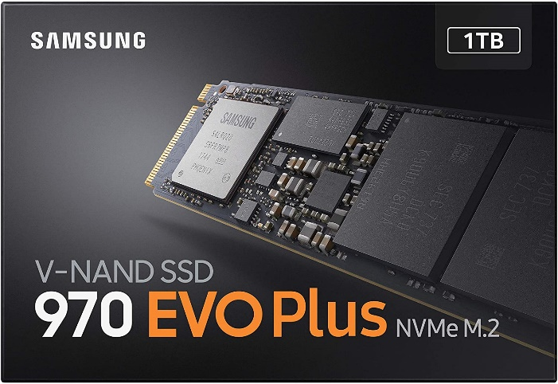
Price: 165.96 £
Brand: Samsung
Series: EVO Plus
Interface: NVMe (PCIe Gen 3.0 x 4)
Capacity: 1 terabyte
Read/Write speed: up to 3500 MB/s
Figure 13 Solid State Drive

- Corsair Carbide Series SPEC-05 Mid-Tower Gaming Case (Corsair, 2018)

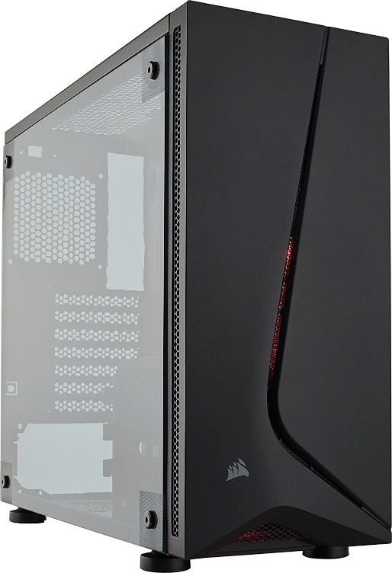
Price: 44.59 £
Brand: Corsair
Item model number: CC9011138WW
Form Factor: Mid-Tower ATX
Item weight: 4 Kg
Figure 14 Case

- Corsair CO-9050039-WW ML Series ML120 Case Fan (Corsair, 2016)

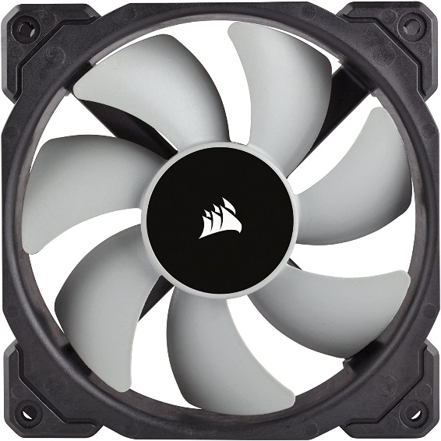
Price: 22.98 £
Brand: Corsair
Model nr: CO-9050039-WW
Voltage: 220 V
Figure 15 Case Fan

- Corsair TXM Series 850 W TX850M ATX Power Supply Unit (Corsair, 2019)

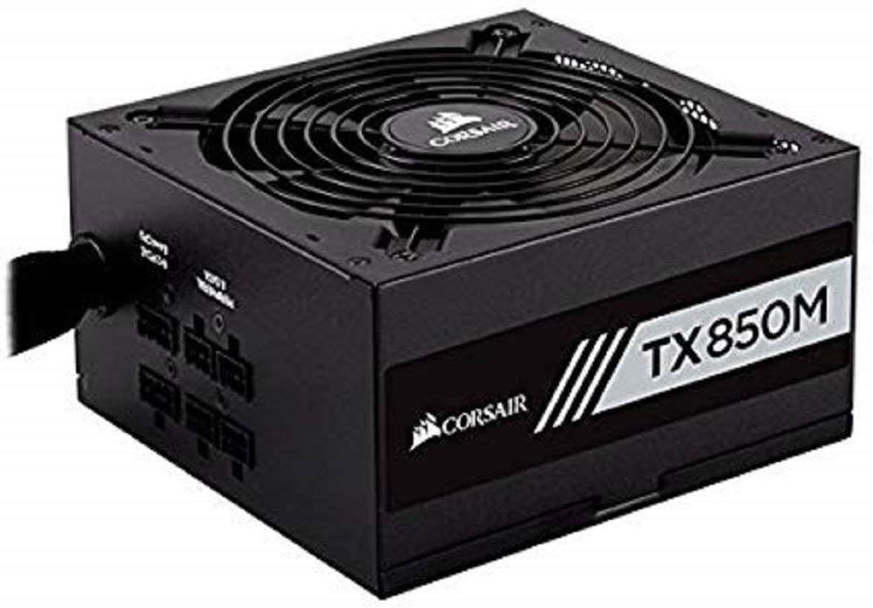
Figure 16 Power Supply Unit

Price: 108 £
Brand: Corsair
Wattage: 850 watts

- EVGA GeForce RTX 2080 SUPER 8GB GDDR6 (EVGA Corporation, 2019)
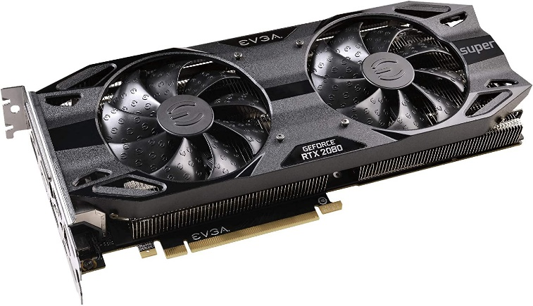
Figure 17 Graphics Card

Price: 681 £
Brand: EVGA
Series: GeForce RTX 2080
Resolution: 7680x4320
Memory Clock Speed: 15500 Mhz
Graphics RAM type: GDDR6
Graphics card RAM size: 8 GB
Wattage : 650 watts

- Cooler Master Hyper 212 RGB Cooling System (Cooler Master, 2018)

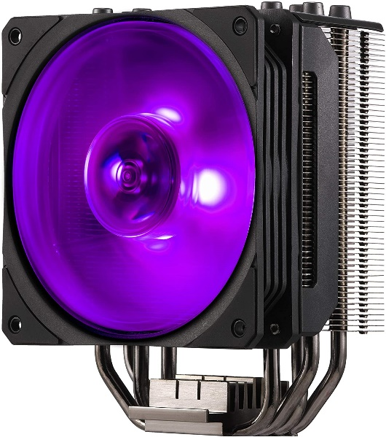
Price: 42.98 £
Brand: Cooler Master
Item model nr: RR212S20PCR1
Computer memory type: PC1066
Wattage: 1.92 Watts
Figure 18 CPU Cooler

- MSI Optix 24" FHD 144Hz Freesync Monitor (Micro-Star International, 2019)

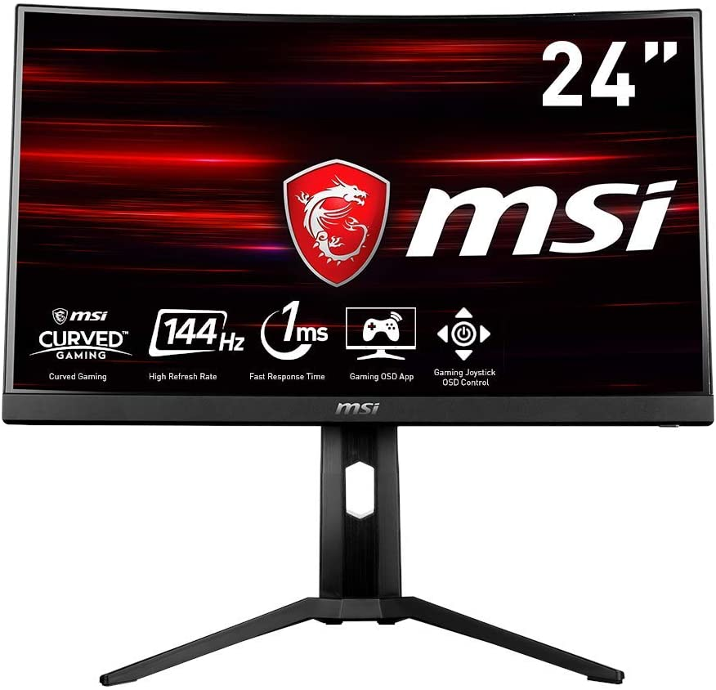
Price: 179 £
Brand: MSI
Item model number: 9S63EA24T061
Manufacturer: MSI Computer
Series: MAG241CPUK
Screen size: 23.6 Inches
Screen Resolution: 1920x1080
Resolution: 1080 Full HD
Response time: 1ms
Display Technology: LED
Ports: HDMI
Refresh Rate: 144 Hz

Figure 19 Monitor

- ASUS ROG Gladius II Core Wired Optical Gaming Mouse (ASUS, 2019)

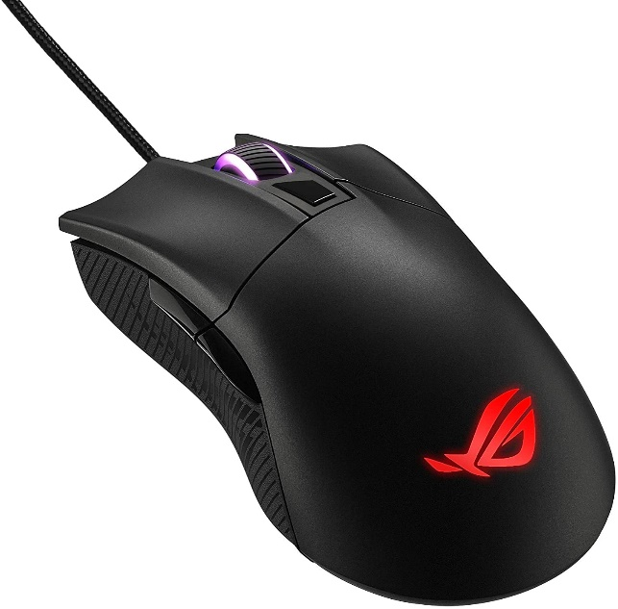
Price: 39.95 £
Brand: ASUS
Series: Mouse Asus Gaming RGB
DPI: 6200
Voltage: 1 Volts
Figure 20 Mouse

- Razer Black Widow Elite Mechanical Gaming Keyboard (Razer Inc. 2019)

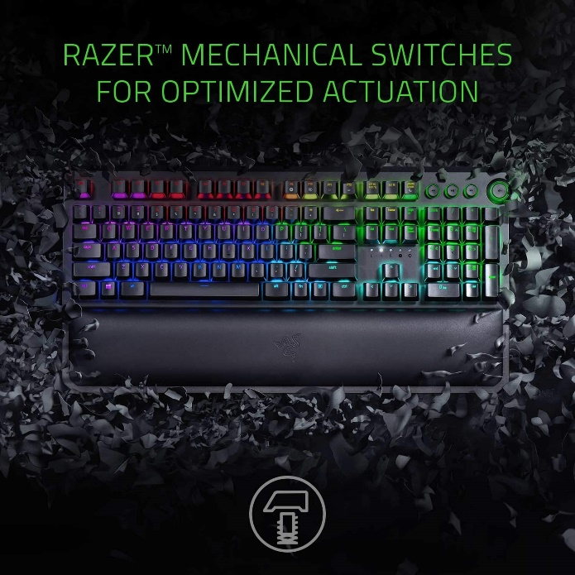
Price: 104 £
Brand: Razer
Series: BlackWidow Elite
Number of USB 2.0 Ports
Figure 21 Keyboard

- Seagate BarraCuda 8 TB Internal Hard Drive HDD (Seagate Technology, 2019)

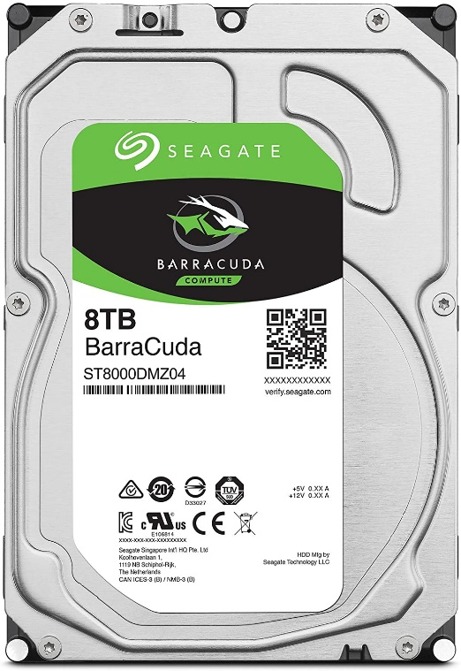
Price: 166 £
Brand: Seagate
Series: ST8000DM004
Form Factor: 3.5’’
Hard Drive Size: 8 Terabytes
Wattage: 5.6
Figure 22 Hard Drive

Reasons for buying this PC build:

The specific build is just meant to be used for 4k video content editing, it provides powerful and the best possible performance in terms of rendering UHD footage. With a 3rd gen Ryzen processor with a clock speed of 4.7 Ghz and the latest GPU which is an EVGA GeForce RTX 2080 Super with a clock speed of 1800 Mhz and memory of 8 Gb should be used for experiencing hyper-realistic graphics.
With 9 TB of space storage (1TB of SSD and 8 TB of HDD) it will be just enough for keeping high resolution footage and aiming for more storage in the future growth. The SSD provides extremely fast writing and reading speed up to 3500 Mb/s.
The Corsair RAM storage of 64 Gb, type DDR4 with a clock speed of 2133 Mhz is ideal for a first powerful PC build. Corsair is well known for producing high quality memory that is performing very well under-stress.
All these to be performed under a MSI monitor of 24’’, FHD with a refresh rate of 144 Hz and response time with 1 ms. Built with Free Sync technology, the MAG241C can match the display’s refresh rate with the GPU for ultra-smooth rendering performance.

References
Anon., n.d. Amazon. [Online]
Available at: https://www.amazon.co.uk/Wireless-Keyboard-VicTsing-Full-Size-Energy-Saving/dp/B07SR1Y9W8/ref=sr_1_1?dchild=1&keywords=1.+VicTsing+Wireless+Keyboard+and+Mouse+2.4GHz+Wireless+%28VicTsing.+2019%29&qid=1598368527&sr=8-1
[Accessed 23 August 2020].
Anon., n.d. Amazon. [Online]
Available at: https://www.amazon.co.uk/Gigabyte-A320M-S2H-Socket-S-ATA-Micro/dp/B078KBKFZ6/ref=sr_1_4?dchild=1&keywords=1.+Gigabyte+GA-A320M-S2H+Micro+ATX+Motherboard&qid=1598388554&sr=8-4
[Accessed 23 August 2020].
Anon., n.d. Amazon. [Online]
Available at: https://www.amazon.co.uk/AMD-A6-9500-Processor-3-50GHz-AD9500AGABBOX/dp/B074BGXW9T/ref=sr_1_fkmr0_1?dchild=1&keywords=2.+AMD+A6-9500+3.5GHz+L2+2+Core+Socket+AM4+CPU+%28Advanced+Micro+Devices%2C+2017%29&qid=1598388866&sr=8-1-fkmr0
[Accessed 23 August 2020].
Anon., n.d. Amazon. [Online]
Available at: https://www.amazon.co.uk/Corsair-CMK16GX4M2B3200C16-Vengeance-Performance-Desktop/dp/B00UVN2C2A/ref=sr_1_1?dchild=1&keywords=3.%2BCorsair%2BVengeance%2BLPX%2B4%2BGB%2BDDR4%2B2400%2BMHz%2B(Corsair%2BMemory%2C%2B2015)&qid=1598388994&sr=8-1&th=1
[Accessed 23 August 2020].
Anon., n.d. Amazon. [Online]
Available at: https://www.amazon.co.uk/ADATA-Ultimate-SU630-480GB-Solid/dp/B07KQXZKBN/ref=sr_1_2?dchild=1&keywords=4.+ADATA+Ultimate+SU630+240GB+Solid+State+Drive+%28ADATA%2C+2018%29&qid=1598389056&sr=8-2
[Accessed 23 August 2020].
Anon., n.d. Amazon. [Online]
Available at: https://www.amazon.co.uk/JUSTOP-Power-Supply-120mm-Cooling/dp/B071RQRPFR/ref=sr_1_fkmr0_1?dchild=1&keywords=5.+JUSTOP+500W+Power+Supply+%28Justop+Limited%2C+2017%29&qid=1598389096&sr=8-1-fkmr0
[Accessed 23 August 2020].
Anon., n.d. Amazon. [Online]
Available at: https://www.amazon.co.uk/ARCTIC-Alpine-64-Compatible-Ultra-Quiet/dp/B001A5V1K2/ref=sr_1_fkmr0_1?dchild=1&keywords=6.+ARCTIC+Alpine+64+GT+25.6+CFM+CPU+Cooler+%28Arctic+Cooling%2C+2008%29&qid=1598389226&sr=8-1-fkmr0
[Accessed 23 August 2020].
Anon., n.d. Amazon. [Online]
Available at: https://www.amazon.co.uk/ionz-ARCTIC-WHITE-COMPUTER-TEMPERED/dp/B087YVTX3F/ref=rtpb_2/260-7427357-8016041?_encoding=UTF8&pd_rd_i=B087YVTX3F&pd_rd_r=cdcec001-9313-4594-a9ef-73959a71bf3d&pd_rd_w=b8SYF&pd_rd_wg=cC7CU&pf_rd_p=21393542-ca06-4f9b-b1e2-0c64b58b7
[Accessed 23 August 2020].
Anon., n.d. Amazon. [Online]
Available at: https://www.amazon.co.uk/AOC-M2470SWH-Widescreen-Multimedia-1920x1080/dp/B00O4ATF2Q/ref=sr_1_1?dchild=1&keywords=8.+AOC+E2270SWHN+21.5%22+LED+FHD+%281920x1080%29+5ms+%28AOC+International%2C+2014%29&qid=1598389316&s=computers&sr=1-1
[Accessed 23 August 2020].
Anon., n.d. Amazon. [Online]
Available at: https://www.amazon.co.uk/Wireless-Keyboard-VicTsing-Full-Size-Energy-Saving/dp/B07SR1Y9W8/ref=sr_1_2?dchild=1&keywords=9.+VicTsing+Wireless+Keyboard+and+Mouse+2.4GHz+Wireless+%28VicTsing.+2019%29&qid=1598389358&s=computers&sr=1-2
[Accessed 23 August 2020].
Anon., n.d. Amazon. [Online]
Available at: https://www.amazon.co.uk/ASUS-B450-F-GAMING-Socket-Motherboard/dp/B07F714FT7/ref=sr_1_3?crid=1DRZZ0DCL1ET7&dchild=1&keywords=ryzen%2B7%2Bmotherboard&qid=1598372280&sprefix=ryzen%2B7%2Bm%2Caps%2C149&sr=8-3&th=1
[Accessed 23 August 2020].
Anon., n.d. Amazon. [Online]
Available at: https://www.amazon.co.uk/Corsair-CMK16GX4M2B3200C16-Vengeance-Performance-Desktop/dp/B017NW5JR6/ref=pd_bxgy_img_3/260-7427357-8016041?_encoding=UTF8&pd_rd_i=B0143UM4TC&pd_rd_r=53733add-1446-4f88-bd8e-e908585559f2&pd_rd_w=ENI7M&pd_rd_wg=Qqdyf&pf_rd_p=dcf35
[Accessed 23 August 2020].
Anon., n.d. Amazon. [Online]
Available at: https://www.amazon.co.uk/AMD-Ryzen-3600-Processor-Cache/dp/B089WCXZJC/ref=pd_bxgy_2/260-7427357-8016041?_encoding=UTF8&pd_rd_i=B07STGGQ18&pd_rd_r=0a524630-4612-4ce4-a960-a94defb9c6f0&pd_rd_w=ShYLV&pd_rd_wg=hoYQj&pf_rd_p=dcf35746-0212-418b-a148-30395d107b2
[Accessed 23 August 2020].
Anon., n.d. Amazon. [Online]
Available at: https://www.amazon.co.uk/Samsung-MZ-V7S1T0BW-Solid-State-Drive/dp/B07MBQPQ62/ref=pd_bxgy_img_2/260-7427357-8016041?_encoding=UTF8&pd_rd_i=B07MBQPQ62&pd_rd_r=e1947574-8f2d-40d9-abea-926d5ba63f89&pd_rd_w=tsAv9&pd_rd_wg=He8uB&pf_rd_p=dcf35746-0212-418b-a148-
[Accessed 23 August 2020].
Anon., n.d. Amazon. [Online]
Available at: https://www.amazon.co.uk/Corsair-Carbide-SPEC-05-Mid-Tower-Chassis/dp/B07BH23K53/ref=sr_1_4?dchild=1&keywords=corsair%2Bcase&qid=1598372544&s=computers&sr=1-4&th=1
[Accessed 23 August 2020].
Anon., n.d. Amazon. [Online]
Available at: https://www.amazon.co.uk/Corsair-CO-9050039-WW-Pressure-Magnetic-Levitation/dp/B01G5I6MRK/ref=sr_1_5?crid=DL9PFU26RUZ3&dchild=1&keywords=case+fans&qid=1598372963&s=computers&sprefix=case+%2Ccomputers%2C145&sr=1-5
[Accessed 23 August 2020].
Anon., n.d. Amazon. [Online]
Available at: https://www.amazon.co.uk/dp/B06WWM31ML/ref=twister_B0725CTR7Y?_encoding=UTF8&th=1
[Accessed 23 August 2020].
Anon., n.d. Amazon. [Online]
Available at: https://www.amazon.co.uk/EVGA-GeForce-Super-Gaming-08G-P4-3081-KR/dp/B07VKPGGR6/ref=sr_1_3?crid=2PX4DHZKJQWSE&dchild=1&keywords=rtx+2080+super&qid=1598373789&sprefix=rtx+20%2Caps%2C148&sr=8-3
[Accessed 23 August 2020].
Anon., n.d. Amazon. [Online]
Available at: https://www.amazon.co.uk/ASUS-Lightweight-Ergonomic-ROG-Exclusive-Switch-Socket/dp/B07V6WWGST/ref=sr_1_4?crid=1UB7GR9Q83PUH&dchild=1&keywords=rog+mouse&qid=1598375206&sprefix=rog+mous%2Caps%2C140&sr=8-4
[Accessed 23 August 2020].
Anon., n.d. Amazon. [Online]
Available at: https://www.amazon.co.uk/Cooler-Master-Hyper-Cooling-System/dp/B07H9JL1P8/ref=sr_1_9?crid=1JH3RHWE5J2IS&dchild=1&keywords=cpu+cooler&qid=1598372805&s=computers&sprefix=cpu+coo%2Caps%2C150&sr=1-9
[Accessed 23 August 2020].
Anon., n.d. Amazon. [Online]
Available at: https://www.amazon.co.uk/MSI-MAG241CPUK-Curved-Gaming-Monitor/dp/B07THFC6KC/ref=sr_1_13?crid=C5GEM2H76O0C&dchild=1&keywords=gaming+monitor+144hz&qid=1598374661&sprefix=gaming+moni%2Caps%2C147&sr=8-13
[Accessed 23 August 2020].
Anon., n.d. Amazon. [Online]
Available at: https://www.amazon.co.uk/Razer-BlackWidow-Elite-Illuminated-programmable/dp/B07FTPKLBF/ref=sr_1_3?crid=23TSDCJTPZK61&dchild=1&keywords=razer+keyboard+gaming&qid=1598374830&sprefix=razer%2Caps%2C158&sr=8-3
[Accessed 23 August 2020].
Anon., n.d. Amazon. [Online]
Available at: https://www.amazon.co.uk/Seagate-BarraCuda-Internal-Drive-Cache/dp/B07D9C7SQH/ref=sr_1_4?crid=1M6DFOJIT2SIE&dchild=1&keywords=2tb%2Bhdd&qid=1598372697&sprefix=2%2Btb%2B%2Caps%2C153&sr=8-4&th=1
[Accessed 23 August 2020].

Appendix: Tables

Scenario 1:
ITEM | PRICE
Gigabyte GA-A320M-S2H Micro ATX AM4 Motherboard | 54.99 £
AMD A6-9500 3.5GHz L2 Desktop Processor | 36.34 £
Corsair Vengeance LPX 4 GB DDR4 2400 MHz | 20.62 £
ADATA Ultimate SU630 240GB Solid State Drive | 23.99 £
JUSTOP 500W Power Supply | 19.95 £
ARCTIC Alpine 64 GT 25.6 CFM CPU Cooler | 3.98 £
ionz KZ08 PC ARCTIC WHITE MID TOWER COMPUTER CASE | 30.00 £
AOC E2270SWHN 21.5" LED FHD (1920x1080) 5ms | 70.00 £
Vic Tsing Wireless Keyboard and Mouse 2.4GHz Wireless | 20.00 £
TOTAL | 279.87 £

ITEM | PRICE
ASUS ROG Strix B450-F Gaming ATX Motherboard | 118 £
AMD Ryzen™ 7 3800XT Processor | 359.39 £
Corsair CMK64GX4M4A2133C13 Vengeance LPX | 236.57 £
Samsung 970 EVO Plus 1 TB PCIe NVMe M.2 SSD | 165.96 £
Corsair Carbide Series SPEC-05 Mid-Tower Gaming Case | 44.59 £
Corsair CO-9050039-WW ML Series ML120 120 mm Fan | 22.98 £
Corsair CP-9020130-UK TXM Series 850 W Power Unit | 108.00 £
EVGA GeForce RTX 2080 SUPER BLACK GAMING, 8GB GDDR6 | 681.20 £
ASUS ROG Gladius II Core Gaming Mouse | 39.95 £
Cooler Master Hyper 212 RGB Black Edition Cooling System | 42.98 £
MSI Optix 24" VA Curved FHD 144Hz Freesync Gaming Monitor | 179.00 £
Razer BlackWidow Elite Mechanical Gaming Keyboard | 104.99 £
Seagate BarraCuda 4 TB Internal Hard Drive HDD | 166.49 £
TOTAL | 2269.97 £
Scenario 2:

