Certificate of Higher Education in Skills for the Workplace:

Broadening Horizons/ Changing Live

Student Name: | Saguira Laguiab
Student Number: | 1714252
Module No: | BMSK4003
Module Title: | Digital Skills and Research Methods
Lecturer: | Joy Botu

Contents
Introduction 3
Research background 3
Research aim 4
Literature review 4
Data collection and sampling method 5
Research methodologies 5
Ethical issues 6
Research findings and data analysis 6
Secondary research 6
Primary research 7
Findings in summary 12
Conclusion 13
References 14
Appendixes 15

Introduction
The business world revolves around information technologies. Information technologies and computer are driving the business towards a new dimension due to increasing competition and opening a new era of customer acquisition as well as increasing efficiency in the workplace. This report is going to specifically illustrate how the use of IT and Computer technologies are changing the business dynamics of Brake Bros and how it is helping to improve its business performance.

Research background
Information technologies and computer are driving the business towards a new dimension due to increasing competition and opening a new era of customer acquisition as well as increasing efficiency in the workplace. However, in the era of information technology and computer, it is significant to analyse their impact on business performance whether they support a company in order to increase its sales volume or operating margin. On the other hand, it is crucial to identify the attitude of the employees regarding technology. That is why this research aims to identify the impact of IT and computer technology on the business efficiency of Brake Bros company. Brake Bros Company for his reason has implemented Information technologies and computer in the organisation so that it can enhance the performance of the staffs and increase profitability (data.brakebros.com, 2019). The company is a renowned baked food supplier in the UK and captured a significant market share in the UK food market.

Research aim
The aim of the research is to show the impact of IT and computer technology on Business performance based on Bake Bros.

Literature review
According to Ibrahim and Aljarah (2018), digital technologies such as IT and computer technologies have transformed the definition of modern business by increasing the business performance of the company. This is because IT and computer technologies have made the tasks easier and convenient for the staffs working in the organization according to Verma et al., (2012). For example, the managing inventory at a convenient level is a challenging task for manufacturing companies using the conventional manual method. “For this reason manufacturing companies sometime may face a shortage of inventories or over inventories due to lack of proper inventory management system” stated by Wikstorm and Illonen (2012). However, inventory management software can solve the problems of under inventory or over inventory as both of them are harmful to the company. On the other hand, customers often face difficulties and inconvenient for the purpose of billing according to Solomon (2017). Digital billing and payment technologies supported by IT and computer can eliminate the inconvenience of the customers and increase satisfaction as well as create positive impression towards the company which has a huge impact on profitability and business performance according to Djuric (2018). That is why modern companies should focus on implementing IT and computer technologist stated by Zizka (2017). Technological adaptability and IT engagement increase the efficiency in the workplace because it removes workload from the employs and can focus on other tasks stated by Solomon(2017). That is why scholars and researchers nowadays put a lot of emphasis on technological adherence by companies. “Market research is a significant task for the retailing companies” stated by Ibrahim and Aljarah(2018). For this reason, digital technologies such as IT and Computer technologies support the companies in order to collect market data regarding competitors, customers and market demand. Djuric(2018) put emphasis on Social media engagement in order to increase the access of information and market data as they provide the opportunities so that they can collect customer reviews and feedback easily from it which increase their efficiency in the workplace. Apart from these, there should have an effective communication channel and medium between the management and the staffs as well as among different stakeholders of the companies such as customers, suppliers, regulators, logistic supports providers etc according to Solomon (2017). Moreover, “a proper communication channel should be created among the retail stores off the companies that it supply goods” stated by Vokanovich (2011). That is why Zizka (2017) put a lot of emphasis on creating an effective communication channel using digital technologies such as computer and internet. Ibrahim and Aljarah (2017) stated that the companies should have an effective HR policy because they increase the workplace efficiency and for this reason, digital technologies and IT can support the company in increasing business performance. That is because digital technologies increase the job engagement of the staffs and eliminate all the barriers from the workplace. On the other hand, according to Verma et al., (2012), customers as well as staffs data protection and ensure the safety of the data is a crucial issue and for this reason, digital technologies can support the companies which also impact on the workplace efficiency as it increases credibility and trust.

Data collection and sampling method
The most significant task of any research is to collect and analyse the collected data from different sources using appropriate techniques and tools. However, data can be classified as primary data and secondary data (Alhayek et al., 2016). Primary data are those that have not been used in previous research as not accessible to all. On the other hand, secondary data are those that may have used by previous research as it has access to all. So, according to data, there are two sources of data namely primary sources and secondary sources. However, for this research, data has been collected from both primary sources and secondary sources as both types of data are required to show the workplace efficiency. However, for the research, data will be collected from 70 respondents from selected Factory of Bake Bros which is located in central London, UK. Moreover, there are two methodologies existed for data collection namely population and sampling (Danieli and Wooodhams, 2015). The population is the total set of data on the other hand sample is the portion of the population. However, a simple random sampling method has been used in this research as using population is not possible in this context. So, a random sampling method is appropriate for this.

Research methodologies
According to Danieli and Woodhams (2015), research methodologies can be classified as quantitative methodologies and quantitative methodologies. However, a quantitative research methodology is one in which numerical data is used and analysed using statistical tools and techniques(Danieli and Woodhams, 2015). On the other hand, a qualitative research methodology is one in which qualitative data is used in order to create a relation and stand a position by accepting or rejecting the hypothesis. For the research of showing the impact of digital technologies on workplace efficiency, both qualitative and quantitative research methodologies will be used because both types of data will be collected and analysed.

Ethical issues
Ethical data collection and implementation of ethical technologies ethically in the organisation is a significant task for the company. However, this research will implement ethics inevitably as the respondents will not be forced in order to provide information and they will respond at their sweet will. On the other hand, the data of the respondents will be preserved following the data protection regulations and will not be disclosed without the consent of the respective respondents.

Research findings and data analysis

Secondary research
Brake Bros Company implemented IT and Computer technologies in 20111 and from then the sales volume of the company has increased around fourfold until 2017. However, in 2011 while the company’s sales volume was only 72.69 million, it reaches 216.76 million in the year 2017.
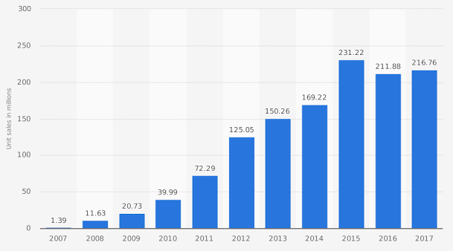
Figure: Sales figure of Brake Bros
Source: (Data.brakebros.com, 2019)
On the other hand, the operating margin and sales revenue of the company has also increased due to the implementation of IT and computer technologies in the firm. While in 2011, the operating margin was around 14%, it reaches 16% in the year 2016 and 2017.
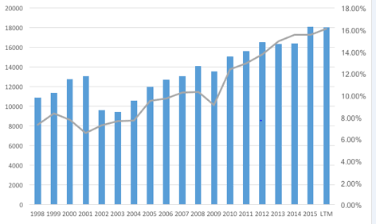
Figure: Operating margin and sales revenue of Brake Bros
Source: (Data.brakebros.com, 2019)
So, from the above analysis, it can be concluded that the business performance of Brake Bros has boosted after implementation of it and computer technologies in the organisation.

Primary research
Gender of the respondents
Data has been collected from 70 respondents and among the respondents; there were 37 male and 33 women.
Table: Gender of the respondents

Figure: Gender of the respondents
However, it has been tried in order to remain equality among men and women so that most appropriate result can be produced from the research.
Does Brake Brose’s performance depend on IT and Computer technologies?
The first question asked the respondents what they believe regarding the performance of the company. If they think that the performance of the company depends on IT and computer technologies.
Table: If Brake Bros performance depend on IT and Computer technologies
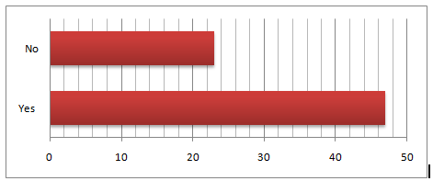
Figure: If Brake Bros performance depend on IT and Computer technologies
However, in this question, around 68% of respondents replied that they think so. On the other hand, another 32% replied negatively on this question. That indicates that most of the staffs believe that IT and computer technology is increasing business performance.
Are IT and computer technologies increase efficiency in inventory management?
The second question asked the respondents regarding the effectiveness of IT and computer technologies by increasing workplace efficiency.
Table: If IT and computer technologies increase efficiency in inventory management
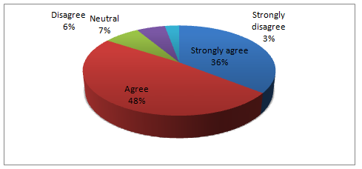
Figure: If IT and computer technologies increase efficiency in inventory management
So, in this question, around 36% responded that they strongly agree with the argument and another 48& agreed with it. Only 7%, 6% and 3% respondents were respectively neutral, disagree and strongly disagreed on this question. That indicates that most of the respondents are agreed with the argument.
Are IT and Computer technology increase sales of the company?
Another question asked the respondents in order to know their attitude regarding the impact of IT and Computer technologies in increasing sales. 27% and 50% of the respondents were strongly agreed and agreed respectively with the argument.
Table: If IT and computer technologies increase sales
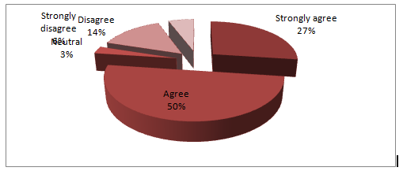
Figure: If IT and computer technologies increase sales
On the other hand, another 3% of the respondents remained silent on the topic. However, 14% and 6% of the total respondents responded as disagreed and strongly disagreeing with the question. So, it is a clear indication that most of the respondents believe that IT and computer engagement increases sales volume of the company.
Are IT and computer technology increase workplace efficiency?
The next question asked the respondents if they think that IT and computer technologies increase workplace efficiency.
Table: If IT and Computer technologies increase workplace efficiencies
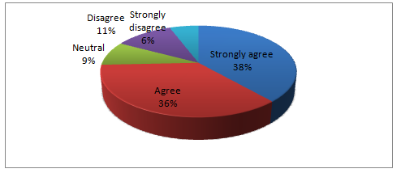
Figure: If IT and computer technologies increase workplace efficiencies
In this question, around 38% respondents respond that they are strongly agreed with the arguments and another 36% responds that they are agreed with it. On the other hand, 9%T of the total respondents responded nothing on it and 11% said they are disagreeing with it. Apart from these, only 6% responded that they strongly oppose the argument.
Should Brake Bros increase its budget in IT and Computer technologies?
The last question asked the respondents if they think if the company will increase IT and computer technology engagement budget in the coming periods. However, in this question, significantly 56% respondents agreed strongly.
Table: If the company will increase IT and computer technology budget.
Another 16% of respondents agreed with the argument and 10% remained neutral. On the other hand, only 13% and 6% of the total respondents disagreed and strongly disagreed respectively.

Findings in summary
From the analysis of data both from primary and secondary research, it is clear that IT and computer technologies have the huge impact on the business performance of the Brake Bros company as it enhances the inventory management, data management, increases sales and overall business performance. Moreover, it has a huge impact on increasing sales volume and operating margin of the company. On the other hand, most of the respondents responded positively that IT and computer technologies positively impact on Business performance and desire to increase the budget in this sector.

Conclusion
From the research, it can be concluded that IT and computer technologies have a significant impact on business performance as it increases the sales volume of the company as well as its operating margin. So, the company should increase its IT and computer technology engagement through increasing budget in this field.

References
Alhayek, I., Maguire-Wright, K. and Flickinger, K. (2016). Utilizing Secondary Data Sources In Combination With Primary Clinical Data To Optimize Data Collection In Prospective Study Designs. The value in Health, 19(3), p.A108.
Danieli, A. and Woodhams, C. (2005). Emancipatory Research Methodology and Disability: A Critique. International Journal of Social Research Methodology, 8(4), pp.281-296.
Djuric, Z. (2018). The importance of Technology engagement in the manufacturing industry. TIMS. Acta, 12(1), pp.65-74.
Ibrahim, B. and Aljarah, A. (2018). A dataset of relationships among social media marketing activities, brand loyalty, revisit intention. Evidence from the hospitality industry in Northern Cyprus. Data in Brief, 21, pp.1823-1828.
Brake Bros.com. (2018). Food manufacturers and suppliers | [online] Available at: https://www.brakebros.com/default. [Accessed 8 January . 2019].
Solomon, M. (2017). Consumer Behavior. Pearson Education UK.
Verma, R., Stock, D. and McCarthy, L. (2012). Customer Preferences for Online, Social Media, and Mobile Innovations in the Hospitality Industry. Cornell Hospitality Quarterly, 53(3), pp.183-186.
Vukanovic, Z. (2011).Impact of IT and Computer on business. Journal of Media Business Studies, 8(3), pp.51-67.
Wikström, P. and Ellonen, H. (2012). The Impact of IT on Business: Online Business Models. Journal of Media Business Studies, 9(3), pp.63-80.
Zizka, L. (2017). The (Mis)use of computer and information technology. Media to communicate CSR in hospitality. Journal of Hospitality and Tourism Technology, 8(1), pp.73-86.

Appendixes
Personal interview questionnaire


