University of Wales Trinity Saint David

Wales Institute of Science & Art


Products and their Material Choices
Materials and Introduction to Processing (ACMA4000)



James Levi
2416761
February 2026
Word Count: 1475

Abstract
Material selection is a critical aspect of product design, influenced by factors such as functionality, durability, cost, aesthetics, and environmental impact. This report analyses three products seen day to day: stainless steel cutlery, a plastic water bottle, and a tempered glass mug. Each object is examined in terms of material properties, manufacturing methods, mechanical and thermal behaviour, lifespan, and cost. Comparisons highlight how differing material characteristics dictate suitability for specific applications, while also identifying limitations and environmental concerns. Potential alternative materials are discussed to illustrate how future designs could improve performance and sustainability.
Table of Contents
Wales Institute of Science & Art 0
1 Abstract 1
1.1 Introduction 3
2 Selection and Description of Objects 4
2.1 Stainless-Steel Cutlery 4
2.2 Plastic Water Bottle (PET) 5
2.3 Glass Mug 5
3 Manufacturing Methods - Comparison 6
4 Mechanical and Thermal Properties – Comparison 9
5 Lifespan and Cost Analysis 10
6 Material Selection and Alternative Choices 11
7 Conclusion 12
8 References 13

Figure 1 - Stainless Steel Cutlery 4
Figure 2 - Plastic Water Bottle 5
Figure 3 - Glass Mug 6
Figure 4 - Manufacturing Process Steps of a Spoon (Studio William 2025) 7
Figure 5 - Injection Blow Moulding Process (Robinson plc, 2026) 7
Figure 6 - Glass Blowing Manufacturing Process (Designwanted.com, 2021) 8

Table 1 - Comparison of Manufacturing Methods 6
Table 2 - Mechanical and Thermal Properties Comparison 9
Table 3 - Comparison of Product Lifespan 10

Introduction
Material selection for a product revolves around its purpose. Some key factors that are considered when a material is being chosen for a product are: the products’ purpose, durability requirements, cost, aesthetics and environmental footprint. This report analyses three different household objects, Cutlery (Stainless-Steel), a plastic water bottle (Polyethylene terephthalate), and a glass mug (Tempered glass). Each of these everyday objects is made primarily from one material. Each object is made from different materials to another, which have fundamentally different properties and manufacturing processes/challenges. This report compares how these materials are chosen for each product by considering their mechanical and thermal properties, while also highlighting potential drawbacks of the materials used, exploring other materials that could be used for these products along with their advantages/disadvantages.

Selection and Description of Objects

Stainless-Steel Cutlery
Metal cutlery is a key kitchen utensil used for cooking and eating. Cutlery can be made from several different metals. However, the predominant material seen in day-to-day life is stainless steel; according to Marketgrowthreports.com (2026), production volume of cutlery exceeds 660 million units annually, 60% of which is made from stainless steel. 18/8 Stainless Steel is the most common amongst this, which is composed of 18% Chromium, to improve resistance to corrosion, and then 8% Nickel, which improves durability and strength, keeping the cutlery shiny after years of use (British Stainless Steel Association (2026), Nickel Institute (2020)). Stainless steel cutlery is manufactured through a series of rolling, cutting, forming and polishing. This manufacturing process is efficient for mass production as it has high throughput, along with consistent quality output.

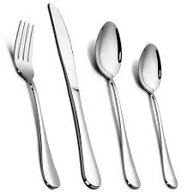
Figure 1 - Stainless Steel Cutlery
Stainless steel is used for cutlery as its very resistant to corrosion, high tensile strength and aesthetically pleasing. Other materials commonly used for cutlery are Sterling Silver or Plastic, which are both lighter. Silver has anti-bacterial properties, which is very advantageous in this application, and plastic is much cheaper to produce.

Plastic Water Bottle (PET)
It’s estimated that 480 billion plastic water bottles are made from Polyethelene Terephthalate (PET) were sold in 2018 alone (Reuters.com). Plastic water bottles are used for containing and consuming water. PET is used for this product as it has a low cost to manufacture, lightweight, aesthetically pleasing and durable. Plastic water bottles are manufactured by injection blow moulding, a process where molten plastic is injected into a mould by compressed air. Some drawbacks to PET are it has low resistance to heat, and as highlighted by Aquasana (2023), 80% of used water bottles end up in landfill, taking 450 years to decompose. Alternative materials to PET could be glass or a more recent development, paper. These materials are recyclable and offer similar quality to plastic bottles at cheap cost.

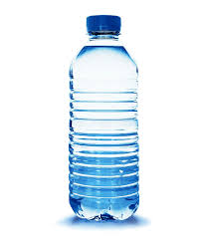
Figure 2 - Plastic Water Bottle

Glass Mug
Glass mugs are primarily made from tempered glass, which is composed of silica (sand), soda ash and limestone (Joyye 2024). Every year 130 million tonnes of glass is produced globally. The manufacturing process for glass mugs is blow moulding, the materials are mixed and heated to around 1600$℃$ to create soda-lime glass, this is then allowed to cool to achieve viscosity for the forming stage, where the molten glass is blown into a mould to take the shape of that mould. Glass is easy to clean and non-reactive – a suitable and aesthetic choice for mugs. Some disadvantages to glass mugs are that glass is fragile and conducts heat, therefore it needs to be handled with caution, especially when filled with hot drinks. Common alternatives to glass is ceramic. An advantage of ceramic is that it retains heat well, keeping drinks warmer for longer than glass (Joyye 2024).
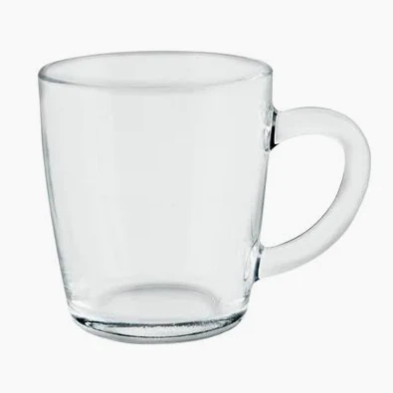
Figure 3 - Glass Mug

Manufacturing Methods - Comparison
Product | Material | Manufacturing Process | Complexity | Production Rate | Cost
Cutlery | Stainless Steel | Rolling, cutting, forming, polishing | Low | High (6000+/hour) | Medium
Bottle | PET | Injection Blow Moulding | High | Very High (24000/hour) | Low
Mug | Tempered Glass | Glass Blowing | Moderate | Moderate (3000+/hour) | Medium
Table 1 - Comparison of Manufacturing Methods

References: PET All Manufacturing Inc. (2026), MISA. (2024).

Metal forming of cutlery is relatively simple once tooling is prepared, allowing high repeatability. The process is a series of rolling, cutting, forming and polishing. In contrast, injection blow moulding for PET bottles is a complex yet efficient process. The process is a series of melting plastic and extruding it into a parison, inserting the parison into a mould cavity and then blowing air into the parison, inflating the plastic to the cavity, which is then allowed to cool before being ejected from the mould. This process can produce 24000 bottles per hour. Glass blow moulding involves a process of heating raw materials to upwards of 1600$°C$, forming through blowing and then annealing, to improve the glass’ durability. This process is slower and more energy intensive in comparison. The choice of manufacturing method is directly tied to material behaviour: metals’ ductility allows forming; thermoplastics’ low melting points allow moulding; and glass’ brittleness demands high temperature shaping and annealing.
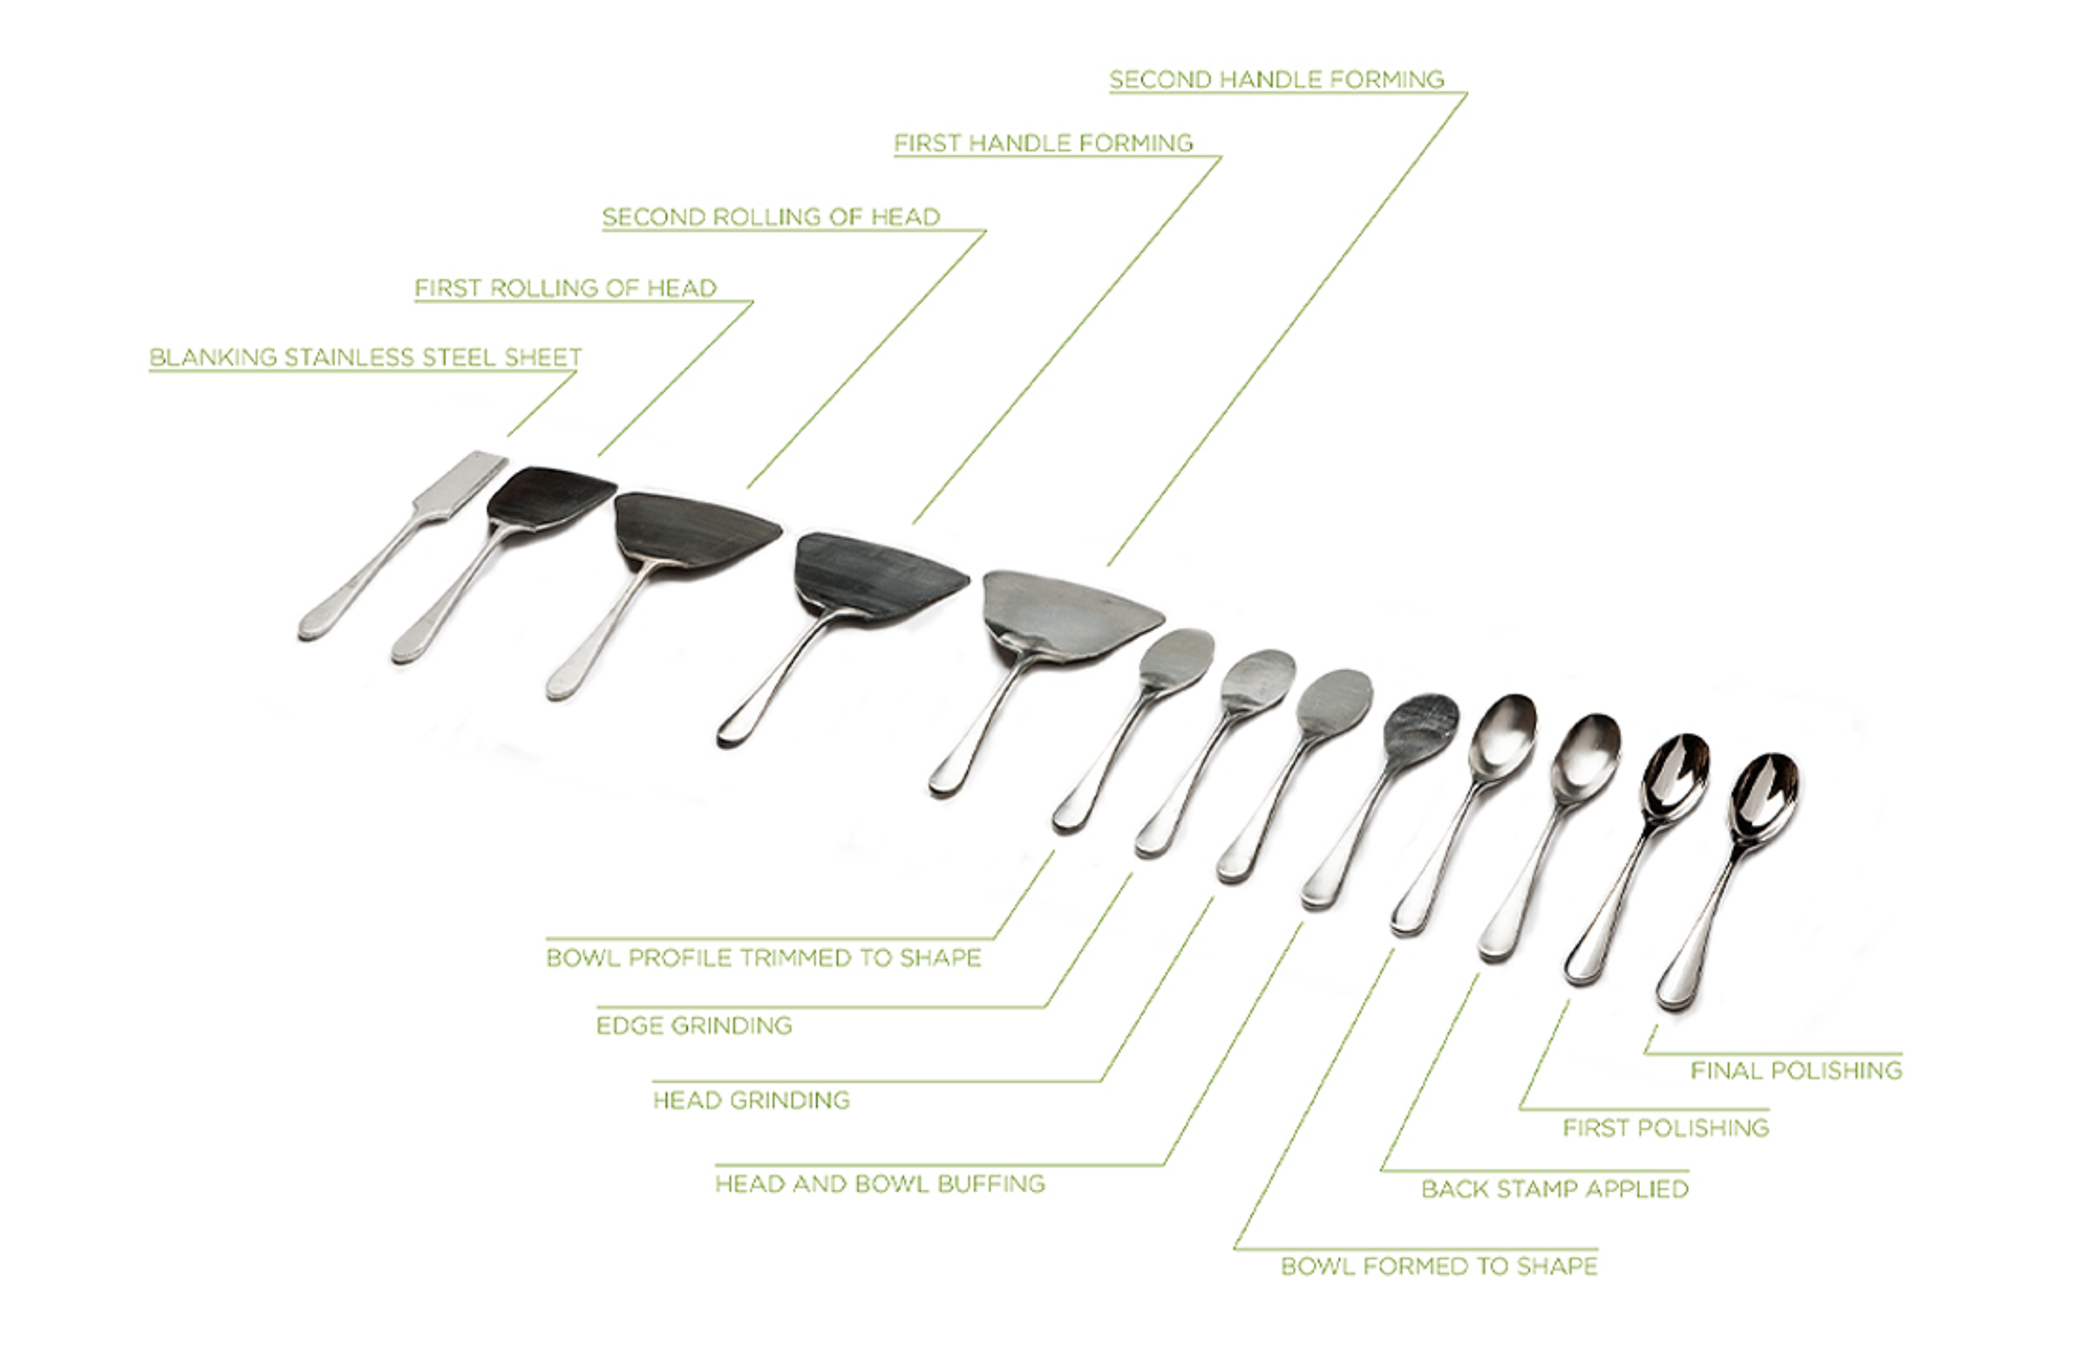
Figure 4 - Manufacturing Process Steps of a Spoon (Studio William 2025) 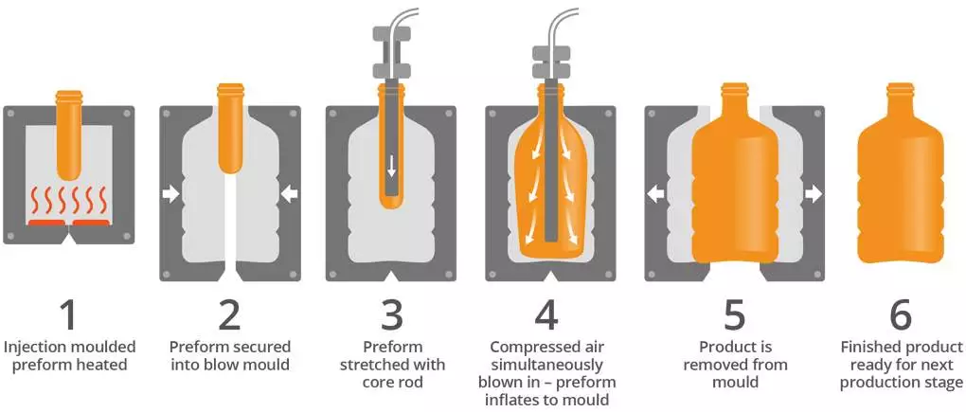
Figure 5 - Injection Blow Moulding Process (Robinson plc, 2026)
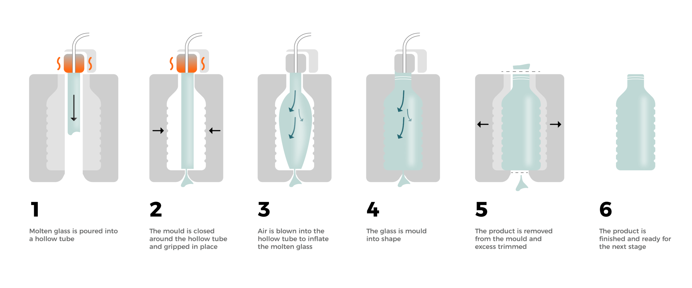
Figure 6 - Glass Blowing Manufacturing Process (Designwanted.com, 2021)

Mechanical and Thermal Properties – Comparison
Table 2 - Mechanical and Thermal Properties Comparison
Material | Density (g/cm^3) | Tensile Strength (Mpa) | Property | Melting Point ($℃)$ | Thermal Conductivity (W/mK)
Stainless Steel | 7.5 | 400 | Ductile | 1400 | 15
PET | 1.38 | 55 | Tough | 250 | 0.15-0.4
Tempered Glass | 2.52 | 40 | Brittle | 1600 | 0.8

References: AZoM.com (2018), The Engineering Toolbox (2003).

The application of each product differs, which reflects in the materials chosen. Stainless steels mechanical properties are notably higher compared to glass and PET. As cutlery is used to cook and eat it must be durable, stainless steels high tensile strength (400Mpa) ensures that cutlery can last decades (The Engineering Toolbox, 2023). The manufacturing process of stainless steel is also possible because of stainless steels ductility, glass cannot be rolled and pressed for example, as it would shatter. Stainless steel is also brilliant for cooking as it has a high melting point and thermal conductivity, unlike PET, where if a plastic spoon was used for cooking it would likely melt.

PET is a very tough material, rather than easily plastically deforming or shattering like Stainless steel and glass, PET has a very high elastic deformation. This is ideal for transporting plastic water bottles, as the product is durable to withstand mass shipping, where the other materials would be damaged. The material is also less dense in comparison, which gives plastic bottles their light weight.

Tempered Glass is hard and can withstand high temperatures, with low thermal conductivity. This is ideal for hot drinks, as PET or Stainless steel will deform or be too hot to handle. Glass’ high melting temperature also allows its use for cooking, however its not as advantageous as stainless steel, because its low thermal conductivity means it takes longer to heat up, but also takes a long time to cool, which can be hazardous when handling. Glass’ hardness also has a drawback, as it is very brittle. This causes glass to shatter, rather than deform, like stainless steel.

Lifespan and Cost Analysis
Table 3 - Comparison of Product Lifespan
Product | Lifespan | Degradation | End of Life
Cutlery | 10+ Years | Corrosion | Raw material is recyclable
Plastic Water Bottle | Single Use | UV Radiation | Recyclable, single use high environmental impact
Glass Mug | 5-10 Years | Chips Scratches | Recyclable, does not biodegrade

Stainless steel cutlery offers excellent longevity and recyclability with minimal degradation. PET water bottles are one time use; slow degradation from UV exposure and poor recycling rates lead to pollution. Glass mugs are durable under normal use but prone to breakage. In terms of cost, PET bottles are cheapest due to low raw material and manufacturing costs. Stainless steel requires higher energy for production but lasts much longer, offsetting its initial expense. Glass sits in between, combining low material cost with high energy consumption to be melted.

Material Selection and Alternative Choices
The materials and manufacturing processes selected for the three objects reflect a balance between performance, cost, manufacturability. Stainless steel was chosen for its high strength, corrosion resistance, and hygienic properties. Its ability to be easily formed through stamping and polished to a smooth finish further supports its suitability. Alternative materials such as aluminium could reduce weight and cost; however, aluminium lacks the same level of durability and scratch resistance and may deform more easily during use.

The plastic water bottle demonstrates a design driven primarily by cost and mass production. PET is favoured due to its low density, transparency, and compatibility with high-speed injection stretch blow moulding. PET presents significant environmental concerns due to short service life and low recycling rates (aquasana, 2023). Alternative materials could be used, such as glass or aluminium, but these are heavier and more expensive to transport.

For the Glass mug, tempered glass is suitable for its thermal stability, hardness, and aesthetic appeal. However, its brittleness increases the risk of failure. An alternative could be a Porcelain, manufactured by slip casting, which offers better thermal insulation, keeping drinks warmer for longer.

Conclusion
This report has shown how material selection strongly influences the manufacturing method, mechanical and thermal performance, lifespan, and environmental impact of everyday objects. Stainless steel, PET plastic, and glass each offer distinct advantages that suit their respective applications, but they also present limitations. The analysis highlights that no single material is universally superior; instead, optimal design depends on balancing functionality, cost, durability, and sustainability. By considering alternative materials and processes, future designs can achieve improved performance while reducing environmental impact and extending product life.

References
Marketgrowthreports.com. (2026). Metal Tableware Market Report | Global Insights [2035]. [online] Available at: https://www.marketgrowthreports.com/market-reports/metal-tableware-market-119424 [Accessed 25 Jan. 2026].

StudioWilliam.com. (2025). How Cutlery is Made. [online] Available at: https://studiowilliam.com/how-cutlery-is-made/ [Accessed 25 Jan. 2026].

‘Sshlmachinery’ and 'Dream' (2025). Advantages of Using Specialized Machines for Stainless Steel Cutlery. [online] Sshlmachinery.com. Available at: What Are The Advantages Of Using Specialized Machines For Stainless Steel Cutlery? - SSHL Machinery [Accessed 25 Jan. 2026].

Tsironi, T.N., Chatzidakis, S.M. and Stoforos, N.G. (2022). The Future of Polyethylene Terephthalate bottles: Challenges and Sustainability. Packaging Technology and Science, [online] 35(4), pp.317–325. Available at: https://onlinelibrary.wiley.com/doi/abs/10.1002/pts.2632 [Accessed 26 Jan. 2026].
Pace, M. (2023). Important Plastic Water Bottle Stats. [online] aquasana.com. Available at: https://www.aquasana.com/info/important-plastic-water-bottle-stats-pd.html [Accessed 26 Jan. 2026].
Scarr, S. and Hernandez, M. (2019). Drowning in Plastic. [online] Reuters Graphics. Available at: https://www.reuters.com/graphics/ENVIRONMENT-PLASTIC/0100B275155/ [Accessed 26 Jan. 2026].
British Plastics Federation (2024). PET Plastic Bottles - Facts Not Myths. [online] www.bpf.co.uk. Available at: https://www.bpf.co.uk/sustainability/pet_plastic_bottles_facts_not_myths.aspx [Accessed 26 Jan. 2026].
British Stainless Steel Association (2026). Cutlery Stainless Steel Grades. [online] British Stainless Steel Association. Available at: https://bssa.org.uk/bssa_articles/cutlery-stainless-steel-grades/ [Accessed 27 Jan. 2026].
Nickel Institute (2020). Food Contact Materials. [online] Nickelinstitute.org. Available at: https://nickelinstitute.org/en/nickel-applications/food-contact-materials/ [Accessed 27 Jan. 2026].
Cedarspringswater.ca. (2018). Eco-Friendly Alternatives for Disposable Plastic Water Bottles | Cedar Springs Blog. [online] Available at: https://cedarspringswater.ca/blog/eco-friendly-alternatives-disposable-plastic-water-bottles/ [Accessed 5 Feb. 2026].
Robinson Plc. (n.d.). Injection Stretch Blow Moulding | Robinson Packaging PLC. [online] Available at: https://robinsonpackaging.com/technical-capabilities/injection-stretch-blow-moulding/ [Accessed 5 Feb. 2026].
Joyye.com. (2024). What Are Mugs Made Of? [online] Available at: https://www.joyye.com/info-detail/what-are-mugs-made-of [Accessed 5 Feb. 2026].
Business Waste. (2025). Glass Waste Facts and Statistics. [online] Available at: https://www.businesswaste.co.uk/waste-facts/glass-waste-facts-and-statistics/ [Accessed 5 Feb. 2026].
Callister, W. D., & Rethwisch, D. G. (2020). Materials science and engineering : an introduction (10th edition.). Wiley.
Groover, M.P. (2011) Principles of modern manufacturing . 4th ed., SI version. Hoboken, N.J. :, John Wiley.
Soulié, P.-L. (2021). What is Machine Glassblowing? [online] DesignWanted. Available at: https://designwanted.com/machine-glassblowing-process/ [Accessed 6 Feb. 2026].
DmFamily (2023). How Glass Cups Are Made? [online] Xi’an Dingmu Household Products Design & Manufacture Co., Ltd. Available at: https://www.xiandingmu.com/news-how-glass-cups-are-made.html [Accessed 6 Feb. 2026].
Pet All Manufacturing Inc. (2026). Pet Blow Molding Machine Manufacturers in Toronto. [online] Available at: https://www.petallmfg.com/pages/products/pet-blow-molding-machines [Accessed 7 Feb. 2026].
MISA. (2024). Glass Bottle Production Methods: Press Blow Vs Blow Blow - A Comparison. [online] Available at: https://www.misapack.com/glass-bottle-production-methods-press-blow-vs-blow-blow-a-comparison/ [Accessed 7 Feb. 2026].
The Engineering Toolbox (2003). Young’s Modulus - Tensile and Yield Strength for common Materials. [online] Engineeringtoolbox.com. Available at: https://www.engineeringtoolbox.com/young-modulus-d_417.html [Accessed 7 Feb. 2026].
Davey, R. (2018). Polyethylene Terephthalate Polyester ( PET, PETP ) - Properties and Applications. [online] AZoM.com. Available at: https://www.azom.com/article.aspx?ArticleID=2047 [Accessed 7 Feb. 2026].

