Drew McClennon (2312801)
University of Wales Trinity Saint David
HTML & CSS Web development
ACCA4023

Table of Contents
Introduction 2
Requirements 2
Implementation 3
Evaluation 6
Appendices 7

Introduction
This report aims to outline the research, development, and evaluation of a website project created for this assignment. I will delve into the purpose of this website and its development. I will also be writing about its usability, optimising it for googles indexing algorithms, validating both the HTML and CSS code. Finishing it up with an evaluation at the end discussing what strengths and weaknesses the website had, and how I can go about improving the site in order for it to perform better, look better, be more accessible, and possibly monetise.

Requirements
This assignment required me to produce a website with a minimum of at least 5 pages which can be navigated between. It had to be responsive to the user (e.g. loading quickly, buttons linking to the correct location, etc). It must also have been created completely from scratch without the use of any website building tools or packages meaning that we had to write all of the HTML and CSS code that we would need, ourselves.
I was pleased to read that we were able to create the website about whatever we chose, for me, that was cars both of which I have owned or plan on owning. This felt like a strong topic to chose for me as it made sense to use separate web pages for each car to give them their own spaces for images and information.
The intended target audience is other people whom are interested in cars, they can find out about cars that I like and see what I have owned and what I plan on owning at some point in the future.

Implementation
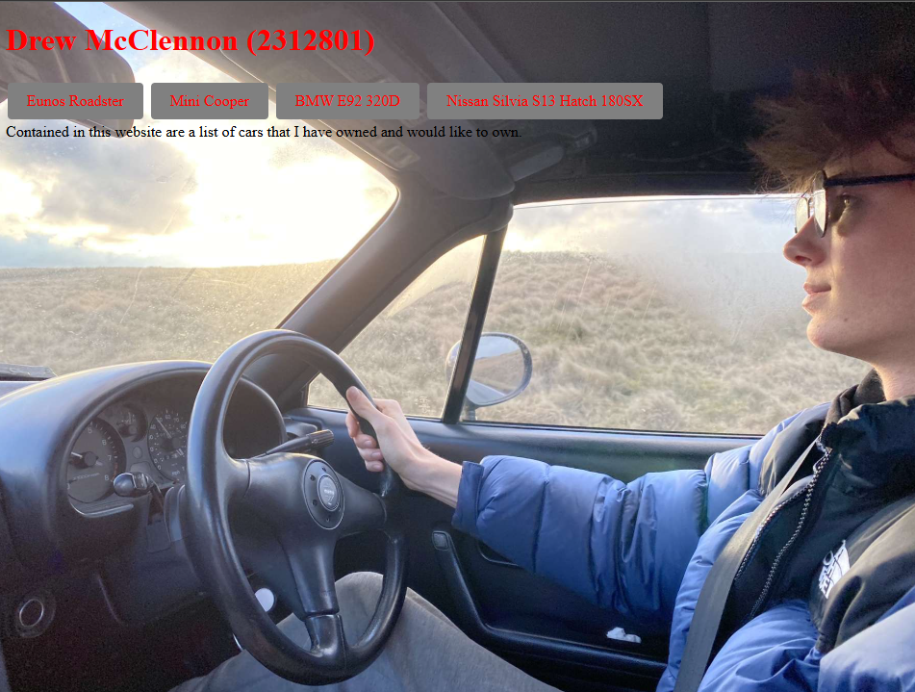
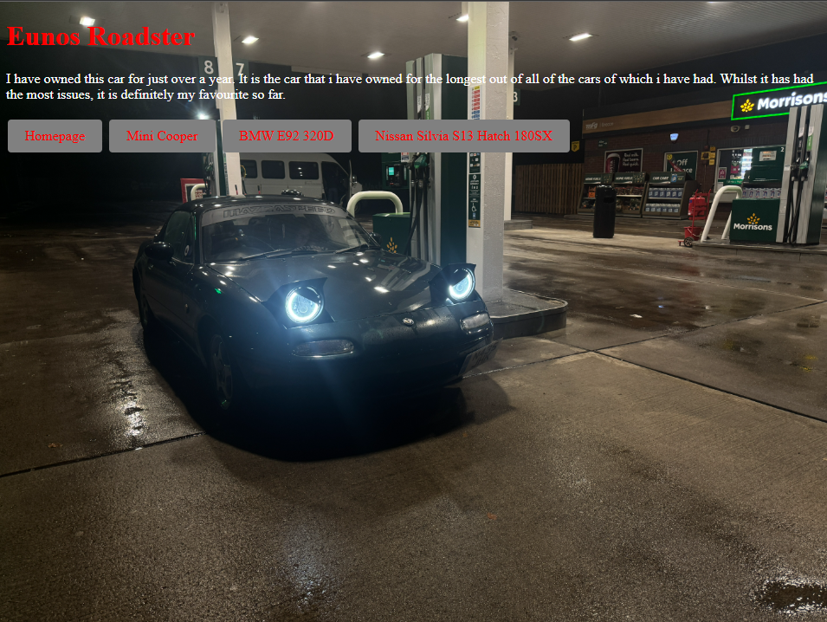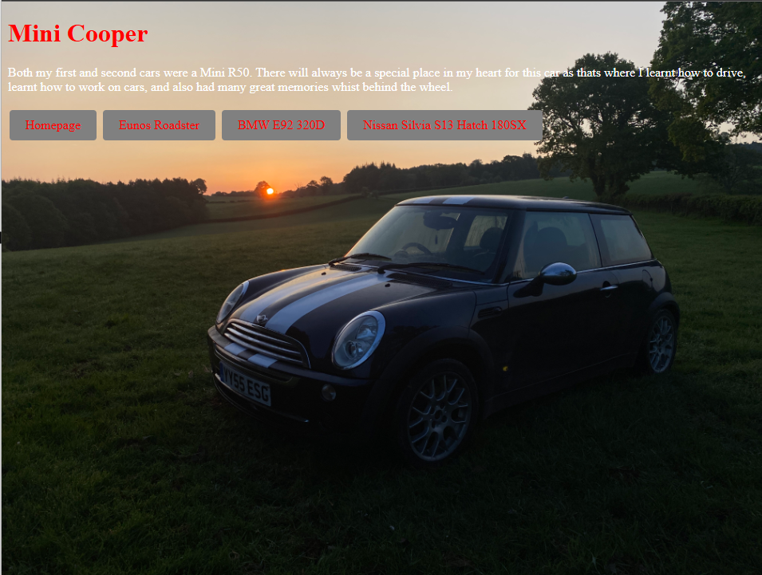
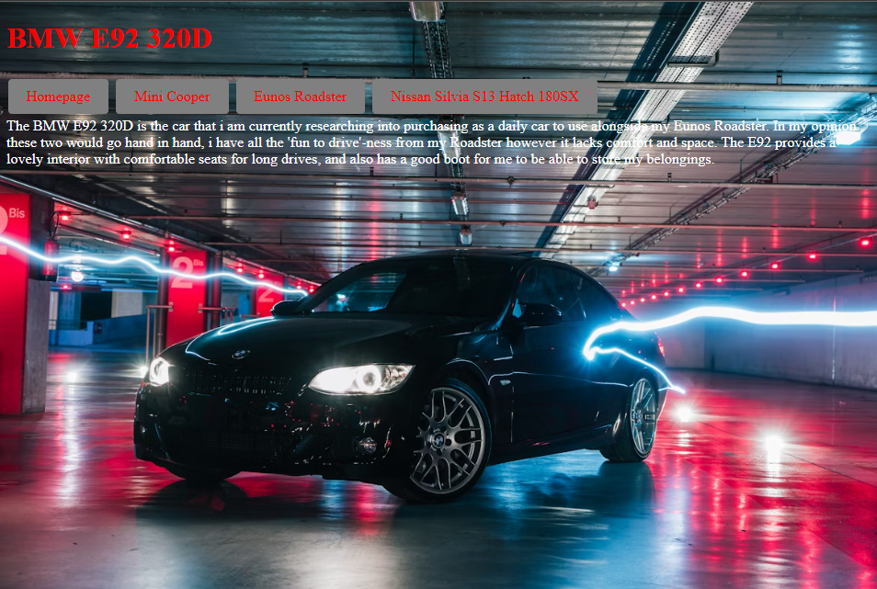
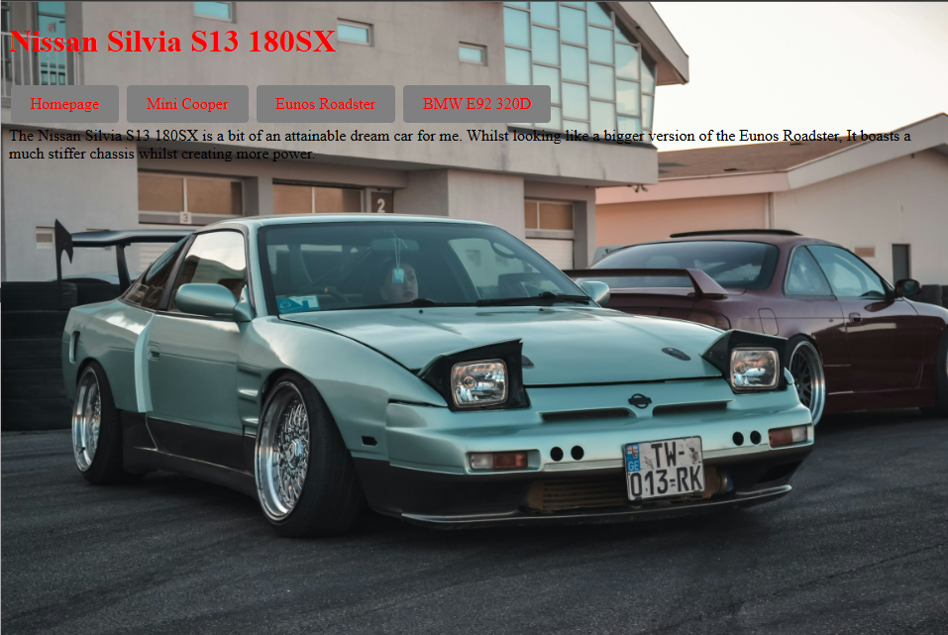

We were asked to validate both our html and CSS code using external websites. As you can see below, upon validating my HTML code for the first time, it had picked up on some errors which I had made when creating my homepage. Mainly my <p1> </p1> attempt at separating my paragraphs within my style sheet for my CSS. I had later found a different way to colour each paragraph how I needed so this was left over and not needed. Once remedied, I ran the checker again and it showed no errors.
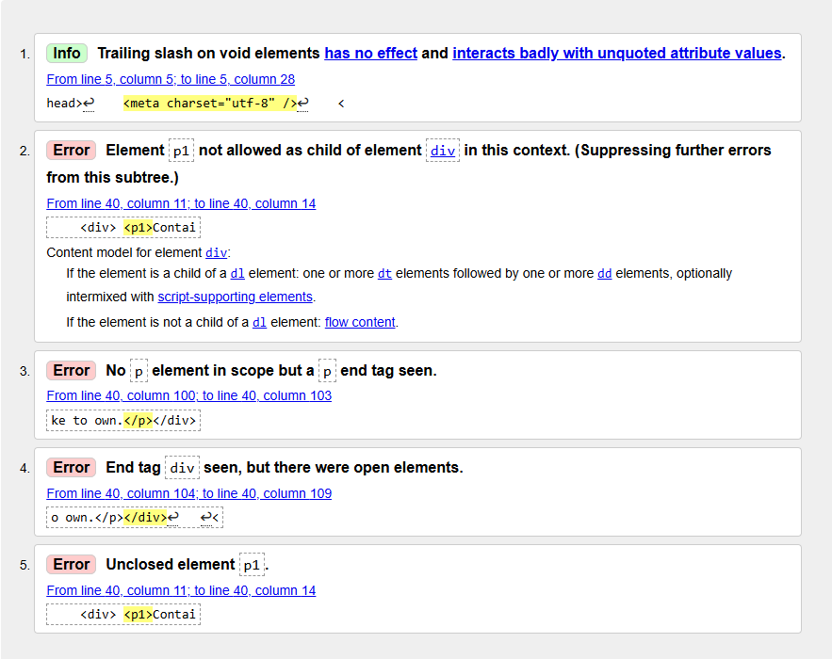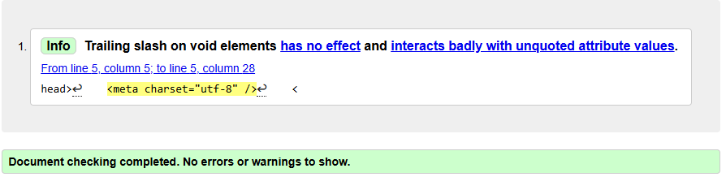

CSS Code Validation:
As you can see below, upon validation you can see that I had no errors for my CSS code.
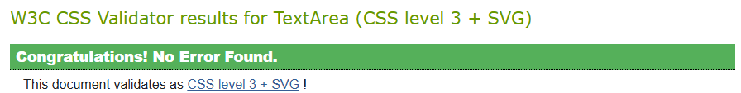

Evaluation
“Website usability is an essential indicator of user friendliness of a website which can be evaluated by observing users when using the website's features and user interfaces.” [1]
I focused on ensuring that my website was easy to and intuitive to navigate. I made this decision as I knew that my website would not have too many features on it and that I needn’t had to focus on much else other than ensuring a smooth user experience.

“Accessibility isn’t just a requirement for public-sector organizations in the European Union (EU). The European Accessibility Act (EAA) mandates that a range of products and services, including many types of online experiences such as e-commerce websites and mobile apps, are accessible to people with disabilities.” [2]
I had to ensure that my website would be easily accessible for people who had disabilities which may affect their motor skills. For this, instead of leaving the buttons to my other web pages as hyperlinks, I created large buttons which not only improve the look of my website and make it look more professional, but it also makes navigating the website much easier for someone who may struggle to click on small links.
“Search engine optimization (SEO) is the art and science of getting pages to rank higher in search engines such as Google, Bing and Yahoo.” [3] Upon research into SEO I discovered that google for instance, will prefer websites which are optimised for mobile devices. To counter this, with all of my elements especially my background images, I set their size to be a percentage (of 100%) rather than a specified pixel size. This will scale my image accordingly so it displays how I intended it to regardless of what you are viewing my website on.
In conclusion, I believe that with further knowledge, I could improve this website tenfold. However with my current skills, I am relatively happy with the outcome. If I were to do it again or make changes to the current site, I would add more content (pictures, videos, statistics)

Appendices
HTML:
Homepage (index.html)
<!DOCTYPE html>

<html lang="en">
<head>
<meta charset="utf-8" />
<title>"Drew McClennon (2312801)"</title>
<link rel="stylesheet" href="style.css">
<style>
body {
background-image: url('homepage.jpg');
background-size: 100%;
background-repeat: no-repeat;
background-attachment: fixed;
background-color: black;
}
.button-class {
background-color: grey;
border: none;
color: red;
padding: 10px 20px;
text-align: center;
text-decoration: none;
display: inline-block;
font-size: 16px;
margin: 4px 2px;
cursor: pointer;
border-radius: 4px;

}

</style>
</head>
<body>

<h1>Drew McClennon (2312801)</h1>
<a href="eunos.html" class="button-class">Eunos Roadster</a>
<a href="mini.html" class="button-class">Mini Cooper</a>
<a href="bmw.html" class="button-class">BMW E92 320D</a>
<a href="nissan.html" class="button-class">Nissan Silvia S13 Hatch 180SX</a>
<div> <p>Contained in this website are a list of cars that I have owned and would like to own.</p></div>

</body>
</html>

Eunos Roadster (eunos.html)

<!DOCTYPE html>

<html lang="en">
<head>
<meta charset="utf-8" />
<title>"Drew McClennon (2312801)"</title>
<link rel="stylesheet" href="style.css">
</head>
<style>
body {
background-image: url(mit.JPG);
background-size: 100%;
background-repeat: no-repeat;
background-attachment: fixed;
background-color: black;
}
.button-class {
background-color: grey;
border: none;
color: red;
padding: 10px 20px;
text-align: center;
text-decoration: none;
display: inline-block;
font-size: 16px;
margin: 4px 2px;
cursor: pointer;
border-radius: 4px;

}
</style>
<body>
<h1>Eunos Roadster</h1>
<p style="color: white;">I have owned this car for just over a year.
It is the car that i have owned for the longest out of all of the cars of which i have had.
Whilst it has had the most issues, it is definitely my favourite so far.
</p>
<a href="index.html" class="button-class">Homepage</a>
<a href="mini.html" class="button-class">Mini Cooper</a>
<a href="bmw.html" class="button-class">BMW E92 320D</a>
<a href="nissan.html" class="button-class">Nissan Silvia S13 Hatch 180SX</a>
</body>
</html>

Mini Cooper (mini.html)

<!DOCTYPE html>

<html lang="en">
<head>
<meta charset="utf-8" />
<title>"Drew McClennon (2312801)"</title>
<link rel="stylesheet" href="style.css">
</head>
<style>
body {
background-image: url(mick.JPG);
background-size: 100%;
background-repeat: no-repeat;
background-attachment: fixed;
background-color: black;
}
.button-class {
background-color: grey;
border: none;
color: red;
padding: 10px 20px;
text-align: center;
text-decoration: none;
display: inline-block;
font-size: 16px;
margin: 4px 2px;
cursor: pointer;
border-radius: 4px;

}
</style>
<body>
<h1>Mini Cooper</h1>
<p style="color: white;"> Both my first and second cars were a Mini R50. There will always be a special place in my heart for this car as thats where I learnt how to drive, learnt how to work on cars, and also had many great memories whist behind the wheel.
</p>
<a href="index.html" class="button-class">Homepage</a>
<a href="eunos.html" class="button-class">Eunos Roadster</a>
<a href="bmw.html" class="button-class">BMW E92 320D</a>
<a href="nissan.html" class="button-class">Nissan Silvia S13 Hatch 180SX</a>
</body>
</html>

BMW E92 320D (bmw.html)
<!DOCTYPE html>

<html lang="en">
<head>
<meta charset="utf-8" />
<title>"Drew McClennon (2312801)"</title>
<link rel="stylesheet" href="style.css">
</head>
<style>
body {
background-image: url(mick.JPG);
background-size: 100%;
background-repeat: no-repeat;
background-attachment: fixed;
background-color: black;
}
.button-class {
background-color: grey;
border: none;
color: red;
padding: 10px 20px;
text-align: center;
text-decoration: none;
display: inline-block;
font-size: 16px;
margin: 4px 2px;
cursor: pointer;
border-radius: 4px;

}
</style>
<body>
<h1>Mini Cooper</h1>
<p style="color: white;"> Both my first and second cars were a Mini R50. There will always be a special place in my heart for this car as thats where I learnt how to drive, learnt how to work on cars, and also had many great memories whist behind the wheel.
</p>
<a href="index.html" class="button-class">Homepage</a>
<a href="eunos.html" class="button-class">Eunos Roadster</a>
<a href="bmw.html" class="button-class">BMW E92 320D</a>
<a href="nissan.html" class="button-class">Nissan Silvia S13 Hatch 180SX</a>
</body>
</html>

Nissan Silvia S13 Hatch 180SX (nissan.html)

<!DOCTYPE html>

<html lang="en">
<head>
<meta charset="utf-8" />
<title>"Drew McClennon (2312801)"</title>
<link rel="stylesheet" href="style.css">
<style>
body {
background-image: url('s13.jpg');
background-size: 100%;
background-repeat: no-repeat;
background-attachment: fixed;
background-color: black;
}
.button-class {
background-color: grey;
border: none;
color: red;
padding: 10px 20px;
text-align: center;
text-decoration: none;
display: inline-block;
font-size: 16px;
margin: 4px 2px;
cursor: pointer;
border-radius: 4px;

}

</style>
</head>
<body>

<h1>Nissan Silvia S13 180SX</h1>
<a href="index.html" class="button-class">Homepage</a>
<a href="mini.html" class="button-class">Mini Cooper</a>
<a href="eunos.html" class="button-class">Eunos Roadster</a>
<a href="bmw.html" class="button-class">BMW E92 320D</a>
<div> <p1>The Nissan Silvia S13 180SX is a bit of an attainable dream car for me. Whilst looking like a bigger version of the Eunos Roadster, It boasts a much stiffer chassis whilst creating more power. </p></div>

</body>
</html>

CSS Code Style Sheet (style.css)
h1 {
color: red;
}

img {
width: 100%;
}

p1 {
color: black;
}

References

[1] | Ramotion, “Website Usability 101: Definition, Principles and Methods,” Ramotion, 17 April 2023. [Online]. Available: https://www.ramotion.com/blog/website-usability/#:~:text=Website%20usability%20is%20an%20essential,rather%20than%20the%20actual%20procedure..
[2] | Level Access, “European Accessibility Act 2005 (EAA),” Level Access, [Online]. Available: https://www.levelaccess.com/compliance-overview/european-accessibility-act-eaa/?utm_source=google&utm_medium=cpc&utm_campaign=G_S_EAA_EMEA&utm_content=NB_EAA_BM&utm_ad=726839816373&keyword_id=kwd-1671848089129&utm_term=eu%20accessibility%20act&matchtype=b.
[3] | Optimizely, “Search Engine Optimisation,” Optimizely, [Online]. Available: https://www.optimizely.com/optimization-glossary/search-engine-optimization/#toc-item-0.

