The Fairmont Monte Carlo – dept….
24 May 2024

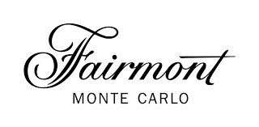

Student name: Monica Roman
ID : 2128507
MONCONSULT LTD.
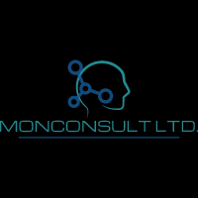

Executive Summary:
The famous Fairmont Monte Carlo hotel in the Principality of Monaco is facing a number of problems that could hurt its ability to compete in the high-end hotel market. Even though the hotel has a great name and a great view of the Mediterranean Sea, it needs to change to meet the needs of its guests, deal with worries about sustainability, and adapt to the way the market is changing in order to stay successful. The Fairmont Monte Carlo has hired a top consulting company that focuses on strategic management and organizational development to help them deal with these problems. The consulting firm has carefully looked at the hotel's internal and external settings using various theoretical frameworks and analytical tools, such as PESTEL, SWOT, and TOWS analysis, to find important problems and strategy chances. There are a lot of things that could be done better, like going digital, expanding sustainable projects, and finding new ways to make money, which the research shows. To make the most of these chances, the consulting firm has created a strategic action plan with specific suggestions and actions to improve the experiences of guests, make operations more efficient, and raise income potential. Some important suggestions are to make big changes to your digital presence, start doing things that are better for the environment, offer more health options, and improve your relationships with brands. By following this action plan, Fairmont Monte Carlo can become a star in luxury hospitality, giving guests the best experiences possible while leaving the least amount of damage on the earth and making the most money possible. In the end, this study shows Fairmont Monte Carlo how to deal with its current problems and take advantage of strategic chances in the high-end hotel market. With the help of [Name of Consulting Firm], the hotel can handle the tricky business world and make sure its long-term success in giving travelers around the world unforgettable experiences.
Table of Contents
Executive Summary: 1
Introduction: 4
Analysis: 5
PESTEL analysis: 5
SWOT analysis: 8
TOWS analysis: 10
Recommendations and Change Management 11
Recommendations for the hotel: 11
Change in leadership and policies in the management: 14
Key Performance Indicators in evaluating: 16
Action Plan: 18
Conclusion: 22
References: 23

Introduction:
The Fairmont Monte Carlo is a symbol of wealth and class in the hotel business. Located in the heart of the Principality of Monaco, the hotel has great views of the Mediterranean Sea, luxurious rooms, and top-notch services and amenities. It has been associated with luxury and elegance since its opening in 1975 with princess Grace Kelly being the opening guest. Even though Fairmont Monte Carlo has a great name, the hotel has recently received a number of reviews in which guests expressed their disappointment in certain services or experiences they had during their stay: cool welcome, bed sizes did not correspond to booking, guests were not informed that there were refurbishment works going on which disrupted their sleep and caused inconveniences, certain food products did not have the expected quality, pool was closed, etc. All these reviews could negatively impact its standing in the tough market for high-end hotels. Since its opening, Fairmont Monte Carlo has become a symbol of class that draws sophisticated travellers from all over the world (Lee & Jan, 2019). The hotel has 602 rooms and suites, including the luxurious Fairmont Gold rooms. It has stunning views of the coast of Monaco and the famous Monte Carlo Casino. Its closeness to famed sites like the Prince's Palace and the Formula One Grand Prix track, mainly the Hairpin turn-one of the most dangerous turns in all Formula 1 tracks- which sits right in front of the hotel, makes it even more appealing to people who want to relax or have an exhilarating stay. Even though Fairmont Monte Carlo has a great past and a strategic position, the recent unpleasant guest experiences need to be addressed and solved strategically. These problems are related mainly to guest experience but also some issues of sustainability. The Fairmont Hotel has hired a consulting company, MonConsult LTD, that specialises in strategy management and organisational development to help them deal with these problems and mitigate recent issues. This consulting firm has worked with some important names in hospitality to drive innovation, improve business efficiency, and give guests the best experiences possible. The firm has a team of experienced professionals who know both best practices and cutting-edge methods in their field. They can help Fairmont Monte Carlo solve its current problems and reach its strategic goals to offer excellent guest service and continue exceeding their guests’ expectations.
This study will use many different theoretical methods and analytical tools, such as PESTEL, SWOT, and TOWS analysis, to look at the problems that Fairmont Monte Carlo is having, assess the areas that need improvements and create strategies to be implemented to create unforgettable experiences and offer quality services for guests. These models will help the hotel get a full picture of the macro-environmental factors outside the hotel, its own strengths and flaws, and its strategy choices. Using these analytical tools, the study aims to give Fairmont Monte Carlo useful information and suggestions that will help them deal with the complicated world of high-end hotels and take advantage of growth and different possibilities. In short, this report will go into detail about the problems that Fairmont Monte Carlo is facing and look at possible strategies to solve them. By using theoretical frameworks, industry knowledge, and useful suggestions, MonConsult Ltd. will help Fairmont Monte Carlo keep its position as a top choice for high-class travelers, offer consistent exceptional service which is paramount for a high degree of guest satisfaction scores and ensure its financial growth and long-term success in the fast-paced hospitality industry.

Analysis:

PESTEL analysis:
A PESTEL analysis for Fairmont Monte Carlo has been provided in the section below and is important for understanding the dynamic nature of the industry that the hotel operates in.
Political factors:
Fairmont Monte Carlo is situated in Monaco, which is a parliamentary monarchy with a safe government. The government of the country actively encourages travel, which makes it a good place for high-end hotels like Fairmont to operate. However, because Monaco is a small country, its neighbours and foreign groups can have an effect on its political choices. This can, in turn, affect policies related to tourism, taxes, and labour laws (Assaf & Josiassen, 2016). Changes in international ties and tensions in geopolitics can also have an effect on the hotel business in Monaco.
Economic factors:
Monaco's economy is strong, with low unemployment and a high income per person. The tourists, banks, and real estate industries all play a big role in this. Wealthy tourists, celebrities and business travellers visit Monaco every year, with a lot of Hallmark events that attract millions of people annually, bringing massive benefits for the hotel industry there, including the Fairmont Monte Carlo (Assaf & Josiassen, 2016). But changes in customer buying habits, economic downturns in key source markets, and foreign exchange rates can all affect the hotel's ability to make money. It's also hard to stay competitive and increase revenue when running costs are going up (food, labour and energy).
Social factors:
Fairmont Monte Carlo serves a wide range of guests, from high-class travellers to business leaders and famous people from all over the world. Trends in society, like the growing desire for experiencing luxury, wellness-focused features, and environmentally friendly practices, affect the hotel's marketing and service offers. Also, consumer tastes are always changing because of things like demographics, changes in lifestyle, and cultural norms. Businesses have to keep adapting to meet guest standards and improve customer satisfaction. Effective digital marketing and image management strategies are also needed because social media has a big impact on how people think about brands and how loyal they are to those brands.
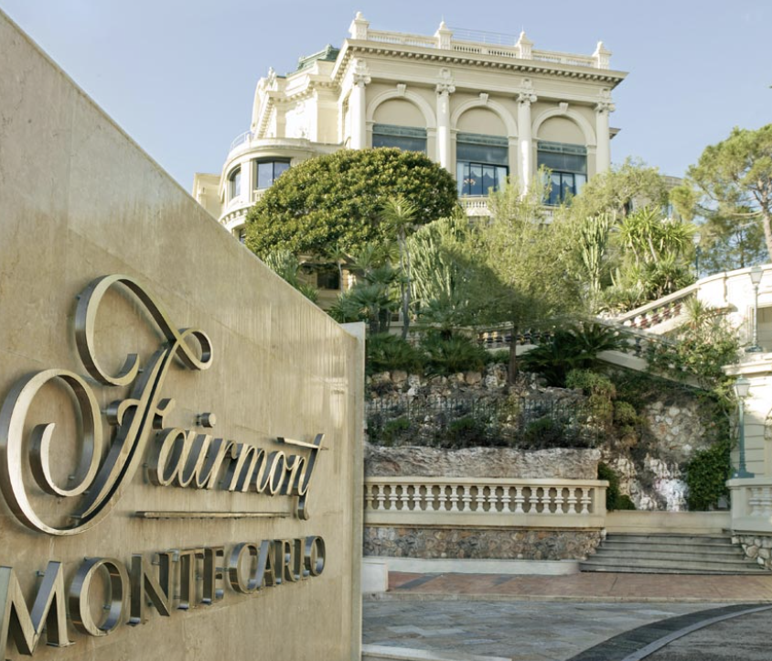
Fig. 1
Technological Factors:
The hotel business depends on technology more and more to stay competitive, make operations run smoothly, and make the guest experience exceptional. To make things easier and offer more personalised services, Fairmont Monte Carlo uses state-of-the-art tools like property management systems, online booking platforms, and customer relationship management software (Teixeira & Gomes, 2017). Improvements in communication and connection have also made it possible for the hotel to interact with guests through a variety of digital methods, from messages sent before they arrive to comments sent after their stay. Fairmont has implemented Easyway, a digital platform that provides a complete solution for the hotel’s operational challenges on daily basis, but also enhances the service and guest experience (Hoteltechreport, 2024). The hotel can use Easyway to improve general guest engagement and experience from beginning to the end, share unique offers and loyalty programme benefits to their guests, creating a more streamlined guest lifecycle.

Environmental Factors:
As sustainability becomes more important to both customers, local communities and governments, the Fairmont Monte Carlo is under pressure to do adopt green policies and prioritise environmental measures to reduce negative impact on local and global environment. Monaco has one of the highest rates of certified rooms (88% of total capacity) and has been pioneering the use of heat pumps. The Fairmont has, since opening, a very sophisticated system that takes water from a 40 meter depth in the Mediterranean Sea and uses it to heat and air-condition its rooms. Environmental rules and standards, like LEED (Leadership in Energy and Environmental Design), must be followed (Gupta & Bhatia, 2018). Fairmont Monte Carlo aims to obtain the Green Globe status this year (Fairmont Monte Carlo, 2024), which is a high sustainability commitment certification. The hotel has many other environmental-friendly services, offers e-bike rentals or electric car transfers to the airport, etc. This shows that the business is responsible and also appeals to travelers who care about the environment, which helps the brand's image and keeps guests coming back. But changes to operations and investments in sustainable infrastructure may have high costs and need to be made over a long period of time to show clear benefits.
Legal Factors:
Laws control many aspects of hotel operations. These include labour laws, health and safety rules, licensing requirements, and taxation policies. Following both local and foreign laws (neighbouring France and Italy) is important to keep business running. Also, changes in the law, like new rules on data privacy or environmental standards, can have an effect on how the hotel works and require policy and procedure changes. Contracts with suppliers, partners, and workers must also be carefully discussed and managed to reduce legal risks and make sure that everyone follows regulations of the industry.

SWOT analysis:
The SWOT analysis for the hotel has been provided in the section below for the readers to understand the underlying capabilities and weaknesses in the company.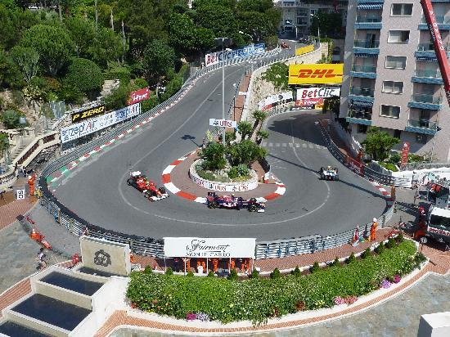
Fig.2 Famous Monaco F1 Grand Prix Hairpin turn

Strengths:
The Fairmont Monte Carlo has a number of strengths that offer a competitive edge in the market for high-end hotels. Because of its perfect location in Monaco, the hotel is a tourist hot-spot and attracts wealthy people from all over the world. There are over 600 beautifully decorated guest rooms and suites on site, all of which have stunning views of the Mediterranean Sea or the famous Monaco Grand Prix track (Poon & Low, 2014). The hotel also has world-class services, such as Nobu restaurant, bars, a rooftop pool, spa facilities, night club, which allow guests to choose from a variety of options and improve their overall stay. The Fairmont Monte Carlo is dedicated to providing excellent service, and its highly trained staff is known for being professional and paying close attention to detail. They make sure that each guest has a unique and memorable stay.
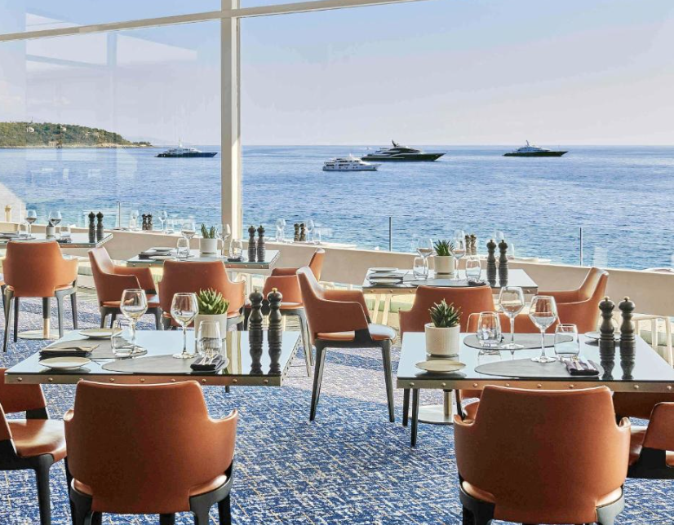
Fig.3 Lobby Lounge Restaurant and Bar
Weaknesses:
Even though Fairmont Monte Carlo has many good points, it also faces problems that could affect its financial performance and guest satisfaction scores. One problem is that the hotel is vulnerable to outside forces like changes in the economy and yearly tourist trends, which can have an effect on occupancy rates and consequently on the hotel’s revenue. As a luxury property, Fairmont Monte Carlo also has to deal with "intense competition" from other high-end hotels and spas in Monaco and nearby places that target the same wealthy guests (Kang & Heo, 2018). Keeping the hotel's "historical charm" while also meeting modern guests' needs for services and technology is also hard. To stay competitive in the changing hospitality industry, the hotel needs to keep investing and reinventing itself.
Opportunities:
Fairmont Monte Carlo can use new market factors and trends to its advantage to encourage growth and new ideas. High-income guests looking for one-of-a-kind events can use the hotel's well-known name and famous position to their advantage. As wellness tourism grows in popularity, Fairmont Monte Carlo can add more specialised and tailored services to meet the needs of guests who want to rest, rejuvenate, and experience overall health benefits. The hotel can also take advantage of the rising demand for "sustainable tourism" by promoting its pioneering heat-pump, dating from 1975, implementing more eco-friendly solutions and supporting "responsible travel" programmes which involve guests’ participation. This will attract customers who care about the environment and raise its image for corporate social responsibility. Strategic relationships with local businesses, event planners, and luxury brands can also create connections and cross-promotional opportunities that help the hotel's brand stand out and reach more customers.
Threats:
Fairmont Monte Carlo could be threatened by a number of things that might affect its business and finances. Uncertainties in the economy, like global recession or financial crisis, can make people less confident and less likely to spend extra money. This can lower the demand for high-end hotels and other leisure services (Altinay & Paraskevas, 2015). Geopolitical pressures, natural disasters, or public health problems like pandemics can also change travel plans and the flow of tourists, which can diminish occupancy rates and income streams. Alternative housing choices like holiday rentals and home-sharing platforms are also popular, creating competition for traditional hotels like the Fairmont. They need to come up with new strategies to stand out and stay relevant in the market. In addition, changes in regulations, like new tax policies or government rules, can affect the hotel's working costs and ability to make money.

TOWS analysis:
The TOWS analysis is helpful for understanding the future strategic outlook of the business in the sense of decision making. It has been provided below for the hotel:
Strengths-Opportunities (SO):
The Fairmont Monte Carlo can use its skills to take advantage of new opportunities in the high-end hotel business. The hotel can improve its brand image and bring in wealthy travelers looking for unique experiences thanks to its great location and status as a high-class spot (Ritchie & Jiang, 2019). Fairmont Monte Carlo can set itself apart from rivals and meet the changing needs of high-end travelers by spending in high-end amenities and personalised services like custom butler services and private cooking classes with the distinguished Nobu restaurant chefs, organising tailored special celebrations in the hotel or on the yachts docked in Monte Carlo Marina. The hotel can also take advantage of the growing demand for environmentally friendly and wellness travel by creating eco-friendly programmes or special wellness packages. These offers will help the hotel meet the needs of travellers who want to have responsible vacations.
Strengths-Threats (ST):
Fairmont Monte Carlo can protect itself from possible threats by using the skills and resources it already has. As a well-known high-end hotel, the hotel can keep customers coming back and lessen the effect of rising competition from other places by giving regular guests special benefits and exclusive loyalty programs (Ritchie & Jiang, 2019). Implementing Easyway platform The Fairmont is able to have real-time interaction with their members and guests, promote special offers and discounts and get their immediate feedback. By focusing on offering great service and keeping guests happy, Fairmont Monte Carlo can also lower the risk of bad reviews and damage to its image, protecting its brand in a market that is becoming more and more competitive. The hotel can also lessen the effects of economic downturns by reducing its reliance on traditional sources of income and increasing its reliance on smart relationships with local businesses and event organisers.
Weaknesses-Opportunities (WO):
Fairmont Monte Carlo can improve the hotel's technology system, add new features like digital butler services (Kim & Kim, 2018) and renovate some outdated amenities to help streamline operations and offer guests a better experience, creating more appeal to travellers. The hotel can also use its size and famous position to host more events, such as high-profile conferences, weddings, and social meetings. This will help the business increase its revenue stream and fill in empty rooms during slow times.
Weaknesses-Threats (WT):
Fairmont Monte Carlo needs to fix its flaws to protect its long-term health and reduce the risk of danger. One major weakness of the hotel is that it is easily affected by changes in the economy and the number of tourists during different times of the year. To lower this risk, Fairmont Monte Carlo can use revenue management techniques to make the most of price and product management. This way, the hotel can make the most money during high-demand times and lose the least during low-demand times (Ko & Pastore, 2018). The hotel can also invest in training and development programs for staff to solve any problems that might arise with service quality or operating efficiency. This type of problem has caused a series of negative reviews for the hotel in the past few months. Fairmont Monte Carlo can also lessen the effect of outside risks on its finances by targeting a wider range of customers and focusing on specific areas through tailored marketing. This way, it can avoid being too dependent on a single market or source of business.

Recommendations and Change Management

Recommendations for the hotel:
The Fairmont Monte Carlo needs to make changes to keep up with changing guest tastes, market trends, and the way competition works in the high-end hotel business. The hotel can stay ahead of the competition, bring in wealthy guests, and ensure long-term success and profit by adopting new ideas, sustainability, and personalized experiences.
Improve digital presence and the experience of the guests:
The Fairmont Monte Carlo should spend money to improve its digital infrastructure so that its guests have a better time and activities run more smoothly. Using digital butler services, personalized guest platforms, and mobile check-in/out can make things run more smoothly and make things easier for guests while also cutting down on costs. According to a study by Deloitte, hotels with more advanced digital features have happier guests and make more money per open room (RevPAR) (Choi & Murray, 2018).
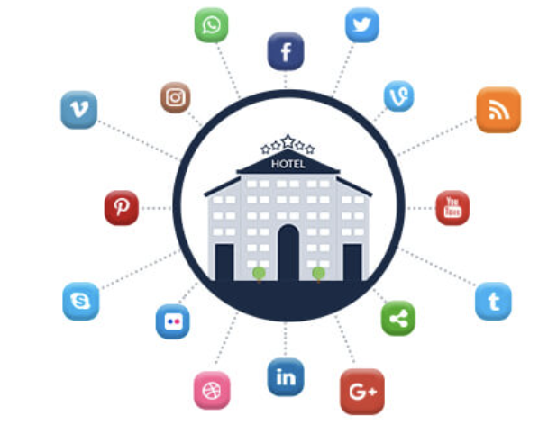
Create projects that will last:
Sustainability is becoming more and more important in the hotel business, so Fairmont Monte Carlo makes it a priority to use eco-friendly methods and start eco-friendly projects. This could mean buying energy from green sources, lowering trash through recycling and composting programs, and getting organic food for its restaurants from farms close by. Sustainable practices not only appeal to travelers who care about the environment, but they also help businesses save money and run more smoothly over time, according to research.
Expand Wellness Offerings:
Wellness travel is becoming more and more popular, so the Fairmont Monte Carlo should add more hotel and wellness services to meet the needs of guests who want to experience overall health. This could mean adding new fitness groups, health programs, and spa services that focus on awareness, relaxing, and renewal. The Global health Institute says that the health tourism market will grow to $919 billion by 2024 (Lee, Park & Yoo, 2016). This is a huge chance for hotels to make money off of this trend.
Diversify Income Streams:
The Fairmont Monte Carlo should look for ways to increase its income streams so that it is less reliant on traditional sources of income and can better handle changes in the economy. This could mean adding more event hosting options so that it can hold more business meetings, workshops, and leisure events all year long (Ramkissoon & Mavondo, 2015). The hotel could also look into forming relationships with nearby companies to give guests access to special deals and events, like food tours or boat charters.
Invest in Staff Training and Development:
The Fairmont Monte Carlo should put a high priority on staff training and development programmes to ensure high levels of guest service because they know how important service quality is in the high-end hotel industry. By giving workers ongoing training in problem-solving, conversation, and cultural understanding, for example, the hotel can give guests an experience that sets it apart from its competitors. An investigation from Cornell University found that hotels with well-trained staff have happier guests and more return business.
Optimise Revenue Management Strategies:
The Fairmont Monte Carlo should use advanced revenue management strategies to make the most money possible and improve price and product control. Using tools for data analysis and projections can help the hotel find trends in demand, change prices on the fly, and make the best use of room assignments to get the highest revenue per available room (RevPAR). A study by McKinsey & Company found that hotels that use revenue management methods see a 2-5% rise in RevPAR compared to hotels that don't.
Strengthen brand partnerships and collaborations:
Working with local businesses and expensive brands can help the Fairmont Monte Carlo's brand stand out and bring in high-value guests. Having partnerships with high-end stores, private clubs, and tour companies can help you promote each other and give your guests unique experiences. The hotel could also look into co-branding opportunities with famous cooks, artists, or fashion designers to create unique eating experiences or events that wealthy travelers would enjoy.
Listen to and respond to guest feedback:
The Fairmont Monte Carlo should listen to and respond to guest feedback through online reviews, polls, and social media to find ways to improve and quickly solve guest concerns. A strong guest feedback management system can help the hotel keep track of performance data, find out how satisfied guests are, and spot trends over time. Fairmont Monte Carlo can improve its guests' trust and image by listening to their concerns and taking action to fix problems. This will lead to more bookings and more money coming in.

Change in leadership and policies in the management:
In the upscale hotel field, Fairmont Monte Carlo, like all businesses, needs to be able to handle change well in order to keep up with changing market conditions, new technologies, and guest tastes. Strong change management practices and processes are needed to make sure that moves go smoothly, that pushback is kept to a minimum, and that efforts to make the hotel more competitive and improve guest experiences are fully realized:
Setting Realistic Goals and a Grand Vision:
Before making any changes, Fairmont Monte Carlo needs to set clear goals and a convincing picture of how things should be in the future. This means explaining why things need to change, setting goals that can be measured, and getting everyone on board with a single goal. By giving workers a clear picture of the future, the company can build trust, get their support, and encourage them to take an active role in the change process.
Getting stakeholders involved and getting their support:
Key players at all stages of the organization must be involved and on board for change management to work well. Early on in the change process, Fairmont Monte Carlo should involve workers, guests, suppliers, and other important parties to get their feedback, handle concerns, and build agreement. Setting up cross-functional teams and discussion groups can make it easier for people to work together, support different points of view, and make sure that change efforts take into account the wants and needs of all parties.
Figuring out readiness and impact:
Before making any changes, Fairmont Monte Carlo should do a full analysis of how ready the organization is and how the suggested changes might affect things. To do this, things like present skills, resource access, cultural relations, and possible risks need to be looked at. By being aware of possible problems and obstacles ahead of time, the hotel can create preventative plans to lower risks, deal with pushback, and make sure the implementation goes smoothly.
Knowing how to communicate well:
During the change management process, it's important to keep everyone involved aware, involved, and on track with the initiative's goals and objectives. The Fairmont Monte Carlo should make a full communication plan that includes monthly reports, town hall meetings, training sessions, and other ways to get the word out, get feedback, and address issues. Open and honest communication increases trust, lowers doubt, and encourages people to work together and take responsibility.
Giving support and training:
Fairmont Monte Carlo should put money into thorough training and development programs for its workers to make sure that they can handle changes and that the hotel runs smoothly. This could include both professional training on new systems or processes and "soft skills" training on things like customer service, leadership, and being able to deal with change. Giving workers constant support and teaching can help them deal with problems, boost their confidence, and be more open to change.
Giving employees power and encouraging new ideas:
The Fairmont Monte Carlo should give its workers the freedom to lead change projects and come up with ways to make things better. By fostering a culture of creativity and ongoing growth, the hotel can get its workers to look for ways to improve things, try new things, and add to its success. Employees who are rewarded for their contributions to change efforts are more likely to feel like they own the change and work hard to make it happen.
Keeping an eye on progress and making changes to plans:
Fairmont Monte Carlo should keep an eye on work, review results, and make changes to tactics as needed during the change management process. By using measurements and key performance indicators (KPIs), the hotel can keep track of how well change efforts are working, find places to improve, and make decisions based on data. The organization can respond to changing conditions, take advantage of chances, and stay flexible in a changing setting thanks to regular reviews and feedback loops.
Fairmont Monte Carlo can make the most of shifts, take advantage of chances for growth and innovation, and ensure long-term success in the competitive luxury hotel industry by putting in place strong change management practices and processes. By encouraging teamwork, talking to each other, and always getting better, the hotel can react to changing market trends, go above and beyond what guests expect, and keep being the best place for high-class travelers to stay.

Key Performance Indicators in evaluating:
If Fairmont Monte Carlo follows the suggestions above, it should be able to reach a number of key performance indicators (KPIs) that show how well and positively its change initiatives have been received. The KPIs cover many areas of the hotel's business, including how guests feel about their stay and how well it does financially.
- Revenue Growth: Find out how much more money making because hotel is selling more, giving customers a better experience, and getting a bigger share of the market.
- RevPAR Growth: Keep an eye on the increase in income per open room (RevPAR), which could mean that more rooms are being used or that the average daily rate has gone up.
- Spa and Wellness Revenue: Keep an eye on the money that comes in from spa services and wellness options. This will show how well new health programs are working and how engaged guests are.
- Scores for how happy guests are: Check to see if the happiness scores of past guests have gone up using polls, online reviews, and other feedback methods.
- Repeat Guest Rate: Find out what number of guests come back to the Fairmont Monte Carlo, which means they were happy and will stay there again.
- Net Promoter Score (NPS): Find out how likely guests are to tell others about the hotel, which shows how satisfied and enthusiastic they are generally.
- Occupancy Rates: Keep an eye on rising room occupancy rates, which show that hotel services are being used more and more.
- Average Length of Stay: Keep an eye on changes in the average length of stays of guests, which can show more engaged guests and better experiences.
- Employee Productivity: Track changes in employee productivity measures, like the number of rooms cleaned per hour or the amount of money each employee brings in. This will show you if your business is running more efficiently.
- Energy Consumption Reduction: Figure out how much less energy is being used because of eco-friendly actions, like installing lights and HVAC systems that use less energy.
- Waste Reduction: Track how much waste is generated and introduce circular economy principles in produce usage, to cut carbon … that the hotel cares about the environment.
- Green Certifications: Get certifications like LEED (Leadership in Energy and Environmental Design) or Green Key to show that the hotel meets strict sustainability standards and improve its environmental credentials.
- Employee Engagement: Use internal polls and feedback systems to see if employee happiness numbers are going up or down.
- Employee Turnover Rate: Keep track of employee turnover rates, which means that employees are more engaged and likely to stay with the company.
- Training Completion Rates: Keep track of completion rates of training and development programs. This shows that employees are getting better at what they do.
- Market Share Growth: Asses Fairmont Monte Carlo's market share growth compared to its competitors in the high-end hotel area.
- Check if there are changes in how people recognise and think about the brand through market research and polls. These changes should show that people are more aware of the brand and appreciate its quality.
- Social Media Engagement: Track the number of new social media fans, engagement measures (tags, likes, shares, and comments), and online mentions that show your brand is getting more attention and interaction with the target market.

Action Plan:
For every issue area that has been identified, this action plan provides detailed instructions, remedies, expected results, deadlines, and budgetary estimates. It gives Fairmont Monte Carlo a methodical way to organize and carry out the suggested tactics and solutions, guaranteeing that they are in line with company objectives and resource distribution.
Number | Problem | Solution | Desired Outcome | Time Scale | Completion Date | Planned Budget
1 | Need for Digital Transformation | Full digital update that includes digital butler services, personalised guest platforms, and mobile check-in/out. | Better experiences for guests, more efficient operations, and more money coming in. | 6 months | 01/01/2025 | $100,000
2 | Limited Sustainable Initiatives | Create and use eco-friendly methods, like healthy food choices, waste reduction programs, and green energy sources. | Less damage to the environment, better brand recognition, and appeal to people who care about the environment. | 12 months | 07/01/2026 | $50,000
3 | Expansion of Wellness Offerings | Add more programs, exercise lessons, and overall health experiences to your spa and leisure center. | Wellness services that bring in more money, make guests happier, and set you apart from rivals. | 9 months | 04/01/2025 | $75,000
4 | Diversification of Revenue Streams | Establish relationships with nearby companies to offer special deals and hold events. | Added new sources of income, grew market share, and became less reliant on old sources of income. | 6 months | 01/01/2025 | $30,000
5 | Staff Training Program | Focus your training and development programs on service quality, leadership, and being able to handle change for all workers. | Enhanced staff happiness, increased engagement, improved working effectiveness, all leads to higher guest satisfaction. | Ongoing | - | $100,000/annum
6 | Optimisation of Revenue Management | Use data analytics and projection tools to come up with improved strategies for managing income. | Maximising revenue per available room (RevPAR), making price and product control better, increase profitability. | 3 months | 01/01/2025 | $50,000
7 | Strengthening Brand Partnerships | Partnership with high-end brands, small businesses in the area, and event organiser to work together on exclusive projects and cross-promote each other. | Better company exposure, a bigger market reach, and standing out through unique encounters. | 9 months | 04/01/2025 | $40,000
8 | Implementation of Feedback Mechanisms | Set up strong ways for guests and employees to give feedback, improve and update constantly Easyway platform. | Continuous feedback and improvement leads to high guest satisfaction. | Ongoing | - | $20,000/annum

Conclusion:
The Fairmont Monte Carlo consulting report concludes with a thorough examination of the hotel's existing prospects and issues, along with strategic suggestions and a plan of action to successfully handle them. By means of identifying pivotal concerns like faults in the customer experience or lack of communicating certain issues that could affect guest stay, the want for digital transformation, restricted sustainable endeavours, and prospects for income diversification, the paper furnishes practical insights to augment the hotel's competitiveness within the upscale hospitality sector. In order to keep up with changing consumer trends and guest expectations, the report's suggestions stress the need of consolidating staff training to offer impeccable customer service, empowering staff to take decisions and solve problems on the spot, embracing digital innovation, improving environmental initiatives, growing wellness programs, and fortifying brand alliances. By putting these suggestions into practice, Fairmont Monte Carlo can establish itself as a pioneer in the upscale hospitality industry, providing outstanding visitor experiences while optimising income potential and reducing environmental effect. The report's action plan gives Fairmont Monte Carlo a methodical way to organize and carry out the suggested tactics, complete with defined goals, deadlines, and financial allotments for every project. The hotel may measure progress, methodically handle obstacles, and achieve quantifiable results in line with its strategic objectives by adhering to this action plan. We would like to thank Fairmont Monte Carlo for the opportunity to work with them on this project as the consulting comes to a close. We are grateful for the confidence you have put in our abilities, and we're determined to help the hotel meet its goals and maintain its lead in the upscale lodging industry. In the event that Fairmont Monte Carlo needs more help or knowledge down the road, we're here to discuss possible joint ventures and aid the hotel in its continuous pursuit of excellence in guest experiences, profitability, and sustainability. Finally, we would like to thank you for your cooperation and engagement throughout this consulting process. We have no doubt that the information and suggestions included in this study will help maintain Fairmont Monte Carlo's standing as a top luxury tourist destination for the long run. We appreciate the chance to work with you once again, and we hope to have the opportunity to do so in the future and wish you the best of luck!

References:
Accor (2024) Fairmont Monte Carlo https://all.accor.com/ssr/app/accor/rates/A598/index.en.shtml?compositions=1&dateIn=2024-04-29&nights=1&facets=fai&hideHotelDetails=false&hideWDR=false&destination=monte-carlo-98000-monaco&utm_campaign=ppc-ach-mafm-msn-uk-en-seu-mix-sear-&utm_content=uk-en-MC-V2645&utm_medium=cpc&utm_source=bing&utm_term=mafm (Accessed: 29 April 2024).
Accor (2023) Notes to Financial Statements [pdf]. Available at: file:///C:/Users/User/Downloads/Accor-2023-Notes-to-Financial-Statements-vPUB-amendee.pdf 01 May 2024 (Accessed: 01 May 2024).
Accor (2024) Why Invest [pdf]. Available at: file:///C:/Users/User/Downloads/01_EN_Why%20Invest%20in%20Fairmont_Accor%20Global%20Development_JUN2020%20(2).pdf (Accessed: 01 May 2024).
Altinay, L., & Paraskevas, A. (2015). Planning research in hospitality and tourism. Annals of Tourism Research, 54, 1-13.
Assaf, A. G., & Josiassen, A. (2016). International hotel performance: A global benchmarking approach. International Journal of Hospitality Management, 53, 1-11.
Fairmont Monte Carlo (2024) Luxury Hotel in Monaco. Available at: https://www.fairmont-montecarlo.com/en/ (Accessed: 29 April 2024).
Fairmont Monte Carlo (2024) Social-environmental responsibility. Available at: https://www.fairmont-montecarlo.com/en/social-environmental-responsibility/#:~:text=The%20hotel%20also%20uses%20cutting,while%20offering%20guests%20unrivalled%20comfort. (Accessed:15 May 2024).
Free Logo Design (2024). Available at: https://www.freelogodesign.org/manager (Accessed: 08 May 2024).
Gouvernment Princier (2024) Employment/ Labour-Law. Available at: https://en.gouv.mc/Policy-Practice/Employment/Labour-Law (Accessed:16 May 2024).

Gupta, S., & Bhatia, S. (2018). Sustainable tourism: Drivers and challenges. Journal of Hospitality and Tourism Management, 35, 91-98.
Hello Monaco (2022) The Fairmont Monte Carlo. Available at: https://www.hellomonaco.com/leisure-entertainment/hotels/the-fairmont-monte-carlo-a-unique-hotel-in-the-very-heart-of-monaco/ (Accessed:29 April 2024).
Hodges, J. (2017) Consultancy, Organizational Development and Change. Kogan Page.
Hotel Tech Report (2024) Guest experience: From email to instant communication. Available at: https://hoteltechreport.com/success-stories/guest-experience/easyway/fairmont-monte-carlo (Accessed: 28 April 2024).
Kang, S. H., & Heo, C. Y. (2018). The impact of hotel website quality on users’ perception and booking intention. Journal of Hospitality Marketing & Management, 27(7), 726-747.
Kim, S., & Kim, M. (2017). The effect of green marketing on green commitment: Exploring the roles of green brand attitude and green brand image. Sustainability, 9(1), 13.
Kim, S., & Kim, M. (2018). The influence of luxury restaurant environments on guests’ emotions and loyalty intentions: The moderating role of destination image. International Journal of Hospitality Management, 72, 1-11.
Lee, H. A., Park, S., and Yoo, S. (2016) Does luxury consumption enhance psychological well-being? Luxury consumption, well-being, and the mediating role of psychological need satisfaction. Psychology & Marketing, 33(2), 103-114.
Lee, T. H., & Jan, F. H. (2019) Understanding the relationship between green hotel initiatives and guest satisfaction: A meta-analysis. Sustainability, 11(6), 1737.
Management Consultans Association (2024) AI and Digital technology to drive growth in consulting in 2024. Available at: https://www.mca.org.uk/press-releases/ai-and-digital-technology-expected-to-drive-growth-in-consulting-in-2024-according-to-independent-new-survey (Accessed: 13 May 2024)
https://mitmagazine.co.uk/Sponsored-Content/Monaco-leads-the-way-on-sustainable-tourism
(Accessed: 15 May 2024).
Ritchie, J. R., & Jiang, Y. (2019). A review of research on tourism risk, crisis and disaster management: Launching the Annals of Tourism Research curated collection on tourism risk, crisis and disaster management. Annals of Tourism Research, 79, 102812.
Sigala, M. (2018). Service intelligence in tourism and hospitality: Theory, research and practice. Journal of Service Management, 29(4), 639-655.
Teixeira, R., & Gomes, C. F. (2017). Drivers and outcomes of green tourism development: A systematic review. Sustainability, 9(10), 1865.
Tripadvisor (2024) Fairmont Monte Carlo Reviews. Available at: https://www.tripadvisor.com/Hotel_Review-g190409-d230423-Reviews-Fairmont_Monte_Carlo-Monte_Carlo.html 01 May 2024 (Accessed: 01 May 2024).

