For this assessment component, I have chosen to review the article “Was Art Really the ‘Book of the Illiterate’?” published by Lawrence Duggan in the journal Word and Image, in 1989. The article was later published in Reading Images and Texts: Medieval Images and Texts as Forms of Communication. This journal consisted of papers from talks from historians at the Utretcht symposium on medieval literacy in 2000. The papers were published as a journal in 2005.
Lawrence G Duggan is a professor at the University of Delaware, and has spent his career focussing on the later Middle Ages, the Renaissance and the Reformation. He is primarily a medieval historian with a distinct interest in German History and the Church. Other works of his include “Bishop and Chapter: The Governance of the Bishopric of Speyer to 1552” and “Armsbearing and the Clergy in the History and Canon Law of Western Christianity”. His focus on the Renaissance means that some of the examples given by Duggan in the article are from the wrong time period from which we gain the source of the debate.
The argument put forth by Duggan in the article is arguing against a quote from Pope Gregory, the source of the debate. In 600CE, Pope Gregory wrote a letter to Bishop Serenus of Marsailles containing the following:
“What scripture is to the educated, images are to the ignorant, who see through them what they must accept, they read in them what cannot be read in books.”
In this quote, Pope Gregory is stating that images can be used to teach the illiterate of the time what they cannot read from books. However, Duggan puts forth the counter argument that this is incorrect. Duggan puts forth the idea that in the medieval period, reading did not have the same definition as it does today. Instead, reading was thought of as either reading something to yourself, or having someone read something to you, and the ability to retain the information and understand it.
According to Duggan, reading a text can communicate new information to a reader: “Words are inherently more precise than images and convey new knowledge”. Duggan also says, “One either knew already what was depicted, or else could not learn from the image alone anything of elementary value”. Along side this, Duggan offers two examples of images that do not convey new knowledge, and instead rely on the reader knowing what the story is that is being depicted. The examples he offers are Masaccio’s Tribute Money, and The Entry into Jerusalem in Duccio’s Maesta. Herein lies the first limitation of Duggan’s article. The two pieces of art that Duggan suggests are evidence that points towards Pope Gregory being incorrect, are from a completely different time period. Pope Gregory’s letter was sent in the 7th Century. Masaccio painted Tribute Money in the 15th Century and Duccio painted The Entry into Jerusalem in the 14th Century. One can assume that the stories that were presented in these two pieces were already common knowledge to 14th and 15th century Christians, and that is why there is no need to tell the story, only to remind the viewer of it. However, the images that Pope Gregory is referencing are very different.
One strength of Duggan’s article is that although it is written for a symposium, where the audience would have been other historians and those who would have a similar interest and the background knowledge of the subject, the article does not read like it. The article is easy to follow, and although there are a number of names mentioned, Duggan does offer an explanation as to who they are, so that if you do not possess the background knowledge, you are able to follow the article.The language used, although significantly smarter than your average person, does not feel intimidating in any way.
The article contributes to the historiographical debate of whether art was used to tell a story, or to remind the viewer of a story. Other historians that contribute to this debate are Herbert Kessler, a medieval art historian, and Celia Chazelle. The article has not gained much reputation in this debate, although it is a heated debate. Duggan has stated that he has had people come up to him and say how influential the paper has been, but also that the work did not gain much attention in the field.
Overall, Was Art Really the ‘Book of the Illierate’? Puts forth many ideas that counter Pope Gregory’s assumption that images were to the illiterate as books were to the literate. However, there are some ideas that Duggan could have worked on, such as suggesting examples of art from the time of Pope Gregory. However, the article was responsible for some contribution to the debate from other historians, leading to more recognition of the debate, which could have led to some more research from other historians.

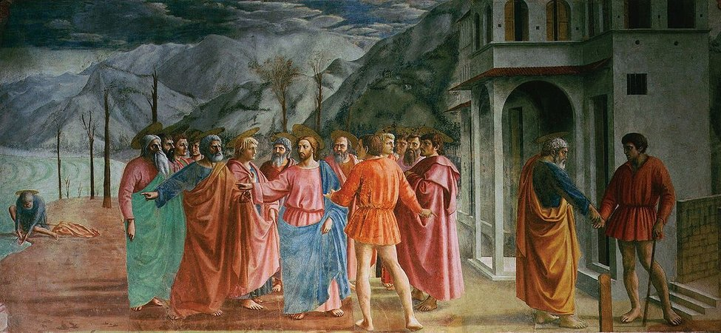
Figure 1 - Tribute Money by Masaccio
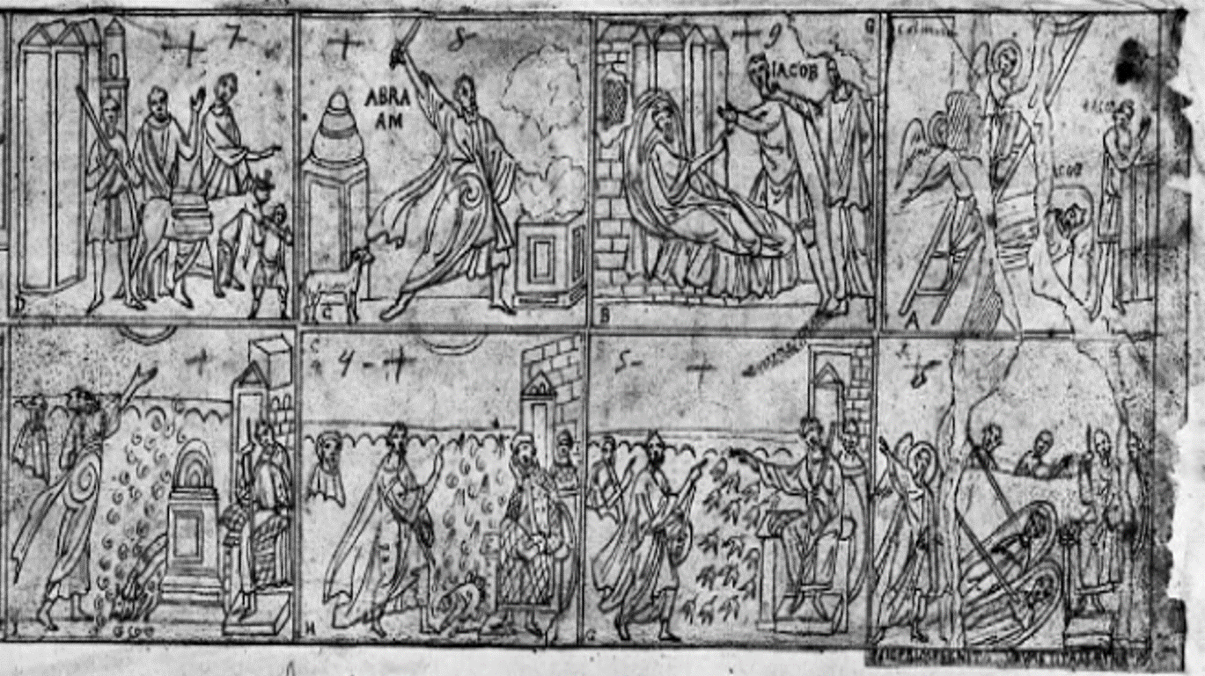
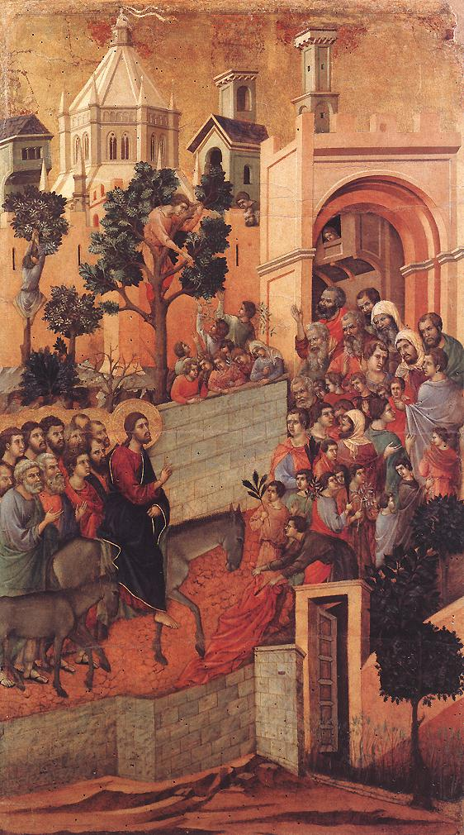
Figure 3 - Late 18th century-early 19th century drawing of the 5th-century decoration on the nave walls of St Paul’s Outside the Walls, Rome
Figure 2 - The Entry into Jerusalem by Duccio

Bibliography –
Duggan, Lawrence, ‘Was Art Really the “Book of the Illiterate”?’ Reading Images and Texts: Medieval Images and Texts as Forms of Communication, ed. by Marielle Hageman and Marco Mostert, Utrecht Studies in Medieval Literacy 8 (Turnhout: Brepols Publishers 2005), pp, 63-107.

Lawrence G. Duggan, ‘Was Art Really the “Book of the Illiterate”?’ Reading Images and Texts: Medieval Images and Texts as Forms of Communication, ed. by Marielle Hageman and Marco Mostert, Utrecht Studies in Medieval Literacy 8 (Turnhout: Brepols Publishers 2005), p, 96.
Duggan, p, 97.
See Figure 1 – Tribute Money by Masaccio
See Figure 2 – The Entry into Jerusalem by Duccio
See Figure 3 - Late 18th century-early 19th century drawing of the 5th-century decoration on the nave walls of St Paul’s Outside the Walls, Rome

