
Module Code: LCMB7035
Module Name: Dissertation

Title: The Impact of Al Adoption on Operational Efficiency: The Mediating Role of Employee Competence

Student Name: Rajesh chaudhary
Student ID: 2433823
Submission Date: 22/09/2026
Word Cunt: 2199
Table of Contents
1. Introduction 3
1.1 Background 3
1.2 Research Problem 3
1.3 Research Aim 4
1.4 Research Objectives 4
1.5 Research Questions 4
1.6 Significance 5
2. Literature Review 5
2.1 Introduction 5
2.2 Artificial Intelligence Adoption 5
2.3 Operational Efficiency 6
2.4 Employee Competence 7
2.5 Relationship between AI Adoption and Operational Efficiency 7
2.6 Theoretical Framework 8
2.6.1 Technology–Organization–Environment (TOE) Framework 8
2.6.2 Resource-Based View (RBV) Theory 9
2.8 Research Gap 10
2.9 Conceptual Framework 10
2.10 Research Hypotheses 11
3. Methodology 11
3.1 Research Philosophy 11
3.2 Research Approach 12
3.3 Research Design 12
3.4 Research Strategy 12
3.5 Population 12
3.6 Sampling 13
3.7 Data Collection 13
3.8 Variables 13
3.9 Data Analysis 13
3.10 Reliability and Validity 14
3.11 Ethical Considerations 14
4. Expected Findings 14
5. Limitations 14
6. Timeframe 15
7. Conclusion 16
References 17

1. Introduction

1.1 Background
Artificial Intelligence (AI) is emerging as the key tool for organisations in the journey of digital transformation, enabling them to automate repetitive tasks, enhance decision-making capabilities and optimise resource utilisation. Advancements in AI have been swift, with the industry making significant strides in adopting the technology over the last few years. Moreover, AI is expected to drive about US$15.7 trillion value to the global economy by 2030, primarily through productivity gains and business innovation (Treat, 2026).

1.2 Research Problem
While the use of AI has grown significantly, there is still a notable challenge in achieving the expected benefits in operational efficiency, with the adoption of AI not necessarily taking into account the knowledge workers' frame of mind, digital competencies and adaptability. Research so far regularly focuses on technological infrastructure and AI skills, with hardly any consideration of employee competence as a way in which AI generates organisational value (Zirar, Ali and Islam, 2023) (Refer to Figure 1).
Figure 1. AI Adaption
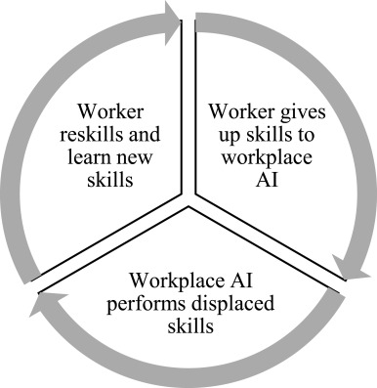
Source: Adapted from: Zirar, Ali and Islam, 2023

1.3 Research Aim
The study is aimed at understanding the influence of the adoption of AI on the operational efficiency and the intervening role of employee competence.

1.4 Research Objectives
- To examine the effect of Artificial Intelligence (AI) adoption on operational efficiency.
- To investigate the mediating role of employee competence in the relationship between AI adoption and operational efficiency.

1.5 Research Questions
Main Research Question
How does Artificial Intelligence (AI) adoption influence operational efficiency in organisations through employee competence?
Sub-questions
- RQ1.1: How does AI adoption affect employee competence in organisations?
- RQ1.2 To what extent does employee competence mediate the relationship between AI adoption and operational efficiency?

1.6 Significance
The study adds to the growing body of research on the AI-enabled organisational performance by adding to the literature the concepts of employee competency as an intervening variable. From a practical perspective, the insights will help guide AI investments against workforce capacity building, helping organisations to achieve operational efficiency and get the most value from their digital transformation programs (Kassa and Worku, 2025).

2. Literature Review

2.1 Introduction
This review article critically analyses the current literature regarding the adoption of Artificial Intelligence (AI), operational efficiency and employee competence. There has been a significant increase in scholarly interest, with many organisations now adopting AI in at least one aspect of their business (McKinsey & Company, 2025). Yet, mixed results about the operational benefits of AI suggest that employee competence might be a mediating process, and there are some theories and empirical evidence still to be uncovered.

2.2 Artificial Intelligence Adoption
AI Application is all but a key enabler of digital transformation, with AI technologies like Machine Learning, Predictive Analytics, Robotic Process Automation (RPA) and Generative AI contributing to the growth of a digital organisation. Extend the organisational ecosystem to involve employees, partners and customers in working with AI, Singh and Pandey argue (2024) (Refer to Figure 2). On the other hand, Amin et al. (2025) highlight the strategic importance of AI in boosting marketing innovation and the competitiveness of businesses. While both studies acknowledge the transformative potential of AI, Singh and Pandey (2024) primarily emphasise the readiness of organisations and the capabilities of humans to leverage the technology, whereas Amin et al. (2025) largely position the technology as the means to create a competitive advantage.
Figure 2. Digital transformation of the extended HR ecosystem through AI adoption
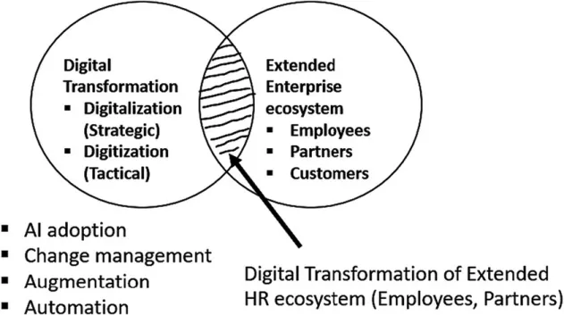
Source: Adapted from: Singh & Pandey, 2024

2.3 Operational Efficiency
Operational efficiency is when an organisation can produce its outputs at the lowest possible operational resource input, operational cost and process time. The results of Komarudin's (2025) research indicate that technological innovations greatly contribute to the improvements in productivity, processes, and speed of processes in both industries, which leads to cost-efficiency improvement that can be measured in the work carried out by digital technologies. However, Handoyo et al. (2023) argue that technology is not the only factor that can drive operational efficiency because other factors, such as business strategy, ownership structure, market uncertainty and competitive intensity, will also affect operational efficiency.

2.4 Employee Competence
Employee competence includes knowledge, technical abilities, digital capabilities, AI literacy, learning capacity and problem-solving skills; all of which are necessary to be effective in operating a technology-driven organisation. As stated by Wijayanti and Sari (2023), the increase in employee competence will always make employee performance better and increase the productivity of the organisation, through strengthening the application of knowledge and the use of employee skills. On the other hand, Kim and Jung (2022) argue that although competence is pivotal, it is not enough alone, because competent employees would have reduced stress level of their workplace and lead to better adaptation to the changes in the organisations, as long as their organisations have an appropriate organisational culture.

2.5 Relationship between AI Adoption and Operational Efficiency
The empirical evidence shows that there is evidence that there is a positive relationship between AI adoption and operational efficiency; however, it depends on the context of the organisation. According to Ngabalin (2025), AI can boost the efficiency of operations through better marketing automation, decision-making, and resource utilisation, ultimately increasing organisational productivity. On the other hand, Saif-Alyousfi and Alshammari (2026) argue that organisational value emergence due to AI usage depends on the technological capability, institutional quality and digital infrastructure (Refer to Figure 3).
Figure 3. Theoretical framework illustrating the relationship between AI adoption, operational efficiency, and organisational factors
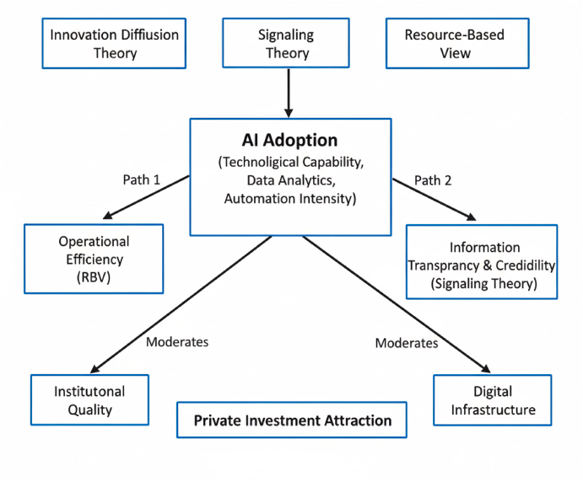
Source: Adapted from: Saif-Alyousfi and Alshammari (2026)

2.6 Theoretical Framework

2.6.1 Technology–Organization–Environment (TOE) Framework
In the Technology–Organization–Environment (TOE) Framework, technological, organisational, and environmental contexts are explained, relating to the technology adoption. Technology alone, but also human resources, top management support, and regulatory conditions, are the factors for an organisation's adoption of AI in decision making, according to Chong and Olesen (2017) (Refer to Figure 4).
Figure 4. Technology–Organization–Environment (TOE) Framework
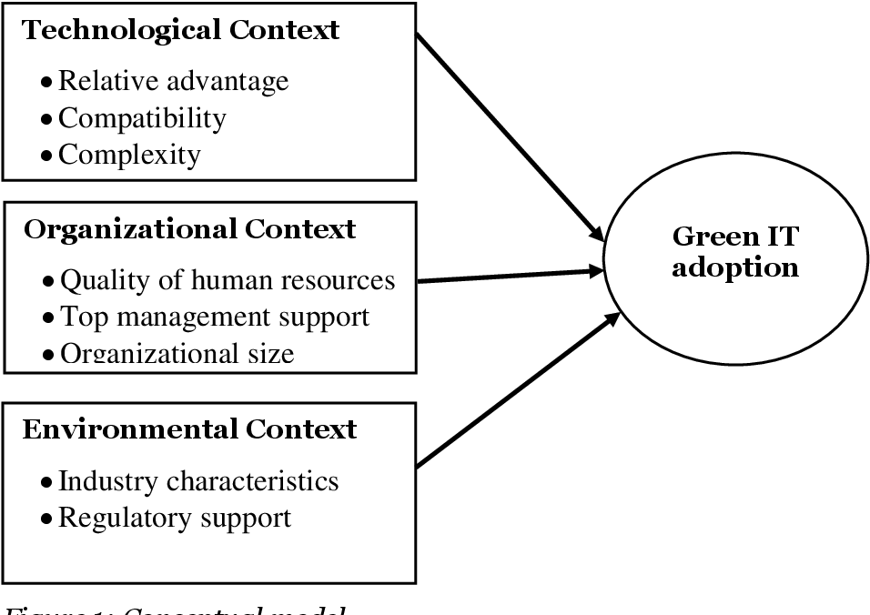
Source: Adapted from: Chong and Olesen (2017)

2.6.2 Resource-Based View (RBV) Theory
According to the Resource-Based View (RBV) of the company, sustainable competitive advantage is not only to technology but also to valuable organisational resources and capabilities. GAPS argues that enabling singular human capabilities ramps up its value to organisational performance, as manager, technical, and employee competence are strategic resources that complement AI (Beamish and Chakravarty, 2021) (Refer to Figure 5).
Figure 5. Resource-Based View theoretical framework.
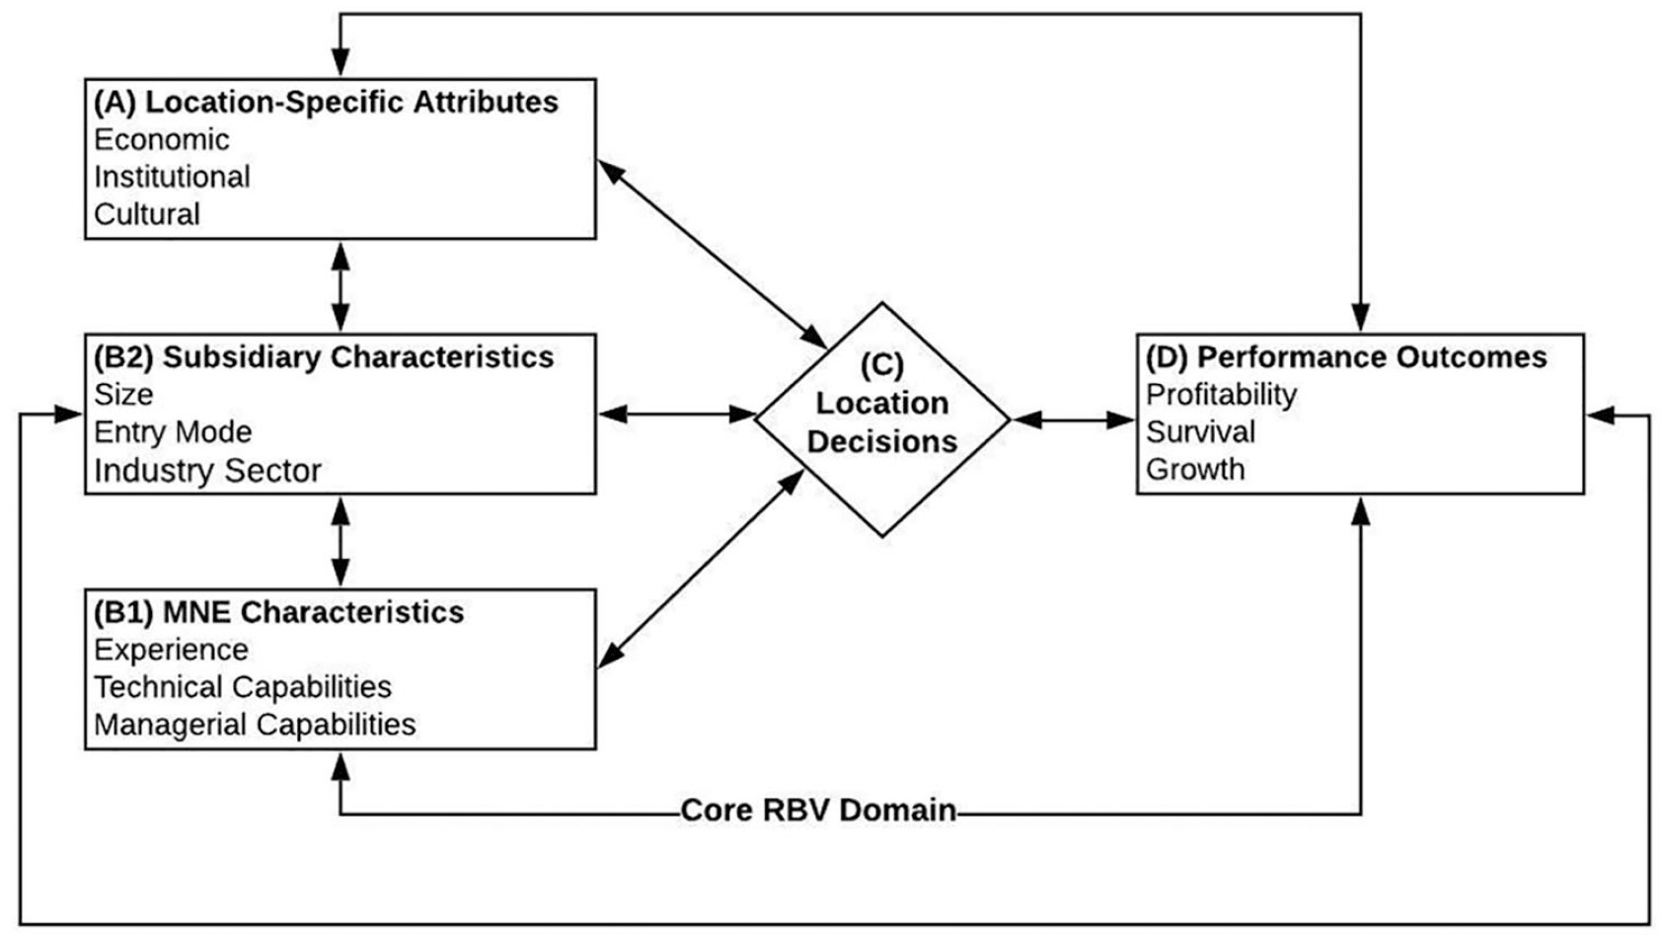
Source: Adapted from:

2.8 Research Gap
While previous research has validated and reproduced that using AI to enhance operational efficiency (Ngabalin, 2025), it has also shown that having competitive employees is essential to ensure organisational success (Wijayanti and Sari, 2023; Kim and Jung, 2022). The link between AI use and operational efficiency is mediated by employee competence, which, based on limited empirical evidence, is a significant research and practice gap, including in theory.

2.9 Conceptual Framework
Based on that logic, the independent variable would be the adoption of AI, and the dependent variable, operational efficiency, with employee competence serving as the independent variable. It believes that when the employees’ competence is improved by adopting AI, the employees become more efficient during their activities. This framework attempts to tackle the literature gap identified by identifying the mechanism by which AI can lead to organisational performance outcomes.
Figure 6. Conceptual Framework
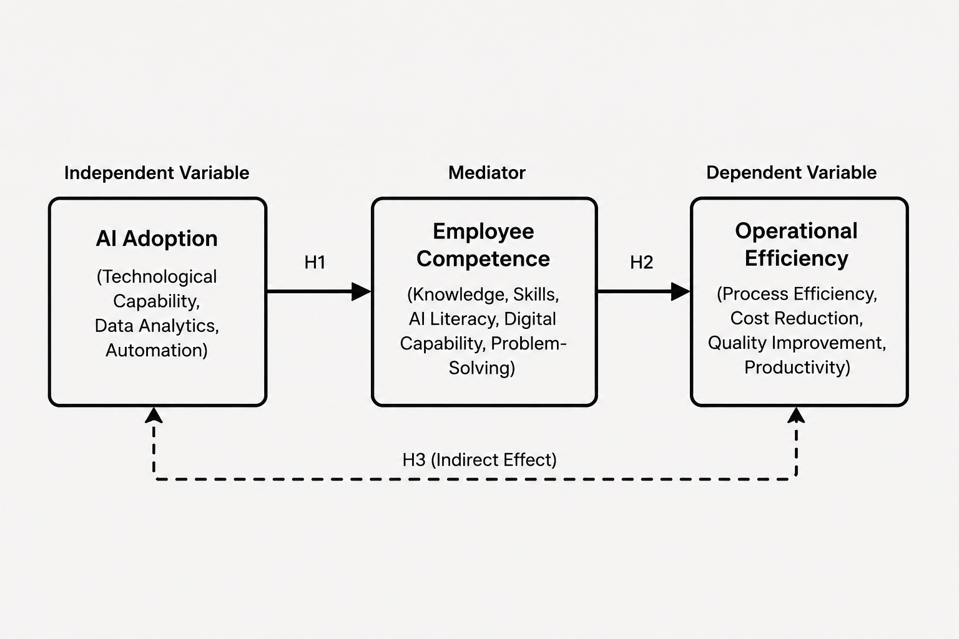
Source: Self-Created

2.10 Research Hypotheses
- H1: Artificial Intelligence (AI) adoption has a positive and significant influence on operational efficiency.
- H2: Artificial Intelligence (AI) adoption has a positive and significant influence on employee competence.
- H3: Employee competence has a positive and significant influence on operational efficiency.
- H4: Employee competence positively mediates the relationship between Artificial Intelligence (AI) adoption and operational efficiency.

3. Methodology

3.1 Research Philosophy
The research philosophy used in this study is positivism, where it is believed that knowledge has objectives, can be measured and examined based on empirical findings. The use of positivism is suitable because this study examines causal relationships between the adoption of AI, employees' competence and operational efficiency and carries quantitative data.

3.2 Research Approach
This research uses deductive research methods in which hypotheses were formulated based on the results of the Technology–Organization–Environment (TOE) Framework and the Resource-Based View (RBV) theories, which were then tested on empirical data. This is because the study intends to explore some predetermined relationships between AI adoption, user skills and operational efficiency.

3.3 Research Design
In this design, the quantitative data is solicited from the respondents in one time and place only, and hence it is called a quantitative cross-sectional survey design. The benefit of a cross-sectional survey over a qualitative design is that it can be conducted with a larger population; therefore, it has a high level of reliability and generalisability of the findings, plus it is cost and time-effective (Pyo et al., 2023).

3.4 Research Strategy
A primary data collection method of the study is a questionnaire survey, which will be used among employees who work in the organisation that has implemented this AI technology. Moreover, online surveys are quickly gaining popularity because they are accessible, have reduced administrative costs and are more efficient in terms of responses (Andrade, 2020).

3.5 Population
The target population include employees who work in organisations where the use of Artificial Intelligence technologies is active in several business areas such as operations, human resources, finance, marketing and customer service. The collected data becomes more relevant and valid when it is taken from the perspective of AI-enabled organisations.

3.6 Sampling
The study uses a purposive sampling technique, which involves targeted sampling of individuals meeting the desired respondent criteria (employees who have experience with the implementation of AI technologies in their workplace). As it is, a sample size of around 100-150 respondents is suggested, which is more than the minimum required for multiple regression and mediation analysis, and would be adequate statistical power to support reliable hypothesis testing.

3.7 Data Collection
A structured online questionnaire (Google Forms) will be the instrument for collecting primary data. Using a five-point Likert-scale (agree 1, somewhat agree 2, neither agree nor disagree 3, somewhat disagree 4 and disagree 5), the questionnaire will consist of closed-ended questions.

3.8 Variables
The study explores the three main variables. Higher adoption of AI is denoted by the independent variable of Artificial Intelligence (AI) adoption, which delineates the level of incorporation of AI technologies in an organisation. The mediator is employee competence, which includes digital capability, knowledge, AI literacy, skills, and problem-solving (Wang et al., 2024). The dependent variable is operational efficiency, which is measured using productivity, process speed, cost reduction, quality improvement and resource utilisation.

3.9 Data Analysis
All data collected is to be analysed with the help of SPSS Statistics from IBM Company. The demographic variables and the distributions of variables will be summarised using descriptive statistics. The internal consistency will be evaluated using Cronbach's Alpha, with values based on 0.70 or higher indicative of acceptable reliability.

3.10 Reliability and Validity
There will be a pilot study of about 20–30 respondents to get a good grasp of the questionnaire before the data collection stage. This will then be assessed via internal consistency (Cronbach's alpha) and content validity (expert judgment of the questionnaire items based on validated research in other studies).

3.11 Ethical Considerations
The research is to be conducted in accordance with the guidelines of the institution during the course of the study. Participants will be given an informed consent sheet that has the purpose of the study, confidentiality, that the study is voluntary, and that they can stop at any point without any penalty.

4. Expected Findings
The study is envisioned to establish the contribution of AI for improved operational efficiency through the productivity, operational costs and process quality paradigm. Based on previous research that showed AI implementation resulted in productivity gains of 20–40%, more organisations using AI are expected to perform better in their operations. Moreover, AI is predicted to enhance staff digital proficiency, AI literacy and problem-solving skills, resulting in better organisational efficiency.

5. Limitations
This study might be limited because of its cross-sectional design, purposive sampling, responses based on self-report and a narrow range of generalisability to other organisations with AI capabilities. These will be addressed by using validated scales to measure, testing with a pilot before starting the full study, anonymous participation, and suitable statistical measures of reliability and/or validity.

6. Timeframe
Table 1. Gantt Chart
Activity | W1 | W2 | W3 | W4 | W5 | W6 | W7 | W8 | W9 | W10 | W11 | W12 | W13 | W14 | W15 | W16
Proposal Writing
Literature Review
Questionnaire Design
Ethics Approval
Pilot Study
Data Collection
Data Analysis (SPSS)
Discussion & Interpretation
Final Editing & Proofreading
Final Submission
Source: Self-Created

7. Conclusion
The current study is a proposed plan that aims to improve the understanding of the impact of employees' competence on the link between the use of AI and efficiency in operations. The proposed quantitative methodology is grounded in the TOE Framework and Resource-Based View, providing for a rigorous approach to generating both theoretical and practical evidence related to the effective implementation of AI.

References
Amin, M.R.M., Asbi, A., Sivakumaran, V.M., Kim, J. and Septiarini, E. (2025). Artificial Intelligence (AI) adoption in marketing strategies: Navigating the present and shaping the future business landscape. Social Sciences & Humanities Open, [online] 12, p.102048. doi:https://doi.org/10.1016/j.ssaho.2025.102048.
Andrade, C. (2020). The Limitations of Online Surveys. Indian Journal of Psychological Medicine, 42(6), pp.575–576. doi:https://doi.org/10.1177/0253717620957496.
Beamish, P.W. and Chakravarty, D. (2021). Using the Resource-Based View in Multinational Enterprise Research. Journal of Management, 47(7), pp.1861–1877. doi:https://doi.org/10.1177/0149206321995575.
Chong, J.L. and Olesen, K. (2017). A Technology-Organization-Environment Perspective on Eco-effectiveness: A Meta-analysis. Australasian Journal of Information Systems, 21. doi:https://doi.org/10.3127/ajis.v21i0.1441.
Handoyo, S., Suharman, H., Ghani, E.K. and Soedarsono, S. (2023). A business strategy, operational efficiency, ownership structure, and manufacturing performance: The moderating role of market uncertainty and competition intensity and its implication on open innovation. Journal of Open Innovation: Technology, Market, and Complexity, [online] 9(2). doi:https://doi.org/10.1016/j.joitmc.2023.100039.
Kassa, B.Y. and Worku, E.K. (2025). The Impact of Artificial Intelligence on Organizational Performance: The Mediating Role of Employee Productivity. Journal of Open Innovation: Technology, Market, and Complexity, 11(1), p.100474. doi:https://doi.org/10.1016/j.joitmc.2025.100474.
Kim, J. and Jung, H.-S. (2022). The Effect of Employee Competency and Organizational Culture on Employees’ Perceived Stress for Better Workplace. International Journal of Environmental Research and Public Health, [online] 19(8), p.4428. Available at: https://pmc.ncbi.nlm.nih.gov/articles/PMC9032235/ [Accessed 4 Jul. 2026].
Komarudin, K. (2025). Optimizing Operational Efficiency Through Technological Innovation: A Comparative Analysis Across Industries. Journal of Innovation and Operational System, 1(1), pp.1–6. doi:https://doi.org/10.59261/jiosjournal.v1i1.1.
McKinsey & Company (2025). The state of AI: How organizations are rewiring to capture value. [online] McKinsey & Company. Available at: https://www.mckinsey.com/capabilities/quantumblack/our-insights/the-state-of-ai [Accessed 4 Jul. 2026].
Ngabalin, A.M. (2025). The Impact of Artificial Intelligence on Operational Efficiency in Marketing Management. Asian Journal of Applied Business and Management, 4(2), pp.545–554. doi:https://doi.org/10.55927/ajabm.v4i2.223.
Pyo, J., Lee, W., Choi, E.Y., Jang, S.G. and Ock, M. (2023). Qualitative Research in healthcare: Necessity and Characteristics. Journal of Preventive Medicine and Public Health, [online] 56(1), pp.12–20. doi:https://doi.org/10.3961/jpmph.22.451.
Saif-Alyousfi, A.Y.H. and Alshammari, T.R. (2026). Artificial intelligence adoption and private investment in renewable energy: Evidence from firm-level data across developed and emerging economies. Energy Strategy Reviews, [online] 64, p.102054. doi:https://doi.org/10.1016/j.esr.2026.102054.
Singh, A. and Pandey, J. (2024). Artificial intelligence adoption in extended HR ecosystems: enablers and barriers. An abductive case research. Frontiers in Psychology, [online] 14. Available at: https://www.frontiersin.org/journals/psychology/articles/10.3389/fpsyg.2023.1339782/full.
Treat, D. (2026). AI’s $15 trillion prize will be won by learning, not just technology. [online] World Economic Forum. Available at: https://www.weforum.org/stories/2026/01/ai-learning-workforce-skills/ [Accessed 4 Jul. 2026].
Wang, G., Niu, Y., Mansor, Z.D., Yee Choy Leong and Yan, Z. (2024). Unlocking digital potential: Exploring the drivers of employee dynamic capability on employee digital performance in Chinese SMEs-moderation effect of competitive climate. Heliyon, [online] pp.e25583–e25583. doi:https://doi.org/10.1016/j.heliyon.2024.e25583.
Wijayanti, F. and Sari, R.N. (2023). The influence of competency on employee performance: (A literature review). International Journal of Accounting Management Economics and Social Sciences (IJAMESC), 1(6), pp.920–931. doi:https://doi.org/10.61990/ijamesc.v1i6.118.
Zirar, A., Ali, S.I. and Islam, N. (2023). Worker and workplace Artificial Intelligence (AI) coexistence: Emerging themes and research agenda. Technovation, [online] 124(124), p.102747. Available at: https://www.sciencedirect.com/science/article/pii/S0166497223000585 [Accessed 4 Jul. 2026].

