

LOCATION: Swansea | LLEOLIAD: abertawe
LEVEL 7 | LEFEL 7
EXAMINATION PERIOD | CYFNOD ARHOLIADAU
May 2018 | mai 2018

MODULE CODE: M7X01695
IMPLEMENTING IP ROUTING

Name :

Student ID :

Date & Time :

This is an individual practical lab-test, held under examination conditions. You will be assigned four Routers, you should configure these Routers based on the following specifications.

The routers that you will configure are: ISP, London, Cardiff and Swansea.

This paper is marked out of 100.

You will have 3 hours to complete this task.

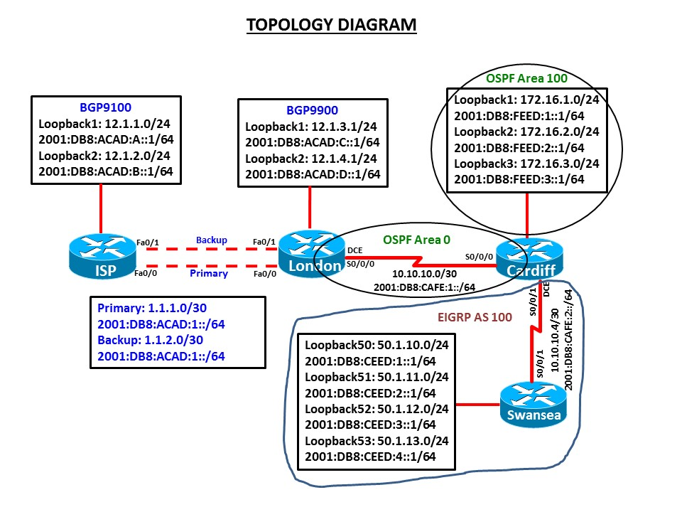

Requirements:

Task 1: IPv4 Addressing Scheme Table

Device | Interface | IP Address | Subnet Mask
ISP | Gigabit ethernet0/0
ISP | Gigabit ethernet0/1
ISP | Loopback 1
ISP | Loopback 2
Cardiff | Serial 0/0/0
Cardiff | Serial 0/0/1
Cardiff | Loopback 1
Cardiff | Loopback 2
Cardiff | Loopback 3
Swansea | Serial 0/0/1
Swansea | Loopback 50
Swansea | Loopback 51
Swansea | Loopback 52
Swansea | Loopback 53
London | Serial 0/0/0
London | Gigabit ethernet0/0
London | Gigabit ethernet0/1
London | Loopback 1
London | Loopback 2

IPv6 Addressing Table

Device | Interface | IPv6 Address | Link-Local
ISP | Gigabit ethernet0/0
ISP | Gigabit ethernet0/1
ISP | Loopback 1
ISP | Loopback 2
Cardiff | Serial 0/0/0
Cardiff | Serial 0/0/1
Cardiff | Loopback 1
Cardiff | Loopback 2
Cardiff | Loopback 3
Swansea | Serial 0/0/1
Swansea | Loopback 50
Swansea | Loopback 51
Swansea | Loopback 52
Swansea | Loopback 53
London | Serial 0/0/0
London | Gigabit ethernet0/0
London | Gigabit ethernet0/1
London | Loopback 1
London | Loopback 2

Task 2 – Network Connections (10 marks)

- Physically cable the network as shown in the topology diagram.

- Configure the router with hostname.

- Configure interfaces with the IPv4 and IPv6 addresses shown in the diagram. Set the bandwidth to 128 kbps on the links between ISP, London, Cardiff and Swansea, set the clock rate on the DCE connections as appropriate

Task 3 – Configure Routing (80 marks)

OSPFv3 with Address Families

- On London and Cardiff configure the OSPFv3 address families for IPv4 and IPv6. Use the router identifier 2.2.2.2 on Cardiff and 3.3.3.3 on London for both address families.

- On Cardiff, enable the Loopback interfaces in OSPF area 100 and the connection between Cardiff and London in OSPF area 0.

- Although there are no other routers in area 100, configure area 100 as a totally stubby area.

- Propagate an IPv4 and IPv6 default route from Cardiff into the OSPFv3 domain. Note: No default IPv4 or IPv6 static routes are configured on Cardiff.

- Configure passive interfaces for EIGRP as appropriate.

Named EIGRP

- Using Named EIGRP configuration for both IPv4 and IPv6, configure Swansea to be in AS 101. Enable the Loopback interfaces and the connection between Swansea and Cardiff for EIGRP. Ensure that automatic summarization is disabled.

- Using Named EIGRP configuration for both IPv4 and IPv6, configure Cardiff to be in AS 101. Enable the connection between Swansea and Cardiff for EIGRP. Ensure that only the connection between Swansea and Cardiff is enabled for name EIGRP. Ensure that automatic summarization is disabled.

- Configure passive interfaces for EIGRP as appropriate.

Redistribution, route filtering, and securing the control plane

- On Cardiff, configure mutual redistribution between OSPF and EIGRP for both IPv4 and IPv6. Assign appropriate metrics where required.

- On Cardiff, stop advertising the 172.16.3.0/24 route to Swansea using a distribute list and ACL.

Note: save sh ip route output before and after to verify the network has been removed from routing table.

- Secure the control plane by enable routing protocol authentication. Secure the EIGRP IPv4 and EIGRP IPv6 using SHA256.

MP-BGP

- Enable EBGP between London and ISP. London is in BGP AS 9900 with the router ID 3.3.3.3 and ISP is in BGP AS 9100 with the router ID 4.4.4.4.

- Advertise London’s Loopback interfaces and ISP’s Loopback interfaces for IPv4 and IPv6 into BGP.

- Modify the weight attributes on London and ISP so that both routers prefer the primary link between autonomous systems.
Note: If the BGP output results are not as expected, be sure to issue the clear ip bgp * on routers London and ISP.

Task 4 – Test network connectivity and path control (10 marks)

- Create a Tcl script and test connectivity from each router to the addresses shown in the diagram.
- Verify that filtered routes are not present in routing tables of the correct routers.
- Verify that traffic from AS 9900 to AS 9100 uses the preferred primary route.

Submission Requirements:

On each Router the following outputs should be copied on to a text file. The file name should be studentname_Pno_routername.txt

Show running-configuration
Show ip interface brief
Show ip route
Show ipv6 interface brief
Show ipv6 route
Show ip bgp neighbors
Show ip bgp summary

All documentation for your solution should be submitted electronically on Moodle.
It is your responsibility that you copy all the files correctly.

