Welcome to Switzerland Travel Blog.
I have been in student field trip to Switzerland with my course from Tourism and Event management faculties. The purpose of our journey was educational, experimental learning on place to explore and evaluate different tourism destination, hospitality and transport system in Switzerland. Switzerland seems to be county of high level luxury and expensive life. It is attracting people mostly for sport, eco and food tourism. During five days we saw a different types of tourism and the way how the process of tourist’s attraction happens. I spent a lot time outdoors and explore some places and the beautiful nature of Switzerland.
One day of my excursion in Switzerland was it capital Bern. It is quite small, easy orientable and looks like Middle age traditional city. Bern placed through river Aare with quiet stone street, shops, small cafes and Old town with unique historical heritage. Bern not look like other capitals, it is quite and cozy, without bustle. Time as if stopped there, flowing smoothly and measured.
I walked around the old town, without rush, looking around on the sides as there were many shops and attractive winds along the way. The most amazing view of huge bars of luxury Swiss chocolate, handmade wood clock and jewellery.
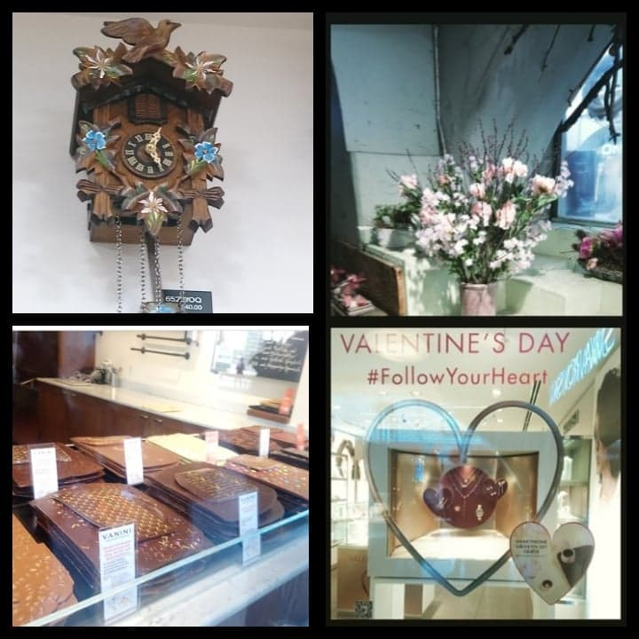
The most popular shopping street Bern is Kramgasse, the length of covered shopping gallery is so long, not enough a day to see all shops located there. You can lose your head from the number of different shops, presented brands and prices. The gallery is not only shop location, but also the way to walk through city hiding from rain.

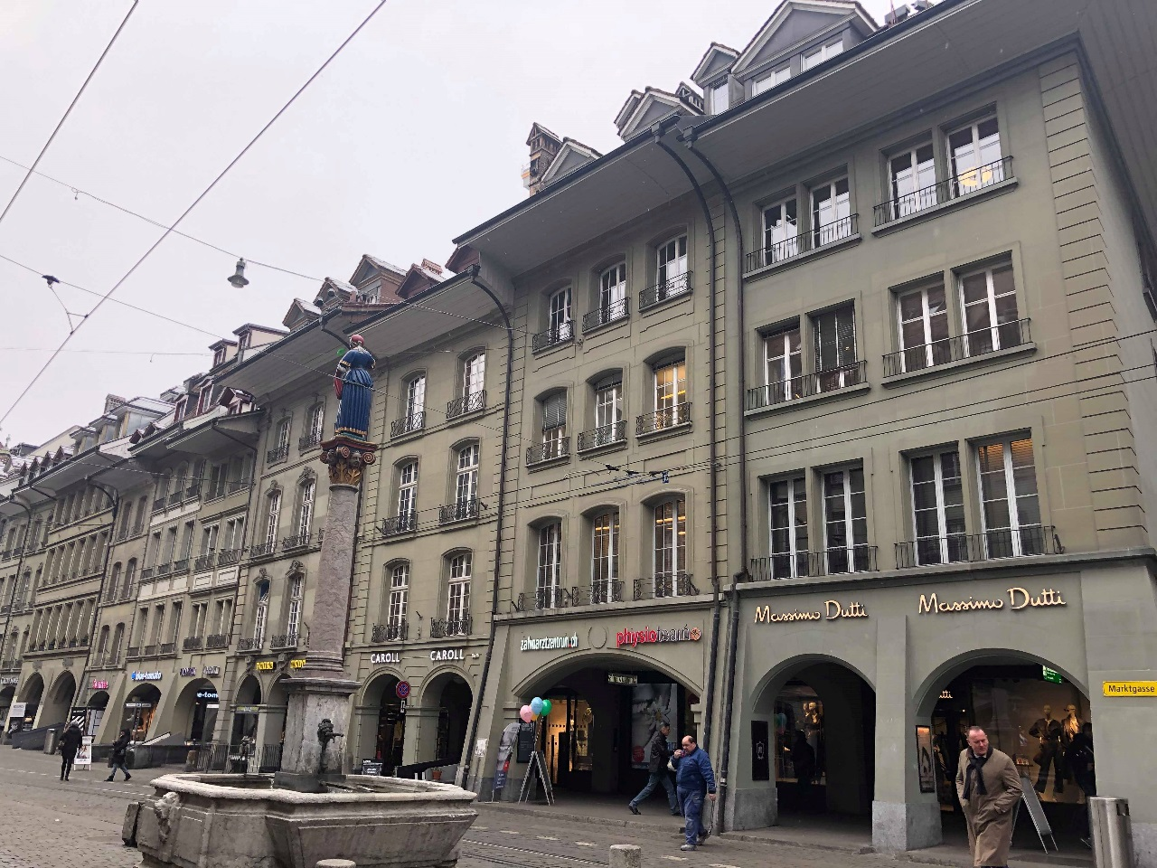

In the Old city, in spite of modern transport, the atmosphere of the city is carried away in the past: the streets paved with stone, ancient buildings and the spirit of the Middle Ages in the air. It fascinates and wants to wander around the city looking at every detail and plunge into the past.
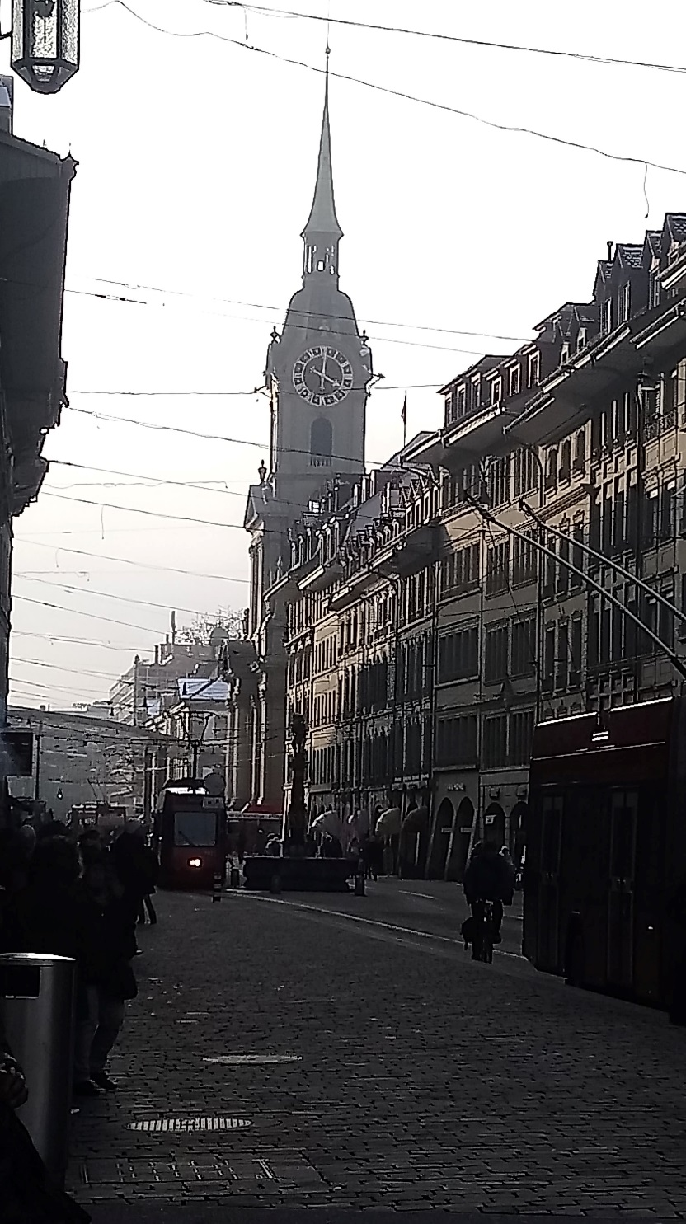
Bern’s street view

Of the most important architectural monuments is the Clock tower- Zytglogge. The tower is the most popular historical monument of Bern. This tower is famous for its unique astrological clock.
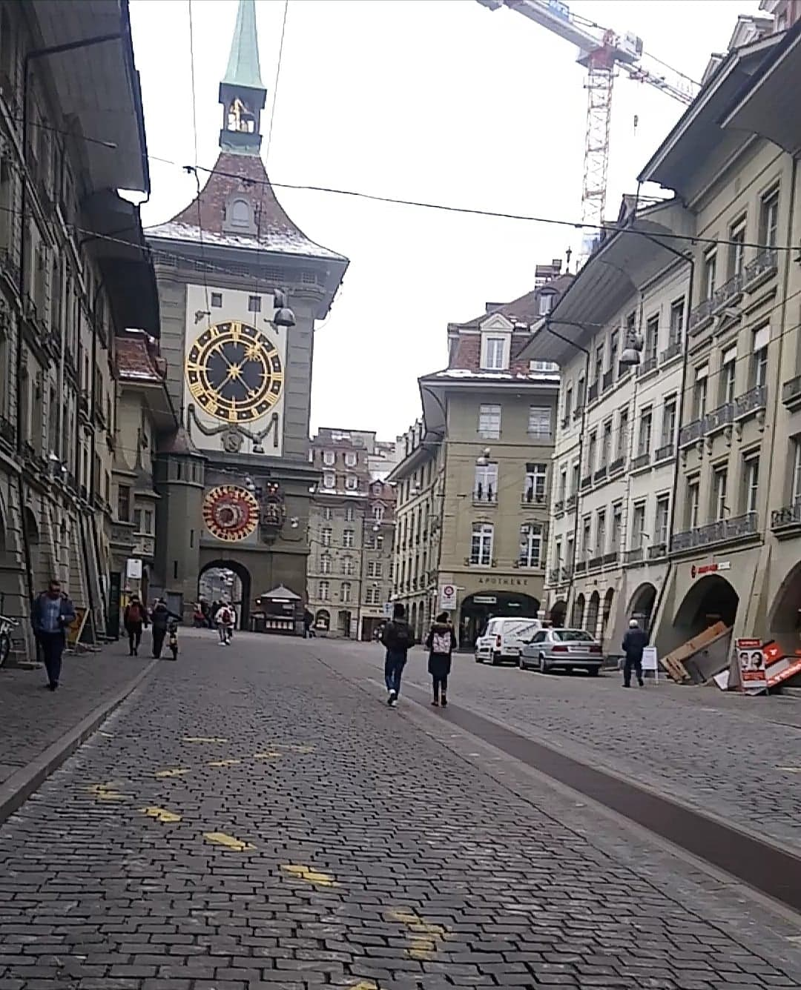

Continuing my way, I was visiting the house of Albert Einstein, where now is a souvenir shop. The scientist was living and working there few years.
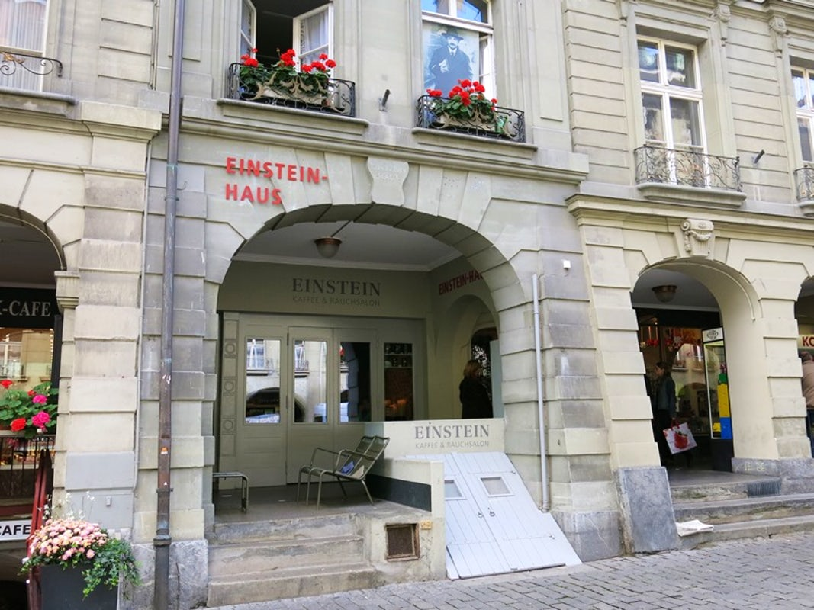

(Visit Einstein House, 2019)

I could not resist and bought these beautiful souvenir -Swiss clock
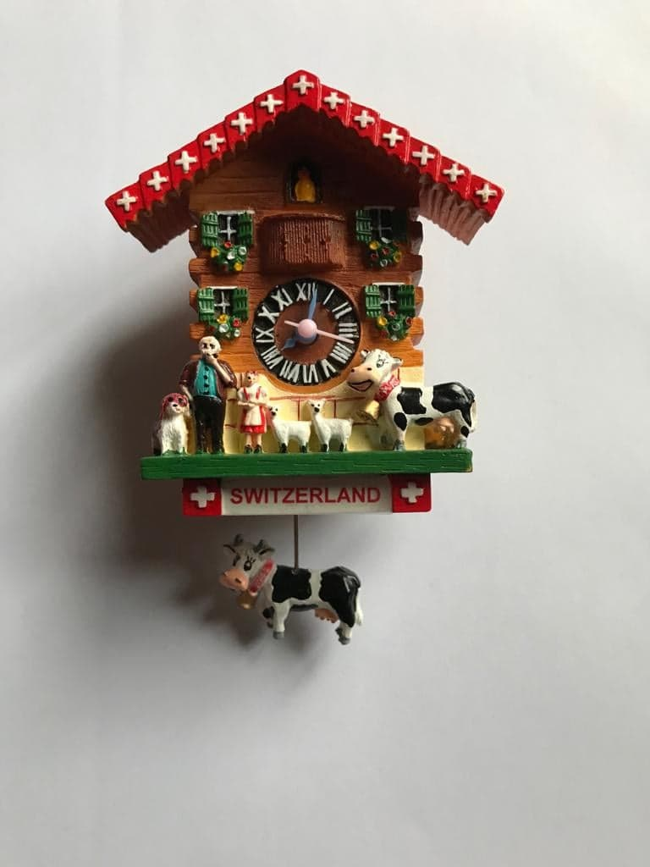
From the bridge over the river opens a lush views of the Bern. The building with green roof is House of Parliament.

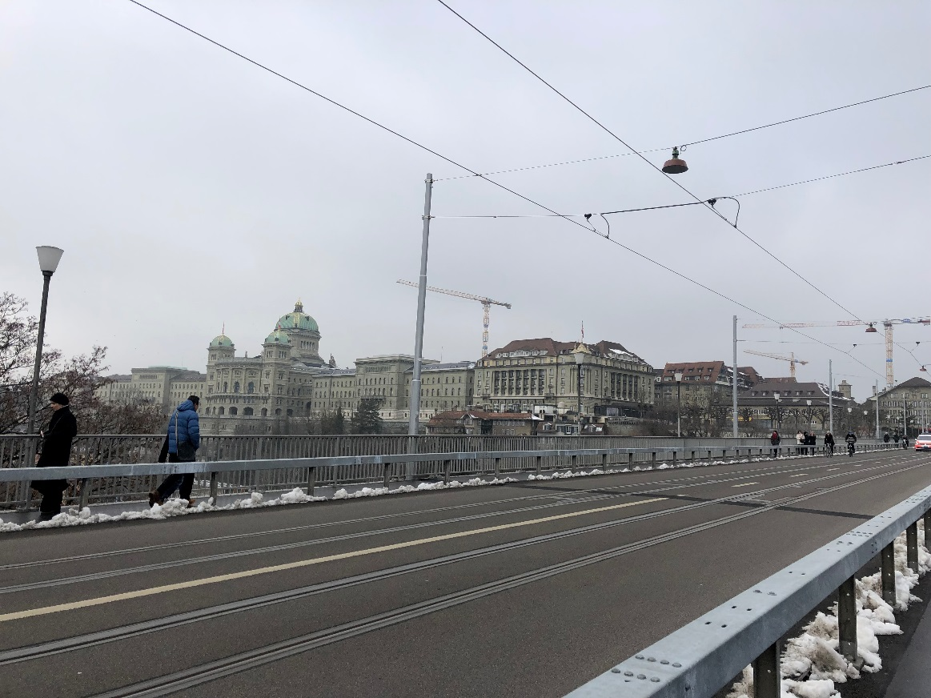
View on Parliament house of Bern

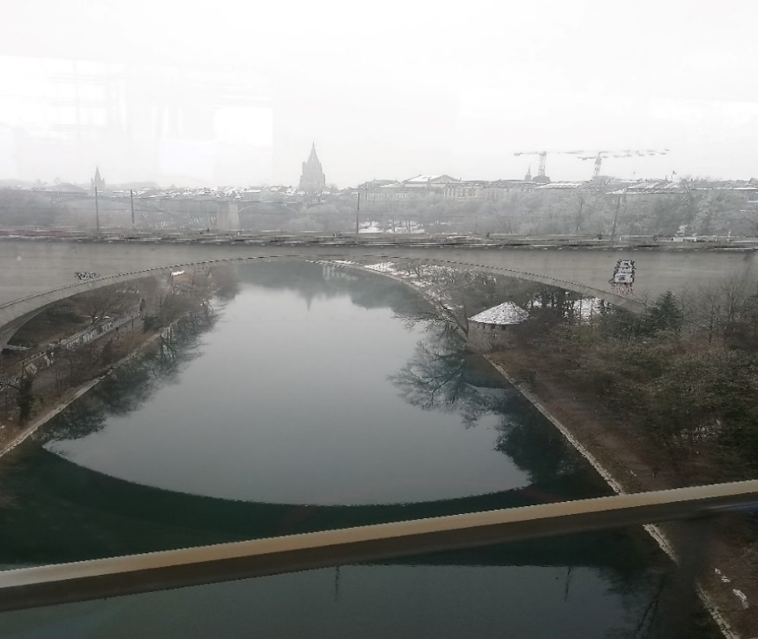
Panorama of town

The most beautiful Bern’s building- Bern Minster. The gothic style basilica was impressive and attracts attention at once from other city’s buildings. From the tower opens a wonderful view of whole city.
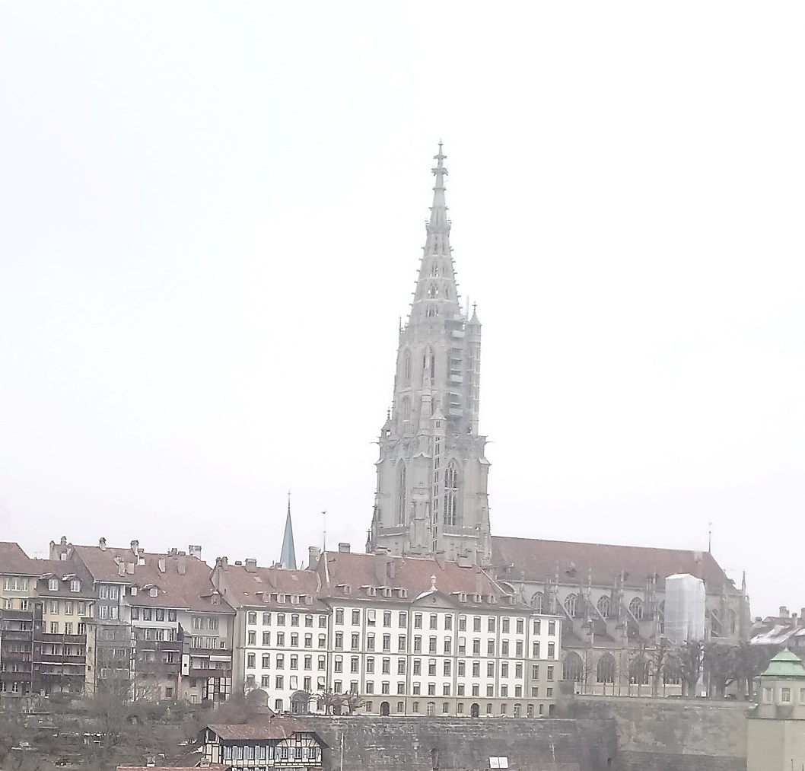

On the other side of the bridge are located a lot of museum: Museum of Communication, Kunstmuseum, Historical and Albert Einstein museums. Unfortunately, on my excursion day few of them was closed.
But luckily the history museum and Einstein were open. The entrance to the museum is guarded by the stone bear. This animal is official symbol of Bern. Therefore, one of the Bern attraction is Bear park, where lives real bears.

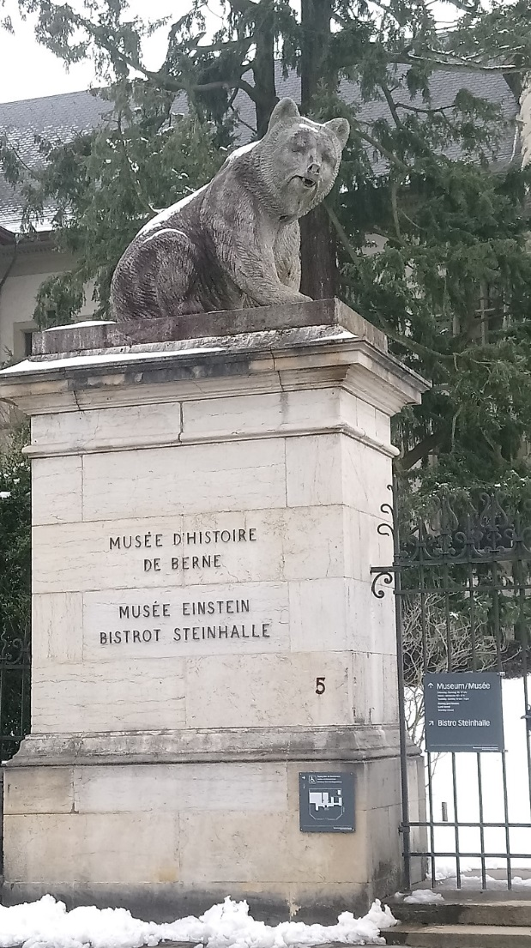

Prices in the museum are very acceptable and a discount for students. I visited the exhibition dedicated to Albert Einstein and history. There were presented personal belongings of the scientist, facts about his personal life as well as information about his research and Probability theory. In the same time another exhibition was devoted to the history of several epochs and history of Switzerland up to the 20th century. I discovered a lot of interesting things for myself.

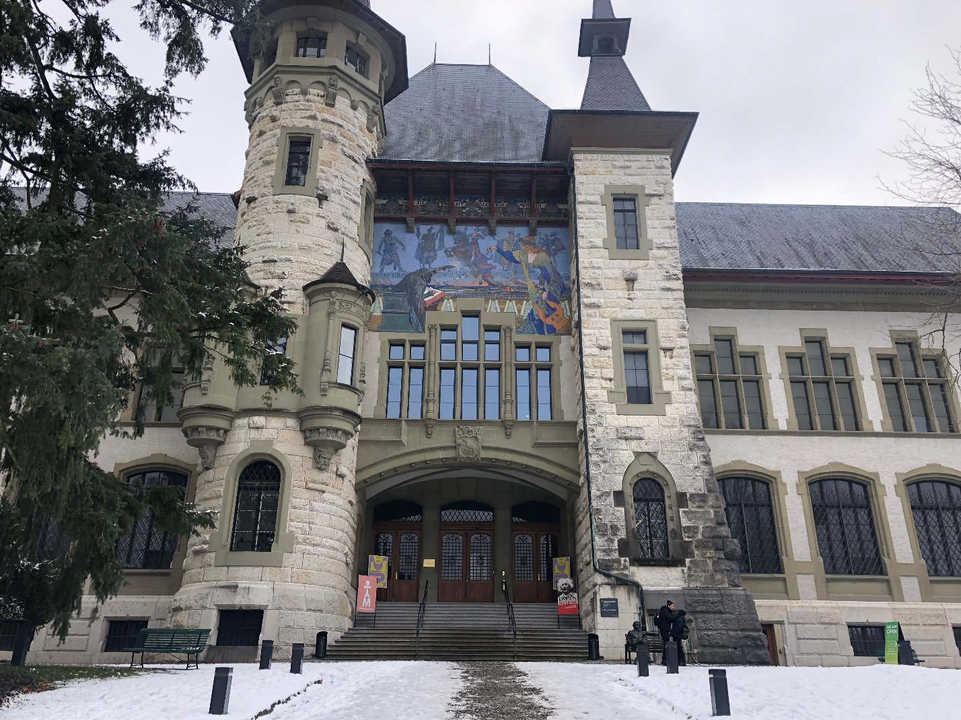

I recommended visiting the city to people who are passionate about history and want spent time together enjoying walks, architecture, shopping and famous Swiss chocolate. Definitely want to come back in Bern during spring to explore famous Rose park, other museums and buy more souvenirs.

References
Visit Einstein house (2019) [image] Available at: https://www.itinari.com/location/einstein-house [Accessed 1Mar. 2019]. (Visit Einstein House, 2019)

