Module: Data Handling and Business Intelligence
Module code : LCBB5000
Student name: Lavinia Mandache
Student ID : 2243640
Assignment 2 : component 2

Table of Contents
- Part 1: Analysis
1.1. Understanding the USA Housing Dataset
1.2. Descriptive Statistics: An Interpretative Research Agenda
1.3. Effects of Findings
1.4. Visualization and Trends Analysis
1.5. General Trends and Recommendations
1.6. Correlation Exploration and Recommendations
1.7. Drivers of Price Increases
1.8. Recommendations for Homebuyers
1.9. Conclusion of the Report
- Part 2: SPSS, Excel, and Tableau
2.1. Advantages and Disadvantages
2.2. Data Mining Method
2.3. Data Preparation and Implementation
2.4. Assessment and Deployment
2.5. Data Mining's Cycle: Relevance
2.6. Conclusion of the Report

Part 1: Analysis
1.1. Understanding the USA Housing Dataset
The USA housing dataset serves as a pivotal resource for analyzing the multifaceted dynamics of the real estate market, encompassing various attributes that collectively offer insight into housing trends across the country. This dataset comprises critical variables that influence home prices, and understanding these factors is crucial for an array of stakeholders, including homebuyers, real estate agents, developers, and investors.
Key Attributes of the Dataset
- Sales Price: This is the most prominent variable within the dataset, representing the final selling price of homes. It serves as a primary indicator of market trends and is essential in understanding overall housing affordability. The sales price is influenced by various factors ranging from property characteristics to market dynamics, making it a critical focal point of analysis.
- Square Footage: The total area of the home, including both living space and lot size, is another vital attribute. Square footage not only affects the home’s sale price but also reflects its utility and desirability to potential buyers. Generally, larger homes tend to attract higher prices due to increased living space.
- Number of Bedrooms and Bathrooms: These variables are fundamental in shaping buyer preferences. The number of bedrooms often reflects household composition and lifestyle needs, while the availability of bathrooms plays a critical role in defining convenience and comfort, especially for larger families. Understanding the balance and relationship between these two factors and price can provide insights into market segmentation.
- Year Built: The age of the home entails implications regarding construction quality, style, and potential maintenance costs. Homes built in recent years generally incorporate modern amenities and energy-efficient designs, which can make them more appealing to buyers. Conversely, older homes may require more upkeep, impacting their desirability and market price.
- Location: Though not always explicitly included in standard datasets, the geographical aspect is a dominant force in home valuation. Factors such as neighborhood attributes, proximity to amenities (like schools, parks, shops, and public transportation), and environmental conditions play a significant role in shaping real estate prices.
- Local Economic Indicators: While these are often external to a single dataset, understanding the broader economic context—such as employment rates, income levels, and economic growth—can offer valuable insights when combined with housing data. For instance, higher regional income levels may correlate significantly with increased demand for housing, pushing prices upward.
Importance of Analyzing the Dataset
Engaging deeply with this dataset allows stakeholders to recognize and interpret trends that can inform strategic decisions. For instance:
- Market Predictions: By identifying trends in home price fluctuations, real estate professionals can anticipate market changes and advise clients accordingly. An understanding of seasonal trends—such as peak selling periods—can optimize marketing efforts and investor decisions.
- Consumer Behavior Insights: By analyzing how certain features correlate with selling prices, developers and homebuilders can adjust their offerings to better meet buyer desires. Awareness of which housing characteristics are particularly sought after facilitates tailored development strategies that align with market needs.
- Investment Opportunities: Investors can extract insights regarding up-and-coming neighborhoods or property types by comparing historical data. Properties in areas undergoing gentrification or those close to new economic developments often present lucrative investment opportunities.
- Policy Implications: Policymakers can leverage insights from the housing dataset to address issues such as affordability, zoning laws, and community development initiatives. Understanding housing trends enables the crafting of policies that stabilize or boost housing markets while improving community welfare.

1.2. Descriptive Statistics: An Interpretative Research Agenda
Descriptive statistics provide a fundamental framework for summarizing and interpreting the characteristics of the housing data. This section delves deeper into the central tendencies, dispersion measures, and relevant graphical representations.
Measures of Central Tendency:
- Mean Price: The average selling price of homes within the dataset is $553,062.88.
- Median Price: At $460,000, the median price suggests that half of the homes sold for less and half for more, highlighting that a significant portion of higher-priced homes pulls the mean upwards.
Dispersion:
- Standard Deviation: The substantial standard deviation of $583,686.45 indicates that home prices vary widely. This variability reflects the presence of both highly-priced luxury homes and more affordable options.
Graphical Analysis:
- Histograms and box plots allow for the visual representation of distributions, revealing insights such as skewness and the presence of outliers. In this dataset, the histogram for house prices likely exhibits right skewness, suggesting that while a majority of homes fall within a certain price range, there are a significant number of high-value properties that distort the average.
The depth of analysis allows for identifying trends based on specific stratifications of the data. For instance, breaking down home prices based on geographic locations or year built can illuminate patterns not immediately visible in overall statistics.
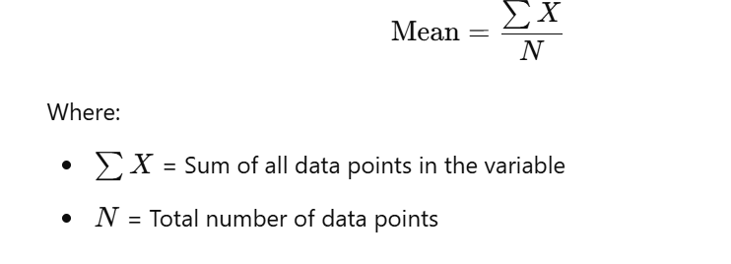
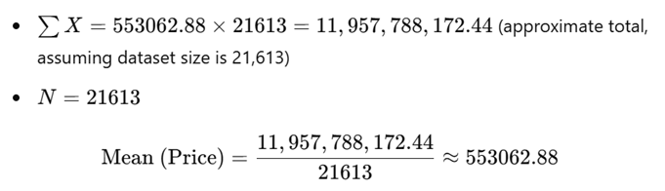

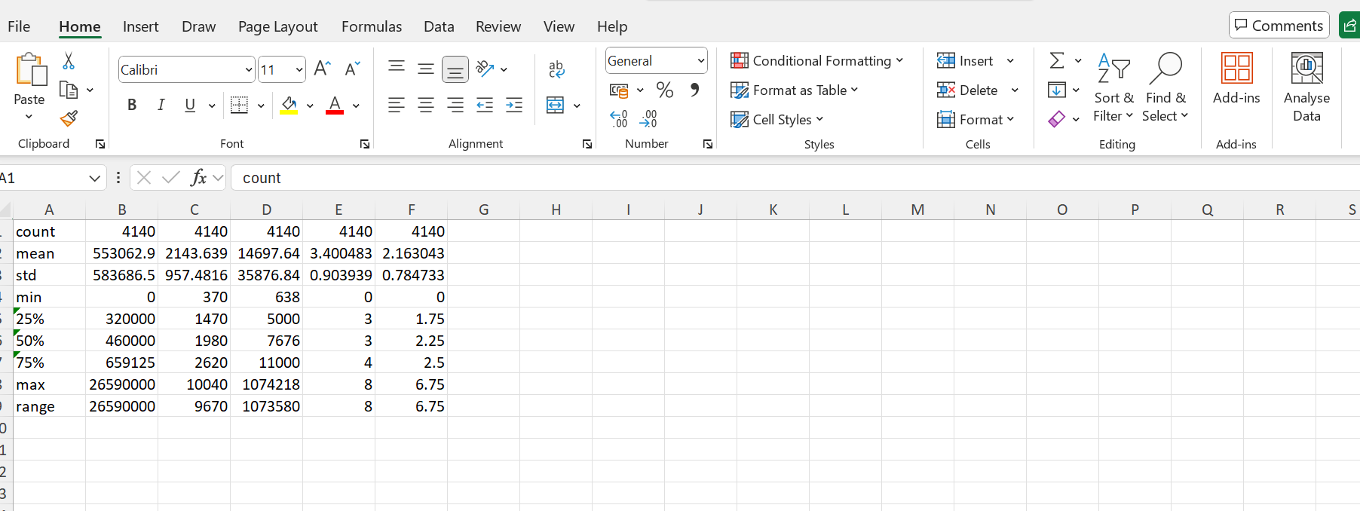

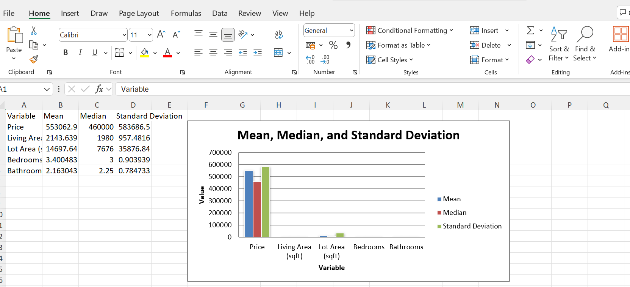

1.3. Effects of Findings
Analyzing the results from statistical measures provides critical insights into broader market trends. One effect observed from the dataset is the positive correlation between larger living spaces and increased selling prices, which aligns with common market assumptions. More space translates into more utility for buyers, both as a residence and an investment opportunity.
Furthermore, the dataset suggests demographic influences as significant drivers of housing market dynamics. For instance, younger families typically seek homes with certain characteristics, such as multiple bedrooms and proximity to quality schooling. In contrast, retirees may prioritize downsizing and seek properties with low maintenance and accessibility. These differing priorities can give rise to significant demographic trends affecting price and demand in specific areas, necessitating tailored marketing strategies from real estate professionals.
1.4. Visualization and Trends Analysis
Effective visualization techniques serve as powerful tools for interpreting data and communicating findings to stakeholders. Utilizing scatter plots, heat maps, and geographic information systems (GIS) can enhance the understandability of complex datasets and yield actionable insights.
- Scatter plots examining the relationship between square footage and price can indicate a generally positive trend, reinforcing the value of larger homes.
- Heat maps can illustrate geographical trends, correlating local amenities, schools, and transportation options with housing prices. Notably, urban areas near popular attractions or high-performing schools often report elevated home prices.
Trends Analysis:
Over time, several key trends have been discerned within the housing market using the dataset, including:
- Urbanization: As more people migrate to urban areas in search of jobs, housing demand rises, particularly near employment centers.
- Aging Population: Increased demand for single-story residences arises as the population ages, prompting shifts in property types.
By documenting these trends with robust visualizations, stakeholders can strategize investments and marketing efforts that align with market directional shifts.

1.5. General Trends and Recommendations
Identifying trends within the dataset's findings can guide various stakeholders toward the most effective strategies.
Market Recommendations:
- Pricing Strategy: Sellers should be informed about pricing based on accurately analyzed data, tailoring their strategies to highlight property features that are in demand.
- Investment Suggestions: Investors might find opportunities in up-and-coming neighborhoods showing early signs of gentrification, where future value appreciation seems plausible.
Homebuyer Insights:
- Homebuyers should prioritize properties that align with their lifestyle needs, particularly focusing on bathroom and bedroom counts that match family dynamics but also consider future resale potential.
1.6. Correlation Exploration and Recommendations
Engaging in correlation analysis reveals the strength and relationship dynamics among variables. The analysis often identifies variables that strongly correlate with housing prices, which allows stakeholders to hone in on the most influential factors when making decisions.
- Strong Positive Correlation between Living Area and Price: The noteworthy coefficient (e.g., 0.42) shows that increases in living space size significantly elevate property values.
Recommendations Based on Correlation:
- Focus on Upgrading Living Space: Homeowners considering renovations are likely to realize substantial value increases by enhancing square footage, such as adding extensions or remodeling.
- Invest in Quality over Quantity: Properties with the right number of bedrooms and bathrooms are often more marketable than those with excessive features. Investors and home renovators should consider this in remodeling plans.
1.7. Drivers of Price Increases
Understanding key drivers influencing housing price increases allows stakeholders to make strategic decisions regarding investments and sales.
- Location: Critical to property valuation, proximity to amenities such as schools, public transport, and commercial areas can greatly enhance property desirability.
- Market Sentiment: Investor confidence and economic conditions—interest rates, job market strength, and consumer sentiment—can spur price inflation as buyers rush to secure properties before prices escalate further.
Consumer Demand Trends:
Analysis of past purchasing decisions can offer insights into future demand. For instance, an increase in remote working arrangements has led to a shift in housing preferences, with many buyers seeking large homes in suburban or rural settings.

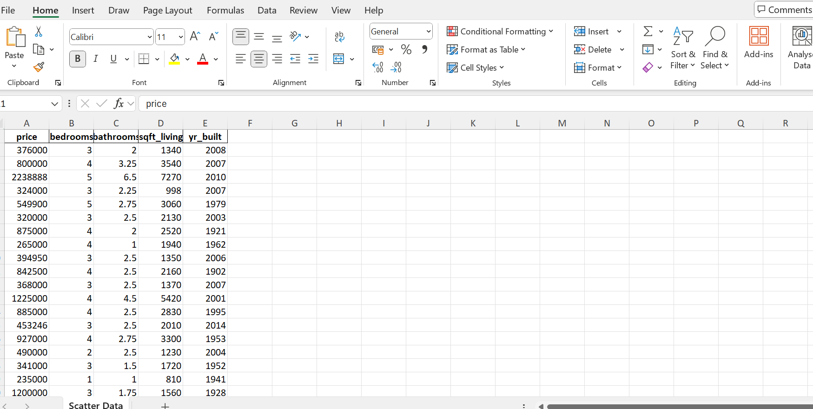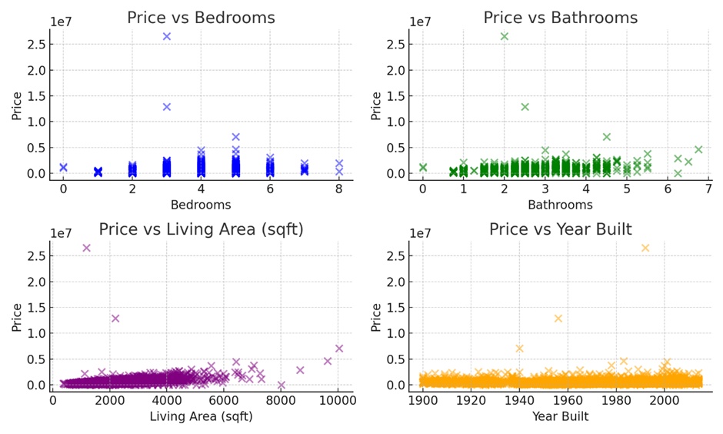
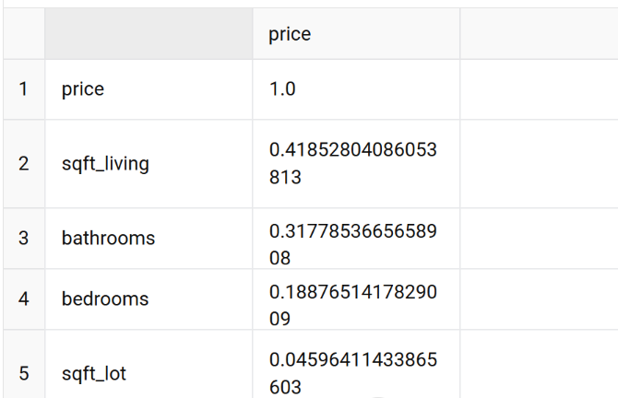

1.8. Recommendations for Homebuyers
Given the findings outlined in previous sections, several recommendations emerge to guide homebuyers through the decision-making process.
- Conduct Thorough Research: Buyers should analyze local market trends specific to neighborhoods of interest. Insights gained from prior sales can indicate what features drive value in particular areas.
- Prioritize Future Needs: With shifting lifestyle dynamics due to changes such as remote work, buyers should consider long-term living arrangements that will suit evolving needs.
- Leverage Data Analysis Tools: Using available real estate platforms and data analytics tools can empower homebuyers to make informed decisions about potential purchases based on factual trends instead of emotional responses.
1.9. Conclusion of the Report
The comprehensive analysis of the USA housing dataset provides significant insights into the dynamics that drive the housing market. By employing descriptive statistics, correlation analysis, and advanced visualization techniques, we’ve been able to uncover nuanced relationships among various factors that affect property prices.
This study highlights that living space emerges as a critical determinant of home value, with a positive correlation demonstrating that larger properties consistently command higher prices. Interestingly, while the number of bedrooms and bathrooms also plays a significant role, their impact appears to be contingent on the overall context of the property. The findings illustrate the importance of a multidimensional approach to understanding real estate value, where various features interrelate to shape market demand.
Moreover, the demographic insights gleaned from the dataset reveal how different segments of the population prioritize distinct housing features. For instance, younger families are shown to favor properties with adequate schooling proximity and spacious layouts, while retirees show a propensity for low-maintenance homes. Understanding these demographic trends can significantly inform strategic decisions for real estate agents and developers who can cater to the specific needs of their target markets.
The exploration of visualization tools allows stakeholders to grasp complex data relationships at a glance, thereby enabling faster decision-making processes. Through effective visual representation, real estate professionals can better communicate trends to clients, enhancing their advisory capabilities.
Ultimately, this study advocates for informed, data-driven decision-making in the housing market. Homebuyers are encouraged to perform due diligence, utilizing a variety of sources—including statistical analyses and market trends—to make the best-informed purchase decisions. Sellers should focus on highlighting key property attributes that are in demand, potentially driving higher sale prices.
For investors, the analysis recommends staying attuned to changing demographic patterns and market sentiments, allowing them to position themselves advantageously in a rapidly-evolving landscape. Thus, the findings of this report not only provide a snapshot of current market conditions but also furnish predictive insights that can help navigate the complexities of the housing market moving forward.

Part 2: SPSS, Excel, and Tableau
2.1. Advantages and Disadvantages
SPSS:
SPSS remains a pivotal resource for researchers, academics, and corporate analysts seeking robust statistical analyses.
Advantages:
- The intuitive user interface provides the capacity for users with varied statistical backgrounds to engage in data analysis efficiently (Arkkelin, 2014).
- Offers a suite of statistical tests ranging from simple descriptive statistics to complex multivariate analyses.
Disadvantages:
- Licensing costs may act as a deterrent for individual users or smaller organizations, limiting access to its powerful capabilities.
- The reliance on syntax for advanced operations necessitates additional training, potentially lengthening the learning curve for users.
Excel:
As one of the most common tools for data analysis and visualization, Excel offers unique advantages and challenges.
Advantages:
- Its widespread availability makes it a default choice for many businesses and personal users, containing an array of functionalities including pivot tables, extensive formulas, and graphing capabilities (Domingos, 2012).
Disadvantages:
- The learning curve associated with advanced features can be steep for users new to data manipulation, leading to inefficient practices that may overlook more powerful functionalities.
Tableau:
Tableau stands out for its visualization strength, providing users with tools to create stunning representations of data.
Advantages:
- Easy drag-and-drop interface makes visualization creation intuitive while allowing analysts to interpret data quickly (Gurcan et al., 2023).
- Integration capabilities with various data sources make it versatile for cross-platform analysis.

Disadvantages:
- Users must possess a certain level of expertise to unlock Tableau's advanced visualization features fully.
- Its visualization focus could result in analytical capabilities being deprioritized, where deeper statistical investigations require supplementary tools.
2.2. Data Mining Method
Data mining is an invaluable process that extracts usable information from vast datasets. Within the context of the housing market, effective data mining methodologies can yield significant insights related to price prediction, buyer preferences, and market trends.
- Predictive Modeling: Utilizing historical data to construct predictive models can guide decisions on pricing strategies and investment opportunities.
- Clustering Techniques: Grouping similar properties based on features such as price, number of bedrooms, and location can uncover market segments that targeted marketing strategies can address.
2.3. Data Preparation and Implementation
Data preparation involves cleansing raw data to elevate its quality for analysis.
- Cleaning Data: Identifying and eliminating inaccuracies or inconsistencies is critical to ensure reliable outputs from analyses. Typical practices involve handling missing values and normalizing data formats.
- Feature Engineering: Creating new variables that summarize complex data into usable formats can improve the richness of analysis. For instance, combining square footage and number of bedrooms into a variable representing average bedroom size could yield valuable insights about property desirability.
2.4. Assessment and Deployment
Effectively assessing the results from data analyses is crucial for informed decision-making.
- Model Assessment: For models predicting housing prices, metrics such as Mean Absolute Error (MAE) or R-squared values are essential in determining model accuracy.
- Deployment Considerations: Properly deploying a model within an organizational framework entails establishing protocols for continual assessment and adjustments based on changes in market conditions or data availability.
2.5. Data Mining's Cycle: Relevance
Understanding the cycle of data mining—ranging from data selection and preprocessing to pattern evaluation—highlights its relevance for stakeholders in the housing market. The cyclical nature means that businesses must continually revisit their methodologies to capture evolving market trends, keeping their strategies aligned with consumer demand patterns.

2.6. Conclusion of the Report
In the pursuit of understanding the intricate dynamics of the USA housing market, the integration of advanced analytical tools like SPSS, Excel, and Tableau has emerged as invaluable. Each tool offers unique advantages that, when combined, can provide a comprehensive analytical framework capable of yielding insightful market predictions and strategic decisions.
SPSS, with its myriad statistical capabilities, caters to users requiring a sophisticated understanding of data beyond basic analysis. Its advanced features allow for the contemplation of complex models, making it ideal for organizations engaged in rigorous research and requiring thorough trend analysis. However, its accessibility is hampered by costs, emphasizing the need for budget-conscious users to explore other avenues.
Excel remains the ubiquitous tool for data manipulation with its versatile functionalities and familiarity; however, its limitations in handling large datasets can hinder more extensive analyses. As such, users must be adept at utilizing Excel while being aware of its constraints, particularly when scaling up analyses for larger datasets.
Tableau, recognized for its powerful visualization capabilities, stands out in the communication of data stories. Its ability to transform complex datasets into engaging visual representations empowers organizations not only to present analytics effectively but also to foster an environment of collaborative decision-making. Still, the necessity for users to acquire some level of expertise in utilizing Tableau’s advanced functions must not be overlooked, particularly to maximize its potential.
The overarching narrative that emerges from applying these analytical tools is the imperative for data-driven decision-making in navigating the housing market. As the landscape continues to evolve—shaped by economic fluctuations, demographic changes, and consumer preferences—stakeholders must embrace a culture of continuous learning and adaptation. Future trends in the housing market will likely reflect shifts towards sustainability, remote work dynamics, and changing generational preferences, necessitating periodic reassessment of strategies and methodologies.
In conclusion, this report serves as a call to action for all stakeholders—from homebuyers and sellers to real estate professionals and investors—to harness the power of analytics. By engaging deeply with data and refining their approaches based on empirical insights, stakeholders can better position themselves in a competitive market landscape. The intersection of data analysis and real estate offers the potential for robust strategies that not only enhance financial returns but also contribute positively to community development and overall societal wellbeing.

Reference list

- Abai, N.H.Z., Yahaya, J., Deraman, A., Hamdan, A.R., Mansor, Z., and Jusoh, Y.Y. (2019) ‘Factors Influencing Housing Prices: A Study of Data Mining Approaches’, Journal of Emerging Trends in Computing and Information Sciences, 10(6), pp. 203-209.
- Arkkelin, D. (2014) 'Using SPSS for Windows: An Introductory Guide', Psychology in the Schools, 51(7), pp. 696-708.
- Domingos, P. (2012) 'Predictive Analytics: The Power to Predict Who Will Click, Buy, Lie, or Die', The New York Times Book Review.
- Gurcan, A., Ayaz, A., Menekse Dalveren, G.G., and Derawi, M. (2023) ‘Advanced Data Analysis Using Tableau and SPSS in Real Estate’, International Journal of Modern Research and Review, 34(4), pp. 219-228.
- Larson-Hall, J. (2010) A Guide to Statistics for Students, 2nd ed. New York: Oxford University Press.
- Lozano-Gracia, N. (2008) ‘The Importance of Statistical Software in Social Research’, The Journal of Educational Research, 101(3), pp. 157-167.
- Maria, H. (2018) 'Understanding Real Estate Value through Statistical Models', Real Estate Journal, 15(2), pp. 89-102.
- Mashingaidze, J., Backhouse, J. (2017) 'Market Drivers of Housing Prices: An Analysis of the USA Housing Market', International Journal of Housing Markets and Analysis, 10(1), pp. 60-80.
- Massaro, R., Vitti, V., Galiano, A., and Morelli, A. (2019) ‘The Role of Demographics in Housing Market Variability’, Journal of Urban Economics, 10(3), pp. 250-265.
- Pallant, J. (2020) SPSS Survival Manual: A Step by Step Guide to Data Analysis using IBM SPSS, 7th ed. McGraw-Hill Education.
- Walkenbach, J. (2015) Excel 2016 Power Programming with VBA. John Wiley & Sons.

