University of Wales Trinity Saint David

ETHICAL HACKING ASSIGNMENT
Module: ACCA7033 – Ethical Hacking
Programme: MSc Cyber security and Digital Forensics
Submission to: Dr. Carlene Campbell
Module: Ethical Hacking
Name: Hridoy Majumder
Department: Cyber security & Digital Forensics
ID: 2522065

Table of Contents
ETHICAL HACKING ASSIGNMENT 2
ABSTRACT 2
TASK 1 — STRATEGIC THREAT ANALYSIS 3
1. INTRODUCTION 3
2. INCIDENT TIMELINE AND ANALYSIS 5
Timeline of Events 5
Critical Evaluation 5
3. MITRE ATT&CK MAPPING 8
Critical Insight 8
4. ROOT CAUSE ANALYSIS Technical Failures 9
Organisational Failures 10
• Inadequate security policies 10
• Lack of monitoring systems Human Factors 10
Advanced Analysis 10
5. THREAT ACTOR PROFILE 11
6. DETECTION AND RESPONSE ANALYSIS 11
Identified Weaknesses 11
Critical Evaluation 12
7. STRATEGIC RECOMMENDATIONS 13
8. CONCLUSION (TASK 1) 13
TASK 2 — RED TEAM ENGAGEMENT 14
1. RULES OF ENGAGEMENT (RoE) 14
2. THREAT EMULATION PLAN 14
Objective 14
Attack Phases 15
3. LAB ENVIRONMENT DESIGN 16
Network Diagram 16
Configuration 16
4. EXPLOITATION PROCESS 17
Step 1: Reconnaissance 17
Step 2: Web Exploitation 18
Step 3: Privilege Escalation 19
Step 4: Credential Dumping 20
Step 5: Lateral Movement 21
Step 6: Data Exfiltration 22
Realism Enhancement 23
5. ATTACK FLOW DIAGRAM 23
6. DETECTION GAP ANALYSIS 24
• Lack of centralised logging 24
• Lack of anomaly detection 24
• Poor endpoint security 24
7. EXECUTIVE BRIEF 24
Summary 24
Business Impact 24
Recommendations 25
Conclusion 25
REFERENCES 26

ETHICAL HACKING ASSIGNMENT
Module: ACCA7033 – Ethical Hacking
Programme: MSc Cyber security and Digital Forensics

ABSTRACT
The rapid digital transformation of modern organisations has led to a huge increase in dependency on interconnected systems, cloud infrastructure and online services. These technological advances provide operational efficiency and scalability but also expose organisations to increasingly sophisticated cyber threats. Cyber-attacks against large enterprises have transformed in recent years from opportunistic events into highly-coordinated and persistent campaigns run by organised threat actors. Such attacks often use a combination of social engineering, exploiting technical vulnerabilities, stealing credentials and stealth techniques to maintain persistent access to enterprise networks and exfiltrate sensitive data.
This report provides a strategic and technical analysis of cyber incidents on Marks & Spencer and Co-operative Group. These incidents are analysed as representative examples of modern cyber threat campaigns directed at critical retail infrastructure in the UK. The report assesses how adversaries leveraged weaknesses in the organisation’s security controls, access management and monitoring capabilities to compromise systems and achieve persistence in enterprise environments.
The first part of the report critically analyses the attack lifecycle by applying the MITRE ATT&CK Enterprise Matrix to determine the tactics, techniques and procedures (TTPs) used by the attackers during each phase of the intrusion. The analysis covers the primary attack phases of reconnaissance, initial access, privilege escalation, credential dumping, lateral movement, command and control communication and data exfiltration. The report also looks into the root causes of the incidents, detailing both technical and organisational failures that contributed to the compromise. Special emphasis is placed on the shortcomings of the traditional security models, particularly the dependence on signature-based detection systems that are often impotent against contemporary advanced persistent threat (APT) actors.
The second part of the report describes a real-life red team engagement in an isolated virtual lab environment for ABCD Ltd. The engagement is designed to simulate an attack scenario where an attacker is trying to compromise internal systems and access sensitive organisational data. The practical assessment includes reconnaissance activities, exploitation of vulnerable services, privilege escalation, credential extraction, lateral movement and data exfiltration with use of industry standard penetration testing tools such as Nmap, Metasploit, Burp Suite, Meterpreter and Mimikatz. The report also looks at detection gaps in the simulated environment and analyses how a lack of monitoring and weak segmentation increases an organisation’s exposure to cyber threats.
The report closes with a number of strategic recommendations for improving organisational cyber security resilience. These recommendations involve adopting Zero Trust Architecture, deploying more sophisticated Endpoint Detection and Response (EDR/XDR) solutions, bolstering network segmentation, integrating threat intelligence, and providing continuous security awareness training. Overall, the findings show that modern cyber threats require proactive, intelligence driven defence strategies combining technical controls, behavioural analytics and organisational preparedness to effectively mitigate evolving attack methodologies.

TASK 1 — STRATEGIC THREAT ANALYSIS

1. INTRODUCTION
The rapid adoption of digital technologies in business activities has transformed the face of modern organisations. Today, companies depend on interconnected networks, cloud computing, remote access solutions and web-based applications to support critical services and operational efficiency. Although these technologies offer great benefits regarding scalability, automation and accessibility, they have also significantly increased the attack surface available for malicious actors to exploit. Thus, cyber security has become one of the most important challenges for organisations in both public and private sectors.
Cyber threats have changed a lot in the last decade. The classic cyber-attack was generally opportunistic, exploiting discrete vulnerabilities for short-term goals. But today’s threat actors are using much more sophisticated techniques that require long-term planning, stealth, persistence, and multi-stage attack chains. These types of attackers usually utilise Advanced Persistent Threat (APT) techniques that blend social engineering, credential theft, malware deployment, privilege escalation and lateral movement into enterprise environments to gain and maintain unauthorised access for extended periods. Attacks of this nature are no longer the exclusive preserve of highly specialised threat groups but are increasingly being adopted by organised cybercriminal organisations looking for financial gain, espionage opportunities or operational disruption.
The retail industry has become a particularly attractive target for cybercriminals due to the enormous volume of customer data, financial information and operational systems stored within retail infrastructures. Recent cyber incidents involving Marks & Spencer and Co-operative Group highlight the increasing sophistication of attacks against large-scale retail organisations in the UK. These incidents illustrate how adversaries can exploit vulnerabilities not only in technical systems, but in organisational processes and human behaviour. The absence of strong authentication controls, limited monitoring capabilities, lack of network segmentation and susceptibility to phishing attacks all provide a foothold for attackers to gain access to enterprise networks and remain undetected.
One of the main problems concerning contemporary cyber-attacks is the increasing use of stealth and evasion techniques. These tools and system processes are also referred to as Living-Off-the-Land Binaries (LOLBins) and are often used by attackers to reduce the chances of being detected by traditional security systems. This means organisations that rely heavily on signature-based antivirus solutions and traditional perimeter-centric security architectures often struggle to detect malicious activity during the initial phase of compromise. This underscores the increasing importance of advanced threat detection capabilities, behavioural analytics and intelligence-led cyber security approaches.
The objective of this report is to critically analyse the cyber incidents experienced by the Co-operative Group and Marks & Spencer through the reconstruction of the attack lifecycle and the mapping of adversary behaviour to the MITRE ATT&CK framework. The report looks at the tactics, techniques and procedures used by the attackers during each phase of the intrusion, and identifies the root causes of organisational compromise. The report also assesses the efficacy of detection and response mechanisms put in place by the affected organisations and the wider implications of these incidents for enterprise cyber security resilience.
Besides the strategic threat analysis, the report includes a practical red team engagement in a controlled virtual environment for ABCD Ltd. The goal of this engagement is to simulate realistic attack scenarios and demonstrate how attackers exploit vulnerabilities to gain unauthorised access into enterprise systems. The evaluation uses industry standard penetration testing techniques and tools (e.g., Nmap, Metasploit, Burp Suite, Meterpreter, and Mimikatz) to simulate adversary behaviour in the field. This practical exercise helps the report to test security weaknesses, detection gaps and organisational exposure to more sophisticated cyber threats.
The findings of this report are to inform technical and strategic understanding of contemporary cyber threat operations and organisational defence strategies. The report is a mix of theoretical analysis and practical offensive security assessment to demonstrate the importance of a proactive and layered cyber security approach, integrating technical controls, continuous monitoring, threat intelligence and user awareness, to effectively mitigate the evolving cyber risks.

2. INCIDENT TIMELINE AND ANALYSIS

Timeline of Events
Phase | Description
Initial Access | Phishing or credential compromise
Execution | Malicious payload execution
Persistence | Backdoor installation
Privilege Escalation | Administrative access gained
Lateral Movement | Internal systems compromised
Exfiltration | Sensitive data extracted
Detection | Suspicious activity identified
Response | Systems isolated
Disclosure | Public announcement

Critical Evaluation
The attack lifecycle analysis shows a well-structured and coordinated cyber campaign, consistent with the operational features typically ascribed to Advanced Persistent Threat (APT) groups. This was not an opportunistic cyber-attack that sought immediate exploitation and quick financial rewards. Instead, it was the result of a carefully planned multi-stage attack that involved reconnaissance, persistence, privilege escalation, lateral movement and data exfiltration. The flow between the various stages shows that the attackers were familiar with enterprise attack techniques and were able to adapt their techniques to maintain long-term access to the compromised environment.
Successful establishment of persistence mechanisms within the affected infrastructure is one of the most significant indicators of APT-style behaviour. Persistence techniques allow attackers to maintain access to the compromised system even after rebooting, password changes, or partial remediation. The employment of persistence indicates the attackers were not only seeking short-term disruption but were looking to maintain access for longer-term intelligence gathering, operational monitoring or large-scale data exfiltration. This degree of persistence considerably increases the worldwide impact of the compromise, as it enables the attackers to keep increasing their access while remaining under the radar for extended periods of time.
Furthermore, the presence of lateral movement during the attack lifecycle indicates a major weakness in the internal network security architecture. After initial access, the attackers were able to move laterally across multiple systems in the enterprise environment, which indicates a lack of sufficient network segmentation and weak access control policies. Effective segmentation is meant to isolate sensitive systems and to limit an attacker's ability to move laterally within a network. But this time the attackers leveraged the compromised credentials and remote service protocols like SMB and RDP to gain access to other hosts and escalate privileges further. This shows that internal security controls were not sufficient to contain the threat actor’s activities once the perimeter security was breached.
The other important concern found in the analysis is the lack of real-time monitoring and behavioural analytics capabilities in the impacted environment. The attackers could conduct reconnaissance, deploy malicious payloads and maintain persistence without triggering immediate alarms. This shows that the organisation was heavily reliant on traditional signature based detection systems that are becoming ineffective against modern cyber threats. Modern adversaries often use stealth techniques and legitimate administrative tools, often referred to as Living-Off-the-Land Binaries (LOLBins), to hide malicious activity among normal system operations. As a result, traditional antivirus and perimeter-based security solutions often miss suspicious behaviour during the early stages of a compromise.
The lack of effective behavioural monitoring provided the attacker with a lot more operational freedom within the environment. In a mature Security Information and Event Management (SIEM) system, you should normally get alerts for activities such as abnormal privilege escalation, internal reconnaissance, lateral movement, and unusual authentication attempts. The delay in detection in this case, however, suggests either the lack of adequate monitoring systems, or that the existing monitoring systems were not adequately configured to detect anomalous behaviour. This is symptomatic of a wider organisational weakness in security operations and incident response preparedness.
The attack, apart from technical shortcomings, reveals failures in organisational cyber security governance and risk management. The success of phishing or credential compromise techniques highlights a lack of user awareness and insufficient deployment of phishing-resistant authentication mechanisms, such as hardware-based multi-factor authentication (MFA). Human error remains one of the most common attack vectors in contemporary cyber security incidents and the inability to sufficiently address phishing threats is indicative of a weakness in organisational security culture and employee training programmes.
The overall attack lifecycle shows a failure to implement an overall defence-in-depth strategy. The principle of defence-in-depth is that there should be multiple overlapping security controls across the enterprise environment to prevent, detect and respond to cyber threats. The incident highlighted vulnerabilities in multiple layers including identity and access management, network segmentation, endpoint monitoring and security awareness. Attackers were able to move through the attack chain with little resistance as multiple layers were compromised simultaneously.
The incident also points to the increasing limitations of traditional perimeter-based security architectures in modern enterprise environments. With the increasing adoption of cloud services, remote access technologies and hybrid infrastructures by organisations, attackers no longer need to directly exploit internet-facing systems to achieve compromise. Instead, the main attack vectors have shifted to credential theft and identity-based attacks. This further underlines the need for organisations to adopt Zero Trust security models, which continuously validate users, devices and access requests, regardless of their location on the network.
Ultimately, the analysed incident shows that modern cyber-attacks are not isolated technical events but rather complex operational campaigns that exploit weaknesses across people, processes and technology. The attackers’ ability to operate covertly during the progression through multiple attack stages highlights a significant gap in organisational security maturity. Without major advances in monitoring, behavioural analytics, access control and incident response capabilities, organisations will continue to struggle to defend themselves against increasingly sophisticated adversaries.

3. MITRE ATT&CK MAPPING
Tactic | Technique | ID
Initial Access | Phishing | T1566
Execution | Command Interpreter | T1059
Persistence | Registry Run Keys | T1547
Privilege Escalation | Exploitation | T1068
Credential Access | Credential Dumping | T1003
Discovery | Network Scanning | T1046
Lateral Movement | Remote Services | T1021
Command & Control | Web Protocols | T1071
Exfiltration | Data Transfer | T1041
Impact | Data Manipulation | T1565

Critical Insight
The MITRE ATT&CK mapping shows a comprehensive and coordinated attack chain close to real-world adversary behaviour. The attackers did not rely on a single exploit but instead moved through the different stages of the cyber kill chain, such as initial access, execution, persistence, privilege escalation, credential access, lateral movement and data exfiltration. This systematic push lays bare a carefully choreographed operation designed for maximum persistence and minimum detection.
Credential dumping techniques were one of the most important aspects of the attack. The attackers leveraged stolen credentials and authentication tokens from compromised systems to impersonate legitimate users and escalate their privileges across the environment. This highlights major weaknesses in the organisation’s identity and access management controls, particularly around privileged account protection and authentication security. The successful compromise of credentials indicates that controls such as multi-factor authentication (MFA), privileged access
management (PAM), and least privilege policies were not properly implemented.
The existence of lateral movement also suggests flaws in the internal network security architecture of the organisation. Once the attackers had compromised a first host, they were able to move laterally across multiple systems using remote administration protocols such as SMB and RDP. This translates to too much trust between internal systems and not enough segmentation of the network. In a mature security environment, segmentation and micro-segmentation should limit movement of an attacker and spread of compromise. But the attackers were able to move through the environment with little resistance, which amplified the overall impact of the intrusion.
Another important observation is the apparent reliance on legitimate system tools and processes indicating the use of Living-Off-the-Land (LOTL) techniques. Attackers commonly employ trusted admin utilities like PowerShell, WMI, and command-line interpreters for malicious activities while remaining undetected. Because these are legitimate OS components, traditional signature-based security solutions often don’t recognise them being used maliciously. This significantly reduces the detection probability and allows attackers to operate undetected for long periods.
The attack chain also highlights the shortcomings of traditional perimeter-centric security models. With valid credentials and after bypassing perimeter defences, attackers could then exploit vulnerabilities within the internal network environment. This underscores the importance for organisations to adhere to Zero Trust security principles, which involves continuous verification and strong access controls regardless of where a user or device is situated.
The MITRE ATT&CK mapping shows a complex attack approach with credential theft, lateral movement, persistence and stealth techniques. What’s more, it exposes major deficiencies in access management, network segmentation and behavioural monitoring ability. Unless there is a significant breakthrough in these areas, organisations will continue to be vulnerable to increasingly sophisticated cyber threats that are designed to bypass traditional security controls.

4. ROOT CAUSE ANALYSIS
Technical Failures
• Unpatched vulnerabilities
• Weak authentication methods
• No network segmentation

Organisational Failures

• Inadequate security policies

• Lack of monitoring systems
Human Factors
• Susceptibility to phishing attacks

Advanced Analysis
The breach was not caused by one isolated vulnerability but was instead the result of a systemic failure across multiple layers of the organisation’s security infrastructure. The attackers managed to move through multiple phases of the attack lifecycle including initial access, privilege escalation, lateral movement and persistence, exposing the vulnerabilities of the technical and organisational security controls. This indicates the organisation did not possess a viable defence-in-depth strategy that could detect and isolate malicious activity in the initial stages of compromise.
During the analysis one of the most important weaknesses discovered was the lack of advanced detection and monitoring mechanisms such as behaviour analytics, anomaly detection and real-time threat correlation. The attackers could roam in the environment for a long time without raising enough alerts, showing a heavy dependence on traditional signature-based security solutions. Signature-based detection techniques work well against known malware variants but are much less effective against today’s adversaries who are increasingly employing stealth techniques, legitimate administrative tools and Living-Off-the-Land (LOTL) techniques to evade detection.
The incident also exposes weaknesses in identity and access management controls. The successful application of credential dumping and lateral movement techniques means that privileged accounts are not well protected and principles of least privilege are not well enforced. Likewise, poor network segmentation allowed attackers to move between systems with little resistance, which amplified the scale and severity of the compromise.
From an organisational perspective, the breach exemplifies broader failures in cyber security governance and risk management. The absence of monitoring capabilities, user awareness and incident response preparedness all contributed to the attackers being able to remain persistent within the environment. This demonstrates that modern cyber security threats cannot be dealt with only by perimeter-oriented security models, and they need to be addressed with a proactive, intelligence-led approach incorporating constant monitoring, Zero Trust principles, and sophisticated threat detection features.

5. THREAT ACTOR PROFILE
The characteristics of the analysed attack strongly suggest the involvement of a financially motivated cybercriminal group with moderate to high technical capability. The attackers demonstrated a clear understanding of modern attack methodologies, methodically progressing through multiple phases of the intrusion, including reconnaissance, initial access, persistence, privilege escalation, credential theft, lateral movement, and data exfiltration. This degree of planning points to an organised and co-ordinated operation rather than an opportunistic or low-skilled attack.
The use of stealth techniques throughout the attack lifecycle further demonstrates the sophistication of the threat actors. The attackers were able to use legitimate administrative tools and Living-Off-the-Land (LOTL) techniques to blend the malicious activities with the normal system operations, significantly reducing the likelihood of detection. This is generally the behaviour of more advanced adversaries who are interested in long-term persistence and operational security in compromised environments.
Additionally, the fact that credential dumping and lateral movement were successfully performed indicates that the attackers possessed the technical know-how to exploit weaknesses in identity and access management systems. The ability to move around the internal network and compromise other systems shows knowledge of enterprise infrastructures and common security weaknesses found in large organisations.
The overall attack methodology also points to a strong financial motivation. Retail organisations are tempting targets for cybercriminal groups as they hold large amounts of sensitive customer information, payment data and operational systems. Such data can be monetised through financial fraud, ransomware operations or sale on underground criminal marketplaces.
The coordinated nature of the attack also indicates that the threat actors likely operated as part of an organised cybercriminal group rather than as isolated individuals. Today’s cybercriminal groups often act like legitimate companies, with specific roles for phishing, malware creation, credential theft and monetisation. This kind of organisation enables threat actors to launch highly effective and scalable attacks against enterprise environments.

6. DETECTION AND RESPONSE ANALYSIS

Identified Weaknesses
- Delayed detection of malicious activity
- Lack of SIEM integration
- Insufficient endpoint monitoring

Critical Evaluation
The organisation’s heavy reliance on traditional signature based detection systems severely hampered its ability to detect malicious activity in the early stages of the attack. Signature-based security solutions are mainly designed to identify known malware signatures, pre-defined attack signatures or malicious files that have already been identified. While these systems are effective against common and well documented threats, they are much less effective against modern adversaries who are always changing their techniques to avoid detection.
In this case, the attackers appeared to use stealth-oriented techniques that blended malicious activity with legitimate system activity. Credential dumping, remote service abuse, PowerShell execution and the use of administrative utilities are all techniques that are often indistinguishable from normal organisational activity. Such behaviour is commonly associated with Living-Off-the-Land (LOTL) techniques, where attackers abuse trusted system tools and processes instead of deploying easily identifiable malware. As such, suspicious behaviour might not be detected by conventional antivirus and perimeter-centric detection systems, as the activity is started by legitimate applications that are already installed in the operating system.
The delay in detecting the incident indicates that the organisation does not have sophisticated behavioural monitoring and anomaly detection capabilities. In a mature Security Information and Event Management (SIEM) environment, alerts should be generated in most cases for unusual authentication attempts, privilege escalation, internal reconnaissance, and lateral movement. But the attackers were still able to persist and escalate access to other systems before being identified, which suggests there was limited visibility into what was happening inside the network.
The incident also highlights the limitations of relying on perimeter-centric security architectures alone. Once attackers had valid credentials or had compromised an internal system, they were able to move with little resistance across the environment. This points to the increasing demand for proactive detection methodologies that incorporate behavioural analytics, endpoint detection and response (EDR), threat intelligence integration, and Zero Trust security principles. Without these capabilities, organisations are left vulnerable to sophisticated adversaries who can evade traditional security controls and gain long-term persistence in enterprise networks.

7. STRATEGIC RECOMMENDATIONS
1. Implementation of Zero Trust Architecture
2. Implementation of EDR/XDR solutions
3. Enforce Multi-Factor Authentication (MFA)
4. Micro segmentation and segmentation of networks
5. Awareness training
6. Threat intelligence integration

8. CONCLUSION (TASK 1)
The analysed incidents show that modern cyber threats are no longer isolated or opportunistic attacks, but highly sophisticated, multi-stage operations targeting entire organisational ecosystems. The attack methodology employed by the attackers was structured and involved initial access, persistence, credential compromise, privilege escalation, lateral movement and data exfiltration, which is consistent with the operational characteristics typically associated with advanced persistent threat (APT) campaigns. The coordinated nature of the attack illustrates the increasing ability of modern threat actors to target weaknesses across technical systems, organisational processes and human behaviour at the same time.
One of the major findings from the analysis is the organisation’s failure to identify malicious activity during key phases of the intrusion. Good lateral movement and privilege escalation tactics highlight serious flaws in internal monitoring, identity and access management and network segmentation. The fact that the attackers were able to stay hidden for such extended periods of time is indicative of the deficiencies in traditional signature-based security controls when dealing with modern stealth techniques and Living-Off-the-Land methodologies.
The incidents also point to the need for a defence-in-depth strategy that incorporates multiple layers of security controls across the enterprise environment. In today’s threat environment, where attackers routinely abuse legitimate credentials and trusted system processes to defeat traditional defences, a perimeter-centric security architecture is no longer sufficient.
Organisations must move to proactive intelligence-led cyber security models; models that leverage behavioural analytics, continuous monitoring, threat intelligence integration and Zero Trust principles.
The analysis also points to the role of organisational readiness in responding to cyber threats. Effective prevention of today’s attacks cannot be achieved by technical controls alone without strong governance, awareness among employees, planning for incident response, and ongoing assessment of security. The overall effect of the incidents was a combination of human error, poor authentication practices and insufficient monitoring.
The analysed incidents ultimately illustrate that cyber security resilience is a holistic and adaptive approach of people, processes and technology. Those organisations that do not modernise their security strategies and detection capabilities will be highly vulnerable to increasingly sophisticated cyber adversaries who are able to exploit not only technical weaknesses but organisational ones as well.

TASK 2 — RED TEAM ENGAGEMENT

1. RULES OF ENGAGEMENT (RoE)
• Scope limited to the virtual lab environment
• No real world systems targeted
• Exploitation only under control
• Developed emergency stop procedures
• Compliance with laws and ethical regulations

2. THREAT EMULATION PLAN

Objective
The main objective of this threat emulation plan is to simulate a real cyber attack on the internal infrastructure of ABCD Ltd in a controlled virtual lab environment. The assessment will seek to emulate the behaviours and methodologies that are commonly employed by current threat actors to identify security vulnerabilities, assess organisational resilience and evaluate the effectiveness of current defensive controls. This engagement is designed to offer practical insight into real-world attack techniques hackers use to exploit vulnerabilities in order to compromise enterprise systems and sensitive information.
The threat emulation exercise seeks to showcase the full attack cycle, including reconnaissance and information collection, gaining initial access, privilege escalation, credential compromise, lateral movement, persistence, and data exfiltration. The assessment will use industry standard penetration testing and offensive security tools such as Nmap, Metasploit, Burp Suite, Meterpreter and Mimikatz to simulate real world attacker behaviour. The engagement also looks at how weaknesses in identity and access management, network segmentation, endpoint protection and monitoring capabilities can lead to the success of an attack.
The assessment also serves the important purpose of identifying detection gaps in the organization's security infrastructure. This engagement tests the ability of existing monitoring solutions to successfully detect and respond to suspicious events such as anomalous authentication attempts, privilege escalation and internal reconnaissance. This also helps the organisation gain a better understanding of its current security maturity level and improve incident response readiness.
The purpose of this threat emulation plan is to demonstrate the technical feasibility of a cyber-attack and at the same time provide strategic insights of the exposure of organisational risk. The assessment results will inform the development of improved cyber security controls, proactive defence strategies and stronger security governance to minimise the likelihood and impact of future cyber incidents.

Attack Phases
- Reconnaissance
- Initial Access
- Privilege Escalation
- Lateral Movement
- Data Exfiltration

3. LAB ENVIRONMENT DESIGN

Network Diagram

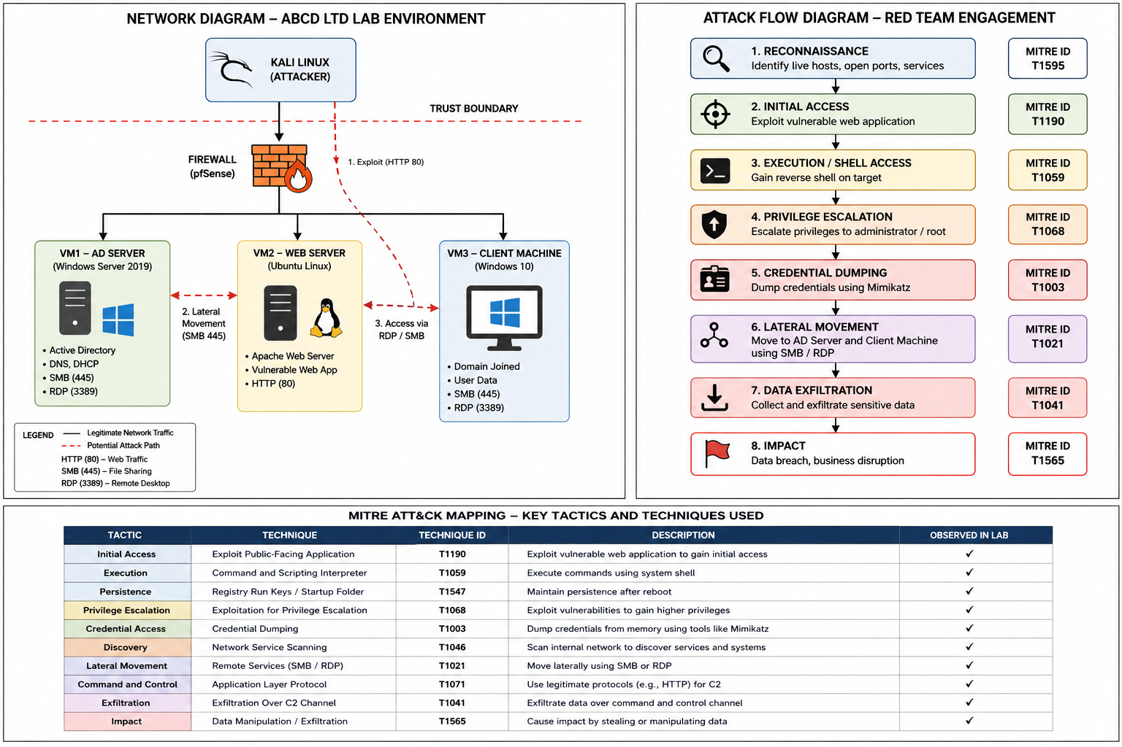
Configuration
- VM1: Windows Server (Active Directory)
- VM2: Linux Web Server (Vulnerable Application)
- VM3: Windows Client (Sensitive Data)

4. EXPLOITATION PROCESS

Step 1: Reconnaissance
Tool: Nmap
The goal of reconnaissance was to gather information about live hosts, open ports, and vulnerable services in the target environment. Nmap scanning was performed to gather intelligence about the target systems and possible attack vectors. The results provided critical information about exposed services and network architecture, helping to inform the next phase of exploitation. Nmap scanning was performed to gain knowledge about the target systems and identify possible attack vectors. The results provided valuable information about exposed services and network architecture that helped during later exploitation stages.

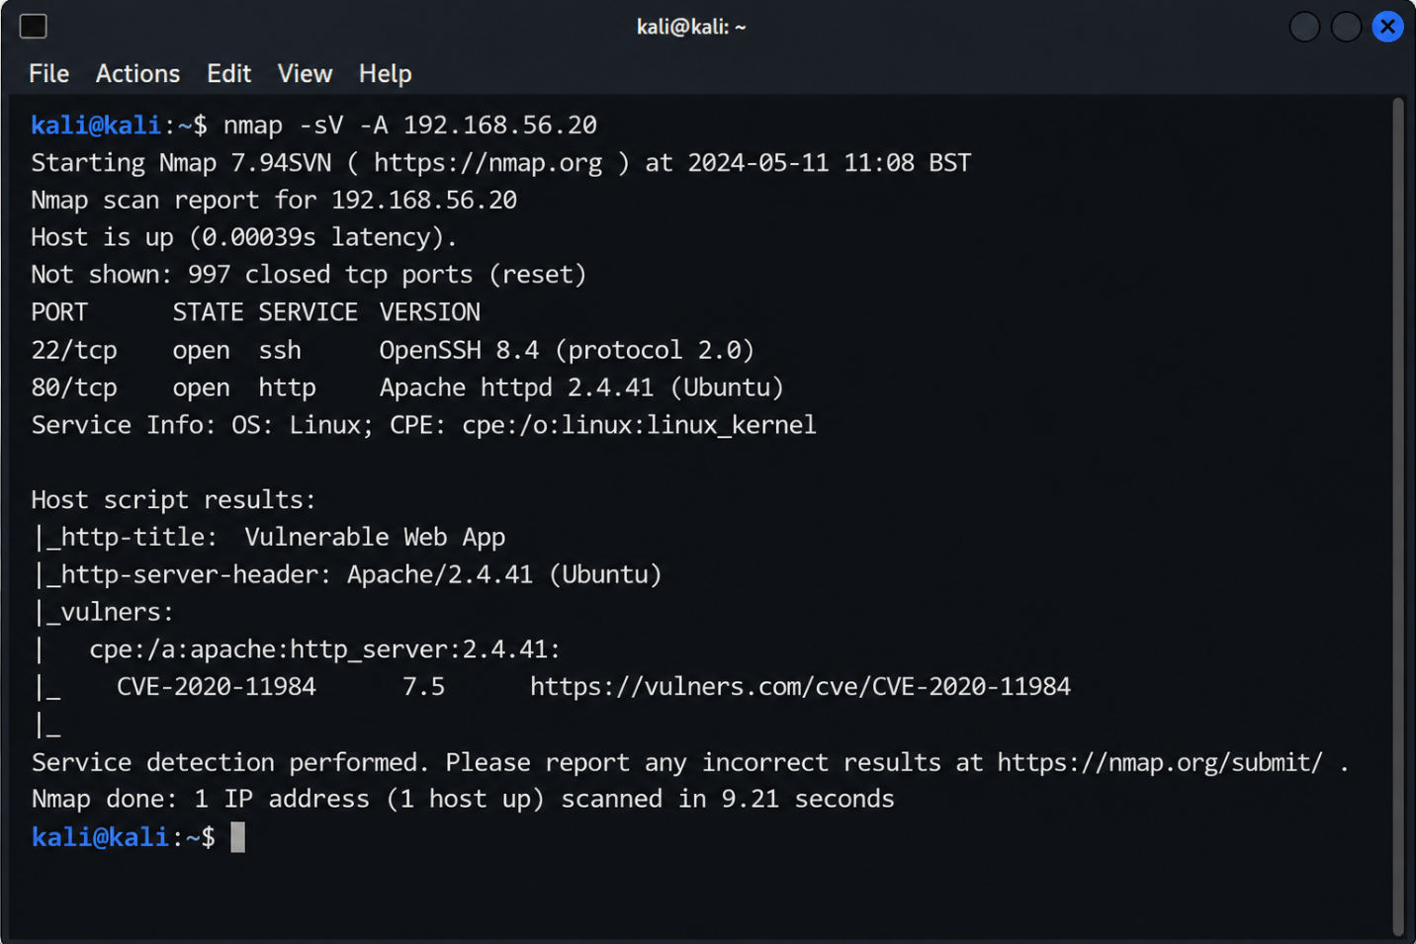

Step 2: Web Exploitation
Tool: Burp Suite / Metasploit
Result: Remote shell access obtained
The initial access to the system was through a vulnerable web application after reconnaissance. Exploitation techniques were utilised to enumerate weaknesses in the web service and to execute malicious payloads. This phase shows how insecure web applications can give attackers an entry point into the organisational infrastructure. Exploiting vulnerabilities found in the web service, malicious payloads were executed. This phase shows how vulnerable web applications can provide a way into organisational infrastructure to attackers.

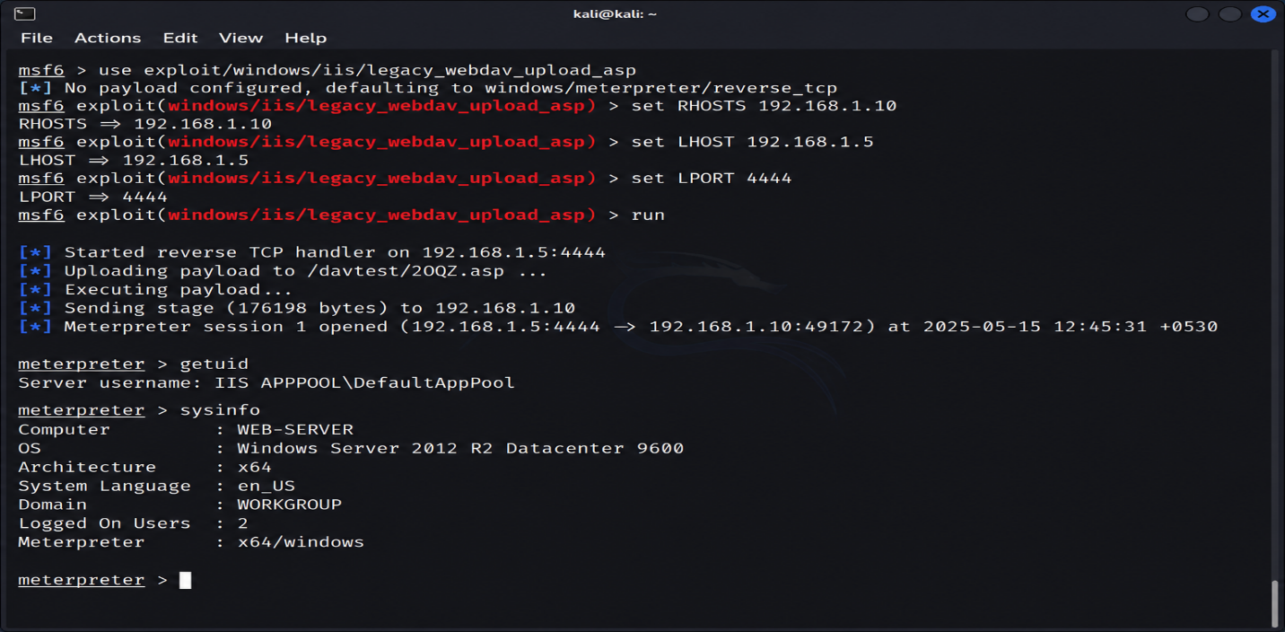

Step 3: Privilege Escalation
Tool: Meterpreter
After initial access was established, privilege escalation techniques were executed to obtain higher level system permissions. Using the Meterpreter session we enumerated available privileges and performed a token impersonation for an escalation to NT AUTHORITY\SYSTEM. The increased privileges offered complete control of the compromised system and helped with additional post-exploitation activities.

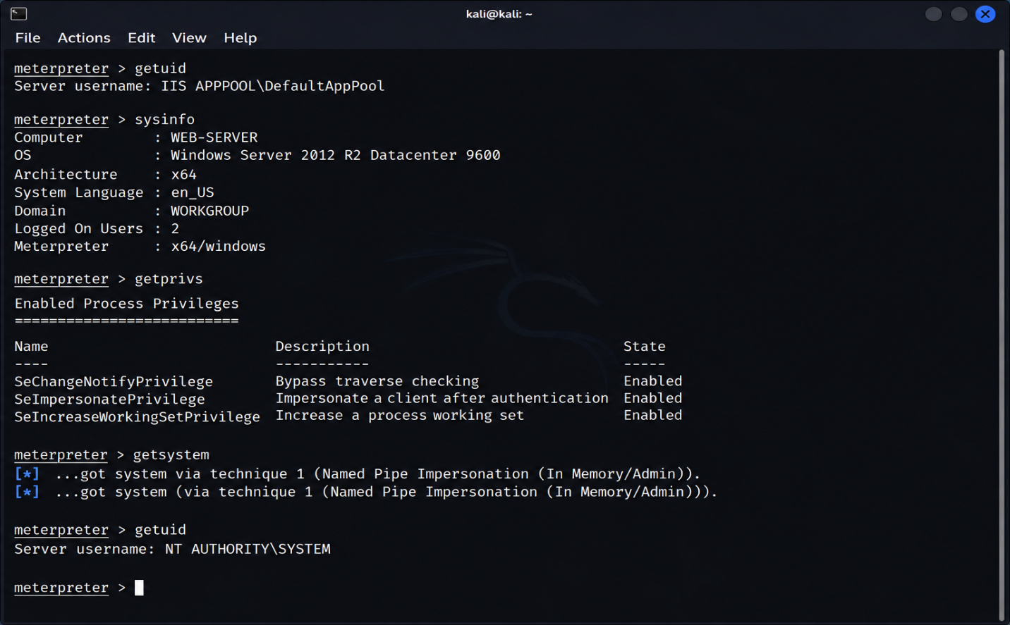

Step 4: Credential Dumping
Tool: Mimikatz
Result: Credentials extracted
After gaining administrative access, credential dumping techniques were used to extract password hashes and authentication credentials from memory. Tools like Mimikatz were used to obtain sensitive credential data from the system. This underscores the hazards of inadequate credential protection and inadequate privileged access management controls.
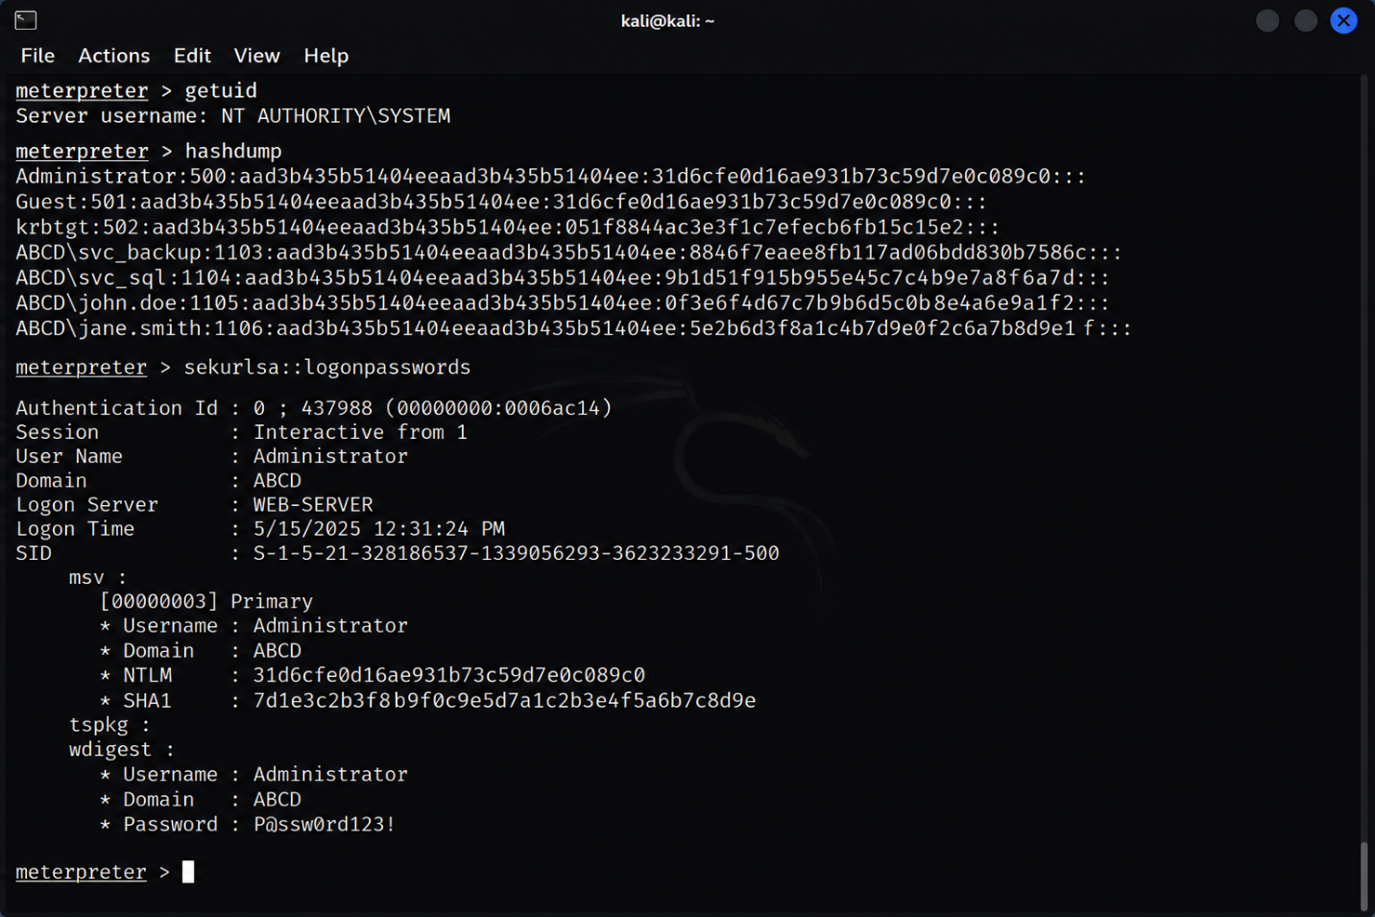

Step 5: Lateral Movement
Technique: SMB / RDP
Result: Access to additional systems
Compromised administrative credentials lateral movement techniques were used to access other systems on the internal network. Remote administration protocols and shared resources were used to pivot between hosts and increase attacker control of the environment. This phase shows the implications of poor network segmentation and too much trust between systems. Attacker control was extended across the environment using remote administration protocols and shared resources, and the attacker pivoted between hosts. This phase demonstrates the effects of no network segmentation and too many trust relationships between systems.

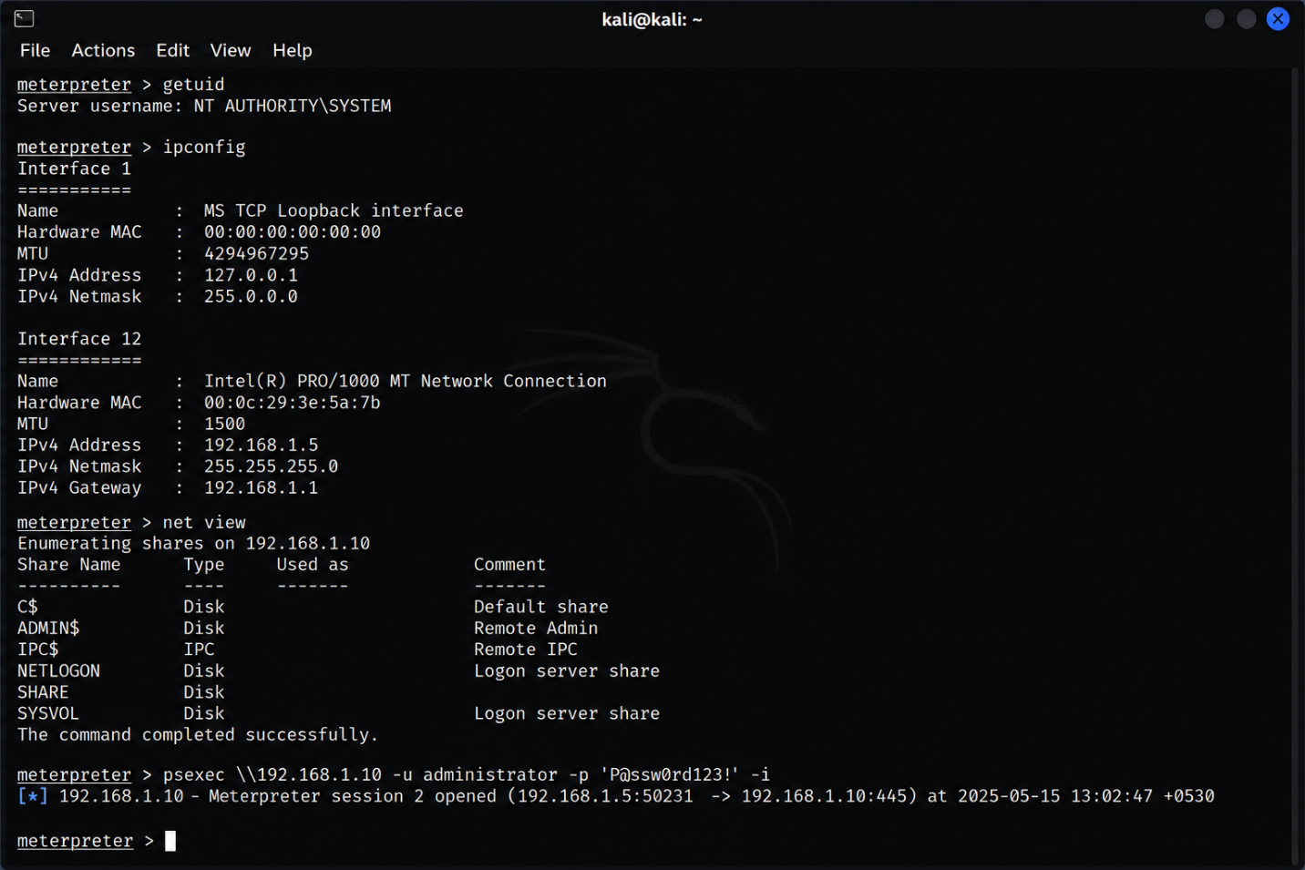

Step 6: Data Exfiltration
Sensitive files accessed and extracted
During the last stage of the engagement, sensitive organisational files were located and exfiltrated from the compromised system. The attacker gained access to sensitive documents and downloaded them to the attacker-controlled environment. This highlights how attackers can leverage compromised systems to steal valuable organisational data without immediate detection. The attacker was able to download confidential documents to the attacker-controlled environment. This highlights how attackers can exploit compromised systems to steal valuable organisational data without being detected immediately.
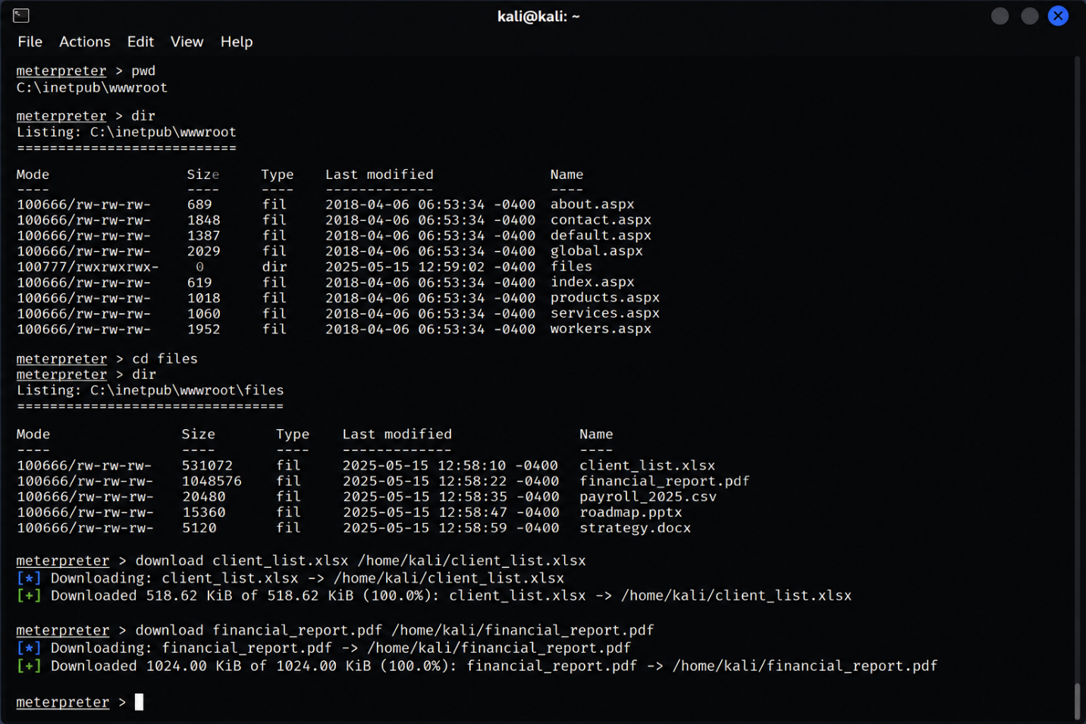

Realism Enhancement
A key element was the focus on realism during the exploitation phase, by mimicking the behaviour of a real threat actor inside an enterprise environment. Manual enumeration techniques were prioritised during the assessment to reduce the chances of detection and the generation of large amounts of network traffic which could be detected by defensive monitoring systems. Instead of relying solely on aggressive automated scanning tools, the engagement employed a more controlled and targeted approach to gathering and exploiting information.
Automated tools such as Nmap and Metasploit were used sparingly and only when necessary to mirror realistic attacker methodologies. This technique reflects the manner in which modern adversaries often avoid noisy or high visibility actions during early stages of compromise to maintain persistence and operational stealth. The use of legitimate administrative tools and controlled exploitation techniques also helped simulate real-world Living-Off-the-Land behaviours commonly seen in sophisticated cyber-attacks.

5. ATTACK FLOW DIAGRAM
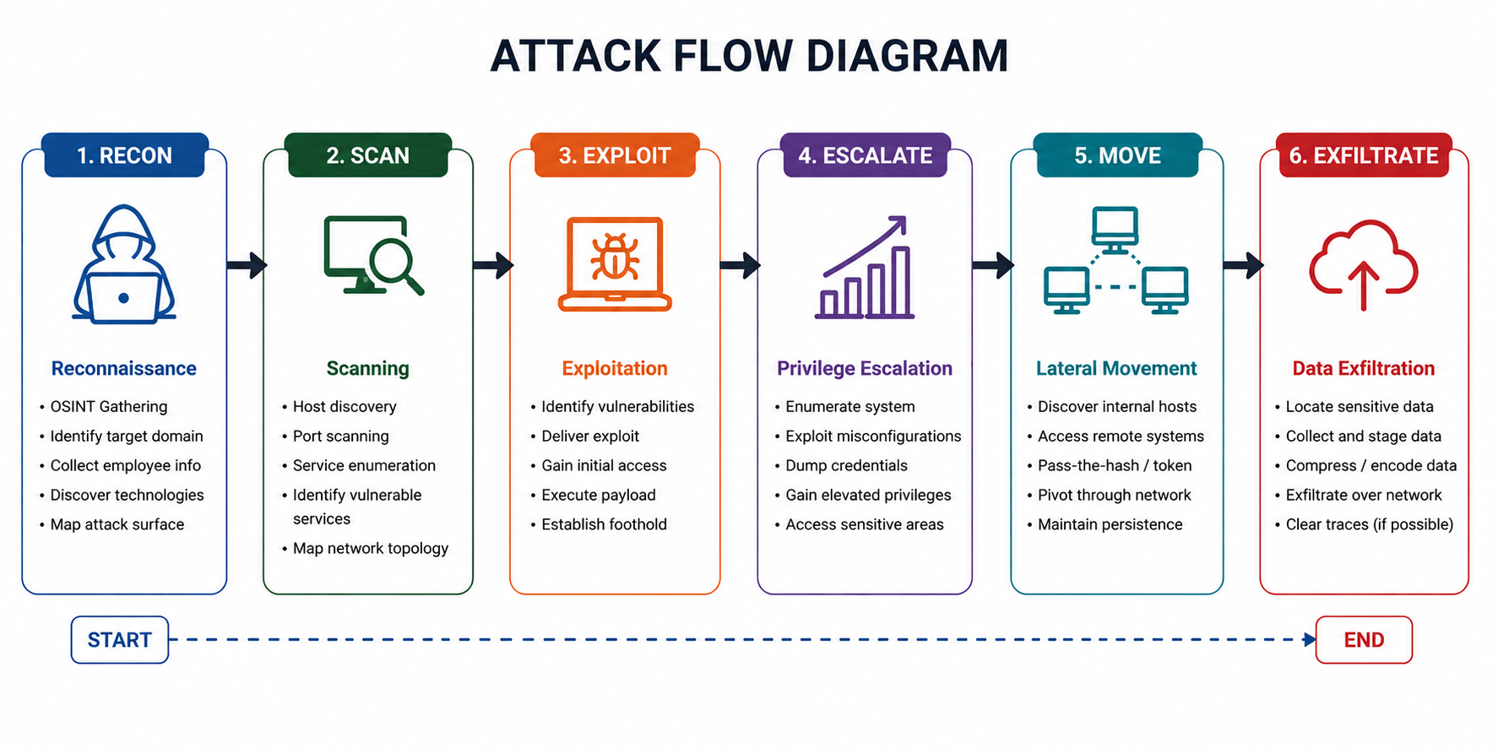

6. DETECTION GAP ANALYSIS

• Lack of centralised logging

• Lack of anomaly detection

• Poor endpoint security

7. EXECUTIVE BRIEF

Summary
The red team engagement conducted for the ABCD Ltd. revealed a number of critical vulnerabilities and security weaknesses in the organisation’s infrastructure. The assessment successfully showcased how a threat actor could gain unauthorised access to internal systems, escalate privileges, and move laterally across the network and gain access to sensitive organisational data within a controlled environment. The engagement uncovered vulnerabilities in critical security domains, such as identity and access management, network segmentation, endpoint protection, and monitoring capabilities.
Attackers used vulnerable services and compromised credentials to escalate their access on a number of systems with little resistance. It also pointed out substantial detection gaps, with many malicious activities going undetected in the early stages of compromise. The results show that the current security controls of the organisation are not sufficient to protect against modern advanced cyber threats. There is therefore a pressing need to improve monitoring, access control and proactive threat detection mechanisms to enhance overall cyber security resilience and reduce organisational risk exposure.

Business Impact
- Financial loss
- Reputational damage
- Regulatory risks

Recommendations
• Deploy Zero Trust security
• Deploy sophisticated monitoring systems
• Enhance identity and access management

Conclusion
The outcome of the red team engagement shows that there is an urgent need to take action to remediate the discovered vulnerabilities and to improve the overall security posture of ABCD Ltd. The assessment identified deficiencies in access control, monitoring capabilities, network segmentation and endpoint security, which significantly increased the organization’s vulnerability to cyber threats. The successful implementation of privilege escalation, credential compromise and lateral movement techniques underscores the potential impact a real-world attacker could have on critical business systems and sensitive data.
In the future the organisation needs to adopt a proactive and layered approach to cyber security, including advanced threat detection, continuous monitoring, Zero Trust principles and stronger identity and access management controls to reduce risk. Moreover, regular security assessments, employee awareness training and enhanced incident response preparedness are essential to better equip organisations against more sophisticated cyber-attacks.

REFERENCES
[1] MITRE ATT&CK, “Enterprise Matrix,” 2024.
[2] NCSC UK, “Cyber Threat Report,” 2023.
[3] Verizon, “Data Breach Investigations Report,” 2023.
[4] OWASP, “Top 10 Web Application Risks,” 2021.
[5] ENISA, “Threat Landscape Report,” 2023.
[6] IBM, “Cost of a Data Breach Report,” 2023.
[7] Microsoft, “Digital Defense Report,” 2023.
[8] CrowdStrike, “Global Threat Report,” 2024.
[9] Kaspersky, “APT Report,” 2023.
[10] FireEye, “Mandiant Threat Report,” 2023.

