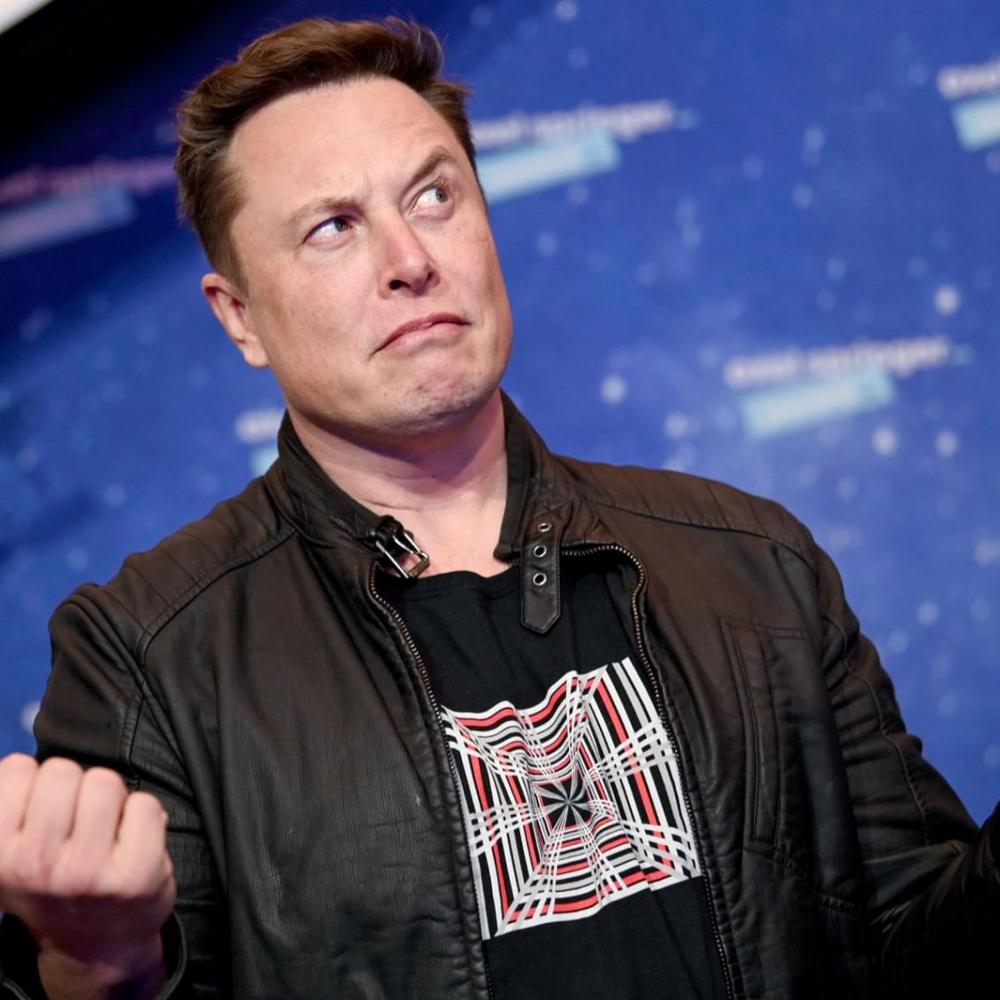

BMBM 6012 Leading and managing people:

Tesla Under Elon Musk: the leadership under the VUCA environment
Student Name Haotian Peng
Student ID 2106635
Elon Musk (as Musk hereinafter) was the founder of PayPal, the CEO of SpaceX and the CEO of Tesla. Born in 1971, Elon Mush with his forward sight into the future and forward momentum into venturing has been perceived as the model of modern innovation and competition. Said by Musk that “when I was in college, I wanted to be involved in things that would change the world.”, and he indeed managed to create remarkable impacts on the whole through its disruptive innovation in the areas of digital third-party payment, electric vehicle, and commercial advanced rockets and spacecraft (Vance, 2015). He was ranked at 1st e in the Innovative Leaders 2019, the 25th of the Most Powerful People in 2018, and the 2nd of the World Billionaires 2021 by Forbes (2022).
VUCA represents a business world that is more volatile, uncertain, complex, and ambiguous than ever before (Bennett and Lemoine, 2014). In the VUCA era, the uncertainty of the environment comes from the continuous emergence of megatrends, such as the advancements in technologies, the outbreak of the covid-19 pandemic, the Brexit geopolitical issues, which constantly break the inherent thinking and cognition and bring about the impact of ideas, which inevitably contains infinite opportunities and chances for organizations (Kok and Van Den Heuvel, 2019; Worley and Jules, 2020). Under the specific context, organizations have been perceived as complex adaptive systems with a number of heterogeneous agents and with massive dynamic networks of interaction. That indicates the fact that the organization cannot be perceived as a single isolated entity but a whole system with continuous international with VUCA environments (Okwir et al., 2018). The new competitive landscapes where every business operates require more effective leadership that cannot only sustain superior organizational performance but also afford rapid adaption to the environmental shift and foster cutting-edge innovation to stay ahead. The previous leadership worshipped by most businesses put a higher emphasis on the controlling are is more directed by workplace productivity, with bare attention paid to adaption and innovation (Bird and Mendenhall, 2016). To succeed in the VUCA environment, leaders take the lead and lead their teams to achieve breakthrough innovations and enter a new stage of growth through accurate prediction of social development trends and continuous continuation of their own strengths. Many have attributed the success of Tesla, PayPal, and Success to the effective leadership of Musk, the present essay attempts to critically evaluate the tyle of Musk’s leadership and discuss whether Musk’s leadership style is effective in the VUCA environment in terms of sustaining higher performance, foster innovation and adaption.
Interest in leadership has been ever strong given the VUCA environment. Nonetheless, there has been conceptual confusion regarding the definition of leadership. With traditional leadership theories being fixating on rank and power, for instance, leadership is the pre-eminence of the control processes for individuals within a group (Mumford, 1906); leadership is the art of controlling and influencing (Copeland, 1942), etc. The emerging leadership theories attempt to define leadership from a wide range of different disciplines, such as interpersonal influence, relationship management, etc. (Lowe and Gardner, 2000; Hogan and Kaiser, 2005) The diversification in the emerging leaderships also lead to the development of leadership frameworks which can be used here to evaluate Musk’s leadership style. The essay utilizes servant leadership, authentic leadership and transformational leadership as theoretical lenses to study Musk’s leadership style.
The concept of servant leadership was developed by Greenleaf (2002), to describe leaders who believe “they are no better than the people they lead, which drives them to serve and manage their followers rather than direct them”. The typical characteristics of a servant leader involve foresight, awareness, conceptualization, stewardship, clearing the past, listening, empathy, building community, persuasion, commitment to growth to others (Greenleaf, 2002). The ability to persuade others to accept his or her point of view is another important competency that a servant leader must possess. The focus of servant leadership is to show pursue and communicate with employees, not to force them to accept (Sendjaya, Sarros and Santora, 2008). In Musk's internal letter to employees, he said to all employees under the simple and clear heading "Attention", "If I send a letter with clear instructions, there are only three actions that management can take. First, write back and say what I said was incorrect because sometimes I'm dead wrong! Second, if I'm too general, ask me to elaborate further. Third, follow the instructions. If you don't do any of the above, the supervisor will be asked to resign immediately.” (Insider, 2021). In this regard, Musk apparently does not persuade his employees in any ways, but tend to be a bit authoritarian by placing commands. Also, Musk has been criticized for lack of empathy. Empathy is the leader's ability to see things from the other's point of view, to understand others and to appreciate their feelings (Greenleaf, 2002). Musk is a boss who keeps a close eye on progress, and he can't tolerate stagnation. Some employees have said that Elon is good to work with as long as he keeps up with the schedule. He often said, "If you have a problem, you can come to me directly. I don't care what the problem is, but I'm going to fix it right away." (Vance, 2015) Tesla has been struggled with delivery delay due to its limited production capability and higher-than-expected demand. Facing with delivery delay and facing, employees have been forced to work for extra longer hours to meet the deadlines; facing with Tesla’s ambition to reach mass market with lower-cost vehicles, employees are treated with relatively lower financial rewards to save costs in operation (CNBC, 2021). These issues are generally been reported among the front-line workers, and Musk dealt with these issues in a relatively passive attitude when the mass complaints started to threaten the corporate image (Schoemaker, Heaton and Teece, 2018). Therefore, Musk is not considered as a servant leadership.
Transformational leadership is an important feature of corporate leadership in the new era. Compared with traditional corporate leadership, transformational leadership pays more attention to the leadership's personal inspirational power, leadership charisma, etc. (Bass and Riggio, 2006) The personal interests of the leader are closely linked with the employees, and the leader needs to maximize and enhance the personal abilities of the employees, so that the employees pay attention to the responsibilities they should take and the tasks they should perform. Indicated by Northouse (2021), transformational leadership includes four dimensions, respectively inspirational motivation (inspiring to get the new heights), individualized consideration (coaching and empowering to success), intellectual stimulation (encourage learning and growth) and idealized influence (lead by example and set the expectations). In terms of idealized influence, Musk, given by its achievement so far, has been perceived as a role model by his employees, and he has attempted to make impacts on his followers in a positive way. For instance, after the third failed launch of the Falcon 1 rocket, Elon told SpaceX's more than 300 employees, "We knew from the beginning that this was going to be very tough, we were launching a rocket after all. Many countries have failed in sending their first stage rockets into space, and we accomplished this feat. We had to buck up and gather our strength because we still had a lot of work to do. Personally, I'm not going to give up.” (Space, 2020) Musk's words have encouraged and restored the confidence of SpaceX employees who have just experienced a failed launch. Dolly Singh, head of SpaceX's patent department who has worked with Elon for many years, said: "Elon has shown some of the most compelling leadership I've ever seen, he can spark energy and determination out of defeat and despair in a moment, and he can shift our focus from retreating to looking forward." (Forbes, 2016) She added, "He focuses on the progress of work and the execution of plans and leads things to positive change, and no one takes more risks than Elon. I choose to follow him rather than people who just make empty promises." (Forbes, 2016) At the same time, Musk has exhibited some effectiveness in intellectual stimulation. Musk once said that “We make very good use of analogy, we do what others are doing, with some minor adjustments. Analogy provides shortcuts that don't require a lot of thinking, and you can't know what's really right and what's really possible if you use analogy. Analogical reasoning looks convincing, but no for creation” (Vance, 2015). He encourages his employees not to rely on the analogy method, but think in a more disruptive way and endows autonomy for innovation for employees of all levels within organizations. “If you can combine knowledge from different fields, you have the opportunity to create extraordinary results, and there are big opportunities for innovation here” (Vance, 2015). That's why Musk encourages everyone to study as wide a range of subjects as possible. With interest, employees can learn the basics of each field and then think about how to integrate knowledge from different fields, which can easily lead to whimsical ideas. In terms of individualized consideration, Musk has valued knowledge accumulation and learning since the company's inception as a way to drive employees past performance goals and achieve rapid career growth. Musk has been committed to promoting learning throughout the organization. He knows that high-potentials have a desire to learn and challenge, and that learning accelerates self-achievement and overate innovation. Tesla's organizational learning includes a series of systematic software, an X-Camp boot camp that every new employee attend, and a large number of rolling, on-the-job training sessions (Vance, 2015). The learning software is updated regularly, and all employees are required to complete the content and pass exams in a timely manner, providing more knowledge updates. In terms of inspirational motivation, refers to the fact that transformational leaders can better achieve team goals by communicating a clear vision of their work to motivate and inspire their potential. In 2006, Musk revealed “The Secret Tesla Motors Master Plan, indicating his overall vision to change the transportation sector through electric vehicles via Tesla’s three-step master plan “build sports car; use the money to build an affordable car; use that money to build an even more affordable car; etc. “ (Tesla, 2006) The vision has clearly and transparently communicated to every employees working in Tesla with measurable and actionable deliverables. The achievement of the first master plan through the rolling out of Model S, Model Y, has led to the Master Plan-Part Deux in which Musk indicates the next ten-year orientation for Tesla. The critical analysis on the four dimensions of transformational leader indicates Musk as an evident transformational leader.
The final leadership framework utilized here is the authentic leadership, as which leaders are seen as real and genuine (George, 2003) . According to Beddoes-Jones and Swailes (2015), there are three prerequisite to be an effective authentic leader, including self-aware (be aware of the impacts of moods, thoughts, and behaviours on followers), ethics ( has the courage to speak up for what they have faith in), and self-regulation (deliberate control of thoughts and emotions). Empathy is an important indicator of self-aware, which, according to the above analysis, is not processed by Musk. However, Musk does have characteristics in ethics and self-regulation. For instance, Musk is highly patient and resilient. As he mentioned in his experience of creating Space X and PayPal, “I think starting a business is a difficult thing to do. To be honest, I wouldn't necessarily advise someone to start a business. It starts out feeling optimistic, there will be an optimistic initial period that lasts about 6 months, maybe a year at most, and then it's a painful ordeal that lasts for years and ends in failure and bankruptcy.” (Vance, 2015) Musk had encountered enormous headwinds in terms of financing problems, R&D problems, and management problems along his venture of Tesla, PayPal and Space X, but he has been able to remain calm, patient, positive and resilient to think about actionable remedies for whatever problems he was facing (Entrepreneur Europe, 2020). But still Musk is a less authentic leader.
The specific transformational leadership style has empirically proved to be positively related to the development of emotional intelligence, social intelligence and learning ability, which are perceived as key skills associated with effective leadership to reduce VUCA, and promote innovation, adaption and performance. Emotional intelligence is denoted as the ability to perceive emptions to assist thought and promote intellectual growth (Mayer and Salovey, 1997). While Musk is apparently smart in terms of IQ, high emotional intelligence allows it to effectively use his emotions to influence employees, such as use his positivity and resilience (the never-give-up attitude) to take the company through various difficulties and crisis, which is typical in VUCA environment. In terms of social intelligence refers to the ability of leaders to form relationship and communicate with employees with assertiveness and empathy(Albrecht, 2006). Though Musk is highly communicable, his empathy dimensions can certainty be further improved to foster more effective transformational leadership. Learning agility refers to the mind-set allowing for the development of novel strategies to solve complex problems (Gravett and Caldwell, 2016). The learning ability evidently exhibited by Elon Musk allow it to put his creative ideas ranging from different areas, from electric vehicles, digital payment, and spacecraft, into successful businesses, and he has been continuously learning from industrial frontiers through open innovation, and continuously diversified the business scope of his businesses, which in turn, foster adaption and innovation to accommodate the VUCA environment. Therefore, the essay argues that the transformational leadership of Musk is effective to foster performance, innovation and adaption in the VUCA environment, but a bit more empathy would be more beneficial to motivate and inspire employees.
The essay using three theoretical frameworks, authentic leadership, servant leadership and transformational leadership, to analyse Musk’s leadership style and leadership effectiveness in the VUCA environment. The analysis indicates Musk as a transformational leadership as he has the features indicated in the four dimensions under the transformational leadership but lacks empathy required by authentic leadership and servant leadership. The leadership is effective as it enables musk to develop high emotional intelligence, social intelligence and learning agility, which are essential skills in the VUCA environment required to develop performance, innovation and adaption, but a bit more empathy could be beneficial in empowering and inspiring employees more effectively.

Reference
Albrecht, K. (2006) Social intelligence: The new science of success. John Wiley & Sons.
Bass, B. M. and Riggio, R. E. (2006) Transformational leadership. Psychology Press.
Beddoes-Jones, F. and Swailes, S. (2015) ‘Authentic leadership: development of a new three pillar model’, Strategic HR Review, 14(3), pp. 94–99. doi: 10.1108/shr-04-2015-0032.
Bennett, N. and Lemoine, G. J. (2014) ‘What a difference a word makes: Understanding threats to performance in a VUCA world’, Business Horizons, 57(3), pp. 311–317.
Bird, A. and Mendenhall, M. E. (2016) ‘From cross-cultural management to global leadership: Evolution and adaptation’, Journal of World Business, 51(1), pp. 115–126.
CNBC (2021) Tesla buyers confounded by delivery delays stretching for months. Available at: https://www.cnbc.com/2021/08/18/months-long-delivery-delays-confound-would-be-tesla-owners.html (Accessed: 10 March 2022).
Copeland, N. (1942) Psychology and the Soldier. Military Service Publishing Company.
Van Dierendonck, D. (2011) ‘Servant leadership: A review and synthesis’, Journal of management, 37(4), pp. 1228–1261.
Entrepreneur Europe (2020) The Elon Musk Way of Persevering in the Face of Adversity. Available at: https://www.entrepreneur.com/article/313333 (Accessed: 10 March 2022).
Forbes (2016) What Is It Like To Work With Elon Musk? Available at: https://www.forbes.com/sites/quora/2016/06/24/what-is-it-like-to-work-with-elon-musk/?sh=56e0641e45ff (Accessed: 10 March 2022).
Forbes (2022) Elon Musk. Available at: https://www.forbes.com/profile/elon-musk/?sh=3780df717999 (Accessed: 9 March 2022).
George, B. (2003) Authentic leadership: Rediscovering the secrets to creating lasting value. John Wiley & Sons.
Gravett, L. S. and Caldwell, S. A. (2016) Learning agility: The impact on recruitment and retention. Springer.
Greenleaf, R. K. (2002) Servant leadership: A journey into the nature of legitimate power and greatness. Paulist Press.
Hogan, R. and Kaiser, R. B. (2005) ‘What we know about leadership’, Review of general psychology, 9(2), pp. 169–180.
Insider (2021) Elon Musk Asks Managers Who Don’t Follow Orders to ‘Resign Immediately’. Available at: https://www.businessinsider.com/elon-musk-managers-emails-music-resign-2021-11?r=US&IR=T (Accessed: 9 March 2022).
Kok, J. and Van Den Heuvel, S. C. (2019) Leading in a VUCA world: Integrating leadership, discernment and spirituality. Springer Nature.
Lowe, K. B. and Gardner, W. L. (2000) ‘Ten years of the leadership quarterly: Contributions and challenges for the future’, The leadership quarterly, 11(4), pp. 459–514.
Mayer, J. D. and Salovey, P. (1997) ‘What is emotional intelligence’, Emotional development and emotional intelligence: Educational implications, 3, p. 31.
Mumford, E. (1906) ‘The origins of leadership’, American Journal of Sociology, 12(2), pp. 216–240.
Northouse, P. G. (2021) Leadership: Theory and practice. Sage publications.
Okwir, S. et al. (2018) ‘Performance measurement and management systems: a perspective from complexity theory’, International Journal of Management Reviews, 20(3), pp. 731–754.
Schoemaker, P. J. H., Heaton, S. and Teece, D. (2018) ‘Innovation, dynamic capabilities, and leadership’, California Management Review, 61(1), pp. 15–42.
Sendjaya, S., Sarros, J. C. and Santora, J. C. (2008) ‘Defining and measuring servant leadership behaviour in organizations’, Journal of Management studies, 45(2), pp. 402–424.
Space (2020) Every SpaceX Starship explosion and what Elon Musk and team learned from them (video) | Space. Available at: https://www.space.com/every-spacex-starship-explosion-lessons-learned (Accessed: 10 March 2022).
Tesla (2006) The Secret Tesla Motors Master Plan (just between you and me) . Available at: https://www.tesla.com/blog/secret-tesla-motors-master-plan-just-between-you-and-me (Accessed: 9 March 2022).
Vance, A. (2015) Elon Musk: How the billionaire CEO of SpaceX and Tesla is shaping our future. Random House.
Worley, C. G. and Jules, C. (2020) ‘COVID-19’s uncomfortable revelations about agile and sustainable organizations in a VUCA world’, The Journal of Applied Behavioral Science, 56(3), pp. 279–283.

