
Computer Architecture and Operating Systems
Operating Systems

Program: Computing Portfolio
Student ID: 2311568
Nate Fox

Contents
Introductory Page 3
Task 1 - Key Functions of General Operating Systems 4
Task 2 - Use of Windows OS CLI commands 8
10 Batch Commands 8
Task 3 - Use of Linux OS CLI commands 11
Task 4. Use of Windows OS scripts 14
Task 5. Use of Linux OS scripts 20
Conclusion 22
References 23
Appendices 26
Tutorial Activity on OS Types from OS Tutorial 1 26
Learning Engagement 28
Task 4 - Windows Script 31
Task 5 – Linux Script 35

Introductory Page

In a world vastly controlled by computers, operating systems are the cogs, the behind-the-scenes controllers which make everything work smoothly and efficiently. Whether using a laptop, a phone or even a smart coffee maker, there’s an operating system quietly managing things making the user experience on these devices an enjoyable one.
This assignment will explore about what an operating system is, what they do and why they’re so important in making our digital lives run smoothly. As well as looking into Windows and Linux scripting languages.

Task 1 - Key Functions of General Operating Systems

An operating system (OS) acts as the computer's brain, coordinating communication and managing hardware and software. It offers a user-friendly interface, such as Windows' Task Manager, for user insight and interaction. We'll now explore general-purpose operating systems, primarily Windows but also some information on macOS and Linux, focusing on their main functions. Screenshots will demonstrate how users manage and monitor these functions.
User Interface
An essential function of an operating system is to offer a user-friendly software interface for easy device interaction. figure 1 displays my Windows 11 desktop interface, showcasing a clear layout for effortless application access. [1]

Figure 1 - Windows 11 Desktop Example
The user interface acts as a gateway for accessing applications and managing system settings.

File Management
As shown in figure 1, folders are visible on my desktop screen. Operating systems like Windows, macOS, and Linux enable users to efficiently organize and manage data using files and folders. Windows features File Explorer (figure 2), macOS has Finder, and Linux provides a file manager.
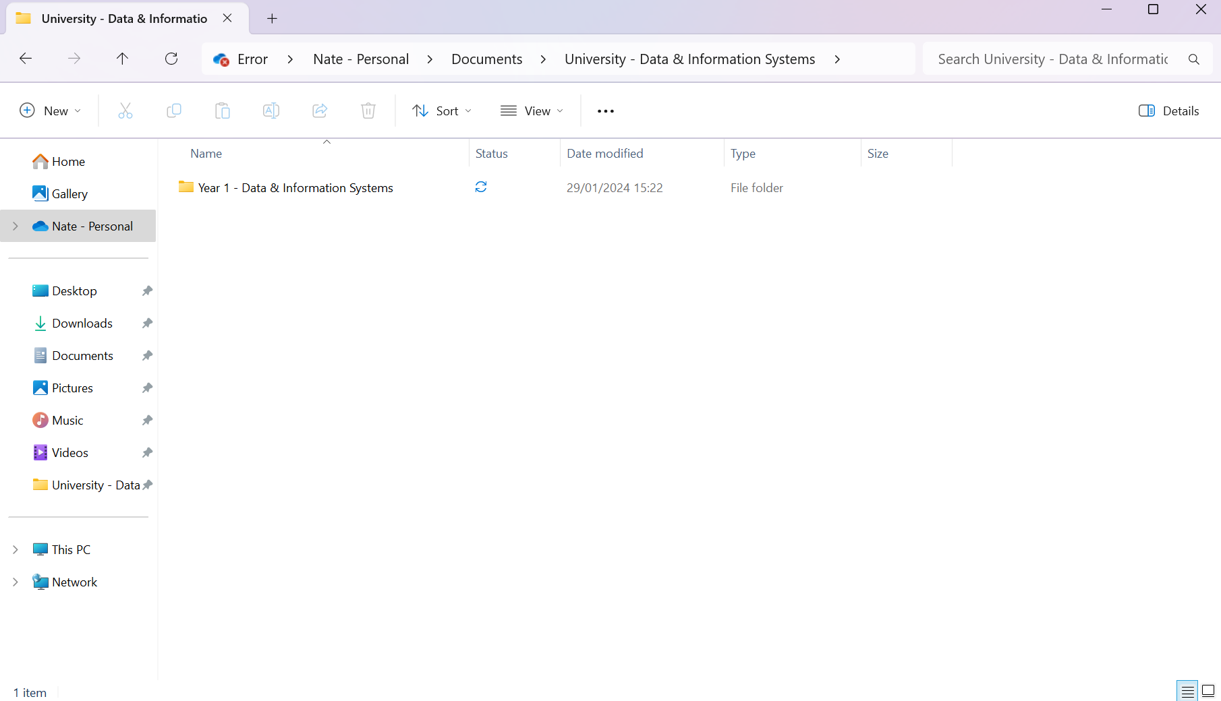
Figure 2 - Windows File Explorer
These operating systems offer tools for users to create, copy, move, delete, and rename files and folders, enhancing user experience by providing freedom to perform necessary actions. [2]

Resource Management
Operating systems manage both software and hardware resources like storage, CPU, and memory for optimal performance and stability. Windows includes Task Manager (figure 3), enabling users to monitor resource utilization and manage intensive processes.
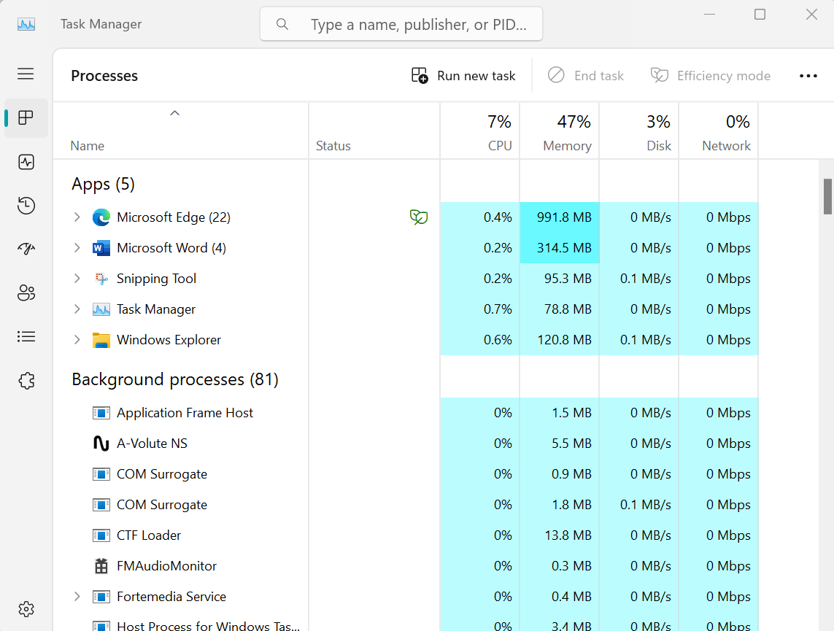
Figure 3 - Windows Task Manager
Other operating systems have tools like macOS's Activity Monitor and Linux's System Monitor, which do similar jobs to Windows' Task Manager. They help you keep an eye on your computer's activities and control what's happening, such as identifying which programs are using a lot of resources. [3]
Security
Operating systems come with tools to protect your computer from harm. For example, Windows has Windows Defender, which scans for viruses. macOS has Gatekeeper, and Linux has a built-in firewall. These tools keep your data safe. See figure 4 for a screenshot of Windows 11 security settings. [4]
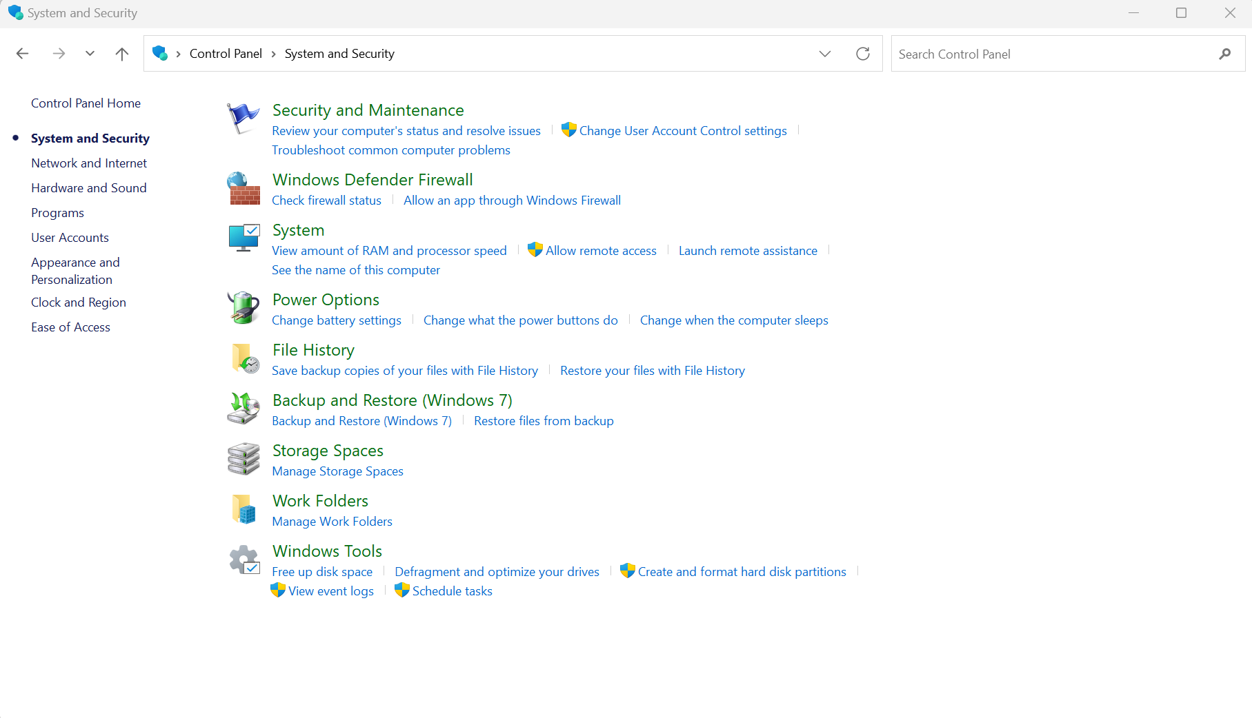
Figure 4 - Windows Security Settings
Software Management
Operating systems also offer users a way to manage software applications. Making it easy to install, update, and remove software. For example, Windows 11 includes an 'Uninstall or change a program' feature (shown in figure 5) that gives users complete control over their installed software.
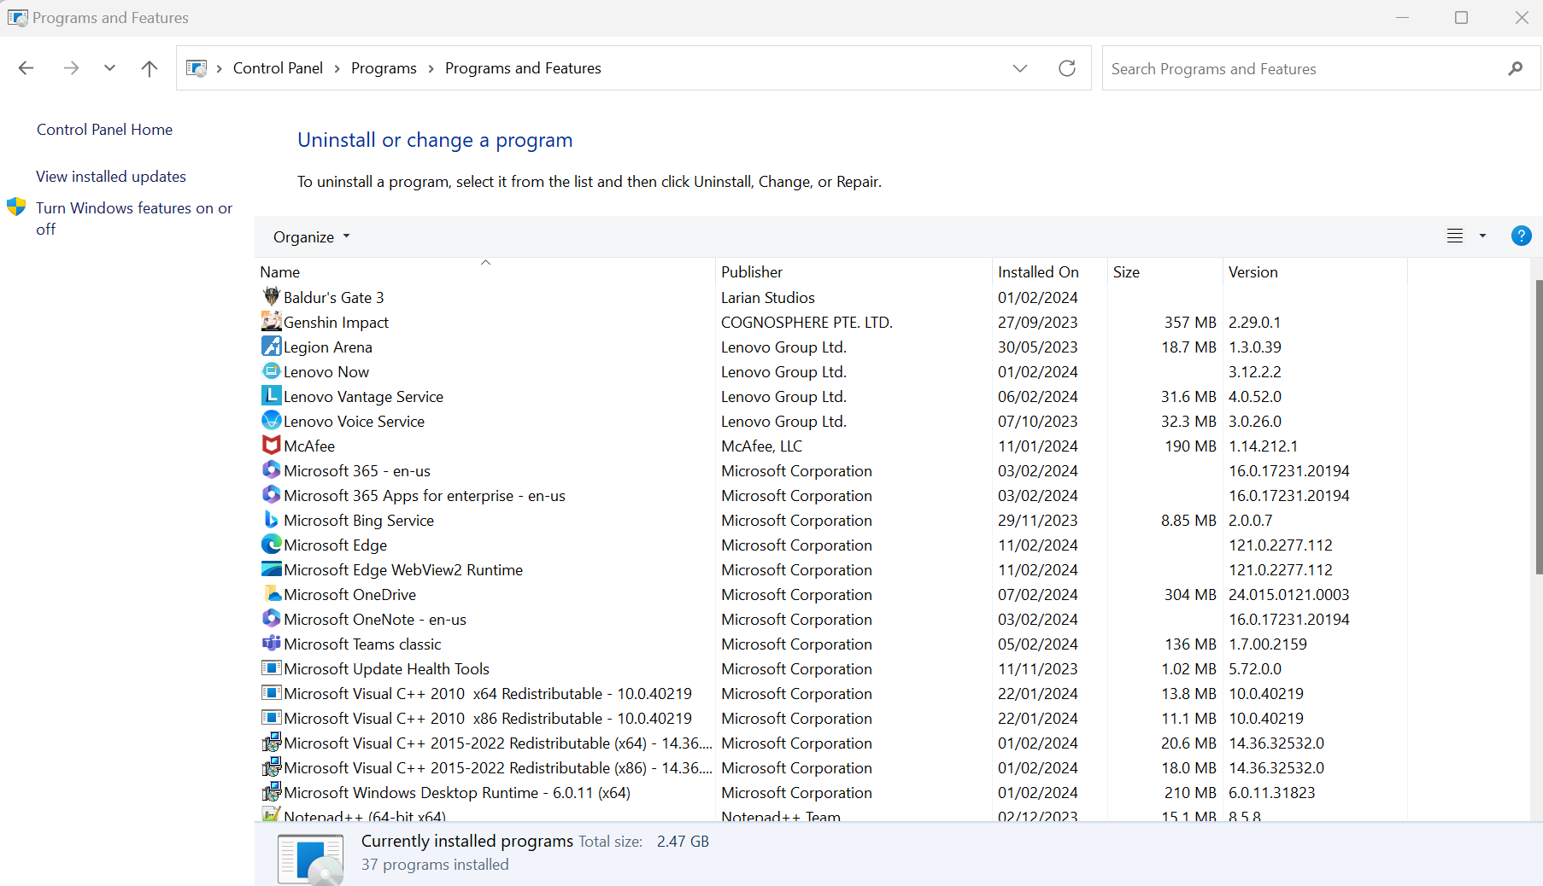
Figure 5 - Windows Program and Features
Operating systems have on-line stores which simplify software discovery and installation, ensuring compatibility and security. [5] [6]

Networking
Networking is essential for operating systems in the digital age, enabling users to connect globally for communication and data exchange. Users configure connections, troubleshoot, and monitor activity with specific programs. Check out Windows 11's network settings in figure 6.
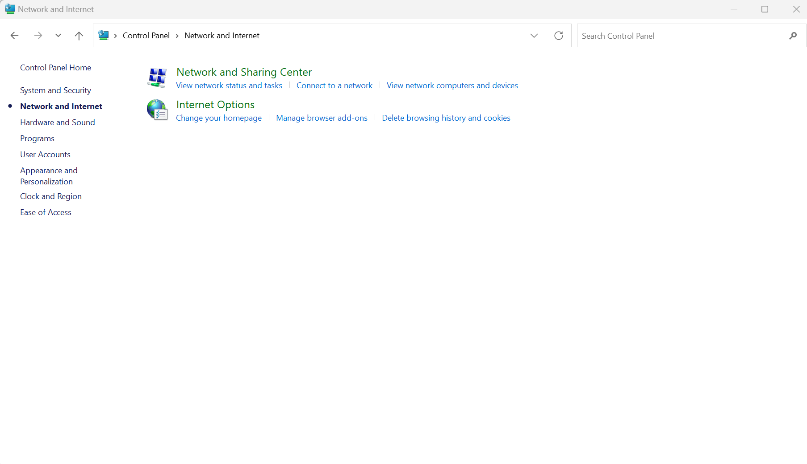
Figure 6 - Windows Network and Internet Settings

In conclusion, popular general-purpose operating systems provide essential functions for efficient and secure task completion, including file security, software management, hardware insights, and internet access. Operating systems are crucial in our digital lives. [7]

Task 2 - Use of Windows OS CLI commands

10 Batch Commands

1, Using ‘dir’ as seen below shows a list of files in the current directory. [8]
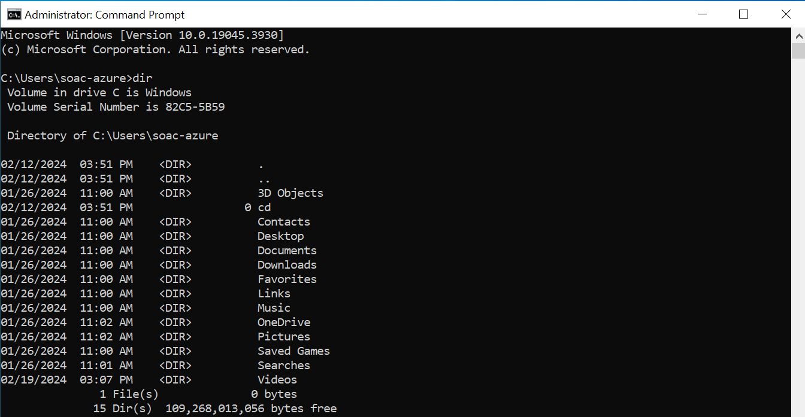
2, Using cd followed by a folder name and pressing enter will take you to the folder destination as seen below: [9]
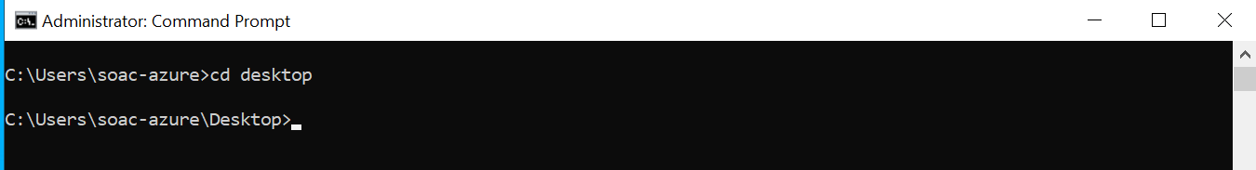
3, Below I have used ‘cd..’ this command allows the user to go back a directory. In this case I case I was in the Desktop folder and by using this command it has taken me back to my root folder.
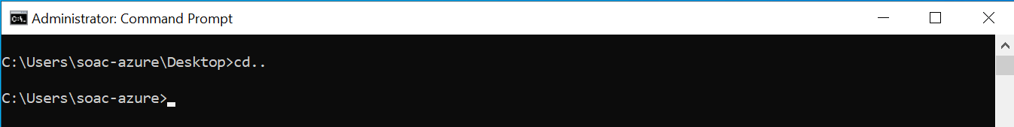
4, In the below example you can see the command ‘cd ../..’ Whereas the location was two pathways down from the root directory, using this command brings the user back to the root directory.
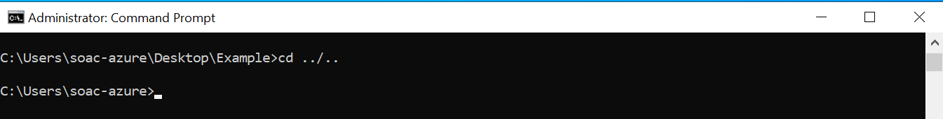
5, As seen below the command to make a new folder can be seen. ‘mkdir test’ makes a new file within the directory named test. When the ‘dir’ is then used as seen below the new test folder can be seen in the directory. [10]
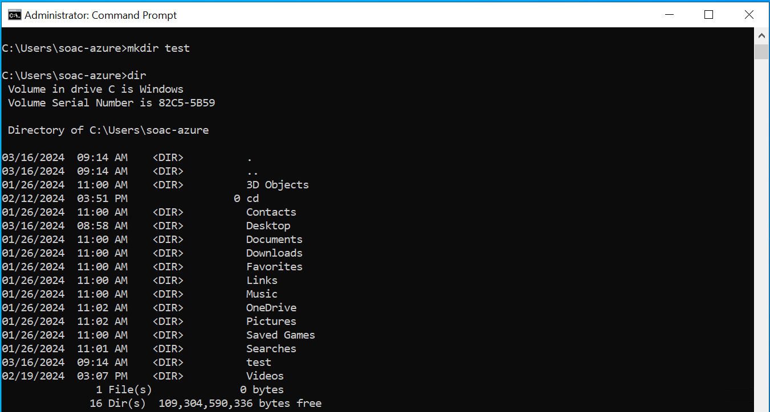
6, To remove a folder from the directory the command ‘rmdir’ along with the folder name can be used. In the below example you can see ‘rmdir test’ has been imputed and once entered into the system removes the test folder as seen below.
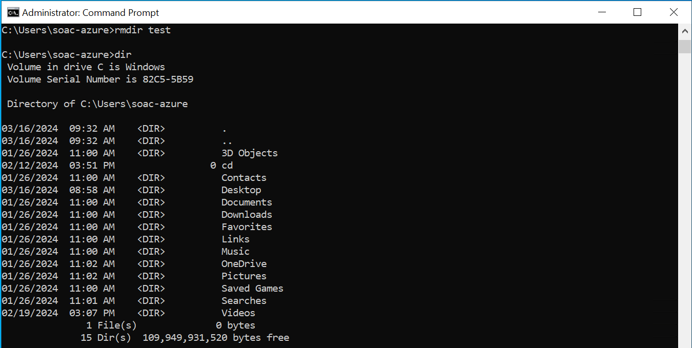
7, Using the command ‘cls’ clears the window of all commands and restarts at the root directory. [11]

8, Adding the command ‘help’ as shown below provides a comprehensive list of batch commands. [12]
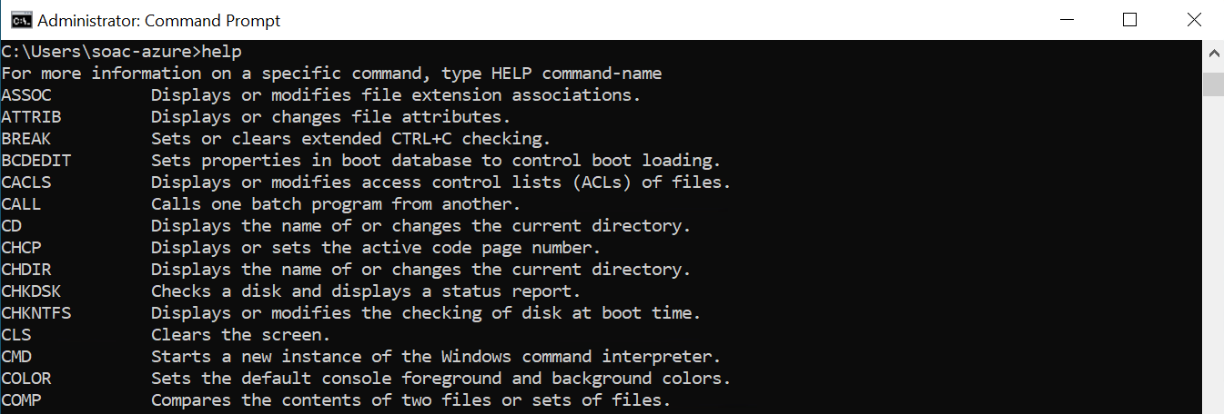
9, The command ‘ipconfig’ as seen below shows the computer address (router web interface). [13]
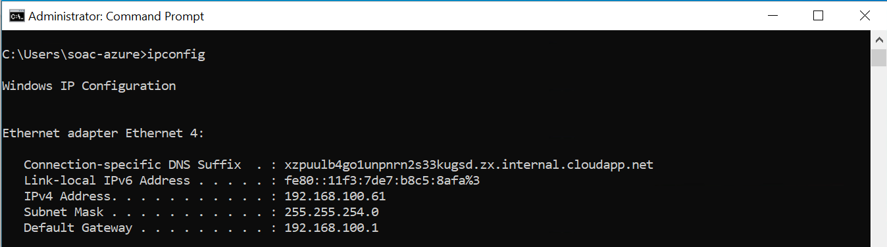
10, Adding the command ‘Whoami’ will display the username of the user as seen below. [14]
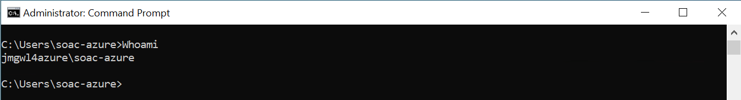

Task 3 - Use of Linux OS CLI commands

1, The ‘ls’ command shows a listing of information about files in a directory. [15]
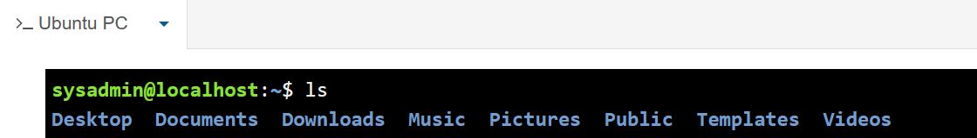

2, If the command ‘ls Documents’ in imputed as shown below a listing of files within this directory location. [16]
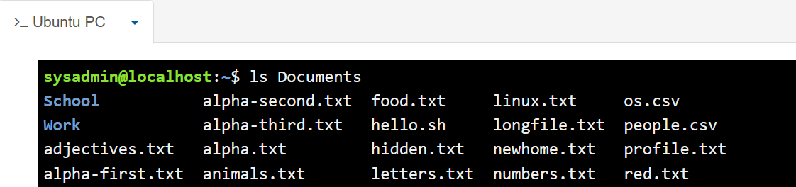
3, When the command ‘ls -l’ is imputed it will show a long-display output giving more information about each of the files listed in a specific directory. [17]
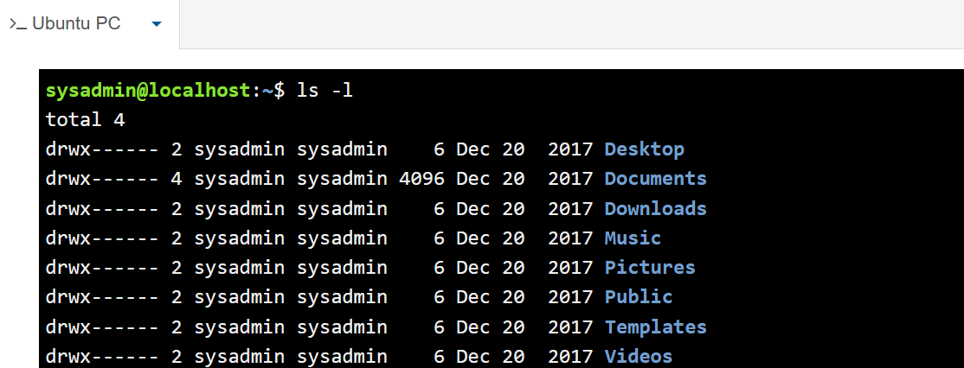
4a, If the user wished to reverse the directory, then the command ‘ls -r’ can be used as seen below. [18]
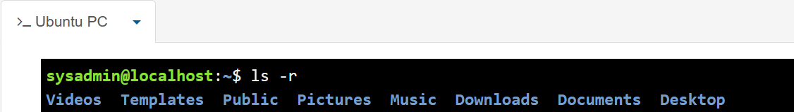

4b, If the user wished to have the files in the directory reversed and have the additional information. They could add together the commands shown above in 3 and 4a above. The command would look like this ‘ls -l -r’ and the output is shown below.
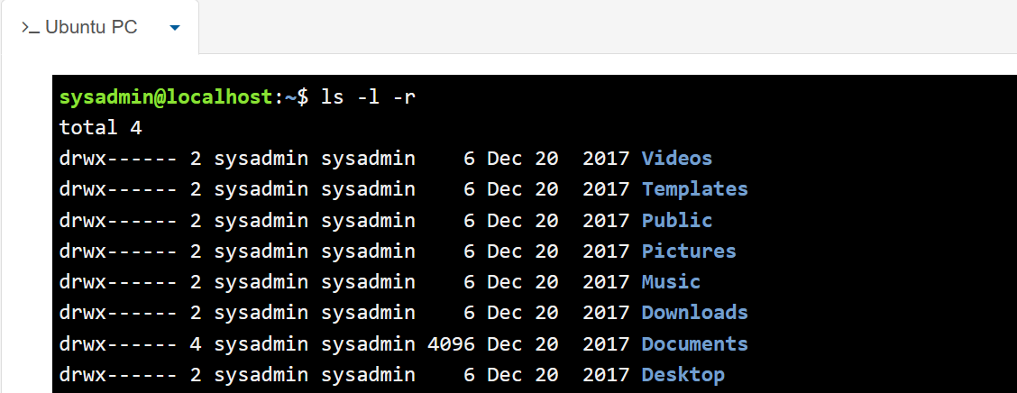
A more simplified command the user could use is ‘ls -rl’ which would provide the same output.
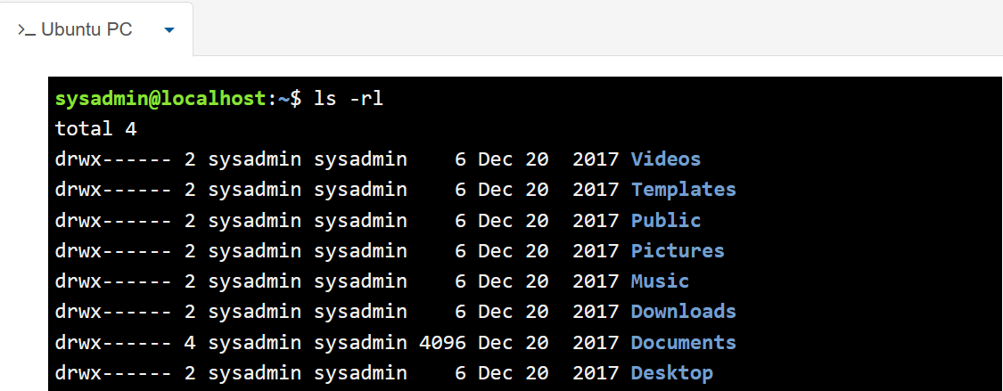
5, If a user wishes to see where they are currently located within a filesystem, they can use the command ‘pwd’ as shown below. [19]
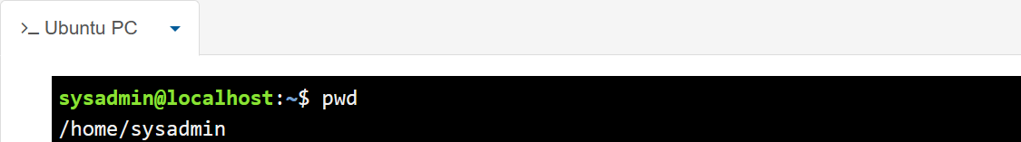
6, If a user wishes to move to the document’s folder in the filesystem, they can use the command ‘cd Documents’. [20]
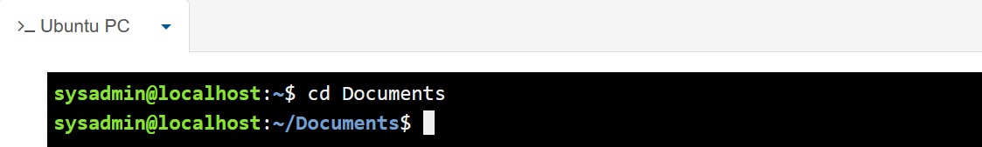
7, If a used wished to navigate through a filesystem to the art folder they would look to separate the folder names with a ‘/’ symbol. In the below example I have also included the command ‘pwd’ to output the current location in the directory.
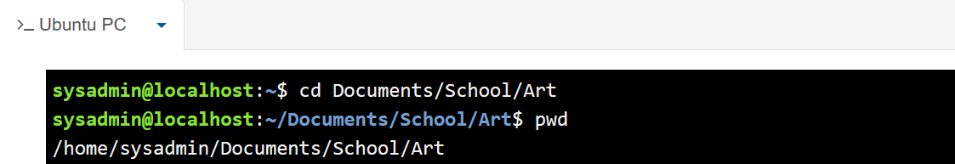
8, Id a user wishes to move a file from one folder to another they can use the ‘mv’ command. As seen below the people file has been moved from the document folder and into the work folder. [21]
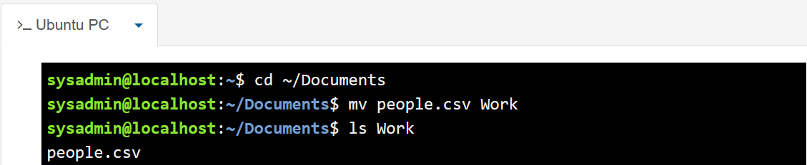
9, The command ‘rm’ is used when a user wishes to remove a file from a directory. In the below example through using this command the linux.txt has been removed. [22]
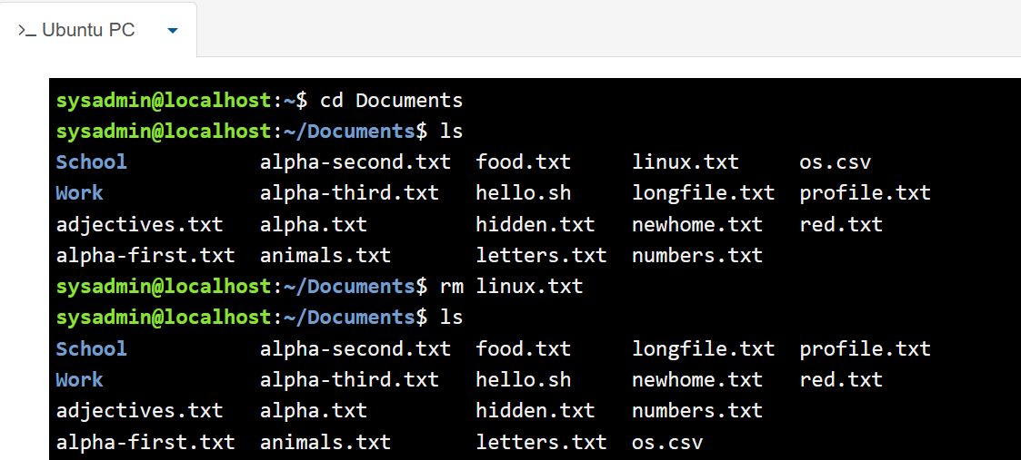
10, When a user wishes to make a new folder, they can use the command ‘touch’ as seen below. [23]
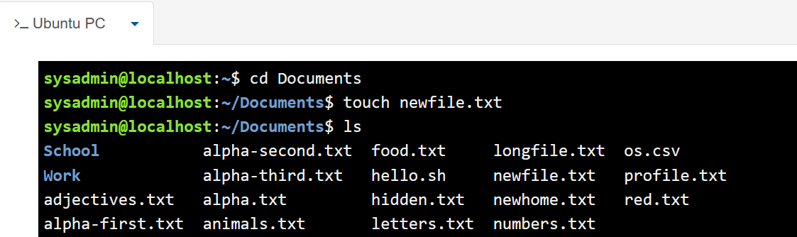

Task 4. Use of Windows OS scripts

I decided to make a shopping list for this question. The user can add and view an item, mark an item as purchased and then remove an item from the list if needed. When the programme starts, the user is taken to the main menu: [24]
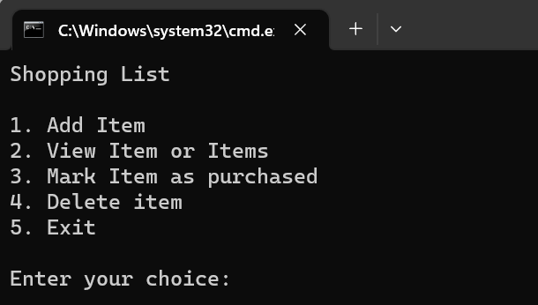
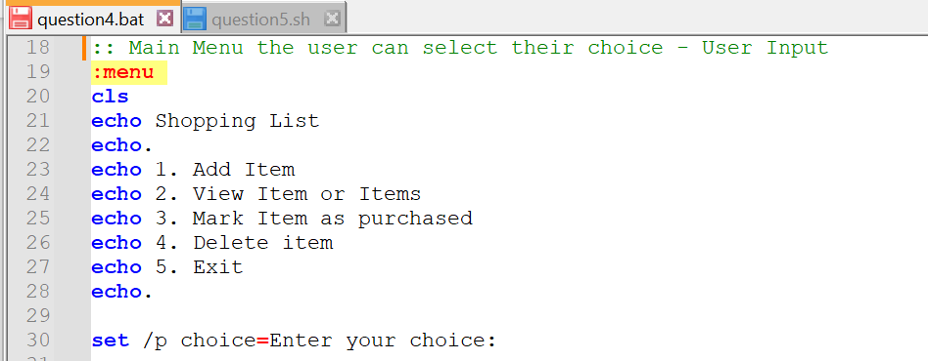
The user input is required straight away to navigate through the options.

Choosing option ‘1’ will take the user to the ‘Add Item’ section of the programme: [25]
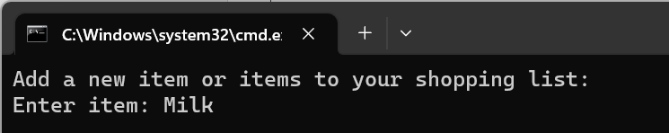
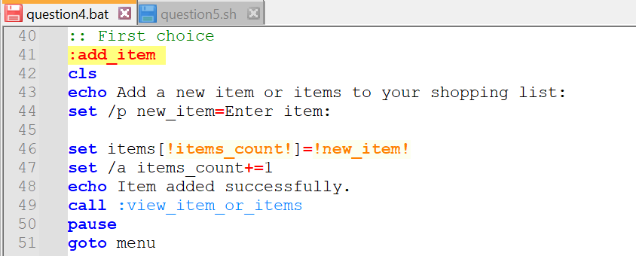
In the above I have imputed ‘Milk’ to be added to the list. Once enter is pressed the script will show the user what is currently in the list:
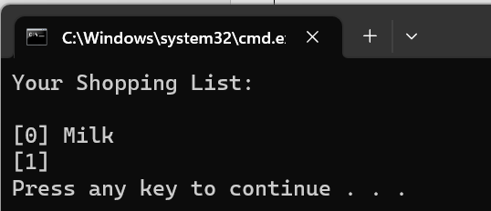
Then any key will take the user back to the main menu.

The user can then type ‘2’ into the programme to view the list: [26]
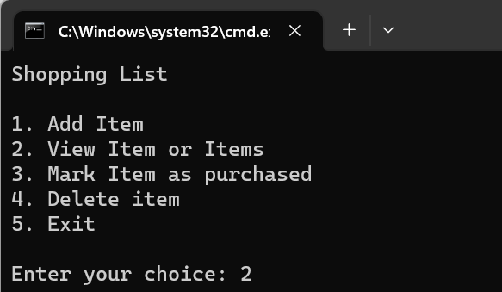
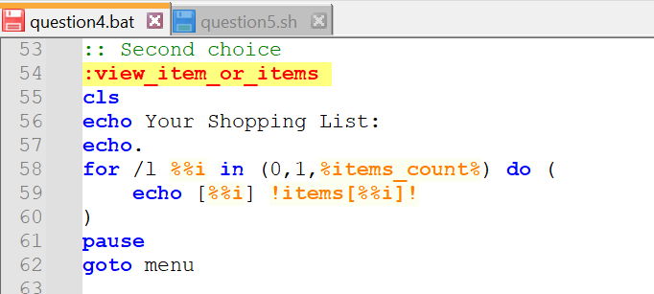
This will let the user view the items of the list:
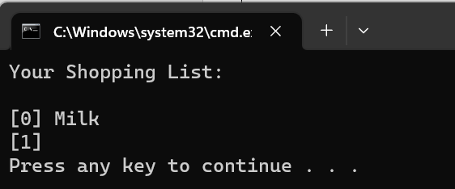
The user can then go back to the main menu through pressing any key.

The next option on the menu is to mark an item as purchased. The user will choose option ‘3’ of the programme and press enter: [27]
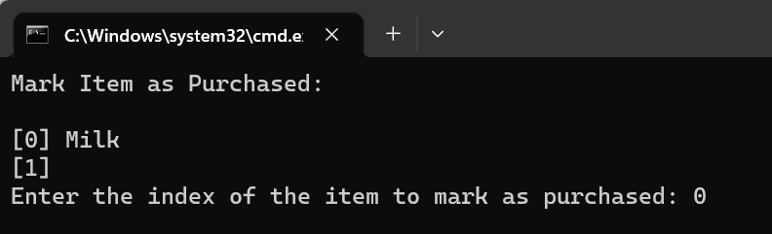
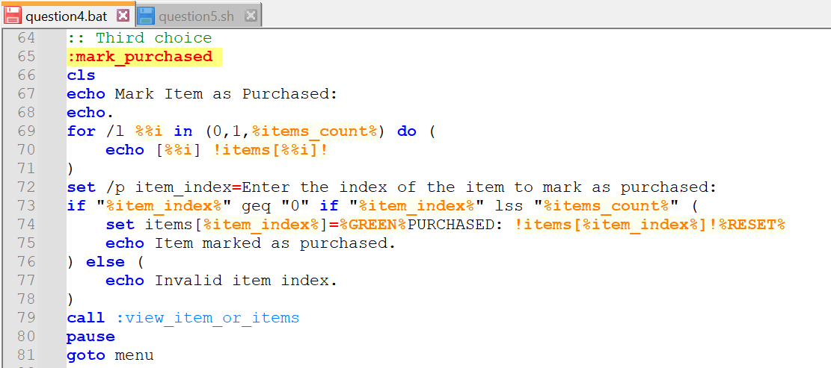
I have inputted ‘0’ to select Milk as being purchased. When enter is then pressed in the programme text will appear next to the selected item as seen below:
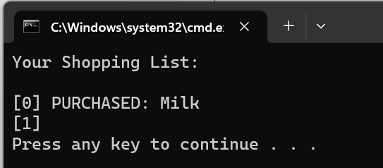
Once the user presses any key, they will revert to the main menu.

If a user then wishes to remove an item from the list, they will select option ‘4’ from the main menu which brings up the following: [28]
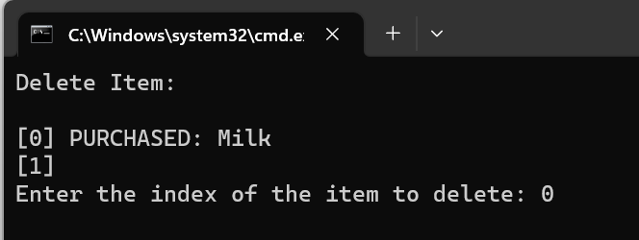
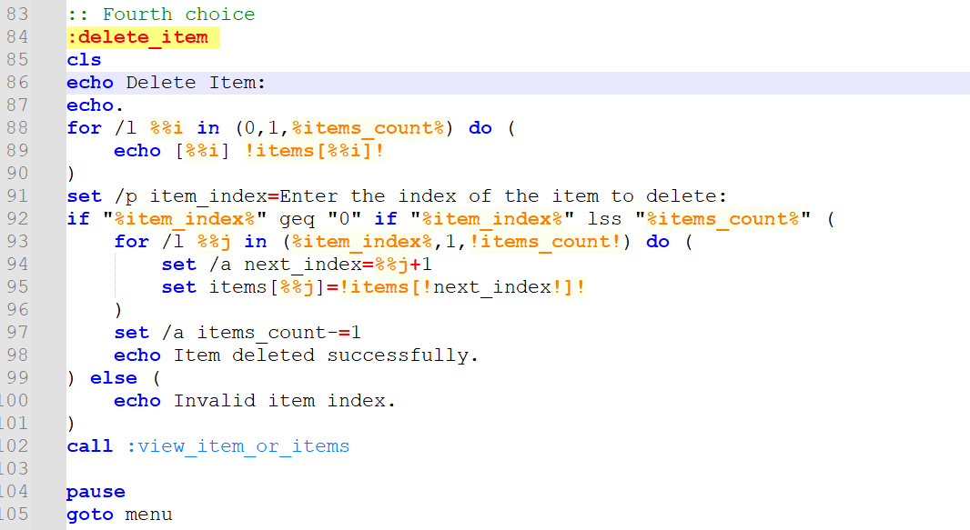
Above I have already inputted ‘0’ to signify that I wish for the purchased milk to be deleted from the list.
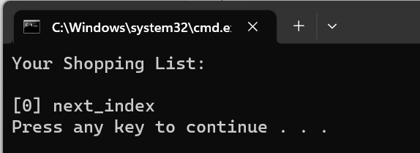
Once enter has been pressed the milk is removed from the list and the programme then shows the amended shopping list above [29] and when any key is then pressed the programme reverts to the main menu.

Option ‘5’ on the programme enables the user to exit the application.
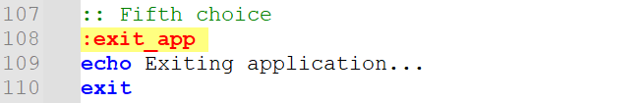
- Variables have been used in this code in the form of choices, item’s count and the items themselves. Along with Array to store the user’s input.
- The ‘goto’ command has been used throughout the script to enable the user to navigate quickly to different sections based on their choice.
- User input has been used. The user needs to enter a number from the main menu and also input their items.
- If statements have been used in the programme. For example, when marking an item as purchased the user needs to input the desired numbered item in the list and press enter. If the user fails to add a number available, then the programme will echo ‘Invalid item index’.
- Loop’s have been used several time ensuring that once an action has been completed the programme loop’s back around to the main menu. Along with the ‘call’ function to bring back the list to be reviewed after amendments.
- Functions have been used in the script for example when marking an item as purchased or adding/deleting an item.
The full script from Notepad++ has been copied to the appendices.

Task 5. Use of Linux OS scripts

To answer this question and to utilise the commands I have learnt I wrote a programme for the user to guess a number. The code used for the random generator looks like this: [30]
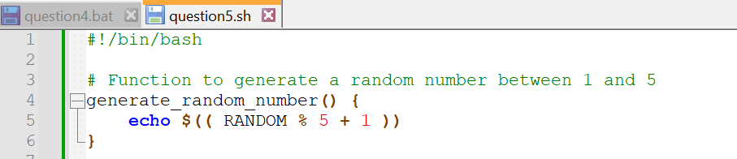
When the programme opens it looks like this:
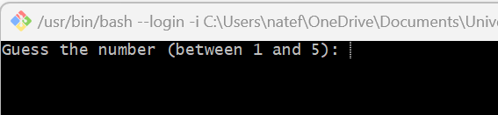
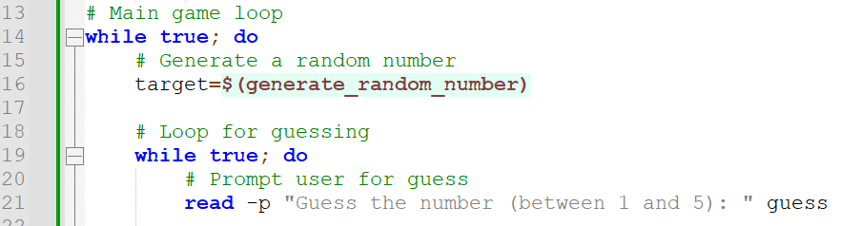
The user needs to input a number between 1 and 5.

The user can continue to guess, and the programme will give them a hint whether the number is too high or too low: [31]
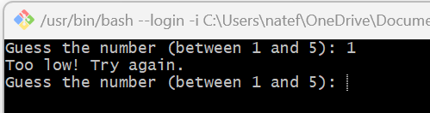
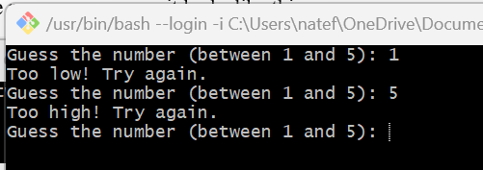
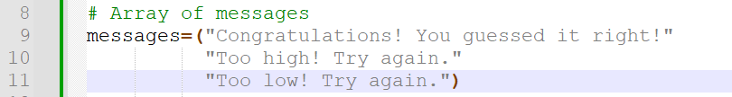
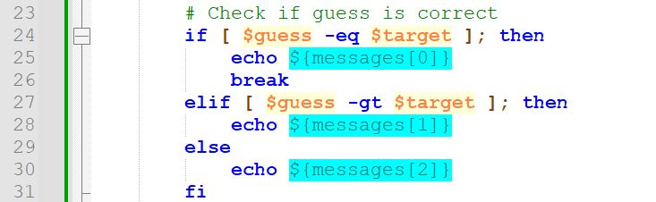
When the user provides the correct number, the output will congratulate them and give them the option to play again: [32]
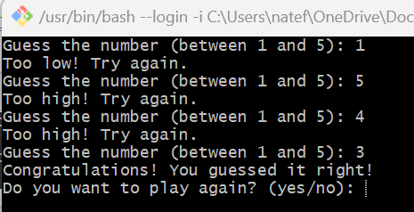
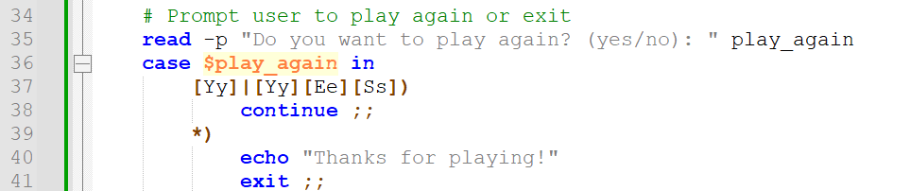

- Variables have been used in the script to store information such as the target number, user’s guess and messages.
- User input has been included for the scripting to work.
- If statements have been used to fetch messages if the number is too high or too low. Utilising ‘elif’ and ‘else’.
- A nested while loop is used to keep the user guessing.
- An array named ‘messages’ has been used to store different messages on various outcomes.
- A case statement has been used to give the player the option to play again and the answer is not case sensitive. [33]
- A function comment has been used to generate a random number.
The full script from Notepad++ has been copied to the appendices.

Conclusion

The operating system (OS) is like the manager of a computer. It handles everything behind the scenes to make sure your computer works smoothly. Think of it as the traffic controller, managing all the cars (hardware) on the road (computer) to keep things running efficiently. One important job of the OS is to manage the computer's hardware, like the processor, memory, and storage. It makes sure each part of your computer gets used properly so that everything runs smoothly when using apps or browsing the web.
The OS also helps the user interact with their computer. It provides the interface on the screen and lets the user do things like open apps, create files, and connect to the internet. It's like the translator between the user and their computer, making sure you can communicate effectively. Security is another big job for the OS. It keeps the computer safe from viruses, hackers, and other threats by setting up barriers and checkpoints to block unauthorized access and protect your data.
Now, when it comes to scripting languages like Batch and Bash, they're like shortcuts that help the user get things done faster. With these languages, we can write simple commands to automate repetitive tasks, like renaming files or organizing folders.
The OS is basically the manager which keeps the user’s computer running smoothly, and scripting languages like Batch and Bash are the handy tools that help the user get things done faster and easier. They work together to make the user’s computer experience better and more efficient.

References

Task 1
[1] “Windows User interface,” Tutorial. https://www.vskills.in/certification/tutorial/windows-user-interface-2/#:~:text=It%20is%20screen%20area%20on (accessed Mar. 29, 2024).
[2] “Windows Basics: Working with Files,” GCFGlobal.org. https://edu.gcfglobal.org/en/windowsbasics/working-with-files/1/ (accessed Mar. 29, 2024).
[3] Archiveddocs, “Windows System Resource Manager Overview,” learn.microsoft.com. https://learn.microsoft.com/en-us/previous-versions/windows/it-pro/windows-server-2012-r2-and-2012/hh997019(v=ws.11) (accessed Mar. 29, 2024).
[4] Microsoft, “Windows operating system security - Windows Security,” learn.microsoft.com, Jun. 07, 2023. https://learn.microsoft.com/en-us/windows/security/operating-system-security/ (accessed Mar. 29, 2024).
[5] BalaDelli, “Software Center user guide - Configuration Manager,” learn.microsoft.com. https://learn.microsoft.com/en-us/mem/configmgr/core/understand/software-center (accessed Mar. 29, 2024).
[6] Microsoft, “Buy Windows 11 Home - Microsoft Store en-GB,” Microsoft Store. https://www.microsoft.com/en-gb/d/windows-11-home/dg7gmgf0krt0 (accessed Mar. 29, 2024).
[7] M. Coppock, “Tech basics: How to manage networking in Windows 10,” Newegg Insider, Feb. 11, 2020. https://www.newegg.com/insider/tech-basics-how-to-manage-networking-in-windows-10/ (accessed Mar. 29, 2024).

Task 2
[8] JasonGerend, “dir,” learn.microsoft.com. https://learn.microsoft.com/en-us/windows-server/administration/windows-commands/dir (accessed Mar. 29, 2024).
[9] B. B. Posey and 02/05/2018, “How To Navigate the File System in Windows 10’s Bash Shell -- Redmondmag.com,” Redmondmag. https://redmondmag.com/articles/2018/02/05/navigate-bash-file-system.aspx#:~:text=The%20Bash%20shell%20won (accessed Mar. 29, 2024).
[10] “Bash Commands to Manage Directories and Files,” Earth Data Science - Earth Lab, Jul. 15, 2019. https://www.earthdatascience.org/courses/intro-to-earth-data-science/open-reproducible-science/bash/bash-commands-to-manage-directories-files/#:~:text=Create%20a%20New%20Directory%20(%20mkdir (accessed Mar. 29, 2024).
[11] “cmd | cls command,” GeeksforGeeks, Sep. 26, 2020. https://www.geeksforgeeks.org/cmd-cls-command/ (accessed Mar. 29, 2024).
[12] “Help Command,” Lifewire. https://www.lifewire.com/help-command-2618092 (accessed Mar. 29, 2024).
[13] JasonGerend, “ipconfig,” learn.microsoft.com, Mar. 02, 2023. https://learn.microsoft.com/en-us/windows-server/administration/windows-commands/ipconfig (accessed Mar. 29, 2024).
[14] JasonGerend, “whoami,” learn.microsoft.com. https://learn.microsoft.com/en-us/windows-server/administration/windows-commands/whoami (accessed Mar. 29, 2024).

Task 3
[15] “ls Command in Linux,” GeeksforGeeks, Jun. 04, 2017. https://www.geeksforgeeks.org/ls-command-in-linux/ (accessed Mar. 29, 2024).
[16] “Ls Command in Linux: Listing Files & Directories,” Linode Guides & Tutorials, Apr. 11, 2023. https://www.linode.com/docs/guides/ls-command-in-linux/ (accessed Mar. 29, 2024).
[17] “Linux Tutorial One,” hpc.ncsu.edu. https://hpc.ncsu.edu/Documents/unixtut/unix1.html (accessed Mar. 29, 2024).
[18] “How to reverse directory listing on Linux,” www.simplified.guide. https://www.simplified.guide/linux/file-folder-list-reverse (accessed Mar. 29, 2024).
[19] R. Zani, “The ‘pwd’ Command in Linux [4 Practical Examples],” LinuxSimply, Dec. 06, 2022. https://linuxsimply.com/pwd-command-in-linux/#:~:text=pwd%20command%20displays%20the%20Absolute (accessed Mar. 29, 2024).
[20] “Linux cd Command: How to Change Directory {11 Practical Examples},” Knowledge Base by phoenixNAP, Dec. 08, 2021. https://phoenixnap.com/kb/linux-cd-command (accessed Mar. 29, 2024).
[21] “mv Command,” www.ibm.com. https://www.ibm.com/docs/zh-tw/aix/7.1?topic=m-mv-command (accessed Mar. 29, 2024).
[22] D. McKay, “The Linux rm Command: Everything You Need to Know,” How-To Geek, Jan. 20, 2023. https://www.howtogeek.com/858815/linux-rm-command/#:~:text=%3EThe%20rm%20command%20lets%20you (accessed Mar. 29, 2024).
[23] “How to use the Linux touch command,” IONOS Digital Guide, Dec. 06, 2023. https://www.ionos.co.uk/digitalguide/server/configuration/linux-touch-command/#:~:text=The%20touch%20command%20is%20used (accessed Mar. 29, 2024).

Task 4
[24] “Create a menu for your batch file | Remote Administration For Windows,” www.intelliadmin.com. https://www.intelliadmin.com/index.php/2011/11/create-a-menu-for-your-batch-file/ (accessed Mar. 29, 2024).
[25] “Batch Script - Input / Output,” GeeksforGeeks, Nov. 25, 2021. https://www.geeksforgeeks.org/batch-script-input-output/ (accessed Mar. 29, 2024).
[26] “For - Looping commands - Windows CMD - SS64.com,” ss64.com. https://ss64.com/nt/for.html (accessed Mar. 29, 2024).
[27] “The Set command and how to use variables in the Windows command line,” commandwindows.com. https://commandwindows.com/variables.htm (accessed Mar. 29, 2024).
[28] “An A-Z Index of Windows CMD commands - SS64.com,” ss64.com. https://ss64.com/nt/ (accessed Mar. 29, 2024).
[29] “Call - Windows CMD - SS64.com,” ss64.com. https://ss64.com/nt/call.html (accessed Mar. 29, 2024).

Task 5
[30] “Bash Shell Scripting | Random Number Generation,” ioflood.com. https://ioflood.com/blog/bash-random-number/ (accessed Mar. 29, 2024).
[31] “Bash Array – How to Declare an Array of Strings in a Bash Script,” freeCodeCamp.org, Sep. 09, 2021. https://www.freecodecamp.org/news/bash-array-how-to-declare-an-array-of-strings-in-a-bash-script/ (accessed Mar. 29, 2024).
[32] A. V. G. L. updated: May 11 and 2021 28 Comments, “Bash While Loop Examples,” nixCraft, Mar. 15, 2008. https://www.cyberciti.biz/faq/bash-while-loop/ (accessed Mar. 29, 2024).
[33] D. McKay, “How to Use Case Statements in Bash Scripts,” How-To Geek. https://www.howtogeek.com/766978/how-to-use-case-statements-in-bash-scripts/ (accessed Mar. 29, 2024).

Appendices

Tutorial Activity on OS Types from OS Tutorial 1

Operating systems (OS) are like the behind-the-scenes managers of your computer or device. They handle everything from running apps to managing files and making sure everything works smoothly. Below are a variety of OS that are used today:
Windows Operating System: Windows is the most common operating system for PCs made by Microsoft. It's what you see when you turn on your computer, with icons, menus, and windows for opening programs and files. [1]
macOS: macOS is what powers Apple's Mac computers. It's known for its sleek design and works seamlessly with other Apple devices like iPhones and iPads. [2]
Linux Operating System: Linux is a type of operating system that's free and open source, meaning anyone can use it and even change its code. It's popular for servers and for people who like to tinker with their computers and make games etc. [3]
Unix Operating System: Unix is an older type of operating system that's still used in some big companies and universities. It's known for being reliable and secure. [4]
Chrome OS: Chrome OS is like a simplified version of an operating system, mainly used in Chromebook laptops. It's great for browsing the web, using Google apps, and storing things online. [5]
iOS and iPadOS: iOS is the operating system for iPhones, and iPadOS is for iPads. They're both made by Apple and work smoothly with other Apple products. [6]
Android Operating System: Android is what powers most smartphones and tablets that aren't made by Apple. It's known for being customizable and has a lot of apps available from the Google Play Store. [7]
Each of these operating systems has its own style and features, but they all do the same basic things: run your computer or device and let you do what you want to do, whether it's browsing the web, playing games, or getting work done.

References:
[1] Microsoft, “Explore Windows 11 OS, Computers, Apps, & More | Microsoft,” Windows. https://www.microsoft.com/en-us/windows/?r=1 (accessed Mar. 29, 2024).
[2] “macOS Sonoma,” Apple. https://www.apple.com/macos/sonoma/ (accessed Mar. 29, 2024).
[3] Linux, “Linux.org,” Linux.org, 2017. https://www.linux.org/ (accessed Mar. 29, 2024).
[4] “Unix,” Wikipedia, Mar. 17, 2020. https://en.wikipedia.org/wiki/Unix (accessed Mar. 29, 2024).
[5] “ChromeOS Features - Speedy, Simple & Secure,” Google Chromebooks. https://www.google.com/intl/en_uk/chromebook/chrome-os/ (accessed Mar. 29, 2024).
[6]“What is iPadOS and How is it Different than iOS?,” www.esper.io. https://www.esper.io/blog/what-is-ipados-and-how-is-it-different-than-ios (accessed Mar. 29, 2024).
[7] erica mixon, “What is Android OS?,” SearchMobileComputing. https://www.techtarget.com/searchmobilecomputing/definition/Android-OS (accessed Mar. 29, 2024).

Learning Engagement

I reviewed the Linux Unhatched Course. I did not complete it fully but managed to get a lot out of the course to help with task 5 of this report. Some screen shots from the course are seen below:
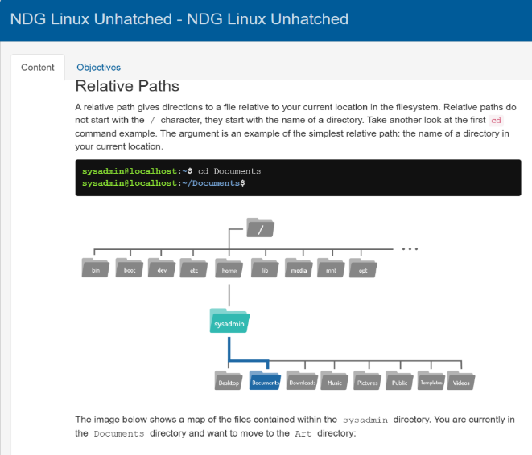
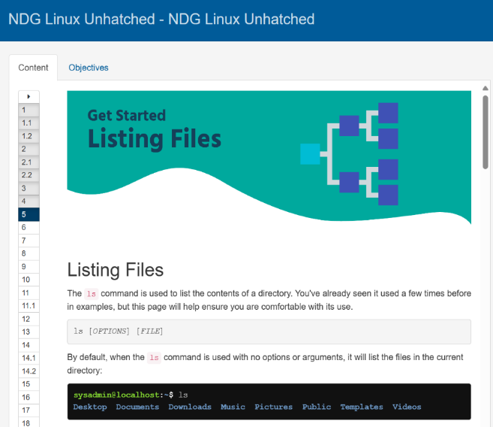
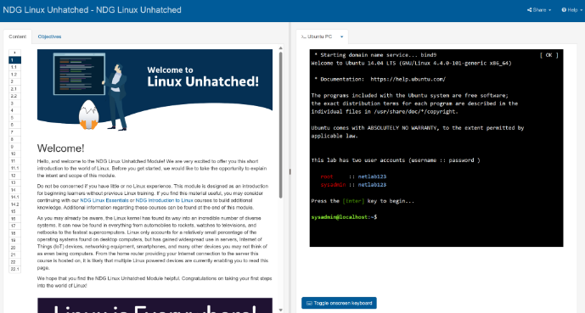

I also reviewed two LinkedIn courses to help understand codng better as I had not done it before.
- https://www.linkedin.com/learning/learning-powershell/relieving-anxiety-with-whatif-and-confirm?resume=false&u=77966930
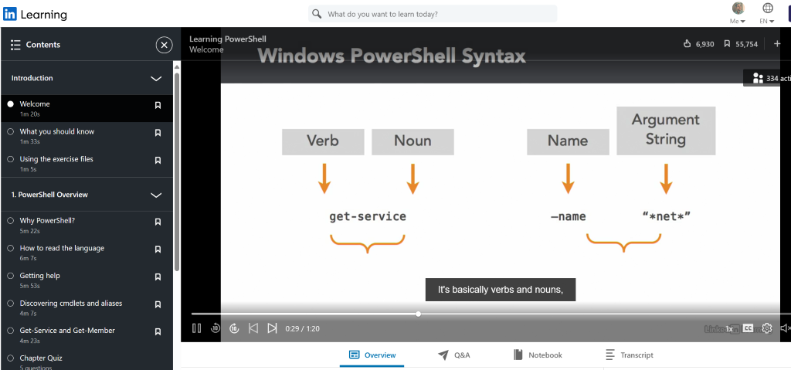
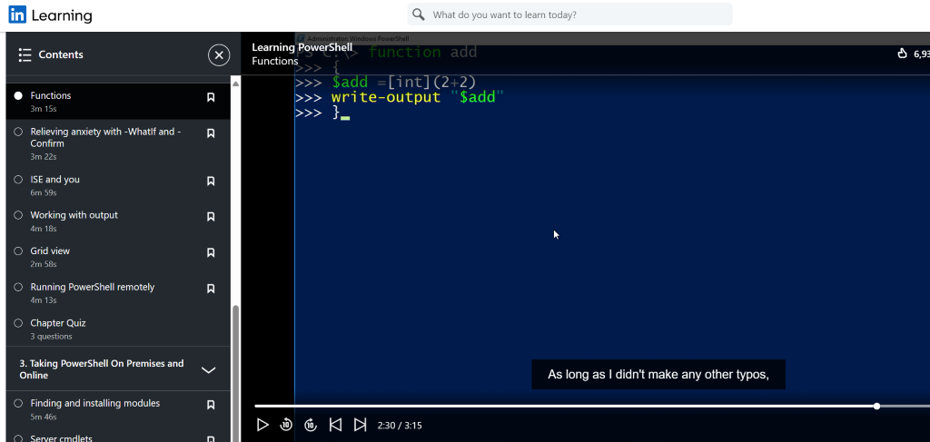

- https://www.linkedin.com/learning/powershell-7-essential-training/utilize-variables?resume=false&u=77966930
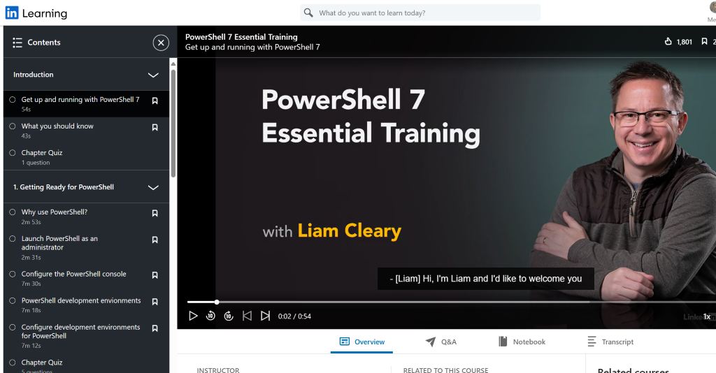
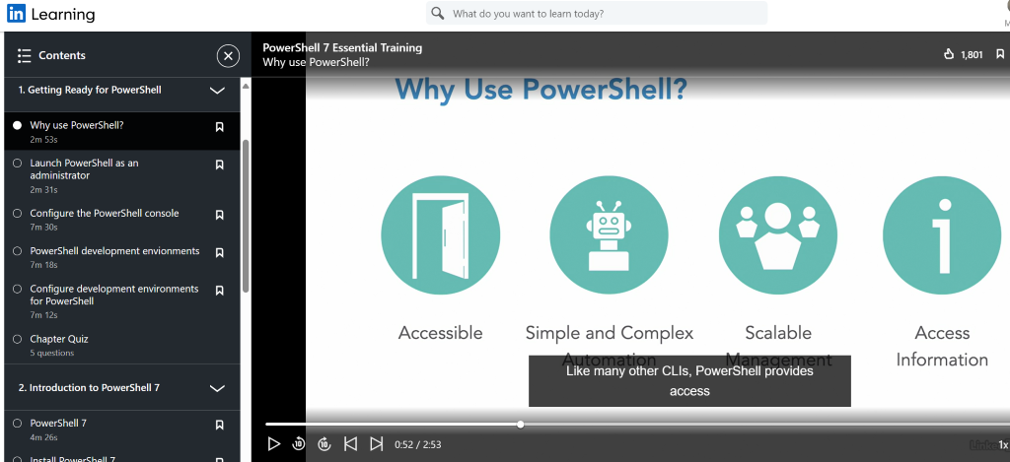
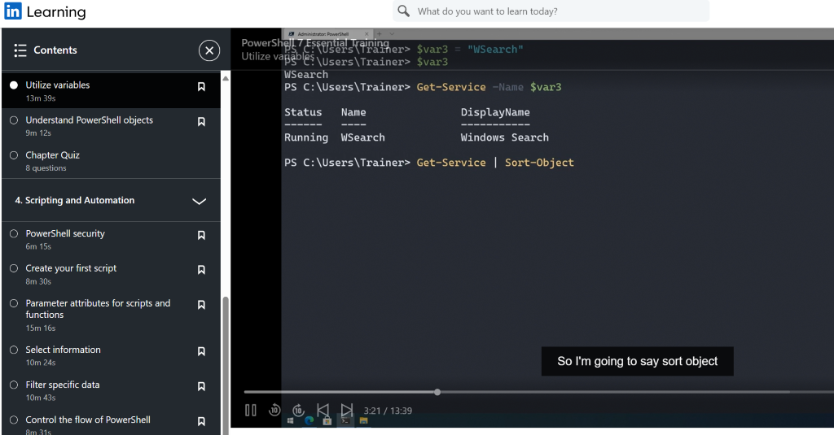

Task 4 - Windows Script

@echo off
setlocal enabledelayedexpansion

:: 'items_count', 'items', 'choice' = Variables
:: The 'goto command' has been used in the menu section
:: 'Input /p switch' has been used to prompt the user for their choice in the main menu
:: An 'Array' has been used with the name 'items' for a user to add items to a shopping list
:: 'if' statements have been used along with 'else' statements in case of data entry error
:: A 'for loop' has been added to enable the user to loop back to the main menu once their action ahs been completed
::

:: Initialize items_count variable
set items_count=0

:: Array to store items
set items[0]=

:: Main Menu the user can select their choice - User Input
:menu
cls
echo Shopping List
echo.
echo 1. Add Item
echo 2. View Item or Items
echo 3. Mark Item as purchased
echo 4. Delete item
echo 5. Exit
echo.

set /p choice=Enter your choice:

if "%choice%"=="1" goto add_item
if "%choice%"=="2" goto view_item_or_items
if "%choice%"=="3" goto mark_purchased
if "%choice%"=="4" goto delete_item
if "%choice%"=="5" goto exit_app

goto menu

:: First choice
:add_item
cls
echo Add a new item or items to your shopping list:
set /p new_item=Enter item:

set items[!items_count!]=!new_item!
set /a items_count+=1
echo Item added successfully.
call :view_item_or_items
pause
goto menu

:: Second choice
:view_item_or_items
cls
echo Your Shopping List:
echo.
for /l %%i in (0,1,%items_count%) do (
echo [%%i] !items[%%i]!
)
pause
goto menu

:: Third choice
:mark_purchased
cls
echo Mark Item as Purchased:
echo.
for /l %%i in (0,1,%items_count%) do (
echo [%%i] !items[%%i]!
)
set /p item_index=Enter the index of the item to mark as purchased:
if "%item_index%" geq "0" if "%item_index%" lss "%items_count%" (
set items[%item_index%]=%GREEN%PURCHASED: !items[%item_index%]!%RESET%
echo Item marked as purchased.
) else (
echo Invalid item index.
)
call :view_item_or_items
pause
goto menu

:: Fourth choice
:delete_item
cls
echo Delete Item:
echo.
for /l %%i in (0,1,%items_count%) do (
echo [%%i] !items[%%i]!
)
set /p item_index=Enter the index of the item to delete:
if "%item_index%" geq "0" if "%item_index%" lss "%items_count%" (
for /l %%j in (%item_index%,1,!items_count!) do (
set /a next_index=%%j+1
set items[%%j]=!items[!next_index!]!
)
set /a items_count-=1
echo Item deleted successfully.
) else (
echo Invalid item index.
)
call :view_item_or_items

pause
goto menu

:: Fifth choice
:exit_app
echo Exiting application...
exit

Task 5 – Linux Script

#!/bin/bash

# Function to generate a random number between 1 and 5
generate_random_number() {
echo $(( RANDOM % 5 + 1 ))
}

# Array of messages
messages=("Congratulations! You guessed it right!"
"Too high! Try again."
"Too low! Try again.")

# Main game loop
while true; do
# Generate a random number
target=$(generate_random_number)

# Loop for guessing
while true; do
# Prompt user for guess
read -p "Guess the number (between 1 and 5): " guess

# Check if guess is correct
if [ $guess -eq $target ]; then
echo ${messages[0]}
break
elif [ $guess -gt $target ]; then
echo ${messages[1]}
else
echo ${messages[2]}
fi
done

# Prompt user to play again or exit
read -p "Do you want to play again? (yes/no): " play_again
case $play_again in
[Yy]|[Yy][Ee][Ss])
continue ;;
*)
echo "Thanks for playing!"
exit ;;
esac
done

