

LEVEL 7 ASSESSMENT SPECIFICATION

Student name: | Chow Sau Kuen, Teresa | Student ID number: | 1812884
Programme: | DBA
Module: | Managing in Complex Environments: Strategies, Insights and Solutions
Module code: | SBPD7006 | Contribution to Overall Module Assessment (%): | 100%
Lecturer: | Dr Leo Ho | Internal Verifier:
Assignment Title: | Management Report | Word count (or equivalent): | 7500 (+/- 10%)
Submission deadline: | 24 March 2019 | Return date of provisional marks & written feedback: | 30 April 2019
Submission method: | All written assessments, where practical and possible, must be submitted via Turnitin unless otherwise instructed by the Lecturer. (Please DO NOT put this assessment specification into Turnitin or it will match many similarities with other students’ submissions.)  Alternative submission method (if applicable):  Late submission of the assessment will result in a late penalty mark. Penalties for late submission: Up to one week late, maximum mark of 50%. Over one week late, 0%. Only the Extenuating Circumstances Panel may approve a change to submission dates.
Academic honesty / referencing: | Academic honesty is required. In the main body of your submission you must give credit to authors on whose research and ideas your work is based. Append to your submission a reference list that indicates the books, articles, etc. that you have used, cited or quoted in order to complete this assessment.

Title: Is Zappos still Delivering Happiness?

Table of Content
- Executive Summary ------------------------------------------------------------------------- ( 4)
- Company Background -----------------------------------------------------------------------( 5)
- History ---------------------------------------------------------------------------------------( 5)
- Holacracy -----------------------------------------------------------------------------------( 7)
- Structure -------------------------------------------------------------------------------( 7)
- Governance Process ---------------------------------------------------------------( 9)
- Advantages of Holacracy --------------------------------------------------------------( 9)
- Objective of the Report --------------------------------------------------------------------- (9)
- People Management Issues in Zappos ------------------------------------------------(10)
- Identification of Retention and Recruitment Issues ---------------------------------(12)
- Difficulties in Retention ----------------------------------------------------------------(12)
- Retention – Negative Comments ------------------------------------------(12)
- Retention – Early Career Employees --------------------------------------(12)
- Retention – Experience Managerial and Specialized Skill Employee --(13)
- Retention – Holacracy System and Zappos Core Value -------------(13)
- No Manager -----------------------------------------------------------------(13)
- Compensation System ---------------------------------------------------(14)
- Circles & Roles -------------------------------------------------------------(14)
- Core Value – Create Fun and A Little Weirdness -----------------(14)
- Hurdles in Recruitment ----------------------------------------------------------------(15)
- Recruitment – Cultural Centric ---------------------------------------------(15)
- Recruitment- Career Path ---------------------------------------------------(15)
- Recruitment – Compensation -----------------------------------------------(16)
- Recruitment- Brand Name --------------------------------------------------(16)
- Recommendations --------------------------------------------------------------------------(16)
- Phase 1 – Retention -------------------------------------------------------------------(17)
- Career Advancement ---------------------------------------------------------(17)
- Remuneration -------------------------------------------------------------------(18)
- Performance Review ---------------------------------------------------------(18)
- Experience Employee and Expertise -------------------------------------(19)
- Workload -------------------------------------------------------------------------(20)
- Phase 2 – Recruitment -----------------------------------------------------------------(20)
- Brand Building ------------------------------------------------------------------(20)
- Cultural and Competence Standards -------------------------------------(20)
- Promote Holacracy -------------------------------------------------------------(20)
- Talent Pool -----------------------------------------------------------------------(21)
- Phase 3 – Long Term Plan ------------------------------------------------------------(21)
- Conclusion -------------------------------------------------------------------------------------(22)
- Appendix A ------------------------------------------------------------------------------------- (24)
- Appendix B -------------------------------------------------------------------------------------(25)
- Appendix C -------------------------------------------------------------------------------------(26)
- Bibliography -------------------------------------------------------------------------------------(27)

Title: Is Zappos still Delivering Happiness?
1) Executive Summary
This business consultant report is to examine how to enrich recruitment and retention strategy of Zappos after it adopts Holacracy which helps developing a committed workforce in the company. Tony Hsieh in his book “Delivering Happiness, A Path to Profit, Passion, and Purpose” mentioned that he wanted to deliver happiness not only to customers and partners, but also to employee. Nevertheless, the organizational change with revolutionary practices include removing manager hierarchy, role focus rather than job focus, and authority decentralization lead to high turnover rate which makes recruitment and retention the top issues in Zappos
In 2014, Farrell & Hurt reported that baby boomer generation which was born between 1946 and 1964 account for 80 million members of UK total workforce while millennial generation, born between 1980 and 2000 was about 75 million (Farrell & Hurt, 2014). According to Bruner & Chancey, the population of millennial generation in US was more than that of Baby Boomers in 2015, 77 million vs 76 million (Bruner & Chancey, 2017). In coming 5 to 10 years, the business world will be led by millennial leaders. According to Feiertag & Berge, Millennials are multi-tasking, lack of communication skill, expect immediacy. They need structure, guidance and regular feedback (Feiertag & Berge, 2008). Other characteristics such as technology literate, confident, individualistic, entrepreneur, seek praise and team-oriented were also reported in other studies (Shaw & Fairhurst, 2008). As such, millennial possess skills in advanced technologies and independent thinking which helps delivering value to companies; concurrently, they pursue for work-life balance and keen to demonstrate themselves so they never satisfied with one job. Jobs with fulfilment and excitement while making contribution to the society would be most admired by them.
To adapt to the evolving working behaviour of next generation, traditional hierarchy model may not able to satisfy the needs. In order to appeal to and to accommodate the interest of millennial generation, Holacracy, a self-management organizational structure, is one of the choices that can apply to companies in the near future. Rud pinpointed that in the evolving business landscape, the world is looking for flat, team oriented, and dynamic workforce that is self-managed and self-motivated (Rud, 2009)
The company of this business report, Zappos, has been softly launched Holacracy since 2013. So far, it is the biggest company (in terms of employee numbers) adopting Holacracy. This online shoe retailer was setup in 1999 and became the largest shoe retailer in 2000. After successfully gaining leadership foothold in online shoe market, In 2009, it was acquired by Amazon while in 2015, the company was fully transformed to Holacracy structure; before that, it was still run by traditional hierarchy model with manager and different reporting layers.
Before 2015, Zappos had been winner of Fortune “100 Best Company to work for” consecutively for seven years. The ranking of Zappos dropped significantly after it adopted Holacracy in 2015 (Fortune, 2019). This implied that internal employee and outsiders were not positive about the restructuring of the company.
Zappos’ Ranking in Fortune’s “100 Best Company to work for”
Year | Ranking
2009 | 23
2010 | 15
2011 | 6
2012 | 11
2013 | 31
2014 | 38
2015 | 86
(Fortune, 2019)
Until now, Holacracy has been implemented in Zappos for almost 4 years. Challenges such as leaving of experienced managerial and skill-specialized staff, recruiting and retaining talents, complexity in remuneration are yet to be resolved. However, with management support together with refined human resources (HR) strategies, it is believed that Holacracy in Zappos will be more adaptable to the company and hopefully, it would become a successful structure for future business corporates.
2) Company Background
A) History
In June 1999, Nick Swinmum founded an online business called Shoesite.com. The website was for online shoes selling in all sizes, colours, and styles for customer selection which was the pioneer at that time. One month later, the brand was renamed Zappos and carried 100 brands. Later, Tony Hsieh, the representative of a capital group called Venture Frog invested $1.1 million into the company. In 2000, he became the full time partner of Zappos. In 2001, Zappos became the largest shoe retailer in the world, offering more brands than others.
In 2006, Nick left Zappos and it reached 1 billion sales revenue in 10 years’ time and sustain the market leader role. Due to the outstanding performance of Zappos, in 2009, Amazon bought the company in 1.2 billion. The deal between Hsieh and Jeff Bezos (CEO of Amazon) was that Zappos has total freedom in daily and company direction, especially in maintaining Zappos’ strong cultural advantage. Amazon understood that it was Zappos’ success driver and accept the deal (Hsieh, 2010). After acquisition, the merchandising strategy of Zappos has expanded from shoes to clothes and accessories
In Zappos, everything is driven by 10 core values
Zappos’s 10 core values
- Deliver WOW through service
- Embrace and drive change
- Create fun and a little weirdness
- Be adventurous, creative and open minded
- Pursue growth and learning
- Build open and honest relationships with communication
- Build a positive tam and family spirit
- Do more with less
- Be passionate and determined
- Be humble
Zappos is “Power by services”. Their marketing strategy is word of mouth. WOW is the key word in Zappos’ culture which means bringing unexpected excitement to customers, colleagues, vendors and other stakeholders, and go above and beyond their expectation (Hsieh, 2010).
Zappos provides Expedited delivery, free shipping and return service, and 365-day return policy. Their competitors are DSW’s and Shoe.com (previously known as Shoebuy.com). Before Amazon’s acquisition, Amazon’s financial data was accessible easily with upward trend from 2000 to 2009 (Appendix A). After 2009, data was limited due to privatization by Amazon. Appendix B shows Zappos’ revenue trend which has been gradually decreasing since 2014.
There are about 1500-1600 employees and 600 of them belong to call center (Pontefract, 2015). During the recruitment process, Zappos will screen out those cultural fit candidates to join a one-month training, then a lumpsum of quit money $1000-$2000 will be proposed on the spot if they think they cannot fit the culture and want to leave. This is to reinforce the new joiners are culturally fit.
Zappos provides first class fringe benefits such as its own dollar Zollars for employees to redeem Zappos branded merchandised. Free food, drinks, sandwiches and salads are available whole day. Facilities include miniature golf course, basketball court, Ping-pong table and gymnasium. Free classes are offered with yoga, kickboxing and cardio. Concierge services are available such as car washing, oil changing and shoe polishing. Other benefits include employee library, free health insurance, life coaching for staff and family, electronic massage chair and nap room (Liggins, 2016).
In remuneration, Zappos uses badges system for salary raise. Every employee entitles to a basic salary and levelling up compensation badges as additional salary. Compensation badges are gained by attending workshops to upgrade “skills” and by calculating the number of “roles” one owns. This implies that higher salary is encouraged by acquiring additional skills and generalized work rather than experiences and professional skills. If one wants to ask for a raise on basic salary, he needs to do a research in the market to justify his requested raise is justified. Then, the whole justification needs to approve by People Pool and Comp circle (Hodge, 2015)
In Zappos’ culture, performance evaluation is not crucial in the process of people management. Before adopting Holacracy, performance appraisal is determined by how well one adapts to Zappos’ culture to perform 10 core values (Sahadi, 2015). Under Holacracy, according to a reporting from Fortune in 2016, there is even no formal performance appraisal at all (Reingold, 2016)
Since every employee is self-managed, they do not have direct reports or bosses. One will be asked to leave the company only if he does not have any roles to play in the company. Before leaving, he needs to go through “the Beach” or “Transition Support” which helps employees to seek for circles. If one stays in the Beach and no roles to play for more than two weeks, he is then requested to leave the company (Reingold, 2016).
B) Holacracy
i) Structure
Holacracy is basically a self-management organizational structure. It was developed in 2007 by Brian Robertson. It removes authority from a traditional management hierarchy and distributes across the organization. It replaces the traditional top-down reporting line by work circles. Everyone in the company does not have jobs nor job titles but have “roles”. Teams are replaced by “Circles”. Circles are served to identify “Tensions” which are the gap between reality and ideal situation and can be interpreted as problems and opportunities. “Lead links” are the leaders of each circle but they have little authority which they cannot force or give advice to employees on how to resolve the issues. Yet, he has the right to invite and remove roles. Roles can make decision by their own as long as the decision can bring good impact to the organization and compile with company 10 core values. They can resign the roles at any time as long as they give notice to lead links. On average, each person has 7.4 roles to play and there are 400-500 circles at one time Circle is like a project team in traditional hierarchy. The authority to decide about roles and assign tasks lies within the circles. Circle is self-operated. Within circle, members can make own decision in a democratic way. There are different functions in each circle, and they are represented by different roles (Bernstein, E.et al. 2016). Under Holacracy, there is a hidden assumption that Hsieh believes every employee can exercise self-direction and self-motivation to achieve objectives of the organization which is theory Y assumption in McGregor’s Theory X and Theory Y management (Mullins, 2011, p.316)
For easy understanding the terminology of different circles, structure and members of Holacracy, a glossary is attached in Appendix C.
Key words: Circle, Roles, Lead Link, Rep Link, Facilitator Role, Secretary, Tension, Anchor Circle, General Company circle (GCC), Super-circle & Sub-circle, The beach, Compensation badge, GlassFrog, Zapponian
Mitchell, J. (2017)

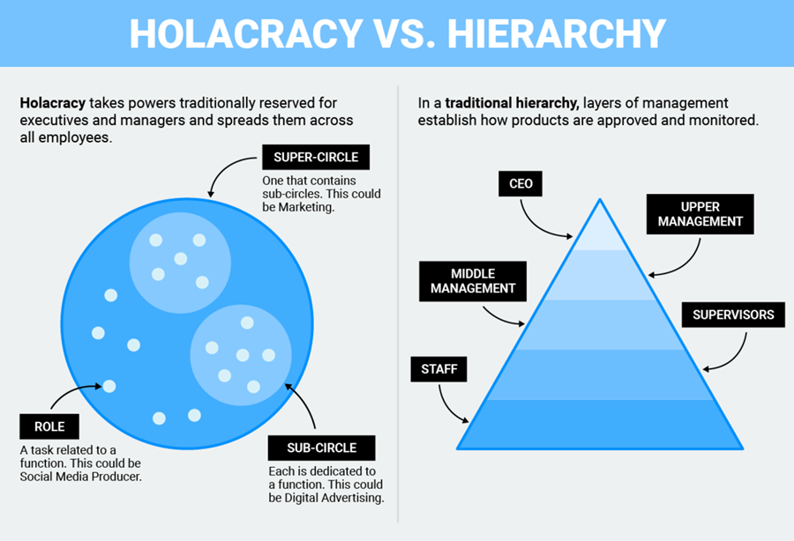

ii) Governance Process
Holacracy is governed by detailed roles, process and operation Constitution. All meeting format needs to follow a strict procedure for formality to streamline the decision -making process. For example, in tactical meeting, process starts with check-in round, checklist review, metrics review & progress update, agenda building, triage issues and closing round. The whole meeting is mainly for updating status rather than discussion. They are encouraged to use simple and short words to answer, e.g. check, no-check, no-updates etc. In closing round, each person is given a chance to speak and interruption is strictly prohibited which they call “integrative decision-making progress” (@2015 HolacracyOne, p.18-20). During the meeting, discussion and instruction are not encouraged so that roles can exercise self-directed and autonomy in decision making. Meeting frequencies are listed in below table.
Meeting | Frequency | Purpose
Tactical Meetings | Weekly | To update the status and to address key issues
Governance Meetings | Monthly | To update and redefine a circle’s operating structure such as adding and removing roles and policies, roles election
Strategy Meeting | Every six month | To review the progress of the circle to develop long run objectives

C) Advantages of Holacracy
The advantage of Holacracy is that it adjusts quickly to the changing business environment which answers the needs of an online retailer. It empowers and motivates employees to participate in decision making which improve the job engagement and learning process. Self-managing roles and practices help nurturing leadership, breeding agility and efficiency, and creating innovative environment. Meanwhile, there are more than a hundred medium and small size companies deploying Holacracy but each of them has minor modification according to the needs.
3) Objective of the report
As a market leader of the industry, it is always essential to envision the future needs and become the spearhead of all epoch-making development. In addition, it is only the market leader could afford to experiment and be the first mover to lead and change the industry landscape. The success of this revolutionary organizational structure means a lot to the business world which help developing a more collaborative environment for Millennials to work in. As Hershatter and Epstein mentioned in their studies, Millennials will be the next generation that will propel and beautify our world to a better future. (Hershatter & Epstein, 2010). In commercial world, to solve the cross-generational tensions in workplace, Holacracy will seem to be an alternative model to try out. As this model is still new and it has only been practicing in Zappos for 4 years (2015-2019) with some refinement in some people management application, it is expected to improve the overall adaptability of this model
4) People Management Issues in Zappos
After Hsieh issued an internal memo in March 2015 to fully adopt Holacracy in mid 2015, there were around 29% of staff left Zappos whilst most of them are managers. “Many people who had helped to create Zappos and had risen to become leaders were being told they were no longer wanted” (Reingold, 2016). Fred Mossler, Tony Hsieh’s right hand man, joined Zappos in 1999 and decided to leave the company after serving 17 years in 2016 (Reingold, 2016).
Hsieh mentioned in one of his interviews in 2018 that the biggest failure he had made in his career was hiring. The add up cost of bad hires costed him $100 million in Zappos (Scudamore, 2018). Apart from the quit money, there are other costs associated with high staff turnover such as separation cost (including time for exit interview, separation pay), the training cost for new joiners (induction & skill training), vacancy costs (the costs involved in hiring part-time during labor shortage time), replacement cost (including the recruitment budget & screening effort), and morale negative effect (Newstrow, 2011, p.227-228). With significant voluntary leaving and bad hires rates, notably, without a reconstructed recruit and retain policies, the company will soon be suffered with shortage of labor, which in turn, affecting deliverables, productivity and overall business in a long run.
Meanwhile, after adopting Holacracy for 4 years, people are still excited in participating in different new roles and taking new accountabilities with the self-organizing, self-developing and self-learning moto all around the company. Even so, how about another 5 to 10 years? Would the same group of people still feel enthusiastic about the fire-fighting roles? Hsieh has mentioned in some of his talks that he would like to expand the longevity of Zappos and it’s also one of the reasons he needs to implement organizational change. Yet, with the high turnover rates, it is quite questionable that his dream would come true.
In an internal memo sent by Hsieh in March 2015, he claimed that the initial agenda to adopt Holacracy was to help employee to develop themselves to the full.
It’s the same in self-managing organizations: the point is not to make everyone equal; it is to allow all employees to grow into the strongest, healthiest version of themselves…it is no longer artificially constrained by the organizational chart (Groth, 2015)
Nevertheless, the changes were clearly not fully accepted by everyone. Negative word of mouth were all over and publicized in media. In Glassdoor, some employee left message to talk about the confusion and frustration in Zappos internal operations. Some said that they were too many meetings and vague decision-making authority (Glassdoor Website, 2016). In Nov 2015, 6 months after fully transformed to Holacracy, Hodge from New Public magazine interviewed some Zappos employees commented that management policy, compensation, performance management, attendance, recruitment and dismissal were very unstable. One of the change managers in Zappos also reported that no one was willing to make decision so life in Zappos was not productive at all (Hodge, 2015).
Ostensibly, the policies and system in Zappos with decentralized decision making, empowerment, self-managed, creative, participative, transparent, agility and adaptative environment, leadership nurturing, work-life balance environment and all sorts of better than average fringe benefits in the market are positive motivators that contribute to job satisfaction to employees, especially for young workforce. Nevertheless, the turnover rate and morale in Zappos after adopting Holacracy are opposite to the expectation. The result can be found in the Grassdoor negative comments and the failure in winning Fortune’s “100 Best Companies to work for”. The situation needs to be addressed before it becomes detrimental to the brand and the organization.
The road map in people management will be implemented in 3 phases with each phase tackling different issues. The whole plan will last for 3 to 5 years. It starts with solidifying retention, follow by improving recruitment, and last but not least, to formulate a long term plan on human resources development to align and collaborate with cooperate strategy.

5) Identification of Retention and Recruitment Issues
A) Difficulties in Retention
i) Retention – Negative Comments
From Glassdoor, a website where employees anonymously review companies and their management, most of the comments were criticizing on limited career ladder, repetitive quick fix duties, unclear performance evaluation standard, job insecure, multi-roles with heavy workload, confusion in compensation badges, lack of guideline and feedback from supervisor (lead links), unfair promotion, and unclear performance expectation in Zappos (Glassdoor, 2018-2019). Some quotes are listed below.
“The company has an excellent onboarding/training program for new employees…unfortunately, there are many objectives ut are given no resources to do your job” (Glassdoor, 2018)
“Great benefits and culture at times. Poor communication and promoted by who you knew and not skills” (Glassdoor , 2018)
ii) Retention – Early Career Employees
Under Holacracy structure, policies such as no managers, autonomy in decision making, compensation ties to roles & skill and multi-roles are all tailored to appeal to millennial generation and early career employees. Early career employees are defined as working years equal or less than 10 years (Lee, Yang & Li, 2017). In Zappos, the employees’ average age was 33 (Richter, 2015). Millennial generation is not quite stable and easier to quit jobs. However, most of the managerial and long service executive had left the company during Holacracy transition period while severance pay of minimum 30% had been given for voluntary resignation (Silverman, 2015). This might affect the team diversity in company’s perspective.
Millennial generation will feel motivated under Holacracy since they are empowered to make decision which gives a sense of fulfillment. The superb fringe benefit is also what they value most. However, as time passes, the repetitive problem-solving tasks will give no excitement to them.
In the long run, without a visible career ladder, employees will not be motivated. According to Herzberg, Two-Factor Model of Motivation, job recognition, advancement and possibility of growth are motivational factors that directly bring motivation to employees (Newstrom, 2011, p.115-116). Vroom’s Expectancy Model also explained that “the expectancy depends on the employee’s perception of the relationship between effort, performance, and rewards” (Newstrom, 2011, p.127) If one has high valence in promotion together with high expectancy and low instrumentality due to managerial favoritism, then the employee will be demotivated and might leave the company. Valence x Expectancy x Instrumentality = Motivation (Newstrom, 2011, p.125-126). In Zappos, due to no managers hierarchy, the promotion chance is very minimal. To retain this group of young employees, there is an urgency to review the promotion structure.
iii) Retention– experience managerial and specialized skill employees
Before transforming to Holacracy, the most frustrated and anxious group of people inside the company are the managers. Between 2013 to 2015, there were totally 2 years of Holacracy transition period. Managers were actively resistant to this re-organization because self-management means no managers. Under Holacracy, employees are work under roles while they all have authority in decision making. As a manager, there is no more guiding, leading and managing people roles to play. Besides, most of the managers have job specialization and long experiences while in the new system everyone needs to play multiple roles, the specialized experience is no longer value in the company as before. It can be shown in the mechanics of the compensation scheme. If someone want to have a salary raise (including Hsieh), other than the original salary, they have to attain and collect badges by involving in multi-roles and acquiring different skills to justify. Since authority is taken away while experience and expertise knowledge are not treasured, most of the employees belong to this segment leaving the company. The consequence is that the company is lacking experienced and expertise employees.
iv) Retention – Holacracy system and Zappos core value
Under Holacracy system, there are several structural changes which may affect the retention practices such as no manager hierarchy, compensation system, and roles & circles. Likewise, some core values also pose impact to staff retention.
- No manager
In Holacracy, there is no titles. The focus is on roles, not jobs. No management implies no managerial grade for further career advancement. This would be a key attributes to trigger employees to leave, especially young workers.

b) Compensation system
Apart from original salary, if employees request for a raise, he needs to earn badges which is determined by roles and skills they own. Employees are free to acquire as much badges as they want to. Each badge accounts for a fixed amount. So, badges are just like a levelling up game.
This policy is not well perceived by all staff, especially those gain seniority, specialized skill and experiences. This situation is understood with Equity theory to explain. The model was developed by Stacy Adam and it stated the followings.
“…employees tend to judge fairness by comparing the outcomes (rewards) they receive with their relevant inputs (contributions) and also by comparing this ratio…One’s own outcomes / one’s own inputs = others’ outcomes / others’ inputs” (Newstrom, 2011, p.129)
Inputs comprise of employees’ contribution, namely, education, seniority, job performance, prior work experience while outputs include raise in pay and bonuses, fringe benefit, job security etc.
In the overall compensation formula, there is no consideration in job performance, expertise nor experience. This is one of the key issues that employees might choose to leave as they feel unfair in the salary structure. According to the National Employee Relationship Report in a 1999 study, fairness at work is one of the important factors that a staff decided to stay beyond two years or not (Stone, 2002, p.52)
c) Circles & Roles:
Holacracy is executed by roles and circles. Each employee has various roles and responsibilities “each of the 7.4 roles and individual fills contains an average of 3.47 distinct responsibilities, resulting in more than 2 responsibilities per employee” (Bernstein, E. et al. 2016). Everyone is frustrated by the heavy workload and sometimes they will come into role confusion.
Millennial generation is happy to learn and participate. Yet, there is no leaders to guide them through the growing and learning path as lead links are only responsible for handling roles allocation and priorities (Utopia, 2017) . According to a study by Feiertag & Berge, this generation needs structure, guidance and regular feedback (Feiertag & Berge, 2008)
- Core value - Create fun and a little Weirdness
Fun and weird is part of the culture in Zappos. The criteria for selecting employee are also based on the adaptability of the culture. Zapponians value the uniqueness in their culture. This will be reflected by their recruitment and performance review guideline. Zappos doesn’t value performance review in their overall human resources management process. According to Hodge, “hire slow and fire fast” is the norm in the company while recruitment and performance review are based on the adaptability of company culture (Hodge, 2015). Managers do culture assessments rather than performance appraisal and give employees feedback on their fit within the culture and how to improve (Sahadi, 2015).
To conclude, the policies and system deployed in Holacracy are much welcome by younger workers. Employees who are experienced, possess managerial skill and job specialization are more likely to leave.
B) Hurdles in Recruitment
Between 2009 and 2015, Zappos has long been the winners in Fortune’s “100 Best Companies to work for”. After the implementation of Holacracy in 2015, Zappos was out of the list. Social and traditional median together with employees were spreading news all over about the confusion and messy situation of the company. The reputation of Zappos and charisma image of Tony Hsieh have been affected in negative way which directly affect the branding and attraction of the company and ultimately hinder recruitment process.
i) Recruitment – cultural centric
Zappos has already deploying a very strategic approach to screen out “non-suitable” applicants which are not culturally fit. Zappos will offer $2000 to the trainee on the spot after the first month training. Hsieh believes that it’s the right timing to give the chance for new joiners to have second thought to rethink if they really like the culture. If no, they can take the quit money away and leaving the company gratefully, concurrently, building a positive image of Zappos (Percival, 2017). As such, Zapponians are in similar personalities who are adventurous, creative, carefree and a bit weird. This is much associated to the quitting bonus of this screening system. However, they have little attention pay to competency and experience. As a company, cultural fit and competency are both crucial in recruitment screening process.
ii) Recruitment – career path
Since the company doesn’t have a clear upward career path under Holacracy, this would hinder the talents to join the company. Most likely, those who are willing to work in a company without promotion opportunity are less aggressive or early career workforce who just want to gain experiences.
iii) Recruitment – compensation
With the implementation of Holacracy, remuneration is based on the basic salary plus compensation badges. The compensation badges can be attained by attending workshops of a particular skill or by the number of roles one is serving. The more compensation badges one gets, the more top-up allowance one has. In another word, the remuneration package is based on skill and roles and put less priorities on performance and experience. People who are specialized in certain field or experienced workforce will less likely to apply because they can get more pay in other traditional companies which are more value these traits.
iv) Recruitment – brand name
A strong brand name would definitely be an asset to appeal to talents.
After transforming to Holacracy, the reputation and the brand value of Zappos has been declined. Financially, starting from 2014, the revenue has been decreasing. In 2018, the revenue was around $724 million which was 27% less than that in 2008’s one billion sales (ecommerceDB, 2019).
To conclude, in order to maintain a healthy workforce in Zappos for the longevity of the brand and the company, a clear career path, fair remuneration and promotion system, workload simplification, objective guidelines in recruitment & performance review, team diversity in company, and succession plan are priorities that needed to address in order to continue foster a “Delivering Happiness” climate for Zapponians.
6) Recommendations
After reviewing the key issues, some recommendations are suggested to better fine-tune the existing practices. Zappos has already had a strong culture driven core values in the company whereas a lot of organizations have ignored this part; yet, the cultural force is somehow a bit dominant. It is expected that a more balanced recruitment and retention policies would help integrating Holacracy system and make a better Zappos.
The people management master plan could be executed in 3 phases. First phase takes one-year time to refine the retention policies which give immediate effect to stop employee from leaving. The second phase will be focused on recruitment to further provide a diversity environment. However, this part might take time to rebuild and regain the reputation of the company; therefore, longer time frame is needed. The third part is the forward-looking approach on human resources management to align with corporate and business strategy. Three-year lead time is needed to have it executed. Having said that, most of the proposed initiatives involve some sorts of policies refinement. It needs to align with top management Tony Hsieh in order to have it implemented successfully. As Hsieh’s ultimate goal is to create an organization that employees genuinely enjoy working and customers are excited about their services, these proposals would help delivering better future to the company, the customers and the society.
In Zappos, the strategy in these years are engaging to loyal and repeat customers. In fact, as a retailer, repeat customers are the most valuable segment because the frequency of purchase is higher than that of new customers. Besides, as Zappos’ strength is in customer experience, this segment is the most appropriate group to target. In general, repeat customers would like to connect with customer service representatives that they come across. In order to secure this segment to align with business direction, employee retention would be necessary to the company.
A) Phase 1 – Retention (1st year)
Retention is chosen to be implemented in phase one because this part is comparatively easier to implement. All it needs is the internal alignment and approval by top management. The initiatives below are mainly focused on retention while some of the policies could improve the recruitment process simultaneously.
i) Career advancement
In Holacracy, there is no managers. Unless the whole group of employees are all in the self-actualization status “one is capable of becoming, using one’;s skills to the fullest, having a rich combination of values and purpose, and stretching talents to the maximum” (Newstrom, 2011), otherwise, there is a need to provide career advancement structure in the company so employees could have a forward looking drive and goal.
Since the essence of Holacracy is no supervisor to provide decision autonomy, it is suggested to give a higher status rather than titles to those who look for career advancement. It is recommended to divide the circle pool into 3 levels. The level is determined by the strategic level and the complexity level of the activities. The circles in higher level will handle more strategic and complex activities. These high-level circles still have decision autonomy as usual. Which circle belongs to which level is decided by GCC. The activity of the circle is also determined by GCC. Employees who are entitled to join higher level of circles will be higher in seniority (long tenured or experienced employees) and higher in competency. Employees that work in the higher level of circle will gain higher status in the company. Each employee will assign a grading based on performance review to determine which level of circle one can join. Aggressive millennial generation can progressively promote to higher levels of circles. Concurrently, this arrangement would help to retain experienced and committed staff. Most importantly, with high level circle segmented to focus on strategic and long-term planning, this would help formulating company strategies in a high-level perspective.
ii) Remuneration
The company’s salary package is a “badge-based” compensation system. People are paid according to skills they possess and earn. Although Zappos claimed employees will be paid base on the market rate of each skill, the reality is that every job comprises of many skills. This kind of arrangement gives a gesture of unfairness while seniority, experiences and specialized skills are less to be recognized. As a result, experienced and employee with specialized skill left Zappos after Holacracy. In the long run, there is a need for Zappos to adapt a more objective base and balanced remuneration system to tie with measurable key performance index (KPI) and competency rather than 100% inclined to cultural fit. A systematic performance tool to assess the employees are also required to assert the fairness of the system. It is suggested to align basic salary package to the level of circles. The higher the circle, the higher the basic salary the roles should entitle to. To align remuneration with performance, it is suggested to set KPI to each circle. A SMART goal setting mechanics could be adopted. SMART stands for specific, measurable, attainable/achievable, relevant/realistic, and timely (Mullins, 2011, p.346). The goal of each circle will be recorded and shared in GlassFrog for transparency.
iii) Performance Review
Performance review is a big topic and always ignored in Zappos. Nonetheless, this is critical to the overall people management in Zappos, so this has to be executed in order to resolve the HR issues. To adapt to Zappos’ culture, the way of performance review can be done softly yet maintaining the objectivity. It can be done by measuring circle output, lead link observation, team members survey and performance development meetup with HR.
As employees are linked to roles rather than jobs, the performance measurables can be tied to the output of the circle. This can be measured by the success rate of the circle with SMART goal set; simultaneously, the employees’ performance can also be done by lead link’s observation. HR will catch up with all lead links on quarterly basis to summarize the performance of the employees. Since each employee are multi roles and working in different circles, a more objective conclusion can be made by collecting feedback from different lead links. Another online 360-degree survey will be created and distribute to each member of the circle to complete before the dismissal of each circle
A more official performance review will also need to carry out by HR bi-annually in company level. To cater for the carefree culture and the self-managed trait of millennial generation, it is suggested to rephase the name of performance review session to something more forward looking, say performance development meetup. The atmosphere is casual which can schedule in tea break or lunch to understand the work status, difficulties, and even personal sharing like coaching session. This will build the bonding and trust between HR and each staff in a long run. Based on the understanding from four different sources, HR will then have a big picture about the morale status of the staff and react proactively to employees who need assistance. Consequently, the turnover rate will be reduced if action is taken appropriately. After consolidating the information, a complete staff profile will be presented to GCC for further discussion. With a solid performance development plan supported by performance driven measures, the whole performance review system will become more objective and fair
iv) Experience employee and expertise
Holacracy structure is favorable to millennial generation, younger workers and generalist (without specialized skills); as a result, experienced & specialized employees will become less committed to the company. However, it is recommended to retain experienced employees and expertise in the company to form mentor circles in the company.
From the studies in early career employees, they are always looking for structure and feedback. In Holacracy, there is no personnel nor structure to provide this kind of feedback mechanism to millennial generation. Although they are self-directed and self-managed who are able to look for answers and solutions, mentor circles would give them more guidelines and advice when they are lost. This will help retaining millennial generation in a way. The basic salary of the mentors will be higher based on their experiences and specialization. Other than that, these mentors can be the lead links in high level circle which can help knowledge transfer and share best practices with their experiences and expertise. Each new joiner will assign a mentor to help them adapt to company culture and give advice on job perspective. Their advices are just for reference and employees are not obligated to take. To cope with Zappos’ culture, mentor can be renamed as “Walk the Journey Buddy”.
iv) Workload
With more and more circles created, employees are stuck with heavy workload. For staff retention, workload issues are needed to address. With SMART goal clearly define the objectives of each circle, it would help minimize the overlapping and duplication of circle creation. AI (artificial intelligence) can also help resolving some basic clerical work. It is recommended to start considering AI as supporting circle role.
B) Phase 2 – Recruitment (1st and 2nd year)
Recruitment takes time. A good company can attract talents easily. Before 2015, Zappos got rewarded in “100 Best Companies to work for” which really help attracting talented people to join. However, with the landing of Holacracy together with the media and employees’ negative comments, applicants will hesitate to apply due to ambiguous career path, unclear remuneration package and lack of fairness in performance measurement system. With some modification together with the upgraded retention process, smooth recruitment will be the byproduct of phase one.
i) Brand building
Zappos has been the consecutive winner in Fortune “100 Best Companies to work for” from 2009 to 2015 and no more after adapting Holacracy. Notably, the brand have been devalued in a way. As it takes time to rebuild brand value and brand image, the success of retention reform as above stated is the foundation of overall HR policy refinement.
ii) Cultural and competence standards
Cultural fit is the DNA of Zappos. Nevertheless, to appeal to talent and competent applicants, the screening criteria would need to refine. A more balanced mix of cultural-fit and competency driven interview tools are needed to incorporate into the screening criteria. This could help building a more diversify company. “…member capacities to think differently and share alternative mindsets can be vitally important for the prevention of deadly diseases like groupthink” (Newstrow, 2011).
iii) Promote Holacracy
For millennial generation, they would like to find a job which is meaningful to the world. Zappos is the first biggest online retail company to deploy Holacracy. The success of Holacracy in Zappos means the success of a new organizational structure in business world. This kind of message can be marketed via social media and other channels to enrich the sense of mission to young and talented employees
iv) Talent pool
As mentioned previously, a lot of experienced employees left Zappos after April 2015. Without clear career path nor performance driven compensation system, it would be difficult to attract talents and aggressive people to join, especially Zappos is located in desert area of Las Vegas. To improve overall productivity and for succession purposes, there is a need to build a talent pool.
As Zappos is strong in social media to build WOW stories, fresh graduates would be the target to appeal to. An introduction of trainee programs would help building talent pool faster.
For HR function, turnover rate and recruitment rate will need to monitor on a quarterly base in order to measure the effectiveness of both retention and recruitment strategies. A bi-annual report will be sent to GCC to further discuss to further discuss the effectiveness of the refined initiatives.
C) In phase 3 - Long term plan (3rd to 5th year)
In Holacracy, apart from GCC and super circle, every role is working independently engaging in different activities. Employees do not have chance to understand the company from a bird view perspective. To build a talent pool would be the scope of work in human resources management to help solidifying committed and capable employees to continue the longevity of the company. Trainee program will be a choice to upbring talents with cultural fit and work towards this goal.
The trainee program will last for 3 years. It is suggested to recruit talented fresh graduates from university as they are easier to adapt to company culture without work history. Dedicated mentors and coaches are required to lead this kind of talents. Management approval and support give “make or break” impact to this program. Since talents like stretch target and challenges, the high-level circle will be their goals where they can involve formulating company directions together with senior management. In fact, Zappos’ self-management environment is an ideal platform to talents for exploration and contribution.
In a long run, it is suggested HR to review the turnover rate in specialized departments such as Finance, IT and HR. If the turnover rate is extremely high, it is necessary to review, monitor and start analyzing if a circle base system is appropriate to apply to all departments including those with specialized skills.
7) Conclusion
The aim of this report is to identify, assess and give recommendations to enrich the recruitment and retention process of Zappos in order to build a capable and committed workforce. Under Holacracy organizational structure, main challenges for building a committed workforce are the ambitious career path and nonperformance driven remuneration system. Recommendations are made in refining these two challenges by dividing circles into three layers to give status and different remuneration package in order to create an career advancement environment while, at the same time, maintaining a self-managed structure. It is also suggested to start developing trainee program for long term succession needs. And, the strong culture is the competitive edge of Zappos but it is also the issues that needs to be tackled in order to form a more diversified team mix in the company.
Although Holacracy system caused a lot of people management issues, Holacracy is still a system which suits Zappos’ business model and corporate strategy; yet, not perfectly entertain all segments of employees. In Zappos, as customer service is their competitive edge, increase responsiveness, WOW customer experience, improve immediacy in time to react to customers’ request are the success factors to sustain the leadership positioning. Since call center is the biggest department in Zappos (600 employees, 38% of total employees), they are the core group that company needs to pay special attention to. This group of people tend to be less educated and mobility is high. In order to retain them, a WOW fringe benefit system and levelling up compensation badges are appropriate to appeal to this group of employees. Since compensation badges is acquired by attaining skills, this policy provides call center people an opportunity to explore new knowledge and increase their earnings at the same time.
Millennial generation is another segment that the company treasures most. Holacracy fosters a empowering, innovating, learning, autonomous, transparent and flexible climate which are favored by early career employees. Nonetheless, their desire in career advancement and promotion are not the key attributes in Holacracy structure. As such, a refined HR strategy to complement both call center and millennial employees will benefit the company and improve the longevity and productivity in a long run.
For experienced and specialized employees which are less valued in Holacracy system, it is suggested to retain them in mentor’s and high-level circles to help contributing to the company.

Appendix A
Zappos revenue turnover from 1999-2009 (Zhang, W. 2015)
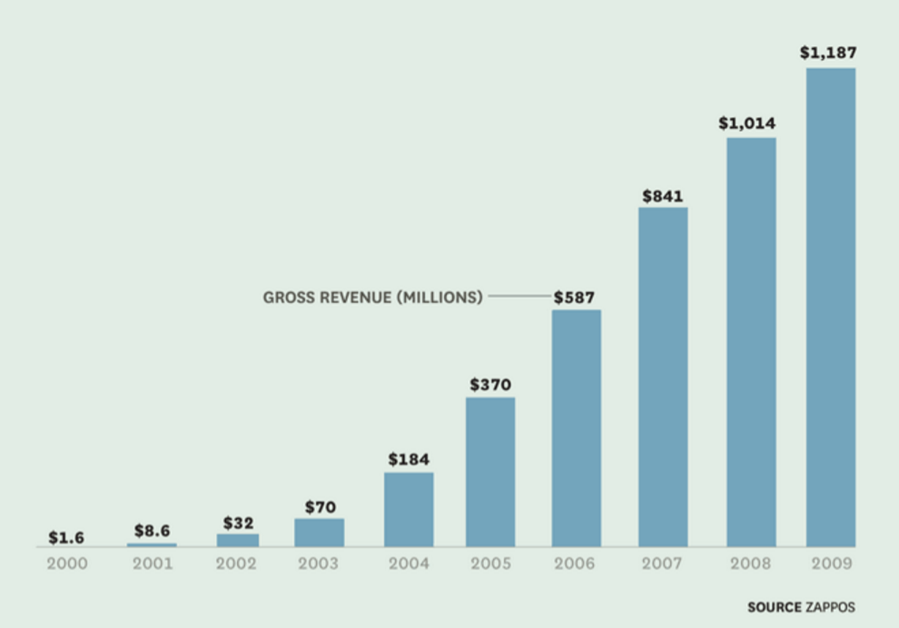
Appendix B
Trend indication of Zappos sales revenue from 2014-2018
(ecommerceDB.com 2019)
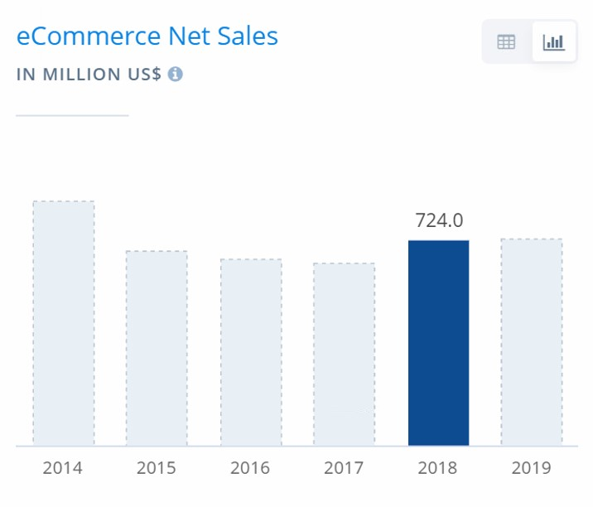
Appendix C
Glossary of Holacracy Terminology (HolacracyOne, 2015)
Term | Definition
Circle | a team which is formed and dismissed to handle company issues.
Role | it has responsbiliteis and accountabilities. It can be created, revised or removed in a circle. Each individual has multiple roles
Lead Link | leader of the circle. It's main responsiblities is to allocating roles prioritize resources and define general stragegy for the circle. It's characteriestics are similar to a traditional manager but it's subject to governance process.
Rep Link | elected by circle members, the bridge between circle and sub-circle
Facilitator Role | elected by circle members, facilitae meeting and circle governance
Secretary | elected by cirlcle members, schedule meetings and keep records in GlassFrog (a software accessible by all employees) to record activities and meeting updates
Tension | problem and opportunity of the circle
Anchor Circle | the Board in traditional company. It also has its own lead link and roles. Anchor circle appoints new circles and lead links for each circle. Hsieh is the lead link in Anchor circle
General Company Circle (GCC) | comprise of traditional executive leadership of the company, circle of Anchor circle
Super-Circle & Sub-Circle | if a circle needs to proliferate the job and create one more branch circle, the circle itself will become the Super-circle while the new branch will call itself sub-circle
The Beach | a status that is for people who do not have any roles to play
Compensation Badge | one can acquire by getting qualification on specific skill. It is also determined by number of roles to play. After getting badges, pay will be raised
GlassFrog | a software to codify and record all activities in the circle, accessible by everyone in the company
Zapponian | people who work in Zappos

Bibliography
Bernstein, E. et al. (2016) 'Beyond the Holacracy Hype', Harvard Business Review, July-August 2016, pp.38-49. Available at: https://hbr.org/2016/07/beyond-the-holacracy-hype (Accessed: 15th March 2019).
Bruner, R. and Chancey, D. (2017) Generation Z. Available at: http://scholar.googleusercontent.com/scholar?q=cache:pb0BYOf4fZsJ:scholar.google.com/+generation+z&hl=en&as_sdt=0,5 (Accessed: 15th March 2019).
ecommerceDB.com (2019) E-COMMERCE REVENUE ANALYTICS Zappos.com. Available at: https://ecommercedb.com/en/store/zappos.com (Accessed: 15th March 2019).
Farrell, L. and Hurt, A.C. (2014) 'Training the Millennial Generation: Implications for Organizational Climate', Journal of Organizational Learning and Leadership, Volume 12, Number 1, pp.47-59.
Feiertag, J. and Berge, Z.L. (2008) 'Training Generation N: how educators should approach the Net Generation', Education + Training, Vol.50 Issue 6, pp. 457-464.
Feloni, R. (2015) 'How Zappos Determines Salaries Under Its New Holacracy System', Business Insider, 27th July. Available at: https://www.inc.com/business-insider/how-zappos-determines-salaries.html (Accessed 15th March 2019).
Fortune (2019) 100 Best Companies to Work For 2009-2015. Available at: http://archive.fortune.com/magazines/fortune/best-companies/ (Accessed: 15th March 2018)
Glassdoor (2019) The Zappos Family Reviews. Available at: https://www.glassdoor.com.hk/Reviews/The-Zappos-Family-Reviews-E19906.htm (Accessed: 15th March 2019).
Groth, A. (2015) Internal Memo: Zappos is offering severance to employees who aren’t all in with Holacracy. Available at: https://qz.com/370616/internal-memo-zappos-is-offering-severance-to-employees-who-arent-all-in-with-holacracy/ (Accessed: 15th March 2019).
Hershatter, A. and Epstein, M. (2010) 'Millennials and the World of Work: An Organization and Management Perspective', Journal of Business and Psychology, 25(2), pp. 211–223.
Hodge, R.D. (2015) First, Let's Get Rid of All the Bosses. Available at: https://newrepublic.com/article/122965/can-billion-dollar-corporation-zappos-be-self-organized (Accessed: 15th March 2019).
HolacracyOne (2015) Holacracy Constitution v4.1. Available at: https://www.holacracy.org/wp-content/uploads/2015/07/Holacracy-Constitution-v4.1.pdf (Accessed: 15th March 2019).
Hsieh, T. (2010) Delivering happiness : a path to profits, passion, and purpose. 1st ed. New York: Business Plus.
Lee, X. and Yang, B. and Li, W. (2017) 'The influence factors of job satisfaction and its relationship with turnover intention: Taking early-career employees as an example', Anales De Psicología, 33(3), pp. 697-707.
Liggins, T. (2016) Zappos' Top 10 Power Perks Ranked. Available at: https://m.zappos.com/about/zappos-top-10-power-perks-ranked (Accessed: 15th March 2019).
Mitchell, J. (2017) 'Holacracy vs Hierarchy and the tale of too many chiefs, and not enough indians', Medium [blog]. 12 April. Available at: https://medium.com/@jmitch/holacracy-vs-hierarchy-and-the-tale-of-too-many-chiefs-and-not-enough-indians-7bda010a3dbb (Accessed: 15th March 2019).
Mullins, L.J. (2011) Essentials of organisational behaviour. 3rd ed. Harlow: Financial Times Prentice Hall/Pearson.
Newstrom, J.W. (2011) Organizational behavior : human behavior at work. 13th ed. New York: McGraw-Hill/Irwin.
Percival, D. (2017) 'Why Zappos Pays People to Quit', Medium [Blog]. 2 August. Available at: https://medium.com/@dperciv1/why-zappos-pays-people-to-quit-7912260b1fe5 (Accessed 15th March 2019).
Pontefract, D. (2015) 'What is Happening at Zappos?', Forbes, 11th May. Available at: https://www.forbes.com/sites/danpontefract/2015/05/11/what-is-happening-at-zappos/#1a824a584ed8 (Accessed 15th March 2019).
Reingold, J. (2016) The Zappos Experiment. Available at: http://fortune.com/zappos-tony-hsieh-holacracy/ (Accessed: 15th March 2019).
Richter, A. (2017) Business, the ZAPPOS Way Inside the nerve of the online retailer. Available at: http://discoverlifemagazine.com/autumn2017/zappos.html (Accessed: 15th March 2019).
Sahadi, J. (2015) How to get a raise at the new manager-free Zappos. Available at: https://money.cnn.com/2015/06/10/pf/zappos-pay-managers/index.html (Accessed: 15th March 2019).
Scudamore, B. (2018) Zappos CEO Tony Hsieh Sums Up His Secret Superpower in a Single Word. Available at: https://www.inc.com/brian-scudamore/airstreams-awesomeness-tony-hsieh-way-to-do-business.html (Accessed: 15th March 2019).
Shaw, S. and Fairhurst, D. (2008) 'Engaging a new generation of graduates', Education + Training, Vol.50 Issue 5, pp. 366-378.
Silverman, R.E. (2015) 'At Zappos, banishing the bosses brings confusion', Wall Street Journal, 20th May. Available at: https://www.wsj.com/articles/at-zappos-banishing-the-bosses-brings-confusion-1432175402 (Accessed 15th March 2019).
Stone, F. (2002) Recruiting and Retaining People. Oxford: Capstone Publishing.
The National Society of Leadership and Success (2017) Lost Utopia: Why Did Holacracy Fail?. Available at: https://nslsfacts.org/2017/09/26/lost-utopia-why-did-holacracy-fail/ (Accessed: 15th March 2019).
Zhang, W. (2015) Zappos: Delivering Happiness, Powered by Service. Available at: https://rctom.hbs.org/submission/zappos-delivering-happiness-powered-by-service/ (Accessed: 15th March 2019).

