The Global Business Environment
Assessment 1
Environmental Analysis of Automobile Industry
Student Name: Maria Nastas
Student ID: 2028223

Executive summary
The report will concentrate on different frameworks to measure both internal and external business contexts for Roll-Royce. Roll-Royce is a luxurious automobile industry in the UK and Roll-Royce serves customers worldwide with the best and luxurious quality cars. PESTLE Analysis helps Rolls-Royce to successfully measure the impact of macro-factors on its business activities. The paper also helps in understanding competitive business advantages and threats of competitors with the help of Porter’s five forces framework. The report will highlight Porter’s diamond, value chain analysis, and value network of Roll-Royce to project light on the operating context of the company. Roll-Royce has a concise business strategy to design innovative and autonomous cars. Domestic consumers' behaviour patterns of the company are significant for anticipating customers’ demands in global markets. Lastly, Roll-Royce has reached its competitive advantages and core values by identifying its threats and opportunities in the existing marketplace.

Table of Contents
1. Introduction 4
2. Evaluate challenges of external and internal business environments 4
3. SWOT Analysis 5
4. PESTLE Analysis 7
5. Porter’s five forces analysis 11
6. Porter’s diamond 12
7. Value chain analysis 14
8. Value network 16
9. Analyse competitive advantages with core values on sustainability 19
10. Conclusion 19
References 21
Books and Journals 21
Websites 21

1. Introduction
The global business environment can be defined as the environment in several countries that influence the home environment as well as organisational culture and resources. It is the network that leads the specific firm to grow worldwide. The report is based on the company Rolls-Royce of the UK that wants to grow in the foreign market. Rolls-Royce motor car company opened its business in 2003 although the Roll-Royce brand has been in use since 1906. The company operates its business in 50 countries with having customers from 150 countries. It believes in transforming advanced technologies into its inventions focusing on three core sectors like civil aerospace, power systems and defence.

2. Evaluate challenges of external and internal business environments
The company wants to expand its business internationally though it has to face various external and internal challenges. Having the motto of reducing environmental impact, the company is facing the thwarting of volcanic fallout. This is a serious issue that the company is trying to solve with its revolutionary aspects. The need for authority requirements as well as engine upgrading will have to be decided by the company (ŞENOL et al., 2017). These challenges must be overcome by the company as they will enhance the uplift of the company procedures. The durability of the engines needs to be checked in certain intervals. A tight deadline with having a lot of procedures and specialised facilities provided by the company in the modules must be met.
Roll-Royce is facing a big loss like revenue aviation that brought a major part of its business. Its products and services guarantee a steady income on which the company can depend enough. Expanding business in the international market makes the company face a high impact of the fact causing crisis and uncertainty. Besides, political influences of the marketplace play a significant role to restrict the expansion of the business. The misinformation from the place and understanding of the people as well as communities resist the further spread of the business (Smith-Gillespie et al., 2018). The unavailability of shareholders in the international markets makes the business face various challenges for spreading its wings.

3. SWOT Analysis

Strengths | Weaknesses
- Brand value: This company is ruling the market over the years by building a strong brand value that helps to expand it more.  - High-skilled technicians: This organisation has high-skilled and motivated workers with proper training provided by the company.  - Good returns of capital: This company becomes successful by executing new projects thus gaining good returns on capital from the market (Do Quang, 2017).  - Strong cash flow: Strong cash flow of the company provides resources to expand in new projects. | - Low profit: The net profit of the company is below the mark.  - Expenses on training and development: Roll-Royce has to invest in the training of the workers to make them eligible.  - Limited success outside: Even being one of the successful brands, the company faces challenges to grow in the international market (ŞENOL et al., 2017).
Opportunities | Threats
- Stable cash flow: Stable cash flow helps to boost the company’s opportunities for investing in several products.  - Benefited by new technologies: Practises of advanced technologies enhance the pricing strategies as well as maintain its customers providing great service.  - Online business: The organisation has opened new services on online platforms serving their needs (Do Quang, 2017).  - Environment-friendly: The inventions of the company are environment-friendly thus being its main motto. | - The rising price of raw materials: The rising price of raw materials is knocking as a threat to the company.  - Currency fluctuation: This company has to face currency problems while dealing with other countries.  - No regular supply of products: The organisation has made several products among which limited products got a response over the years thus causing a threat to the company (Smith-Gillespie et al., 2018).
Table 1: SWOT analysis
(Author)

4. PESTLE Analysis
As a macro-environment analysis framework, PESTLE analysis is applied to scan the external business environment of Roll-Royce. PESTLE analysis is given below.
PESTLE factors | Description | Impact
Political factors | Brexit uncertainty- It creates restrictions for the automobile industry to expand its business in the EU countries. The automobile industry has to pay 25% of tariffs and 30% of taxes on the trading of products and services in the EU countries (Sinha, 2019, p.3).  Corruption perception index- The corruption perception index of the UK is 77 (medium) that signifies the existence of corruption in the UK market that possess threats for Roll-Royce to expand its business in the global context. | High
Economic factors | Fluctuated inflation rate- The UK’s inflation rate was 1.79% in 2019 and 0.85% in 2020 that creating issues for the automotive industry to fix the price of products and services (Statista, 2021, p.2).  Increments in the unemployment rate- The unemployment rate of the UK was 4.5% in 2020 and the unemployment rate is increased to 5.6% in 2021 due to Covid-19 (CIPD, 2021, p.3). Roll-Royce is able to hire more skilled employees due to the increments in the unemployment rate. | High
Social factors | Covid-19- The corona pandemic reduces the number of customers in Roll-Royce showrooms that reduce sales of the automobile industry (Rolls-Royce, 2021, p.2). The automobile industry faces issues to earn profit during Covid-19.  Lifestyle attitudes- As a developed country, the lifestyle of the UK people is rich and they are fond of purchasing luxurious cars. The buying decisions of customers depend on the quality of the car, efficiency of the car engine, prices, and competitiveness of the brand (CIPD, 2021, p.3). | High
Technological factors | Investment in R&D- Rolls-Royce adopts the latest technology to stay competitive in the market. The company invests more financial assets in its R&D projects for developing upgraded and emerging technologies.  Technological alignment- The UK market allows different emerging technologies to produce new car models with electric and hybrid models. The automobile industry uses autonomous systems such as AEB (Autonomous Emergency Braking), cameras, radar, and lidar technology to avoid accidents (Rolls-Royce, 2021, p.2). | High
Legal factors | Differences in legislation – Being a globally operated company, Roll-Royce is facing legal challenges to operate its operations in different countries (Rolls-Royce, 2021, p.2). The price policy of different countries is applied by different legislation that needs to be known by the company.  Intellectual property rights laws- The IP rights help Roll-Royce to protect its business ideas and knowledge while expanding business on the global level through patent, trademark, and copyright. | Moderate
Environmental factors | Environmental laws- The environment protection laws are different in different countries that affect the operating contexts of Roll-Royce.  Renewable sources- Rolls Royce is functioning towards attaining maximum applications of the renewable sources for holding sustainable supply chain systems. Roll-Royce has a concern about eco-friendly business planning for protecting the environment from pollution (Rolls-Royce, 2021, p.2). | Moderate
Table 2: PESTLE Analysis
Source: (Author)
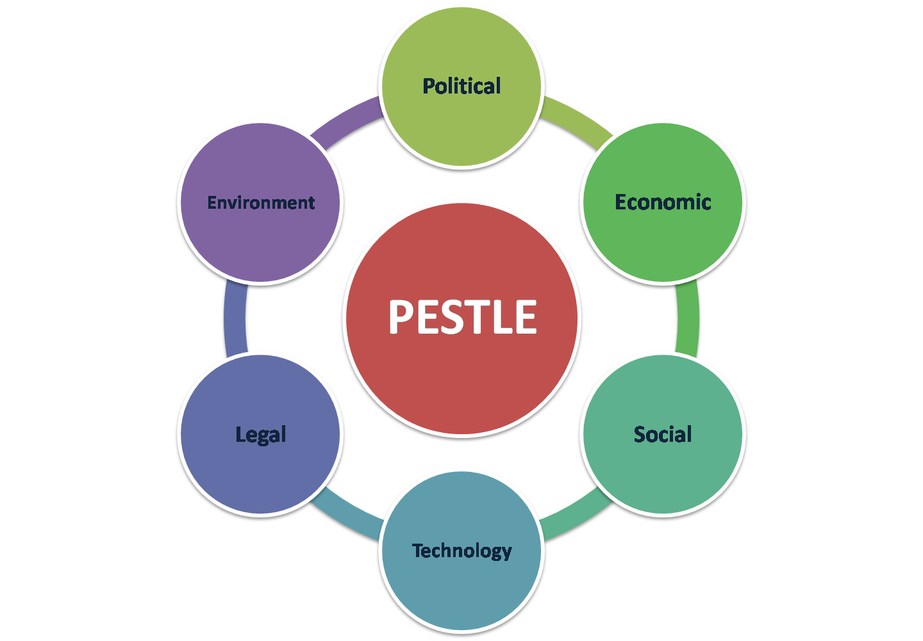
Figure 1: PESTLE Analysis
Source: (Author)

5. Porter’s five forces analysis
Threat of new entrants: The threat of new entrants in this field is moderate for Roll-Royce as they have concentrated on high competitive advantages. Roll-Royce has fixed their targeting to balloon 7.2 billion passengers by 2035 as it is measured by a double count of their current passengers in airlines. For any new entrant organisations, it is impossible to target a large audience for their organisations effectively (Porter Analysis, 2021).
Bargaining power of suppliers: The behaviour of quality assurance of Roll-Royce allows it to concentrate cost integration effectively. The suppliers are fixed by Roll-Royce as the quality of raw materials is directly linked with the quality of manufactured products.
Bargaining power of buyers: The customers of Roll-Royce are divested across the world effectively and the profit from the international defence marketplace helps Roll-Royce to increase its business growth earlier (Aleksanyan, 2021). However, the three primary producers such as Boeing, and Airbus, mentioned to be the leader of the airline industry, allow Roll-Royce to switch to a higher cost and Bombardier allows it to maintain quality assurance to customers.
The threat of substitute products: The measurable and overall threat of substitution is very low as the demand for air travelling and defence technology has increased a lot. Roll-Royce has developed its ranking as 27th in the global marketplace which is effective for its sustainable growth in future (Porter Analysis, 2021).
Rivalry among the existing players: In this field, CFM has a 39% share whereas Roll-Royce has only 12% still now. It has increased the competition among the existing automobile organisations in the UK (Porter Analysis, 2021).
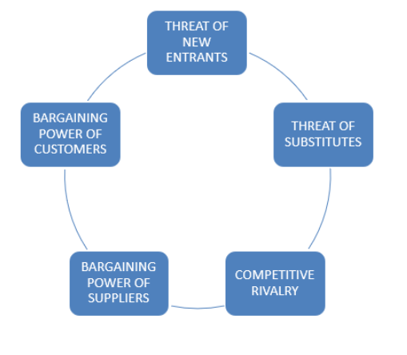
Figure 2: Porter’s five forces for Roll-Royce
(Source: Coventry University, 2019)

6. Porter’s diamond
According to Porter’s diamond framework, four factors determine the national competitive advantages (Amreen, 2019, p.3). These are given below.
Factor conditions- The factor conditions provide core competencies of an organisation by deploying natural resources, human resources, capital resources, and technological innovation (Amreen, 2019, p.3). The natural resources of Roll-Royce set up the operational and production plant for Roll-Royce. Roll-Royce has both equity and debt-based capital with highly skilled and talented employees.
Demand conditions- The sophisticated domestic demands for Rolls-Royce push the organisation into the utilisation of its resources and capabilities towards innovation. Roll-Royce analyses the market trends and customers’ demands that lead the organisation to develop unique and luxurious cars for the customers.
Supporting and related industries- The existence of related and supporting industries in both domestic and global markets are the facilitator for Roll-Royce to expand its business. The core competitors of Roll-Royce include McLaren, Jaguar, Land Rover, Mercedes Benz, Aston Martin, and many more create pressure on Roll-Royce to expand its business and develop its performance (Rolls-Royce, 2021, p.2). Roll-Royce has a competitive global supplier network that distributes its products in different markets.
Firm structure, strategy, and rivalry- The company satisfies the needs of the customers for maximising the value of money through an efficient process of car production. Roll-Royce has a flat organisational structure that supports open communication and a quick decision-making context. Roll-Royce operates in a highly competitive market that possesses a higher degree of competition (Rolls-Royce, 2021, p.2).
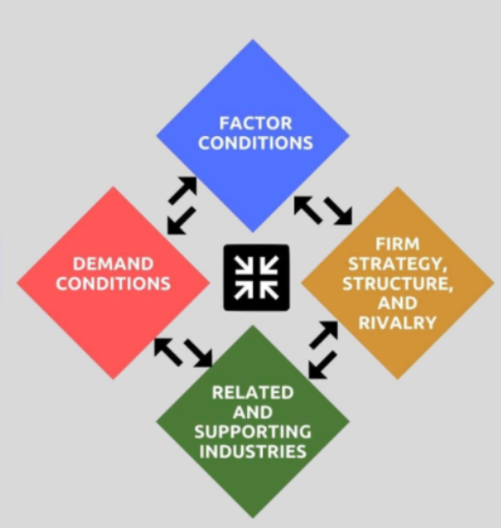
Figure 3: Porter’s diamond
Source: (Amreen, 2019, p.3)

7. Value chain analysis
Value chain analysis sheds light on both the primary and supporting activities of the organisation. These are illustrated below.
Primary activities- The primary activities are directly engaged with the production and selling of the products in the market (Cgma, 2021, p.3).
Inbound logistics- Roll-Royce develops a strong supplier relationship to store and distribute the products in the market. Roll-Royce develops product development phases and transforms raw materials into finished products.
Operations- Operational activities of Roll-Royce include raw material preserving, machining, assembling and testing (Cgma, 2021, p.3). Car equipment repairing and maintaining belongs to the operations category.
Outbound logistics- Roll-Royce has a B2B product delivery context to the customers where Roll-Royce markets its products through other relevant companies (Rolls-Royce, 2021, p.2). Roll-Royce analyses and optimises the outbound logistics for exploring the sources of competitive advantages.
Marketing and Sales- The marketing funnel is used by Roll-Royce to structure the activities of marketing and sales. Rolls-Royce has a sales force, promotional activities, advertising, pricing, quoting, and channel selection marketing and sales activities.
Service- Roll-Royce offers both post-sales and pre-sales services that play a crucial role to develop customer loyalty. Roll-Royce provides 24*7 customer service to its customers for resolving their doubts and queries (Rolls-Royce, 2021, p.2).
Supporting activities- The supporting activities facilitate and coordinate the primary activities of Roll-Royce.
Firm infrastructure- The firm infrastructure activities of Roll-Royce include accounting, planning, financing, quality management, legal challenges handling, and strategic management (Purcell et al., 2017, p.9).
Human Resources- Rolls-Royce analyses HRM activities by recruiting and selecting the employees, training them, managing their performance to motivate the employees.
Technology development- Roll-Royce applies automation software, customer service, product design, data analysis, and emerging technology for manufacturing innovative cars and promoting them in the market.
Procurement- Rolls-Royce considers its procurement activities for optimising the inbound and outbound activities. The entire supply chain activities of Roll-Royce are supported by procurement activities (Purcell et al., 2017, p.9).
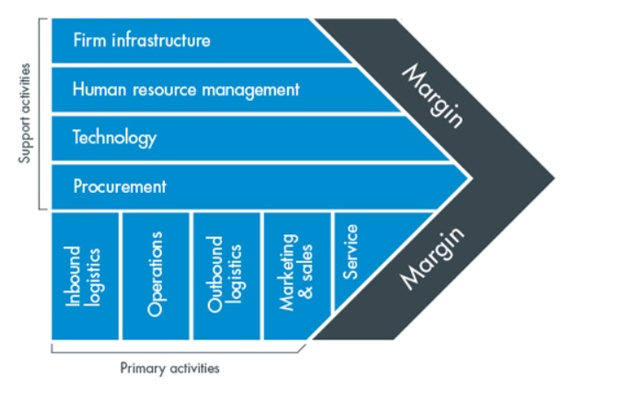
Figure 4: Value Chain Analysis
Source: (Cgma, 2021, p.3)

8. Value network
The value network concentrates on the assessment of the organisational members and their interactions within the value network. These are illustrated below.
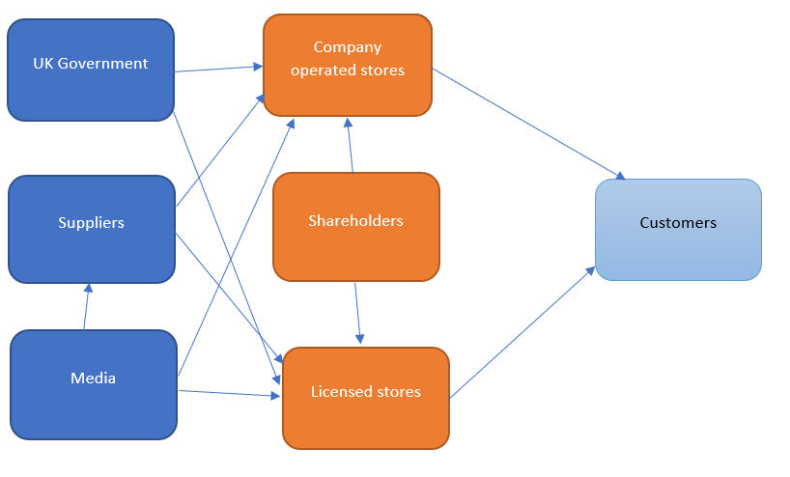
Figure 5: Value network analysis
Source: (Author)

Network Group | Comment
Company-operated stores | Approximately, 70% of the business revenues of Roll-Royce come from company-operated stores. The UK Government, media, and suppliers interconnect with company-operated stores.
Licensed stores | Roll-Royce has 135 licensed stores that contribute to 30% of the business revenues of the company (Rolls-Royce, 2021, p.2). The UK Government, media, and suppliers interconnect with licensed stores.
Government | The UK Government works as an independent network group that affect the operations of company-operated stores and licensed stores.
Media | It has a great effect on the performance of both licensed stores and company-operated stores (Tkachenko et al., 2020, p.2). Recently, Roll-Royce faced issues due to the extensive tax issues and critical viewpoint of the media.
Suppliers | This networking group consists of suppliers of different technologies, steel, aluminium, copper, magnesium, composites, glass, rubber, and many more (Rolls-Royce, 2021, p.2). Suppliers interact with both licensed stores and company-operated stores.
Customers | This networking group is the prime determinant of Roll-Royce profitability and purchases products from licensed stores and company-operated stores (Tkachenko et al., 2020, p.2).
Shareholders | This networking group contact licensed stores and company-operated stores for investing financial assets and capital.
Table 3: Value network analysis
Source: (Author)

9. Analyse competitive advantages with core values on sustainability
Quality assurance: According to the current business strategy of Roll-Royce, it is always concerned with quality assurance services and products to its customers which are supported by the external business environment of the UK effectively. The decreasing fluctuation rate of the UK economy allows it to fix its price list along with quality assured products easily by reducing its manufacturing costs (Coventry University, 2019).
Objective orientation: The use of frugal innovation within the production house of Roll-Royce allows the organisation in avoiding unnecessary costs regarding its manufacturing strategy. Additionally, demand-oriented innovation within marketplace determination allows them to run their work activity according to business objectives effectively (Aleksanyan, 2021).
Sustainable business value: The use of frugal innovation within production and business strategy allows Roll-Royce to apply the latest technology of this country for providing sustainable engines to the environment. Thus, Roll-Royce is also maintaining its Corporate social responsibilities to its origin efficiently (Coventry University, 2019).

10. Conclusion
This paper concludes that Roll-Royce has organised its business values using the positive influences of the external business environment of the UK successfully. The growth of the automobile industry has become unpredictable nowadays because of the higher increasing global warming from the CFCs from engines effectively. During the current two decades, the aerospace and defence industry is growing day by day and the main rival of Roll-Royce has been identified as General Electric aviation. Thus, using the latest technological invention, Roll-Royce has reached its level of sustainability overproduction in order to facilitate people more environmentally friendly travelling opportunities effectively.

References

Books and Journals
Aleksanyan, A.K., 2021, October. Unmanned navigation system. In Journal of Physics: Conference Series (Vol. 2061, No. 1, p. 012119). IOP Publishing.
Do Quang, H., 2017. Marketing SWOT Analysis of Rolls-Royce Motor Cars (Doctoral dissertation, Empire State College).
Purcell, S.W., Crona, B.I., Lalavanua, W. and Eriksson, H., (2017). Distribution of economic returns in small-scale fisheries for international markets: a value-chain analysis. Marine Policy, 86, pp.9-16.
ŞENOL, Y., GÖKÇEK, V. and SEYHAN, A., 2017. SWOT-AHP Analysis of Autonomous Shipping. In 4th International Multidisciplinary Congress of Eurasia Proceedings (Vol. 2, pp. 58-69).
Sinha, D. ed., 2019. Global Supply Chains and Multimodal Logistics: Emerging Research and Opportunities: Emerging Research and Opportunities. IGI Global.
Smith-Gillespie, A., Muñoz, A., Morwood, D. and Aries, T., 2018. ROLLS-ROYCE: A Circular Economy Business Model Case.
Tkachenko, I.N., Pervukhina, I.V. and Zlygostev, A.A., (2020). Modeling the contribution and benefits of company stakeholders. Upravlenec, 11(2).

Websites
Amreen Z. (2019). What is Porter’s Diamond Model of National Advantage? [online] Available from: https://tradebrains.in/porters-diamond-model/ [Accessed 21 December 2021]
Cgma (2021). Value Chain Analysis [online] Available from: https://www.cgma.org/resources/tools/essential-tools/value-chain-analysis.html [Accessed 21 December 2021]
CIPD (2021). PESTLE Analysis [online] Available from: https://www.cipd.co.uk/knowledge/strategy/organisational-development/pestle-analysis-factshee[Accessed on 21 November 2021]
Coventry University, (2019) Strategic management [online] Available from:https://mba2020.home.blog/2019/06/09/strategic-management-psbm115cl/ [Accessed on 21 December 2021]
Porter Analysis, (2021) Porter’s five forces for Rolls-Royce [online] Available from:https://www.porteranalysis.com/porters-five-forces-analysis-of-rolls-royce-holdings/ [Accessed on 21 December 2021]
Rolls-Royce (2021). Rolls-Royce [online] Available from: https://www.rolls-roycemotorcars.com/ [Accessed on 21 November 2021]
Statista (2021). United Kingdom: Inflation rate from 1986 to 2026 [online] Available from: https://www.statista.com/statistics/270384/inflation-rate-in-the-united-kingdom/ [Accessed on 21 November 2021]

