BA Leadership and Management Skills for the Workplace
BMSW5105
Workplace Culture and its Impact on Organisational Efficiency
Task 1
Student: Yanko Yankov
Student number: 2127550

Table of Contents
Introduction 3
Section 01: Organizational Culture, Ethos, and Values of Google 4
1.1 Defining Organizational Culture 4
1.1.1 Organizational Culture Theories 4
1.1.2 How Google Aligns Its Organizational Culture with Theories 5
1.2 Ethos and Values in Google 5
1.2.1 Principles and Beliefs 5
1.2.2 Google’s Value Reinforcing Strategy 6
1.3 The Role of Leadership in Building Culture 7
Section 02: Practice of Sustainability at Google 9
2.1 Sustainability Practice in Organizational Culture 9
2.2 Theories to Evaluate Organizational Sustainability 9
2.2.1 Theories and Their Implications 9
2.2.2 Comparative Analysis 11
2.3 Assessing Google’s Sustainability Practices 11
2.3.1 Strengths and Weaknesses 11
2.3.2 Areas for Improvement 12
Section 03: Recommendations 13
Ensuring an Inclusive Work Environment 13
Ensuring Employee Well-being 13
Motivating Continuous Development 14
Increasing Collaboration Using Technologies 15
Conclusion 16
References 17

Introduction
As a well-known worldwide IT behemoth, Google leads the way in innovation and is reshaping the digital market with its ground-breaking goods and services. In addition to its technological competence, Google's organizational culture has drawn much attention and appreciation. Examining Google's environmental initiatives, staff well-being plans, and fundamental values, this research explores the complex web of Google culture. Organizational culture has a significant impact on an organization's ability to succeed, adapt, and maintain the general well-being of both its employees and itself in modern settings. It acts as the foundation for the identity, principles, and methods of operation of an organization. In an ever-changing global economy, attracting top personnel, fostering innovation, and achieving sustained success all depend on an understanding of and ability to use this culture. This report begins with an introduction to Google’s culture and an examination of its basic values before delving deeply into the company's organizational culture. It then closely examines Google's sustainability policies and how they affect the company's operations. The report evaluates areas that could use development as well and makes suggestions for improving Google's working culture. We hope that our analysis will offer insightful information on the factors that have helped Google become the market leader it is today.


Image: Google Logo (Source: Google)

Section 01: Organizational Culture, Ethos, and Values of Google
The common values, attitudes, customs, and behaviors that define an organization are referred to as its organizational culture. It stands for the psychological and social climate of a business, affecting how people interact, make choices, and view their jobs (Schein, 2010). A common description of organizational culture is that it is the "personality" of the organization, defining its identity and offering a framework for comprehending and handling diverse circumstances.
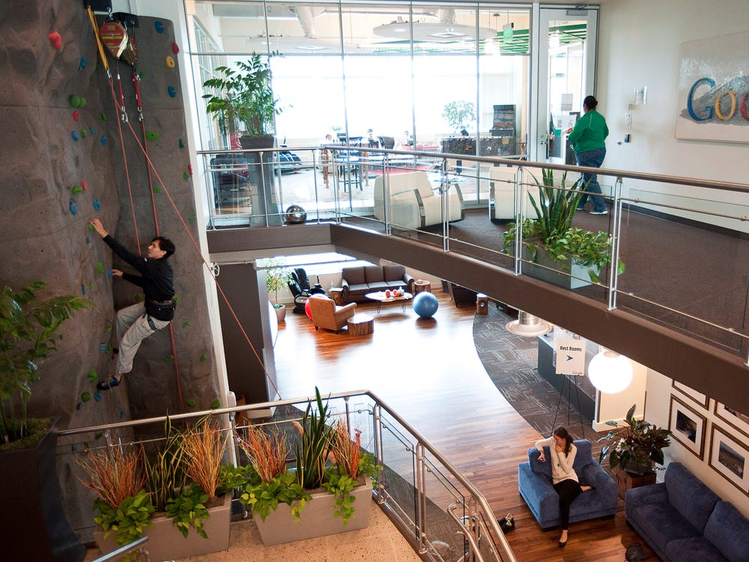

Image: Inside Google Office (Source: Business Insider)

1.1 Defining Organizational Culture

1.1.1 Organizational Culture Theories
There are some prominent theories of organizational culture. They are explained in the following-
Theory of Socialization: According to this theory, people go through a socialization process when they work in an organization, where they pick up and absorb the values and cultural norms of the group. This procedure aids in the integration of new hires into the current culture.
Theory of Cultural Evaluation: According to this view, corporate culture changes throughout time in response to both internal and external influences. It is not static. It highlights how leaders and followers may consciously shape culture, which is dynamic.
Theory of Sociocultural: This theory, which draws on sociology and anthropology, contends that organizations can be thought of as miniature communities with distinct cultures of their own. It highlights how rituals, shared language, and symbols shape organizational culture (Alvesson and Sveningsson, 2015).

1.1.2 How Google Aligns Its Organizational Culture with Theories
There are various ways in which Google's corporate culture corresponds with these theoretical frameworks:
Firstly, Google prioritizes orientation and onboarding initiatives. Through immersive events, the company's culture is conveyed to new hires, helping them internalize Google's principles and develop a sense of belonging.
Secondly, Google is renowned for its innovative and flexible culture. The organization promotes experimentation and risk-taking, which is consistent with the Cultural Evolution Theory's description of organizational culture as dynamic (Zohar and Hofmann, 2012).
Lastly, the sociocultural approach is in line with Google's emphasis on open communication, cross-functional cooperation, and the use of technology to enhance engagement. Through these procedures, workers develop a common language and sense of belonging.

1.2 Ethos and Values in Google
Google's organizational culture is built around its ethos and principles. The aforementioned principles serve as the foundation for the organization's operations and decision-making procedures.

1.2.1 Principles and Beliefs
Innovation: Google is a company that is committed to constant innovation. Its problem-solving techniques, offerings, and services all reflect this idea. To push limits and develop ground-breaking innovations, the organization pushes its staff to think outside the box and take calculated risks.
User-oriented Strategy: Understanding and satisfying the requirements of its users is a top priority for Google. In addition to making information more accessible and helpful, the company aims to deliver goods and services that improve user experiences (Hogan and Coote, 2014).
Open Culture: Google promotes transparency and teamwork. It motivates workers to collaborate across teams, exchange ideas, and help achieve the group objective of using technology to make the world a better place.
Long-Term Goals: When making decisions, Google looks at the big picture. It seeks to provide long-lasting solutions that benefit the environment and society.
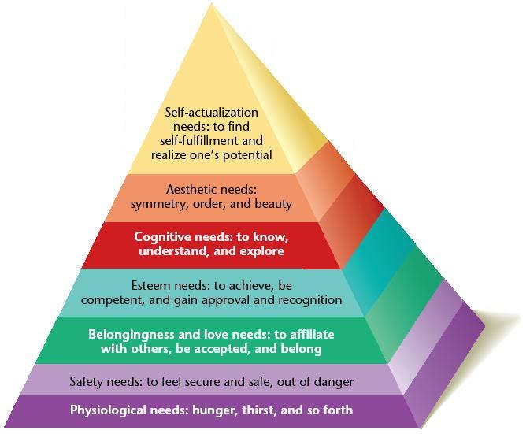

Image: Google’s Corporate Values and Goals (Source: Ivy Panda)

1.2.2 Google’s Value Reinforcing Strategy
Google uses a variety of strategies to spread awareness of and uphold its principles among its employees:
Clarity of Values: Official declarations from the company, including its mission statement and code of conduct, clearly indicate its values. For staff members, these documents provide a set of guidelines.
Exemplification of Leadership: The leaders of Google are vital in promoting and living up to the company's ideals. They provide an exemplary example by acting and making decisions that highlight the value of creativity, teamwork, and user-centricity (Linnenluecke and Griffiths, 2010).
Recognition: Employees who embody Google's values are acknowledged and rewarded by the firm. Recognition from the public, honors, and chances for professional growth might all fall under this category.
Providing Training: Google funds training and development initiatives for staff members that highlight the significance of the organization's principles. The expectations and norms of the culture are strengthened by these activities.
Evaluation: Frequent performance reviews and feedback systems gauge how well employees align with Google's core values. This makes it easier for people to understand how they fit into maintaining the company's values.

1.3 The Role of Leadership in Building Culture
Since leaders are the creators and defenders of the standards, values, and beliefs that make up an organization's culture, their influence on its culture is crucial. This influence is especially noticeable at Google. Google's distinctive culture has been fostered and maintained in large part by important leaders (Naranjo-Valencia et al, 2011). For example, Google's co-founders, Larry Page and Sergey Brin, instilled an innovative culture in the organization from the beginning. Their innovative methodology placed a strong emphasis on being willing to take chances, venture into unknown areas, and question accepted wisdom. Projects like Google X, which explored bold, moonshot concepts, were an example of this mentality in action.
Recalling the value of data-driven decision-making, former Google CEO Eric Schmidt made additional contributions to the company's culture. In problem-solving, his analytical style reaffirmed Google's dedication to objectivity and empirical data. Following in Schmidt's footsteps, Sundar Pichai has promoted an approachable and empathic culture, carrying on the legacy. One of Google's key values is in line with Pichai's leadership style, which places a strong emphasis on comprehending and satisfying consumer requirements.


Image: Sundar Pichai (Source: NDTV)
Google emphasizes distributed leadership heavily in addition to top-level leadership, which fosters creativity at all organizational levels. This methodology enables staff members to assume responsibility for their tasks and enhance the organization's collaborative and innovative culture. The 20% policy, for example, shows how Google believes in its workers' ability to spur innovation by allowing them to set aside a portion of their workweek for personal projects (Cheung et al, 2012). Additionally, the leadership of Google has demonstrated a dedication to diversity and inclusion, which has grown to be ingrained in the company's ethos. A more inclusive workplace has been established by leaders through the implementation of programs and policies, realizing the importance of many viewpoints in fostering creativity.

Section 02: Practice of Sustainability at Google

2.1 Sustainability Practice in Organizational Culture
Integrating ethically and socially conscious practices into an organization's operations, decision-making processes, and way of thinking is known as embedding sustainability in organizational culture. This means coordinating corporate plans with values that put society's and the environment's welfare first. Google has come a long way in incorporating sustainability into its corporate culture. The business has set high standards for itself, including running totally on renewable energy and becoming carbon neutral. Google has also pledged to end waste in its operations and use only 100% recyclable materials in its products. These goals are firmly ingrained in the mission and values of the organization; they are not merely stand-alone projects. For example, Google's Code of Conduct, which places a strong emphasis on ethical behavior and environmental stewardship, reflects the company's dedication to sustainability.
Google invests in renewable energy initiatives as one of the main ways it promotes sustainability. By entering into power purchase agreements for solar and wind energy, the corporation has made a direct contribution to the growth of renewable energy sources (Büschgens ET AL, 2013). Furthermore, Google actively contributes to the reduction of electronic waste utilizing programs like "Circular Google," which tries to prolong the life of electronic gadgets. These environmentally friendly policies have a significant effect on Google's operations. Google lowers its carbon footprint and protects itself from potential hazards brought on by volatile energy prices by investing in renewable energy. Additionally, stakeholders—such as investors and customers—resonate with sustainability initiatives, as they increasingly give preference to businesses that have a track record of environmental stewardship. This has the potential to improve Google's standing, foster client loyalty, and draw in top personnel. Moreover, Google's eco-friendly efforts encourage creativity among staff members. To find sustainable solutions, Google frequently develops innovative technologies and procedures that have wider industry applicability than just Google.

2.2 Theories to Evaluate Organizational Sustainability

2.2.1 Theories and Their Implications
Tripple Bottom Line: An organization's performance is evaluated in three areas under the TBL framework: economic, social, and environmental. It assesses how corporate activities affect revenue, people, and the environment. Making decisions that affect the environment, society, and finances all takes sustainability into account thanks to this all-encompassing approach.
Google's efforts in sustainability are in line with the TBL model. The company makes financial investments in renewable energy, which lowers its operating costs and promotes economic development in the localities where its projects are located. Google places a high value on diversity and the well-being of its workforce, fostering a happy work atmosphere (Tsai, 2011). The company's efforts to reduce its ecological footprint are exemplified by its use of recycled materials in its products and its aim to become carbon neutral.
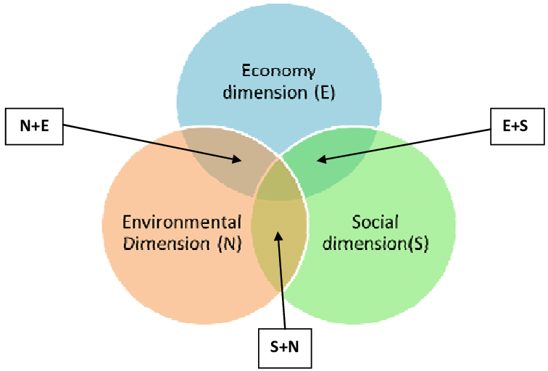

Image: TBL Model (Source: ResearchGate)
Sustainability Development Goals: The Sustainable Development Goals (SDGs) are a group of 17 international objectives created by the UN to address diverse social, economic, and environmental issues. They give organizations a thorough framework to match their objectives with those of global sustainability.
There are multiple SDGs that Google's sustainability initiatives align with. For example, its focus on carbon neutrality and renewable energy helps achieve Goals 13 (Climate Action) and 7 (Affordable and Clean Energy). Moreover, the company's programs to advance education and improve digital accessibility are in line with Goals 10 (Reduced Inequalities) and 4 (Quality Education).

2.2.2 Comparative Analysis
Google's eco-friendly efforts surpass numerous industry benchmarks. The company goes above and above what its peers in the industry expect in terms of its commitment to being carbon-neutral and utilizing only renewable energy. Furthermore, Google goes above and beyond the typical standards of many technology companies by investing in circular economy techniques like product refurbishment and recycling. This shows a proactive attitude to minimizing electronic waste.

2.3 Assessing Google’s Sustainability Practices

2.3.1 Strengths and Weaknesses
Strengths | Weaknesses
- Intending to run entirely on renewable energy, Google has made significant investments in the field. This pledge shows how committed the business is to lowering its carbon footprint and supporting international efforts to tackle climate change.  - Google has demonstrated its commitment to responsible resource management with the "Circular Google" program and its efforts to incorporate recycled materials into its products. This strategy encourages a more sustainable product lifespan and reduces waste (Warrick, 2017).  - Google leverages its technological capabilities to create creative answers for problems related to sustainability. Google Earth Engine and DeepMind for Climate are just two examples of projects that show a commitment to using technology to improve the environment. | - Although Google has made progress in enhancing the sustainability of its internal operations, it still has to improve in terms of addressing the environmental impact of its supply chain. This covers things like the procurement of raw materials and manufacturing procedures.  - Google may improve openness by offering sustainability reports that are more thorough. Stakeholders could gain a better understanding of the company's sustainability objectives and success with the use of more transparent measurements and comparisons.  - Even though Google is a leader in environmental sustainability, social sustainability factors including labor practices, community involvement, and ethical sourcing could need more attention (Cheung et al, 2012).

2.3.2 Areas for Improvement
Reducing Emission: Google might aim for net-zero emissions throughout its whole value chain, setting even more challenging carbon reduction targets. This would strengthen the business's will to tackle climate change.
Diversification: Despite Google's best efforts, there is still space for improvement when it comes to representation, especially in senior roles. Increasing the effectiveness of these programs would promote an inclusive and fair workplace (Paais and Pattiruhu, 2020).
Stakeholder Engagement: Improving communication with outside parties, such as the communities affected by Google's operations, can result in more knowledgeable and cooperative sustainability initiatives. This can entail collaborations with neighborhood groups and hands-on participation in neighborhood projects.

Section 03: Recommendations

Ensuring an Inclusive Work Environment
Encouraging diversity and inclusivity among employees is essential to developing a lively and dynamic company culture. Regardless of characteristics like color, gender, age, or cultural origin, it entails appreciating and acknowledging the distinct histories, experiences, and viewpoints of every employee. Policies to aggressively seek and hire people with a variety of backgrounds may be put in place by Google. This might be doing inclusive job postings, focused outreach, and getting rid of prejudices in the hiring process. Additionally, they may set up anti-discrimination laws and flexible work schedules, among other rules, to foster an inclusive workplace (Plantin et al, 2018). They might offer educational courses that emphasize the value of inclusivity and diversity and give staff members the tools they need to create a welcoming workplace environment. They might assign workers to sponsors or mentors who can offer direction, encouragement, and chances for professional growth, especially to members of disadvantaged groups.

Ensuring Employee Well-being
The term "employee well-being" refers to a person's contentment and physical, mental, and emotional health at work. A key element of well-being is work-life balance, which emphasizes the necessity for people to have the time and means to take care of their personal needs outside of the workplace.
- Giving workers choices like shorter workweeks, flexible scheduling, and remote work enables them to better balance their personal and professional obligations.
- Employee mental health can be considerably enhanced by offering counseling services, mental health resources, and a stigma-free environment for asking for assistance.
Long-term job happiness and career advancement depend on striking a balance between the demands of the workplace and one's own personal and professional development. It includes:
- Giving staff members access to conferences, workshops, and training promotes professional growth and makes them feel like they've accomplished something personally.
- Transparent career progression frameworks enable staff members to manage their current work obligations while setting goals and pursuing their long-term objectives (Chirico and Nordqvist, 2010).
- Employees can develop new skills and find joy in their work when they are allowed to try out other projects or roles inside the company.

Motivating Continuous Development
Throughout one's career, gaining new knowledge, skills, and competencies is referred to as continuous learning and development. Individuals must remain relevant in a continuously changing professional environment.
- Providing employees with a diverse range of training programs, workshops, and seminars covering pertinent topics enables them to gain new skills and information.
- Matching staff members with seasoned mentors or coaches offers individualized coaching and promotes skill development in a nurturing setting.
- Offering employees options for growth inside the company and clear professional advancement pathways motivates them to make personal development investments. Employees' long-term growth is demonstrated by providing financial assistance or paid time off for higher education, such as obtaining advanced degrees or certificates.
The acquisition of skills and knowledge by employees that directly contribute to the success of the firm is ensured when learning and development activities are in line with organizational goals. You can accomplish this by:
- Learning initiatives can be guided by clearly outlining the talents and skills that are essential to accomplishing company goals (Sarooghi et al, 2015).
- Managers can determine which areas require further training and development to accomplish corporate objectives by conducting evaluations regularly.
- Establishing avenues for staff members to offer input on their educational experiences aids in ensuring that subsequent endeavors are more closely aligned with the requirements of the company.

Increasing Collaboration Using Technologies
Using digital tools and platforms to promote smooth communication, information sharing, and teamwork among employees, regardless of their location or time zone, is known as "leveraging technology for enhanced collaboration." It helps businesses to remove geographical obstacles and build a staff that is more cohesive and effective.
- Collaboration and communication among team members are improved by real-time messaging, file sharing, and video conferencing made possible by platforms like Slack, Microsoft Teams, and Zoom.
- Teams may arrange work, establish priorities, and monitor progress with the use of platforms like Trello, Asana, and Jira. This keeps everyone on the same page and informed about project deadlines and milestones (Plantin et al, 2018).
- Version control concerns are removed when several users work together in real-time on documents, spreadsheets, and presentations using cloud-based storage systems, Google Workspace, and Microsoft Office 365.
- Employee knowledge sharing, feedback seeking, and project collaboration are made possible via internal social networks and forums like as Yammer and Workplace by Facebook.
To improve communication and knowledge sharing across its global workforce, Coca-Cola deployed Salesforce Chatter, a social collaboration tool. This enhanced the productivity of the sales team and promoted cross-functional cooperation and decision-making (Zheng et al, 2010).
Slack is used by e-commerce company Shopify to facilitate communication amongst its geographically dispersed workforce. Employees now communicate more effectively, solve problems more quickly, and feel more a part of the team as a whole.
Microsoft Teams was used by General Electronic to improve collaboration and communication between its many business divisions. As a result of the platform's enhanced project coordination, real-time interactions, and decreased email overload, productivity, and teamwork were eventually increased.

Conclusion
A review of Google's sustainability policies and organizational culture demonstrates the company's admirable dedication to environmental stewardship, innovation, and inclusivity. The organization demonstrates a progressive mindset by prioritizing renewable energy, implementing circular economy efforts, and implementing diversity and inclusion programs that meet industry standards. Google has the chance to strengthen its sustainability efforts in the areas that have been suggested for development, such as supply chain sustainability and reporting transparency. In addition to boosting morale and productivity, fostering inclusivity, diversity, and employee well-being as well as ongoing learning and development can help create a staff that is more resilient and adaptable. Putting these suggestions into practice might greatly improve Google's organizational effectiveness, which would help it better handle changing obstacles and stay ahead of the competition. Eventually, Google's dynamic and forward-thinking corporate culture is largely responsible for its success, acting as a catalyst for the company's continuous expansion and influence on the world scene. Google's culture is a driving force behind its success in the digital industry, drawing in top talent and creating an environment that is conducive to creativity.

References
Alvesson, M. and Sveningsson, S., 2015. Changing organizational culture: Cultural change work in progress. Routledge.
Büschgens, T., Bausch, A. and Balkin, D.B., 2013. Organizational culture and innovation: A meta‐analytic review. Journal of product innovation management, 30(4), pp.763-781.
Cheung, S.O., Wong, P.S. and Lam, A.L., 2012. An investigation of the relationship between organizational culture and the performance of construction organizations. Journal of Business Economics and Management, 13(4), pp.688-704.
Chirico, F. and Nordqvist, M., 2010. Dynamic capabilities and trans-generational value creation in family firms: The role of organizational culture. International Small Business Journal, 28(5), pp.487-504.
Hogan, S.J. and Coote, L.V., 2014. Organizational culture, innovation, and performance: A test of Schein's model. Journal of business research, 67(8), pp.1609-1621.
Linnenluecke, M.K. and Griffiths, A., 2010. Corporate sustainability and organizational culture. Journal of world business, 45(4), pp.357-366.
Naranjo‐Valencia, J.C., Jiménez‐Jiménez, D. and Sanz‐Valle, R., 2011. Innovation or imitation? The role of organizational culture. Management decision, 49(1), pp.55-72.
Paais, M. and Pattiruhu, J.R., 2020. Effect of motivation, leadership, and organizational culture on satisfaction and employee performance. The Journal of Asian Finance, Economics and Business, 7(8), pp.577-588.
Plantin, J.C., Lagoze, C., Edwards, P.N. and Sandvig, C., 2018. Infrastructure studies meet platform studies in the age of Google and Facebook. New media & society, 20(1), pp.293-310.
Sarooghi, H., Libaers, D. and Burkemper, A., 2015. Examining the relationship between creativity and innovation: A meta-analysis of organizational, cultural, and environmental factors. Journal of business venturing, 30(5), pp.714-731.
Schein, E.H., 2010. Organizational culture and leadership (Vol. 2). John Wiley & Sons.
Tsai, Y., 2011. Relationship between organizational culture, leadership behavior and job satisfaction. BMC health services research, 11(1), pp.1-9.
Warrick, D.D., 2017. What leaders need to know about organizational culture. Business Horizons, 60(3), pp.395-404.
Zheng, W., Yang, B. and McLean, G.N., 2010. Linking organizational culture, structure, strategy, and organizational effectiveness: Mediating role of knowledge management. Journal of Business research, 63(7), pp.763-771.
Zohar, D. and Hofmann, D.A., 2012. Organizational culture and climate.

