javairia suleman 2522371
Daniel haruna Introduction to health and social care
component one: poster & essay

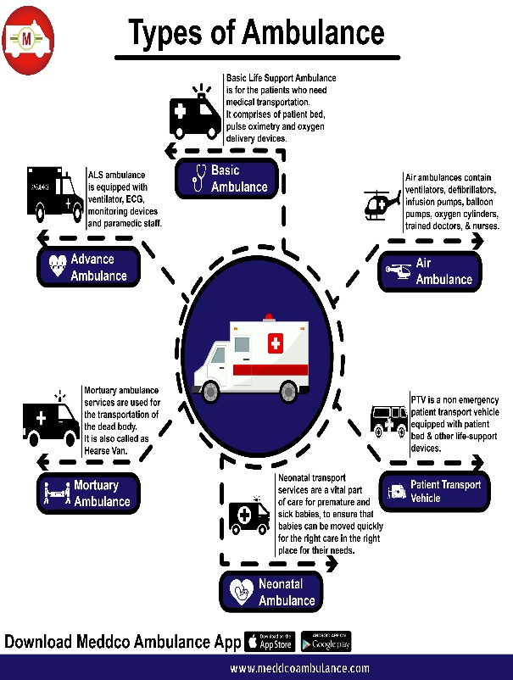
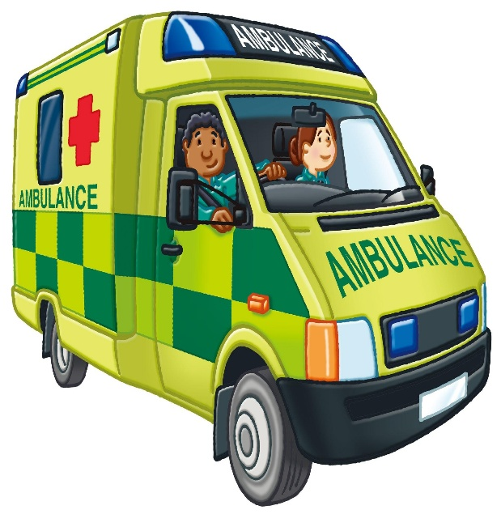
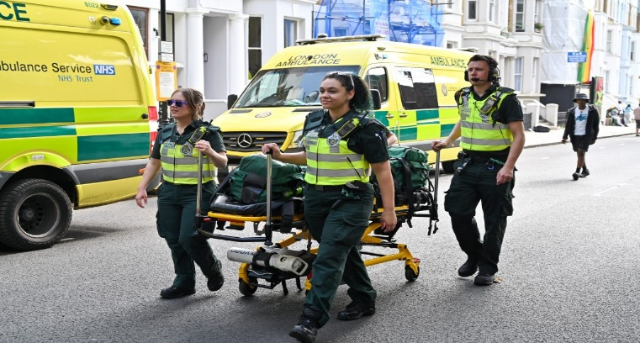
1. An ambulance is a specifically designed emergency vehicle used to transport people who are sick or injured.
2. Ambulances carry important medical equipment that allows paramedics to give treatment before patients arrive at hospital.
3. Paramedics are trained healthcare professionals who provide emergency support and make quick choices during medical situations.
4. They help people physically by treating their injuries and helping to manage any of their medical conditions, whilst also offering emotional support.
5. One of the main aims of ambulance services is to keep patients stable and safe while travelling to hospital.
6. Ambulance services play an important role in the healthcare system across the world.
7. Fast medical attention can improve recovery and reduce the chance of further issues.
8. Ambulances also use technology, communication systems and patient information to improve response times and provide quality care.
1. One of the main challenges ambulances faced between 2023-2024 was the handover delays at hospitals. Ambulance services lost 1.6 million hours waiting to hand patients over to A&E. hospitals are often full and don’t have enough staff or beds. Whilst paramedics wait, they can’t respond to other 999 calls. Setting up dedicated handover teams in hospitals to help take patients off ambulances quickly will help approve time spent on handovers.
2. Another challenge faced by this service was the rise in 999 calls made by patients. Number of calls went up by 8% in a year to 8.8 million. The more calls there are, the less paramedics available. Even though response times improved for category 1-4 calls, the big demand made it hard to keep that up. If the NHS put more resources into telephone triage and patient care so non urgent calls done become 999 issues. Hiring more paramedics and adding more ambulances during the more peak times will help match the rise of demand.
1. An ambulance’s main goal is to respond to 999 calls quickly and start helping people right where they are, not having to wait until you get to hospital.
2. Paramedics will first do a quick assessment called a triage assessment which helps them sort patients by who needs help first. If someone has life- threatening problems, they will get treated before anyone else.
3. Paramedics are trained to deal with serious medical stuff on the spot. Trouble breathing, heart problems, bad Injuries, they are always trained to handle them. This can mean administering oxygen, meds.
4. They make sure to keep an eye on you until you arrive at the hospital. They’ll monitor your condition, help with managing pain, and ensuring nothing changes.
5. They known what to do within seconds of an emergency. These professionals have the skills to act fast, stop bleeding, restart a heart. This is what makes a difference before you reach the A&E.
6. The help and support don’t stop when they leave your home. Ambulance staff can treat you at home if it is safe, talk you through important things over the phone.
1. Ambulances first started with St John ambulance volunteers in 1904. Back during these times there wasn’t a national service. The volunteers were trained in basic first aid and would go to big events to help those who were injured. They didn’t have very much equipment, but they were always the first to give care before patients reached the hospitals.
2. WW1 made ambulance teams work faster and become closer with medical staff. Volunteers and doctors had to treat and move large numbers of injured soldiers very quickly. This enabled ambulance services to work well under extreme pressure. It showed how important it was to have trained staff who could act fast.
3. During the 1930s brought faster transport with the help of actual vehicles. London replaced their horse drawn ambulances with motors, which cut down response times. This change meant that ambulances could be used for everyday emergencies.
4. When the NHS started in 1948, ambulances became apart of their team. It made care more consistent and meant patients didn’t have to rely on local charities for help.

Mental health is just as important as physical health, and for many individuals it requires ongoing support. In England, the NHS provides community mental health services in the community for adults aged 18 and over and are dealing with serious or complex conditions. These services are being delivered by specialist teams based in local areas. Their job is to provide care, support and advice outside of hospital settings so those vulnerable people can receive help without pausing their lives. The main focus of these staff is on three important things. Firstly, they support people so that they can manage their condition and stay connected with their families, work, and daily routines. Secondly, they respond quickly when someone is having a mental health crisis. Finally, they try and help earlier to stop the problem from spiralling. This approach recognises that mental illness affects more than just the person. Carers, relatives and friends of those affected are also impacted, so the services often offer help and support for them to. This essay will explain how community mental health services work, the history of how it all started and the main functions of this service.

During the 1700s and the 1800s, mental health care in the UK was very different to how it is now. Most people with mental illnesses were sent to live in mental asylums. At the time, society believed that separating these individuals from the public would protect everyone. However, the asylums became overcrowded and underfunded. There wasn’t enough staff, and the living conditions were very poor. Treatments were very basic and harsh, with little or no focus on patient recovery. Instead, the main focus was to control the persons behaviour and make sure patients were kept contained. Restraints and punishments were common, and so most people had little or no chance of returning to a normal life. Medical knowledge during this time was very limited. Conditions like depression and schizophrenia were not really understood or diagnosed, so many people didn’t receive the correct help. Care was more about managing and keeping people isolated rather than supporting them and helping them to get better. this hateful attitude towards mental health was clearly shown in official documents and records. Acts of parliament used terms like lunacy and mental deficiency, which made having a mental illness shameful. Physical healthcare improved steadily and became free for everyone during 1948. Mental healthcare, however, stayed the same for many years. It wasn’t until the second war, when large numbers of soldiers returned with post traumatic stress, that mental health began to receive more attention and funding.
Today community mental health teams provide care to people living at home. A team normally will consist of nurses, therapists, social workers. One person from this team will normally be assigned as the care coordinator. Their role is to stay in contact with you regularly and help manage the persons care plan. This makes support more consistent and easier to access for the correct professionals. Social care works alongside this service but focuses more on practical daily needs. It can assist with things like managing money, housing, getting to appointments, help with benefits. The change from asylum-based care to community- based support has made mental health services more accessible and instead focused on helping people live independently as possible. Overall, mental health services have changed from locking people away to supporting them.

- Krupa, D.J. (2025). What is an ambulance? Hospital- us.org. Available at: What is an ambulance? ( Accessed at: 21 June 2026)
- NHS England (2023) ambulance, Available at: NHS England » Ambulance ( Accessed at: 21 June 2026)
- Hutchinson. S. (2023) History of UK ambulance services. Available at: History of UK ambulance services - EMSUK LEARNING (Accessed at: 21 June 2026)
- North. S. (2026) Available at: What does the ambulance service do in the UK? - Park (Ing) Day ( Accessed at: 21 June 2026)
- Aace ( 2024) Available at: NHS ambulance services achieve performance improvements despite significant growth in demand and handover delays equating to 183 years of lost ambulance capacity - aace.org.uk ( Accessed at: 21 June 2026)
- NHS England ( 2024) Available at: NHS England » Culture review of ambulance trusts ( Accessed at: 21 June 2026)

1. NHS mental health teams - Community, crisis, and early intervention support
2. 2.1 Describe how mental health care has changed with regard to: • historical approaches to care • the use of community care – Care Learning
3. Support services for mental health
4. Mental health services - NHS
5. THE HISTORY OF MENTAL HEALTH

