

Student name:BAI KARGBO
Student ID:2412356

Module name:INTRUCTION O HEALTH AND SOCIALCARE
Module code:LCHS003
Lecturer name MUHAMMAD ALIYU
Challenges face by dentistry services in UK
1. Work force shortage: Recruitment and retention are ongoing challenges, with many dentists reducing or leaving NHS work in favour of private practice due to workload and financial pressures (Britasiadoctors 2026).
2. Funding constraints: many practices report that NHS payments do not fully cover the cost of providing some treatments (Local government Association 2025).

Conclusion
Today UK dentistry staff is at crossroad due to persistent shortages, especially in NHS.
Staff challenges will need coordinated action across regulators, training institution, employers and policymakers,

NHS Health Promotion: Healthy and Unhealthy
Beverages,
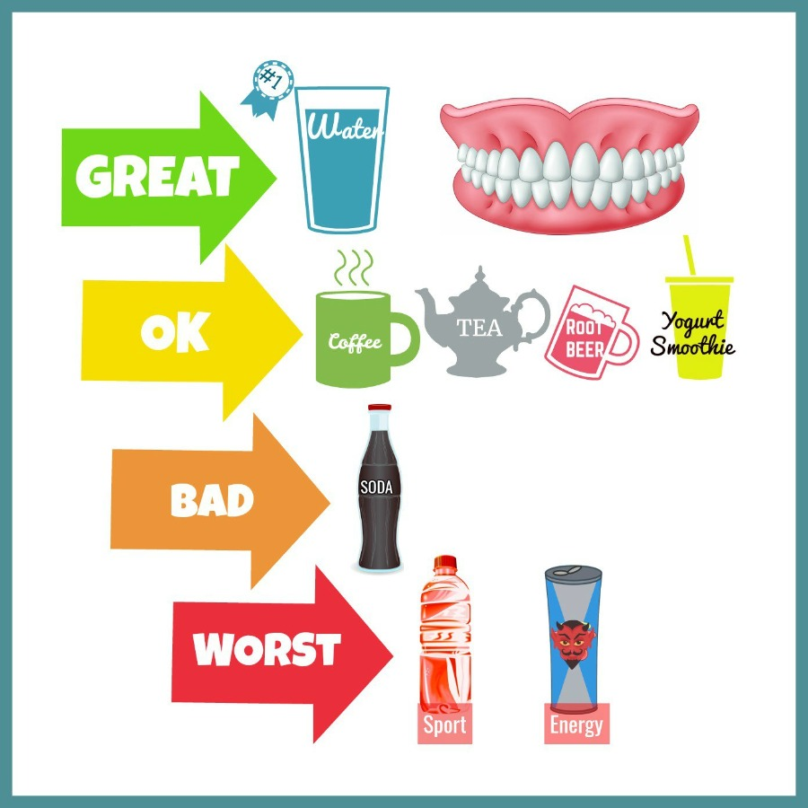
Pic.3 Coccarodental (2023)
Functions of the dentistry service in UK
Health promotion, prevention and treatment: dentistry helps stop teeth and gum problems before they start through: Oral hygiene advice and early detection of disease. 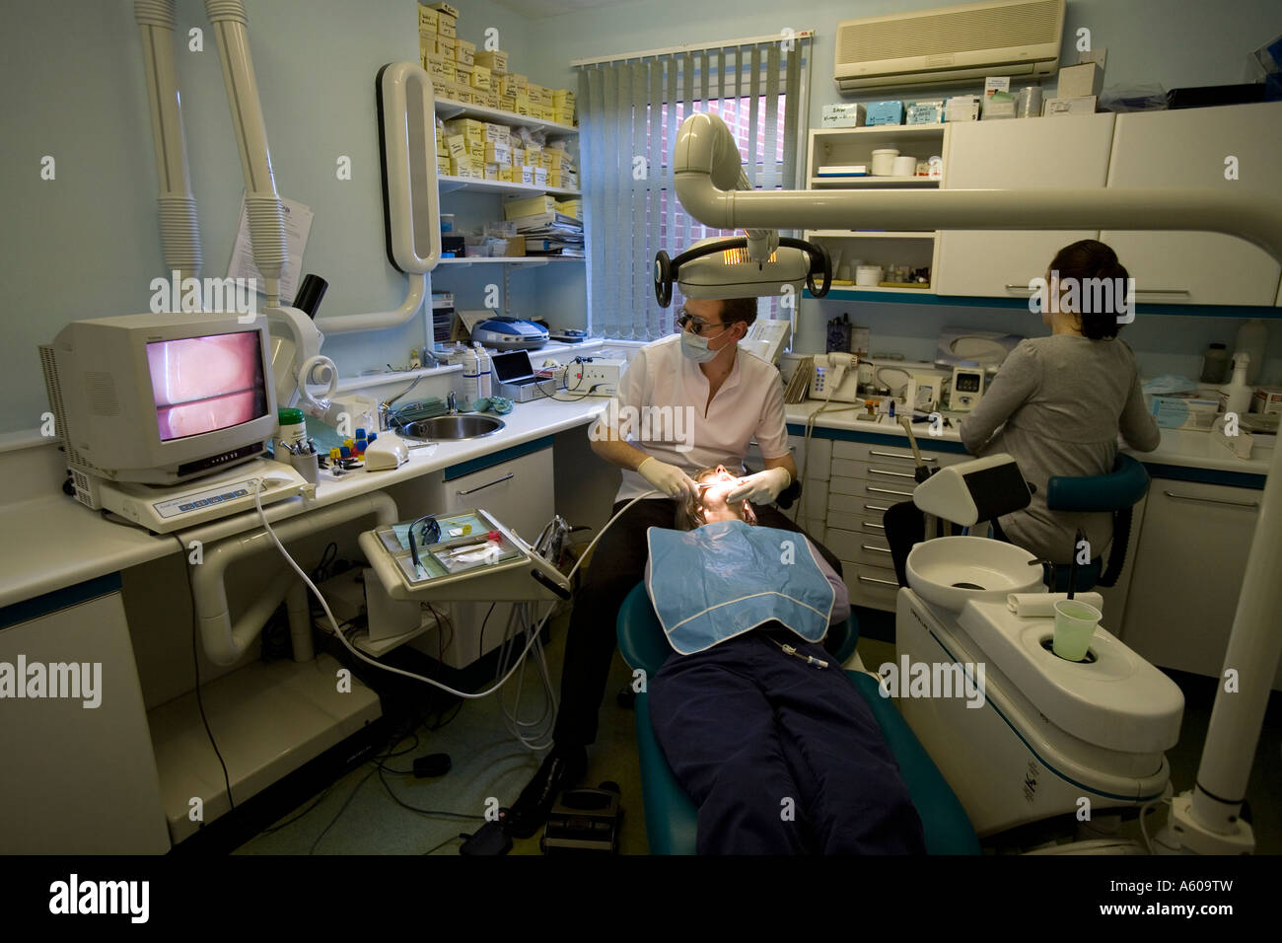
Pic.2 James (2007)
DENSTISTRY SERVICES History
Dentistry has evolved over thousands of years, moving from rudimentary tooth extraction to a highly specialised clinical science (Oral Health Foundation, 2020). People of all ages can experience tooth decay, once they have teeth from childhood to adult years and DO NOT TAKE CARE of their teeth and gum.

Pic.1 Dental Care (2026)

Dentistry services in the UK are provided through the National Health Service (NHS) and private dental clinics.
The main dental services include routine examinations, preventive care, emergency treatment, Restorative treatments include fillings, crowns, bridges, dentures, and root canal therapy to or replace damaged or missing teeth.

Research Poster Title Goes Here
Student Name, Course Name, Email Details Go Here

Element
Introduction Historical origins
Today, current British residential care home sector is an institutional cooperation between welfare state idea and market system delivery (Blakeley and Quilter-Pinner 2019). The historical path of residential care home characterised by developing from corrective control to specific care. The state was responsible for the management of the weak, needy elderly through the union workhouse under the “Poor Law Amendment Act 1834” which was governed by the principle of "less eligibility” (The Health Foundation no date).
These organisations were using consciously degrading circumstances to discourage dependence on public funds, therefore aged without independent means was regarded as an individual moral failure (The Health Foundation no date). With “Minority Report of the Royal Commission on the Poor Laws (1909)”, a serious ideological shift happened resulting to dissociating old age from poverty, which recognised that the elderly individuals needed state-supported, non-corrective residential environments. The “National Assistance Act 1948” before World War II stopped the Poor Laws and Section 21 became a statutory duty on local authorities to provide residential accommodation for the elderly and frail in need of care, thereby creating a local means to sterilised long-stay hospital wards (Munson 2025).
In UK currently, the elderly residential care sector operates based on mixed economy of care funding system. The residential care is means-tested where the state acts mainly as a commissioner instead of a direct provider. Generally, elderly residential care is divided into two form, self-funded and Local Authority funded. In the case of Self-Funder elderly residential care in England, has been funded by the individual(s) with their capital and savings above a threshold of £23,250, with an average weekly residential cost payment about £1,298 (Bach-Mortensen et al 2025). On the other hand, Local Authority Funded elderly residential care is done by Local council Authority who will intervene and negotiate on their behalf, when the individual(s) does not meet the threshold of £23,250 in terms of their savings and assets (Bach-Mortensen et al 2025). For example, nearly 84% of residential care beds are functioned by private (independent) for voluntary providers, profit corporations, and private equity firms and hence this system works under a severe economic and legal pressures (Blakeley and Quilter-Pinner 2019).

The significance in enhancing quality of life in residential care home have play a vital role in providing care and support for elderly adults who need support with their daily living activities. Therefore, the quality of life for residents in care homes is a key consideration and care homes must endeavour to generate a supportive and fostering environment.
Despite these structural contradictions, residential care homes remain a unique pillar of the health care ecosystem, driving significant quality-of-life enhancements for vulnerable older adults.
Research by National Institute on Aging (2019), Qualification of Social Isolation is elderly research which has founds that long lasting loneliness in older adult’s aid in fast tracking cognitive decline and exacerbates depression. High-quality residential care transforms isolation into communal living through structured social activities and peer companionship (National Institute on Aging 2019).
Department of Health (2015, pp 23), physical dignity and safety for individuals living with progressive dementia or complex multi-morbidities, residential care provides safe physical infrastructure for them. Therefore, Department of Health (2015, pp 23-26), highlighted that, round-the-clock professional monitoring, falls deterrence, and nutritional optimisation protect resident’s bodily safety at the same time protective their dignity.
OECD (2020 pp. 1144-147), indicated that, relief of informal caregivers by transferring complex clinical and physical demands to a trained social care workforce, the service eases severe caregiver burnout. This restores healthy family dynamics, transforming relatives from exhausted, untrained primary caregivers back into supportive partners, sons, or daughters (OECD 2020 pp. 144-147).

References
Britasiadoctors (2026), The state of UK Dental workforce in 2026, Challenges and opportunities (Jan. 16), available at https://www.borittasiadoctors.co.uk, access 9/07/2026
Coccarodental (2023), Healthy and Unhealthy Beverages for Your Teeth, What to Know, available at https://www.drcoccarodmd.com/health, access 27/07/2026
Dental Care (2026), Dentistry for all ages, available at https://www.dencity.in/dentistry, access 27/06/2026
James J (2007), A Dentist at work: a routine check-up on a female patient, https://www.alamy.com, access, 27/07/2026

References
Bach-Mortensen, A., et al (2025), England’s two-tier care system deepens social care inequalities, (Jul.15), (BJM clinical Research journal), (Vol 390), pp.3 available at https://researchonline.lse.ac.uk/id/eprint/128942/1/BMJ, access 4/7/2026
Blakeley G. and Quilter-Pinner H. (2019), The Financialisaton of Adult Social Care, Institute of Public Policy Research, available at https://ippr.org.files.svdcdn.com, access 4/7/2026
Department of Health (2015), Health Building Note 08-02 Dementia- Friendly, Health and Social Care Environments, available at Health Building Note 08-02: Dementia-friendly health and social care environments, access 10/07/2026
Munson S. (2025), History of home care in the UK, available at History of home care in the UK, access 5/07/2026
National Institute on Aging (2019), Social isolation, loneliness in older people pose health risks, Research (April 23), available at https:// www.nia.nih.gov/news/social-isolation, access 7/7/2026
OECD (2020), Health Policy Studies, who Cares? Attracting and Retaining Care Workers for the Elderly, available at https://www.google.co.uk/books, access 8/7/2026
The Health Foundation (no date), Workhouses and the Poor Law Amendment Act 1834, (Public Health Historical context), available at https://navigator.health.org.uk, access 3/07/2026

