

LEVEL 4 ASSESSMENT SPECIFICATION
Student name: | Iulica Codreanu | Student ID number: | 2511908
Programme: | Cert HE Business Skills for the Workplace
Module: | Employability and Career Development
Module code: | LCLM4005 | Contribution to Overall Module Assessment (%): | 50%
Module Leads: | Dr. Inderjit Grewal - London  Dr. Sujeewa Herath -Birmingham | Internal Verifier: | Dr. Lizeta Demetriou  Naomi Doerge  Dr. Chung Lai Johnny Wan  Fatima Hashmi
Assignment Title: | Portfolio of written tasks | Word count (or equivalent): | 1,500 words
Submission deadline: | Week 11  Monday 20th July 2026 10 am | Return date of provisional marks & written feedback: | 17th August 2026

Table of Contents
Introduction 3
Task A 4
Task B 5
Task C 7
Conclusion 9
References 10
Appendices 11
Appendix 1: Job advertisement 1 11
Appendix 2: Job advertisement 2 15

Introduction
For future professional development, having suitable skills and experience will be advantageous to attain the desired job role (Niati, Siregar, and Prayoga, 2021, p. 2385-2393). This portfolio will discuss with the employability and the career development plan for the attainment of the desired transport planner job role. In this aspect, two job advertisements for the desired job role, relevant skills, and a self-assessment PDP plan will be presented here. The self-assessment or the use of SWOT analysis is effective for self-evaluation and assess whether the existing skills in me are suitable for the desired job role or not. To boost the weak areas, a PDP plan will also be developed here that helps in developing the weak areas within a strict time frame.

Task A
Having chosen the role of Transport Planner for future employment, two job adverts have been selected. From the two job advertisements presented here (refer to the appendix), it has been found that there are some skills that are required to attain this desired job role. These skills include analytical, decision-making, problem-solving, communication, teamwork, time management, and technical skills. Moreover, from these two advertisements, it has also been found that analytical, teamwork, and technical skills are common in these two advertisements. Knowledge of the project, quality, output of the project, along with the budget and time-bound writing of the report, communication with the internal or external stakeholders, clients, employees, and others, are found in these two advertisements. Furthermore, the knowledge of the development of technical expertise in the project or project planning is the common knowledge found in these two advertisements.
From the discussion of the communication skills in the two advertisements, technical skills have been selected to assess their future competencies in the chosen area of future employment. For the attainment of a future role like a transport planner, having technical knowledge is extremely significant (Ceder, 2021, p. 455-479). This skill provides advantages in the implementation of proper technical principles for the development of transport system programs, along with this, it also helps in alignment with this planning and the appraisal techniques as well. In the transport sector, there are some areas that require proper planning and develop the presentation, attributes and drives the communication among the stakeholders. Having this skill will be advantageous to progress in professional life as well, and attain career growth opportunities. For the future, treseoeoert pomannainare role, sreehrtyataion of the vehicles, manage the project, assess number of oeyoele, their rdeieremnets, in all of these aspects, having the technical knowledge is highly advantageous. Apart from this, it provides the idea of the GIS or geographic information system, data analysis, programming, transparent modeling, aligning with the standards of engineering and design, and others.

Task B
Self-Assessment
SWOT analysis
Strengths | Weaknesses
- Handling of card and cash payments  - Knowledge of the road safety regulations  - Navigation and route planning  - Responsible and safe driving | - Time management  - Communication  - Financial management  - Problem-solving skill
Opportunities | Threats
- Grab the position of transport planner or manager in the transport department.  - Develop new routes and provide comfort to the customers  - Make the audience to abide by the road safety rules | - Competitive threats  - Face issues in the development of a suitable budget  - Problems to deal with the problematic situation
Table 1: SWOT analysis
(Source: Created by learner)
Analysis:
For the evaluation of self-assessment and understand the personal strengths and weak areas, a SWOT table has been presented here. This is also effective to determine which areas require further improvement for the future opportunities and attain the desired job role of transport planner. However, as I have experience in this field and perform the role of taxi driver, I have gathered some knowledge in this aspect. As I was a taxi driver and dealt with numerous people who had different payment systems, it led me to adopt this style as well. Due to this reason, I am comfortable with both card and cash payment, which is effective in communicating with both of the young and old generations (Seldal and Nyhus, 2022, p. 281-306). Serving almost five years in this field, I have developed my knowledge in the different routes, which will deliver me the strengths, to negotiate and plan for new routes and fulfil the requirements of the customers.
Furthermore, I have also developed my knowledge in the legal guidelines about the responsibilities and safe driving, which is beneficial for both of the drivers and passengers, for their safety concerns. Aligning with the requirements in the job advertisement, it can be stated that I am good at the GPS navigation system, which will help me for the navigation in the routes, plan transport activities, operate vehicles, and properly use it for future purposes. In the future, I am able to perform flexible work, which will be suitable for the etsapaoaraty departmental activities. Hiwvwre, there are some weak areas in me as well, which require some rectification for the development of future career growth and to attain the desired job role of transport planner. Communication, financial management, problem-solving, and time management are some of these skills that require further development for future purposes and attainment of a job role (Burns, 2020). These differences pose threats to me and will obstruct me from attaining the future job role. For such deficiencies, I can face competitive threats, issues in the development of proper budget planning, allocation of the financial resources at the suitable places, and others. Additionally, problem-solving skills are another essential skill in this aspect, which is deficient in me and poses challenges for future purposes.
Lack of problem-solving skill led to face challenges in the management of any critical situation, handling the customer behaviour, any navigation problems, route management, and some others. This will also hamper the decision-making potential as well and resolve any problematic or critical situations. In the future desired job role of transport planner, a critical or problematic situation can arise, whether relevant to the customer's specifications, route management, upgradation of navigation subsystem, or others. Deficiencies in this skill will lead to decode huge trouble for them in future purposes as well (Elder and Paul, 2020). In this discussion a PDP plan and short-term as well as long-term employment goals opportunities have been provided which refers the idea on how to develop the weak areas and strengthen the portfolio to attain transport planner job role in the future.
Evidence of Readiness
I was involved in the role of delivery driver at Amazon in Birmingham. After two years, I was as the Forklift driver at warehouse operative, Iforce. Finally, I was a taxi driver at Uber, this driving experience has led me to develop some significant skills in me and eagerness to attain the desired job role in the future as a transport planner.

Task C
Employment Goals
Short-term employment goals
I have to develop my communication and time management skills in the short-term employment goals aspect. These goals are specific to me for the development of my career path and strengthen my abilities to reach to audiences and fulfil the activities within the time frame. Communication skills are effective for working in a team or communicate with people, manage the staff to work as required, and others. Whereas the time management skill will provide the competitive advantages, and will help me to fulfil the work on time, maintain the quality, navigate the routes, develop new commuter facilities, accomplish related projects, and others.
Long-term employment goals
For the long term ascapacat, I have set the target of development of problem-solving and financial skills, such as I can perform a project associate role in the transport department on a contract basis (Plotch, 2025). The development of financial knowledge will enable me to boost my skills, prepare a proper budget, allocate resources to the project activities, navigate and apply any technical instrument or others. Furthermore, I have to improve my problem-solving skills as well, to solve any technical issues, make stable decisions, and others. In the future perspectives, team activities, problems can come, whether in the degravitation, safety guidelines, working procedure, route management, or others. The adoption of this skill will be perfect for the attainment of the future job role of transport planner.
Personal Development Plan
Actions | Timelines | Resources | Measurable
To develop my communication skills, I have to involve myself in social and professional activities and listen to YouTube videos. | Within 3 months | Mobile, tablet, | The number of people to communicate with and the frequency of communication can be used as KPIs to measure this skill.
To improve time management skills, I have to attend seminars or group activities. | Within 5 months | Pen, pencil, notebook | Frequency of completion of tasks within the time, and quality of the activities can be the KPIs to measure the development (van Sluijs and Matzat, 2024, p. 525-537).
To boost my problem-solving skills, I have to be involved in project works, group activities, and others. | Within 7 months | Pen, pencil, notebook, mobile | KPIS such as time taken to solve the problem, quality of the solutions, and decision-making taking potential can be used here.
To enhance financial knowledge, I have to be involved in training programmes, certificate courses, and similar courses. | Within 11 months | Pen, pencil, notebook, mobile | Accommodation of the financial resources, development of a budget, can be used as KOPIs to measure the development of this skill.
Table 2: Personal Development Plan
(Source: Created by learner)

Conclusion
This portfolio has been discussed with the required skills and existing experience in me, which will help me attain the desired job role of transport planner in the future. From the discussion, it has been found that having the experience as a taxi driver will help to attain this job role wehw3weras there are some difficulties as well, which require further improvement. These skills are such as communication, financial skills, problem-solving, and time management, and for the development of these, a PDP plan has also been presented here, involving their significance and actionable strategies.

References
Burns, R. (2020) Adult Learner at Work: The challenges of lifelong education in the new millenium. Routledge.
Ceder, A., (2021) ‘Urban mobility and public transport: future perspectives and review’, International Journal of Urban Sciences, 25(4), pp.455-479.
Elder, L. and Paul, R. (2020) Critical thinking: Learn the tools the best thinkers use. Bloomsbury Publishing USA.
Indeed (2026a) Senior/ Principal Transport Planner. Available at: https://uk.indeed.com/viewjob?jk=897a59289afd9350 (Accessed: 18 July 2026).
Indeed (2026b) Transport Planner. Available at: https://uk.indeed.com/viewjob?jk=1bf1bf3ad16c52e7 (Accessed: 18 July 2026).
Niati, D.R., Siregar, Z.M.E. and Prayoga, Y. (2021) ‘The effect of training on work performance and career development: the role of motivation as intervening variable’, Budapest International Research and Critics Institute (BIRCI-Journal): Humanities and Social Sciences, 4(2), pp.2385-2393. Available at: https://doi.org/10.33258/birci.v4i2.1940
Plotch, P. (2025) The People Behind Major Transit Projects [online] Available at: https://enotrans.org/wp-content/uploads/2025/04/The-People-Behind-Major-Transit-Projects.pdf (Accessed: 18 July 2026).
Seldal, M.N. and Nyhus, E.K., (2022) ‘Financial vulnerability, financial literacy, and the use of digital payment technologies’, Journal of Consumer Policy, 45(2), pp.281-306.
van Sluijs, M. and Matzat, U. (2024) ‘Predicting time‐management skills from learning analytics’, Journal of Computer Assisted Learning, 40(2), pp.525-537. Available at: https://doi.org/10.1111/jcal.12893

Appendices

Appendix 1: Job advertisement 1
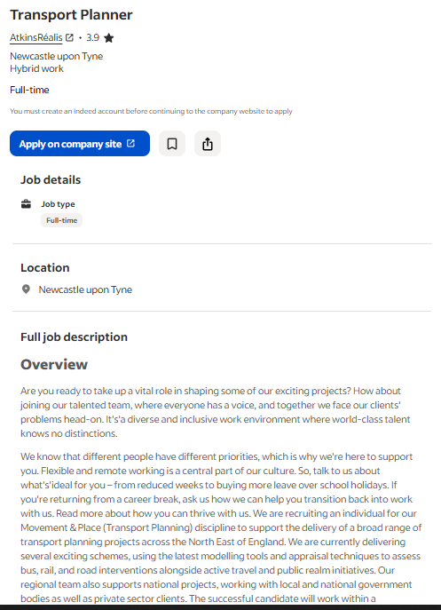
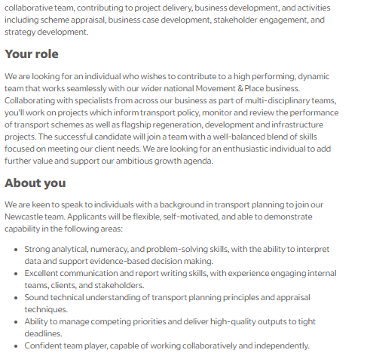
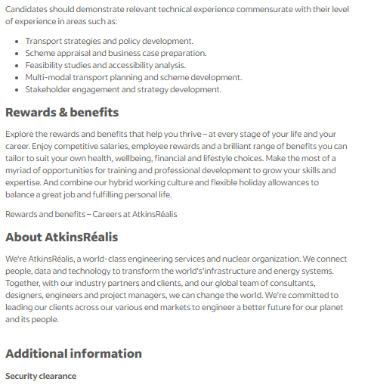
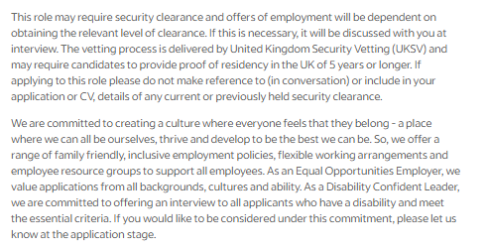
Table 3: Job advertisement 1
(Source: Indeed, 2026a)

Appendix 2: Job advertisement 2
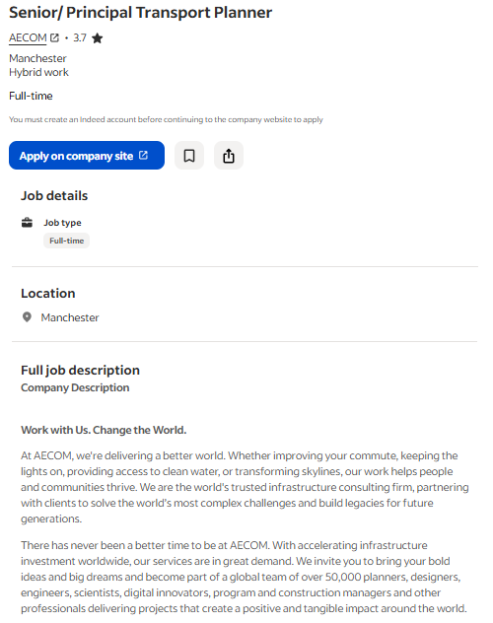
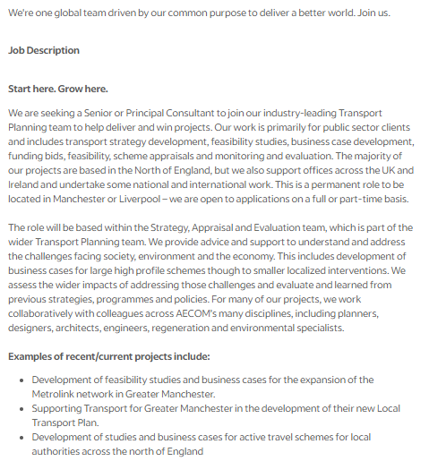
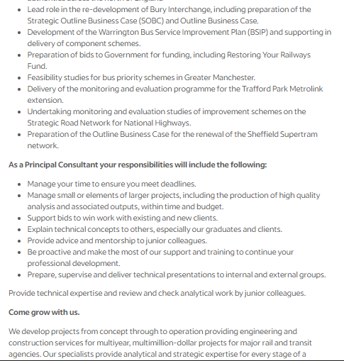
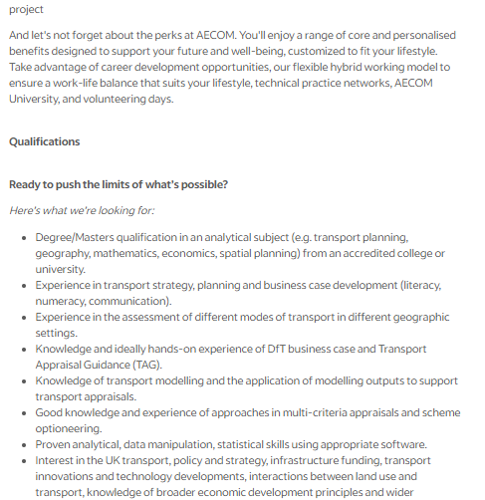
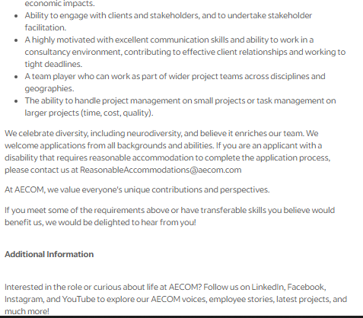
Table 4: Job advertisement 2
(Source: Indeed, 2026b)

