
STAKEHOLDER
MANAGEMENT PLAN
Birmingham Eastside Metro Extension
A real UK local transport infrastructure project

Assessment details | Information
Programme | BA (Hons) Business Management
Module | Stakeholder Engagement
Module code | LCBB4013
Assessment | Component 1: Coursework Portfolio
Role | Junior Stakeholder Manager
Student name | Alexandru Alin Odobescu
Student ID | 2332549
Submission date | 26 July 2026, before 2pm

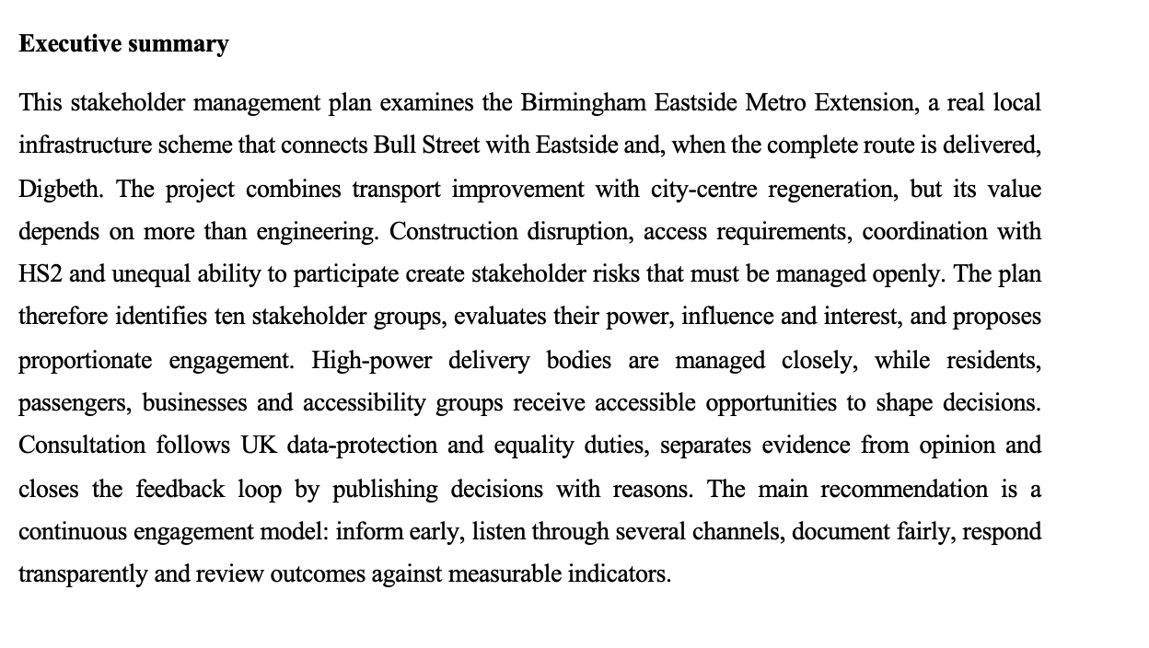

Table of Contents
Executive summary 2
Element 1 Introduction 2
1.1 Selected project and relevance 2
1.2 Key stakeholders and expected benefits 3
Element 2 Stakeholder engagement strategies 4
2.1 Analytical approach 4
2.2 Stakeholder map and justification 6
2.3 Communication plan 7
2.4 Consultation strategy and escalation 10
Element 3 Ethical consultation, participation and feedback 11
3.1 Consultation methods and ethical data collection 11
3.2 Bias and diversity, equity and inclusion (DEI) 11
3.3 Feedback collection, review and accountability 12
Element 4 Conclusion and reflection 13
4.1 Conclusion 13
4.2 Reflective account 13
References 15
Appendix A Engagement monitoring dashboard 16

Element 1 Introduction

1.1 Selected project and relevance
Stakeholder management is when considering this part the systematic identification, analysis and planning of how therefore when demanding this stakeholders are given some involvement in decisions to be made. Freeman (1984) suggests as per this considerations that organisations can produce stronger results by also accounting for interests of several stakeholders rather than only focusing on the formal owner. Public infrastructure is an obvious space for this idea while checking involves public money, shared streets and community wellbeing. But this engagement advice therefore needed is neither practical nor fair as not every stakeholder needs to be treated the same: some have statutory power, others bear the delivery risk and others it is important to be stated feel the greatest impact on a day-to-day basis. Hence, any useful design must balance inclusion and prioritisation.
Birmingham Eastside Metro Extension Transport for West Midlands and Midland Metro Alliance Running on the twin-track route between Bull Street and High Street Deritend, this stretch will serve four permanent stops in the east of Birmingham city centre. More than half of the line runs un-Wired and above ground, which reduces visual intrusion on major streets within the city. Opening of the first section to Millennium Point on 5 April 2026, with extension to Digbeth and connection to HS2 Curzon Street. The whole Digbeth connection in this portfolio is from the viewpoint of local infrastructure and not limited to just phase 1.
The initiative is important because can be assure it links transport, jobs, education, culture and regeneration. Access to destinations made easier by when offering driverless stops in the vicinity of Moor Street, Millennium Point, Curzon Street and Digbeth. This will help West Midlands deliver an ambitious integrated public-transport network and potentially drive local business footfall. Moreover, track allocations also may obstruct sidewalks, relocate when suggesting bus stops, generate sound and diminish passing exchange. While many of its benefits are one-time future costs, some costs are front-loaded and inequitable. Proper engagement is what keeps the project team from assuming that a therefore to understand gain to the city at large is worth any localized burden.

1.2 Key stakeholders and expected benefits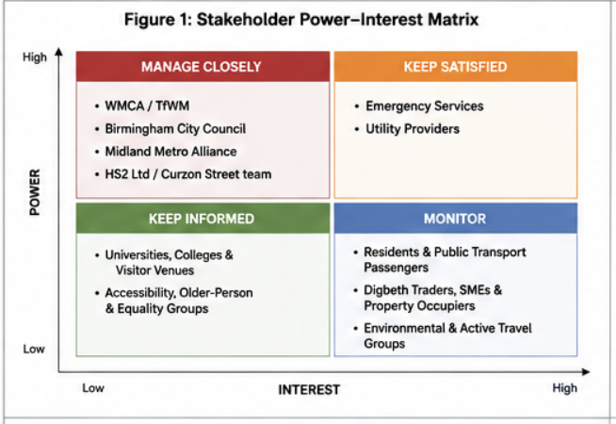
Stakeholder | Connection to project | How the stakeholder may benefit
WMCA / Transport for West Midlands (TfWM) | Sponsor, transport authority and strategic decision-maker | Network integration, public value and modal shift.
Birmingham City Council | Highway, planning and local democratic authority | Regeneration, improved public realm and access to jobs.
Midland Metro Alliance and contractors | Design and construction delivery partners | Safe delivery, organisational reputation and future capability.
HS2 Ltd / Curzon Street delivery team | Major interfacing infrastructure body | Coordinated station access and reduced design conflict.
Residents and public-transport passengers | People living in or travelling through Eastside and Digbeth | Reliable access, wider travel choices and potentially cleaner streets.
Digbeth traders, SMEs and property occupiers | Businesses affected by works and future footfall | Better customer access and regeneration, balanced against disruption.
Universities, colleges and visitor venues | Birmingham City University, Millennium Point, Thinktank and nearby organisations | Safer and easier journeys for students, staff and visitors.
Accessibility, older-person and equality groups | Represent people who may face mobility, sensory, language or digital barriers (Tyler, 2006) | Step-free, legible and inclusive streets, stops and information.
Emergency services and utility providers | Maintain safety, access and essential networks | Coordinated works and protected response/service continuity.
Environmental and active-travel groups | Advocate lower emissions and sustainable movement | Modal shift and better public realm, with scrutiny of construction impacts (Midland Metro Alliance, 2026).

These benefits are feasible but not guaranteed it is ideal. A tram extension may enable lower-car travel if it's affordable, reliable, and handy. Regeneration may boost as per this part footfall, but development may hurt small businesses first (AccountAbility, 2015). If therefore to understand and consider temporary footways, signage, or alternate routes exclude disabled persons, accessible it is relevant vehicles do not provide an inclusive journey (Midland Metro Alliance, 2025). Instead of using the can be consider project business case, the management plan must evaluate benefits with affected parties and track undesired repercussions.

Element 2 Stakeholder engagement strategies
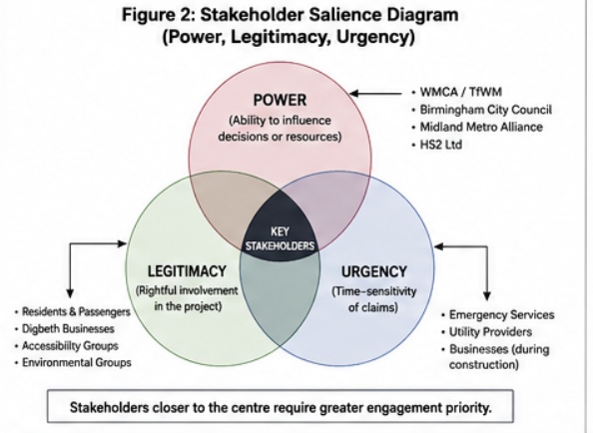

2.1 Analytical approach
Power, legitimacy, and urgency therefore to understand determine stakeholder salience, and a power–interest grid helps managers choose engagement intensity. Power means official can be assure control over money, approval, land, or access; influence represents the ability to modify opinion, design, or delivery; and interest means exposure to outcomes in this plan. Stakeholder responsibilities must be address , not survey results, inform professional planning ratings. This distinction is therefore being relevant crucial since numerical scores might mislead (Transport for West Midlands, 2024). Because media and governmental all of them related support can quickly elevate a low-power business group, ratings should be assessed as per this part at each project stage.
Stakeholder | Power | Influence | Interest | Justification | Response
WMCA / TfWM | High | High | High | Funds/sponsors the scheme and controls transport integration. | Manage closely
Birmingham City Council | High | High | High | Statutory, highway and democratic responsibilities. | Manage closely
Midland Metro Alliance | High | High | High | Controls design, programme, contractors and site information. | Manage closely
HS2 Ltd | High | High | Medium | Physical and programme interface at Curzon Street. | Manage closely
Residents and passengers | Medium | Medium | High | Many users; experience service and construction impacts. | Keep informed / involve
Digbeth businesses | Medium | High | High | Disruption and access affect income; collective voice is influential. | Involve closely
Universities and venues | Medium | Medium | High | Large trip generators and trusted local institutions. | Keep informed / consult
Accessibility/equality groups | Medium | Medium | High | Specialist evidence and Equality Act relevance. | Involve and co-design
Emergency services/utilities | High | High | Medium | Safety, response access and utility continuity. | Keep satisfied / coordinate
Environmental/active travel groups | Low | Medium | Medium | Expert scrutiny and public advocacy. | Consult / monitor

2.2 Stakeholder map and justification
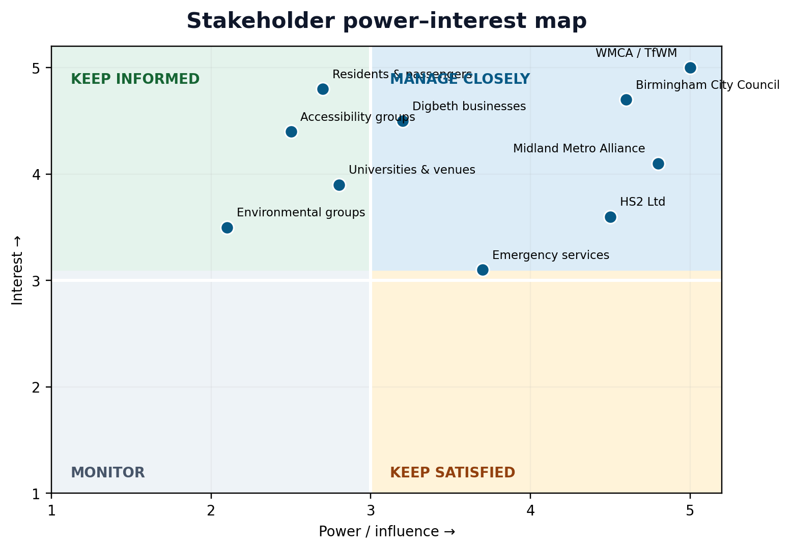
Figure 1. This management plan's power–interest map. Indicative positions should be examined quarterly.
WMCA/TfWM, Birmingham City Council, the Midland Metro Alliance, and HS2 Ltd. can authorise, fund, redesign, enable, or delay it si relevant important projects in the manage-closely quadrant. Through an integrated governance board, interface schedule, risk register, and named owners, they must participate frequently and make decisions (West Midlands Combined Authority, 2021). Close management resolves dependencies fast. Its weakness is that therefore dominant organisations can set the agenda and see community interaction as post-decision communication (International Association for Public Participation, 2018). Board documents as per this part should include a community-impact section and display unsolved issues alongside cost and program hazards to limit this risk (Freeman, 1984).
Because they care but have little authority, residents, passengers, accessibility groups, universities, and venues are mostly in the when checking keep-informed or involve area. Reed (2008) says involvement is better when stakeholders can affect decisions therefore neededrather than just receive information.
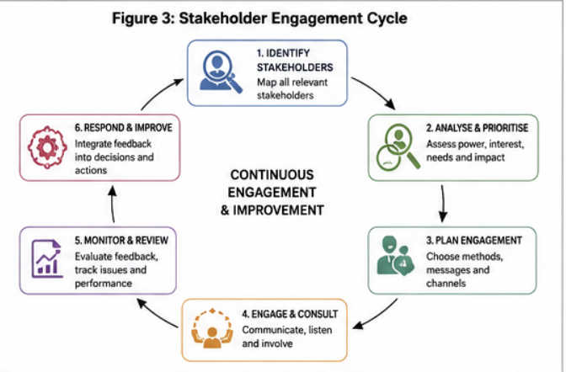
Individual Digbeth businesses have minimal statutory power, but collectively they can influence councillors, media coverage, can be assure and public acceptability.
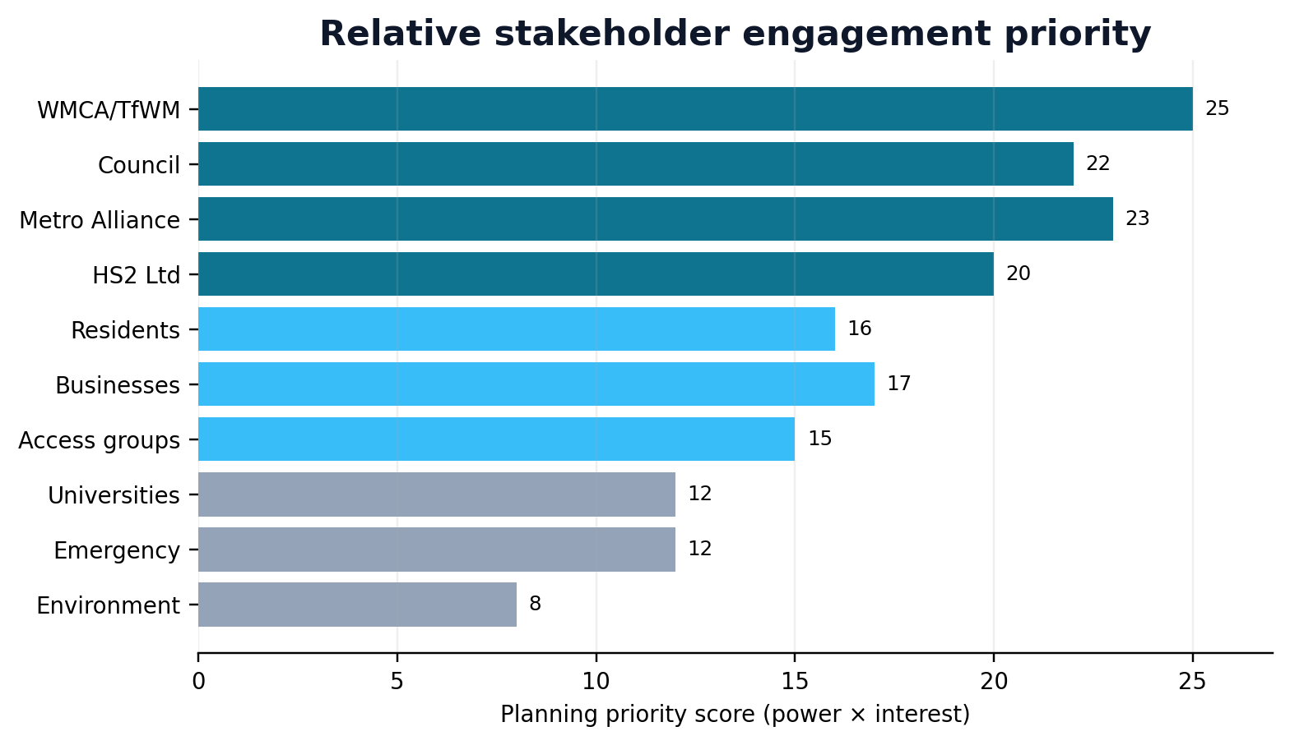
Stakeholder opinion is not measured in this planning tool (Reed, 2008).

2.3 Communication plan

Audience | Information shared | Timing | Medium | Owner | Measure
WMCA/TfWM, Council, Metro Alliance, HS2 | Programme, safety, cost, interface decisions, risks and community impacts | Fortnightly; urgent issues within 24 hours | Governance meeting, dashboard and secure email | Project director / stakeholder manager | Decision log; actions closed on time
Residents and passengers | Work dates, road/stop changes, noise, access, service benefits and how to comment (Birmingham City Council, 2023) | Monthly; minimum 14 days before planned disruption | Letters, email/SMS alerts, website, stop notices, local newspaper and drop-ins | Community liaison lead | Reach, enquiries answered, sentiment and complaints trend
Digbeth businesses | Access/loading plans, phasing, mitigation, contacts and future opportunities | Fortnightly during nearby works; weekly look-ahead | Named liaison visits, telephone, email bulletin and business forum | Business liaison officer | Businesses contacted; access issues resolved; repeat complaints
Accessibility/equality groups | Temporary routes, platform design, wayfinding, audio/visual information | Before design freeze; monthly during relevant works | Accessible workshop, site walk, large print, Easy Read and phone option (Mitchell, 1997) | Inclusive design lead | Issues accepted/rejected with reasons; accessibility audit
Universities and venues | Term/event dates, crowd movement, works and travel information | Monthly and before major events | Coordination call, email pack, web/social content | Stakeholder manager | Joint plans completed; disruption incidents
Emergency services/utilities | Closures, diversions, buried services and emergency access | Weekly technical meeting; immediate escalation | Technical workshop, drawings, secure phone/email | Construction manager | Permits, clashes and response-access incidents
Environment/active travel groups | Noise, air quality, materials, trees, cycling/walking continuity | At milestones and quarterly | Evidence briefing, workshop and published monitoring summary | Environmental manager | Mitigation actions and unresolved concerns

Timing is 'early enough to influence'. Correct but not meaningful consultation (Bryson 2004) a post-traffic management notice Planned interruption communication should start at least 14 days before the planned disruption and repeated with an interval of 48 hours (UK Government, 2023). Some updates are critical for the safety and may need a shorter lead time so ensure you record the reasons behind those too. Where possible, the use of plain English, mapping and a single point of contact route is recommended, in addition to translation services or requests for alternative formats (West Midlands Combined Authority, 2021) Digital-only engagement can exclude older, poorer and less able stakeholders so mail, telephone and in-person communication is still essential. Social media is fast.
2.4 Consultation strategy and escalation
Three consultation levels will exist. Facts such as working hours and limits of safety (West Midlands Combined Authority, 2021) form the basis of information activity. Second, where opportunities still exist, consultation gathers preference choices for the timing of loading limitations and temporary crossing locations.
A six-week consultation period with one daytime and one night-time drop-in, an online form that is also accessible, telephone answers, dedicated visits to businesses and small meetings with disability and community organizations would mean choices in material design or operational. Every question should outline the choice, options, must-have safety or legal bounds and what evidence needs to be verified (Cabinet Office 2018). Responses will be coded by stakeholder type, location and theme (Mendelow, 1991) and finally safety, equity, cost, program environment & deliverability. The paper will not tell you what element wins over others it talks on trade off, mentions the change.
There is a need for a clear escalation path. Respond to normal queries within a two-day working period, and respond with solutions in five days. Safety issues or blocked routes need to be reported as soon as possible to site managers (UK Government, 2023). If business access fails repeatedly, there are significant equality impacts, or it is a conflict between the Metro and HS2 programs, it runs through the project governance board which should have an ultimatum and an owner (Bryson, 2004). When the loop is closed: every month a "you said, we did, you saw" report This way, stakeholders can see positive changes and reasonable limits, which build confidence in the method. However, keeping personal data and business sensitive information might still be important.

Element 3- Ethical consultation and participation and feedback system

3.1 How to consult and collect data in an ethical manner
Without respect for liberty, the first step in any ethical consultation is missing. Survey-takers need to know who is asking, why they are doing it, how long the data will be kept and whether notes may be used. Consent should not involve reading a lengthy privacy notice just to discover what you have agreed to (Reed, 2008). The UK's General Data Protection Regulation and Data Protection Act 2018 require that the data is collected legally, not overly retained, kept secure, and the rights of subjects to be compromised. This means that the project should only receive email address when someone actually requested information and nothing else until necessary, legally justified and is safe.
Full Description of the Proposed Method: An anonymous questionnaire, recorded workshops, stakeholder interviews, accessible site walks and an enquiry/complaint log. distinct channels serve distinct purposes. Surveys show patterns that many respondents indicate, whereas interviews and walks tell you why a route or notice is troublesome. Surveys and interviews can oversimplify a complex experience and may be biased based on the facilitator (West Midlands Combined Authority, 2021). Therefore, triangulate evidence, avoid leading questions and be clear what is fact and what interpretation. All workshop recording should be in writing unless participants agree to being audio recorded (West Midlands Combined Authority, 2021) Edge Play

3.2 Bias and DEI
There is a potential for bias in the people invited, the questions asked and interpretations. Because you consult only your well meaning volunteers there is self-selection bias. Due to confirmation bias (Mendelow, 1991), staff prefer comments confirming the selected design. The availability bias can potentially create the illusion in which a recent complaint appears more representative than is warranted (Mendelow, 1991). To reduce these problems, Recruitment should combine publicity with targeted invitations, avoid leading language in questions, have two team members independently check coding and keep underrepresented views rather than averaging away unfavorable or minority ones. A short methodology note should include counts of response options, and a caveat against remedying consultation in the guise of a scientific vote (UK Government, 2023).
DEI is more than just channel-wide invites Public sector equality is mandated by the Equality Act 2010, which also provides anti-discrimination legislation. Equity is about making reasonable adjustments to allow people to participate (West Midlands Combined Authority, 2021). Reported measures include: step-free venues close to public transport, wheelchair-accessibility site tours, access to British Sign Language or speech-to-text support (or similar), provision of large print and Easy Read material, translated summaries, and responses by telephone and on paper; evening sessions for workers; reasonable expenses paid to invited community representatives. These protections require time and money, but exclusion results in design failure, legal risk, and a lack of trust. Access needs should be confidential and noted down securely in the engagement register rather than used as a camp label for participants.

3.3 Feedback collection, review and accountability
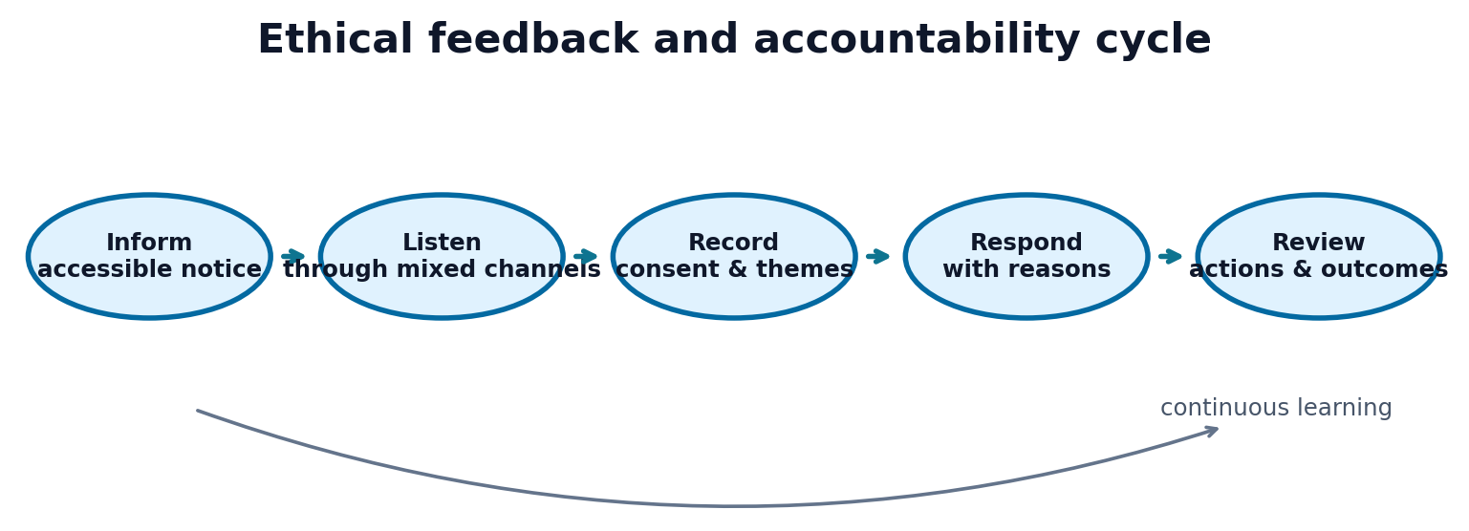
Figure 3. Ethical feedback cycle: only project responses and reviews make consultation credible.
The engagement register, in a regulated format, will record feedback by reference number, date on which it was received, channel of communication (correspondence or call), stakeholder category (as mentioned above), location of the carrier/fiat custodian company from where the user communicates with you about what they need to be done theme (correspondent code for what purpose channels are utilized such as whatsapp or email; urgency level (how urgent is too your customer) and minimum deliverable outcome. Analytical data will be role-based and personal identifiers removed (Birmingham City Council, 2023). Writers of- Weekly operational reviews and monthly topic reports (International Association for Public Participation, 2018). The topics will be noise, business continuity, safety, accessibility, environment and design-service-quality-communication. Quantitative counts show frequency, while anonymised examples maintain context (Midland Metro Alliance, 2026) A high number is not always the deciding factor because an issue on safety or equality, which is low in frequency might be more serious.
Independent review should challenge the delivery staff. The evaluators of the first evaluation are led by the stakeholder manager but construction lead for safety, inclusive-design lead for accessibility and governance board for disputed high-impact decisions. Quarterly audits of closed cases should evaluate response speed, evidence quality and stated action (Cabinet Office 2018). The performance metrics will be on consultation reach by channel, all of them realted representation gaps, recognition within two days or five days for complaints addressed, repetition of complaints, accessibility steps completed and satisfaction with all actions after closure as a stakeholder (Freeman 1984). Targets foster discipline but should not be the substitute for considered responses and a number response-time (Birmingham City Council, 2023).
Participants must receive comments lastly. The public summary shall include Issue, evidence, judgement, action owner and due date (Mitchell, 1997). If a recommendation therefore to review is rejected, it should be because of safety, statute, price, program or competing needs and not ‘not possible. These will be removed: personal, security and commercial data. This being said, it balances the act of being open and secretive and demonstrates procedural fairness can be assure every bit as important to trust as the end result (Reed, 2008).

Element 4 Ending with a Reflective Conclusion

4.1 Conclusion
Birmingham Eastside Metro Extension shows stakeholder engagement is part of delivery not PR It aims to link Eastside and Digbeth into Birmingham's transit system, educational and cultural offer and help regeneration. These gains endure, despite instant disruption, complicated HS2 co-working preparations and capacity of next stakeholders. Technically it may work but if businesses are closed overnight, disabled passengers are routed on dangerous detours or the community cannot see how its evidence affected choices it might not be seen as a success.
In the case of WMCA/TfWM, Birmingham City Council, the Midland Metro Alliance and HS2 Ltd it suggests tight management because they control key resources and interfaces while acknowledging that residents, companies and accessibility groups are rich in relevant expertise themselves and may influence critical issues. The user is designed to do more than send one message, this communication plan sends messages matched with stakeholders channel and frequency. Governance meetings expedite institutional decision-making; whereas letters, visits, phone calls, accessible workshops and public updates stimulate engagement. The matrix must be reviewed quarterly and escalated on an issue basis, as positions can change.

4.2 Reflective account
As a Junior StakeholderManager, I had to reshape my understanding of what project success looks like. The Metro extension first appeared to me as an engineering and transport project .I figured that stronger linkages would be beneficial to the public and a lot of the heavy lifting in terms of engagement would reside with building schedules. Having applied stakeholder theory now I realize one project can put forth several experiences.
Power and interest distinction is enabled by stakeholder maps. What I learned is that official power is not always interest-based. The residents and small businesses may be most afflicted, yet they have no power to approve budgets or designs. The project team has to leave some moral room for their data. That being said, I learned to never trust the grid. A
I lost my faith in consultation too. Although it is quick and enables people who filled the survey in their comfort of homes, it can sometimes exclude people without computers (another data divide), time or governments they trust. I mixed methods and then talked about how bad they were. I therefore to review am interested if each activity can alter a decision.
The section on ethical aspects emphasised the point that more data does not imply better. Though the project can respond due to being able to track contact details, enter disability information and record written feedback, this brings privacy concerns.
The key lesson that I learned is actions create faith when suggesting . Pretty consultation materials appeal to people, but stakeholders want to know if messages are seen before they are Massacred, whether staff actually answer difficult questions and whether therefore needed things that begin well are delivered on.
Good stakeholder engagement improves the prospect of a safe, useful, socially-acceptable and sustainable Metro expansion. It will not prevent arguments or building impacts, and far too much consultation could postpone while suggesting decisions in case the roles of people are vague.

References
AccountAbility (2015) AA1000 Stakeholder Engagement Standard. London: AccountAbility.
Birmingham City Council (2023) Our Future City Plan: Central Birmingham 2040 Framework. Birmingham: Birmingham City Council.
Bryson, J.M. (2004) ‘What to do when stakeholders matter’, Public Management Review, 6(1), pp. 21–53.
Cabinet Office (2018) Consultation Principles: Guidance. London: HM Government.
Data Protection Act 2018, c. 12. London: The Stationery Office.
Equality Act 2010, c. 15. London: The Stationery Office.
Freeman, R.E. (1984) Strategic Management: A Stakeholder Approach. Boston: Pitman.
Information Commissioner’s Office (2024) A guide to the UK GDPR. Available at: https://ico.org.uk/for-organisations/uk-gdpr-guidance-and-resources/ (Accessed: 20 July 2026).
International Association for Public Participation (2018) IAP2 Spectrum of Public Participation. Denver: IAP2.
Midland Metro Alliance (2026) Birmingham Eastside Metro Extension. Available at: https://metroalliance.co.uk/projects/birmingham-eastside-extension/ (Accessed: 20 July 2026).
Midland Metro Alliance (2025) Birmingham Eastside Metro Extension: Project Factsheet. Birmingham: Midland Metro Alliance.
Mendelow, A.L. (1991) ‘Environmental scanning: the impact of the stakeholder concept’, Proceedings of the Second International Conference on Information Systems, Cambridge, MA.
Mitchell, R.K., Agle, B.R. and Wood, D.J. (1997) ‘Toward a theory of stakeholder identification and salience’, Academy of Management Review, 22(4), pp. 853–886.
Reed, M.S. (2008) ‘Stakeholder participation for environmental management: a literature review’, Biological Conservation, 141(10), pp. 2417–2431.
Transport for West Midlands (2024) First phase of Metro trackwork completed on Moor Street Queensway. Available at: https://www.wmca.org.uk/news/first-phase-of-metro-trackwork-completed-on-moor-street-queensway/ (Accessed: 20 July 2026).
Tyler, T.R. (2006) Why People Obey the Law. 2nd edn. Princeton: Princeton University Press.
UK Government (2023) The Green Book: Central Government Guidance on Appraisal and Evaluation. London: HM Treasury.
West Midlands Combined Authority (2021) West Midlands Local Transport Plan: Reimagining Transport in the West Midlands. Birmingham: WMCA.

Appendix A Engagement monitoring dashboard
Indicator | Initial target | Review frequency | Reason
Planned disruption notices issued on time | ≥ 95% at least 14 days before works | Monthly | Tests whether communication is early enough to help.
Routine enquiries acknowledged | ≥ 90% within 2 working days | Weekly | Shows responsiveness.
Routine enquiries answered | ≥ 85% within 5 working days | Weekly | Balances speed with answer quality.
Urgent accessibility or safety issues | 100% same-day escalation | Weekly | Protects users and reduces harm.
Representation check | No major stakeholder group absent without follow-up | Per consultation | Reduces participation bias.
Published decision feedback | 100% of material consultations | At decision | Closes the feedback loop.
Repeat complaints | Downward trend by work package | Monthly | Indicates whether root causes are resolved.



