Developing Relationships and Workplace Achievement
Teacher: Ze Zook
Student Name: Faisal Abdi Yussuf 1712895.

Table of Contents
Introduction 2
Company Overview 4
Potential benefits to Hugo Boss UK and the individual of personally developing individuals in the workplace 5
Critically evaluating development vehicles available to your organisation 11
Developing a plan to meet the identified development needs and expectations of an Individual 19
Conclusion 24
References 25

Table of Figures
Figure 1: Company Logo of Hugo Boss 4
Figure 2: Stages in Maslow’s Hierarchy Model 8
Figure 3: Factors in Herzberg’s two factor model 9
Figure 4: Five stages in Management By Objective Model 12
Figure 5: Steps in McKinsey Feedback Model 13
Figure 6: Mechanism of providing feedbacks 15
Figure 7: Different types of learning styles in VARK model 16
Figure 8: Five stages in training need analysis 17

List of Tables
Table 1: Personal SWOT Analysis 19
Table 2: Listing of SMART Objectives 20
Table 3: Explanation of personal development plan in weak areas 21

Introduction
Individuals are the assets of any company the skills and competency level individuals will determine the competitive advantage over the competitorsconcerning the ability and capacity of human resources within the workplace(Smith, 2017). Developing relationships with the co-workers and team members bring the team and individual productivity and further improves the communication skills of individuals. The top priority of organisational should be taking the steps that would improve the job knowledge, expertise level, and other skills required for completion of the jobs. Training and development programs are conducted for this purpose. However, this report deals with the discussion and evaluation of developing relationships among individuals and workplace achievement. Hugo Boss UK ltd is selected in this purpose. The first part of this report includes the discussion of potential benefits to the company and individuals of personally developing individuals with the workplace. The next part discusses the assessment of development vehicles available to Hugo Boss Ltd to develop the individuals within the workplace. The final part of this report includes the personal SWOT analysis, SMART objectives, and personal developing planning for individual development.

Company Overview
Hugo Boss UK ltd is the retailer and wholesaler of fashion clothing of high-quality manufacturing tailored suits for both men and women(HUGO BOSS, 2020). The other manufacturing products of Hugo Boss involve casual wear, dress, kids wear, bags, and perfumes.

Figure 1: Company Logo of Hugo Boss(HUGO BOSS , 2020)
The company is in the retail (discretionary) industry of UK and within the consumer sector. Huge Boss not only operates in UK rather all over the world. It was founded in 1997 and since then it seems to be a successful company offering the best services to the customers.

Potential benefits to Hugo Boss UK and the individual of personally developing individuals in the workplace
The workplace is the collection of individuals who contribute to the company directly and indirectly for the achievement of organisational goals and objectives(Harrison, 2016). The more individuals are developed and skilled in the workplace, it can be said the employees would offer even their best versions for the betterment of the company. However, the following are the benefits of personally developing individuals in the workplace to the Hugo Boss UK.
Higher employee’s productivity:Higher employees ‘productivity depends on how competent and skilful the employees are in the workplace. Developed, skilful, and disciple employees tend to offer more within shortest possible time along with the lower input(Peterson and Peterson, 2017). In operation of Hugo Boss UK, employees show more commitment and enthusiasm to work hard when the company looks after their personal development to the career pathways. New technologies may be introduced in the workplace, but the employees are not developed or trained to get attached with the technological procedures, then technology won’t offer its best services. Consequently, Hugo Boss UK would face a loss in capital investment. Hence, to get the best out ofcapital investment, individual development is a must.
Error reduction:Error reduction is possible when the doer knows how to do the tasks perfectly with higher job knowledge and personal development. Six sigma-models in operation management focus more on error reduction that would minimise the total operational costs for the company(Hargreaves, 2012). Six sigma-models reinforce on the personal development of individuals of Hugo Boss UK to achieve the goal of error reduction of work tasks.
Low Turnover and Absenteeism: Skilful and competent employees are the assets of the company. They are exactly what every company needs. According to the recent survey conducted by a research, company found that absenteeism among the competent employees is 30% lower than that of less competent and skilful employees(Williamson, 2018). Additionally, job turnover is also low in case of developed, disciplined, and skilful employees.
Less Supervision time: Supervisors of Hugo Boss UK need to supervise and monitor the activities of subordinates in the workplace that requires a huge amount of time and perseverance. However, this scenario is the opposite of the skilful, competent, and developed employees who can look after their activities themselves. This results in the less supervision time for the supervisors of Hugo Boss UK and they can contribute more to other activities apart from monitoring the activities of skilful employees.
Increased competitive edge: The competitive edge of Hugo Boss UK largely depends on the workplace. Apart from achieving the cost leadership or differentiation strategies, companies are looking for developing the workforce so that they can achieve a competitive edge over the competitors focusing on improving the workforce(Halachmi, 2015). Workforce runs the operations, offers the best output and gets the things done perfectly with fewer errors and time. Thus, Hugo Boss UK can achieve a competitive advantage over the competitors.
Potential Benefits to Individuals:
Job Satisfaction: Job satisfaction is first and foremost benefit to the individual of developing individuals in the workplace. When things go well according to the plan, employees tend to remain satisfied with their workload because they can do the thing with perfection and the knowledge they possess. They are satisfied with what they are doing and their contribution to the company. This is kind of benefits to both the company and individuals as well.
Decision making power: Well trained and developed mind can improve their decision making power too. As a result of the individual development in the workplace, employees and employers can improve the decision-making process and may contribute to the decision-making process comes from the top management. Through this, participation in the decision-making process from all parties is ensured.
Self - Awareness: The self-awareness of individuals is improved through the personal development plans of individuals working in Hugo Boss UK. Self-awareness helps to protect the individuals from severe issues in the workplace such as health issues, accident etc(HUGO BOSS, 2020). The individual also can be able to find the personal weaknesses and strengths in the workplace.
Improved personal ethics:Training for personal ethics is also given to the employees of Hugo Boss UK. This has positive impacts on the ethical values of individuals. Doing illegal things or keeping individuals from the tasks employees are supposed to do handicaps moral development. Therefore, developing individuals in the workplace makes sure that individual employee improves their ethics and values in the workplace.
Focus on career development: Personally developed individuals dare to keep themselves ahead of others in terms of career development(Harvey and Buckley, 2015). They have clear ideas of how to focus and concentrate on the current personal situation so that they can work for the betterment of individual career.

Application of theories to motivate the individuals within the workplace
Several motivational theories are available to the company to motivate the individuals in regards to their development. Maslow’s hierarchy theory and Herzberg’s two-factor theory will be discussed in the following section.
Maslow’s Hierarchy Theory of motivation: Maslow’s hierarchy theory has five stages which are discussed below
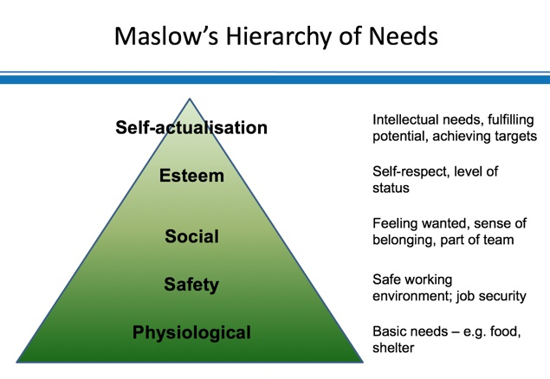
Figure 2: Stages in Maslow’s Hierarchy Model(Smith, 2017)
Physiological Needs:Physiological needs are the biological needs required for human survival such as food, air, workplace facilities, salary, etc. To meet the physiological needs of individuals Hugo Boss Ltd provides accommodation facilities, food services, transportation services, and a reasonable salary to the individuals within the workplace.
Safety needs: Individuals like to work for such company which ensures job security and safest work environment to its employees(ARMSTRONG, 2014). Individual safety and security are the top priorities of Hugo Boss Ltd. It ensures they feel safe and improve the workplace environment to avoid any unimaginable accidents.
Social needs: To ensure the social needs of individuals, Hugo Boss Ltd forms a team and assigns the tasks to be completed within a team or group. This is to promote socialism and communication among the team members. Every team member should be given priority and acceptance by the team leader.
Self Esteem: Self-esteem of individuals involve reputation, respect from others and team members, achievement, and status within the society or team members. The design of a reward system for individual and team members is ensured within the workplace by Hugo Boss ltd to promote the self-esteem to keep the employees and motivated and animated.
Self-Actualisation:In the self-actualisation level, individual tend to understand their self-worth and demand from the company(Daugherty, 2015). The assistant manager can become a manager. Therefore, Hugo Boss Ltd has promotion and succession planning to recognise individual self-worth.
Herzberg’s two-factor theory: Herzberg’s two-factor theory discusses two factors that determine the motivation level of individuals. These are job satisfaction factors and job-dissatisfaction factors. Working on removing the job dissatisfaction factor doesn’t indicate that workers are satisfied rather the company should focus on ensuring the jo satisfaction factors to motivate the individuals with the workplace.
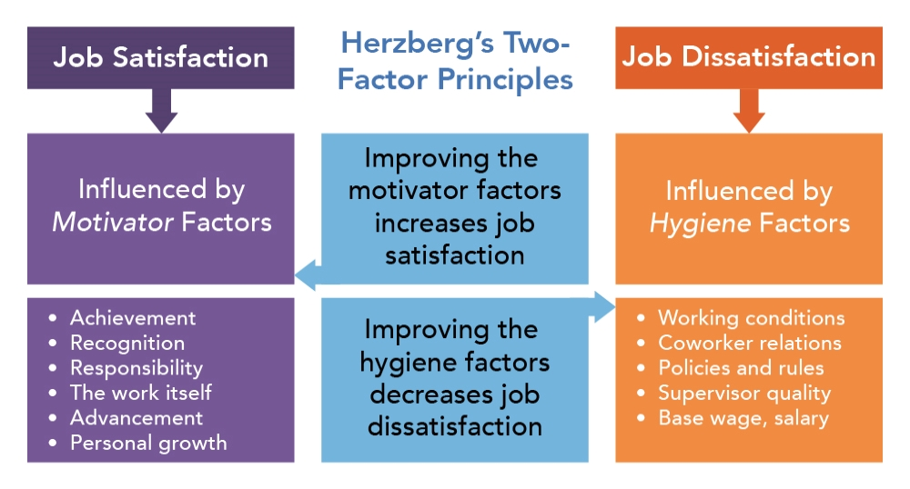
Figure 3: Factors in Herzberg’s two factor model(Carr, 2018)
Job satisfaction and job dissatisfaction factors should be improved at the same time. Job satisfaction factors include recognition, achievement, advancement or promotion, and individual growth within the workplace(Auld, 2017). On the other hand, job dissatisfaction factors include relations with the co-workers, working condition, salary, and quality of the supervisors. Hugo Boss Ltd focuses on both and works for individual development at the same time through this theory of motivation.

Critically evaluating development vehicles available to your organisation
Hugo Boss UK has been applying multiple development vehicles to ensure personally developing individuals in the workplace.

Techniques for supervision and formal appraisal of Hugo Boss UK:
Assessment Centre Method:This supervision and appraisal technique involves supervising and appraising the personality of individuals to know more about them and personal situation in the workplace. Tolerance, acceptance, and openness are the parameters considered in supervising the individuals(CIPD The Professional Body for Human Resources and People Development, 2020). These parameters also help the supervisors to appraise the individual performance from different perspectives to get an overall performance of the subordinates. The biggest weakness of this technique is that this method ignores the individual skills in appraising the subordinates.
Rating scale method:This is the most popular and effective in supervising and appraising the individual workers used by Hugo Boss UK. In this systematic performance appraisal technique, supervisors tend to rate individual employees based on the performance quarterly or annually. The rating is designed from 1-10 in scale. Higher ratings indicate good performance during the period.

Methods for ensuring the fair and objective appraisal in Hugo Boss UK
The methods to appraise the individuals of Hugo Boss UK are important in the sense that these methods seek to identify the overall performances from the subordinates. However, these methods should be fair and aligned with the objectives of the company. The Management By Objective (MBO) model is useful to ensure the fair and objective or assessment of individuals.
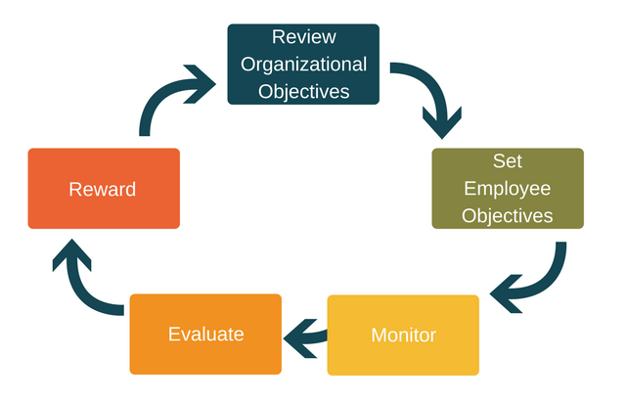
Figure 4: Five stages in Management By Objective Model(CIPD The Professional Body for Human Resources and People Development, 2020)
The first step of the MBO model is to review the organisational objectives of Hugo Boss UK so that the assessment or appraisal technique can be conducted keeping the organisational objectives in mind. The organisational objectivesshould be communicated with all the internal and external stakeholders of the company. The second step of this model for a fair appraisal is to set the employees objectives. The supervisors of Hugo Boss UK set the employees’ based on their skills and experience(HUGO BOSS, 2020). The employee objective is short term in nature whereas it long term for the company as a whole. The basic employee objective is to complete the tasks assigned to them with perfection, fewer errors, and within the deadline. Mostly, the supervisors assign individuals to a team to work collectively and co-operatively for a better outcome the effectiveness. The third step is to monitor the activities of team members so that they can focus fully on the activities assigned to them. There is a tendency that individuals try to deviate from their workloads in the absence of supervisors out of their ethics(Hargreaves, 2012). The next step is to evaluate individual performance. Hugo Boss UK has been evaluating the performance comparing the actual performance with the benchmark or standards the company has set assess the performance. Finally, in the assessment of fair appraisal procedures, the company is rewarding the employees to recognise their contribution to the achievement of the firm’s objectives. The above-mentioned technique such as rating scale is used to reward the individuals. Higher rating holders will get the benefits and rewards beforehand.

Methods to monitor, evaluate, and record individual feedback
Hugo Boss UK applies the McKinsey Feedback model to monitor, evaluate, and record the individual feedbacks within the workplace. The explanation of this model is shown below.
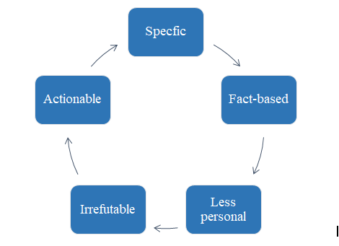
Figure 5: Steps in McKinsey Feedback Model(Harrison, 2016)
The very first step of this model is the specification in which the manager of Hugo Boss UK ltd tells the employees about their performance specifically and directly and also the; line manager needs to tell the individuals what the company expects from them under what circumstances(Williamson, 2018). The next step is the fact-based in which the company collects the facts for an individual after monitoring the tasks over time and evaluate the facts to provide feedback to individuals. This is more like an analysis based step to record the feedbacks of individuals. The next step includes less personal which means the line managers evaluate, monitor, and record feedbacks of individuals keeping aside the individual attributes. In this way, true comparisons among the individuals would be possible that brings the authenticity of the evaluation and feedback processes. Appropriateness of the evaluation and recording feedbacks is ensured in this step. Years of experience helps the company to make the process irrefutable. Finally, the line or management team takes timely and proper measures and actions for final evaluation and recording of feedbacks within the workplace.

A mechanism to provide appropriate feedback:
There are two types of mechanism techniques available to Hugo Boss Ltd such as positive feedback mechanism and negative feedback mechanism. These two types of mechanism for providing feedback are explained below in the context of Hugo Boss Ltd.

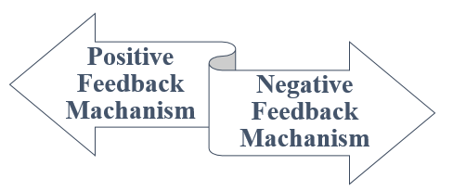
Figure 6: Mechanism of providing feedbacks(Daugherty, 2015)
Positive feedbacks mechanism: In the positive feedback process, the company tends to provide positive feedback to the individuals appreciating their performances and contribution to the firm. The line manager or supervisors approach to the individuals directly and tells them that they are performing well and the company appreciates their performances(Ellison, 2017). Additionally, the management of the company motivates and encourages the employees to improve their overall performances further.
Negative feedback mechanism: In the negative feedback mechanism process, the company monitors and evaluates the individual performance within the workplace and finds the negative circumstances in their performances. The supervisor doesn’t directly tell the individuals about their poor performance rather go for an indirect process to convey the message that they are performing poor that needs to be improved further.

Evaluating the learning styles available to Hugo Boss UK Ltd
VARK model is a popular model to explain the learning styles available to the company. The application of this model to Hugo Boss UK ltd is shown below.
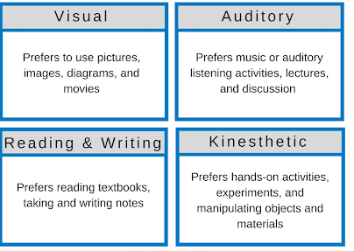
Figure 7: Different types of learning styles in VARK model(CIPD The Professional Body for Human Resources and People Development, 2020)
The first step of VARK learning style model is the visual presentation in which the company uses pictures, images, diagrams, or even movies so that individuals can learn from the visual presentation related to their tasks and job knowledge. The auditory style indicates that something to be learned through auditory listening activities such as music, group discussion, lectures, and music(Cavaliere and Sgroi, 2015). Kinesthetic learning style is widely used by Hugo Boss UK Ltd to let the individuals learn something. This learning style involves experiments, hands-on activities, manipulating objects and materials. The learning style available to the company is the reading and writing style. This is the most common method used for the learning of individuals. In this style, Hugo Boss Ltd allows individuals to read magazines and articles published by the company for learning purpose. In addition to that,the management team delivers short notes compiling the necessary information and knowledge to the individuals.

Training needs analysis for the individuals within the workplace
Training needs analysis is the systematic process for determining the training within the workplace and the total number of individuals that should be included in the training and development process. There is a five steps model to analyse the needs for training and development within the workplace of Hugo Boss Ltd(HUGO BOSS, 2020).
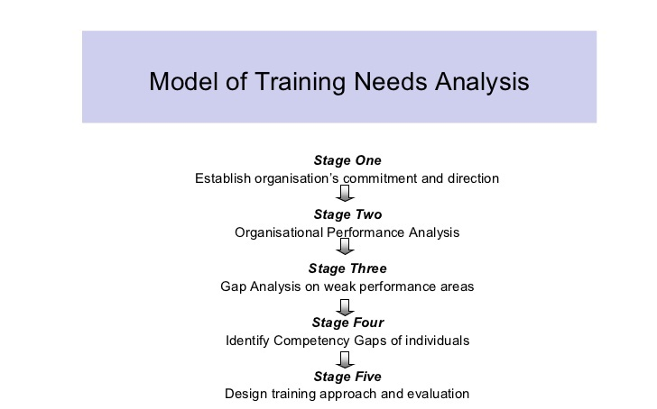
Figure 8: Five stages in training need analysis(Halachmi, 2015)
The very first step of training needs analysis involves establishing the organisations’ commitment and direction towards the long term goal achievement. In this stage, Hugo Boss Ltd sets the goals and objectives that need to be achieved in the long run through forming the teams of individuals and providing necessary pieces of training to them(Ellison, 2017). The next stage in the training needs analysis model is the analysis of organisational performances. Normally, training and development programs are conducted if there is room to improve the organisational performance if employee’s productivity and effectiveness can be improved giving training to them. The next stage is a vital one in which the company identifies the weak areas that lower the individual performance. The training methods depend on the areas that must be improved for better outcomes(Carr, 2018). The fourth stage of training needs analysis involves identifying the gaps in individual competency.The training methods also depend on the gap of individual competency. The next step is the design of a training approach and evaluation. In this final step, the analysis conducted in the above stages determineswhich methods the company should be conducted to work on the weak areas and improve the competency level further.

Analysis of different training and development methods:
Hugo Boss UK ltd mainly applies two types of training methods to the individuals after analysing the training needs for the individuals within the workplace. These two training methods are on the job training method and off the job training method.
On the job training method: On the job training method involves providing training to the individuals while allowing them to work on their assigned tasks. This is kind of supervise andadvising on the individuals type of methods. Hugo Boss rotates the individuals from one position to another, assigns mentors and coach to individuals, and introduces apprenticeship within the workplace as an approach of on the job training method(ARMSTRONG, 2014). This method is less costly and completion of work tasks will be ensured at the same time. However, negligence would take place in this method since the work activities and pieces of training will be going at the same time.
Off the job training method:The techniques involve in off the training method are case studies, role-playing, simulation, lectures, and management games. Case studies and role-playing techniques are often used by Hugo Boss in its training and development programs. In the case study analysis, individuals are given a case to solve within a specific time(Auld, 2017). This type of case study solution will improve the technical and creative thinking skills of the individuals. The company selects particular individuals and assigns them with a different role to be played so that they can learn how to do other roles perfectly. This method improves the multitasking skill of individuals.

Developing a plan to meet the identified development needs and expectations of an Individual

Steps in career development process
The previous section has identified the steps involved in the training needs analysis for the development of individuals.Career development process involves the design the set of strategies and work on the basis of the strategies adopted. The very first step in career development strategies is setting the development goals and objectives that should be achieved in the long run. In this step individuals need to set what objectives and goals he/she wants to achieve in professional growth perspectives. The next step is the identification of personal strengths, weakness, opportunities, and threats. Personal SWOT analysis would be conducted in this regard. The next step involves listing the SMART objectives in the career development process. The objectives should be specific, measurable, achievable, realistic, and timely. The final step involves taking the actions to improve the weak areas. Different types of actions implemented depend on the individual goals and objectives and the current skills individuals have. Hugo Boss Ltd has been taking several strategies over the years to recognise the individuals talents, development them, and assist them to become successful in their professional life. However, to develop a detailed plan for the development it is important to conduct the personal SWOT Analysis.
Table 1: Personal SWOT Analysis
Strengths | - Have the ability to work within a team and cooperate with the team members  - Strong sense of urgency  - Strong communication skill with the management team, team leaders, team members, and supervisors.  - Can work urgently with fewer errors.  - Can organise and shape the work activities so that team members can understand the tasks easily and complete them perfectly  - Strong comprehension and understanding skills.  - Have the transferrable skill  - Can ensure the proper use of resources  - Committed to the success of the company  - Respectful to other team members  - Have a strong sense of humour  - Good networking skill
Weaknesses | - Lack of technical skill  - Am not a multitasking team member  - Lack of job experience and job knowledge  - Negative thoughts kept in mind if things are not going according to the plan  - Lack of time management skill  - Shyness to speaking in front of the people  - Lack of confidence  - Putting off works for tomorrow  - A distraction now and then
Opportunities | - Enhancing education and job knowledge  - Overcoming the fear of failure  - Putting more confidence in myself  - Helps from the team members and supervisors  - Internship under the boss.  - Training and development programs conducted by the company
Threats | - Limited ability to develop further  - Overtime working and taking extra pressure might kill my creativity.  - Limited Job experience

SMART Objectives: The SMART objectives include the objectives that should be put on mind while taking actions for personal development(Carr, 2018). The SMART objectives should be specific, measurable, achievable, realistic, and timely.
Table 2: Listing of SMART Objectives
Particulars | Objectives
Specific | - The very specific objective is to develop myself in the career development pathways.  - To become the best team member is the specific objective in a short time and get the best of me is the specific long term objective.  - To complete the tasks within the deadline ensuring the work quality.  - To improve the communication skill  - To improve the networking skill  - To think outside the box
Measurable | - To observe how other works at their best  - To learn from the team members  - To keep in good touch with the supervisors
Achievable | - To go for 5 interviews within 2 months  - Increase the work tasks by 10% consistently for the first 6 months and 20% for the second half of the year
Realistic | - Co-operating with the team members  - Communication the supervisor to and fro  - To improve the technical skill  - To become a multitasking team member
Timely | - Start taking actions for personal development is thetimeliest objective so far.

Personal Development Plan: Personal development plan includes the design of the detailed plan or roadmap to work on the weak areas that can be considered as the strengths after the development procedures. The following table includes the personal development plan in the career pathways.
Table 3: Explanation of personal development plan in weak areas
Weak Areas | Actions to be taken | Duration
Lack of Technical skill | To improve the technical skill, time must be well spent with the technicians with the company to observe how they think and impose their critical thinking on the work process. 3 months of training under the technicians will be taken from the next 2 months. I will stay at the office after the regular work hours to learn from the supervisors. | 3 months
Not a multitasking team member | Achieving multitasking skill is a must in this era of technological advancement. To achieve the multitasking skill, taking help from the team member who is expertise in a particular area is needed. Besides, attending seminars and conference should be ensured to learn something new. Internet browsing and YouTube videos will help in this regard to learn something new skill required for completing the tasks effectively. | 4 months
Weak leadership skill | The company has been arranging leadership programs for the leaders of the company. Attending these leadership programs would enable me to get an insight into the successful leaders and how they lead the global companies. There is a lot of books about successful leaders and their work ethics. Collection and reading of 10 books will be ensured within the next 2 months | 2 months
Lack of time management skill | This is one of the most important skills to be achieved to develop in career pathways. Time management skill will be ensured by keeping the to-do list and listing the work activities based on the priority and importance. More efforts and time will be allocated to the top activities and less time will be allocated to the least important activities. Completing the tasks within the deadline will be another option to work further on improving time management skill. | 3 months

The above table shows the actions to be taken to work on the weak areas. However, there might alternative courses of actions if the situation changes. More weak areas might be identified with the passage of time. The focus should be kept on the individual development consistently with passion, endeavour, and hard work. Team members, supervisors, management team, and company itself will be acting as the moderator for the achievement of personal development plan.

Conclusion
No organisations can go far without the development of their individuals. The survival of the organisations also depends on the ability, skills, and productivity of individuals. On that note, timely training and development programs should be conducted by the company. The training needs analysis should be conducted beforehand to identify the weak areas of individuals and the range of training methods that need to be taken. The relations among the team members and the ability to work as a team ensurea better outcome from the individuals.

References
ARMSTRONG, M., 2014.ARMSTRONG's HANDBOOK OF HUMAN RESOURCE MANAGEMENT PRACTICE. [S.l.]: KOGAN PAGE.
Auld, L., 2017. The Developing Individual. Manchester: Open College.
Carr, C., 2018. Team Leader's Problem Solver. Englewood Cliffs, NJ: Prentice Hall.
Cavaliere, L. and Sgroi, A., 2015. Learning For Personal Development. San Francisco: Jossey-Bass.
CIPD. 2020. CIPD The Professional Body For Human Resources And People Development. [online] Available at: <https://www.cipd.co.uk/> [Accessed 13 March 2020].
Daugherty, A., 2015. Organizational assessment, restructuring, and evidence-based management.Performance Measurement and Metrics, 16(1).
Ellison, D., 2017. Staff Development—Developing Individual Potential.AORN Journal, 7(3), pp.77-81.
Halachmi, A., 2015. Performance Measurement, Accountability, and Improved Performance.Public Performance & Management Review, 25(4), pp.370-374.
Hargreaves, D., 2012. Learning For Life. Bristol: Policy Press.
Harrison, R., 2016. Learning & Development. London: Haymarket.
Harvey, M. and Buckley, M., 2015. Introduction: International issues in human resource management. Human Resource Management Review, 8(1), pp.1-3.
Hugoboss.com. 2020.HUGO BOSS | Official Online Shop | Menswear &Womenswear. [online] Available at: <https://www.hugoboss.com/uk/home> [Accessed 13 March 2020].
Peterson, R. and Peterson, R., 2017. Training Needs Assessment. London: Kogan Page.
Smith, K., 2017. Manager and team development. European Management Journal, 9(1), p.115.
Williamson, M., 2018.Training Needs Analysis. London: Library Association Pub.

