University of Wales Trinity Saint David

School of Engineering

Emissions

Matthew Perry

P147909

BSc Automotive Engineering

Emissions Control & Diagnosis
M5X02202

Abstract

This report has looked at different components and the effects they have on emissions. It also discuss euro 6 and what the industry is doing to meet these requirements. The gases which are produced in the catalyst converter are discussed and fuel and air ratio are talked about and how they affect the emission, the chemical reaction is mentioned due to fuel and air ratio. The report is looking at how engine can be improved to meet euro 6 what’s is needed to achieve euro 6. How ventilation is achieved and how it stops vapour going to the atmosphere is discussed.

Contents Page

Introduction Page 4

Literature Review Page 5,6,7

Methodology Page 8

Results Page 9,10

Analysis Page 11

Conclusions Page 12

References Page 13,14

Introduction

This report will be looking at emission control of components to improve engine efficiency and lower the emission, it will also discuss about the euro six standards. Some testing was done in lab to compare different engines to see the effects of different components to meet the euro standards for that engine. When testing was done the appropriate equipment was used this will be discussed as well as the different types of components in the system. Other things that will be discussed include: Catalytic Converter, Temperature, EVAP, EGR, SAIR, PCV, Air/Fuel ratio, and Euro 6.

Literature Review

When a catalytic converter is at its normal operating condition, according to Pulkrabek & Shaver (1993) the converter removes carbon monoxide, hydrocarbons and oxides of nitrogen of more than ninety five percent, the catalytic has to be at operating temperature of about 400C for it to be that efficient. When the catalytic is cold its very inefficient there for the emissions reach the atmosphere. The catalytic takes several minutes to warm up, the problem is automobile travel is short distance therefor the catalytic converter is it not at operating temperature where is most needed in urban areas, where low emission is needed the most. During start up a rich mixture is used to heat the catalytic up quicker, to reduce the warm up period the oxygen is taking out of the exhaust by running a rich mixture and pumping air into the exhaust before the cat to try and optimize efficiency. Running a rich mixture will cause high levels of HC and CO emission, up to ninety percent of all HC emission is at start-up of the engine. To improve the heat up of a catalytic converter is to mount it as close to the manifold as possible. To test the efficiency of a catalytic converter and the equipment or readings needed would be a inferred temperature gun or a gas analyser, or the readings from the lambda sensor before and after catalytic. Using the temperature gun the temperature should be higher after the catalytic than before for it to be efficient. Gas analyser can be used to check to see how much CO and HC is being produced. If the O2 sensor is operating correctly then at idle then the minimum voltage should be 0.1 volts and maximum 0.9 volts this can be found by using an oscillating waveform. When the fuel mixture is rich the 02 sensor should a read maximum voltage of 0.9 volts (within 100 milliseconds), if the mixture goes lean the sensor should drop to its minimum voltage of 0.1 volts. With a 2 way catalyst it will oxidize the HC and CO but not the NOx, if it’s a 3 way catalyst it oxidize the HC, CO and reduces the NOx.

EVAP
Evap is used to stop vapours entering into the atmosphere, according to George, n.d. (2012) this has a big effect on global warning due to the vapours being vented into the atmosphere, due to the release of the carbon dioxide and other polyatomic. One of the basic and simple things to help with vapours is a seal in the fuel cap. The system consists of a canister full of charcoal, hoses, valves, and vents in the fuel lines. When the vapours enter the canister, the canister holds the vapours until they are ready to be redirected to the chamber and burnt. When the canister has stored the vapour and is ready to release the vapour to be burnt, this happens by moving a valve which creates a vacuum to draw the vapours into the engine. This can be done through mechanically or electronically, the ECU tells the valve when to purge the canister of vapours, fresh air is also drawn to give a better combustion process.

EGR
EGR helps with the challenges of global warming, EGR means exhaust gas recirculation. The EGR helps to reduce NOx (oxides of nitrogen), the EGR reduces the NOx by lowering the oxygen in the cylinder, which then reduces the temperature of combustion. This method is an efficient way to lower the NOx, also a percentage of air is replaced with CO2 which will lower the combustion temperature which has the effect on the NOx.
If the EGR valve was always open it would cause the gases to constantly flow into the intake manifold which would result in bad idle, this is due to the engine being cold and it’s trying to recirculate the gases when the engine isn’t up to operating temperature. When the engine has warmed up it may have the same affect when at low rpm. This could cause stalling of the engine, due to low rpm and the EGR being open. EGR opens when the engine up to temperature and the vehicle is moving. If the EGR was always open it will increase the fuel consumption. According to ferrell, n.d. (2018) Hydrocarbons will increase at low rpm or cold engine due to temperatures in the chamber caused by the fuel not being burnt properly.
If the EGR was always closed it will cause a blockage and stop the gases from recirculating back into the intake manifold, this can cause loud detonations, a second ignition can happen, the power of two ignitions combined can create some engine damage. Due to not having the gases recirculating the combustion chamber can be at a higher temperature which will increase formation of oxides of nitrogen.

SAI
What’s is SAI, SAI is secondary air injection which work by pumping air into the manifold to help heat the catalytic converter up faster to improve the emission. This will cause emission reduction, this will make a thermal oxidation before the catalyst. This will create exhaust gases to be a higher temperature which will improve the chemical process inside the catalyst. According to Lee & Heywood, (2010) emissions will be reduce by using the SAI system which will improve the CO by 37% to 93% and HC by 46% to 88% in a comparison to normal operating conditions, when catalyst is at operating temperature it will reduce NOx. If the engine didn’t have SAI then the catalytic will take a longer period of time to warm up there for creating higher emission while the catalyst is getting up to temperature due to longer warm up period. The fuel mixture would also be rich due to not having the air pumped in to the manifold. When the engine is cold the engine will run a rich mixture and the air will be pumped into the manifold to optimize the warm up period of the catalytic converter.

PCV
What is PCV, PCV is Positive crankcase ventilation which help to stop the harmful vapours going into the atmosphere, which comes from the engine. The vapours go from the crankcase into the intake manifold to be burned in the chamber with the air fuel ratio, this is done by a vacuum. This is all controlled by the PCV valve.
Open PCV systems, if the vapour is down to a minimal there is no problem as draws air through a vented filler cap. When there’s to much vapour in the crankcase it is then forced back to the oil filler cap which is vented and into the atmosphere. This is not the best way for pollution control.
Closed PCV systems, the oil cap is not vented which means the vapour will go back to air filter housing. The vapour will then go into the intake manifold to be burned which will prevent vapours going into the atmosphere.
The PCV valve meters the vapour and the flow from the crankcase into the intake manifold. This is controlled by the manifold vacuum, which changes as the engine speeds change.
A PCV system that’s is neglected will fail to function which will cause the crankcase not to be ventilated enough, which in turn will cause the oil to become sludge due to contamination of the oil. The internal engine parts will not be protected by the oil as its contaminated which will cause corrosion to parts. The vapours going into the manifold won’t be able to be metered correctly, it will cause bad idle and stalling of the engine due to the upset of the fuel and air ratio.
If a PCV is faulty which causes the valve to be stuck in closed position. The things that can be checked according to ferrell, (2017)is Check for oil leaks due to the pressure build up might have blown a seal or gasket causes an oil leak, increase in pressure internally. Black smoke from the exhaust also check oil to see if contaminated and see if it’s thick or like sludge.
If the PCV valve is stuck open or a vacuum leak it could cause rough idle due to a misfire caused by a lean air fuel mixture, increase in oil consumption.

Air/Fuel ratio
If there’s an imbalance in the air and fuel ratio this can cause an increase in NOx and hydrocarbons. Hydrocarbons in petrol will not be burned unless they are mixed with air. According to Toyota Motor Sales, USA, (n.d) air is made up of roughly 21% oxygen (02) 78% nitrogen (N2). Hydrocarbons in the fuel will react with the oxygen which will create water (H20) and (CO2) carbon dioxide which helps with heat and pressure inside the cylinder. Nitrogen and oxygen can react with each other which form nitrogen oxides (NOx). The correct air/fuel ratio is called stoichiometry, if the fuel is richer than stoichiometry the emissions and economy will suffer and if lean the power, emissions and driveability will suffer. Carbon monoxide can be caused by unburnt fuel, if there’s not enough oxygen in the air fuel mixture the mixture will not be burned properly, not enough oxygen it will not oxidize the carbon atoms to produce carbon dioxide. Carbon monoxide is formed if the carbon atoms and the oxygen has one atom this creates carbon monoxide.

Methodology

Euro 6 emission have improved massively, when testing the emission they must pass for euro 6, to pass the emission test, according to healy, (2017) the petrol car for Carbon monoxide should be 1.0g/km and 0.17g/km of hydrocarbons. Diesel emission of carbon monoxide should be 0.5g/km and 0.17g/km of hydrocarbons. Petrol and diesel cars less than 0.005g/km of particulate matter. In a comparison look at euro 1 carbon monoxide 2.72g/km and 0.97g/km of hydrocarbons. Particulate matter of a diesel need to be below 0.14g/km.
For an engine to be able to enter the euro 6 standards, it be good for the engine to have a three way cat to oxides the HC and CO and reduce the NOx, also for the cat to be used in euro 6 the warm up phase needs to be faster this can be done by retard ignition timing to send a burn down the exhaust to pre heat the catalytic up faster. EGR this will help to reduce the NOx by lowering the oxygen in the chamber. Evap will stop any vapour entering the atmosphere so will help with global warming not having harmful gases in the atmosphere. PCV will help stop vapours entering atmosphere so this would have to be a closed system which will send the vapours back in to be burned. A good fuel and air ratio to makes sure the fuel is all burnt to reduce the emission. By having the correct mixture will be most efficient way to burn the fuel and air. Modern injection will also help with the euro 6 emission.

Results
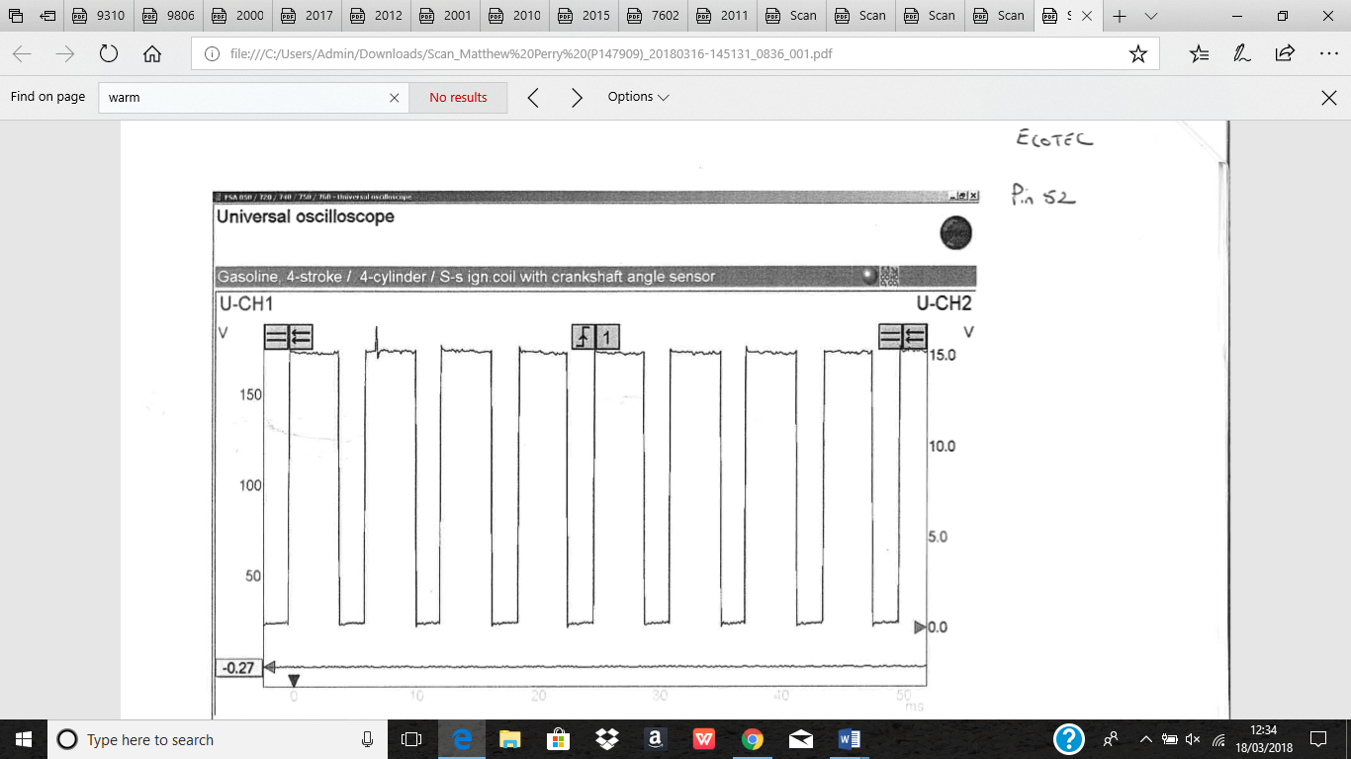
Fig.1

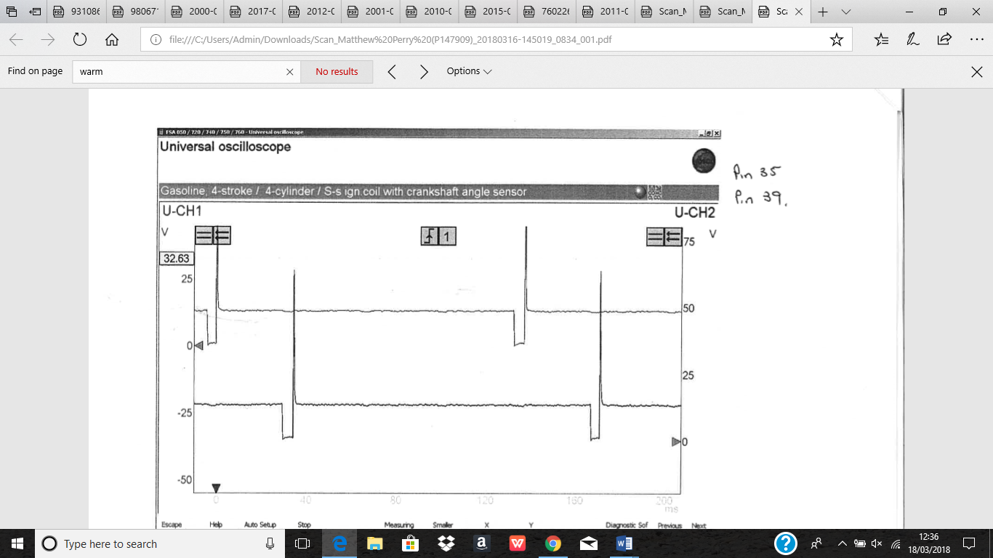
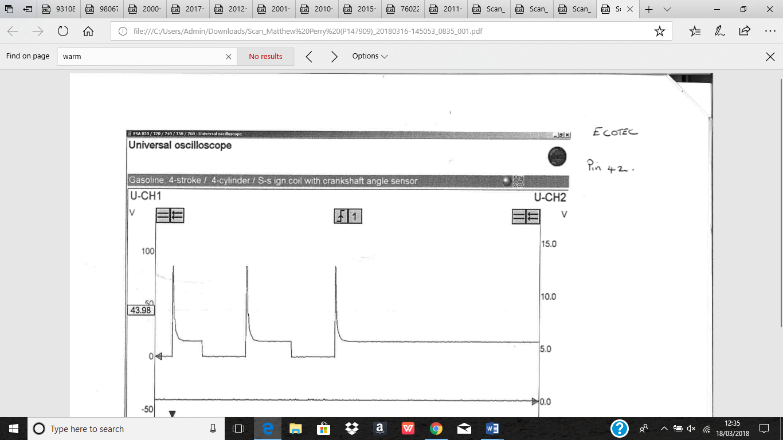
Fig.3
Fig.2
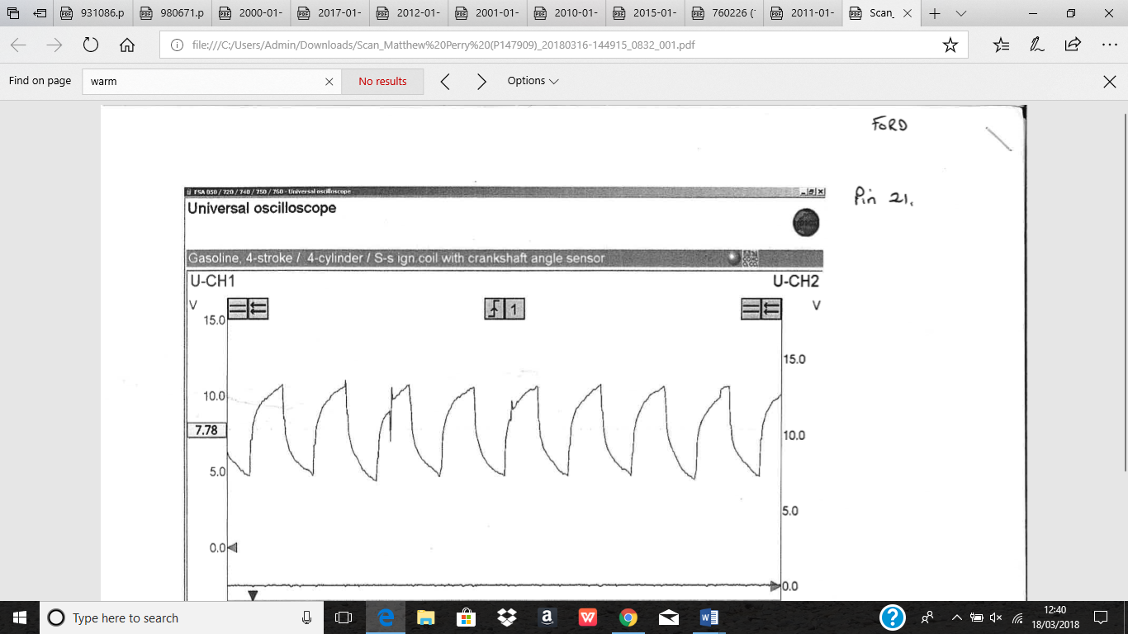
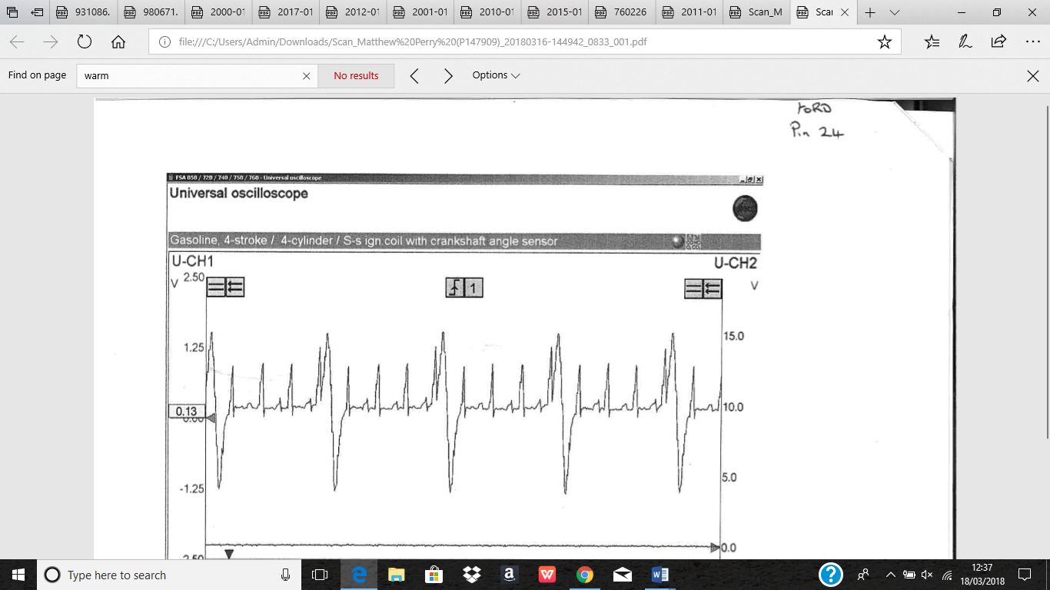
Fig.5
Fig.4

Analysis

Fig 1 Eco Tec pin 52 shows negative side of the idle valve pulse width which shows the load looking at current draw.

Fig 2 Eco Tec pin 42 shows negative side of the EGR solenoid valve.

Fig 3 Ford pin 35 and pin 39 shows injector No.3 and 4 earth via ECU can see they are off set.

Fig 4 Ford pin 24 shows AC input from camshaft phase sensor not hall.

Fig 5 ford pin 21 shows pulsed of idle control valve.

Conclusions

In this report it has looked at emission standard, emissions have reduced a lot since euro 1 and keep progressing and improving. With the new emission standards none of the vapour can enter the atmosphere. The modern catalyst are becoming more complicated but more effective. Also some components are used to meet the euro 6. Components have been discussed saying what they do and how they help with emission and help with the global warming. The vapours not entering the atmosphere has impact on the global warming. The biggest problem is trying to preheat the catalyst converter quickly enough, if it’s cold it is very ineffective and then becomes effective once up to operating temperature.

7. References
Anon., 2017. HOW EMISSION SYSTEMS WORK. [Online]
Available at: https://www.2carpros.com/articles/how-emission-control-systems-work
Anon., n.d. [Online]
Available at: https://www.princeton.edu/ssp/64-tiger-cub-1/64-data/combustion-chemistry.pdf
Anon., n.d. [Online]
Available at: http://www.baldwinfilter.com/literature/english/10%20TSB's/94-2R1.pdf
Anon., n.d. [Online]
Available at: http://www.baldwinfilter.com/literature/english/10%20TSB's/94-2R1.pdf
Anon., n.d. Auto tap. [Online]
Available at: http://www.autotap.com/techlibrary/understanding_oxygen_sensors.asp
Anon., n.d. The benefits of exhaust gas recirculation (EGR). [Online]
Available at: https://www.perkins.com/en_GB/products/emissions_technology/emissions-technology/exhaust-gas-recirculation.html
ferrell, d., 2017. Bad PCV Valve Symptoms and How to Test the PCV Valve Yourself. [Online]
Available at: https://axleaddict.com/auto-repair/How-to-do-a-PCV-valve-test
ferrell, D., n.d. Symptoms of a Bad EGR Valve. [Online]
Available at: https://axleaddict.com/auto-repair/Bad-EGR-Valve-Symptoms-and-What-to-Do-About-Them
George, p. E., n.d. How Evaporative Emission Control Systems Work. [Online]
Available at: https://auto.howstuffworks.com/evaporative-emission-control-system1.htm
healy, j., 2017. EURO EMISSION STANDARDS EXPLAINED. [Online]
Available at: https://www.carkeys.co.uk/guides/euro-emission-standards-explained
Itakura, H., Kato, N. & Kohama, T., 2000. Studies on Carbon Canisters to Satisfy LEVII EVAP Regulation, s.l.: detroit.
Kochs, M. W., Kloda, M. & Venne, G. v. d., 2001. Innovative Secondary Air Injection Systems, detroit: s.n.
Korin, E., Reshef, R., Tshernichovesky, D. & Sher, E., 1998. Improving Cold-Start Functioning of Catalytic Converters by Using Phase-Change Materials, detroit: s.n.
Lee, D. & Heywood, J. B., 2010. Effects of Secondary Air Injection During Cold Start of SI Engine, s.l.: s.n.
Pulkrabek, W. w. & Shaver, r. A., 1993. Catalytic Converter Preheating by Using a Chemical Reactio, Columbus: s.n.
Reddy, S., 2012. Understanding and Designing Automotive Evaporative Emission Control Systems, s.l.: s.n.
Rohani, b. & choongsik, b., 2016. science direct. [Online]
Available at: https://www-sciencedirect-com.ezproxy.uwtsd.ac.uk/science/article/pii/S1359431116333786
schager, m., n.d. Automotive Evaporative Emissions Systems.
Schweikert, J. F. & Gumbleton, J. J., 1976. Emission Control , detroit: s.n.
Whitaker, P., Kapus, P., Ogris, M. & Hollerer, P., 2011. Measures to Reduce Particulate Emissions from Gasoline DI engine, s.l.: s.n.
Smog-tech institute, (n.d). Catalytic Converter Testing. Available at: www.smogtechinstitute.com/smogtech/images/PDFs/CatalyticConverterTesting
CITATION: Li, Z., Dong, M., Harrigan, D., and Gardner, M., "Bench Test Method for Fuel Tank Vent Valve Noise Induced by EVAP System Pressure Pulsation," SAE Technical Paper 2017-01-0447, 2017, doi:10.4271/2017-01-0447
CITATION: Nakagawa, S., Numata, A., and Hori, T., "Individual Cylinder Control for Air-Fuel Ratio Cylinder Imbalance," SAE Technical Paper 2015-01-1624, 2015, doi:10.4271/2015-01-1624.

Toyota Motor Sales, USA, (n.d). Emissions #1 – Combustion Chemistry.
Motor & Equipment Manufacturers Association, (n.d). Technical Service Bulletin 94-2R1 Positive Crankcase Ventilation (PCV).

