Hotel Placement-Food & Beverage Operations
Forest of Arden Marriott Hotel & Country Club
Department: Conference & Banqueting
M401918_BIRM
Mubaraca Mombassa – 1905613
Week: 1
Work Undertaken:
- Conference and Banqueting Training Manual
- Allergy Training
- Clean & Tidy
- Tea &Coffee Stations (tables for refreshments)
- Morning prep/Lunch prep/Dinner prep
- Know the Rooms
- Coffee break Cabaret
- Daily Tasks

Self – Appraisal
Strengths:
Last week, I had an opportunity to have some basic understanding of what happens inside the department of conferences & banqueting and also outlines the responsibilities duties of how they work there. The department comprises 20 meetings rooms, 4 foyers areas, 4 bars and marquee which open up on a seasonal basis.
It is a good experience knowing the styles of service prepare for the conferences & banqueting rooms. Where people who go out of their way to make every event, of every size, truly marvelous.
There has been a lot of progress in terms of understanding how, they organize and run: Private functions: such as weddings, parties, dinners, and dances. Business functions: such as presentations, exhibitions, training events, conferences, sales promotions, and product launches, Improvements in communication, and providing information to guests.
I learned how to check plans, Explanation conferences, weddings, social events, Buffet, set menus and Choice menus. Also how to checklist refreshing a conference room, such as Pilkington suite, Boardroom, Jaguar, Triumph, Rover, Singer, Alvis, Aylesford and Morgan suite for any new bookings.
Banqueting Main Set Up Styles, such a Theatre style, Banquet style, Classroom Style, Cabaret-style and Boardroom style. Tidy up the rooms and ensure the next event or meeting be clean and ready.
Weaknesses:
My struggle, in the beginning, was to understand the plan sheet, find the rooms and compartments of things to prepare the rooms, bars, and tea coffee stations. But with the help of members of staff, everything is running well now and knowing all that to do when I needed.

Lost Opportunities:
I highlighted the styles of service, tables plan, and the floor plan, to be more physical and require more attention, after first week. But I am more confident and I gained some experience and have good skills now after this amazing challenge. All the staff I worked alongside was more than helpful and always willing to show me how to do something. The staffs are very friendly, and positive. Especially when, I was looking for something, that I couldn't find or see how it was done and then look if I can do that task myself.
Plans for next week:
- Get one more shift on Tuesday (11/02/20)
- Conference and Banqueting – How it is organized, what it is necessary and what kind of plan is required to be taken.(continue:)
- Get my rota with the housekeeping Manager..

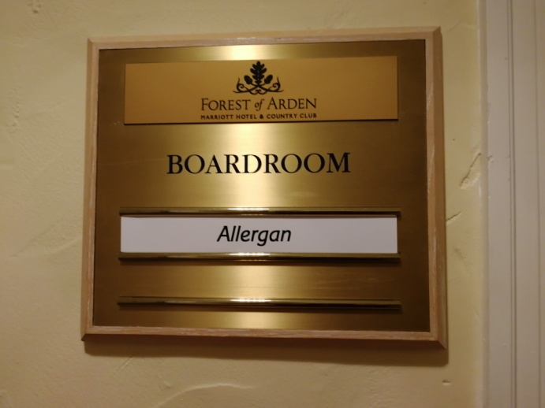 Rooms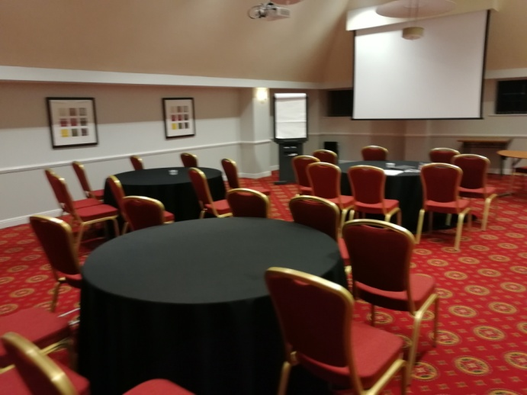Cabaret plan

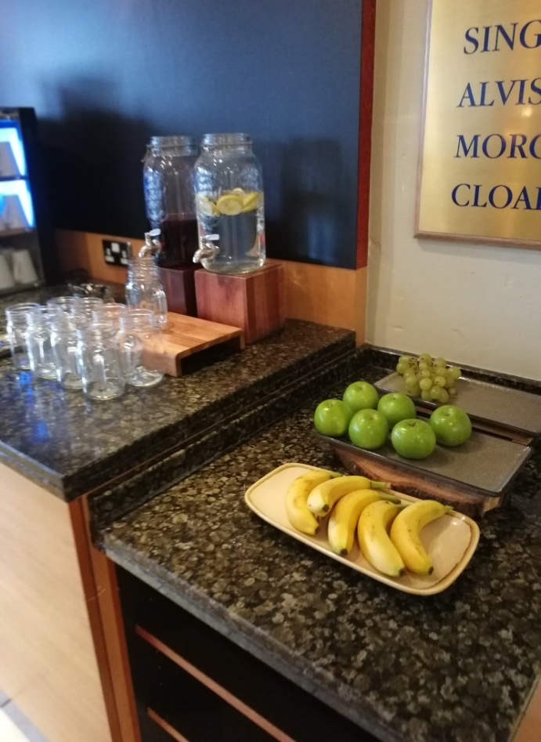Refreshment of coffee & tea stations
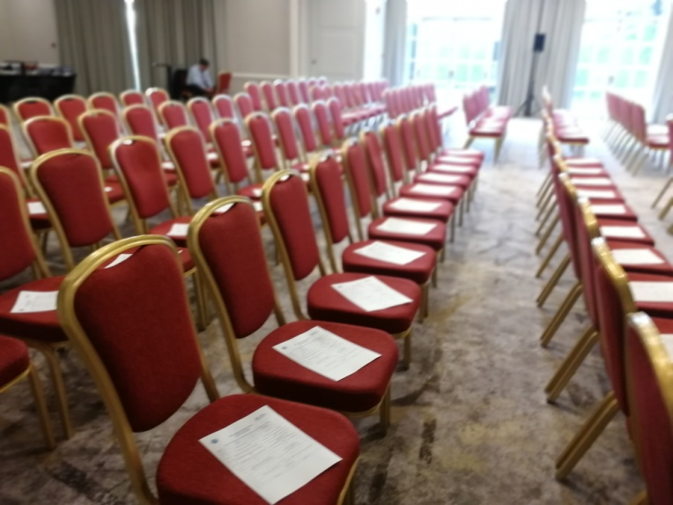Conference of Conservatives Women

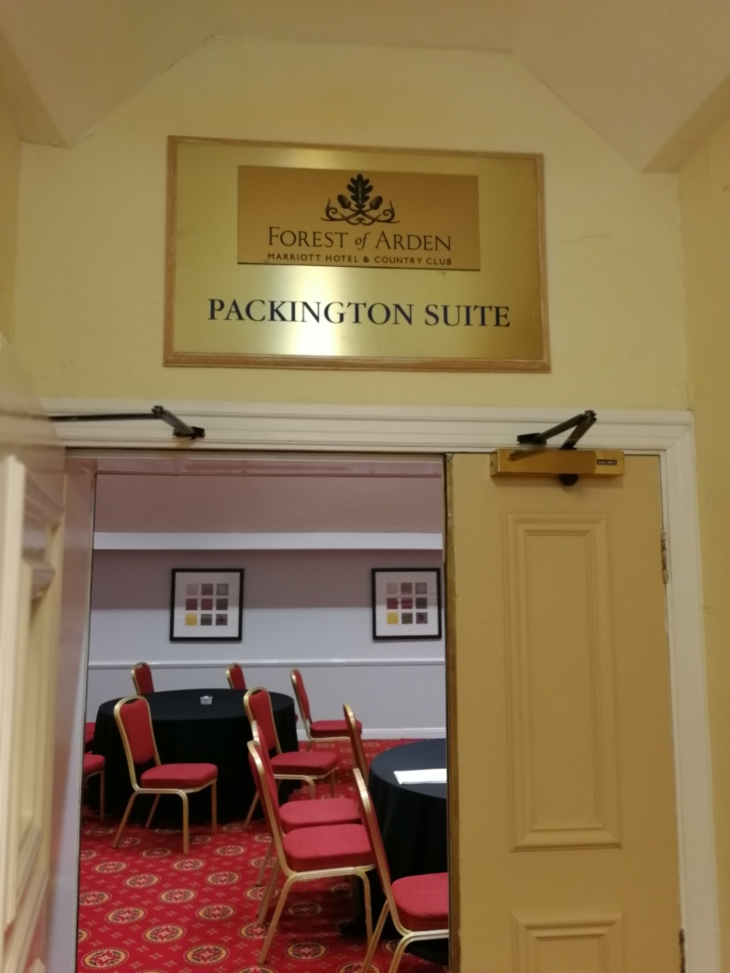Packing ton suite

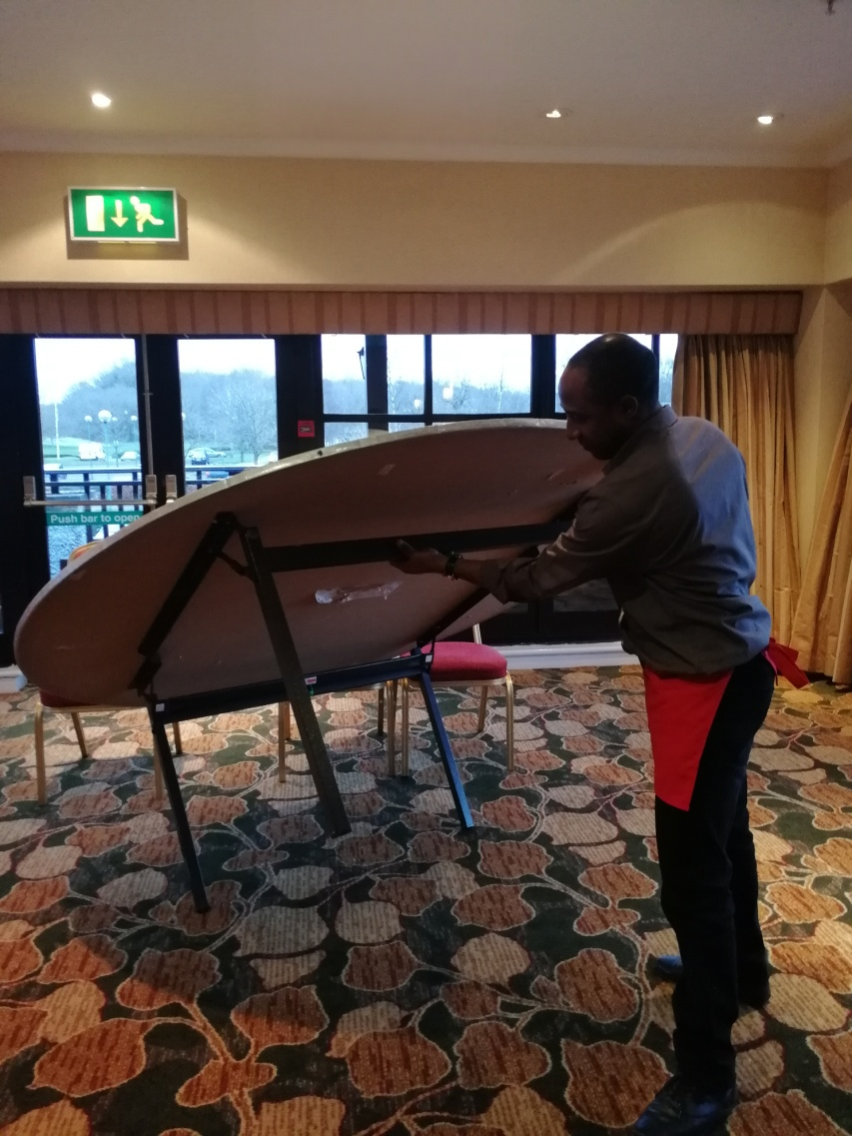
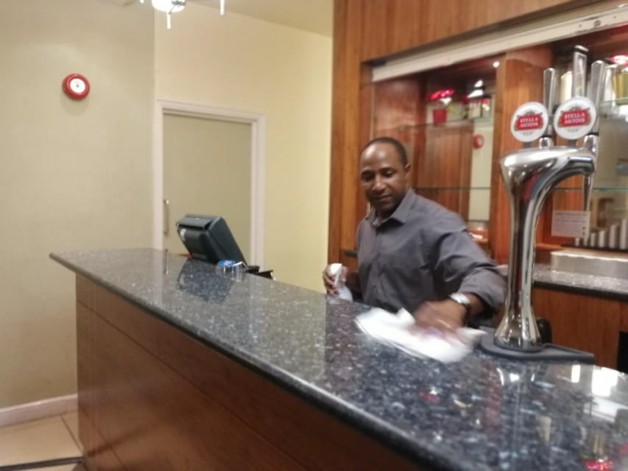 Cleaning the Bar

