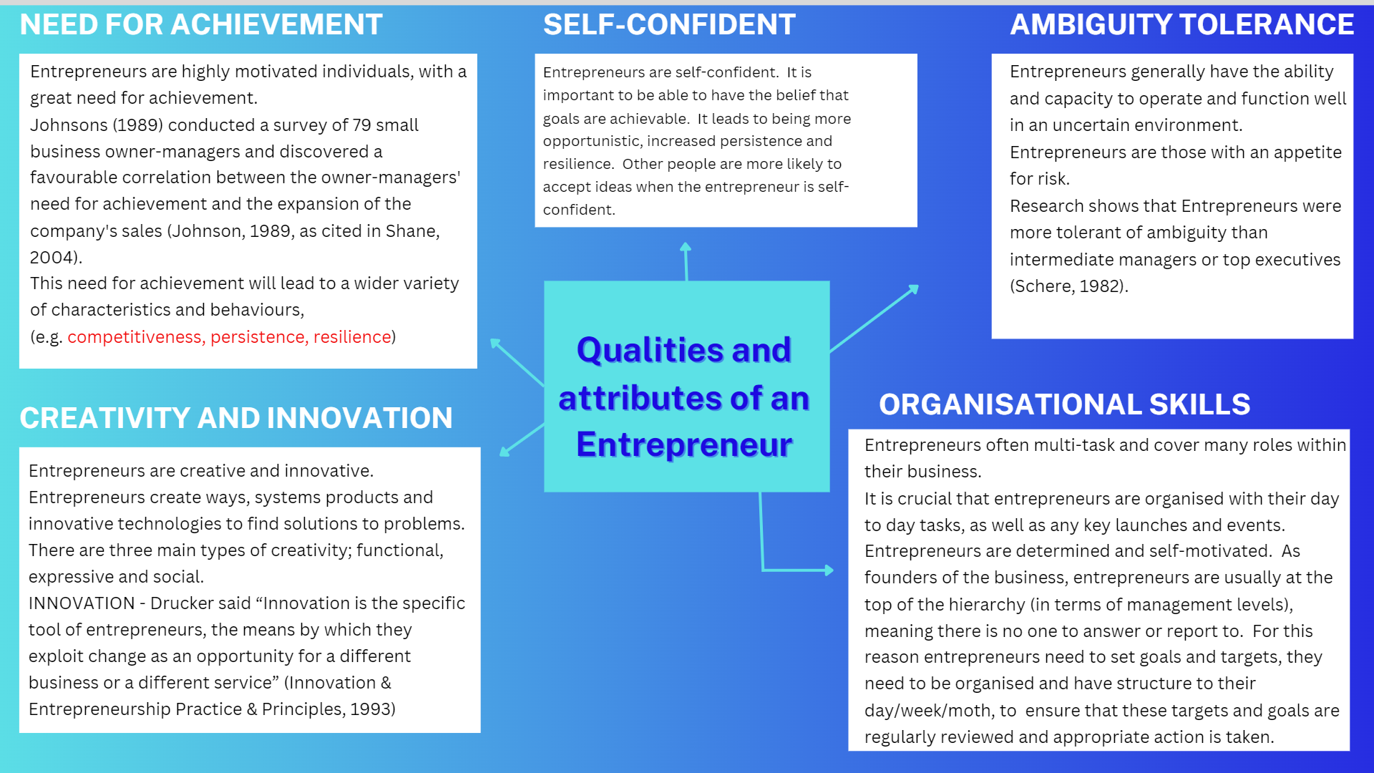

References:
Innovation & Entrepreneurship Practice & Principles. (1993). HarprBusinrs,1993.

Schere, J. L. (1982). Tolerance of Ambiguity as a Discriminating Variable Between Entrepreneurs and Managers. Academy of Management Proceedings, 1982(1), 404–408. https://doi.org/10.5465/ambpp.1982.4976860

Shane, S. (2003). A General Theory of Entrepreneurship: The Individual-opportunity Nexus. United Kingdom: E. Elgar.

