STUDENT NAME: Daisy Prossy Nangoonzi
STUDENT ID NUMBER: 2433877
PROGRAMME: BSC HEALTH AND SOCIAL CARE
MODULE: INTRODUCTION TO PHYSIOLOGY
MODULE CODE: BMHP5023
MODULE Tutor: Shaila Hussain

ASSIGNMENT TITLE: COMPONENT 1: WRITTEN ASSIGNMENT (CASE STUDY REPORT)

TABLE OF CONTENTS
a) INTRODUCTION 1
b) EXPLAIN HOW BLOOD SUGAR LEVELS ARE MAINTAINED AT A SAFE AND EFFECTIVE LEVEL FOR THE BODY’S NEEDS. 1
C) SHOW HOW OXYGEN AND GLUCOSE ARE USED TO PRODUCE ENERGY THROUGH CELL METABOLISM 3
C.1 Relationship Between Diabetes and Cellular Energy Production 5
D) BRIEFLY EXAMINE HOW RECORDING AND TRACKING BLOOD SUGAR LEVELS HELPS INDIVIDUALS WITH TYPE 2 DIABETES TO SAFELY MANAGE THEIR CONDITION. 6
Supporting Individual Self-Management 6
Supporting Healthcare Decision-Making 6
Reducing the Risk of Diabetes Complications 6
Limitations of Blood Glucose Monitoring 7
e.1 HEALTHY DIET AND WEIGHT MANAGEMENT 7
e.2 Physical activity and exercise 7
e.3 Smoking cessation 8
f. Role of health and social care professionals 8
F. CONCLUSION 8
g. REFERENCE LIST 9

LIST OF FIGURES
Figure 1: adapted from BBC Bitesize, n.d.) 5
Figure 2: Aerobic Cellular Respiration and ATP Production 7
Figure 3: demonstrates how glucose and oxygen combine during aerobic respiration to produce ATP, which provides energy for normal cellular activities. 8

INTRODUCTION
Diabetes mellitus is a metabolic condition characterised by constant raised blood glucose levels caused by problems with insulin production, insulin action or both. Insulin is a hormone produced by the beta cells of the pancreas that allows glucose to move from the bloodstream into body cells where it is used to produce energy. When insulin is insufficient, glucose remains in the blood that leads to hyperglycaemia and increasing the risk of serious health complications (Waugh and Grant, 2014).
Type 2 diabetes mellitus (T2DM) is the most common form of diabetes and develops when body tissues become resistant to insulin. Although the pancreas initially compensates by producing more insulin, prolonged demand can reduce pancreatic beta-cell function causes persistent increases in blood glucose levels (Cook, Shepherd and Boore, 2021). Unlike Type 1 diabetes, which is mainly caused by autoimmune destruction of pancreatic cells, T2DM is strongly associated with lifestyle factors although genetic and environmental influences are included.

EXPLAIN HOW BLOOD SUGAR LEVELS ARE MAINTAINED AT A SAFE AND EFFECTIVE LEVEL FOR THE BODY’S NEEDS.
Maintaining stable blood glucose levels is important because glucose is the primary energy source for many body cells especially the brain. The body uses a complex control system involving hormones, organs and feedback mechanisms to ensure that glucose availability matches the body's energy requirements.
The pancreas acts as the main regulator of blood glucose through the release of insulin and glucagon. These hormones work together through a negative feedback mechanism, meaning that changes in blood glucose levels trigger responses designed to restore balance.
Following the consumption of carbohydrate-containing foods, digestion breaks carbohydrates down into glucose molecules. Glucose is absorbed through the small intestine into the bloodstream that makes blood glucose levels to rise. In response, pancreatic beta cells detect this increase and release insulin.
Insulin binds to receptors on body cells especially muscle and liver cells that makes glucose to move from the blood into cells. Excess glucose is converted into glycogen and stored in the liver and muscles through a process called glycogenesis. This reduces blood glucose concentration and provides a stored energy supply for future needs (Waugh and Grant, 2014).

Figure 1: adapted from BBC Bitesize, n.d.)
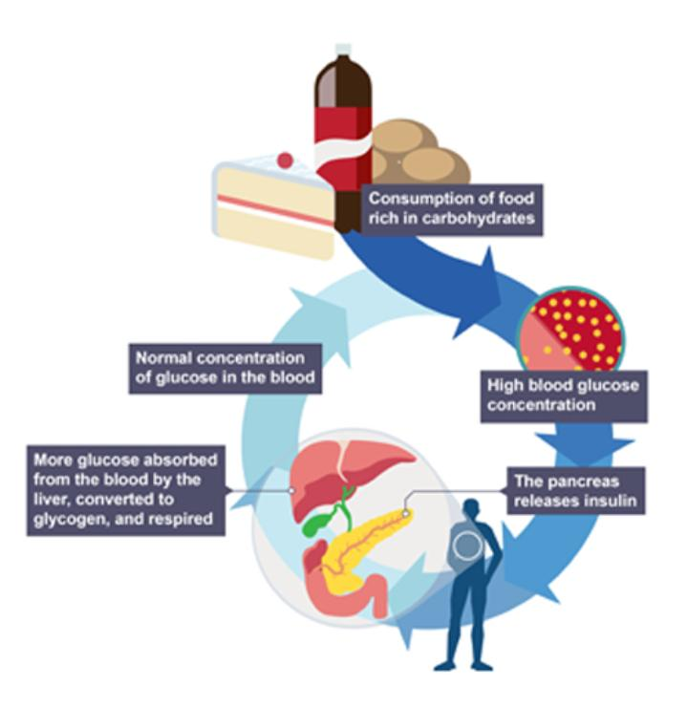
Blood glucose regulation during fasting or exercise
When blood glucose levels fall, such as between meals, during overnight fasting or during physical activity, pancreatic alpha cells release glucagon. Glucagon stimulates the liver to break down stored glycogen through a process called glycogenolysis. This releases glucose into the bloodstream to provide energy for body tissues.
The liver can also produce new glucose through gluconeogenesis when glycogen stores become limited. This process helps maintain sufficient glucose availability, particularly during prolonged periods without food or during increased energy demands (Cook, Shepherd and Boore, 2021).
Through the coordinated actions of insulin and glucagon, the body maintains glucose homeostasis. However, in Type 2 diabetes, insulin resistance disrupts this balance, causing glucose to remain elevated in the bloodstream. Understanding this process helps patients recognise why lifestyle activities such as healthy eating, physical activity and regular monitoring are important components of diabetes management.

C) SHOW HOW OXYGEN AND GLUCOSE ARE USED TO PRODUCE ENERGY THROUGH CELL METABOLISM
The human body requires a continuous supply of energy to maintain important functions such as movement, growth, tissue repair, temperature regulation and the activity of vital organs. The main source of energy for cells is glucose, which is obtained from the digestion and absorption of carbohydrates. However, glucose cannot be used directly by cells without being converted into a usable form of energy. This process occurs through cellular metabolism especially aerobic respiration which takes place mainly within the mitochondria of cells (Waugh and Grant, 2014).
Glucose and oxygen are important components of aerobic respiration. During this process, glucose molecules are broken down in the presence of oxygen to produce adenosine triphosphate (ATP), which is the main energy currency of the body. ATP provides energy required for cellular activities, including muscle contraction, nerve transmission, protein synthesis and active transport across cell membranes (Tucker, 2011).
The chemical equation for aerobic respiration is:
Glucose + Oxygen → Carbon dioxide + Water + Energy (ATP)
This process involves several stages, including glycolysis, the citric acid cycle (Krebs cycle) and the electron transport chain. Glycolysis occurs in the cytoplasm of the cell, where glucose is initially broken down into smaller molecules called pyruvate. The pyruvate then enters the mitochondria, where further reactions occur to produce larger amounts of ATP through oxidative phosphorylation (Cook, Shepherd and Boore, 2021).
The mitochondria are often described as the “powerhouse” of the cell because they are responsible for producing most cellular energy. Oxygen plays a critical role in the final stage of aerobic respiration by accepting electrons within the electron transport chain. Without sufficient oxygen, ATP production becomes less efficient and cells may rely on anaerobic respiration, which produces significantly less energy and results in the formation of lactic acid (Waugh and Grant, 2014).

Figure 2: Aerobic Cellular Respiration and ATP Production
Available at: https://www.bbc.co.uk/bitesize/guides/zs3jrwx/revision/3 (Accessed: 11 July 2026).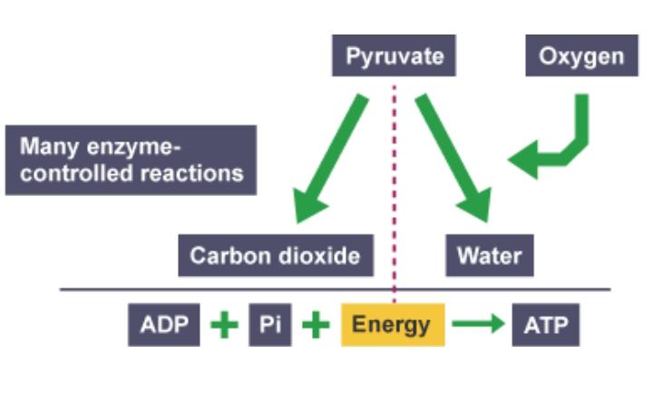

Figure 3: demonstrates how glucose and oxygen combine during aerobic respiration to produce ATP which provides energy for normal cellular activities.

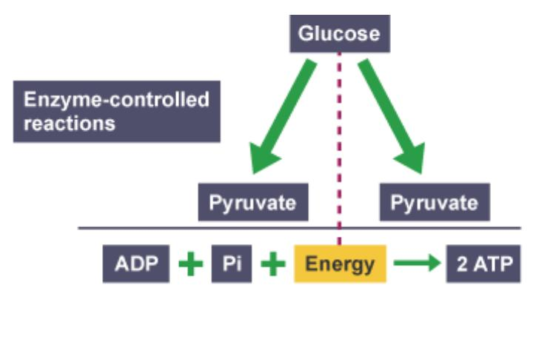

C.1 RELATIONSHIP BETWEEN DIABETES AND CELLULAR ENERGY PRODUCTION
Impaired insulin action affects the movement of glucose from the bloodstream into body cells for individuals with Type 2 diabetes. Although glucose may be present in high concentrations in the blood, cells are unable to access it efficiently because insulin resistance prevents effective glucose uptake. This creates a situation where blood glucose levels remain elevated while cells experience reduced availability of glucose for energy production (Waugh and Grant, 2014).
When glucose cannot enter cells effectively, the body may begin using alternative energy sources, such as stored fat and protein. Over time, this can contribute to fatigue, reduced physical capacity and metabolic disturbances. Persistent high blood glucose levels also contribute to cellular damage by affecting blood vessels and increasing oxidative stress which contributes to diabetes-related complications (NICE, 2022).
Physical activity can improve this process because contracting muscles can increase glucose uptake independently of insulin. During exercise, muscle cells require more ATP hence increasing their demand for glucose and oxygen. Regular exercise therefore improves insulin sensitivity and helps individuals with Type 2 diabetes maintain better blood glucose control (NHS, 2023).
Understanding the relationship between glucose, oxygen and energy production helps individuals with diabetes recognise why maintaining balanced blood glucose levels is important. Effective management supports normal cellular function and reduces the risk of complications associated with prolonged hyperglycaemia.

D) BRIEFLY EXAMINE HOW RECORDING AND TRACKING BLOOD SUGAR LEVELS HELPS INDIVIDUALS WITH TYPE 2 DIABETES TO SAFELY MANAGE THEIR CONDITION.
Recording and tracking blood glucose levels over time is an important aspect of effective Type 2 diabetes management. Diabetes is a long-term condition in which glucose levels can change depending on food intake, physical activity, medication, illness, stress and other lifestyle factors. A single blood glucose measurement provides limited information; therefore, monitoring patterns over time provides a more accurate understanding of how well the condition is being controlled (NICE, 2022).
Blood glucose monitoring enables individuals and healthcare professionals to identify whether treatment plans are effective and whether adjustments are required. For example, consistently high readings may indicate that dietary habits, physical activity levels, medication or other aspects of diabetes management require review. Similarly, unexpectedly low readings may suggest a risk of hypoglycaemia, particularly in individuals using insulin or certain glucose-lowering medications (NICE, 2022).

Supporting Individual Self-Management: Regular recording of blood glucose measurements encourages individuals to become actively involved in managing their condition. Self-management is a key principle of modern diabetes care because individuals make daily decisions about food choices, physical activity, and medication use and lifestyle behaviours.

Supporting Healthcare Decision-Making: Blood glucose records provide valuable information during consultations with healthcare professionals. Practice nurses, general practitioners and diabetes specialists can use this information alongside other measures, such as glycated haemoglobin (HbA1c), to assess long-term glucose control and determine whether treatment adjustments are needed.

Limitations of Blood Glucose Monitoring: it should be recognised that blood glucose testing alone does not manage diabetes. Effective control requires a combination of monitoring, medication where required, healthy eating, physical activity, weight management and regular healthcare reviews. Patients should also receive appropriate education on how and when to test their glucose levels because unnecessary monitoring can increase anxiety and may not always improve outcomes for individuals not using medications associated with hypoglycaemia (NICE, 2022).

e.1 HEALTHY DIET AND WEIGHT MANAGEMENT
Weight management should focus on gradual and sustainable changes rather than rapid weight loss. This includes improving dietary quality, increasing physical activity and developing healthier daily routines. Some individuals may benefit from structured weight management programmes or specialist support depending on their clinical needs.

e.2 Physical activity and exercise
Regular physical activity is one of the most effective lifestyle strategies for improving blood glucose control in Type 2 diabetes. Examples include brisk walking, cycling, swimming, gardening and resistance exercises. Individuals who are currently inactive should gradually increase activity levels according to their ability and health status (NHS, 2023). However, Exercise recommendations should be personalised because some individuals may have complications such as neuropathy, cardiovascular disease or mobility difficulties that require additional support. Healthcare professionals should consider individual circumstances and provide safe, achievable activity plans.

e.3 Smoking cessation
Smoking is a significant risk factor for people with diabetes because it increases the likelihood of cardiovascular complications which are already more common among individuals with Type 2 diabetes. Tobacco chemicals contribute to inflammation, oxidative stress and impaired blood vessel function, which can worsen insulin resistance and increase the risk of heart disease and stroke (NICE, 2022).

f. Role of health and social care professionals
Effective diabetes management requires a holistic and person-centred approach. Structured diabetes education programmes support individuals in developing skills needed for self-management, including monitoring blood glucose, recognising symptoms of high or low blood glucose and understanding how lifestyle choices affect their condition. Increased knowledge improves confidence and enables patients to participate actively in decisions about their care (NICE, 2022).

F. CONCLUSION
The endocrine system plays a central role in blood glucose homeostasis through the actions of insulin and glucagon. Research demonstrates that lifestyle changes can significantly improve blood glucose control and reduce the risk of diabetes-related complications. Supporting patients through education, encouragement and personalised care planning enables them to become active participants in managing their condition. Within primary care, practice nurses have a key role in empowering individuals with the knowledge and skills required to manage Type 2 diabetes safely and effectively.

g. REFERENCE LIST
BBC Bitesize (n.d.) Blood glucose regulation. Available at: https://www.bbc.co.uk/bitesize/guides/z688jhv/revision/5 (Accessed: 11 July 2026)
Cook, N., Shepherd, A. and Boore, J. (2021) Importants of Anatomy and Physiology for Nursing Practice. London: Learning Matters.
National Institute for Health and Care Excellence (NICE) (2022) Type 2 diabetes in adults: management (NG28). Available at: https://www.nice.org.uk/guidance/ng28 (Accessed: 12 July 2026).
NHS (2023) Type 2 diabetes. Available at: https://www.nhs.uk/conditions/type-2-diabetes/ (Accessed: 13 July 2026).
Tucker, L. (2011) An Introductory Guide to Anatomy and Physiology. 5th edn. London: EMS Publishing.
Visible Body (n.d.) Visible Body. Available at: https://www.visiblebody.com (Accessed: 11 July 2026).
Waugh, A. and Grant, A. (2014) Ross and Wilson Anatomy and Physiology in Health and Illness. 12th edn. London: Churchill Livingstone.
World Health Organization (WHO) (2025) Diabetes. Available at: https://www.who.int/health-topics/diabetes (Accessed: 13 July 2026).

