Student Name:  Ioana Ferariu  Student ID Number:  2029573 | Module: Hotel Placement – Food & Beverage Operations (BMIH4002)  Lecturer: Laurence Blake

Topic of choice: | Allergies and Intolerances and the importance within the industry
I have chosen this topic as it is one with a huge importance within the hotel industry, as it can lead up to closing the business if the laws are being violated. When a person has troubles digesting different foods, which can cause several uncomfortable and often painful side effects, means he has food intolerance. The most common food intolerances include: dairy; gluten; caffeine; salicylates which are often found in fruits, vegetables, spices and nuts; amines which are found in a variety of foods; sulphites and FOODMAPs which are a group of short-chain carbs (Food Standards Agency, 2021). In addition to food, stress can also contribute to intolerance. However, irritable bowel syndrome and celiac disease are one of the most common causes of food intolerance. Although usually not harmful, food intolerance tends to cause a variety of unpleasant side effects such as gas, convulsions, irritability, rashes and itching. Although is not a legal obligation for hotels and restaurants to label intolerant foods, but from my point of view I recommend it. Allergies are very different from intolerance. Some symptoms can be relatively similar, but allergies are very dangerous and can often be fatal and should be taken more seriously. When the immune system of the body responds to specific foods, it causes an allergic response. Currently, there are an estimated 2 million people diagnosed with food allergies in the United Kingdom (Food allergies: An epidemic in the making? 2021). If any of their items include one of the following allergies, hotel restaurants must notify their customers: gluten-containing cereals, shellfish or crustaceans, eggs, fish, peanuts, soya and soybeans, milk, almonds, celery and celeriac, mustard, sesame seeds, sulphites, lupin, molluscs (Food Standards Agency, 2021).
Unlike intolerance, food allergies can cause fairly serious reactions such as dyspnoea, swelling, and even lowering blood pressure. No matter how mild an allergy is, the potential effects cannot be underestimated. The food and hospitality industry are rushing things about food safety. Starting with October 2021, the government introduced the Natasha Law (BSACI, 2021). Until October last year, companies had to provide a summary of allergen ingredients in foods rather than a complete list of ingredients. However, labelling requirements of the Natasha Law require companies to provide complete information about the ingredients of their products, whether allergic or not, and all pre-packaged food direct sales (PPDS) (BSACI, 2021). From my point of view is the best idea, because in this way consumers are informed of what they are eating and becomes their choice if they still want to eat it or not.
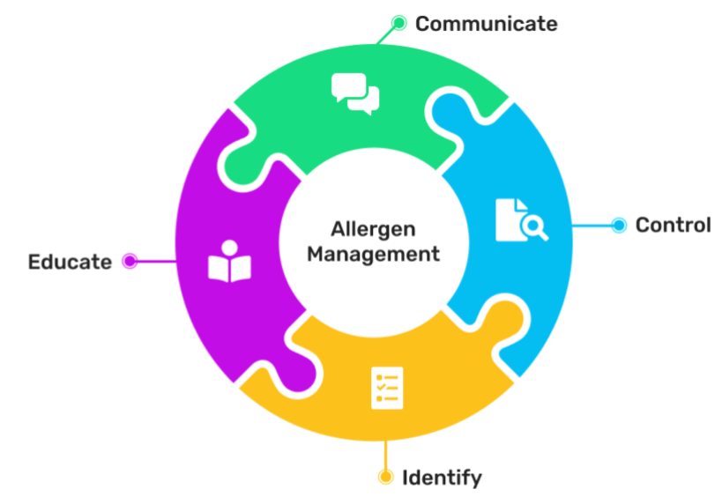

Figure 1: Allergen management. Source: Apicbase (2021)

I have learnt that it is important to have some knowledge within this area to be able to read correct a label and to understand the ingredients. At the same time, I have depicted new information about the standards that are present within the food industry. By far, the most important one is HACCP which stands as the standard that each company that respects its customers should be accredited or certified, in order to give its consumers, the confirmation that their products are following the laws and are good and safe to be consumed. For me, this is a topic that I want to explore a bit more, therefore I am interested in reading a bit more about this standard (U.S. Food and Drug Administration, 2021) so that I can improve my knowledge in this area, also, I am very interested in this food quality standard as it is something that I will look for on all the food packages that I will buy from now on.
This topic I have chosen is an important one within the industry, because an increasing number of people are being diagnose with food allergies, therefore the hotel industry must take this number into account as well in order to be able to offer to all of its customers high level standards services. It is important for a hotel to advertise the importance that they are giving to food allergies and intolerances because if the number of people with these conditions is increasing, they will be more and more interested in the hotels that are paying attention to this standard and they will become their customers, meaning that the hotels could increase guest volumes and hotel revenues. If I would be part of this category and I would need to travel, for sure I would look for a hotel that has a restaurant and a chef that is interested in covering these topics. We need to have more and more hotel managers that pay attention to these issues and offer their customers quality services.

REFERENCE LIST (not included in word count)
Ag.ndsu.edu (2021) Introduction to HACCP & Food Safety Plan — Food Law. Available at: https://www.ag.ndsu.edu/foodlaw/overview/introhaccp (Accessed 23 January 2022)
Apicbase (2021) Food Allergen Management - Full Breakdown for Restaurant Managers & Executive Chefs. Available at: https://get.apicbase.com/food-allergen-management-ultimate-guide/ (Accessed 24 January 2022)
BSACI (2021) Natasha’s Law comes into effect on 1st October 2021 - BSACI. Available at: https://www.bsaci.org/natashas-law-comes-into-effect-on-1st-october-2021/#:~:text=Natasha%27s%20Law%20comes%20into%20effect%20on%201st%20October%202021.,consumers%20on%20the%20same%20premises. (Accessed 26 January 2022)
Food Standards Agency (2021) Allergen guidance for food businesses. Available at: https://www.food.gov.uk/business-guidance/allergen-guidance-for-food-businesses (Accessed 30 January 2022)
Food Standards Agency (2021) Food allergy and intolerance. Available at: https://www.food.gov.uk/safety-hygiene/food-allergy-and-intolerance (Accessed 26 January 2022)
Openaccessgovernment (2021). Food allergies: An epidemic in the making?. Available at: https://www.openaccessgovernment.org/food-allergies/125160/ [Accessed 28 January 2022]
U.S. Food and Drug Administration (2022) HACCP Principles & Application Guidelines. Available at: https://www.fda.gov/food/hazard-analysis-critical-control-point-haccp/haccp-principles-application-guidelines (Accessed 23 January 2022)

