Student: Nicoleta Angheluta

Student Number: 1914622

Module title: Accounting fundamentals – assessment 1

Lecturer: Dr. Riaz Bahtti

Table of Contents
Introduction 1
Question-01 2
Preparing the income statement of Wales Plc for the year ended 31st December 2019 2
Preparing a statement of financial position of Wales Plc at the date 31st December 2019 4
Question- 02 8
a. Calculating the required ratios of Jerry Plc for the year 2019 and 2018 8
b. Discussing the situation revealed by the ratios calculated in section (a) 8
Question-03 9
a. Identifying three different groups of company accounts and discussing why these user groups are interested in the information provided in the financial statement 9
b. Discussing the advantages and disadvantages of a highly regulated financial reporting regime on the perspective of both the user and preparer of the financial statements 11
c. Discussing the limitations of financial statement 12
Conclusion 14
References 15

Introduction
The financial statement is the technique of knowing the organisational standing in terms of its resources, liabilities and ownership (Valand, 2019). The report is made showing the financial statement and financial ration analysis of two companies. Besides, the report describes the groups to use this statement and their motive behind the use briefly. The report also highlights the positive and negative sides to use this statement along with the limitations of using it.

Question-01

Preparing the income statement
The income statement is one of the tools that help an organisation to calculate the loss or profit through a scrutiny analysis of its expenditure and revenues over a certain time (ROBINSON, 2020).
Wales Plc Income Statement
31st Dec 2019
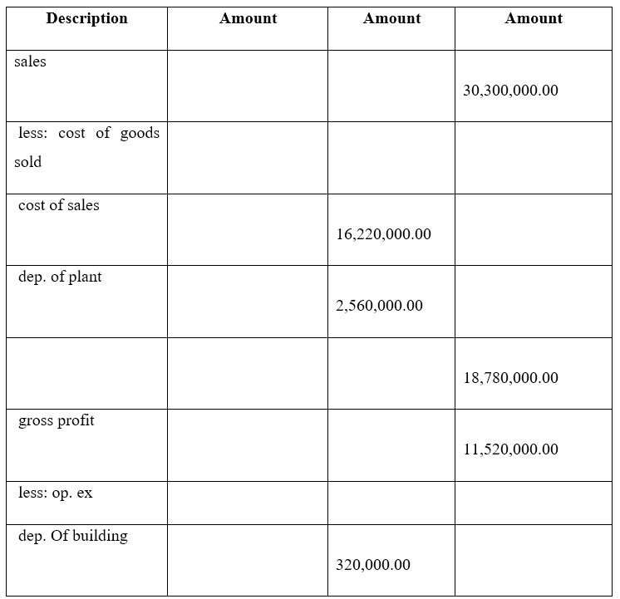
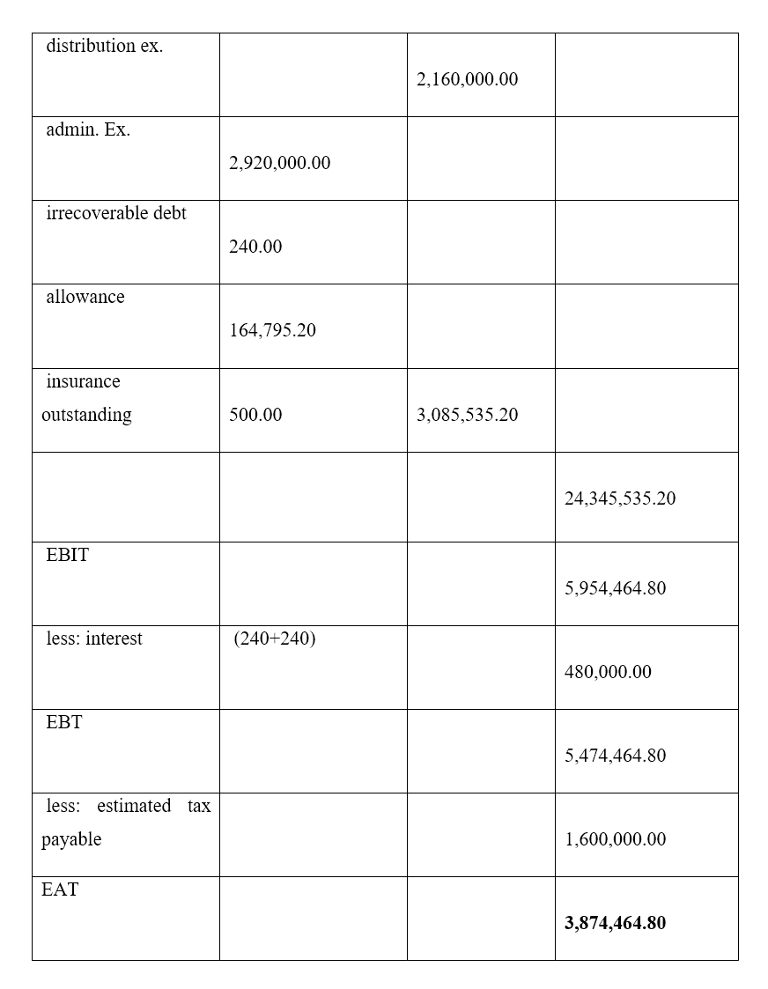

Preparing a statement of financial position
The statement of financial position is known as the tool to enumerate the resources, ownership, and liabilities of an organisation to evaluate its financial state at a particular time (ROBINSON, 2020).
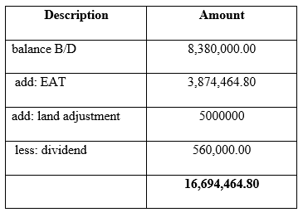
Wales Plc Statement of Financial Position
31st Dec 2019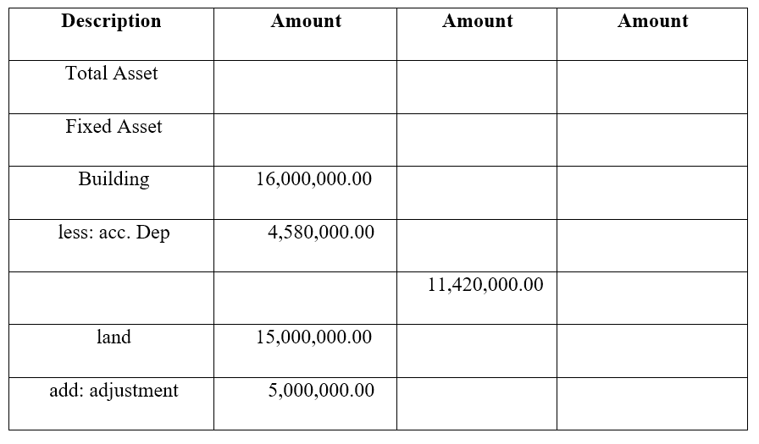
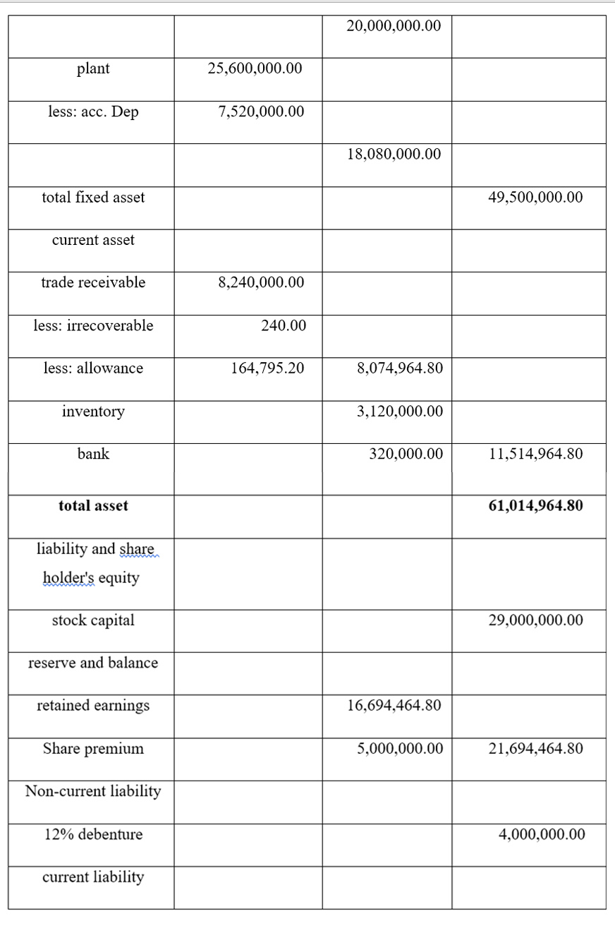
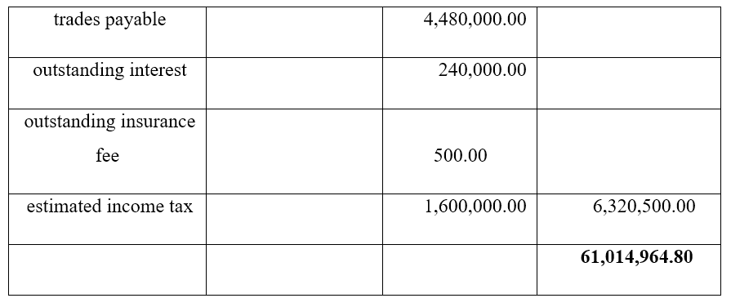

Question- 02

Calculating the required ratios of Jerry Plc for the year 2019 and 2018
Here reflects the ratio analysis of Jerry Plc for the consecutive years 2018 and 2019.
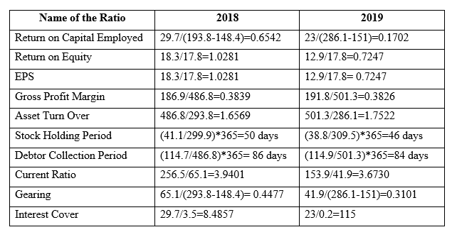

Discussing the situation revealed by the ratios calculated in section (a)
Here the return on capital employed in 2018 and 2019 are 0.6542 and 0.1702 which means that these are the figure of generated profit for each pound of capital invested in the company. The return on equity showed here are 1.0281 and 0.7247 which defines that for each pound invested by the common shareholders, these figures are earned in the two years as their profit. The EPS of the company shows that the income per pound is 1.0281 and 0.7247 in 2018 and 2019 for the shareholders respectively. Gross profit margin is 0.3830 and 0.3826 for the year 2018 and 2019 and it signifies that each pound of sales creates a profit of 0.3830 and 0.3826 before cutting the other expenses related to the organisation. Asset turn over of Jerry Plc highlights that Jerry Plc earns 1.6569 and 1.7522 for every pound of assets. The stock holding period refers to the total time of inventory turnover of the Jerry Plc. Debtor collection period of the two years of Jerry Plc reflects that it took 86 day in 2018 and 84 days in 2019 to gather money from all the accounts receivables. The current ratio analysis of the organisation means that Jerry Plc had enough assets to be able to pay 3.9 and 3.7 per cent of its liabilities. Gearing referred that 0.44 and 0.31 per cent borrowing of Jerry Plc has been done through the long term sources in the year 2018 and 2019. The interest coverage of Jerry Plc shows that the company generated 8.4 and 115 times greater revenue in accordance with its interest payments in the year of 2018 and 2019.

Question-03

Identifying three different groups of company accounts and discussing why these user groups are interested in the information provided in the financial statement
The company accounts are created with a view to having the purpose of serving the users with the potential information regarding the current financial standing of an organisation. Some of the users of the company accounts are mentioned below in order to have better knowledge about them.
- Investors: Potential investors are those who provide funds or willing to grant funds and take the risk in capital sharing. Their investment is always at high risk and so they try to anticipate their probabilities regarding the invested projects through the evaluation of the accounts of the company. They mainly try to inquire about the financial situation of the organisation, its capability to pay the dividend, its cash flow management, etc. to understand whether they should get their money here (Palea, 2018).
- Employees: Employees are parts of an organisation who are hired in order to get involved with organisational activities on a salary basis. Employees and the trade union require information regarding the company’s cash flows, profitability and stability as their salary and bonus are dependent on it. They mainly try to get the information related to the pension funds, provident funds, and the benefits provided to them. Besides, they try to attain the information regarding their superiors and their financial benefits through the statements.
- Government: The government is another group that evaluates the company accounts and the information related to it so that it can impose the rules and regulations in a proper way (Palea, 2018). Government agencies and various departments of theirs always tend to get information with a view to gathering the accurate amount of tax from an organisation. A variety of government agencies like- environmental commission need information in order to understand the importance of granting or taking over any project.
These users evaluate the financial statement as they try to get information about their benefits like- how much cashflow the organisation generates, their ability to bring increment in the shareholders’ assets, etc. The reasons are scrutinised here in order to understand the in-depth importance of the users to evaluate the financial statements.
- The organisational environment is never consistent and so the information regarding the organisation keeps on changing. The equity, earning per share, the number of total sales and the environment of the organisation, etc. are the main contents that tend to be inconsistent. So the user groups try to get familiar with this changing trend through financial statements in order to ensure their benefits.
- The core point of using the financial statement is to get a clear idea about the organisational performance along with its growth. The investors can understand the organisation’s structural position of financing through the balance sheet and the income statement provides overall analysis about the organisational profit-loss. The cash flow statement gets them familiar with the money management system of the company in cash and so they are able to take a correct decision.
- Sometimes the internal user group like- employees have the interest of participating in the organisational transactions as a shareholder. Before getting involved in the business, they try to assess the risk through financial statements. Besides, they also try to understand their benefits as an internal party of the organisation and so they want to collect information regarding this from the organisational statement reports.
- The government usually try to get the corporate tax and other advantages from companies and also wants to implement their laws in a perfect way too. So they keep strict eyes on the financial statement of an organisation.
The above part has clarified the different users and their reasons for assessing the financial statements as they have to understand their benefits along with the assurance of less risk.

Discussing the advantages and disadvantages of a highly regulated financial reporting regime
Both the users and the preparer of the financial statements make the reports ready in order to understand the positive and negative perspectives regarding it. Now a brief analysis is going to be conducted in the below sections.
In the perspective of the users:
The users of the financial statement of an organisation go through many sorts of advantages and disadvantages and they are described below-
Advantages | Disadvantages
The users can get information on their own interests that will enable them to make the perfect decision. | The financial statements are generally prepared on the basis of past data and so if a user wants to get the current and latest knowledge about organisational consequences, he or she will not get the expected data here (Singh, 2018).
It helps them to know about a company’s improvements and profitabilities which is needed to calculate the risk related to their investments or other benefits. | Sometimes the users can not get accurate data about the company’s growth and performance due to the biased behaviour of the company.
The government has to handle many policies like- monetary policy and so it has to have a sound knowledge about the condition of the corporate sector which can be gained through financial statements (Singh, 2018). | The information achieved through the financial statement is not always the complete one which might hinder the decision-making process of the users.
Table 1: The Advantages and Disadvantages of the Financial Statement for the User
Source: Self-designed

In the perspective of the preparer:
The preparer has to deal with many types of positive and negative things by the use of financial statements and that is highlighted here-
Advantages | Disadvantages
The preparer can examine the functional progress and growth of the profit of the organisation through the financial statement. | The financial statement discloses the organisational position to the external parties which is not always good for the organisation.
The preparer can evaluate the field of investment projects through the information gathered from the statement. | Sometimes the organisations have to pay a bigger amount to the government for tax because of having a good profit (Singh, 2018).
The preparer sometimes able to get loans from financial institutes like-banks easily due to having a well enough financial statement | If the financial statement shows that the condition of the organisation is not pretty enough, it hampers its goodwill.
Table 2: The Advantages and Disadvantages of Financial Statement for the Preparer
Source: Self-designed

Discussing the limitations of financial statement
The financial statements are a very necessary component of a company which reflects the organisational performance in numbers. However, it has some limitations in certain criteria and they are mentioned here-
- The financial statements are created using the historical costs and so the current market value of the resources and other products are ignored here.
- Inflation is another element that is not considered by the financial statement and so during the time of high inflation, the financial statement is unable to give accurate data.
- Sometimes organisations try to generate fraud numbers through their financial statements in order to manipulate the shareholders, pay less tax, give low incentives to the employees, and so on.
- The financial statements do not clarify anything regarding the future, though sometimes investors can predict that the companies revenue will grow in the future years by seeing a continuity in the growth rate (Velez-Pareja, 2017). However, it is not certain that the prediction will be exactly as predicted because the financial statement does not tend to provide any sort of assurance regarding this.

Conclusion
The report is based on the financial statement and ratio analysis based mathematical tools and solutions and the core thing to highlight here is the importance of financial statements in an organisation. The people or third party to use it and their intention behind the use are also mentioned here. The pros and cons of the financial statements and the limitations of using it are showed here briefly.

References
Palea, V., 2018. Fair Value Accounting and its Usefulness to Financial Statement Users. SSRN Electronic Journal.
ROBINSON, T., 2020. INTERNATIONAL FINANCIAL STATEMENT ANALYSIS WORKBOOK. [Place of publication not identified]: JOHN WILEY & Sons.
Singh, Y., 2018. Accounting And Financial Management For I.T. Professionals. New Delhi: New Age International.
Valand, P., 2019. A Study Of Financial Statement. Indian Journal of Applied Research, 1(12), pp.8-10.
Velez-Pareja, I., 2017. Guidelines for Forecasting Financial Statements from Historical Financial Statements for Valuation Purposes (Updated). SSRN Electronic Journal.

