BMIH5003 Cultural Awareness
Hotel Handbook for Intercultural Competence
Lecturer- Lisa Bassler
Mihaela Masca
ID 2126876

Executive Summary

This report aims to provide a handbook for staff to manage service experiences in two countries, Germany and Japan, from both guest and host perspectives. In this report, the significance of cultural intelligence and sensitivity has been discussed by using two different cross-cultural theories between Germany and Japan. It also provides the way through which staff can provide the best services to its customers. A table of do's and don'ts which is also included in this report, provide a summary through which they can deal with the people of both countries. In the end, it is concluded from this report that guest services can be enhanced by increasing the cultural intelligence and sensitivity among the staff of the hotel. A worker with the best knowledge about the culture and norms of the customer is more able to satisfy his customer than others. In recommendation, it is suggested that cultural information should be offered to staff to increase their abilities.

Table of Contents
Introduction 4
A.German Culture……………………………………………………………………………….4
B.Japanese Culture……………………………………………………………………………..5

Cross-Cultural -Theories- Hofstede’s Theory of Cultural Dimension ………………..……6
Cultural Intelligence and Sensitivity……………………………………………………………7
Do's and Don'ts…………………………………………………………………………………..8
Conclusion…………………………………………………………………………………….…8
References…………………………………………………………………………………..…10

Introduction
Guest services refer to those facilities which are provided to customers by the staff of the hotel to enhance their experience. On the other hand, cultural awareness refers to knowledge about different cultures and their values (Liu et al., 2022). This is essential for the hotel to keep their staff aware of the different culture and their norms, which help them in dealing with customers of numerous cultures effectively and support them in offering high-quality service (Abramson, 2017).
The main purpose of this report is to show the cultural difference between Germany and Japan, and also to discuss the reason behind the importance of cultural intelligence and sensitivity for staff using cross-cultural theories.
This report also aims to produce a hotel handbook for staff that will support them in managing customer service experiences for internal guests. In addition, the report will also explain how staff might need to adapt their services to serve the customers as per their cultural values and needs.

A. German Culture
Germany is a popular tourist destination attracting visitors from around the world, making it crucial for hotel professionals to possess intercultural competence to ensure exceptional guest experience. Germany has a long-standing tradition of hospitality. Hotels in Germany strive to provide warm and welcoming service to guests, ensuring their comfort and satisfaction throughout their stay. From the design and decoration of rooms to the presentation of food and beverages, every aspect is carefully considered. (Commisceo-global.com).
Germans pay great attention to details, and this is evident in all industries, also it is helping them to prioritize thrift, savings, and investment in order to achieve long-term goals (Hofstede-insights.com, 2021).

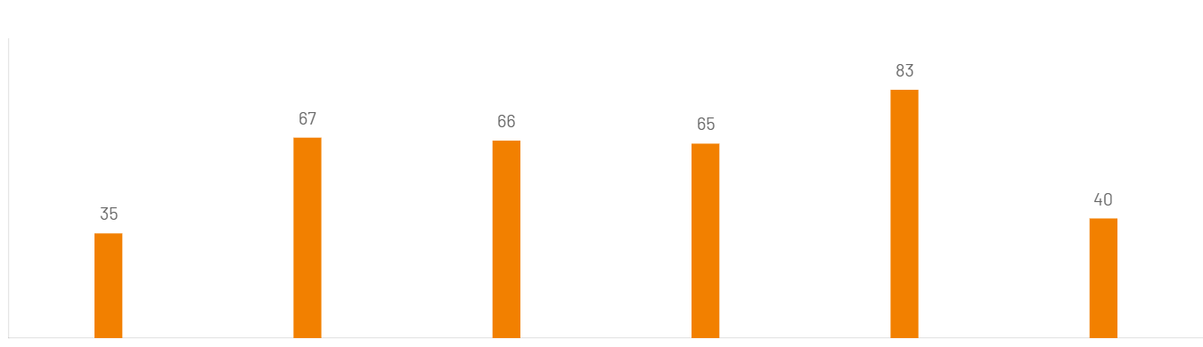
Figure 1. Analyse Germany
Source: (Hofstede-insights.com, 2021)

- Japanese Culture
Japan has a unique and fascinating hotel culture rooted in the country’s rich traditions and customs. Some of the key aspects of Japan’s hotel culture are concepts as Omotenashi, Ryokans and Onsens, Futons and Yukatas (Morishita, 2016).
Japanese hotel design often embraces a minimalist aesthetic characterized by clean lines, natural materials, and a sense of tranquillity. Japan’s hotel culture reflects the country’s deep-rooted traditions, attention to detail, and commitment to exceptional hospitality. Japanese employees in their corporations are most motivated when they compete in teams. In Japan, the desire for excellence and perfection may also be considered as a representation of masculinity. Examples include the material services provided by hotels and restaurants and the manufacture (monodukuri) and presentation (gift-wrapping, food presentation) of these things. (Hofstede-insights.com, 2021).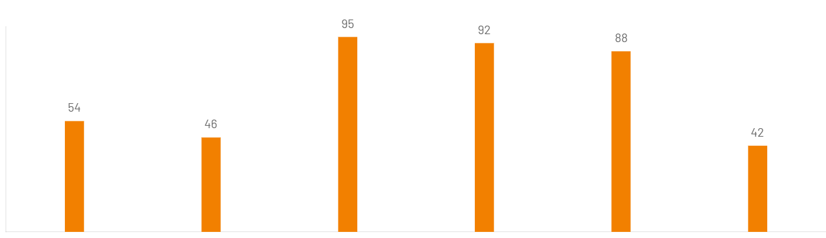

Figure 2. Analyse Japan
Source: (Hofstede-insights.com, 2021)

Cross-Cultural Theories

Hofstede's Theory of Cultural Dimension

Cross-cultural theories are the frameworks that offer information into recognising and adapting to different cultural standards, attitudes, and expectations (Jandt, 2016).
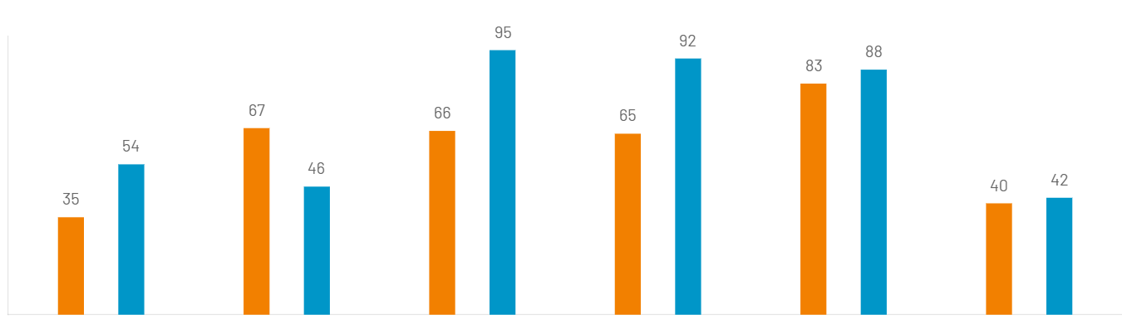
Figure 3. Hofstede Cultural Dimensions differences between Germany and Japan
Source: (Hofstede-insights.com, 2021)

The Hofstede comparison scheme shows that Japan has a higher hierarchical society than Germany or other any European country. And there is a visible difference between Individualism, Masculinity, and Uncertainty Avoidance, the only similarity is on Long Term Orientation and Indulgence. (Hofstede-insights.com, 2021)

Individualism
- Germany is known for its individualistic culture. Individual autonomy, success, and independence are highly regarded. People often put their personal demands and aspirations ahead of those of the group.
- Japan leans towards collectivism. Group harmony loyalty, and maintaining social cohesion are important values. People are more likely to identify themselves with their groups, such as family, company, or community, and prioritize group goals over personal interests (Armstrong, et al.1997).

Masculinity
- Germany is considered a relatively masculine culture. Success, assertiveness, and material achievements are valued. There is a focus on competition and the accumulation of wealth and possessions.
- Japan also exhibits masculine cultural traits. However, Japanese society has a unique blend of masculine and feminine values. While competition and success are important, there is also an emphasis on cooperation, harmony and modesty (Beckmann, Menkhoff and Suto, 2008).
Uncertainty Avoidance
- For German people details are equally important in order to convey the belief that a topic or undertaking has been properly thought out. Germans prefer to use their increasing knowledge to offset their growing uncertainty (Gardini, et all., 2018). This is because of their low Power Distance, which implies that the increased accountability of the boss does not apply to their judgement.
- Japan has a relatively high uncertainty avoidance. This is a strong preference for stability, structure, and predictability and those are because of the all-natural disaster which they have faced over time. Japanese society values rules, regulations, and social norms to reduce uncertainty and manage risk (Beckmann, Menkhoff and Suto, 2008).

Cultural Intelligence and Sensitivity
Cultural intelligence is the skill which makes a person able to work in culturally diverse circumstances, while cultural sensitivity is the ability to be aware of cultural differences. It is a fact that different people have different cultures and standards, and all should be valued and respected. Workers, especially those working in the hospitality industry, interact with different people daily (Zhang and Zhou, 2022).
Furthermore, they allow employees of the hotel to deliver modified and updated services to encounter the specific cultural requirements of customers or travelers (Wang et al., 2022). Cultural intelligence and sensitivity in the hotel staff can also benefit the organization as they assist in enhancing customer satisfaction. Due to cultural differences among workers and teams, their productivity slows down, and the chance of conflict goes high.However, Cultural intelligence and sensitivity are beneficial in boosting teamwork and collaboration among workers (Chase, Mackie, 2002). Workers can grow more positive and strong relations with each other through this, which ultimately increases the reputation and productivity of the hotel (Kecskés, 2022).

Do's and Don'ts
Do's | Don'ts
It is customary to remove your shoes at the door in the great majority of Japanese houses. | Avoid being late for meetings, Germans are very strict when it comes to punctuality
In Japan, priority seating should always be provided to the elderly, pregnant and/or disabled passengers. | Germans don't like you to call them late at night, especially in the weekend, they have an evening routine and it is special for them.
In Germany, when you raise your glass make eye contact. It is an offense if you are not doing so. | In Japan, do not start eating first, wait until everyone has food in front of them before you begin to eat.
Greet everyone, with a firm handshake and eye contact, German place a high value on this. | In Japan, don’t approach Geisha or Maiko  for selfies.
(gotravel123.net); (theinvisibletourist.com)

Conclusion
It is concluded from this report that Cultural intelligence and sensitivity play a vital role in the success of the hotel and make it able to increase its productivity and revenue. This also helps the staff to provide unique guest services to their guests of different cultures and backgrounds. This report evaluated and discussed key cultural differences, customs, and between Germany. And Japan. It also provides the strategy by which hotel staff can satisfy the guest of both countries. Furthermore, it has been recommended that hotel should completely train their workers about how to deal with customers of different cultures and values. They must know to respect and give value to all customers equally. It is also recommended that a cultural awareness session should also be provided to workers by which they can learn about the different cultures and easily handle customers in future.

References
Abramson, Neil, R.(2017) Managing Cultural Differences, 10th Routledge.
Armstrong, R.W., Mok, C., Go, F.M. and Chan, A. (1997).The importance of cross-cultural
expectations in the measurement of service quality perceptions in the hotel industry. International Journal of Hospitality Management, (online) 16(2), pp.181-190. doi:https://doi.org/10.1016/S0278-4319(97)00004-2 (Accessed 11 June 2023).

Chase, Mackie, 2002. Larry A. Samovar and Richard E. Porter, Wadsworth/Thomson

Learning, Belmont, CA, 2001, Communication between cultures (4th ed.), Elsevier Ltd; International Journal of Intercultural Relations, Vol.26 (3), p.329-332.
Commisceo-global.com,https://www.commisceo-global.com/resources/country-guides/germany-guide (Accessed 8 June 2023).
Beckmann, D., Menkhoff, L. and Suto, M. (2008). Does culture influence asset
managers’ views and Behavior? Journal of Economic Behavior& Organization, 67(3-4), pp.624-643. doi:https://doi.org/10.1016/j.jebo.2007.12.001 (Accessed 11 June 2023).
Gardini, M.A., 2018, Academia Versus Practice? Toward a Debate on the Value of Academic Education in the German-Speaking Hospitality Industry, Journal of Hospitality & Tourism Education 30:4, pp. 250-256
Gotravel123.net
www.gotravel123.net/things-not-to-do-in-germany-cultural-dos-donts-to-know (Accessed 5 June 2023).
Hofstede-insights.com. (2021). Country comparison tool. (online) Available at: https://www.hofstede-insights.com/country-comparison-tool?countries=germany (Accessed 29 May 2023).
https://www.hofstede-insights.com/country-comparison-tool?countries=japan
(Accessed 8 June 2023).
Jandt, F (2016) An Introduction to Intercultural Communication, 8th edition, Sage: San Bernadino.
Kecskés, I. ed., 2022. The Cambridge Handbook of Intercultural Pragmatics. Cambridge University Press.
Morishita, S., 2016. Managing omotenashi in onsen ryokans A case study of Kurokawa Onsen in Kyushu, Japan. Journal of Global Tourism Research, 1(2), pp.157-160.
Theinvisibletourist.com, https://www.theinvisibletourist.com/dos-and-donts-in-japan-tourist-guide-etiquette/#:~:text=This%20guide%20to%20do%E2%80%99s%20and%20don%E2%80%99ts%20in%20Japan,Island%20Don%E2%80%99t%20deface%20significant%20UNESCO%20World%20Heritage%20sites, (Accessed 11 June 2023).
Wang, C., Wu, S.Y., Nie, Y.Z., Cui, G.Y. and Hou, X.Y., 2022. Open-mindedness trait affects the development of intercultural communication competence in short-term overseas study programs: a mixed-method exploration. BMC Medical Education, 22(1), pp.1-9.
Zhang, X. and Zhou, M., 2022. Information and digital technology-assisted interventions to improve intercultural competence: A meta-analytical review. Computers & Education, p.104697.

