UNIVERSITY OF WALES:  TRINITY SAINT DAVID |  |  | PRIFYSGOL CYMRU:  Y DRINDOD DEWI SANT
LOCATION: LAMPETER |  | LLEOLIAD: LLAMBED
LEVEL 6 |  | LEFEL 6
EXAMINATION PERIOD |  | CYFNOD ARHOLIADAU
January 2017 |  | Ionawr 2017

CLAH6007
West meets East:
At the Borders of the Oikoumene and Beyond

TIME: 2 HOURS
answer Two OUT OF SIX QUESTIONS IN section A

answer ONE out of FOUR QUESTIONs in section B

Candidates should ensure that they avoid repetition of material in their answers to different sections, and between their answers and their coursework essays.

SECTION A (50 MARKS)

ANSWER TWO OUT OF SIX QUESTIONS IN SECTION A

Analyse the context and content of two of the following six passages/images:

1. “India, which, after the death of Alexander, had shaken, as it were, the yoke of servitude from its neck, and put his governors to death. The author of this liberation was Sandrocottus, who afterwards, however, turned their semblance of liberty into slavery; for, making himself king, he oppressed the people whom he had delivered from a foreign power, with a cruel tyranny. This man was of mean origin, but was stimulated to aspire to regal power by supernatural encouragement; for, having offended Alexander by his boldness of speech, and orders being given to kill him, he saved himself by swiftness of foot… Sometime after, as he was going to war with the generals of Alexander, a wild elephant of great bulk presented itself before him of its own accord, and, as if tamed down to gentleness, took him on its back, and became his guide in the war, and conspicuous in fields of battle. Sandrocottus, having thus acquired a throne, was in possession of India, when Seleucus was laying the foundations of his future greatness; who, after making a league with him, and settling his affairs in the east, proceeded to join in the war against Antigonus.” – Justin 15.4 – trans. by J. S. Watson (1853).

2. “The Kingdom of Da Qin [the Roman Empire] is also called Lijian. As it is found to the west of the sea, it is also called the Kingdom of Haixi [Egypt]. Its territory extends for several thousands of li. It has more than four hundred walled towns. There are several tens of smaller dependent kingdoms. The walls of the towns are made of stone... The king goes each day to one of the palaces to deal with business. After five days, he has visited all of them. A porter with a sack has the job of always following the royal carriage. When somebody wants to discuss something with the king, he throws a note in the sack. When the king arrives at the palace, he opens the bag, examines the contents, and judges if the plaintiff is right or wrong... Their kings are not permanent. They select and appoint the most worthy man. If there are unexpected calamities in the kingdom, such as frequent extraordinary winds or rains, he is unceremoniously rejected and replaced. The one who has been dismissed quietly accepts his demotion, and is not angry. The people of this country are all tall and honest. They resemble the people of the Middle Kingdom and that is why this kingdom is called Da Qin [literally, ‘Great China’]. The people of this country are honest in business; they don’t have two prices. Grain and foodstuffs are always in good supply. The resources of the state are abundant... The king of this country always wanted to send envoys to the Han, but Anxi [Parthia], wishing to control the trade in multi-coloured Chinese silks, blocked the route to prevent... In the ninth yanxi year [AD 166], during the reign of Emperor Huan, the king of Da Qin, Andun [Marcus Aurelius Antoninus], sent envoys from beyond the frontiers through Rinan [Commandery on the central Vietnamese coast], to offer elephant tusks, rhinoceros horn, and turtle shell. This was the very first time there was [direct] communication [between the two countries]. The tribute brought was neither precious nor rare, raising suspicion that the accounts [of the ‘envoys’] might be exaggerated.” - Fan Ye Hou Han Shu 88.11-12 – Trans. Hill (2015).

3. “Great King Ptolemy [III], son of King Ptolemy and Queen Arsinoe, who are brother and sister gods, themselves the children of King Ptolemy and Queen Berenice, who are saviour gods, a descendant on his father’s side from Heracles, son of Zeus, and on his mother’s side from Dionysus, son of Zeus, having assumed from his father a royal dominion of Egypt, Libya, Syria, Phoenicia, Cyprus, Lycia, Caria, and the Cyclades islands, led an expedition into Asia with a force of infantry, cavalry, a fleet of ships, and elephants from Troglodytis and Ethiopia. These animals his father and he himself first hunted out from these places and brought to Egypt for use in war. Having become master of all the land west of the Euphrates – Cilicia, Pamphylia, Ionia, the Hellespont, Thrace, and of all the armed forces in those lands as well as Indian elephants, and having brought the monarchs in all those places in subjection to him, he crossed the Euphrates river and subdued Mesopotamia, Babylonia, Susiana, Persis, Media, and all the remaining territory as far as Bactriana. He recovered all those holy objects that had been carried away from Egypt by the Persians, and he carried them back to Egypt with the rest of the treasure from the region. He sent his forces by way of canals that had been dug... [text breaks off here]” – Cosmas Christian Topography 2.93-98 – trans. by Bowersock (2013).

4. 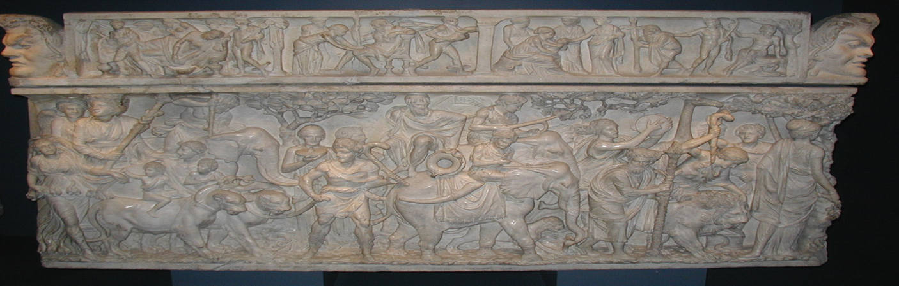

5.
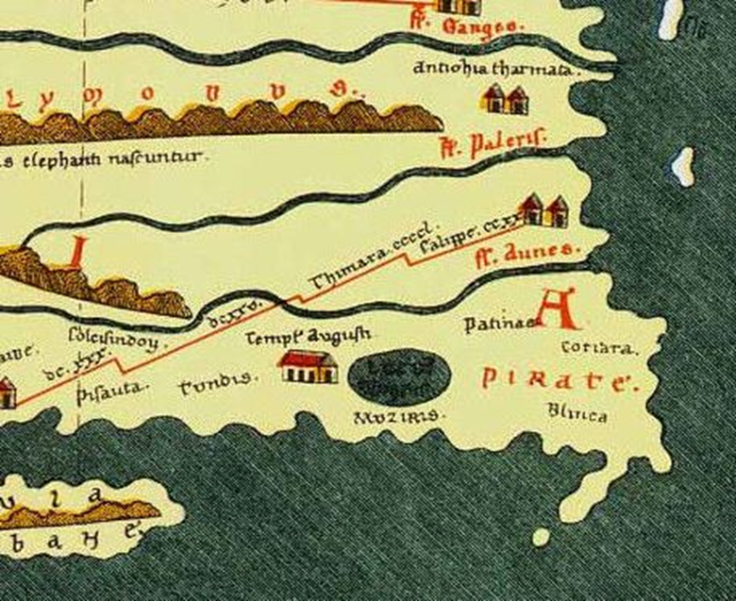

6.
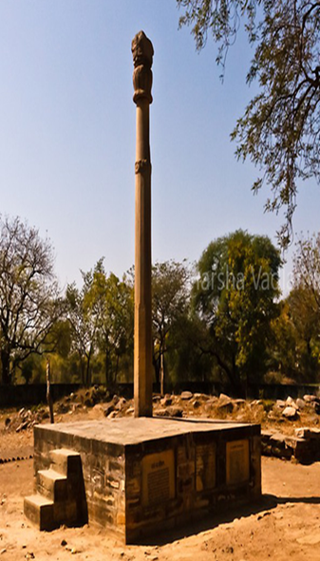
[Accompanying inscription] “This Garada-Standard of Vishnu, the god of the gods was erected here by the devotee Heliodorus…sent by the Great Greek King Antialcidas the son of Dion, a man of Taxila… as ambassador to King Kasiputra Bhagabhadra, the Savior son of the princess from Benares, in the fourteenth year of his reign…”
SECTION B (50 MARKS)

answer ONE out of FOUR QUESTIONs in section B

Write an essay on one of the following titles. You must ensure that you do not choose questions which will involve you repeating a significant amount of material from any of your answers in Section A.

1. Assess the impact that Alexander the Great’s campaigns had on the representation of India in the Classical sources.

2. Critically discuss the development of Ptolemaic interests in the Eastern Desert and Red Sea regions.

3. Critically discuss how Philostratus’ representation of India in the Life of Apollonius of Tyana suits the purposes of his work?

4. How much historical credence should be placed in the “discovery traditions” connected to Eudoxus of Cyzicus and Hippalus?

