Case Study.

Maureen Ann Lyttle.
Programme: Certificate of Higher Education in Skills for the Workplace.
Module: Psychology for Health and Social Care.
Student Number: 2029466
Module code: BMHP4003_BIRM.
Lecturer Name: Rebecca Kavanagh

Table of Contents
Introduction 2
1. Social identity theory 3
“Cognitive Processes of Social Identity” 4
2. Theory of Planned Behaviour 4
3. Frustration Aggression Hypothesis 6
Conclusion 7
References 8

Introduction
Specific systems of human cognition, action, and emotion can be explained by psychological theories, which are conceptual behaviors for organizing and analyzing these concepts. Psychologists develop these theories to create predictions about human behavior or events that may occur if certain behaviors are present. These “theories” help draft strategies to enhance employee behaviors, increase motivation, and promote productivity in the workplace. Based on the case scenario, a city-based youth offending team responds to the ongoing rise in young offenders. For example, Mason is one of the young offenders who has already spent 18- months in jail for narcotics. Psychological approaches are critical in understanding why young offenders return to their problematic behavior. The assignment will employ several theories to understand the behavior of the youth. Other hypotheses may illuminate Mason's motivations and suggest ways to assist him. The paper will contain the analysis based on three theories: the theory of planned behavior, social identity theory, and frustration Aggression hypothesis.

Social identity theory
Personal and social identities interact in social identity theory, a branch of social psychology. Social identity theory aims to explain and predict how people perceive their identities as individuals or members of groups. An additional focus of the idea is how people's perceptions and group actions are influenced by their personal and social identities.
As the group implies, the social identity sphere encompasses all of one's affiliations and affiliations. “Social identity theory, which social psychologists Henri Tajfel and John Turner articulated in the 1970s, outlines the circumstances under which social identity becomes more relevant than one's identity as an individual”. As a result of this theory, intergroup behavior may be influenced by a person's social identity.
Participants in these experiments were randomly divided into several groups. Although their group members had no practical value, the study found that participants preferred their in-group to the out-group, even though they had no prior contact with members of either group and had no reason to favor their in-group over the out-group.
According to the case study, he is a teenager, so he would connect to the adolescent social group in the neighborhood. The group's identity may be measured in Mason's second stage of social identification. Because of the rise in the number of young criminals, the features of this society have a group on Mason. It is crucial to understand bias because if Mason feels that the organization supports a specific behavior from him, he will behave in that manner.it is also vital to emphasize that the idea of "in-group" is not anything Artificial or alien in social identity theory. Instead, it is about a person's identity of a person it is a truthful, accurate, and fundamental element of a person. So, it is vital to understand the behavior of Mason.

“Cognitive Processes of Social Identity”
According to the “social identity theory," people must go through three conceptual processes to categorize themselves as belonging to an in-group or an out-group.
To better comprehend our social environment, we use social categorization to categorize individuals into social groups. Using this method, we can identify individuals, including ourselves, depending on the groups we belong to. More often than not, we group people depending on their socioeconomic status.
Social categorization frequently focuses on the similarities of folks in the same group and the disparities between people in other groups. There are several social categories that one might fall into, but the social importance of each classification categories with the context in which one finds oneself.
In the second phase, A person's sense of belonging to a group is formed during the social identification phase. A group's behavior is more likely to resemble its members if they feel a strong belonging to a particular group.
In the third phase, called "social comparison," people compare their own group's standing and social position in status to that of other groups.
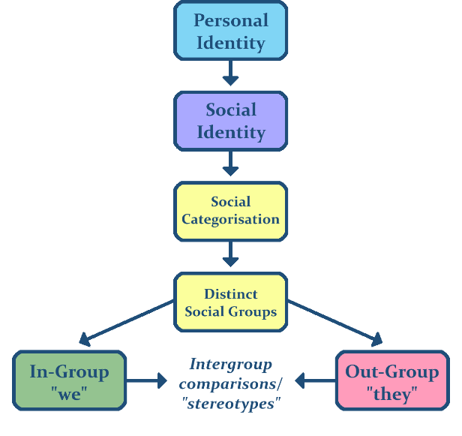

Theory of Planned Behaviour
“The Theory of Planned Behavior (TPB) started as the Theory of Reasoned Action in 1980 to forecast an individual's intention to engage in a behavior at a specific time and place”. The theory was supposed to represent all people can regulate behavior. This model emphasizes the importance of one's beliefs about the probability that their actions will have the intended results and assessing the risks and advantages of such ideas.
Smoking, drinking, use of medical services, breastfeeding, and substance abuse have all been effectively predicted and explained using the TPB. According to the TPB, student ability and motivation are interwoven to achieve behavioral objectives (behavioral control). Behavioral, normative, and controllable are the three types of beliefs separated by this theory.
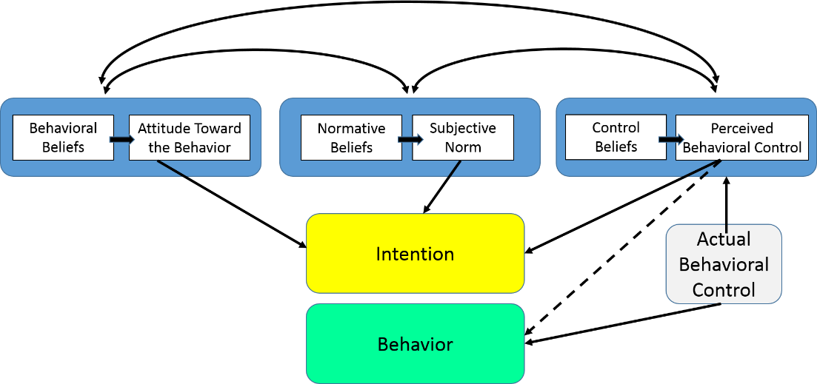
The investigation demonstrates that Mason's intention might be due to proximal cognitive representation. Attitudes are the most crucial indicator of the "intention to re-offend." To put it in another behavior, the likelihood of someone like Mason committing an offense is directly proportional to their level of desire or intention to do so. Thus, it may be claimed that the behavior is not always regulated and may not always be voluntary. Normative beliefs, behavioral beliefs, and control beliefs play an essential behavior in determining his actions. Mason's behavior might be due to the assumption that he can get away with these acts as he previously acquired possession of narcotics.
Similarly, he may think that he is required to perform in a way that shapes his attention. As a result, Manson's repetitious behavior may be explained by his belief that he could work in a specific way without suffering any significant consequences. That is why he is likely to behave this way anytime. So, Mason will likely be involved in the offense, assuming that he would gain social approval for his behavior as a teenager.

Frustration Aggression Hypothesis
“The theory proposed in 1939 by John Dollard and colleagues that (a) frustration always causes an aggressive drive and (b) aggression is always the product of earlier frustrations. Neal E. Miller, one of the proponents of this theory, later recognized that frustration could lead to different kinds of acts but maintained that the drive to aggression would become more prevalent as the thwarting continues. In 1989, U.S. psychologist Leonard Berkowitz (1926) proposed that the frustration must be distinctly unpleasant to trigger an aggressive urge. The aggression–frustration hypothesis is another name for this idea”.
The hypothesis that aggressive behavior is caused by a person's frustration with their goals is also known as the frustration-aggression theory. One way to test this hypothesis was to investigate scapegoating and hate research crimes, which showed how, during times of stress (such as an economic downturn), aggrieved people might release their animosity against an easy target, a minority group.
“Frustration-aggression hypothesis” was influential for many years in the field. There were also significant objections to the hypothesis due to its theoretical rigidity and overgeneralization; it was evident that the hypothesis' range needed to be limited to establish its validity. Using the first hypothesis as an example, it failed to distinguish between aggressive and instrumental types of aggression. The actor's primary purpose is to do injury rather than gain control or dominance (such as control or domination). The frustration-aggression hypothesis can be exclusively confined to hostile aggression situations to meet this objection.
Finally, it turned out that the link between frustration and aggressiveness was more complex than “Dollard and his colleagues” had first believed. “American social psychologist Leonard Berkowitz changed the initial frustration-aggression hypothesis to propose that frustration is a psychologically unpleasant state that can lead to aggressive behavior. Frustration, according to Berkowitz, will lead to aggression to the extent that negative emotions are elicited. And frustration isn't the only negative emotion that can lead to violent outbursts”.
Negative emotions, sentiments, and recollections of how we reacted to negative situations in the past are all regarded because of aversive experiences. “Berkowitz found that such negative feelings and thoughts lead automatically to the fight-or-flight response. Fight or flight was assumed to be based on the intensity of the negative emotion and the subjective assessment and perception of the circumstance”.
According to this theory, expressing one's anger through physical or verbal aggression can provide catharsis and relieve one's emotional strain. However, a charge may be defined. Differently, Mason believes his attack was through criminal crimes. He may have exercised this aggression in other kinds when given an opportunity; this is known as displacement. The following figure shows how a person may act in a specific way as per the Frustration Aggression theory. In the case of Mason, there is a potential that he is releasing his frustration through these actions. Thus, it is essential to determine the drivers of his behavior.
According to researchers, violent media material can promote the link between aggression and frustration. Various drivers can lead to certain behaviors, as the theory successfully explains. Historically, early psychologists described frustration as an occurrence coming from "termination of reinforcement" that previously sustained a demeanor. Understanding Mason's behavior is essential in figuring out what motivates his actions. The young offender team can go to his family to study his family circumstances and see whether his family's problematic behavior is causing his aggressive behavior. Theory shows that frustration may affect arousal levels in the brain. One of the critical reasons for aggression is the "unpleasant ambient state." The unpleasant behavior might be the explanation for aggressive urges in Mason. It is also vital to emphasize that there might be an environmental cue causing his aggressive behavior in the case of Mason.
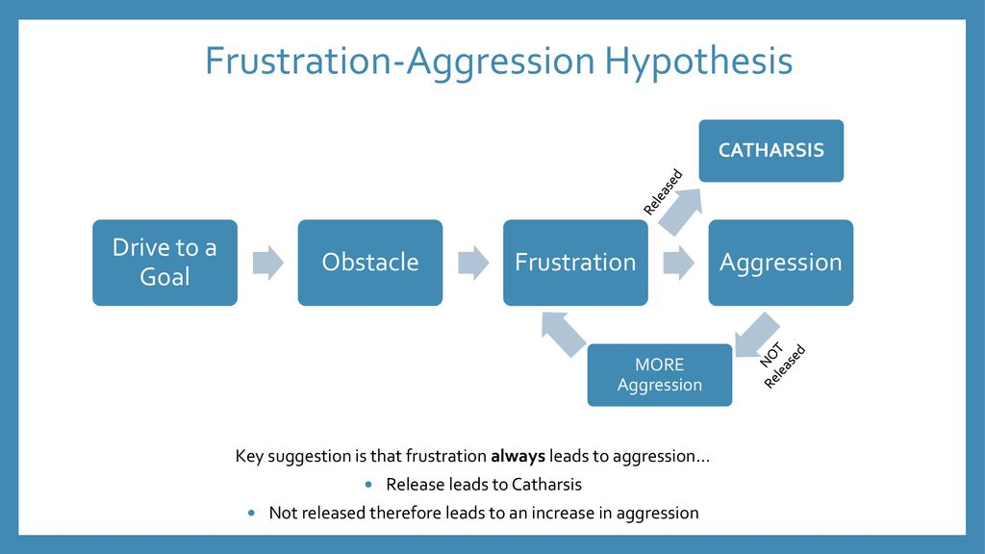

Conclusion
In conclusion, the report should explore Mason's case and other theories to understand the reason for Mason's behavior. Mason The information has addressed numerous ideas that have presented a new viewpoint on the behavior of Mason. This research shows that Mason may be acting due to peer pressure or his sense of social belonging. For Mason's bad behavior to be corrected, the offending youth team must know what's going on in his problematic behavior.

References
Ellemers, N., 2019. Social identity theory: Definition, history, & facts. Encyclopedia Britannica. [online] Available at: https://www.britannica.com/topic/social-identity-theory.
Vinney, C., 2018. Social Identity Theory and the Cognitive Processes Behind In-Group Favoritism. [online] ThoughtCo. Available at: https://www.thoughtco.com/social-identity-theory-4174315.
Barraclough-Brady, A., 2021. Octonauts-National Identity and Attribution Theory in Children Learning About Nations.
LaMorte, W., 2019. The Theory of Planned Behavior. [online] sphweb.bumc.bu.edu. Available at: https://sphweb.bumc.bu.edu/otlt/MPH-Modules/SB/BehavioralChangeTheories/BehavioralChangeTheories3.html.
Burns, J.C., and Saint Arnault, D., 2019. Examining attitudes, norms, and perceived control: Young African American males' views of social media as a model for condom use education. Cogent Social Sciences.
Avital Mentovich and Jost, J.T., 2017. Frustration-aggression hypothesis | Definition, Application, Development, & Facts. In: Encyclopædia Britannica. [online] Available at: https://www.britannica.com/science/frustration-aggression-hypothesis.
Nickerson, C., 2021. Frustration-Aggression Hypothesis - Simply Psychology. [online] www.simplypsychology.org. Available at: https://www.simplypsychology.org/frustration-aggression-hypothesis.html.
Indeed Career Guide., n.d. What Are Psychological Theories? (Definition, Tips, and Examples). [online] Available at: https://www.indeed.com/career-advice/career-development/psychological-theories.

