

Module Title: Marketing Management
Module Code: LCMB7024
Component 1

Report Title: Marketing Environment Analysis and Growth Strategy of Tata Steel’s Low-Carbon Transition

Student Name: Bogdan Pacuraru
Student ID: 2245496

Table of Contents
1. Introduction 3
2. Company Overview 3
3. Task 1: Marketing Environment Analysis 4
3.1. Natural Environment Factor 4
3.2. Second External Factor 6
3.3. Opportunities and Challenges 7
4. Task 2: Strategic Growth and Competitive Positioning 8
4.1. Ansoff Matrix Application 8
4.2. Competitive Advantage 10
4.3. Porter’s Generic Strategy 11
5. Task 3: Critical Reflection on AI Usage 11
5.1. AI Tools Used 12
5.2. Verification of AI Information 12
5.3. Personal Contribution 12
5.4. Ethical Reflection 12
6. Conclusion 13
References 14

1. Introduction
The worldwide metals and mining business has encountered growing pressures to lessen their emissions and implement sustainable practices (Smith and Wentworth, 2022). Tata Steel is investing in low carbon technology in order to align with government regulations regarding greenhouse gas emissions and satisfy the growing expectations of its customers for having environmentally friendly products. This report assesses the external marketing environment for Tata Steel by examining the natural environment and another dimension like technological influences. Additionally, the report evaluates strategic growth opportunities for Tata Steel using the Ansoff Matrix to demonstrate how Tata Steel can create a competitive advantage as it transitions to sustainability. The report also provides a critical reflection on the use of artificial intelligence during the assignment and investigates the ethical considerations of using AI-generated content to verify the accuracy of AI-generated data. The overall analysis illustrates how Tata Steel’s marketing strategy and sustainability initiatives can complement each other to foster growth in the long term, especially within the steel industry.

2. Company Overview
Tata Group, a multinational company that makes steel, based in India that was established in 1907. Operates around India, Europe, and South East Asia which is part of the Tata Group (Tata Steel, 2018). Tata Steel has a good reputation and provides products to many different industries, including automotive, construction, industrial, and infrastructure. Due to the focus of consumers and governments on environmental issues worldwide, Tata Steel has also expanded its commitment to producing sustainable and low carbon steel products by setting a target of attaining net-zero carbon emissions by 2045 (Tata, 2022). Tata Steel is investing significantly in the development and deployment of green technologies, including technologies for hydrogen steelmaking, electric arc furnaces, recycling systems, and carbon capture and storage. Furthermore, Tata Steel is also utilising artificial intelligence (AI), automation, and digitalisation to improve its operations while further reducing its environmental impact (Gajdzik and Wolniak, 2021). These initiatives are intended to improve Tata Steel's competitive position, brand image, and meet the increasing demand from consumers for sustainably produced steel in the international marketplace.

3. Task 1: Marketing Environment Analysis

3.1. Natural Environment Factor
The natural environment is one of the external factors that has the greatest impact on Tata Steel and the shift to low carbon steel. Traditional steel production is coal and blast furnace based, resulting in high greenhouse gas emissions in the global steel sector. Steel companies now face pressure from rising climate change issues due to the need to cut emissions and to use sustainable production processes (SteelWatch, 2025). Companies are now expected to be responsible and contribute to global sustainability goals by governments, environmental organisations, investors and customers.
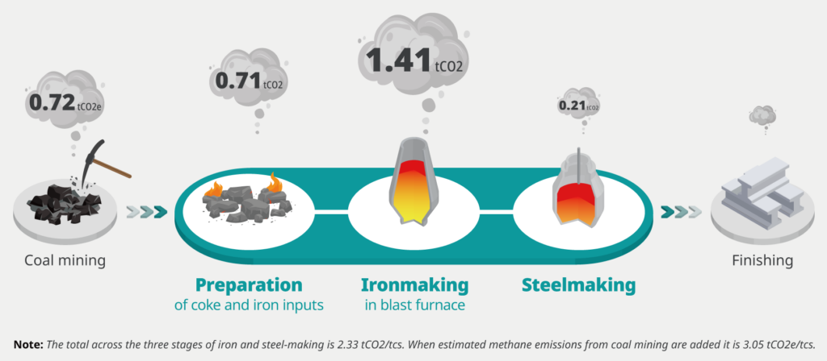
Figure 01: GHG emissions per tonne of steel at each stage of production
(Source: SteelWatch, 2025)
To address these concerns, Tata Steel has implemented sustainability measures and set long-term environmental goals. The company is seeking to reach the net zero carbon emissions by 2045 and has put measures in place to lower its environmental footprint through better production technologies. They involve electric arc furnaces, carbon capture, renewable energy and hydrogen-based steelmaking technologies. Electric arc furnaces use recycled steel and electricity rather than coal-based blast furnaces, making them more environmentally friendly (Somers, 2022). These technologies can help to cut carbon emissions and enhance environmental performance.
Their business decisions are also influenced by environmental regulations. Globally governments are endorsing precise carbon reduction policies, environmental reporting requirements and sustainability regulations (Luo and Tang, 2023). Tata Steel also has regulatory issues in Europe about pollution control and carbon emissions from the production plants. These requirements raise the cost of operations as well as encourage innovation and investment in “green” technologies.
Moreover, implemented the principles of circular economy by promoting steel recycling and minimising waste production. Recycling steel conserves energy and minimizes the use of raw materials (KUMAR, n.d.). The company has also been working on conserving water resources and being energy efficient in its manufacturing plants. The company's sustainability efforts enhance its environmental footprint and foster stakeholder connections.
The natural environment also influences consumer actions and brand image. Consumers and industrial buyers are increasingly looking for companies that are environmentally responsible. Steel companies have been asked by automotive and construction companies to make the products greener due to their sustainability goals (Tolettini and Di Maria, 2023). Hence, the investment in low carbon steel production can strengthen the trust of the customers, brand loyalty and competitive advantage of Tata Steel. Also sustainability is important for marketing mix (PALEPU et al., n.d.).
There are challenges to transition towards sustainable production. The investment costs of green technologies, the need for advanced infrastructure and the time required for their implementation are high. The adoption of cleaner technologies can have an impact on the efficiency of production and employment as well (Li et al., 2023). In spite of these challenges, sustainability is key to Tata Steel's future success and competitiveness on the market.
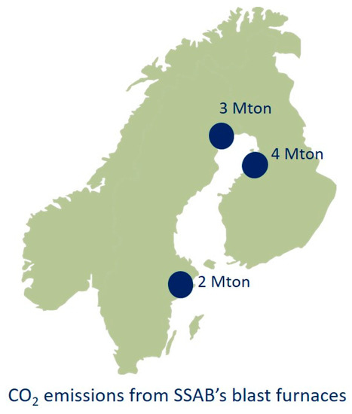
Figure 02: CO₂ Emissions in SSAB Steelworks
(Source: Pei et al., 2020)

3.2. Second External Factor
Technological Environment
Another key external element is technology, which is also having an impact on Tata Steel's low-carbon journey. Technological innovations enable the steel industry to be more efficient, cut waste, reduce emissions, and gain a competitive edge (Stavropoulos et al., 2022). Artificial Intelligence (AI), automation, and digital technologies are becoming essential in the modern steel industry to enhance production processes.
The company has been using Industry 4.0 technology like AI, machine learning, automation, and digital monitoring systems. Predictive maintenance, process optimisation, quality control and energy management are supported by these technologies. AI and automation enhance the efficiency of the operations. They decrease mistakes, minimise manufacturing costs and boost productivity. Digital systems also enable the company to track its environmental performance and energy use (Ajiga et al., 2024).
The steel industry is increasingly looking to clean technologies. Tata Steel is focused on hydrogen steelmaking and renewable energy systems to move away from coal. The use of hydrogen technology is expected to be one of the most promising solutions to lower carbon emissions in steel production due to its lower greenhouse gas emissions (Mallett and Pal, 2022).
Innovations in technology also help produce low carbon steel products. Adopted green technology organisations can stand out from their rivals and gain the loyalty of green-minded consumers (Zhu et al., 2023.). Investment in research and development boosts Tata Steel's capability to respond to the changing needs of the market and enhance its sustainability performance. Hence, technological improvement is a key factor in meeting the company's environmental and competitive goals (Sharma and Vij, 2024).
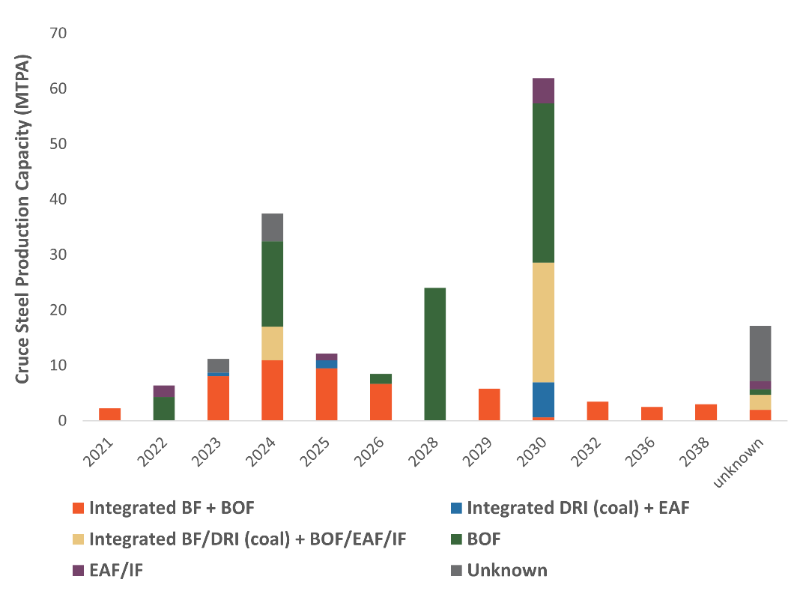
Figure 03: India Crude Steel Projects 2038
(Source: Tiwari, 2023)

3.3. Opportunities and Challenges
Green steel offers several opportunities to Tata Steel. The increasing demand for sustainable products helps to expand market share and customer relationships. Low carbon industries are also being promoted by government and investors via funding, partnerships and sustainability incentives. This could therefore enhance the long-term profitability and reputation of Tata Steel, its strong sustainability strategy (Mir et al., n.d.).
However, there are some significant issues. Green technologies have high investment expenses and are not always profitable (Kasraee, Shirazi and Alba, 2026). Global steel industry firms investing in similar sustainable tech could limit competitive edge. Further, there is also business uncertainty due to changing regulations and fast changes in technology. Additionally, Tata Steel's sustainability efforts bring the company a good start to the low-carbon steel market in the future.

4. Task 2: Strategic Growth and Competitive Positioning

4.1. Ansoff Matrix Application
Ansoff Matrix | Existing Products | New Products
Existing Markets | Market Penetration  - Increase sales of existing steel products  - Improve customer loyalty through sustainable branding  - Use AI and automation to improve efficiency and reduce costs | Product Development  - Develop low-carbon and green steel products  - Invest in hydrogen-based steelmaking and electric arc furnaces  - Introduce eco-friendly steel for automotive and construction industries
New Markets | Market Development  - Expand green steel exports to Europe and North America  - Target environmentally conscious industries  - Enter markets with strict carbon regulations | Diversification  - Invest in renewable energy partnerships  - Develop recycling and circular economy businesses  - Explore sustainable infrastructure materials
The Ansoff Matrix is a framework for determining how a business can grow by four strategies: market penetration, market development, product development, and diversification. Market development and product development are the most appropriate for Tata Steel to assist its move towards low carbon steel production (Qomaro, Nasrulloh and Salleh, 2024).
Market Development is a strategy of introducing already developed products into new geographic markets or customer segments. Tata Steel can enter into new markets with its green steel products, as environmental regulations and sustainability awareness are rising, especially in Europe and North America. Governments and industries are now increasing their focus on carbon emissions reductions in manufacturing industries as per World Steel Association (2025). This presents significant opportunities for those companies making sustainable steel products. The steel industry is increasingly under environmental pressure as it accounts for around 7-9% of the global carbon dioxide emissions (Horst and de Andrade Júnior, 2022).
In Indian industrialisation steel played a major role. The National Railways Plan 2030, Housing for All Mission and industrial corridor projects are likely to drive up the demand for steel to a considerable extent, Mallett and Pal (2022), explain. But the benefits of increased steel production come with issues. Sustainable transformation will be required for the future growth of industry.
Tata Steel's competitive growth is best achieved by product development. Product development is creating new or improved products for current markets. Tata Steel can leverage on its market position by making steel with cleaner production technologies environmentally friendly and low carbon. Teixeira (2025), states that green steel technologies like hydrogen steelmaking, electric arc furnaces, and carbon capture systems are increasingly viable and cost-effective.
Tata Steel can also forge collaborations with renewable energy suppliers, green steel centres, and other stakeholders. Hoffmann, Eloot and Gurlit (2024), emphasises the potential for emissions reduction by shared renewable energy resources, hydrogen systems, and recycling plants. Thus, product development based on innovation can create a long-term growth and competitiveness for Tata Steel.
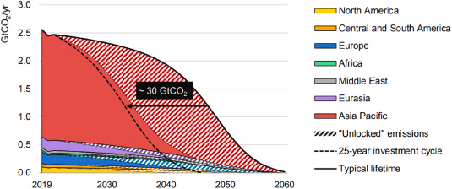
Figure 04: Emissions Across Steel Plant Lifetimes
(Source: Teixeira, 2025)

4.2. Competitive Advantage
The global steel industry can generate competitive advantages for Tata Steel from its sustainability strategy. One significant benefit is sustainable branding. Businesses which have a “green” approach and a commitment to carbon reduction are increasingly gaining customers, investors and governmental backing (Anukwonke and Abazu, 2022). Tata Steel can build a positive brand image and stakeholder relations by encouraging the adoption of green steel products and sustainability efforts.
Competitive advantage is also derived from innovation and technology. Tata Steel has invested in artificial intelligence (AI), automation and digital systems to increase efficiency and decrease environmental impact. With the help of AI, process control, quality control, energy efficiency and waste reduction are enabled. According to Huang et al. (2021), digital Twins and AI Process Control, AI technologies enhance operational efficiency and contribute to sustainability. A study by Jena et al. (2026), shows how AI can enhance sustainable manufacturing, optimising resource usage and reducing energy usage. As Wu et al. (2025), state that technological innovation and integration with renewable energy are crucial for cost-effective steel decarbonisation.
Trust and reputation of customers are another source of competitive advantage. KPMG India Metals and Mining Report 2025 revealed that customers are now looking for sustainability, transparency and doing good within companies operating in the industrial sector (KPMG, 2024). Tata Steel's environmental programs can help to build customer loyalty and lasting partnerships with industrial customers. This is an example of how the performance of sustainability impacts the public image of the company and its reputation.

4.3. Porter’s Generic Strategy
Porter's generic strategies refer to organisations gaining competitive advantage by either being low cost or different or by focusing on a niche. For Tata Steel, the best way to “differentiate” during their low carbon transition is the most appropriate.
Differentiation is providing products that are unique and valuable to customers. Tata Steel can set itself apart by making environmentally friendly steel products that have fewer carbon emissions (Shanmugam et al., 2021). The push towards green steel products is gaining momentum in a variety of industries, particularly in the automotive sector, infrastructure, and sustainable building.
Tata Steel's investments in innovation, renewables, and sustainability efforts can enhance brand credibility and customer loyalty as suggested by Aithal (2024). The company can also sell the low-carbon steel products at a premium in the eco-responsible markets. Thus, product development and differentiation can contribute to Tata Steel's sustainability and competitive edge in the global steel industry in the longer-term.

5. Task 3: Critical Reflection on AI Usage

5.1. AI Tools Used
This report was partly created by an AI tool like ChatGPT for outline concept, grammar and content organisation. AI also assisted with proofreading, checking grammar, syntax, and rephrasing sentences to meet academic standards. Dwivedi et al. (2024), suggests that generative AI tools can enhance the efficiency, productivity, and information management in research and professional practices.

5.2. Verification of AI Information
AI technology gives quick access to information. However, due to “hallucinations” the information provided by an AI tool may not always be correctly reported (Ji et al., 2023). Therefore, all content created using AI tools underwent cross-checking against peer-reviewed journals, company reports, or reputable industry sources. Numerical or sustainability data was validated through academic databases. Such cross-checks reduced the chance of reporting misleading information and enhanced the credibility of the overall analysis. Begum et al. (2025), systematic cross-checking is a method to provide a higher quality of academic work.

5.3. Personal Contribution
The final structure, analysis, critical evaluation and conclusions were written independently. Theories have been selected and sustainability strategies were evaluated by using personal judgement and opinions. These are evaluated based on personal judgement and opinion. Suggestions generated by AI were edited and retyped to fit the requirements of the assignment and academic standards. The assignment reflects the technological help and critical analysis.

5.4. Ethical Reflection
Honesty and transparency as well as clearly differentiating between the AI assistance and the original analysis, are key ethical considerations when using AI in higher education. Therefore, this assignment allows for the use of AI to conduct research and to proof read the papers; however, the critical evaluation, application of theory and conclusion are to be produced independently. The ethical use of AI is efficient; however, the over-reliance on it will likely diminish originality. Namoco and Ifedayo (2026), highlighted that integrity and honesty are fundamental to the use of AI in education, and therefore, students must adequately reference their sources and illustrate their own comprehension of the material. Also, Sikandar, Marghoob, and Ullah (2026) support that AI should always be used for assistance and not as a substitute for independent effort and critical thinking.

6. Conclusion
In summary, Tata Steel is shifting towards lower carbon production to align with the global steel industry's need for sustainability going forward. The marketing environment and strategic choices of Tata Steel are determined by technological advancements and environmental pressures. Tata Steel will face major challenges in the areas of capital cost and the transformation of operations. However, this will provide numerous opportunities for innovation and increased competitive advantages as well as enhance the reputation of the Tata Steel brand. The Ansoff Matrix will be used by Tata Steel to provide a strategic tool for growth and differentiation through product development, particularly the introduction of green steel. Reflections on applying artificial intelligence (AI) will show the necessity of properly implementing AI tools and maintaining academic integrity. The process of integrating sustainability into Tata Steel's strategic marketing will allow the company to remain competitive within its industry while satisfying stakeholder expectations and fulfilling its environmental obligations.

References
Aithal, P.S., (2024). Achieving business excellence through ethical business model: A success story of Tata Group, India. Poornaprajna Int. J. Manag. Educ. Soc. Sci, 1(2), p.165.
Ajiga, D., Okeleke, P.A., Folorunsho, S.O. and Ezeigweneme, C., (2024). The role of software automation in improving industrial operations and efficiency. International Journal of Engineering Research Updates, 7(1), pp.22-35.
Anukwonke, C.C. and Abazu, C.I., (2022). Green business through carbon credits. In Climate change alleviation for sustainable progression (pp. 315-332). CRC Press.
Begum, S., Ullah, M.I.J., Hussain, M.K., Eshra, S.A., Hossain, A., Rahaman, M.A. and Rahman, M.M. (2025) ‘Robotic AI systems for fake news detection in IoT-connected social media platforms using sensor-driven cross-verification’, Journal of Posthumanism, 5(11), pp.391–405.
‌Dwivedi, Y.K., Pandey, N., Currie, W. and Micu, A. (2024) ‘Leveraging ChatGPT and other generative artificial intelligence (AI)-based applications’, International Journal of Contemporary Hospitality Management, 36(1), pp.1–12.
Gajdzik, B. and Wolniak, R., (2021). Transitioning of steel producers to the steelworks 4.0—Literature review with case studies. Energies, 14(14), p.4109.
‌Hoffmann, C., Eloot, K. and Gurlit, W. (2024). Green-steel hubs: A pathway to decarbonize the steel industry. [Online] Available at: https://www.mckinsey.com/industries/metals-and-mining/our-insights/green-steel-hubs-a-pathway-to-decarbonize-the-steel-industry. [Accessed On: 15.05.2026]
Huang, Z., Shen, Y., Li, J., Fey, M. and Brecher, C., (2021). A survey on AI-driven digital twins in industry 4.0: Smart manufacturing and advanced robotics. Sensors, 21(19), p.6340.
Jena, M.C., Sahoo, J.M., Iqbal, S. and Sahoo, R., (2026). Application of artificial intelligence in sustainable manufacturing. Environmental Progress & Sustainable Energy, p.e70361.
Ji, Z., Lee, N., Frieske, R., Yu, T., Su, D., Xu, Y., Ishii, E., Bang, Y.J., Madotto, A. and Fung, P. (2023) ‘Survey of hallucination in natural language generation’, ACM Computing Surveys, 55(12), pp.1–38.
Kasraee, A.R., Shirazi, H. and Alba, K., (2026). A Scientometric Review of Green Technologies in the Steel Industry. Iranica Journal of Energy & Environment, 17(1), pp.72-92.
KPMG, (2024). 2024 Global Metals and Mining Outlook [Online] Available at. https://assets.kpmg.com/content/dam/kpmg/za/pdf/2025/GM-TL-01664_Mining-and-Metals-Outlook-TL_High.pdf [Accessed On: 15.05.2026]
KUMAR, O., (n.d.). Impact of Circular Economy and Supply Chain integration in Indian Steel Industry-a case study.
Li, C., Ahmad, S.F., Ayassrah, A.Y.B.A., Irshad, M., Telba, A.A., Awwad, E.M. and Majid, M.I., (2023). Green production and green technology for sustainability: The mediating role of waste reduction and energy use. Heliyon, 9(12).
‌Luo, L. and Tang, Q., (2023). The real effects of ESG reporting and GRI standards on carbon mitigation: International evidence. Business Strategy and the Environment, 32(6), pp.2985-3000.
Mallett, A. and Pal, P., (2022). Green transformation in the iron and steel industry in India: Rethinking patterns of innovation. Energy Strategy Reviews, 44, p.100968.
Mir, R.N., Alsum, S.A., Madkhali, S.I. and Mathari, B.,(n.d.). Corporate Social Responsibility (CSR) for Renewable Energy Adoption in Carbon-Intensive Industries: A Developing Economies Perspective with Focus on the Indian Steel Industry. Journal For Basic Sciences ISSN NO, 1006, p.8341.
Namoco, S.O. and Ifedayo, A.E. (2026). ‘Ethical use of ChatGPT in research writing’, Veredas do Direito, 23, pp.e234903–e234903.
PALEPU, K., NARAYANDAS, D., KAK, R. and TAHILYANI, R., (n.d.). Digital Transformation at Tata Steel.
‌Pei, M., Petäjäniemi, M., Regnell, A. and Wijk, O., (2020). Toward a fossil free future with HYBRIT: Development of iron and steelmaking technology in Sweden and Finland. Metals, 10(7), p.972.
Qomaro, G.W., Nasrulloh, N. and Salleh, A.Z., (2024). Leveraging The Ansoff Matrix for Strategic Growth in Packaged Food Micro-Enterprises. Dinar: Jurnal Ekonomi dan Keuangan Islam, 11(1), pp.51-66.
Shanmugam, S.P., Nurni, V.N., Manjini, S., Chandra, S. and Holappa, L.E., (2021). Challenges and outlines of steelmaking toward the year 2030 and beyond—Indian perspective. Metals, 11(10), p.1654.
Sharma, A.K. and Vij, S., (2024). Dynamic Capability of the Most Sustainable Firm in Indian Metal Industry: A Mixed-Method Approach. IUP Journal of Business Strategy, 21(1).
Sikandar, S., Marghoob, L. and Ullah, S. (2026) ‘Academic honesty and ethical learning practices among university students’, Social Sciences Spectrum, 5(2), pp.81–90.
Smith, D. and Wentworth, J., (2022). Mining and the Sustainability of Metals. Parliamentar y Office of Science and Technology, UK Parliament, London.
Somers, J., (2022). Technologies to decarbonise the EU steel industry.
Stavropoulos, P., Panagiotopoulou, V.C., Papacharalampopoulos, A., Aivaliotis, P., Georgopoulos, D. and Smyrniotakis, K., (2022). A framework for CO2 emission reduction in manufacturing industries: a steel industry case. Designs, 6(2), p.22.
SteelWatch (2025). SteelWatch Explainer: Why steelmaking drives climate change – and why it doesn’t have to be this way - SteelWatch. [Online] Available at: https://steelwatch.org/steelwatch-explainers/climate/. [Accessed On: 15.05.2026]
Tata (2022). Forging Sustainable Steel | Sustainability | Tata group. [Online] Available at: https://www.tata.com/newsroom/business/tata-steel-sustainable-aalingana. [Accessed On: 15.05.2026]
Tata Steel (2018). About Tata Steel | Global Company | Profile & Details. [Online] Available at: https://www.tatasteel.com/corporate/our-organisation/company-profile/. [Accessed On: 15.05.2026]
Tiwari, S. (2023). Taking Stock of Steel: India’s Domestic Production Outlook and Global Investments in Green Steel Production. [Online] Available at: https://www.climatepolicyinitiative.org/taking-stock-of-steel-indias-domestic-production-outlook-and-global-investments-in-green-steel-production/. [Accessed On: 15.05.2026]
‌Tolettini, L. and Di Maria, E., (2023). Structuring and measuring environmental sustainability in the steel sector: A single case study. Sustainability, 15(7), p.6272.
World Steel Association (2025). Sustainability Indicators 2024 report. [Online] Available at: https://worldsteel.org/wider-sustainability/sustainability-indicators/. [Accessed On: 15.05.2026]
Wu, X., Meng, J., Liang, X., Sun, L., Coffman, D.M., Kontoleon, A. and Guan, D., (2025). Technological pathways for cost-effective steel decarbonization. Nature, pp.1-9.
Zhu, Y., Zhang, H., Siddik, A.B., Zheng, Y. and Sobhani, F.A., (2023). Understanding corporate green competitive advantage through green technology adoption and green dynamic capabilities: does green product innovation matter?. Systems, 11(9), p.461.

