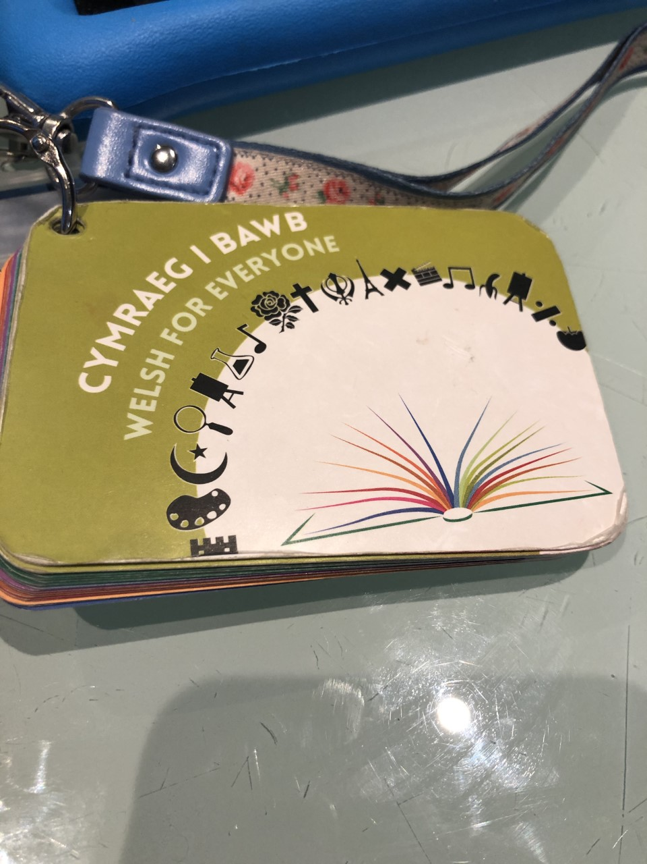
September 2019-
Cymraeg I bawb was purchased to help support my welsh development. I keep this attached to my lanyard and use it for incidental welsh, welsh praise, welsh assessment comments, days of the week, months of the year ect on a dily basis.

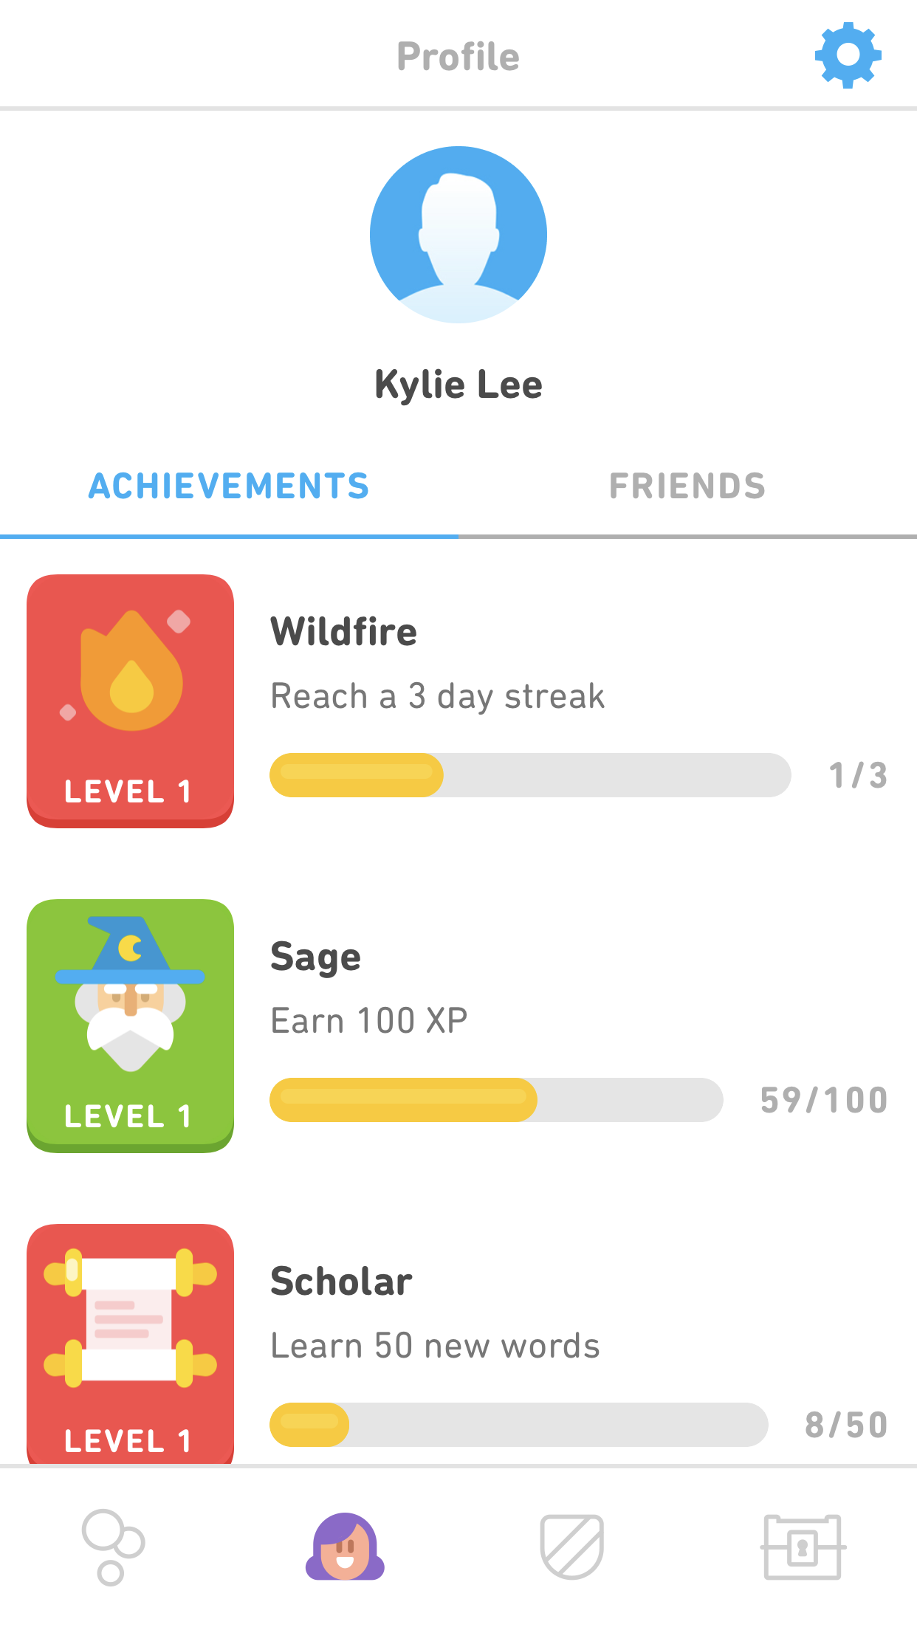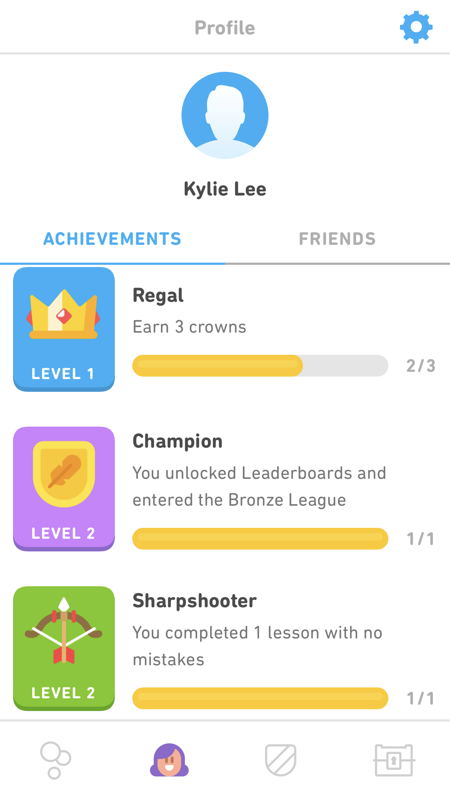
Duo Lingo App has been used daily to support my welsh development. Below is evidence of some assessments.

