MANAGEMENT AND ORGANISATIONAL BEHAVIOUR

-Hilton Hotel Group-
Report

Name: Corina Maria Danila
Student ID Number: 2118573
Module Title: Management and Organisational Behaviour BMIH5004
Lecturer: Lola Villard-Coles

Summary

This report provides an audit and analysis of the Hilton Hotel group, a global superpower in the hotel industry, examining the organizational structure, culture, objectives, strategy, and current performance results. Hilton's matrix organizational structure, customer-focused culture, and aim to be the best hospitable company is a reasonable basis. Its reputation has been enhanced by recent change programs like "Travel with Purpose" and digitalization, which have streamlined processes at the company. Hilton's strategic direction emphasizes expansion, development, and sustainability, which matches its robust profits. Compared with Hilton's rivals, such as Marriott International and Accor Hotels, its focus on sustainability, along with Hilton's brand diversity, provides its unique competitive advantage. Hilton can strengthen its position as the hospitality industry leader by focusing on sustainability, innovation, expansion in rising markets, and employee competencies to provide excellent guest service.

Table of Contents
Summary 2
Introduction 4
Organization Structure, Culture, and Goals 4
Organisational Structure 4
Organisational Culture 5
Organisational Goals 5
Recent Change Initiatives and Their Impact 6
Recent Change Initiatives 6
Impact of Change Initiatives 6
Strategic Direction and Current Business Performance 7
Strategic Direction 7
Current Business Performance 8
Comparison with Competitors 8
Recommendations 9
Conclusion 10
Appendices 11
Reference List 14

Introduction
The hospitality industry is among the most dynamic and competitive, where evaluation and adaptation are inevitable to cater to current consumer tastes while keeping up with modern market trends (Mullins and Dossor, 2013). This report aims to provide an extensive audit and assessment of the Hilton Hotel Group, a significant worldwide chain of hotels. Considering its storied history and global presence, conducting an audit on Hilton would be interesting. The analysis will focus on various important factors of the enterprise that range from the structural system, culture, goals, preceding change policy, strategic orientation, and actual business profitability. Moreover, comparing Hilton to other hotel groups like Marriott International and Accor Hotels is vital to show their strengths and liabilities. This research will conclude with recommendations to help Hilton remain a hospitality market leader.

Organization Structure, Culture, and Goals

Organizational Structure
Hilton uses Matrix organization, which combines the advantages of division and function orientation into one practice, creating a hybrid model through which Hilton can successfully specialize in specific purposes across various brands and geographical locations (Mullins and McLean, 2019). This setup comprises functional departments that handle specific tasks, including marketing, finance, and human resources (see Appendix A). Moreover, the divisional structure facilitates the management of different brands and geographical regions to allow Hilton to accommodate different market segments with their specifications (Mullins, 2016). Such a structure enables Hilton to efficiently cater to the differences in the areas and the changing consumer tastes. Nevertheless, despite its merit, the matrix structure has complexities, such as collaboration and decision-making (Boddy, 2014). Hilton's response to this complexity involves sophisticated technologies used in communicating among the various arms within the organization matrix.

Organizational Culture
The organizational culture of the Hilton Hotel Group is exceptionally sophisticated and founded on a deep appreciation of high-quality service and the well-being of workers (Zientara et al., 2020). Through continuous practice, it has developed a customer focus and service orientation that drives all its operations. Culture encompasses more than just ideas but drives the activities and performance of employees at Hilton (Huczynski and Buchanan, 2013). The Hilton team member promises to embody this culture, forming the business's core objective, which proves Hilton's devotion to promoting an embracing environment full of respect towards colleagues (Hilton, 2019). It highlights the importance of employee welfare in creating an environment that considers the people's sense of belonging and motivation to serve excellently.

Organizational Goals
The vision for Hilton Hotel Group is to be recognized worldwide as the most hospitable company, having the most ambitious and realistic goal in defining the organization’s strategic orientation. It then manifests in concrete objectives which guide the organization’s decisions and actions through the specified purposes (Armstrong, 2012). Hilton's primary goals entail increasing the company's presence worldwide, improving customer experience, and reaching environmental objectives (see Appendix D) (Hilton, 2022). The firm is interested in boosting and broadening its assortment of possessions with new investments and collaborations into foreign markets around the globe. Moreover, Hilton focuses much on customer satisfaction, knowing it is the root of continuous profitability (Tai, Wang and Luo, 2021). In this respect, the company uses an empirical technique to collect data on guests' interests to base their subsequent strategic choices and actions on facts rather than assumptions. According to Hilton (2022), it has adopted the role of bringing about beneficial changes in the communities it involves itself within an increasingly environmentally conscious world. Energy and water use management are some environmental practices Hilton upholds (see Appendix B).

Recent Change Initiatives and Their Impact

Recent Change Initiatives
- The recent changes in Hilton's strategies that are currently taking place represent the efforts aimed at adapting to a changing world along with adjusting to societal trends and customers' perceptions (Bloisi, Cook and Hunsaker, 2007). For example, the "Travel with Purpose" program and significant digitalization investments are among Hilton's most remarkable efforts.
- The Travel with Purpose initiative exemplifies Hilton's commitment to sustainability and the company's socially responsible stance (Hilton, 2022). Hilton's adoption of this initiative shows it acknowledges its global citizenship responsibilities towards others. Through this program, Hilton has incorporated sustainable practices within its day-to-day management and activities, including ethical sourcing, energy conservation, and community engagements (Abdou et al., 2022). Hilton strives to achieve a green company status and ensure its operations benefit the surrounding communities by changing its ideology to distance itself from its predominant industry.
- Hilton's investment in digitization is the response to the modern tendencies in the hospitality sphere. Guest expectations have undergone enormous metamorphosis in this digital era (Linxi, 2021). Today's passengers want a personalized experience from booking to checking out. The ever-changing guests' needs require a lot of investment from Hilton, which intends to use digital technology to raise the level of service and improve operational efficiency (Rollinson, 2008). These digitalization moves involve both front-end tools for customers and back-end processes that allow Hilton to maneuver rapidly in response to market changes.

Impact of Change Initiatives
- The "Travel with Purpose" initiative has improved the brand's reputation and customers' perception of Hilton. Hilton's Light Stay is a leading CSR performance reporting tool that provides the company with centralized oversight over the global operations of its franchise hotels (see Appendix C) (Hilton, 2022). Initially, it was designed for energy, carbon, water, and waste, but later added more indicators like local sourcing of supplies, youth training, and volunteer hours.
- Light Stay comes with a strategic tracking mechanism that is worldwide spanning and covers environmentally sustainable and operational, design and construction practice statistics (Hilton, 2022). In addition, it incorporates some engagement features of best practice spotlights and improvement advice for helping hotel managers and their workgroups adopt CR practices.
- For example, the "Meet with Purpose Checklist" provides workable tips that customers can practice during meetings and events (see Appendix E) (Hilton, 2022). Guests’ check-in online, and the experience is customized to suit the needs of each guest, thus raising its levels of convenience and effectiveness as far as guest interaction with the brand is concerned. This approach has increased guest satisfaction and loyalty (Ali et al., 2021). Through this procedure, customers can participate in environmentally conscious activities, consume consciously, and contribute positively towards the destination (Hilton, 2022). Environmentally, the platform model’s data to analyze and predict utility usage while paying attention to the social impact, including volunteering events, program impact data, and in-kind donations or local partnerships.
- These initiatives strengthen brand equity and customer loyalty, thus boosting a company's positive reputation (Pereira, Silva and Dias, 2021). Every Hilton property in the world uses Light Stay to rate how well they measured up against earlier years, as well as other companies in the global sector (Hilton, 2022). Tourists care more about sustainability, and Hilton Hotel fits their needs thanks to responsible enterprises' ecotourism focus.

Strategic Direction and Current Business Performance

Strategic Direction
- Directional strategy in Hilton involves an advanced outlook focused on growth, innovation, and conservation. It defines Hilton's core strategy in a highly competitive and dynamic environment within the hospitality industry (Hilton, 2019). Hilton's continuous drive towards growth in the number of brands and properties worldwide shows its strategic emphasis on expansion.
- Expansion is integral to Hilton's commitment to being the most hospitality company globally (Zientara et al., 2020). Hilton's strategy rests on innovation as one of its fundamental elements, as it acknowledges the necessity of technology considering changing customer tastes.
- Hilton has significantly invested in developing advanced digital solutions to improve visitor satisfaction (Hilton, 2022). Hilton's pledge towards innovation makes it a progressive organization that can respond to the changing needs of its visitors.
- The focal point of Hilton's strategy entails sustainability. It continuously works on limiting its impact on the environment and often interacts with local communities (Zientara et al., 2020). Hilton's holistic strategy meets its corporate social responsibility and fits the growing number of consumer-conscious people.

Current Business Performance
- The efficacy of Hilton's strategic direction can be seen in the organization’s current business performance, present in almost all market segments, including high-end and affordable hotels (Zhang, 2023). Diversification allows Hilton to cater to various customer preferences and budgets, reducing its vulnerability to economic fluctuations.
- A critical benchmark of Hilton's success lies in its financial achievements. Over time, the company's revenues and profits have kept rising, as reflected in its financial returns (Zientara et al., 2020). Such persistent financial development indicates Hilton's capacity to adapt to the current market situation.
- Its performance in an industry susceptible to economic fluctuations and geopolitical events illustrates its agility in coping with such challenges (Hilton, 2022). In addition, focusing on sustainability and social responsibility can lure eco-conscious travellers into Hilton's hotels (Zientara et al., 2020). It improves the brand reputation and provides an advantage in a market where sustainability becomes critical for customers.

Comparison with Competitors
- In a competitive business environment, the firm competes against other large hotel groups like Marriott International and Accor Hotels (Górska-Warsewicz and Kulykovets, 2020). Hilton's sustainability and social responsibility concern differentiates it from other hotel brands. "Travel with Purpose" programmed and comprehensive sustainability Hilton gives a competitive advantage over other companies (Hilton, 2022). Such emphasis on sustainability will likely attract increasingly eco-conscious tourists, an emerging market for Hilton's competition.
- On the other hand, Hilton's brand diversity and wide international presence can also be listed as main strengths (Zientara et al., 2020). By catering for different market segments ranging from high-end to low-budget hotels, the company has a robust customer base that lessens reliance on a specific market segment.
- The worldwide coverage of Hilton's properties enables the company to access multiple foreign markets and guarantees its successful presence on the world map (Zientara et al., 2020). Hilton's competitors, Marriott International and Accor Hotels, have unique strengths and strategies. Górska-Warsewicz and Kulykovets (2020) state that Marriott incorporates several acquired brands into their portfolio, while Accor Hotel relies on its loyalty program to stand out.

Recommendations
- Considering the outcomes of this audit and analysis, the Hilton hotel group should remain on course in sustainable development to fit into the rising demand for eco-travel (Moise, Gil-Saura and Ruiz Molina, 2021). Hilton Hotels could improve its reputation by leading in sustaining resources by enhancing its sustainability and workforce diversity.
- To improve the guest experience and increase operational efficiency, Hilton Hotels can continue focusing on research and innovation, especially on the digital front (Hilton, 2021). It is imperative to consider worldwide expansion into new regions to leverage the opportunities presented by the rapidly evolving hospitality business.
- Emerging markets, which exhibit expanding middle-class populations, escalating travel demands, and burgeoning tourism sectors, are commonly distinguished by significant opportunities for expansion (Mullins and Dossor, 2013). Establishing a presence with the Hilton brand will allow the company to explore other customers to serve and revenue sources.

Conclusion
Auditing and analyzing the Hilton Hotel Group has shown an effective organizational structure, a customer-oriented atmosphere, and clearly defined corporate objectives. The recent change initiatives concerning sustainability and digitization have led to positive organizational change. Expansion and sustainability are the key focus areas of Hilton's strategic direction, and they demonstrate their flexibility and durability characteristics amid tough competition in the industry in terms of performance. Balancing sustainability, innovation, expansion, and employee development makes Hilton one of the leaders in the hospitality industry globally. Suppose this is achieved by focusing on the same fundamental factors. In that case, Hilton will continue to be a trendsetter in global hospitality by meeting customer demands, unlocking growth potentials and responding to changing needs.

Appendices

Appendix A
The figure below is a visual representation of a Matrix organisational structure.
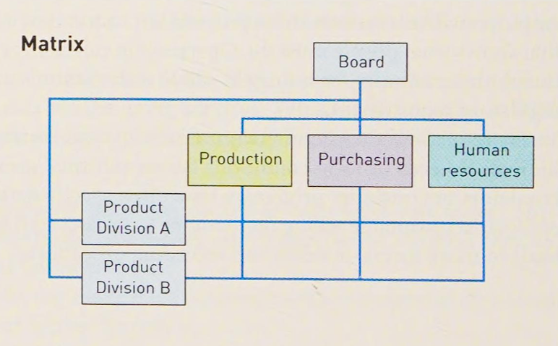
Figure: Matrix management structure (Boddy, 2014).

Appendix B
The figure below shows the water conservation strategies results employed by Hilton Hotels.
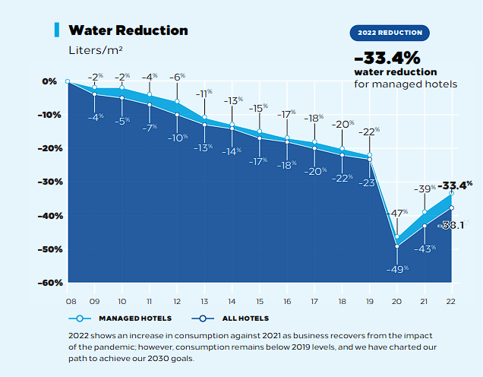
Figure: Water reduction graph (Hilton, 2022).
Appendix C
The figure below shows the evolution of Hilton's Light Stay since its development.
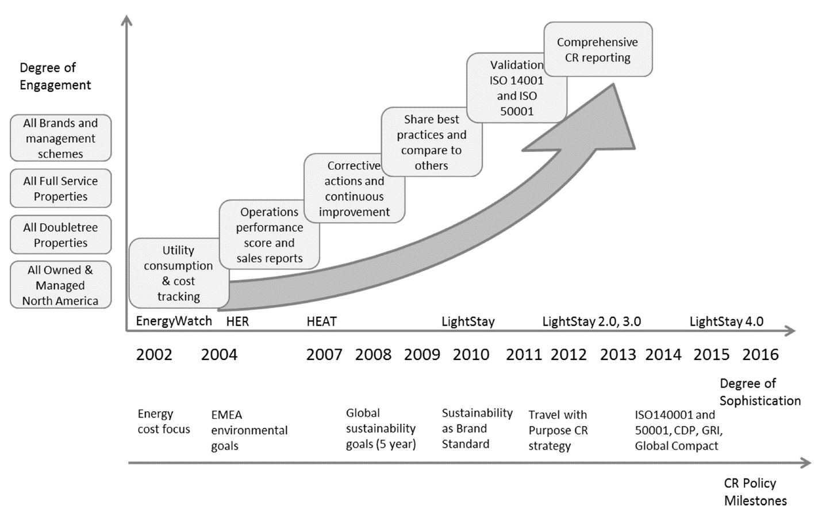
Figure: Light Stay evolution graph (Zientara et al., 2020).

Appendix D
The figure below represents Hilton Hotel Group's worldwide efforts towards reducing carbon emissions and enhancing sustainability.
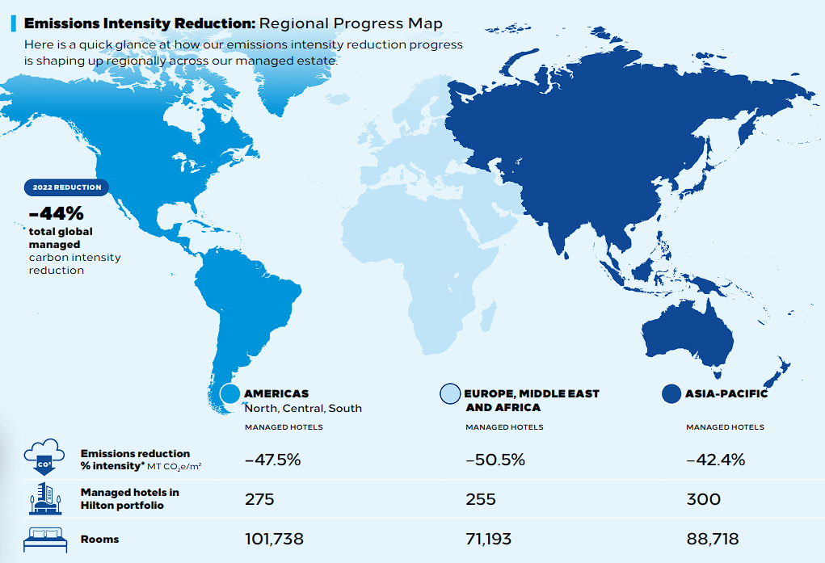
Figure: Graphical representation of reduced carbon emissions (Hilton, 2022).

Appendix E
The image below is a graphical representation of the Meet with Purpose initiative operations.
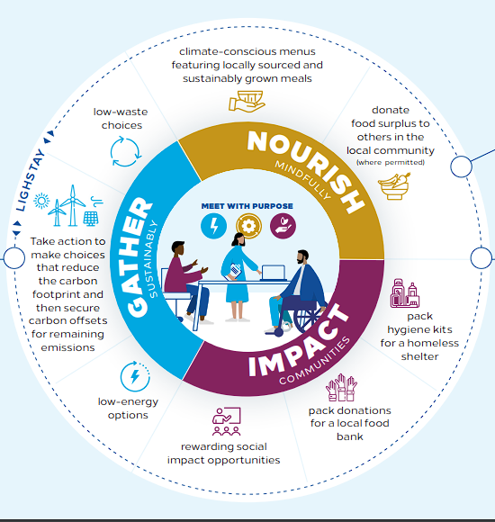
Figure: Meet With Purpose initiative (Hilton, 2022).

Reference List
Abdou, A.H., Hassan, T.H., Salem, A.E., Albakhit, A.I., Almakhayitah, M.Y. and Salama, W. (2022). The Nexus between Environmentally Sustainable Practices, Green Satisfaction, and Customer Citizenship Behavior in Eco-Friendly Hotels: Social Exchange Theory Perspective. Sustainability, [online] 14(19), pp.1–20. https://doi.org/10.3390/su141912791.
Ali, B.J., Gardi, B., Othman, B.J., Ahmed, S.A., Ismael, N.B., Hamza, P.A., Aziz, H.M., Sabir, B.Y., Sorguli, S. and Anwar, G. (2021). Hotel Service Quality: The Impact of Service Quality on Customer Satisfaction in Hospitality. International Journal of Engineering, Business and Management, [online] 5(3), pp.14–28. https://doi.org/10.22161/ijebm.5.3.2.
Armstrong, M. (2012). Armstrong's Handbook of Management and Leadership: Developing Effective People Skills for Better Leadership and Management. Third edition ed. [online]. London Philadelphia: Kogan Page. Available at: https://www.amazon.com/Armstrongs-Handbook-Management-Leadership-Developing/dp/0749465522.
Bloisi, W., Cook, C.W. and Hunsaker, P.L. (2007). Management and Organisational Behaviour. [online]. McGraw-Hill Education. Available at: https://books.google.com/books/about/Management_and_Organisational_Behaviour.html?id=2TPMAAAACAAJ.
Boddy, D. (2014). Management: An Introduction. 6th Edition ed. [online] Amazon. Pearson. Available at: https://www.amazon.co.uk/David-Boddy-Management-Introduction-6th/dp/B00NBKZUFQ.
Górska-Warsewicz, H. and Kulykovets, O. (2020). Hotel Brand Loyalty—A Systematic Literature Review. Sustainability, [online] 12(12), pp.1–34. https://doi.org/10.3390/su12124810.
Hilton (2019). Learn More about Hilton Culture. [online] Hilton. Available at: https://jobs.hilton.com/us/en/culture.
Hilton (2021). A Decade of Innovation in Just One Year: Seven Surprising Ways the Pandemic Has Changed Hotels Forever. [online] Stories From Hilton. Available at: https://stories.hilton.com/corporate-news/hilton-many-pandemic-safety-innovations-to-remain.
Hilton (2022). Hilton 2022 Environmental, Social and Governance Report. [online] Hilton ESG. Available at: https://esg.hilton.com/wp-content/uploads/sites/4/2023/04/Hilton-2022-Environmental-Social-and-Governance-Report.pdf.
Huczynski, A.A. and Buchanan, D.A. (2013). Organisational Behaviour. 8th ed. [online] Harlow: Pearson Education Limited. Available at: https://www.amazon.com/Organizational-Behaviour-Andrzej-Huczynski/dp/0273774816.
Linxi, X. (2021). The Digital Transformation Strategy of Hilton During COVID-19. Advances in Economics, Business and Management Research, [online] 190, pp.1–5. Available at: https://www.atlantis-press.com/article/125961101.pdf.
Moise, M.S., Gil-Saura, I. and Ruiz Molina, M.E. (2021). The Importance of Green Practices for Hotel guests: Does Gender matter? Economic Research, [online] 34(1), pp.1–22. https://doi.org/10.1080/1331677x.2021.1875863.
Mullins, L.J. (2016). Management & Organisational Behaviour. 11th ed. [online] Harlow: Pearson. Available at: https://www.worldcat.org/title/management-and-organisational-behaviour/oclc/939861688.
Mullins, L.J. and Dossor, P. (2013). Hospitality Management and Organisational Behaviour. 5th ed. [online] Harlow: Pearson. Available at: https://www.pearson.com/en-gb/subject-catalog/p/hospitality-management-and-organisational-behaviour/P200000005088/9780273758419.
Mullins, L.J. and McLean, J. (2019). Organisational Behaviour in the Workplace. 12th ed. [online] Harlow: Pearson. Available at: https://www.perlego.com/book/1032322/mullins-organisational-behaviour-in-the-workplace-pdf.
Pereira, V., Silva, G.M. and Dias, Á. (2021). Sustainability Practices in Hospitality: Case Study of a Luxury Hotel in Arrábida Natural Park. Sustainability, [online] 13(6), pp.1–21. https://doi.org/10.3390/su13063164.
Rollinson, D. (2008). Organisational Behaviour and Analysis: An Integrated Approach. 4th ed. [online] Harlow, England; New York: Pearson Education. Available at: https://www.amazon.com/Organisational-Behaviour-Analysis-Integrated-Approach/dp/0273711148.
Tai, Y.-F., Wang, Y.-C. and Luo, C.-C. (2021). Technology- or Human-Related Service Innovation? Enhancing Customer satisfaction, delight, and Loyalty in the Hospitality Industry. Service Business, [online] 15(4), pp.667–694. https://doi.org/10.1007/s11628-021-00461-w.
Zhang, J. (2023). Analysis of Strategic Human Resource Management Practices. Frontiers in Business, Economics and Management, [online] 8(3), pp.215–222. https://doi.org/10.54097/fbem.v8i3.7872.
Zientara, P., Bohdanowicz-Godfrey, P., Whitely, C. and Maciejewski, G. (2020). A Case Study of LightStay (2010–2017)—Hilton's Corporate Responsibility Management System. Energies, [online] 13(9), pp.1–22. https://doi.org/10.3390/en13092303.

