

APPENDIX GA36c

LEVEL 6 ASSESSMENT SPECIFICATION
Student name: | ERIN SMITH | Student ID number: | 1803017
Programme: | Outdoor Adventure Education
Module: | Critical Incidents in Adventurous Activities
Module code: | BMOE6001 | Contribution to Overall Module Assessment (%): | 50%
Lecturer: | Graham Harvey | Internal Verifier: | Denise Leonard
Assignment Title: | Critical Incident Portfolio | Word count (or equivalent): | 2,500
Submission deadline: | 15th January 2021 | Return date of provisional marks & written feedback: | 22nd February 2021
Submission method: | All written assessments, where practical and possible, must be submitted via Turnitin unless otherwise instructed by the Lecturer. (Please DO NOT put this assessment specification into Turnitin or it will match many similarities with other students’ submissions.)  Alternative submission method (if applicable):  Late submission of the assessment will result in a late penalty mark. Penalties for late submission: Up to one week late, maximum mark of 40%. Over one week late, 0%. Only the Extenuating Circumstances Panel may approve a change to submission dates.
Academic honesty / referencing: | Academic honesty is required. In the main body of your submission you must give credit to authors on whose research and ideas your work is based. Append to your submission a reference list that indicates the books, articles, etc. that you have used, cited or quoted in order to complete this assessment.

Module Learning Outcomes
(from module syllabus)
- Critically reflect on the antecedents and prevailing conditions relevant to the cases being studied
- Suggest a range of pragmatic preventative and remedial measures relevant to the cases being studied
- Demonstrate the ability to critically assess and respond positively to critical incident scenarios in a range of complex and/or unpredictable contexts

TASK DESCRIPTION

With reference to Reason’s (1990) “Swiss cheese model” produce a portfolio that explores the systemic factors relevant to the 1999 Saxetenbach Canyon disaster. Your account should explore critically the systemic factors that contributed to the incident, the event itself and the key outcomes.

Your portfolio can be submitted as a presentation, a film, a blog, an audio account or any other agreed format. It should have 4 distinct elements:

The first section should set the scene- the history of the activity at that site, the activity providers approach, the nature of the site and the people involved.

The second section should accurately describe the incident- what happened on the day, focussing on key factors that were instrumental in the outcome.

The third section should examine the immediate response and the long term implications of the incident.

The final section should be a reflective account which highlights your own learning from studying this incident and if/ how it might affect your personal approach to outdoor adventures.

Student FEEDBACK FORM
This section details the extent to which the assessment criteria are demonstrated by you, which in turn determines your mark. The marks available for each category of skill are shown. Lecturers will use the space provided to comment on the achievement of the task(s), including those areas in which you have performed well and areas that would benefit from development/improvement.
Generic Assessment Criteria | Marks available | Marks  awarded
1. Engagement with Literature Skills  . | 10
Refer to a good range of technical and academic literature to support your critical analysis of the critical incident
2. Knowledge and Understanding Skills | 20
Clearly demonstrate your critical appreciation of Reason’s Swiss Cheese model (1990). Demonstrate your knowledge and understanding of the dynamic environment of “combined water rock activities” as described by AALA in note 6.06 (2016) and the guidance notes from other governing bodies that might be considered relevant to this incident.

3. Cognitive and Intellectual Skills | 30
Explore this critical incident with reference to Reason’s Swiss Cheese model (1990), Critically analyse the key responses to the incident and the impact the incident has had on the organisation/ delivery of adventurous activities in Switzerland. Highlight parallels and notable differences between how the Swiss operate and current UK system.

4. Practical Application Skills | 30
Identify and critically analyse the contributory factors that led to the incident.
Make explicit links between these factors and control measures that you would promote to mitigate these factors
With reference to the current Swiss system of regulating adventurous activities, and other relevant technical and environmental considerations, indicate whether you think that the contributory factors can be mitigated against so that this activity can be safely undertaken.
5. Transferable Skills for Life and Professional Practice | 10
Highlight how your critical examination of this incident might relate to your own practice of outdoor adventurous activities, from the perspective of a member of activity staff, as a commissioning agent or participant.

Assessment Mark (Assessment marks are subject to ratification at the Exam Board. These comments and marks are to give feedback on module work and are for guidance only until they are confirmed. ) | Late Submission Penalties (tick if appropriate) |  | %
 | Up to 1 week late (40% Max) |  | %
 | Over 1 week late (0%) |  | %

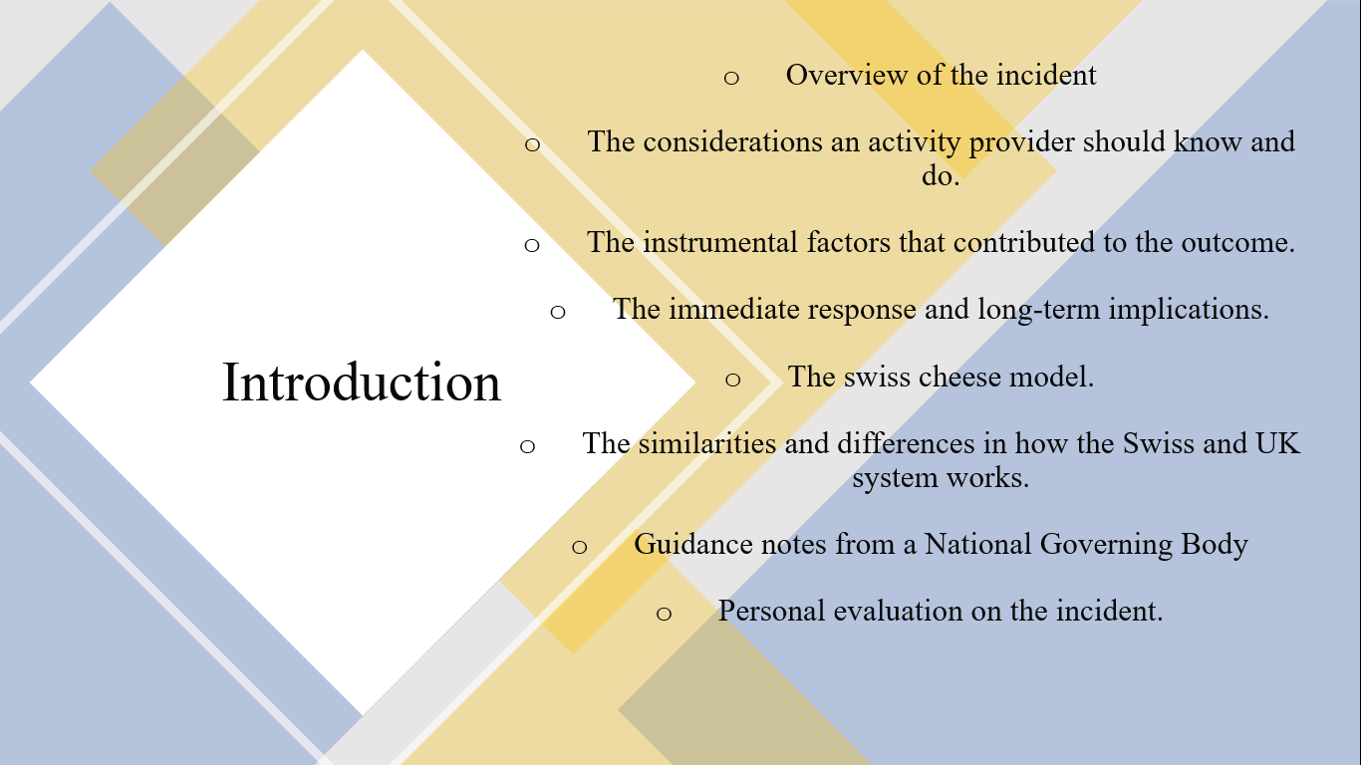
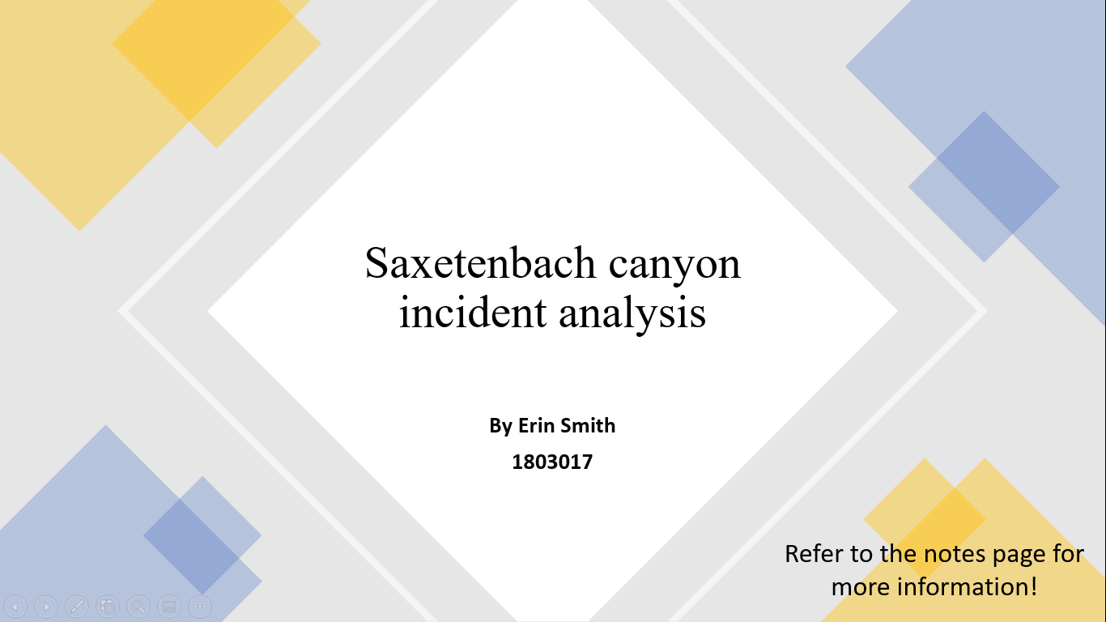

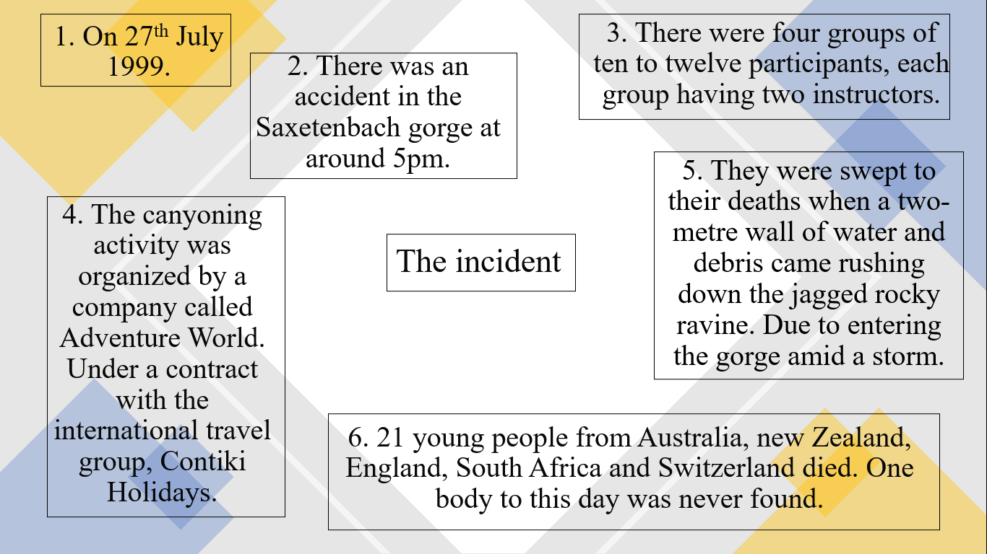

This section will be talking a little bit about the history of Saxetenbach gorge, an overview of what happened, why it happened, when it happened and who was involved.

On 27th July 1999, there was an accident in the Saxetenbach Gorge, in which twenty-one young people from Australia, New Zealand, England, South Africa, and Switzerland died (Saxeten - History - Saxetenbach Disaster, n.d.). Forty-five young people on two separate Contiki tours participated in canyoning organised by the company Adventure World (Johnson, 2019). Under a contract with the international travel group, Contiki Holidays (Head, 1999).

Canyoning involves a combination of hiking, abseiling, swimming and rock scrambling, following streams, waterfalls and other natural obstacles through deep, narrow, water-filled slots between sheer rock walls (Hardiman and Burgin, 2011). Saxetenbach gorge is made up of small and narrow spots, water sculptures, bubbling pools and small to medium-sized waterfalls (Tourismus, n.d.).

At 4:30 pm the first group of 10 to 12 participants and two guides entered the Saxeten River. Over the next 45 minutes, three more groups began a descent of the Saxeten River (Jenkins, 1999). Where they were later swept to their deaths when a two-metre wall of water and debris came rushing down the jagged rocky ravine (Head, 1999).

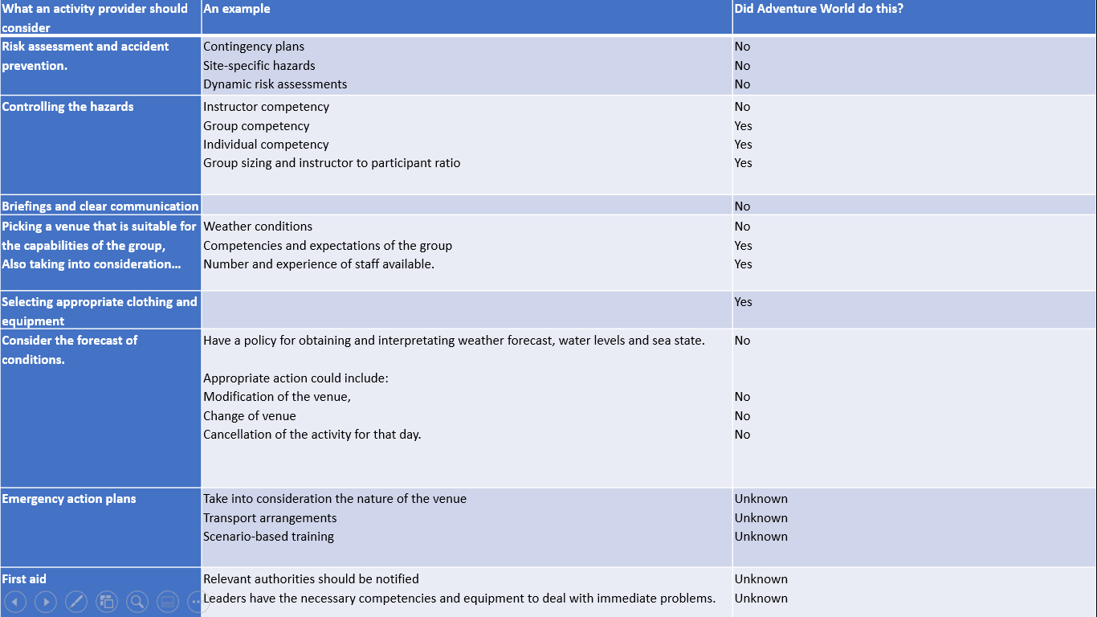

This section will talk about the legalities an activity provider should consider, going into more detail with the headings and showing you evidence of where adventure did and did not follow each legality.

Risk assessments and accident prevention
Under health and safety legislation, you have a duty to ensure the health and safety of group leaders and participants. You must ensure a risk assessment is undertaken, i.e. assessing and planning for contingencies arising from foreseeable changes. (HSE Guidance on Rock and water activities, n.d.).

Site-specific hazards (SSH)
SSH are the hazards associated with the route to and from the venue where the activity is taking place (Combined Rock Water Activities, 2020).

Dynamic environment
The three main dynamic risks to consider in a dynamic environment are- impacts with a solid object, drowning and hypothermia (Combined Water Rock Activities – A Safety Checklist, 2016). The leaders of Adventure World- Bernhard Gafner, and Bernhard Steuri admitted that safety instructions for adventure sport guides were not written down. It was only after the accident that the company introduced printed safety manuals (Former Adventure World manager takes the stand, 2001).

Group leader/instructor competency
A former guide, Dave Erikson told reporters that he quit the outfitter in 1996 after it started employing guides who lacked proper training or experience. "They were pushing younger, inexperienced people into the canyons to work," he was quoted as saying. "An experienced guide knows when to get out” (Leland, 1999).

Group sizing and instructor to participant ratio
There were forty-five participants and eight instructors that went into four separate groups of ten to twelve people (Jenkins, 1999). One researcher suggests canyoning is better with anything up to fourteen people (Canyoning versus Coasteering | Which is Better? | Intrepidus Outdoors, n.d.). Another researcher suggests the ideal canyoning group size is three to five people (Jones, 2002). Group sizes may just depends on what the instructor is comfortable with.

Briefings and communication
A participant stated “I did not have any idea what canyoning was- a lot of people had no idea. It just sounded fun. We were just trusting our guides.” (Jenkins, 1999). There was varying levels of outdoors experience and, according to one, no special instruction from Adventure World (Leland, 1999).

Suitable venue choice
Choose a venue that is suitable for the capabilities of the group. Also taking into consideration: weather conditions, competence and expectations of the group and the number and experience of staff available (HSE Guidance on Rock and water activities, n.d.).

Clothing and equipment
Selecting appropriate clothing and equipment is important for the safety of the participants and instructors. They were provided with a wet-suit, life jacket, helmet and harness (Lashmar and Karacs, 1999). You should consider the forecast of conditions and have a policy for obtaining and interpreting weather forecasts, water levels and sea state.

Appropriate action could include: modification of the venue, change of venue or even the cancellation of the activity for that day (HSE Guidance on Rock and water activities, n.d.). A local fire official told reporters that he warned the Adventure World group about the approaching storm. "I couldn't stop them," said Martin Seemater, 43. "The leader said to me, “We know what we're doing. We know our job” (Leland, 1999). As the group walked to the canyon, it was "pouring with rain" and there was thunder, it continued to rain as they started canyoning. "The water had risen quite significantly and had changed to a very dark brown." (CNN.com - Six guilty in Swiss canyon deaths - December 12, 2001, 2001).

A different company called Alpin Raft was out at Saxetenbach the same day as Adventure World. The leader Heinz Loosli looked up toward the peak at a formation of clouds
gathering, this was a bad sign. He considered the odds, in a gorge that narrow, any flash storm could be a disaster. He cancelled the trip (Leland, 1999).

Emergency action plans
It is advised emergency action plans are taken into consideration, where relevant authorities should be notified and the leaders have the necessary competencies and equipment to deal with immediate problems (HSE Guidance on Rock and water activities, n.d.).

First aid
An activity provider should know first aid and know what to do if a casualty needs medical attention. Taking into consideration the nature of the venue, transport arrangements and scenario-based training (HSE Guidance on Rock and water activities, n.d.).

Overall, adventure world only did 6 out of the 21 considerations so when Adventure world stated "Something absolutely extraordinary, incomprehensible and unforeseeable must have happened (Head, 1999). They are wrong because there is evidence to show that they could have prevented the situation by covering all considerations.

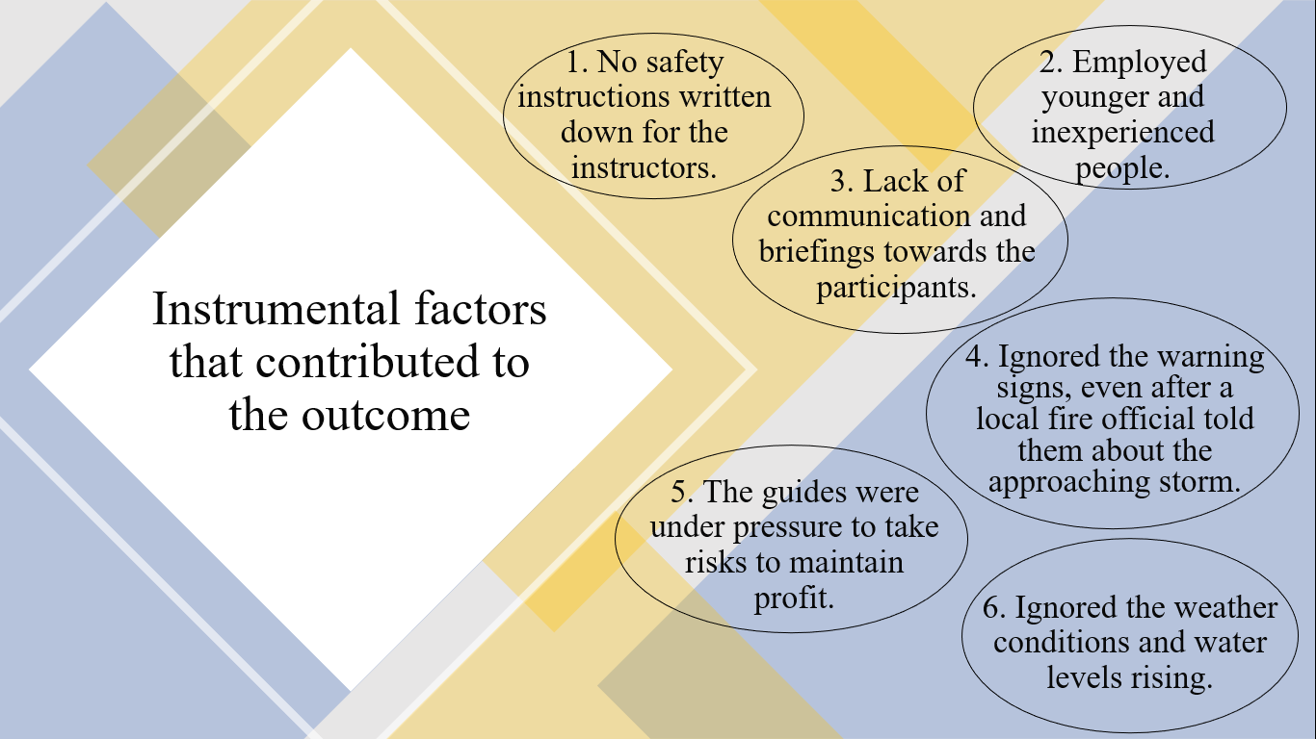

All of the instrumental factors stated above could have been mitigated if adventure world considered the control measures, such as including safety manuals, or turning down inexperienced people, or taught the guides communication and briefings with the participants so they have more of an insight of what canyoning was, they should have understood the severity of what extreme weather conditions can do, especially in water and they should have never ignored the warning signs.

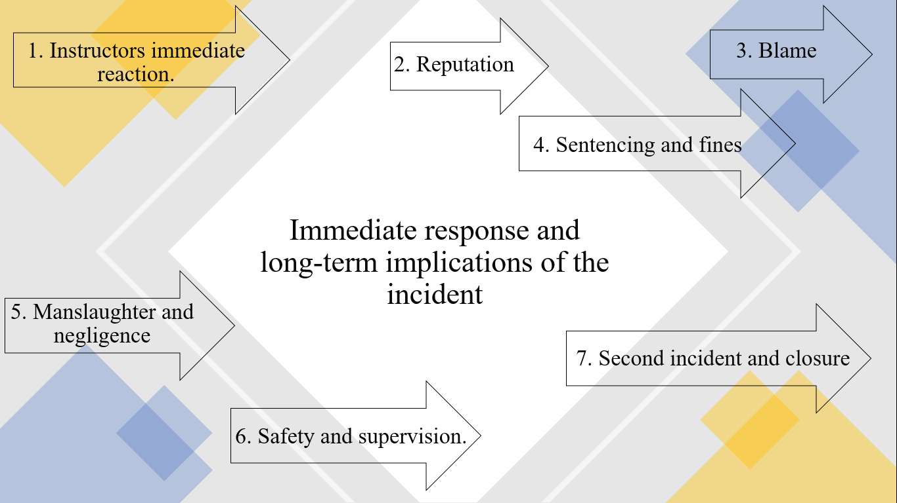

This section will talk about the immediate response and long term implications, specifically focusing on the reaction and responses from adventure world and witnesses.

- During the incident, a 30-year-old guide Karin Müller jumped in and dragged Nigel Mitchell out of the water. Mike Abbott and another guide began running downstream towards an eddy where they guessed survivors would be to be pulled out (Jenkins, 1999). Müller jumped back into the flood and pulled another client to safety. Almost immediately turned around and did it again. The fourth time she entered the water to save a victim being carried past, the current caught her and swept her away forever (Jenkins, 1999).

- After the incident took place Adventure World manager Georg Hoedle said: "Something absolutely extraordinary, incomprehensible and unforeseeable must have happened, because our guides know every centimetre of the river" (Head, 1999).

- Peter Balmer of Adventure World said: “The water must have come like an explosion. No-one could have predicted that.” He also described the company's staff as “thorough professionals” (Head, 1999).

- After the incident, the three directors, Peter Balmer, Stephan Friedli, and Georg Hoedle, each received five-month suspended prison sentences and fines of £3,145 for failing to order a risk analysis and ban canyoning during storms. In all, eight associates of Adventure World were charged with manslaughter through culpable negligence (Allison, 2001). The two surviving guides were found not guilty. The judge said it was not their responsibility to cancel the trip (CNN.com - Six guilty in Swiss canyon deaths - December 12, 2001, 2001).

- Managers Felix Oehler and Bernhard Gafner were accused of manslaughter through culpable negligence (Brooks, 2001).

- Stefan Friedli who was president of the board of management was charged with “allowing a canyoning trip to be led into the Saxet Brook without having worked out a set of safety provisions," particularly during thunderstorms, and for "inadequately supervising the general managers and lead guides of Adventure World” (Bechtel, 2001).

- Ten months later, Adventure World started taking groups down the site of the tragedy again. from May 1st (Harsh criticism of decision to resume canyoning at site of disaster, 2000). Less than a year after the canyoning tragedy a 22-year-old man slammed into the ground during a bungee jump with a cord that was too long. This led to the closure of Adventure World (BBC News | EUROPE | Six guilty in Swiss canyoning trial, 2001). Switzerland later adopted a code of conduct for commercial extreme sports operators (CNN.com - Six guilty in Swiss canyon deaths - December 12, 2001, 2001).

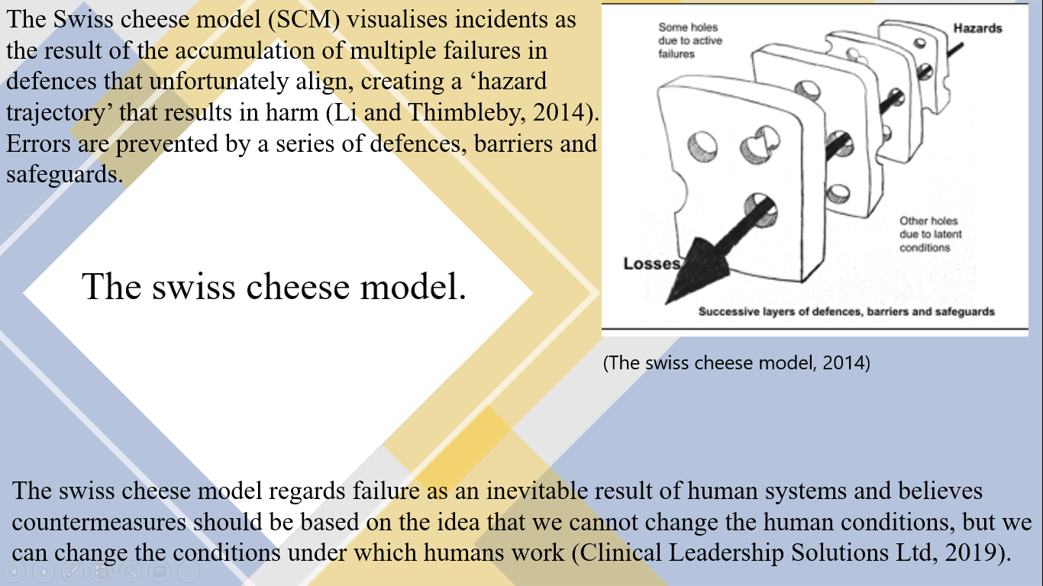

This section will talk about the swiss cheese model specifically talking about what it is and how it is formed, also talking about active failures and latent conditions, going into detail with what each one means and how they can be a contributory factor to causing accidents if they are ignored.

There are two reasons why there are ‘holes’ in the defence system - Active failures and Latent conditions (Clinical Leadership Solutions Ltd, 2019). The model implies that if enough layers of defences are in place, at least ones with non-aligning holes, the probability of an accident can be minimised (Li and Thimbleby, 2014).

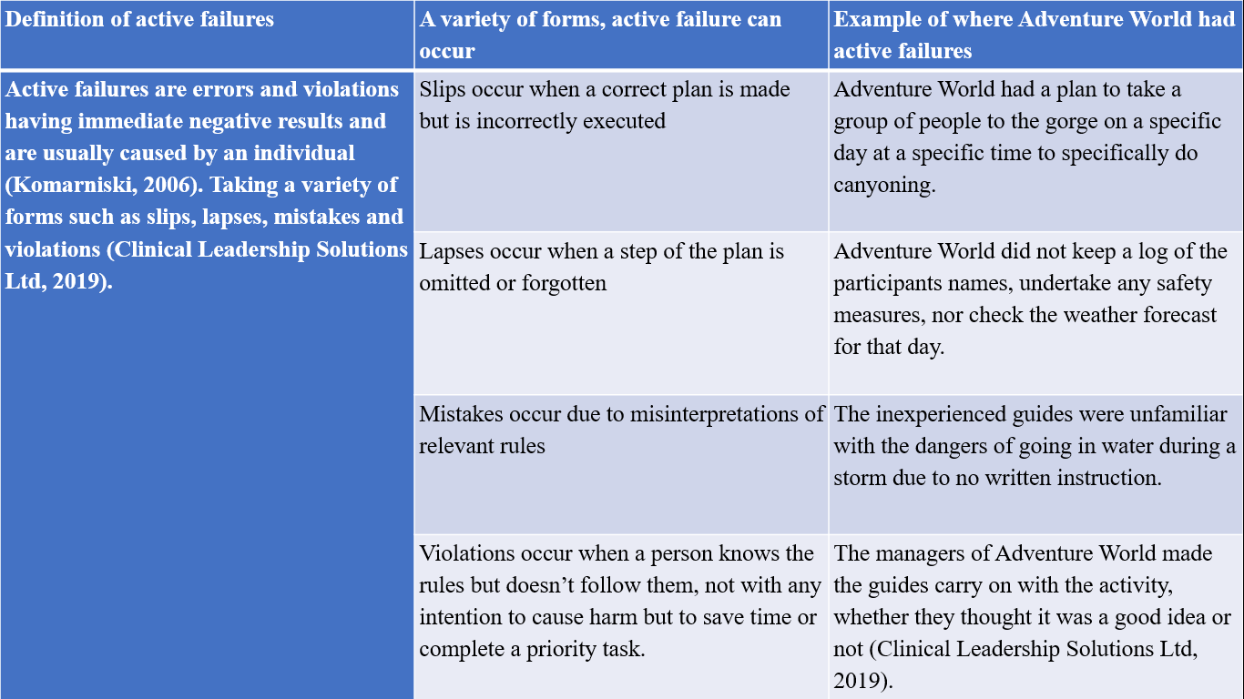
Active Failures

Latent failures are typically failures in the health and safety management systems. Latent failures are usually hidden within an organisation until they are triggered by an event likely to have serious consequences (Core topic 2: HF in accident investigations, n.d.).

Latent conditions can cause some of the opening and closing holes in defences to occur through:
- Ineffective training
- Inadequate supervisions
- Ineffective communications
- Inadequate staffing

Long lasting holes in defences can be caused by:
- Ineffective equipment
- Unworkable procedures
- Poor design of devices, equipment or supplies.

SCM was a contributory factor that could have been mitigated if Adventure World paid attention to the warning signs, thereby the ‘holes’ that became aligned could have been avoided. There were issues further down the system, that were also responsible for the final outcome that made the likelihood of an incident to become greater.

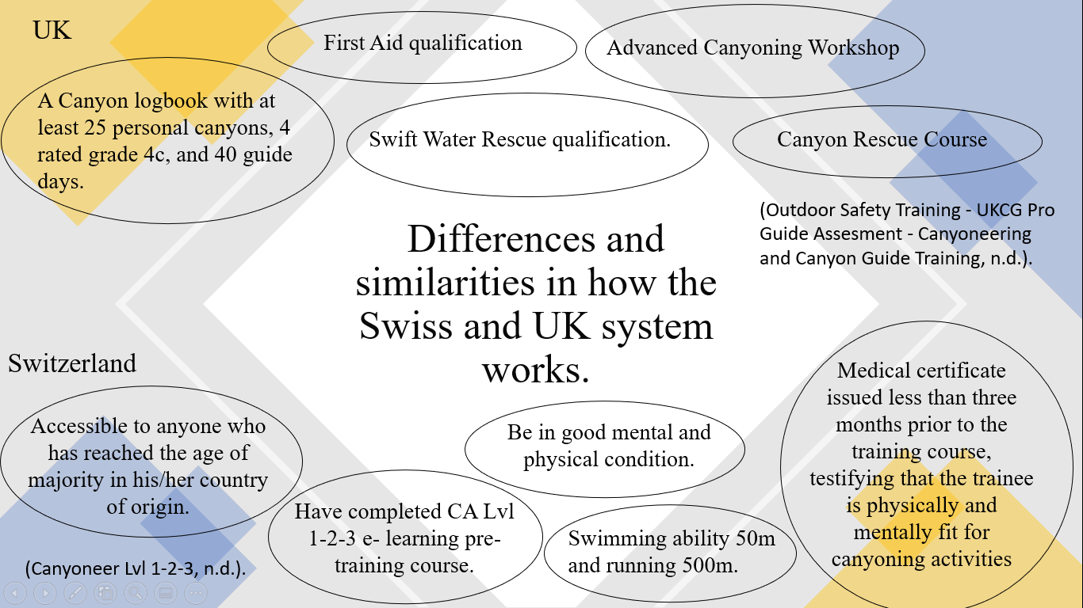

This section will include the qualifications and Prerequisites needed to become a canyoneer in Switzerland and the UK, this section will also talk about the importance of having certain qualifications beforehand.

In Switzerland, a guide does not need any experience or qualifications, other than being 18 or 21+ and in good mental and physical condition. The swiss system seems to encourage work experience rather than gaining long term qualification and experience. As a participant I would expect the guides to be qualified and competent, but for Switzerland this may not be the case, this would make me cautious to take part in the activity.

In the UK, legislation requires you to have a lot of experience and qualifications to become a Canyoneer. I would feel more comfortable to take part in a canyoning activity in the UK because instructors must have all the knowledge and qualifications prior to applying for canyoning jobs.

Issues that could arise is, if someone in the UK decides to do a job in canyoning twenty years after gaining their knowledge and qualifications, the requirements needed for canyoning may have changed. However, research shows the only thing that you need to keep updated is the First aid qualification that lasts three years (How Long Does A First Aid Training Certificate Last For?, 2019). And the swift water rescue qualification which also lasts three years (Swiftwater and Flood Rescue Technician (SRT), 2015).

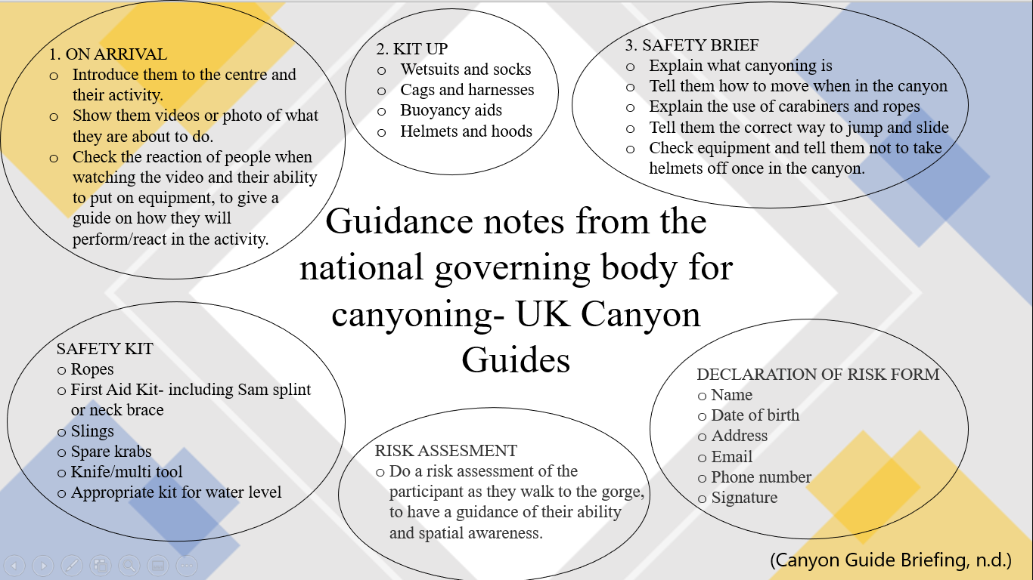



Canyoning does have risks, that is why it is so important to consider every safety measure to prevent an incident from happening.

If I were an activity staff member, weather conditions would be at the forefront of my mind. I have spent many days outside in most weather conditions, I have been reinforced throughout my time at university to check the weather, I have been taught about the dangers of going into a river during or after a period of heavy rainfall. As a staff member you should consider, the extent of the rain, the time span and the region wherein it is falling.

Torrential rain has the maximum potential of disrupting a canyoning experience, dramatically increasing the water volume coursing through the canyon (Is it possible to experience canyoning in the rain? - Canyoning, 2018).

It started to rain, the guide reassured the participants that there were several exit points along the gorge (Froelicher and Wienand, 2019). We must take into consideration why the staff still carried on taking a group of people into the gorge even after several warning signs.

Marty Henzi, said the river guides were under pressure to take risks to maintain profits. "It is basically a classic case of profit over safety" (Head, 1999). If I were put in a situation where someone who is higher in the hierarchy told me to carry on with the session, I would normally do so, purely because of power issues and because I would risk losing my job. As an instructor something I would be conscience of, would be my actions or decisions that could have consequences that affects another person's welfare.

It wasn’t the inexperienced guides fault it was the systems, the managers should have given appropriate training beforehand. When employed by a company there is an expectation that you will undertake the work assigned to you, and in this instance the activity went ahead, although there were many warning signs, the obligation of the instructors was to ensure that the activity went ahead, however, once in the gorge it is the instructor's responsibility to assess the risk and at this stage, they could have made the decision to exit the gorge regardless of the pressure that the owners of the company put them under. In this instance the instructors did not foresee the risks due to their inexperience.

As a participant who has experience in outdoor activities, I would assess what approaches they make and would be confident enough to question whether what the instructor wants us to do is safe and would decide whether I would like to take part further. An activity provider should notice the competencies within the group and the competence of an individual.

The Saxetenbach incident has changed the way I will think when taking part in an outdoor setting, it has made me realise that no matter how experienced or competent you think you are; mother nature and other mistakes will one day overpower you and leave you with consequences. So, look at the weather, listen to other professionals and just take a step back and think whether the next decision you make is the right one. What I have learnt from this incident is how safety briefings, appropriate equipment and the competence and experience of the instructors could have made a big impact on the outcome.

The incident was preventable and following this, lessons have been learnt, although the safety regulations in the UK are considerably more controlled compared to the safety regulations in Switzerland.

Word count: 2,555

References

2014. The Swiss Cheese Model. [image] Available at: <https://www.rcpe.ac.uk/sites/default/files/li.pdf> [Accessed 16 December 2020].

2016. Combined Water Rock Activities – A Safety Checklist. [ebook] Adventure Activities Licensing Authority, p.2. Available at: <http://file:///C:/Users/esmit/Downloads/AALAN_6.06_rev_1_Combined_Water_Rock_Activities.pdf> [Accessed 10 December 2020].

Allison, R., 2001. Tour Firm Staff Guilty Of Swiss Deaths. [online] the Guardian. Available at: <https://www.theguardian.com/uk/2001/dec/12/travelnews.travel#:~:text=The%20three%20directors%20of%20the,and%20ban%20canyoning%20during%20storms.> [Accessed 8 December 2020].

Bechtel, D., 2001. Canyoning Trial Underway In Interlaken. [online] SWI swissinfo.ch. Available at: <https://www.swissinfo.ch/eng/canyoning-trial-underway-in-interlaken/2407708> [Accessed 14 December 2020].

Brooks, R., 2001. Managers Deny Responsibility For Canyoning Tragedy. [online] SWI swissinfo.ch. Available at: <https://www.swissinfo.ch/eng/managers-deny-responsibility-for-canyoning-tragedy/2409930> [Accessed 14 December 2020].

Canyonguides.org. n.d. Canyon Guide Briefing. [online] Available at: <https://www.canyonguides.org/canyon-guide-briefing/> [Accessed 29 December 2020].

Canyonguides.org. n.d. HSE Guidance On Rock And Water Activities. [online] Available at: <https://www.canyonguides.org/hse-guidance-on-rock-and-water-activities/> [Accessed 9 December 2020].

Canyoning. 2018. Is It Possible To Experience Canyoning In The Rain? - Canyoning. [online] Available at: <https://canyoning.co.uk/canyoning-in-the-rain/> [Accessed 27 December 2020].

Clinical Leadership Solutions Ltd, 2019. Reasons Swiss Cheese Model. [video] Available at: <https://www.youtube.com/watch?v=MfWpMrEOlJ8&t=21s> [Accessed 21 December 2020].

Edition.cnn.com. 2001. CNN.Com - Six Guilty In Swiss Canyon Deaths - December 12, 2001. [online] Available at: <http://edition.cnn.com/2001/WORLD/europe/12/11/swiss.canyon.verdict/> [Accessed 8 December 2020].

Froelicher, C. and Wienand, A., 2019. 'I Just Surrendered': How An Aussie Survived Disaster And Found Closure 20 Years On. [online] SBS Your Language. Available at: <https://www.sbs.com.au/language/english/i-just-surrendered-how-an-aussie-survived-disaster-and-found-closure-20-years-on> [Accessed 23 December 2020].

Hardiman, N. and Burgin, S., 2011. Canyoning Adventure Recreation In The Blue Mountains World Heritage Area (Australia): The Canyoners And Canyoning Trends Over The Last Decade. [ebook] p.1324. Available at: <https://www-sciencedirect-com.ezproxy.uwtsd.ac.uk/science/article/pii/S0261517711000057> [Accessed 8 December 2020].

Head, M., 1999. Profit Drive Blamed For Swiss Canyon Tragedy. [online] World Socialist Web Site. Available at: <https://www.wsws.org/en/articles/1999/08/swss-a06.html> [Accessed 13 December 2020].

Icopro.org. n.d. Canyoneer Lvl 1-2-3. [online] Available at: <https://www.icopro.org/pages/canyoneer-level-123_14.html> [Accessed 21 December 2020].

Intrepidus Outdoors. n.d. Canyoning Versus Coasteering | Which Is Better? | Intrepidus Outdoors. [online] Available at: <https://intrepidusoutdoors.co.uk/canyoning-vs-coasteering#:~:text=We%20believe%20that%20canyoning%20is,performed%20one%20at%20a%20time.> [Accessed 9 December 2020].

Jenkins, M., 1999. A Storm In The Distance. [online] Outside Online. Available at: <https://www.outsideonline.com/1889196/storm-distance> [Accessed 9 December 2020].
Johnson, T., 2019. The Swiss Canyoning Disaster. [online] Available at: <https://tiffanyjohnson.com.au/the-swiss-canyoning-disaster/> [Accessed 8 December 2020].

Jones, D., 2002. Canyoning FAQ. [online] Bushwalkingnsw.org.au. Available at: <https://bushwalkingnsw.org.au/clubsites/FAQ/FAQ_CanyoningDJ.htm> [Accessed 9 December 2020].

Komarniski, R., 2006. Who Is Responsible?. [online] Aviation Pros. Available at: <https://www.aviationpros.com/home/article/10383416/who-is-responsible#:~:text=Active%20failures%20are%20errors%20and,results%20in%20an%20active%20failure.> [Accessed 21 December 2020].

Lashmar, P. and Karacs, I., 1999. Swiss River Disaster: Black Wall Of Water Swept Down The Gorge,. [online] The Independent. Available at: <https://www.independent.co.uk/news/swiss-river-disaster-black-wall-of-water-swept-down-the-gorge-crushing-everyone-in-its-path-1109256.html> [Accessed 13 December 2020].

Leland, J., 1999. A Wall Of Black Water. [online] Newsweek. Available at: <https://www.newsweek.com/wall-black-water-165758> [Accessed 9 December 2020].

Li, Y. and Thimbleby, H., 2014. Hot Cheese: A Processed Swiss Cheese Model. [ebook] Swansea, pp.116-118. Available at: <https://www.rcpe.ac.uk/sites/default/files/li.pdf> [Accessed 16 December 2020].

Liquisearch.com. n.d. Saxeten - History - Saxetenbach Disaster. [online] Available at: <https://www.liquisearch.com/saxeten/history/saxetenbach_disaster> [Accessed 8 December 2020].

Mountain Training. 2020. Combined Rock Water Activities. [online] Available at: <https://www.mountain-training.org/help/downloads/combined-rock-water-activities> [Accessed 10 December 2020].

n.d. Core Topic 2: HF In Accident Investigations. [ebook] p.2. Available at: <https://www.hse.gov.uk/humanfactors/topics/core2.pdf> [Accessed 21 December 2020].
News.bbc.co.uk. 2001. BBC News | EUROPE | Six Guilty In Swiss Canyoning Trial. [online] Available at: <http://news.bbc.co.uk/1/hi/world/europe/1704669.stm#:~:text=The%2022%2Dyear%2Dold%20slammed,the%20closure%20of%20Adventure%20World.> [Accessed 15 December 2020].

Outdoorsafety.co.uk. n.d. Outdoor Safety Training - UKCG Pro Guide Assesment - Canyoneering And Canyon Guide Training. [online] Available at: <https://www.outdoorsafety.co.uk/outdoor-courses/ukcg-canyon-training/pro-canyon-guide-assessment> [Accessed 21 December 2020].

Rescue3europe.com. 2015. Swiftwater And Flood Rescue Technician (SRT). [online] Available at: <https://www.rescue3europe.com/index.php/water-safety-a-rescue-training/13-swiftwater-and-flood-rescue-technician-srt> [Accessed 29 December 2020].

Skills Training Group. 2019. How Long Does A First Aid Training Certificate Last For?. [online] Available at: <https://www.skillstg.co.uk/blog/how-long-does-first-aid-certificate-last/> [Accessed 29 December 2020].

Skybrary.aero. 2016. James Reason HF Model - Skybrary Aviation Safety. [online] Available at: <https://www.skybrary.aero/index.php/James_Reason_HF_Model> [Accessed 16 December 2020].

SWI swissinfo.ch. 2000. Harsh Criticism Of Decision To Resume Canyoning At Site Of Disaster. [online] Available at: <https://www.swissinfo.ch/eng/harsh-criticism-of-decision-to-resume-canyoning-at-site-of-disaster/1458316> [Accessed 15 December 2020].

SWI swissinfo.ch. 2001. Former Adventure World Manager Takes The Stand. [online] Available at: <https://www.swissinfo.ch/eng/former-adventure-world-manager-takes-the-stand/2408320> [Accessed 9 December 2020].

Tourismus, S., n.d. Easy Saxeten Canyon | Switzerland Tourism. [online] Switzerland Tourism. Available at: <https://www.myswitzerland.com/en-gb/experiences/easy-saxeten-canyon/> [Accessed 8 December 2020].

