Somma Howard
2114477
Kingsway, Swansea Report

Table of Contents
Introduction 2
Resource cost overview 3
Time overview 4
Resources 6
Productivity and Incentives 7
Effective communication 7
Little recognition and incentives 7
Excessive meetings 8
Solutions 8
Project Delay (carpet design) 9
Reference list 12

Introduction
The UWTSD has received a planning consent for a new office development in Kingways, Swansea/ It comprises mainly of lower and upper basement levels, 5 floors and a plant room on its roof. The roof has a unique system that is a blue roof. A blue roof is s specifically designed oof for rainwater retention. This is constructed above the waterproofing element of the roof’s base. It is expected to begin on March 4th, 2024.

Resource cost overview

Figure 1
Figure 1 shows the relationship between the money spent for work and how much is spent on material. Work here refers to the money that is used for paying labourers for their works carried out on the roof construction. According to the chart, £850.00 was used for the purchasing of the materials needed for the roof and the employees’ payments came up to a total of £9,416.00. To summarize, most of the money used during the roof construction period was spent of payments for the workers.

Name | Standard Rate | Cost | Work
Architech | £60.00/hr | £2,880.00 | 48 hrs
Structural engineer | £22.00/hr | £176.00 | 8 hrs
Roofing contractor | £18.00/hr | £576.00 | 32 hrs
Plumber | £15.00/hr | £1,320.00 | 88 hrs
Electrician | £18.00/hr | £432.00 | 24 hrs
Labourer 1 | £12.60/hr | £1,008.00 | 80 hrs
Labourer 2 | £12.60/hr | £1,512.00 | 120 hrs
Labourer 3 | £12.60/hr | £705.60 | 56 hrs
Labourer 4 | £12.60/hr | £806.40 | 64 hrs
Figure 2

Figure 2 breaks down what each worker gets paid at an hourly rate. It also logs and highlights the number of hours that was done by each employee and gives an overall cost. The overall cost is the total for each worker is calculated by the number of hours they have worked throughout the task, and the amount they get paid for every hour they have worked. This figure ranger between £180.00 and £2,900.00.

Time overview
The diagrams below show the timeline of activities for the construction of roof. The roof construction is broken down into two parts. The first step is the construction of a flat concrete roof used as a based to accommodate the second part which is the blue roof construction.
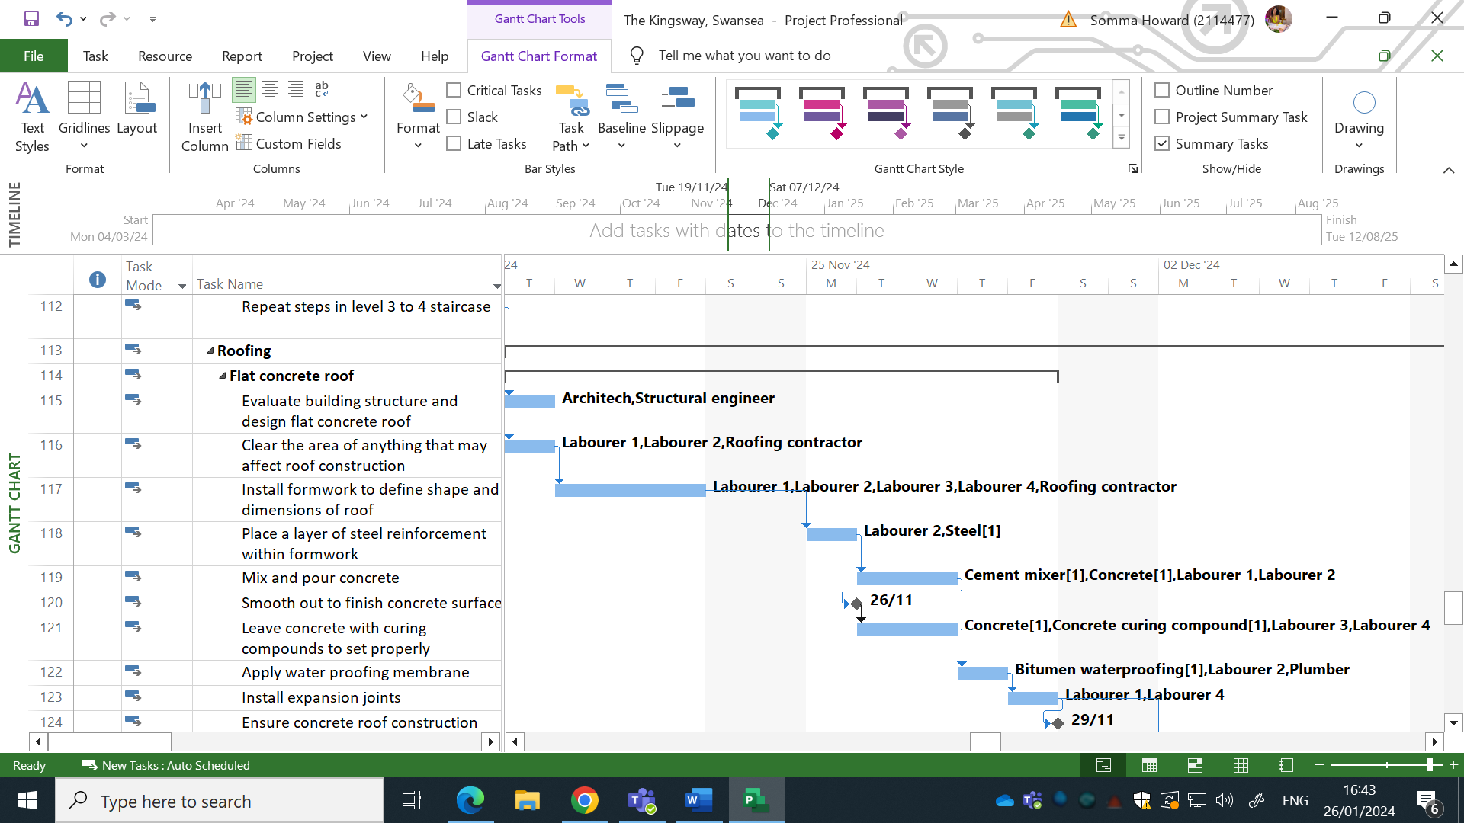
Figure 3
Figure 3 shows the timeline of the flat roof concrete construction. It shows the individual activities and steps on how it is constructed. It also points out the resources; materials and workers needed to carry out each task. Based on the timeline shown above, we can see that the flat concrete roof is scheduled to begin on the 19th of November 2024 and end the 29th of November 2024. This is a total of 9 working days it is expected to take.

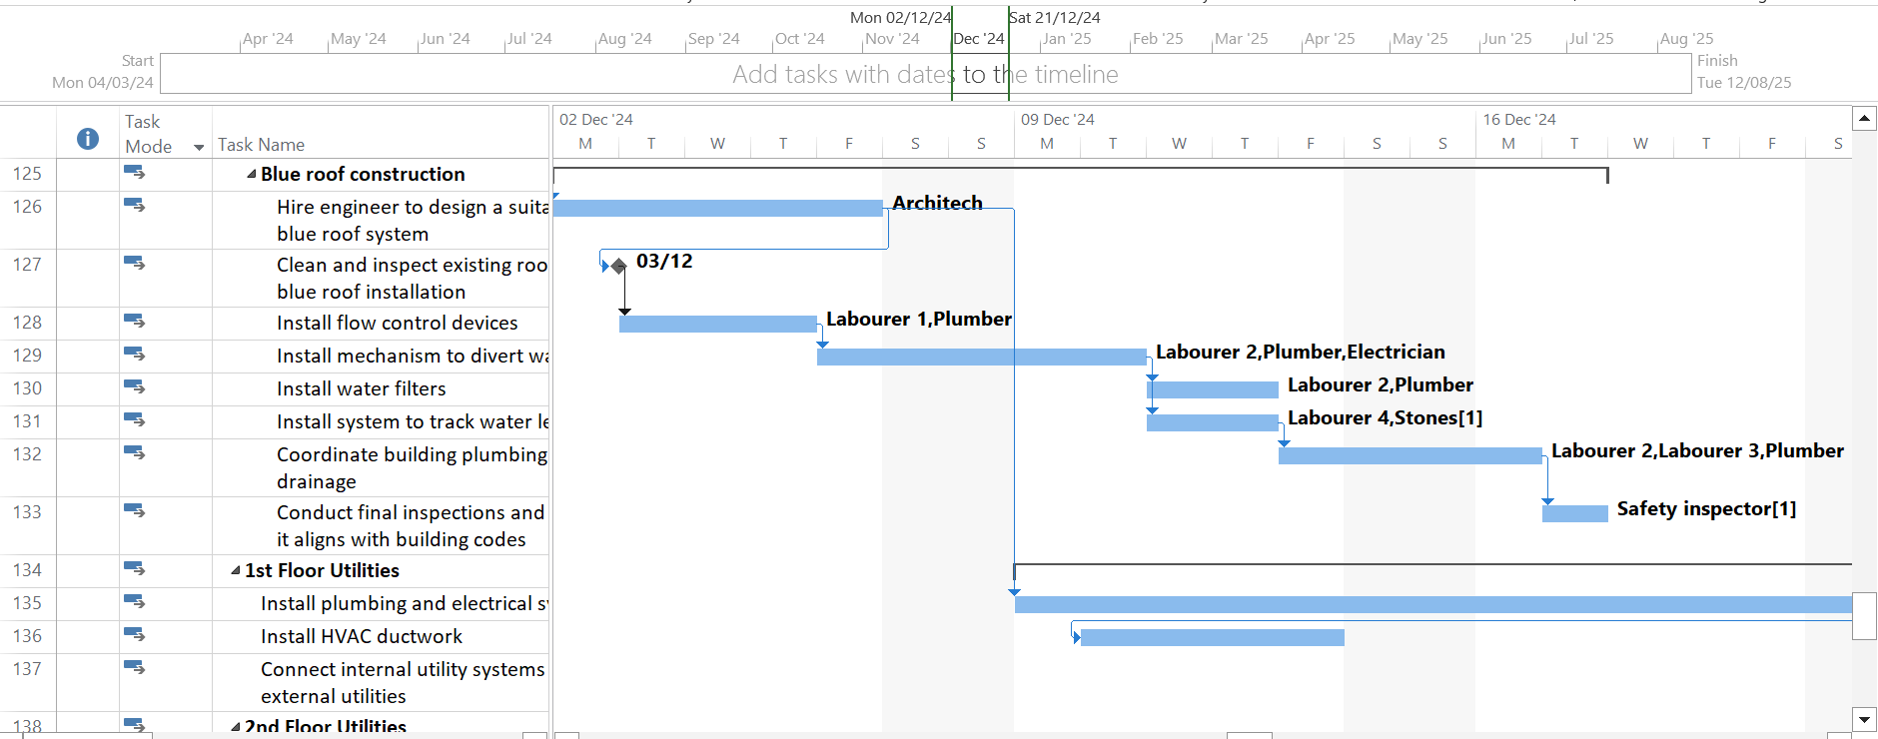
Figure 4
Figure 4 is the continuation of the roof construction, but specifically the blue roof. This unique type of roof style required more specialist type for different task. These specialist workers primarily include an architect, plumber, electrician and a safety inspector. The duration period shown on the timeline for the blue roof construction is expected to last from Monday 2nd December 2024 and to be completely finished the 17th of December 2024. This specialised roof should last a total of 12 working days before its completion.

Resources
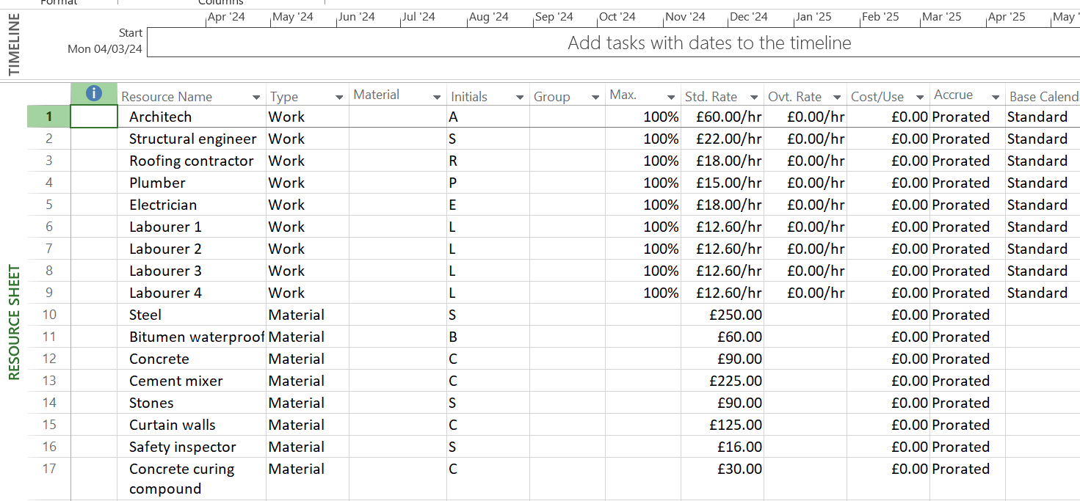
Figure 5
Figure 5 gives a breakdown of each specialist, labourer and materials necessary for the project. It shows the standard rate at which employees are paid per hour and the cost for each material. It also specifically identifies what item type each resource is.

Productivity and Incentives
Projects can experience performance issues by its employees. Performance issues affects several factors on the job. Employees may work slower, and time would be lost. This affects the time schedule of when certain task completion dates were expected to be met and would result it delays. Performance issues can also affect the quality of the work on a project. Some of the most common challenges that affects work productivity includes:

Effective communication
Employees must be properly notified of their assigned roles and target goals. Reliable feedback from the respective authorities about the employees work and if they’re carrying it out correctly is one way to effectively improve productivity.

Little recognition and incentives
If employees are criticised regularly and rarely recognised for the work efforts, employees tend to lose motivation as their efforts go unnoticed and is not appreciated. In certain cases, some employees may feel like others are recognised more for their efforts than they are. This can cause them to be working under stress or even lack motivation.

Excessive meetings
Employers hosting several work meetings, especially throughout the workday can make the employees lose focus of their specific task at hand. They may become distracted and the urge to be productive slips away as they begin to procrastinate more and wait for the end of the workday.

Solutions
There are several ways we can aim to improve productivity and incentives in the workplace.
Employers can effectively communicate with their workers about their expectations and goals from the employee ensure that they understand their roles and responsibilities. Employers can also aim to provide small training sessions for the enhancement of their skills which would contribute significantly to the project.
Provide a balance of both good and bad feedback. More negative feedback would cause the workers to lose motivation. They should be criticised on areas of their work that needs improving, however, should also be recognised for their positive contribution on the workplace.
Incentives are also ways that employees can get motivation for work. Knowing there is a reward in the end if company target goals, or even individual target goals are met would make an employee more eager to work towards it. Even giving acknowledgement and recognition for work is an incentive to the employee. Acknowledgements and even rewards to employees for their positive contributions would encourage them to work more efficiently.
Offer or improve employee benefits. This would allow room for the employee to feel more connected and engaged with their work.
There are also ways of carrying out incentives that are non-monetary. This can include giving promotions or even leadership roles to give them a chance to show authority and be responsible for given tasks.

Project Delay (carpet design)
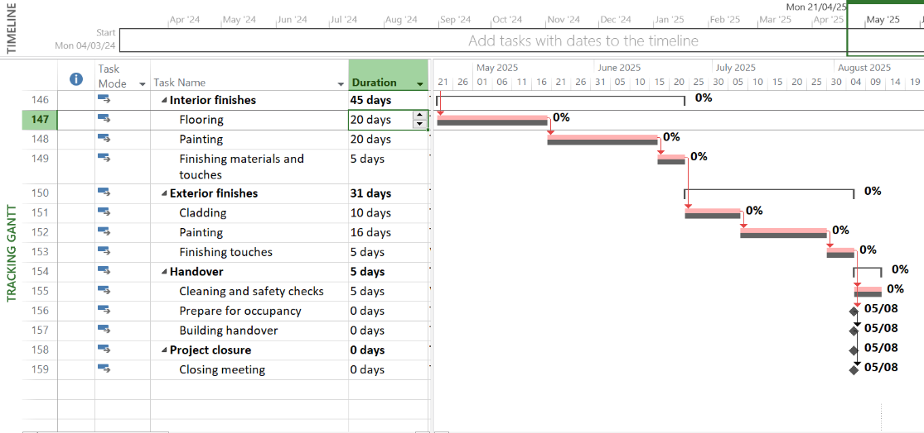
Figure 6
Figure 6 shows the tracking gantt. The flooring for the interior finishes is expected to take a total of 20 days. However, the client has changed their mind about the carpet design for the flooring and has re-ordered new carpets. The new order is expected to arrive later. This change to the flooring for the interior finishes would cause a delay in the remaining tasks for the project. According to the baselines of the project, the construction process from concept to handover and project closure woulh be the 5th August 2025.

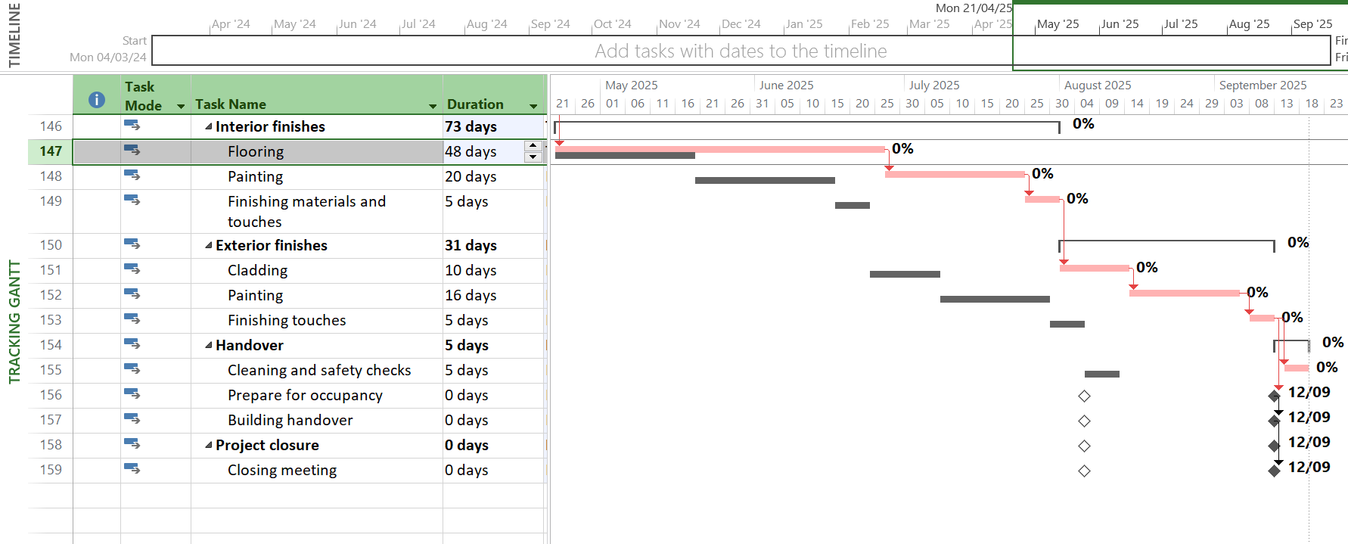
Figure 7
Shown in figure 7 above, we can now see the baseline of the original date for each task completion in the project, and the delay in the project’s work. The project has experienced a delay due to the change in carpet design. This delay is set to last 4 weeks and would now take 48 days for the flooring works. This has set back the end date of the project to the 12th of September 2025.

These 4 weeks delay due to the change in carpet design has significantly altered the production of the building. Although this set back is not a fault due to the contractor’s but is as a result of a personal choice and preference of that of the client, it is the contractor’s responsibility to want to get the work back on track and to finish as soonest as possible.
With aims to achieve this, the contractor can offer incentives to the employees to aid in speeding up work. These incentives can include, working extended hours on weekdays with an increased pay for overtime, working on weekends with higher hourly pay. Another incentive to consider would be to hire more staff on site to increase the productivity rate and finish sooner.

Reference list
- freitas, chris. “8 Barriers to Workplace Productivity | KBI Benefits.” Www.kbibenefits.com, 1 Oct. 2021, www.kbibenefits.com/barriers-to-productivity-in-the-workplace.
- Maier, Steffen. “The 5 Biggest Productivity Challenges (and How to Overcome Them).” Future of Work, 23 Oct. 2018, fowmedia.com/overcoming-productivity-challenges/#:~:text=A%20Gallup%20study%20found%20that. Accessed 26 Jan. 2024.

