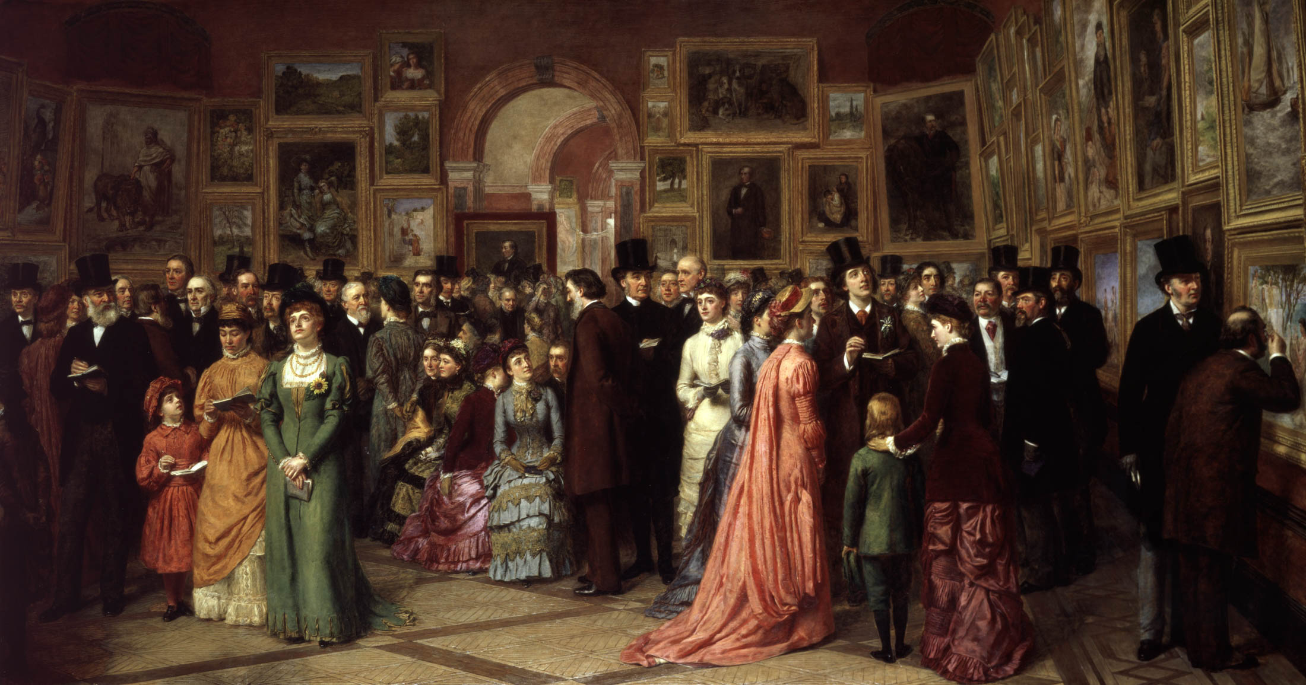

William Powell Frith A Private View at the Royal Academy 1881

Major Project (incorporating External Liaison/Virtual Platform Project)
M6X01790

Lecturer: Professor Tim Davies

HAND-OUT: week commencing: 25/1/21
SUBMISSION: week commencing: 17/05/2021
FEEDBACK: week commencing 7/06/2021

 |  | RESULT:

ASSIGNMENT SPECIFICATION

Student name: | Assignments will not be accepted without a name here |  |  | Student P number: |  | Assignments will not be accepted without P number
Programme: | BA (Hons) Fine Art: Studio, Site and Context |  |  | Faculty/School:
Module: | Major Project  (Incorporating External Liaison Project: Virtual Platform) |  |  | Module Level (4, 5, 6, 7): |  | 6
Module code: | M6X01790 |  |  | Contribution to Overall  Module Assessment (%): |  | (75% + 25%)  100%
Lecturer: | Tim Davies |  |  | Internal Verifier: |  | Sue Williams
Assignment Title: | Major Project  (Incorporating External Liaison Project: Virtual Platform) |  |  | Assignment No (x of x): |  | 1 of 1
Hand Out Date: | 25/1/21 | Submission Date: | 17/05/21 |  | Feedback Date: |  | 7/06/21
Referencing: | Written coursework submissions: In the main body of your submission you must give credit to authors on whose research your work is based. Append to your submission a reference list that indicates the books, articles, etc. that you have read or quoted in order to complete this assignment (e.g. for books: surname of author and initials, year of publication, title of book, edition, publisher: place of publication). Harvard or APA referencing systems is accepted.  Practical coursework submissions: You must give credit to designers or artists whose work you have used to inspire your own. Where specific designs or images have been used in your development work you must indicate the name of the ‘author’ and details of the source of the work (e.g. book, journal, website etc.).
Disclosure: | I declare that this assignment is all my own work and that I have acknowledged all materials used from the published or unpublished works of other people. All references have been duly cited.
Student’s Signature: | Assignments will not be accepted without a signature here and date > | Date of submission:
Turnitin: Lecturer to tick to indicate if an electronic version of the assignment must be submitted to Turnitin.  If both electronic and hard copy submissions are required then both versions MUST be submitted by the same deadline. No marks will be released until both submissions are received.  Note: the Turnitin version is the primary submission and acts as a proof of receipt for the student.  A paper receipt must be completed for hard copy submissions, including portfolios and other design work. |  |  | YES
 |  |  | NO | x
Penalties for late submission: Up to one week late, maximum mark of 40% for first attempt.
Work cannot be accepted after 1 week and will be recorded as a non-submission, 0%.

- The Assignment Specification Form MUST be at the front of all assignment submission. Assignments will not be accepted without this form, as it is a requirement that you sign the disclosure regarding referencing conventions.
- DO NOT include this form in your Turnitin submission or it will match many similarities with other students’ submissions.

This form must be signed and submitted with your assignment

ASSIGNMENT DESCRIPTION

Learning Outcomes
Module Learning Outcomes being Assessed:
- Identify and critically evaluate an intellectually challenging idea that would be appropriate for Major investigation.

- Communicate effectively the research areas, design solutions technical requirements and overall specification relevant to their Major Project idea using contemporary methods and techniques.

- Project-manage an extended research, production and evaluation process in as effective a manner as possible.

Task
The personal Major Project element of this module gives students the opportunity to concentrate on their individual creative development and personal growth within their specialist area.

At every stage of the work, students will be challenged and expected to employ both convergent and divergent thinking in the process of research, observation, investigation, speculative enquiry, visualization and design. By planning their own project, it is intended that students should be self-reliant, self-motivated and capable of taking a large part of their education into their own hands.

Students are also able to pursue concepts and make visual statements that have particular relevance to them as individual artist communicators. The students are challenged through tutorials and workshops to innovate and strive for excellence in their making and presentation skills.

The external liaison element, VIRTUAL PLATFORM, complements the Major Project through a parallel enquiry in liaison with external parties. These liaisons are particular to the distinct contextual identity and career development aspirations of the individual with the ultimate aim of ensuring a sustainable future for the student working in this field. These liaisons can usually take many forms from placement to enterprise, interviews to case studies, archive research to exhibition to name but a few, but this year will be executed within the VIRTUAL PLATFORM. It is intended that the External Liaison Project makes sense of the highly creative vision engendered by the Major Project and that the two significant elements of this module are interdependent, one informing the other.

As part of the Major Project it is anticipated that students will have the opportunity to engage in the development and definition of a sustained body of work, which takes forward research conducted as part of the Advanced Creative Enquiry module. Students’ creative aims or underlying research themes should be identified and perused. This process will involve a wide range of data collection methods which might include drawings, photographs, test pieces, speculation, trial and error and testing of materials and methods. Students would also be expected to refer to case studies through research into the work of other artists and thinkers whose ideas share a common interest or help to critique the project and its development. Throughout the module students should keep records of their activities in visual diaries, notes and digital formats which should be used for self-reflection and discussed during seminars and tutorials.

Guidance for Students in the Completion of Tasks
Students should attend all lectures and seminars, group and individual tutorials and should also direct their own studies in regard to the development of their Major Project supported by the module’s programme of formal teaching.

The Major Project is an opportunity to focus on a sustained enquiry which should draw on the research conducted as part of Advanced Creative Enquiry module and the Independent Project. The module should extend and consolidate the research established during the first part of level 6 through the development of concepts and their articulation into artefacts, images and test pieces. Experimentation, notation, trial and error should be recorded throughout the course of the module and should be reflected upon in order to gain a better self-knowledge and understanding of potential direction that the work could take. The outcome of the module should bring together the research to form a coherent and informed visual statement using appropriate media together with self-reflection, evaluation and visual analysis.

Each Major Project will reflect the interests of the individual student and is the opportunity to develop a unique voice within the field of Fine Art practice, which can further be developed as a post graduate. Looking towards the conclusion of the degree, the External Liaison (including Virtual Platform) part of the Major Project is an opportunity to test ideas outside of the institution and is a valuable experience in the development of a student’s individual practice. Choice of such projects are as varied as the practices and aspiration of the students but can include the development of a collaboration, site specific work, exhibition or intervention outside of the university, Covid-19 restrictions permitting, but engagement in the Virtual Platform will provide external liaison opportunities in any case.

Assessment & Feedback
Students will be provided with written feedback and the opportunity to discuss their performance in seminars and tutorials.

There are two distinct aspects to the Major Project which form a portfolio of work. These are:
- a report, equivalent to 3,750 words, which should also be illustrated, summarising the External Liaison/Virtual Platform project and resultant exhibition. This will form 25% of the overall module mark.
- A body of thoroughly researched course work developed in consultation with the Major Project teaching team. This work should demonstrate an in depth study leading towards the development of sustained body of creative practice. For assessment the portfolio should include research, such as drawings, photographs, test pieces, visual diaries, annotated notes, preliminary images such as paintings and photographs or artefacts, together with considered work selected and displayed as part of the end of year show. This will form 75% of the overall module mark.

The information below indicates how each learning outcome for this module will be assessed:
Learning outcome 1
The portfolio of work submitted for assessment should communicate that the student has identified and critically evaluated an intellectually challenging idea that would be appropriate for Major Project investigation. This will be evidenced through the scope and breadth of research materials considered and the processes used to interrogate this material, leading to the development of the central Major Project theme.
Learning outcome 2
The resulting work selected for the end of your show should communicate effectively the research areas, design solutions technical requirements and overall specification relevant to their Major Project idea using contemporary methods and techniques.
Learning outcome 3
In addition, the manner in which the Major Project has been conducted will be considered, to include the management of an extended body of research and its production and evaluation. The effectiveness of this will be evidenced in the interrelationship of materials, how research has been considered and executed and the way in which ideas have been developed and perused.

100% Coursework in two Assessment Components:

Assessment Component 1 – 75%
Exemplar:
The nature and shape of the project will be decided in consultation with the tutorial team assigned to your Major Project, culminating in the degree show exhibition. This may be a physical exhibition, if circumstances allow, but in any case, there will be a digital exhibition on the UWTSD website.
Assessment Component 2 – 25% (3,750 words equivalent)
Exemplar:
Report - A reflective summary of the External Project/Virtual Platform process and the ensuing results and separate exhibition.

Addendum
Due to the extraordinary circumstances we all find ourselves in, all modules will have a revised assessment procedure.

Please attend all meetings online (and face-to-face if/when appropriate) and maintain contact through Microsoft Teams with all the staff and feel free to request tutorials as you would normally do but through Microsoft Teams.

There are 2 distinct aspects that will form a digital portfolio of work in the event that a physical end of year exhibition is not possible. These are:
A) a report (equivalent to 3,750 words) which should also be illustrated, summarising the external liaison/virtual platform and resultant online exhibition. Documentation of all conversations, discussions, emails, phone calls with external bodies must be compiled and submitted in digital form. This is 25% overall of the mark.
B) a body of researched course work developed in consultation with the fine art team. This work should demonstrate an in-depth study leading towards the development of a sustained body of creative practice. For assessment, the digital portfolio, which will contribute to the UWTSD online exhibition if a physical exhibition is not possible, should include research such as drawings, photographs, test pieces, visual diaries, annotated notes, preliminary images such as paintings and photographs or artefacts and this will form 75% of the overall module mark.
The research and your major practice will form the definitive statement of the culmination of your research and practice.

