Student name: Shaera Miah
Student number: 1711954
Lecturers name: Paul Ranson
Assignment title: Managing project in the organisation
Module title: BMSK5004

Table of content
Introduction……………………………………………………………………………….3
Organisation of that the project is being developed for……………………………….4
critical assessment of the risks associated with the project…………………………..4
project management tools and techniques being used in the case study……………5
how the project plans will be communicated to the stakeholder………………………6
Personal reflection and recommendation for future…………………………………7

Introduction
This report will discuss about our project planning company called THE SUCCESSOR. There are four project managers in our team I will also discuss about the overview of our company which gives general summary and how we delivered the project to vintners. I also discussed about project life cycle it provides structured approach for the delivery of the project. Stakeholders are the steering group they are the sponsor and specialist of the project. I will discuss about user stories, digital user story, Delphi technique, and Gantt char where it shows how the project will progress. I will also talk about how we estimated the time and price and how we used the iron triangle to create a balance among scope, schedule, time and cost to deliver a quality product overall it helps us to workout additional time and cost required.

- Describe the organisation of that the project is being developed for?

We are a project planning company called THE SUCCESSORS. Our aim of this project is to shift business of a vintner’s family they want us to help them with this process to move their Shop from the current location to the new location. It is a family business we as a project managers will organise their move from the shop in Shirly to the new warehouse in Spark hill and this is divided in to three parts,
Refit the new warehouse, set up a new business process and transfer content from the shop in Shirley. So, the technique we have used is called the PRINCE2 (Projects In Controlled Environment). This technique helps to try to reduce the risk of project by working on instinctive framework and it will also help us increase the possibility to deliver the project successfully (Bentley, 2012).

- Provide a critical assessment of the risks associated with the project
Alongside that as we were going forward with the project, we might face certain risk at some point of this project for example . Generally, delivering a project’s defined scope on time and inside budget are the attributes of project success. Unfortunately, those success factors are frequently not executed, mainly for massive complicated projects where both external influences and inner task requirements may additionally alternate significantly through the years. Project risk management is a continuous system of identifying, analysing, prioritising and mitigating risk that threaten an initiatives likelihood of success in terms of price, schedule, quality, safety and technical performance. (project leadership)
similarly, in our project there were common project risk involved such as Delphi technique we’ve used to estimate the price for the tasks, and it is to estimate future demand for the product and service whereby experts are in Risk, cost and schedule example we might have come across problem like Delphi (Dagen, 2019) stated there is a lack of guidance and agreed standards on how to interpret and examine the results, universally agreed deﬁnitions of consent, and the way to select the contributors. Delphi is time-consuming and exhausting for both researchers and participants, explaining why it is vulnerable to drop-outs.
Hence, we would reduce the risk by
- selecting experts that’s need to be decided on wisely.
- Proper control conditions must to be created.
- There must be an excessive level of commitment by individuals of the team.
- There should be careful action taken toward the equal agreement by panel individuals.
In its simplest form, it reduces stress on any team professionals and replaces it with a carefully designed program of segmental, individuals responds commonly performed via questionnaires, interspersed with opinion feedback and extra information. We have discovered the Delphi method* beneficial in trying to determine what goes back on main source of the projects from what one might expect, using it so that it will place all categories on our impartial variables, e.g., resource demands, scheduling, variables price, promotional expenses and cost of new government guidelines (Peter, 1977)

- Describe the project management tools and techniques being used in the case study.
While we were on the process of our project these are the tools we have used to communicate with the stakeholders and make our project management more effective and efficient. Everyone who are involved in managing project need to be aware that they naturally observe the challenge life cycle of the project it is an important stage for the life cycle. A project need to have a discovery level wherein we learn what is required if this level is avoided at any point it could cause the mission to fail. After that we have proceed with a plan that begins the initiation level, as an end result our presentation is the result of the discovery and initiation level. If the stakeholders agreed with the plan, then we will go on to the deliver and then close the project. Then we have organised a meeting to assess if it has met their expectation this stage is called realisation. We have used a technique called user stories. With this method we attempted to define nature of problem we would face all through this challenge and a way to solve them. User stories has brief natural sentences which are regularly recorded on post it notes on a brown paper or an assignment management software. Depending on the project user stories may be written by various stakeholders which include clients, users, managers or improvement team participants.
We have used digital user story we have sent an electronic version via email to stakeholders. An appropriate way to consider a user story is that it's miles a reminder to have a communication together with your customer which is another way to say it's a reminder to perform a little just-in-time estimation. In quick, user stories are very limited and higher-level requirements to make and priorities user stories.
We have also used iron triangle where it has three project constraints need to be discussed in detail with the customer before the project starts. They need to understand what it will value in terms of scope, quality or time in addition to budget. You’ll additionally need to establish that there won’t be any sudden or drastic changes in the course of the project (Pasikki and Dumrongthai, 2013). Chevron develops the CPDEP procedure for getting used as a project management tools for making plans, design, and performance of the project. It is wildly and normally used in most of both principal and small capital projects inside Chevron Corporation. The Chevron consists of five section which is identified as accompanied and to be consider in order to achieve the best for project (Haughey, 2020) stated we use Moscow as a prioritisation method is used to determine which requirement to finish first, which should come later and which to exclude. is a method where we ask as many people as we will to work out what priorities each stories has. The commonly used one is Gantt chart. Gantt charts were created by Henry Gantt (1910), Gantt charts simplest constitute a part of the triple constraints of the project, due to the fact they attention mainly at the scheduled management. Moreover, Gantt charts do not represent the scale of a project or the relative length of a project or the relative size of work factors, therefore the value of a behind-time table situation is easily miscommunicated. To complete a whole project efficiently, you must control a massive number of activities and make sure they're completed on schedule (Bowen, n.d.) Using Gantt charts is beneficial because they deliver an immediate overview of the project against the timescale. For example, the minimal time it's going to take to deliver, and which tasks need to be finished. In addition, it helps pick out the crucial route – the collection of duties that need to for my part be finished and updated at all times if the whole task is to give on time. This reduces the threat of a problem arising which would avoid the delay of development of the management information system. Here is a copy of our Gantt chart that shows how we prioritised and how long it took to complete each task throughout the project.
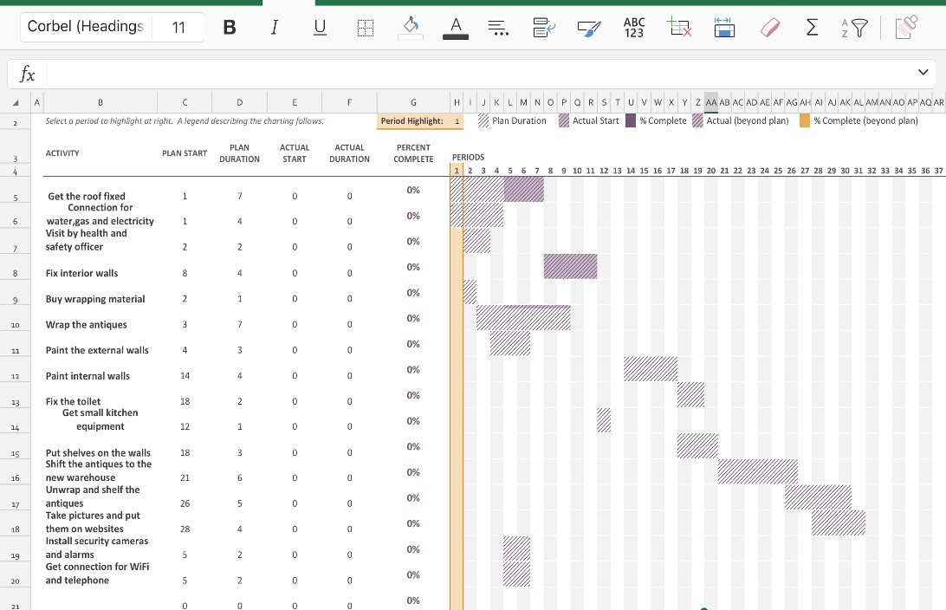

- Show how the project plans will be communicated to the stakeholder

According to book ‘Effective Project Management’ (Roberts, 2011), who states that each one of those who have claim inside the achievement of the venture must play their issue with talent, sensitivity and with a clear know-how what together they are seeking to achieve. There are many approaches to keep the stakeholders informed about the project management. One of them is communication plan – developing this plan will assist team participants to recognise when and the way to inform each taking part stakeholder. This became an important step as it helped us designate who the stakeholders are, what the targets for verbal exchange are and the approach for communication. As nicely as, historical past information regarding the challenge, ability dangers worried with conversation and the budget. Secondly, to inform the stakeholders we created reports with the use of Gantt chart. The use of a project management software that produces reviews helped us to keep updated at the status of the responsibilities, troubles and the milestone finishing touch. Therefore, a file deeming the challenge is a vital element of communicating with stakeholders because it would inform them precisely what has been completed. Regular meetings with stakeholders is crucial because it aims to update them the significance of the report. This allows make sure that everything that has been set out, has been study and gives time to interact with stakeholders, resolve any troubles (Roeder, 2013). As mission managers we communicated with stakeholders through sharing our Gantt chart on stay- consumer testimonies on excel we might then use the Gantt chart to schedule each of our obligations for over period of time, then damage down massive piece of work into a series of project and planning whilst to finish them.

- Personal reflection and recommendation for future
Over the past weeks I have learnt about to become project manager you have to be determined and confident towards project. In class by involving in group activities and working in a team has helped me a lot on building self-confidence and learning new skills.
My job was to prioritise each of the task with small title on sticky notes on the brown paper so that it helps us identify it quickly. With this technique we tried to define the nature of problems we might face during this project and how to solve them. I also created digital user stories using Microsoft planner where I tried to manage resources and stay on budget. A member in of my team can log into our online Gantt software from any location and see exactly what they must be working on after which update their progress. I’ve learnt about Moscow and chevron method. Moscow technique where we ask as many people, we can to work out what priorities each story has, for example, some are must-haves, want-to haves, could-haves and nice to have. Chevron technique is where teams archives specific goals and meet the success criteria of the project the primary constrain of Chevron method are time, scope, quality and budget.
For future recommendation and self-improvement in project management I would complete prince2 qualification where you can manage projects areas or maybe in future, I will use Agile course which covers an approach to project management. The most vital things I can do as a project manager is to remove barriers for our teams. That can assist hold projects inside the agreed-upon framework, make the workflow more efficient and hold everything on timetable (Florentine, 2016).
Ways to improve my own performance by planning self-development is to improve on important areas so that can expand my knowledge and develop new skills. I will also need to list on which are the areas I have strength and weakness on such as, well organised , confidence, talented, intelligent and fast learner. I’m going Take a good look at the list and select one goal which is most important to me and what I will need work on first and which of the strength can help me focus and achieve goal.

References:
Pekar, P. P. (1977). Project assessment: a guide for implementation. Project Management Quarterly, 8(3), 18–22.
References
2014. Project Risk Management. [ebook] Available at: <https://assets.kpmg/content/dam/kpmg/pdf/2014/02/KPMG-PALS-9-Project-risk-management.pdf> [Accessed 30 February 2020].

Bentley, C., 2012. PRINCE2. Milton: Taylor & Francis.

Bowen, R., n.d. Ways To Keep Project Stakeholders Informed. [online] Bright Hub PM. Available at: <https://www.brighthubpm.com/monitoring-projects/52884-keeping-project-stakeholders-in-the-loop/> [Accessed 20 February 2020].

Haughey, D., 2020. Moscow Method. [online] Project Smart. Available at: <https://www.projectsmart.co.uk/moscow-method.php> [Accessed 24 March 2020].

Kumar, P., 2005. Effective Use of Gantt Chart for Managing Large Scale Projects. ProQuest, 47(7), pp.14 - 21.

Pasikki, R. and Dumrongthai, P., 2013. SW CPDEP, PROJECT MANAGEMENT PROCESS FOR THE RIGHT DECISION FOR DRILLING AND COMPLETION IN GEOTHERMAL. [ebook] Available at: <https://www.researchgate.net/publication/333814897_SW_CPDEP_PROJECT_MANAGEMENT_PROCESS_FOR_THE_RIGHT_DECISION_FOR_DRILLING_AND_COMPLETION_IN_GEOTHERMAL> [Accessed 30 February 2020].

Prince2.com. 2020. Project Management Triangle: A Triple Constraints Overview | UK. [online] Available at: <https://www.prince2.com/uk/blog/project-triangle-constraints> [Accessed 16 March 2020].

Roberts, P., 2007. Guide To Project Management. Economist Books.

Roberts, P., 2011. Effective Project Management. Kogan Page Ltd.

Roeder, T., 2013. Managing Project Stakeholders. Hoboken, N.J.: John Wiley & Sons.

Support.office.com. n.d. Project Management Goal: Communicate Project Information. [online] Available at: <https://support.office.com/en-gb/article/project-management-goal-communicate-project-information-c56bd8ca-42df-45c4-9f84-ef0b33714d17> [Accessed 27 March 2020].

