BMIH6001 Contemporary Themes in the Hotel and Hospitality Sector

Declaration: I confirm that I have not used any AI tools in the research and creation of this assignment. I confirm that I have not presented any AI generated materials as my own work. I confirm I have copies of my drafts, notes, and other resources I used, which I may be asked to provide in evidence.
Signature: Roxana Maria Burlacu
Student ID: 2014302
Date: 09 June 2025

Slide 1

Hello everyone. My name is Roxana Burlacu, and I am pleased to welcome you to this presentation on waste management strategies in budget hotels.

Slide 2

This research explores a fundamental contemporary theme in hospitality, namely the challenge of reducing the waste of food, plastic, and energy. The hospitality industry produces important waste due to overproduction, reliance on single-use items, and inefficient energy systems (Khatter, 2023).
Sustainability has become a strategic obligation rather than an option (Camilleri, 2016). From this perspective, budget hotels face specific challenges due to limited financial and human resources (Khatter et al., 2019). Additionally, budget hotels are facing increasing pressure from regulatory bodies to reduce waste. An example in the UK market is the regulatory pressure to enforce the Environment Act 2021. Additionally, the research shows an increasing number of eco-conscious guests (UK Government, 2021; Booking.com, 2022).
This paper investigates how these hotel operators respond to the urgent call for sustainability through waste reduction. The examination includes current strategies, policies, and guest expectations regarding waste reduction for budget hotels. The paper aims to examine and fill the gap between ambition and implementation of waste reduction. Hence, it contributes to the broader research on achieving net-zero emissions in the hospitality industry.

Slide 3

This slide presents the theoretical foundation of the researched topic.
In hospitality, sustainability is no longer just a trend. Sustainability has become a necessity due to climate change (Tribe, 2009; Costa and Costa, 2022).
According to Elkington’s (1997) triple bottom line framework, sustainable operations must balance environmental, social, and financial responsibilities. The Brundtland Report (United Nations, 2025a) reinforced the need to preserve natural resources for future generations.
In the hospitality sector, sustainability practices can be included within hotel core operations. These practices in the hotel sector align with Sustainable Development Goal (SDG) 12. This specific SDG calls for waste reduction through prevention, recycling, and reuse (United Nations, 2025b).

Slide 4

To understand how hotels manage waste, we turn to two important theories. Stakeholder theory, as developed by Freeman (1984), suggests that businesses have responsibilities beyond profits. This perspective fits perfectly in hospitality, where many internal and external groups, such as guests, staff, and communities, are involved (Khatter et al., 2019). Additionally, systems theory explains the interdependence of hotel departments (Brotherton and Wood, 2008). Waste reduction strategy requires integration across all systems, from supply chains to daily housekeeping (Brotherton and Wood, 2008).

Slide 5

This slide focuses on current waste management practices adopted by hospitality operators. Khatter (2023) highlights the importance of portion control and inventory tools for food waste reduction. Hotels also cut down on plastic waste by switching to refillable amenities, as noted by Martin-Rios et al. (2020). For energy, new technologies such as smart lighting and automated HVAC systems help reduce the consumption (Costa and Costa, 2022). These strategies reduce the environmental impact of hotel operations. They also increase efficiency of resource use, brand equity, and customer satisfaction regarding their tourism experiences (Calisto et al., 2021).

Slide 6

Despite this progress in sustainable practices, budget hotels face major barriers in implementing green waste strategies.
Research by Khatter et al. (2019) shows that large hotel chains outperform smaller operators in implementing these strategies. This happens due to better financial resources.
Independent budget hotels may lack funding, training, and access to reliable data. Some also employ greenwashing tactics, which deceives guests and undermines their trust (Nisa et al., 2022). A key limitation remains the inconsistency in staff training and guest involvement (Khatter, 2023). These are critical areas that require support.

Slide 7

This research paper used a qualitative method based on secondary data analysis, as per Saunders, Lewis and Thornhill (2015). Data was collected by reviewing academic literature, industry reports, and sustainability reports from industry leaders like Hilton and Marriott.
Several frameworks were employed to structure the analysis. As the previous slides presented, the frameworks included the stakeholder theory and the system theory. The analysis also employed the PEST framework, which will be presented in the next slide. This last one has helped identify how political, economic, social, and technological forces shape waste practices in the hospitality sector (Khatter, 2023). The stakeholder theory facilitated an examination of how internal and external stakeholders either influence or contribute to waste management decisions. The systems theory demonstrated the interdependence between the various departments within a hotel.

Slide 8

This slide presents the external macro-environmental factors influencing waste management practices in budget hotels.
Politically, the UK’s Environment Act 2021 has introduced mandatory food waste separation and landfill taxes. Moreover, the Glasgow Declaration pushes the industry towards net-zero targets, as per the UK Government (2021) and UN Tourism (2025). However, budget hotels often lack the expertise or resources to comply effectively with these regulations (Khatter et al., 2019).
Economically, high energy prices and inflation have determined many operators to reduce waste. Premier Inn, for example, has invested in motion-sensor lighting and smart thermostats to reduce energy consumption (Premier Inn, 2025). Despite long-term potential savings, budget hotels still struggle with the upfront cost of green technology unless supported by subsidies (Khatter et al., 2019). In contrast, major brands like Hilton and Marriott invest at scale in green solutions due to stronger financial capacity (Hilton, 2023; Marriott International, 2023).
Social factors are increasingly significant. According to Booking.com (2022), 81% of travellers prefer eco-friendly hotels, and more than 60% say they are influenced by visible sustainability actions. Hotels that clearly show their environmental efforts, like towel reuse programs and plastic-free amenities, build stronger trust. However, variations in staff training and risks of greenwashing reduce guest confidence in some budget hotels (Khatter, 2023; Nisa et al., 2022).
Finally, technological innovations such as AI inventory tools, motion-sensor HVAC systems, and smart bins are transforming waste management. Hilton’s cloud tracking systems and Marriott’s AI platforms for kitchens are examples of best practices (Hilton, 2023; Marriott International, 2022). On the other hand, most budget hotels lack the IT infrastructure and trained personnel to implement or sustain these tools (Sima et al., 2020).
These external forces are creating momentum for sustainable change. At the same time, they show the structural disadvantages faced by budget hotel operators.

Slide 9

In conclusion, waste management is no longer optional. It represents a strategic requirement for sustainable hospitality. While large hotel chains are making significant progress, budget hotels face persistent barriers due to their limited financial, technical, and human resources.
This research highlighted how macro-environmental forces, such as new regulations, guest preferences, and operating expenses, are pushing all hotels to act more sustainably. The key enablers include stakeholder commitment and effective use of greener technologies.
However, bridging the gap for smaller operators requires targeted political and industry support, particularly in training, incentives, and scalable digital solutions.

Slide 10

To support sustainable waste management in budget hotels, several practical steps are recommended.
First, staff training is crucial. Without the involvement of employees, sustainability efforts often remain superficial (Khatter, 2023). Next, budget hotels should adopt low-cost solutions such as LED lighting or basic digital tracking apps to manage food and energy waste (Khatter et al., 2019).
Guest participation is also important. For example, clearly posted signs about towel reuse or food waste at breakfast can influence their behaviour (Camilleri, 2016). To ensure consistency, internal audits can help identify where policies aren't being implemented effectively. Large chains such as Hilton and Marriott have already implemented this practice (Hilton, 2023; Marriott International, 2023).
Finally, smaller operators need better access to government and industry support, such as grants, training, and shared service models (Raub and Martin-Rios, 2019). These interventions can make sustainable waste management goals more achievable across the sector.

Slide 11


Any question?

Slide 12
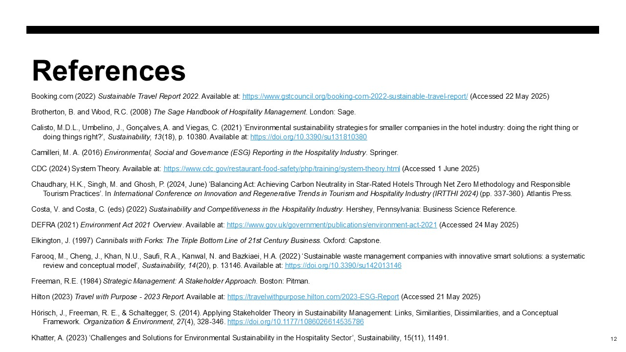
References
Booking.com (2022) Sustainable Travel Report 2022. Available at: https://www.gstcouncil.org/booking-com-2022-sustainable-travel-report/ (Accessed 22 May 2025)
Brotherton, B. and Wood, R.C. (2008) The Sage Handbook of Hospitality Management. London: Sage.
Calisto, M.D.L., Umbelino, J., Gonçalves, A. and Viegas, C. (2021) ‘Environmental sustainability strategies for smaller companies in the hotel industry: doing the right thing or doing things right?’, Sustainability, 13(18), p. 10380. Available at: https://doi.org/10.3390/su131810380
Camilleri, M. A. (2016) Environmental, Social and Governance (ESG) Reporting in the Hospitality Industry. Springer.
CDC (2024) System Theory. Available at: https://www.cdc.gov/restaurant-food-safety/php/training/system-theory.html (Accessed 1 June 2025)
Chaudhary, H.K., Singh, M. and Ghosh, P. (2024, June) ‘Balancing Act: Achieving Carbon Neutrality in Star-Rated Hotels Through Net Zero Methodology and Responsible Tourism Practices’. In International Conference on Innovation and Regenerative Trends in Tourism and Hospitality Industry (IRTTHI 2024) (pp. 337-360). Atlantis Press.
Costa, V. and Costa, C. (eds) (2022) Sustainability and Competitiveness in the Hospitality Industry. Hershey, Pennsylvania: Business Science Reference.
DEFRA (2021) Environment Act 2021 Overview. Available at: https://www.gov.uk/government/publications/environment-act-2021 (Accessed 24 May 2025)
Elkington, J. (1997) Cannibals with Forks: The Triple Bottom Line of 21st Century Business. Oxford: Capstone.
Farooq, M., Cheng, J., Khan, N.U., Saufi, R.A., Kanwal, N. and Bazkiaei, H.A. (2022) ‘Sustainable waste management companies with innovative smart solutions: a systematic review and conceptual model’, Sustainability, 14(20), p. 13146. Available at: https://doi.org/10.3390/su142013146
Freeman, R.E. (1984) Strategic Management: A Stakeholder Approach. Boston: Pitman.
Hilton (2023) Travel with Purpose - 2023 Report. Available at: https://travelwithpurpose.hilton.com/2023-ESG-Report (Accessed 21 May 2025)
Hörisch, J., Freeman, R. E., & Schaltegger, S. (2014). Applying Stakeholder Theory in Sustainability Management: Links, Similarities, Dissimilarities, and a Conceptual Framework. Organization & Environment, 27(4), 328-346. https://doi.org/10.1177/1086026614535786
Khatter, A. (2023) ‘Challenges and Solutions for Environmental Sustainability in the Hospitality Sector’, Sustainability, 15(11), 11491.

Slide 13
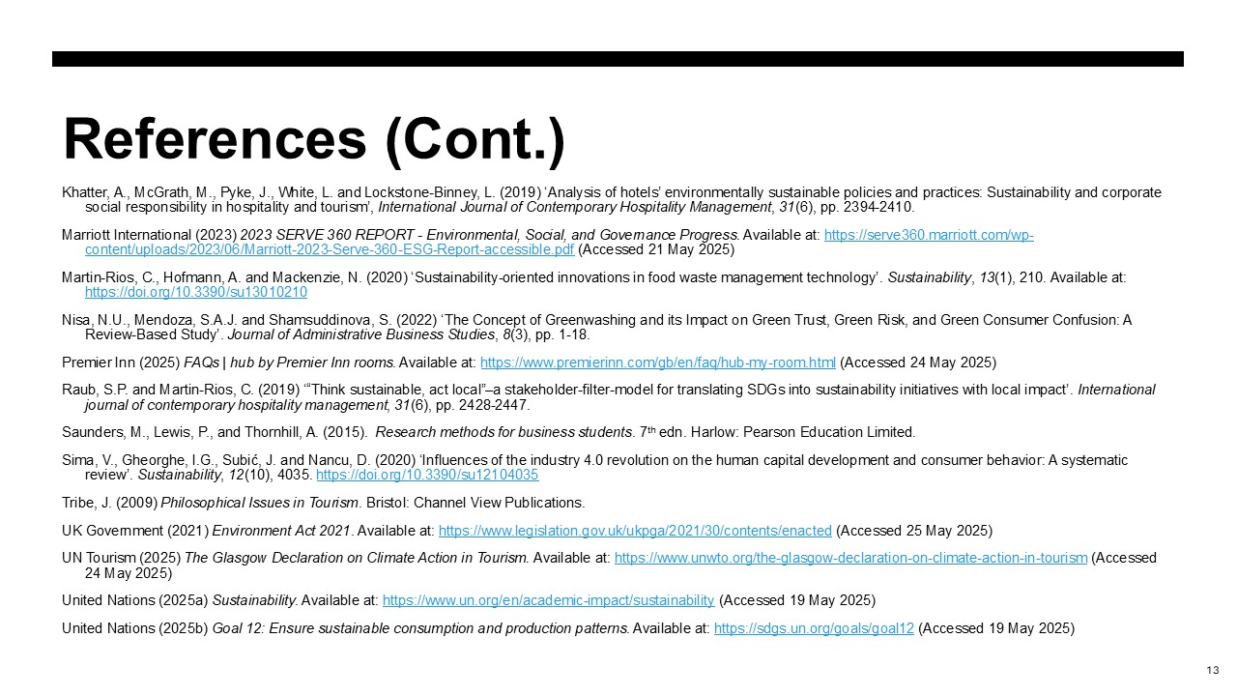
Khatter, A., McGrath, M., Pyke, J., White, L. and Lockstone-Binney, L. (2019) ‘Analysis of hotels’ environmentally sustainable policies and practices: Sustainability and corporate social responsibility in hospitality and tourism’, International Journal of Contemporary Hospitality Management, 31(6), pp. 2394-2410.
Marriott International (2023) 2023 SERVE 360 REPORT - Environmental, Social, and Governance Progress. Available at: https://serve360.marriott.com/wp-content/uploads/2023/06/Marriott-2023-Serve-360-ESG-Report-accessible.pdf (Accessed 21 May 2025)
Martin-Rios, C., Hofmann, A. and Mackenzie, N. (2020) ‘Sustainability-oriented innovations in food waste management technology’. Sustainability, 13(1), 210. Available at: https://doi.org/10.3390/su13010210
Nisa, N.U., Mendoza, S.A.J. and Shamsuddinova, S. (2022) ‘The Concept of Greenwashing and its Impact on Green Trust, Green Risk, and Green Consumer Confusion: A Review-Based Study’. Journal of Administrative Business Studies, 8(3), pp. 1-18.
Premier Inn (2025) FAQs | hub by Premier Inn rooms. Available at: https://www.premierinn.com/gb/en/faq/hub-my-room.html (Accessed 24 May 2025)
Raub, S.P. and Martin-Rios, C. (2019) ‘“Think sustainable, act local”–a stakeholder-filter-model for translating SDGs into sustainability initiatives with local impact’. International journal of contemporary hospitality management, 31(6), pp. 2428-2447.
Saunders, M., Lewis, P., and Thornhill, A. (2015). ​ Research methods for business students. 7th edn. Harlow: Pearson Education Limited.
Sima, V., Gheorghe, I.G., Subić, J. and Nancu, D. (2020) ‘Influences of the industry 4.0 revolution on the human capital development and consumer behavior: A systematic review’. Sustainability, 12(10), 4035. https://doi.org/10.3390/su12104035
Tribe, J. (2009) Philosophical Issues in Tourism. Bristol: Channel View Publications.
UK Government (2021) Environment Act 2021. Available at: https://www.legislation.gov.uk/ukpga/2021/30/contents/enacted (Accessed 25 May 2025)
UN Tourism (2025) The Glasgow Declaration on Climate Action in Tourism. Available at: https://www.unwto.org/the-glasgow-declaration-on-climate-action-in-tourism (Accessed 24 May 2025)
United Nations (2025a) Sustainability. Available at: https://www.un.org/en/academic-impact/sustainability (Accessed 19 May 2025)
United Nations (2025b) Goal 12: Ensure sustainable consumption and production patterns. Available at: https://sdgs.un.org/goals/goal12 (Accessed 19 May 2025)

