

Kieran Howells

Principles of System Engineering Assignment

UWTSD Swansea
OME

BEng
Academic Year: 2024 - 2029

Supervisor: David Holley
December 2025

UWTSD
OME

BEng

Academic Year 2024 - 2029

Kieran Howells

Principles of System Engineering Assignment

Supervisor: David Holley
December 2025

This thesis is submitted in partial fulfilment of the requirements for the degree of OME
(NB. Remove if the degree award is based solely on examination of the thesis)

© UWTSD 2025. All rights reserved. No part of this publication may be reproduced without the written permission of the copyright owner.

Academic integrity declaration
I declare that:
- the thesis submitted has been written by me alone.
- the thesis submitted has not been previously submitted to this university or any other.
- that all content, including primary and/or secondary data, is true to the best of my knowledge.
- that all quotations and references have been duly acknowledged according to the requirements of academic research.
I understand that to knowingly submit work in violation of the above statement will be considered by examiners as academic misconduct.

Acknowledgements
Click here to enter acknowledgement text.

Table of Contents
Academic integrity declaration i
Acknowledgements ii
List of Figures iv
List of Tables v
List of Equations vi
List of Acronyms vii
1 Introduction 8
1.1 Background 8
1.2 Material Properties 8
2 Detonation Transfer 9
2.1 Critical Parameters 9
2.2 Detonation Transfer 10
3 Velocity of detonation 11
3.1 Density 11
3.2 Relation to OME 12
3.3 Where can this be observed 12
3.4 Limitations 12
4 Conclusions 13
5 References 13
Appendices 14
Appendix A 15
Appendix B Appendix title (use Heading 7) 16

List of Figures
Figure 1 The Ideal missile design from viewpoint of various specialists [1] 9
Figure 2 The requirements generated by the stakeholders 10
Figure 3 Record Player Use Case 11
Figure 4 QFD 1 Functional Importances 14
Figure 5 Function Means Analysis 16
Figure 6 System Pugh matrix 17
Figure 7 QFD 2 18
Figure 8 Design Book title 21
Figure 9 Requirements set 21
Figure 10 Required Functionality 22
Figure 11 Rationalised requirements PW 22
Figure 12 Design QFD 1 23
Figure 13 Functional Importance Graph 23
Figure 14 Functional Metrics 24
Figure 15 Function Means Analysis 24
Figure 16 System Pugh 25
Figure 17 Design QFD 2 25
Figure 18 Feature Importance Chart 26
Figure 19 DFMEA 26

List of Tables
No table of figures entries found.

List of Equations
No table of figures entries found.

List of Acronyms
Acronym | Description
DFMEA | Design Functions Means & Effects Analysis
SE | System Engineering
LCM | Lifecycle Management
LCMS | Lifecycle Management System
QFD | Quality function deployment

Introduction to Systems Engineering

Background
Systems Engineering (SE) is an alternate method for engineers to use to solve problems. With this mindset an engineer will look at the system as a whole with the requirements of the system being the initial primary focus. [1] The required function, lifetime and management will be taken into consideration from the start [1]which is what give SE an advantage over the solution focused engineering methods. By taken a look at the system as a whole and understanding the requirements and the functions behind those requirements engineers can use this to build a model of what the design needs to do and from there work out how these systems and subsystems work together and function before turning it into a design. This means that many of the issues that may appear can be caught early on without the need for redesign or even the actually production of a prototype. But this whole system view can be taken down in levels to look at the subsystems and the component systems that make up the whole. This gives a clear outlook on the whole product being designed, developed, maintained and disposed. [1]

View of the System
The view of the whole system is the key point to systems engineering. This allows us to filter what the specialists that are involved with the design process say in order to create a balanced solution. Figure 1 shows an example of what designs from different specialists could look like as a result of bias or focus towards their specialties.
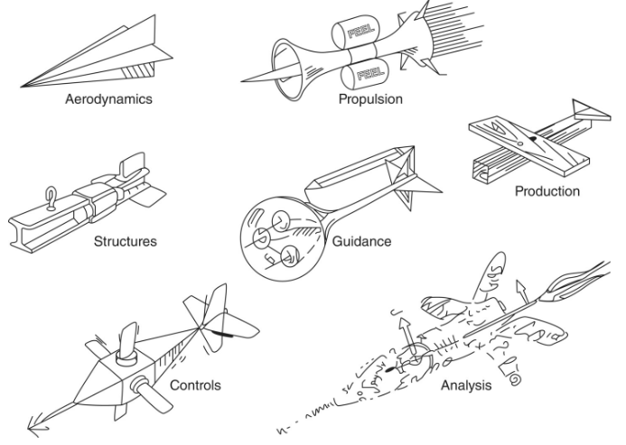
Figure 1 The Ideal missile design from viewpoint of various specialists [1]
This is just an example of the thought process of specialists during design phases. SE looks to take each of these parts whilst also looking at the system as a whole [1]. A systems engineer could then look at these designs and view the requirements and functions that make them up and then filter them into relevant requirements of the project.
SE also allows for complex systems and subsystems to be broken down to the components levels. Doing this using this framework allows for the components to work together as the choice of components will be supported by the evidence gathered with these tools. From there everything can slowly be integrated moving up through the components to subsystems and at the end the system as a whole. With this the requirement set at the beginning has a higher chance of being satisfied compared to a solution based approach [1].
With this in mind the student was asked to apply these SE techniques and methods in order to design a household item with from a set of requirements.

Requirements & Functional Requirements

Stakeholder Requirements
First the student selected a household item to redesign. The student selected a record player as the item to redesign with the stakeholders being those who use/ listen to the music played by said player. This meant that there would be 4 major stakeholders for this item. These were the student, the student’s father, mother and brother. A design book was provided as a tool to assist in the SE method and supporting activities were completed assisting the toolset.
Using the design book provided the student questioned each of the stakeholders to determine the requirements.
A Requirements set was the produced allowing for the student to then investigate the required functionality.
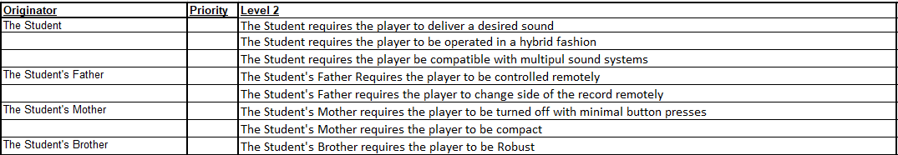
Figure 2 The requirements generated by the stakeholders
These requirements vary in their relation to the primary function of a record player which is to entertain with sound. One of the stakeholder’s requirements is for the record player to be robust. While some may see this as an odd requirement it is still a requirement that has to be met. How robust is something that could be determined further into the design phase but the requirement remains.

Required Functionality
The required functionality is the functions required in order to meet the requirement set. These can be gathered by using a tool called the use case. This is a simple but effective method that allows the student to step into the shoes of the user. In this case the student is one of the users allowing for an easy creation of the use case but when this framework is used in industry this use case allows for the engineers involved to view the system from the eyes of the user. This is valuable as the user will be the ones most effected by the system meaning that this is the most likely point for undesirable behaviours to be identified. [1]
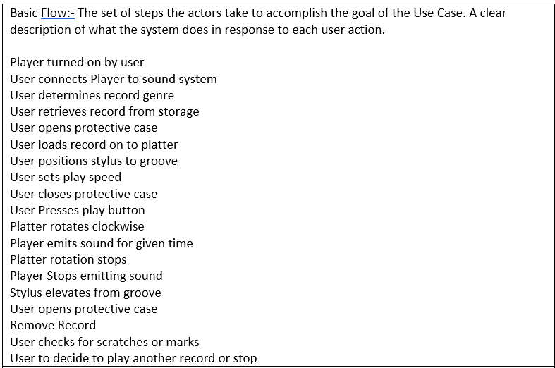
Figure 3 Record Player Use Case
When creating a use case, it is important to keep each function simple and to the base level. To help with this, engineers can use a verb noun relationship in order to keep things simple. One example from the student’s design book is to “open case”. This simple function defines part of the system that can be investigated further as the student moves through the levels. Creating a use case begins with assessing the actors involved with the activity. These can be anyone or anything that has any engagement with the system from the record player and sound system itself to the users. Pre and post conditions are stated with the standard operation being the main focus. This excludes environmental factors such as power outages for an electric item. From there figure 3 can be produces which is the basic flow of the activity. This is the standard way in which the activity is completed, and this is where the functions are identified. Then an alternate flow may be considered to assess what happens if any of the functions are not completed correctly and the potential exceptions that prevent the users from completing the goal. But this is not the only tool available, Gemba visits or a visit to the end user allow for the designer to see how the end user interacts with the product. This could help to gather additional needs that are not articulated in the requirements. [2]

Rationalised Requirements
Once the student has gathered the requirement set and the functions in order to meet those requirements, they can now rationalise those requirements. This can be done using a tool called the pairwise comparison. This tool scores the requirements against each other to determine its “intensity” [2] or in other words how one item compares to another ranking them. Each item is compared to one another and a preference is taken between the two as a would you rather option 1 or 2. Once ranked the focus can then be determined for each function and funding could be associated based on rank.

Concept

QFD 1
Quality Function deployment (QFD) is yet another systems engineering tool This tool can be used at many different stages of the project as a way of linking stakeholder or user requirements to functions. QFD 1 links the requirement set to the required functionality from the use case. This helps to identify key systems and even subsystems if their correlations are found between many different functions. For example, in the students QFD 1 the platter rotating, sound emission and platter stopping are all linked together. This could then be grouped together as the sound delivery system with the rotation starting and stopping being the input for the sound emission. This allows SE users to break down into subsystems meaning that we can take a step down into levels below applying the same techniques until we reach the lowest level.

V Diagram
The V Diagram shows the progression through the project taking the steps down until we reach the lowest levels such as components or the subsystems of the components. By applying this SE users can then understand each level of the overall system and what subsystems affect others if there is an issue. Take QFD 1 as an example. One requirement is the delivery of the desired sound from the record player and as QFD 1 shows the closing of the case has nothing to do with that requirement. In other words, if there was an issue with the sound delivery then we can narrow our search to the specific level of the V diagram and then the functions that effect that requirement using QFD 1.

Functional Importance
The importance of each function is determined by the scores taken in QFD 1. This allows the student to evaluate each function and apply the appropriate focus to each.
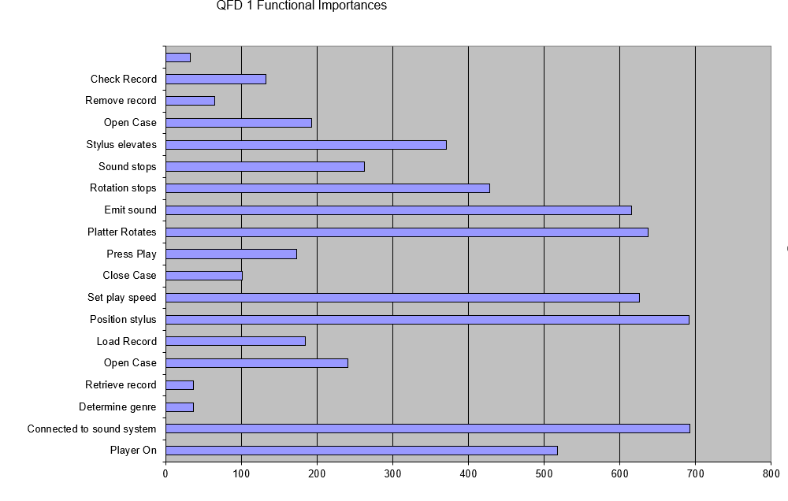
Figure 4 QFD 1 Functional Importances
Figure 4 shows that in this case the students top three functions were connection to sound system, position of stylus and the rotation of the platter. This was to be expected as these are all the underlying requirements for sound to be emitted which is the primary requirement of the record player. This means that they can be grouped as a subsystem and investigated together to create the correct component to the overall system. On the other hand, the function with the least importance was to determine the genre. This would mean the users of SE could now provide the appropriate resource to the function’s development starting with the most important and moving down through the ranking.

DFMEA
The DFMEA or design failure modes and analysis is a way of scoping potential failure modes of any given function. Figure 19 shows two functions that have been assessed along with the rating of each of the issues. In this case no solutions have been selected so general failures are assess so they can be prevented in the final product. The DFMEA will feed back into the design in order to prevent obvious failures from happening. The short coming of this tool is the non obvious failures which are difficult to spot before they happen. Completing these in teams and having different views of the same failure modes of a function could be useful in order to catch varying failure modes. This tool is then applied in later stages such as the production phase with the PFMEA and further down. These protect both the user and the product and potential manufacturing methods may have hazards to workers or even the user such as sharp edges. The Scoring for these documents is either 1 – 5 or 1 – 10 with one being the low score on severity, occurrence and detection while ten would include a system failure with multiple casualties. In this case scores such as 24 and 32 may be considered as as low as reasonable practical meaning that the scores are low enough to accept the risk as trying to decrease it further is not possible without high capital expenditure.

Functional Metrics
The functions have now been identified and ranked and now the “how much” comes into play. The functions identified need to have a targeted performance to meet. This could come from the requirements set but also could be a desired behaviour. In the student’s case there will be tests regarding the sound and playback systems in order to ensure the correct sound quality and playback speed. The student’s brother had the requirement of the record player being robust meaning the material now needs to be tested and chosen. Another metric would be the change over time, the time between the changing side or record, which is an unspoken requirement.

Function Means Analysis
This part of the design phase is where being open minded is critical. This phase is again based off the use case completed for the record player. Different methods of completing each step are reviewed with all options being noted down ignoring capabilities for now. As seen in figure 3 the use case is the base of this analysis with the functions identified being the focus.

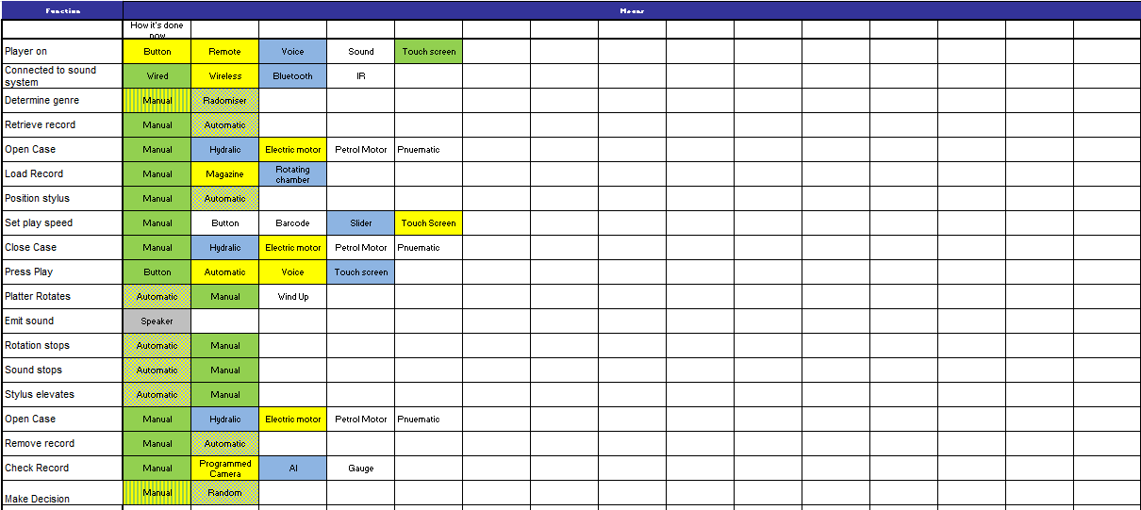
Figure 5 Function Means Analysis

Figure 5 shows the completed function means analysis for the record player. The highlights are the different concept ideas for the project with there being three concepts. Manual in the green, magazine in the yellow and automatic in the blue. The multicoloured tiles show that two concepts will both use the same method to complete the function. By creating multiple concepts SE can then compare them in order to see what the best suit to the project is. This could be determined by metrics such as cost and time or as the one that is best suited to meet all requirements.

Systems Pugh

The Pugh matrix is the method used to compare the concepts. The baseline for this comparison is to view the requirement set and how the original design meets these requirements. This is done by scoring the original design as zero and comparing the new concepts against the current player. This will be 1 for better, -1 for worse and a 0 for the same. This allows us to then tally up the score and see clearly which has the best score. This sometimes could be a design that engineers were not expecting to be selected which is why it’s important to complete the comparison using a fair benchmark.
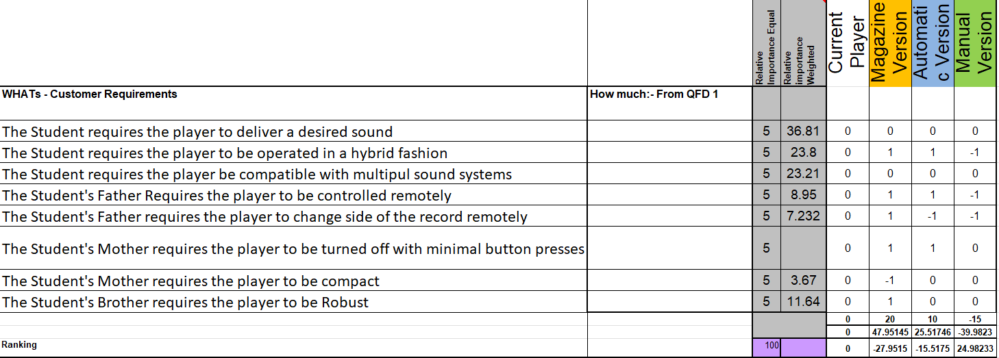
Figure 6 System Pugh matrix
This is the final step before we select our concept and move through to the design phase of systems engineering.

Design

QFD 2
For the next stage we use the QFD tool again. Instead of measuring the “how much” of our functions now the functions take the space of our requirements and we look to the Functional means and we measure the importance of these means to the functions. Looking to the V diagram this allows us to step down another level and compartmentalise this complex system breaking it down but viewing how this integrates with the other functions. From a set of requirements from stakeholders the student has now created three concepts and compared them to select a final design without having to design create, test and redesign. This could be seen as one of the key advantages of SE.
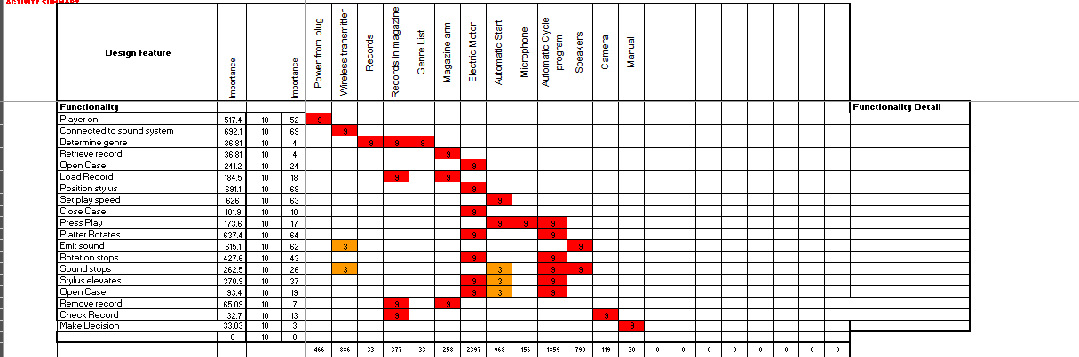
Figure 7 QFD 2
Figure 7 shows the QFD 2 from the design book. When viewed, the automatic cycle system of the record player is one of the most important features of the design. But in order to make this more approachable and for it to be used in design reviews we can create a feature importance chart, similar to the functional importance graph completed previously.

Feature importance Chart
The feature importance chart allows us to clearly see which features are critical. One of the reasons why creating both a QFD 2 and a feature importance chart is important is that the QFD 2 allows for the identification of features that could be grouped into a subsystem. Similar to QFD 1 with the subsystems of the functions which allows for more complex systems to be tracked in an orderly manner and resource to be allocated efficiently.

Summary
The student first gathered a set of requirements from the key stakeholders. From there

References

[1] | S. J. Seymour, D. A. Flanigan, S. M. Biemer and A. Kossiakoff, Systems engineering : principles and practice, John Wiley & Sons, Inc., 2020.
[2] | R. Banchs and M. Pop, To Understand a Process, You Need to “Go See” and Create a Map, 2021.
[3] | N. Sahand, O. Sewoong and S. Devavrat, “Rank Centrality: Ranking from Pairwise Comparisons,” Operations Reasearch, vol. 65, no. 1, pp. 266-287, 2017.

Appendices
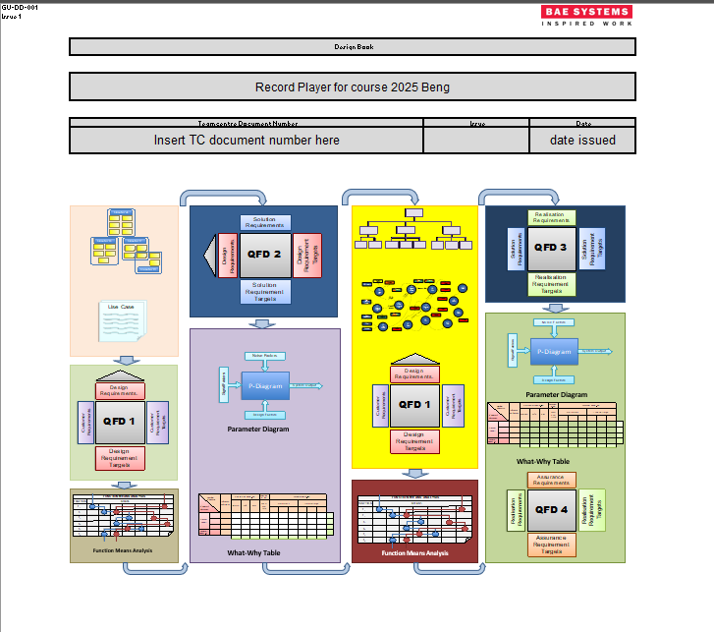
Figure 8 Design Book title

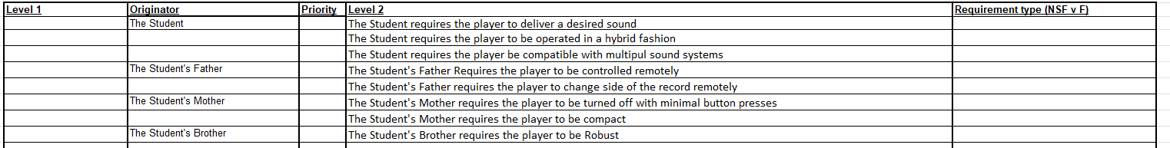
Figure 9 Requirements set
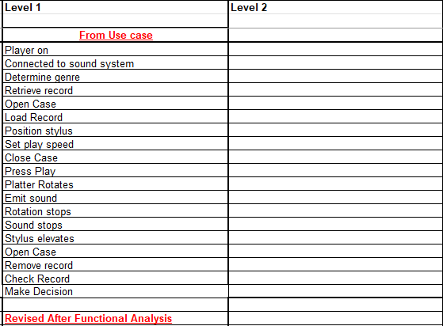
Figure 10 Required Functionality

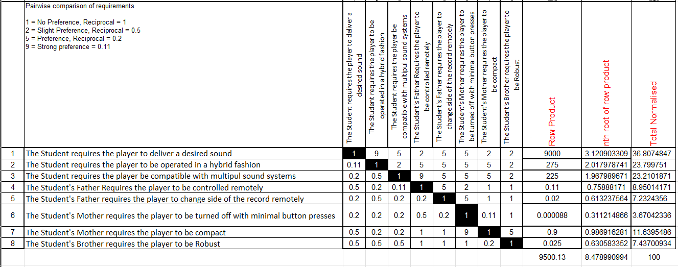
Figure 11 Rationalised requirements PW

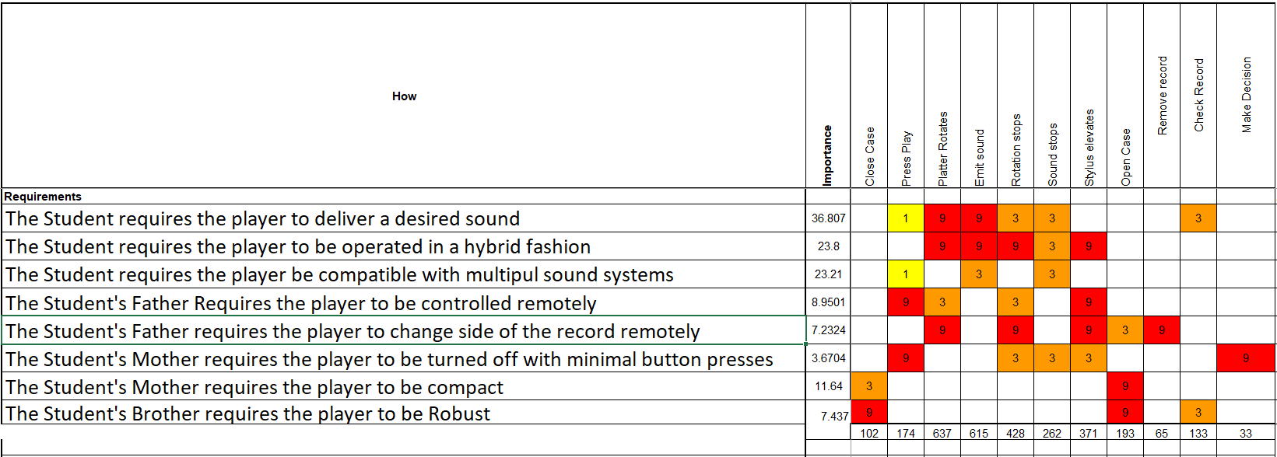
Figure 12 Design QFD 1

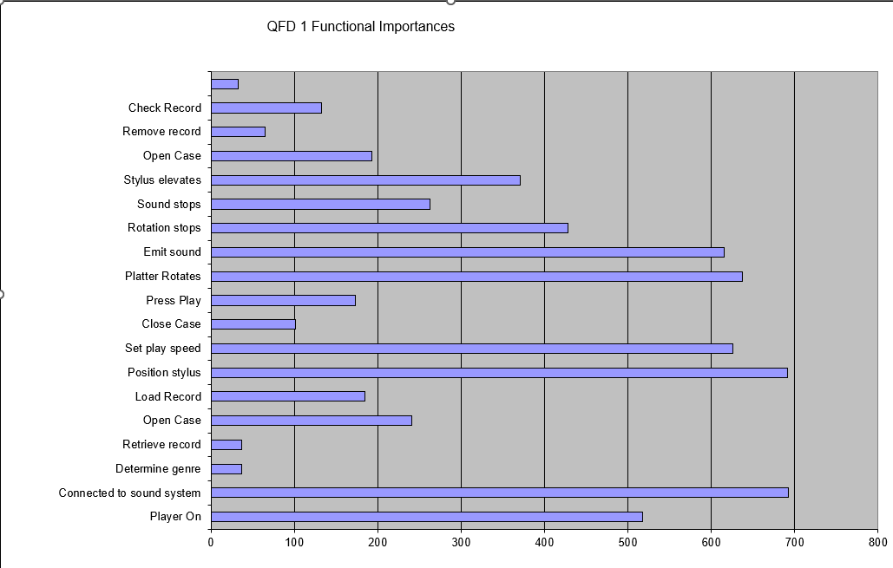
Figure 13 Functional Importance Graph

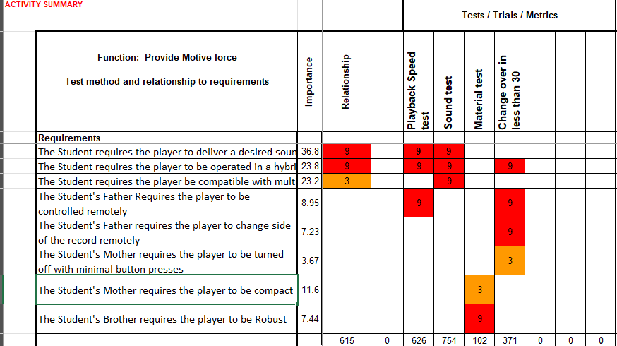
Figure 14 Functional Metrics

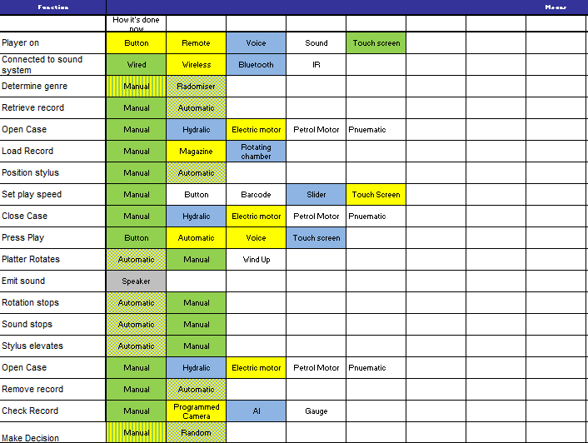
Figure 15 Function Means Analysis

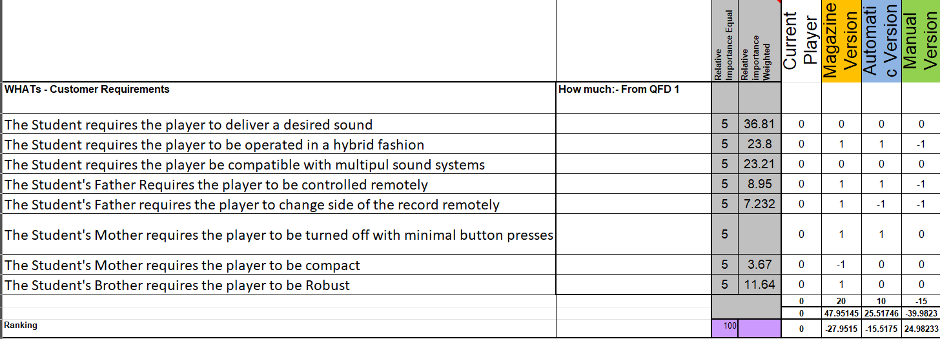
Figure 16 System Pugh

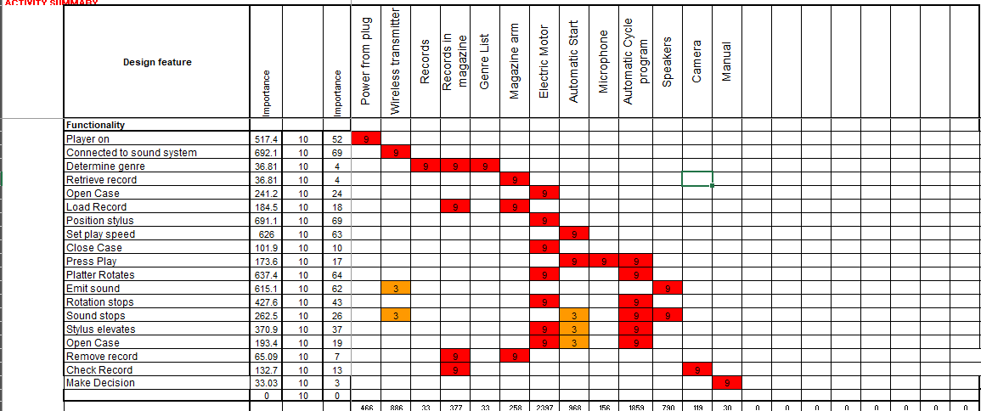
Figure 17 Design QFD 2

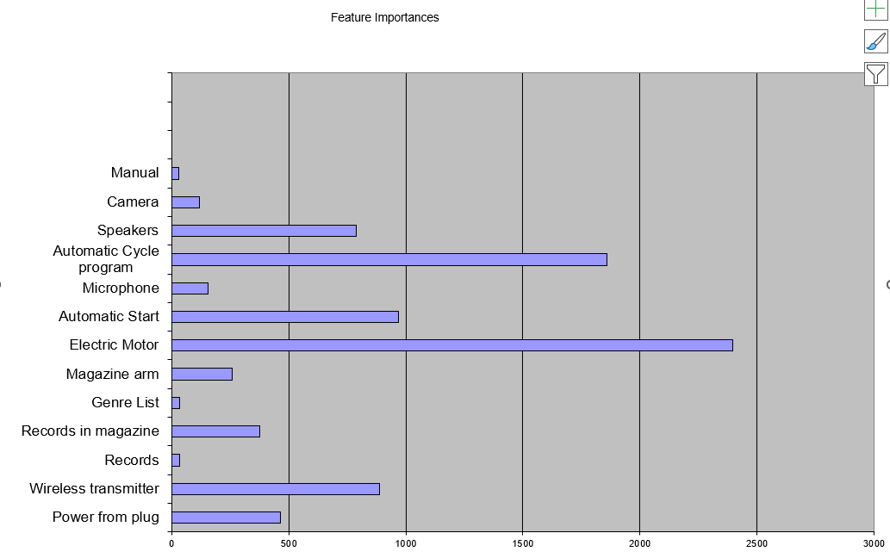
Figure 18 Feature Importance Chart

Figure 19 DFMEA

Appendix title (use Heading 7)

Appendix section (use Heading 8)

Appendix subsection (use Heading 9)

