Name: Jonathan S. Davies
Student Number: 1707239
Module: Project Management & Research Methods
Lecturer: Sue Maw
Module Code: ACDA5004

BeSafe Travel Application
Managing a Hardware/Software Project for Disaster Recovery

Table of Contents
Table of Contents 1
Introduction 3
Section 1 – Project Information 3
1. Background 3
1.1 - Context 3
1.2 - Why? 3
1.3 - Idea 3
2. Project Definition 3
2.1 - Purpose 3
2.2 - Objectives 4
2.2.1 – Objective 1 4
2.2.2 – Objective 2 4
2.2.3 – Objective 3 4
2.2.4 – Objective 4 4
2.3 - Scope Inclusions 4
2.4 - Scope Exclusions 4
2.5 – Deliverables 5
2.6 - Constraints 5
2.6.1 – Timescale 5
2.6.2 – User Accessibility 5
2.6.3 – Legal Issues 5
2.6.4 – Offline Usability 5
2.7 – Authority 5
2.7.1 – Stakeholders 5
2.8 – Resources 6
Section 2 – Project Considerations 6
3. Business Case 6
3.1 – Benefits 6
3.2 – Cost Analysis 6
3.3 – Timescale 6
4. Risk 6
Section 3 – Persons of Interest 7
5. Roles & Responsibilities 7
5.1 – Organisation Structure 7
6. Project Schedule 7
Section 4 - References 8
Section 5 - Appendices 0
7.1 Appendix A1 0
7.2 Appendix A2 1
7.3 Appendix A3 2
7.4 Appendix A4 3
7.5 Appendix A5 4

Introduction
This document has been created to provide essential background information, outlines, boundaries and targets for the proposed project and also to serve as a management/evaluation tool that will track the projects milestones.

Section 1 – Project Information

Background

- Context
Improving the way in which people can access information regarding a multitude of disasters and provide localized advice in regard to common first aid issues and general preparation.

- Why?
Millions of people are killed/injured or otherwise displaced every year from the effects of disasters. Both the lack of preparation for a disaster and the placid way in which the general population perceive the risks involved with a disaster contribute massively to the outcome [1].

- Idea
An application that will present relevant safety information regarding disasters of all different types in a way that is easy to understand for the user. It is aimed at travelers and people that reside in high risk areas and the information that is displayed is specified for them.

Project Definition

- Purpose

This idea was conceptualized following a discussion of the recent tsunami disaster in Indonesia. It was thought that if the local people had an application on their phone that offered potentially life-saving information that would have been invaluable both pre-disaster (such as a list of safe areas or equipment for a household etc.) and post-disaster (including first-aid instructional pictures or twitter updates from a local government response agency) then the cost of human life could have been reduced.

- Objectives

– Objective 1
Provide the user with accurate information regarding disasters.

– Objective 2
Produce travel safety information and send alert notifications via a traffic light warning system.

– Objective 3
Detail emergency scenario instructions for first-aid and provide a link to local government response agencies social media pages.

– Objective 4
Encourage users to engage in preparations for disasters that are local to them.

- Scope Inclusions

The scope can be broken down into two paths, the project scope and the product scope, as outlined by the American Management Association [2]. For this PID, both areas will be taken into consideration.
- The project will comprise of numerous disciplines including programming, web developing, database management, application and networking.
- It will be aimed at people that live in areas prone to either man-made or natural disasters, or travelers that are visiting those areas.
- The type of problems that this product will cover are natural disasters, terrorism, war, crime and biological threats.
- The product will have a worldwide coverage but is restricted by local languages and internet connection.

- Scope Exclusions

- The app will not contact the emergency services on the user’s behalf.
- It will not provide evacuation routes.
- It will not allow calls to be made from within the app.
- It will not plan a holiday or provide popular holiday destinations.
- The information inside will not be ‘real-time’.
- The medical advice found within the app is not a substitute for medical training.

– Deliverables

- Functional mobile application targeted at disaster prevention.
- A user interface that is simple to use and quickly conveys relevant information.
- Vetting process that will assess if the quality of incoming information.
- User documentation report.

- Constraints

– Timescale
The first and major constraint in this project is time as the deadline to have a working prototype is January. This forces the project team to carefully plan out an extensive timetable of events to ensure that the project is finished on schedule. Also if the team are having technical issues, there will not be any chance of an extended deadline.

– User Accessibility
A major part of the application is a colour coded information system. Users that are colour blind needs to be taken into account.

– Legal Issues
Legal aspects need to be considered when distributing medical advice.

– Offline Usability
Should the user not have internet connection, the application will have to rely on cached memory.

– Authority

– Stakeholders
 | Stakeholder Name
Internal (within team) | Project members  Project manager
Internal (outside team) | Managers – (Sue Maw)  Finance Department
External (outside company) | Project members families  End users  Government agencies  Distributers (apple store & android marketplace)

– Resources

The resources needed to complete the project are listed below:
- Development machines with required specifications.
- Specialized software (Visual Studio).

Section 2 – Project Considerations

Business Case

– Benefits
The end user will benefit from the information that will be provided from the application.

– Cost Analysis
This project is forecast to have no costing due to the fact that all project members are in university.

– Timescale
This project needs to be completed by 18/01/2019. There is no option to extend the project beyond this.

Risk
A risk is something that can have an adverse effect on the project. A list of risks has been outlined below:
- Project member not contributing to the project.
- Personal emergency that may render a project member incapable of work.
- The project team may lack the technical skillset to effectively produce this product.

Section 3 – Persons of Interest

Roles & Responsibilities

– Organisation Structure
The role of the project manager is viewed as less of a boss/leader and more of a collator of information for the entire team.

Project Schedule

The project has been split into four areas:
- Analysis
- Design
- Implementation
- Testing
A break down that outlines these areas in greater detail has been provided in the form of a Gantt chart in appendix 1-4.

Section 4 - References

[1] | S Wilson. et al, “The Lack of Disaster Preparedness by the Public and it's Affect on Communities,” The Internet Journal of Rescue and Disaster Medicine, vol. 7, no. 2, 2007.
[2] | J. C.-B. Paul C. Dinsmore, “Project Scope Management in Practice,” in The AMA Handbook of Project Management, Amacom, 2014, pp. 85-87.

Section 5 - Appendices

7.1 Appendix A1

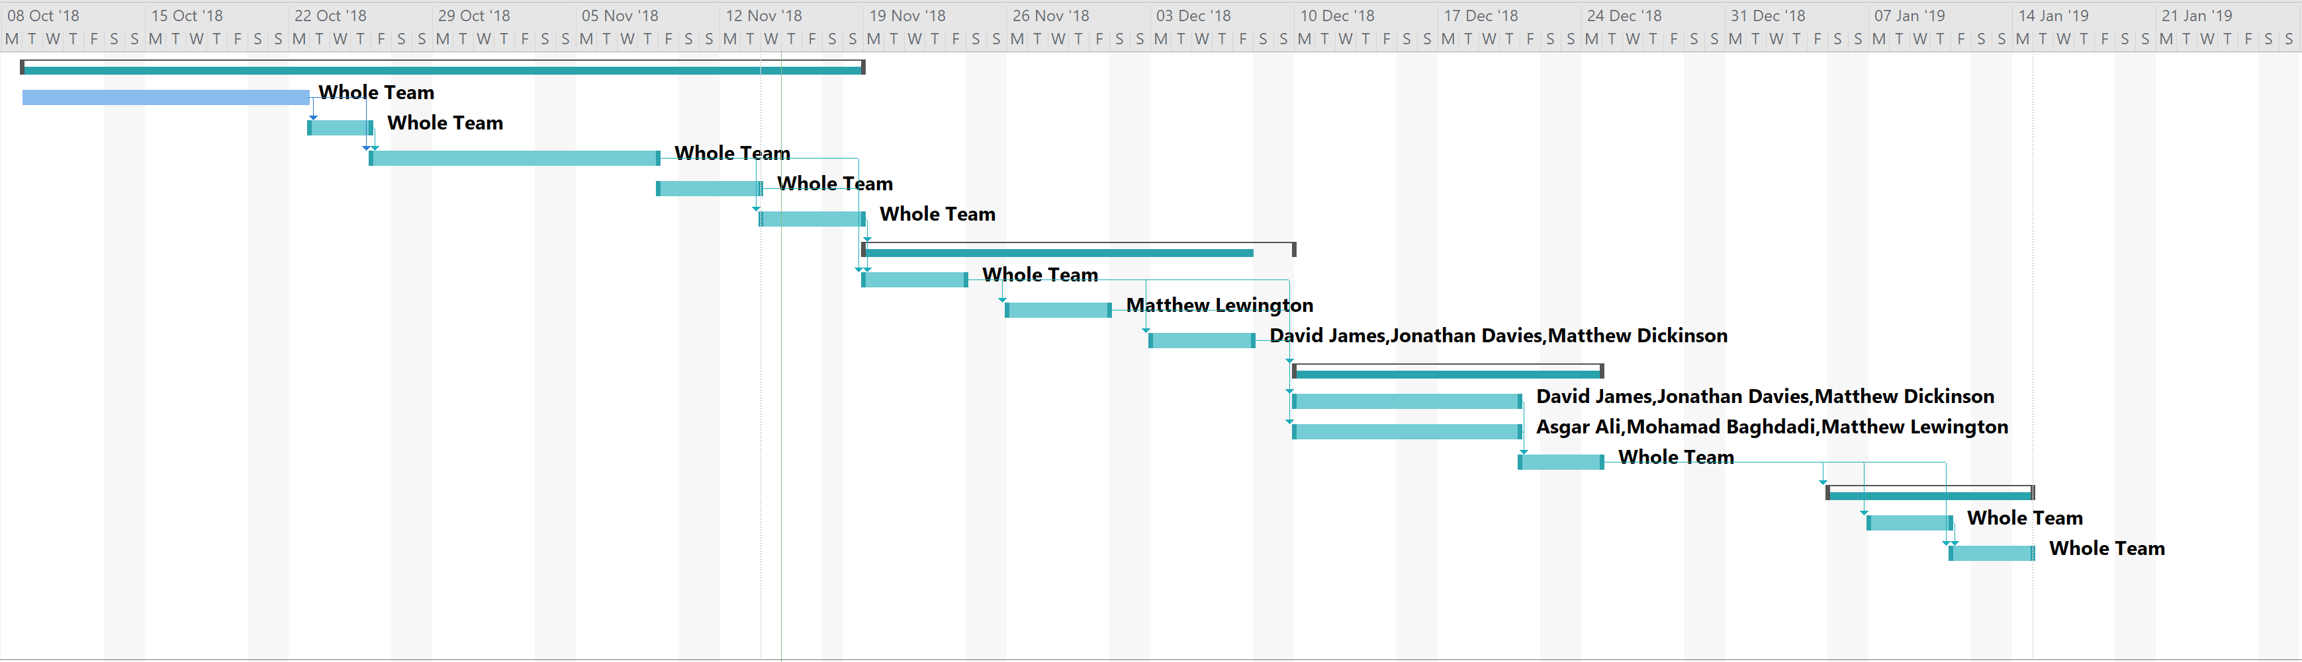
Figure 1 - Gantt Chart

7.2 Appendix A2

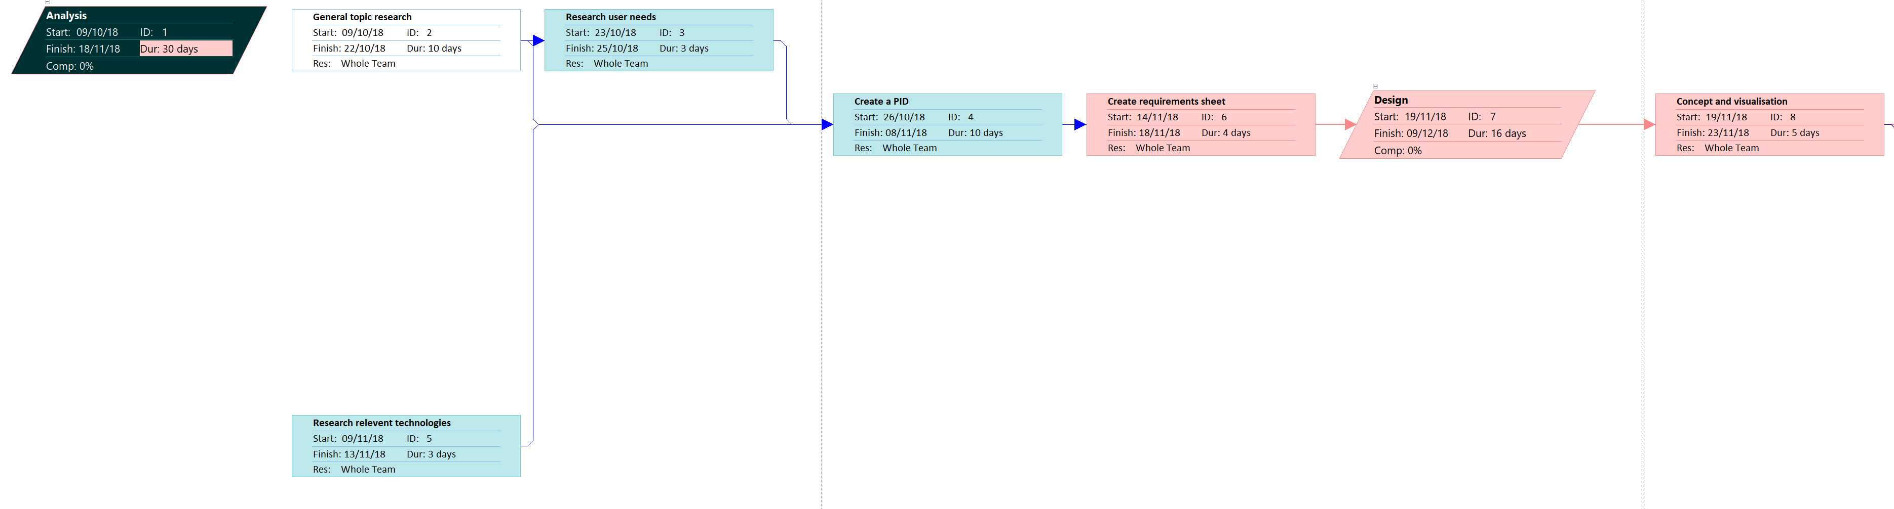
Figure 2 - Critical Path 1

7.3 Appendix A3

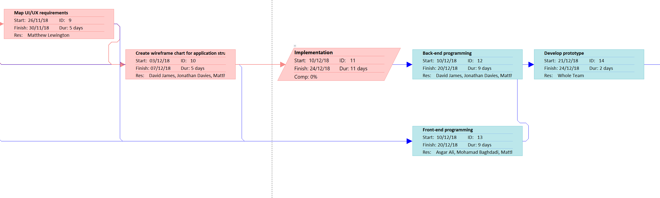
Figure 3 - Critical Path 2

7.4 Appendix A4
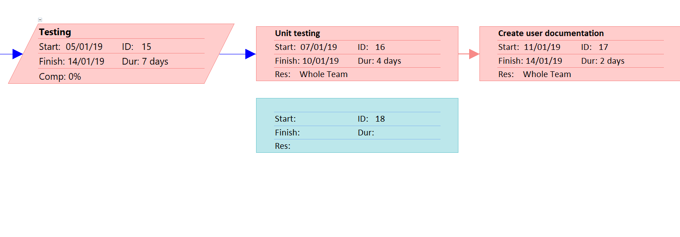
Figure 4 - Critical Path 3

7.5 Appendix A5

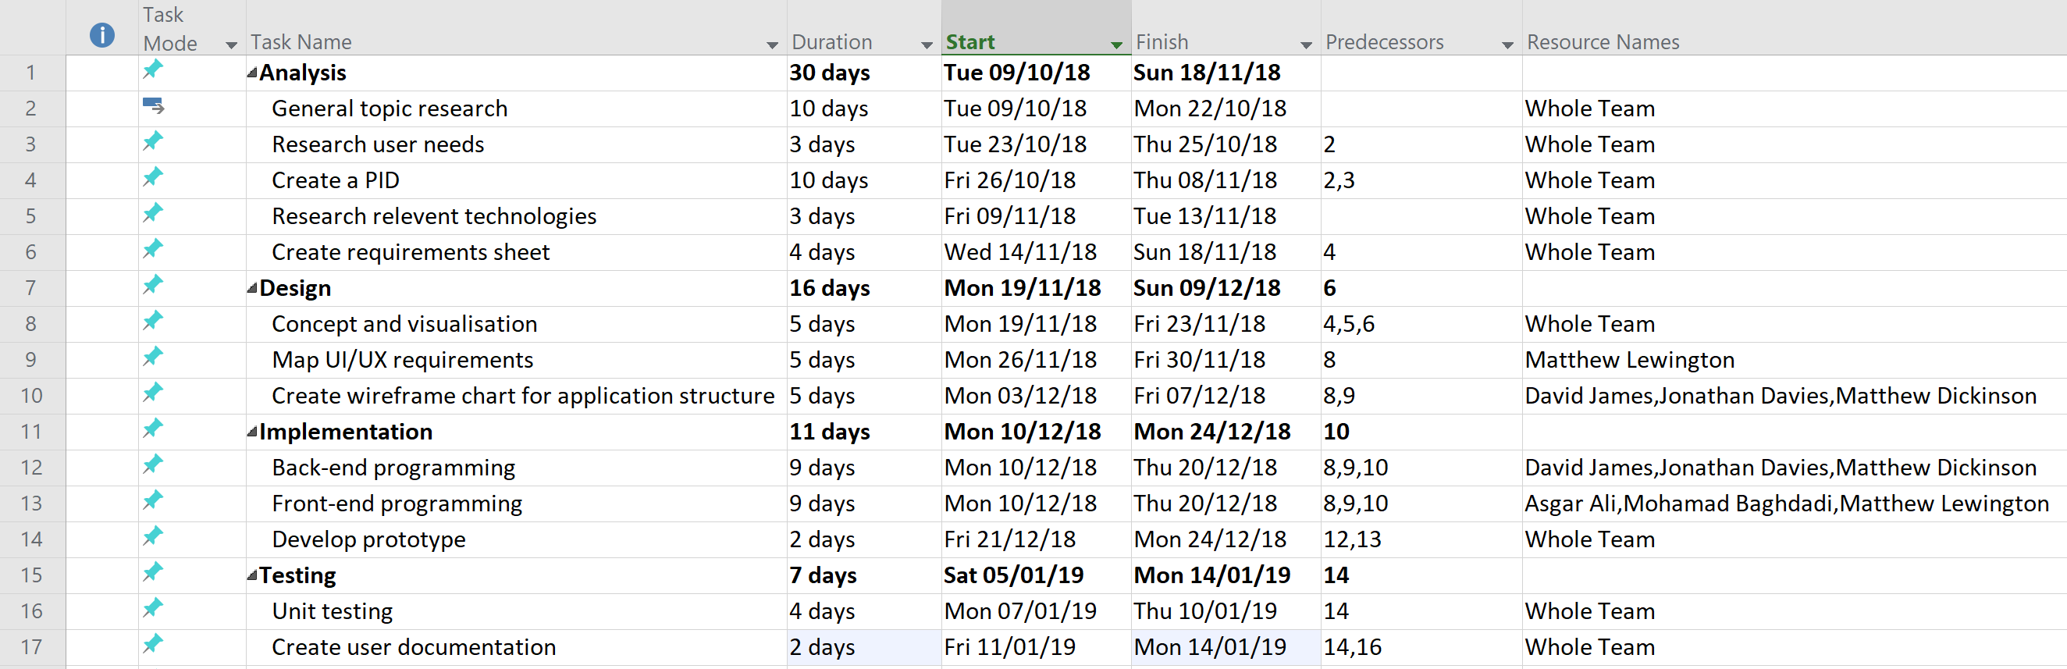
Figure 5 - Task Sheet

